Contents
Contents i
Abstract iii
Resumo iv
List of Figures v
List of Tables ix
List of symbols and acronyms x
1. Introduction 1
1.1. Regional context and objectives of this study 2
1.1.1. Objectives of this study 4
2. Scientific equipment and datasets 6
2.1. Characterization of aerosol properties 7
2.1.1. Some definitions 8
2.2. Integrating Nephelometer 11
2.3. Multi-Angle Absorption Photometer (MAAP) 16
2.4. Tapered element oscillating microbalance (TEOM) 19
2.5. Aerodynamic Particle Sizer (APS) 22
2.6. Site description 24
2.7. Datasets 27
3. Aerosol properties measured at Évora 30
3.1. Overall results 31
3.1.1. Aerosol scattering properties measured at Évora. 31
3.1.2. Aerosol absorption properties/Black carbon, total aerosol mass concentration and other derived properties 39
3.2. Seasonal variations of the aerosol properties 46
3.2.1. Seasonal variation of the scattering properties measured at Évora 46
3.2.2. Forest fires in summer and scattering measurements. 50
3.2.3. Seasonal evolution of BC, mass concentration and other aerosol properties 52
3.3. Daily variations of the aerosol properties 57
3.3.1. Daily variations of the scattering properties measured at Évora 57
3.3.2. Daily variations of BC, mass concentration and other aerosol properties 60
4. Influence of air mass history on the aerosol properties 66
4.1. Influence of air mass history in the scattering properties 68
4.2. Influence of air mass history on the measurements of BC/absorption coefficient, mass concentration and other properties. 70
5. Case studies of aerosol events of different types 75
5.1. Observations of dust events at Évora 76
5.2. Observations of events of aerosols from forest fires 79
5.3. Observations of events of continental polluted aerosols 81
5.4. Comparisons between the different aerosol types 84
6. Concluding remarks 87
References 91
Appendix A. Some statistical definitions 106
Appendix B. Nephelometer calibration 108
Appendix C. Relative humidity correction for scattering measurements 109
Appendix D. Comparison between TEOM and HiVol sampler. TEOM calibration 111
Appendix E. Tables of monthly statistical results 114
Appendix F. Data base of aerosol episodes observed between 2002 and 2009 119

Abstract
Climate relevant characterization of different aerosol types observed near the surface over Portugal

This thesis documents the results of ground based, in-situ, aerosol optical and physical properties measured or determined in the city of Évora, Portugal. These aerosol properties were obtained between 2002 and 2009 and correspond to the first study of ground surface aerosol climatology carried out in Portugal, where the characterization of the optical and physical aerosol properties was made through the combination of different ground based instruments at the site. Average aerosol properties were obtained at different timescales. These properties were also related to different possible source regions. Among the database of aerosol episodes which was built, several case studies were analyzed in order to derive “characteristic” average properties of different aerosol types. This study contributes to the investigations carried out by the scientific community towards a better understanding of the role of aerosols in the climate system.

Resumo
Caracterização dos aerossóis climatologicamente relevantes observados à superfície em Portugal.

Nesta tese são apresentados os resultados das medições de propriedades físicas e ópticas dos aerossóis, efectuadas à superfície em Évora, Portugal. As medições destas propriedades ocorreram entre 2002 e 2009 e correspondem ao primeiro estudo sobre a climatologia de aerossóis à superfície levado a cabo em Portugal, onde a caracterização das propriedades físicas e ópticas dos aerossóis foi feita através da combinação de diferentes instrumentos de superfície instalados no local. Propriedades médias dos aerossóis foram obtidas para diferentes escalas temporais. Estas propriedades foram também relacionadas com possíveis regiões de origem. Da base de dados de episódios foram analisados vários casos de estudo para a obtenção de propriedades características relativas a diferentes tipos de aerossóis. Este estudo é uma contribuição para o esforço da comunidade científica para uma melhor compreensão do papel dos aerossóis no sistema climático.

List of Figures
Figure 2.1. Nephelometer basic scheme.. 13
Figure 2.2. Nephelometer TSI-3563 installed at CGE facilities. Sampling inlet (upper left), instrument on operation (lower left) and under maintenance (upper and lower right). 14
Figure 2.3. Mie scattering and backscattering efficiencies for 550 nm and 1.33+0i refractive index. 15
Figure 2.4. MAAP 5012 operating at CGE’s facilities. 16
Figure 2.5. Optical sensor of the MAAP. Left: position of the photodetectors at detection angles θ₀ =0º, θ₁ =130º, and θ₂ =165º with respect to the incident light beam (λ MAAP = 670 nm). Right: layout of the MAAP sensor unit, where the arrows indicate the airflow through the sensor unit across the filter tape. Image adapted from Petzold et al. (2005). 18
Figure 2.6. Schematic representation of radiation processes to be considered in the two-layer system consisting of an aerosol-loaded filter layer and the particle-free filter matrix. Image adapted from Petzold et al. (2005). 18
Figure 2.7. TEOM’s detection unit. The mass transducer is enclosed within the black component (right picture) under controlled environment. 19
Figure 2.8. TEOM’s control unit. 20
Figure 2.9. Pallflex TX40 filters, before and after being used (left), and mass transducer (within the detection unit) open during filter exchange operation. 20
Figure 2.10. Aerodynamic Particle Sizer 3321 installed at CGE’s facilities. 22
Figure 2.11. Aerosol Flow Through the APS Model 3321. 23
Figure 2.12. Location of Évora, within Portugal, in the western European continent. Source: http://www.ngdc.noaa.gov/mgg/shorelines/shorelines.html. 24
Figure 2.13. City’s view and location of the sampling site within the city of Évora (yellow star). Source Google maps. 25
Figure 2.14. Relative magnitude of the hourly traffic density at Évora (adapted from Plano Director Municipal, Município de Évora, 2007). 26
Figure 2.15. Relative frequency of the wind direction measured at the Évora Geophysics Centre between 2002 and 2009 for the different seasons. 26
Figure 2.16. Monthly average (a) temperature, (b) relative humidity, (c) wind speed and monthly accumulated precipitation for the period of 2002-2009. The grey bars enclose the quartiles (P25 and P75) for temperature, relative humidity and wind speed. 27
Figure 2.17. Temporal scheme of measurements performed with each of the instruments. 28
Figure 3.1. Relative frequency distributions of hourly measurements of (a) scattering and (b) backscattering coefficients, at 550 nm, backscatter ratio, (c) Ångström exponent, α₄₅₀₋₇₀₀ and backscatter ratio at 550 nm. The solid lines represent the results of the fitting procedure. When the frequency distribution is multi-modal the dashed lines represent the individual modes and the solid line the composite distribution. 32
Figure 3.2. Temporal evolution of the hourly values of the scattering coefficient (550 nm) for the period of 2002 to 2009. 35
Figure 3.3. Ångström exponent versus fraction of light scattering by sub-micrometer particles, after (Carrico 2000; Sheridan et al., 2001; Doherty et al., 2005). The regression line obtained in the linear fitting is also shown. 36
Figure 3.4. Probability density of the hourly scattering coefficients at (a) 450, (b) 550 and (c) 700 nm versus Ångström exponent. The colour scale represents the density of points from blue, with less density, up to red with the highest density of points. 38
Figure 3.5. Relative frequency distribution of σ_{ap}(670) and BC. The solid line represents the results of the (lognormal) fitting. 40
Figure 3.6. Relative frequency distribution of $ω$. The solid line represents the results of the fitting procedure. The dashed lines represent the individual modes. 40
Figure 3.7. Relative frequency distribution of σ_{ep}(670). The solid line represents the results of the fitting procedure. 41
Figure 3.8. Temporal evolution of the hourly values of the absorption coefficient (670 nm) for the period of 2007 to 2009. The right axis is scaled to show the equivalent BC mass concentration. 42
Figure 3.9. Probability density of the absorption coefficient versus the single scattering albedo. 42
Figure 3.10. Temporal evolution of the hourly values of the mass concentration for the period of 2006 to 2009. 44
Figure 3.11. Relative frequency distribution of M and BC fraction. The solid lines represent the results of the (lognormal) fittings. 45
Figure 3.12. Scattering coefficient, at 550 nm, versus mass concentration (a) and relative frequency distribution of the mass scattering efficiency at 550 nm (b). 46
Figure 3.13. Monthly scattering coefficient, at 550 nm, and Ångström exponent measured at Évora between 2002 and 2009. Full symbols and open symbols represent the mean and median values, respectively, while the light gray bars enclose the quartiles (P25 and P75). 47
Figure 3.14. Monthly variation of the spectral scattering coefficients, σ_{sp}(450), σ_{sp}(550) and σ_{sp}(700). Full circles and open circles represent the mean and median values, respectively, while the light gray bars enclose the quartiles (P25 and P75). 49
Figure 3.15. Monthly variation of the spectral Ångström exponent. Full circles and open circles represent the mean and median values, respectively, while the light gray bars enclose the quartiles (P25 and P75). 49
Figure 3.16. Scatter plot with the monthly median α as a function of the monthly median σ_{sp}(550) for the months between 2002 and 2009. 50
Figure 3.17. Total area burnt in Portugal in the summers between 2000 and 2009. The data was taken from the Portuguese Bureau of Agriculture. 50
Figure 3.18. Daily scattering coefficient (550 nm) and Ångström exponent for August 2005, when forest fires were frequent and 2008 when no significant forest fires were occurring. 51
Figure 3.19. Monthly mean scattering coefficient (550 nm) and Ångström exponent as a function of the monthly burnt area, between 2002 and 2009. 52
Figure 3.20. Monthly variation of the Black Carbon mass concentration and extinction coefficient, at 670 nm (2007-2009). Full circles and open circles represent the mean and median values, respectively, while the light gray bars enclose the quartiles (P25 and P75). 53
Figure 3.21. Monthly variation of M between 2006 and 2009. Full circles and open circles represent the mean and median values, respectively, while the light gray bars enclose the quartiles (P25 and P75). 54
Figure 3.22. Monthly variation of BC fraction between 2007 and 2009. Full circles and open circles represent the mean and median values, respectively, while the light gray bars enclose the quartiles (P25 and P75). 55
Figure 3.23. Monthly variation of the single scattering albedo, $ω$, between 2007 and 2009. Full circles and open circles represent the mean and median values, respectively, while the light gray bars enclose the quartiles (P25 and P75). 55
Figure 3.24. Scatter plot of the hourly BC versus M for winter and summer periods (a) and hourly values of BC and M during a desert dust episode in December 2007. 56
Figure 3.25. Monthly variation of the mass scattering efficiency (550 nm), E_{sp}(550), between 2006 and 2009. Full circles and open circles represent the mean and median values, respectively, while the light gray bars enclose the quartiles (P25 and P75). 56
Figure 3.26. Median daily variation of σ_{sp}(550) for the different days of the week. The respective quartiles, P25 and P75, are also shown. 59
Figure 3.27. Median daily variation of σ_{sp}(550) for the different seasons of the year. The respective quartiles, P25 and P75, are also shown. 60
Figure 3.28. Hourly median values of σ_{sp}(550) versus α based in the respective daily variations for spring and winter periods. 60
Figure 3.29. Median daily variation of BC for the different days of the week. The respective quartiles are also shown. 62
Figure 3.30. Median daily variation of BC fraction for different days of the week. The respective quartiles are also shown. 62
Figure 3.31. Median daily variation of M for the different days of the week. The respective quartiles are also shown. 62
Figure 3.32. Median daily variation of $ω$ for different days of the week. The respective quartiles are also shown. 63
Figure 3.33. Daily variation of median values of extinction coefficient (670 nm) for the different days of the week. The respective quartiles are also shown. 64
Figure 4.1. Probability density plots for back trajectories arriving at Évora, and average path for each trajectory category (lower right figure). The frequency of occurrence for each trajectory category is also shown. 67
Figure 4.2. Relative frequency distributions of σ_{sp}(550) for each trajectory type (bin size = 10 Mm⁻¹). 69
Figure 4.3. Relative frequency distributions of the Ångström exponent for each trajectory type (bin size = 0.2). 69
Figure 4.4. Relative frequency distributions of σ_{bsp}(550) for each trajectory type (bin size = 10 Mm⁻¹). 69
Figure 4.5. Relative frequency distributions of σ_{ap}(670) and BC for each trajectory type (bin size = 0.2 µgm⁻³ for BC). 72
Figure 4.6. Relative frequency distributions of M for each trajectory type (bin size = 5 µgm⁻³). 72
Figure 5.1. Temporal evolution of the scattering coefficient (550 nm) and mass concentration in May/ June 2006. 77
Figure 5.2. Temporal evolution of the Ångström exponent in May/ June 2006. 77
Figure 5.3. Temporal evolution of the coarse and fine number concentrations in May/ June 2006. 77
Figure 5.4. Temporal evolution of the scattering coefficient (550 nm) and mass concentration in December 2007. 78
Figure 5.5. Temporal evolution of the Ångström exponent in December 2007. 78
Figure 5.6. Temporal evolution of the coarse and fine number concentrations in December 2007. 78
Figure 5.7. Terra Modis image from 23 August 2005 and set of back-trajectories computed for the period from 19 to 26 August 2005. 79
Figure 5.8. Temporal evolution of (a) scattering coefficient and (b) Ångström exponent in August 2005. Please notice the logarithmic scale in figure 5.8a 80
Figure 5.9. Temporal evolution of the scattering coefficient (550 nm) and mass concentration in August 2006. 81
Figure 5.10. Temporal evolution of the coarse and fine number concentrations in August 2006. 81
Figure 5.11. Temporal evolution of the scattering coefficient (550 nm) and mass concentration in November/ December 2007. 82
Figure 5.12. Temporal evolution of the Ångström exponent in November/December 2007. 83
Figure 5.13. Scattering coefficient (550 nm) versus fine mode (a) and coarse mode (b) number concentration. 83
Figure 5.14. Temporal evolution of the Black carbon mass concentration in November/ December 2007. 83
Figure 5.15. BC fraction versus the single scattering albedo. 84
Figure 5.16. Set of back-trajectories, computed for the period between 28 November to 6 December 2007, showing the continental influence of the air masses arriving at Évora during this period. 84
Figure 5.17. Scattering coefficient (550 nm) versus mass concentration for (a) dust and forest fires and (b) pollution aerosols. The lines and respective slopes (m²g⁻¹) represent the mass scattering efficiencies. 86

List of Tables
Table 2.1. Summary of the aerosol properties measured and computed by means of the combination of the different instruments. 29
Table 3.1. Statistical parameters of the scattering and backscattering coefficients, at 450, 550 and 700 nm, and respective fitting parameters to lognormal distributions (see Appendix A for details in the statistical quantities). 31
Table 3.2. Statistical parameters for the Ångström exponent, calculated for different wavelength ranges, and hemispheric backscatter function, at 450, 550 and 700 nm. The respective fitting parameters to normal distributions are shown below. In the case of α, a sum of two normal distributions was used. 32
Table 3.3. Summary of some measurements reported in the literature regarding long term periods (of at least one year and considering European sites). 37
Table 3.4. Used criteria for different aerosol types in terms of spectral scattering coefficients and Ångström exponent. 39
Table 3.5. Statistical parameters for σ_{ap}(670), $ω$(670) and σ_{ep}(670) (hourly values). The respective fitting parameters are shown below. Lognormal for σ_{ap}(670) and σ_{ep}(670) and sum of two normal for $ω$(670). The number of data is different for σ_{ap}(670) and $ω$(670) or σ_{ep}(670) because nephelometer and MAAP were not always measuring simultaneously. 41
Table 3.6. Statistical parameters for BC, M, BC fraction and E_{s}(λ) (hourly values). The respective fitting parameters to lognormal distributions are shown below. 45
Table 4.1. Average and median values of σ_{sp}(550), α and σ_{bsp}(550) for each trajectory type. 70
Table 4.2. Average and median values of σ_{ap}(670), ω, M, BC, BC fraction, σ_{ep}(550) and E_{sp}(670) for each trajectory type. 73
Table 5.1. Average optical and physical aerosol properties for different aerosol types. These results account for the periods when each aerosol episode was more intense, in order to isolate, as much as possible, each aerosol type. 85

List of symbols and acronyms

Symbols

b(λ) | Spectral backscatter fraction | -
BC | Black Carbon mass concentration | µgm⁻³
BC fraction | Black Carbon fraction to total aerosol mass concentration | -
c | Particle counts | -
D | Particle diameter | m
dN/dlogD | Particle size distribution | cm⁻³
E_{sp}(λ) | Mass scattering efficiency at wavelength λ | m²g⁻¹
E_{ap}(λ) | Mass absorption efficiency at wavelength λ | m²g⁻¹
f | Frequency of oscillation | s⁻¹
K | Spring constant | kgs⁻¹
m | Mass | kg
m₀ | Tube mass of TEOM | kg
m_{F} | Filter mass of TEOM | kg
M | Total aerosol mass concentration | µgm⁻³
N | Total particle number concentration | cm⁻³
N_{0.5-10} | Particle Number concentration with diameter in the size range  0.5-10 µm | cm⁻³
N_{F} | Particle Number concentration of the fine fraction | cm⁻³
N_{C} | Particle Number concentration of the coarse fraction | cm⁻³
Q | Air flow-rate | m³s⁻¹
Q_{sp} | Aerosol scattering efficiency | -
Q_{bsp} | Aerosol backscattering efficiency | -
SF | Fraction of light scattered by sub-micrometer particles | -
t | time | s
x | Size parameter | -
α | Ångström exponent | -
Δm | Accumulated mass in the TEOM filter | kg
Δt | Time interval | s
φ | Azimuthal angle | rad
θ | Scattering angle | rad
λ | Wavelength | m⁻¹
f(λ,Ω) | Scattering function | Wm⁻²sr⁻¹
σ_{ap}(670) | Absorption coefficient at the wavelength of 670 nm | Mm⁻¹
σ_{bsp}(λ) | Spectral backscattering coefficients | Mm⁻¹
σ_{ep}(670) | Extinction coefficient at the wavelength of 670 nm | Mm⁻¹
σ_{sp}(λ) | Spectral scattering coefficients | Mm⁻¹
$$\overline{ω}$$ | Single scattering albedo | -

Acronyms

APS | Aerodynamic Particle Sizer
HYSPLIT | Hybrid Single Particle Lagrangian Integrated Trajectory Model
LIDAR | Light Detection and Ranging
MAAP | Multi-Angle Absorption Photometer
TEOM | Tapered Element Oscilating Microbalance
MT | Trajectories classified as Maritime
MIB | Trajectories classified as Maritime Iberian
EU | Trajectories classified as European
IB | Trajectories classified as Iberian
AF | Trajectories classified as African
agl | Above ground level
SF | Fraction of light scattered by sub-micrometer particles

Introduction
This thesis focuses on the experimental investigation of physical and optical properties of the atmospheric aerosols near the ground surface. The measurements and the results, unique in Portugal, were carried out at Évora, a relatively small city, located in the south-western Iberian Peninsula. This study is a contribution to the scientific efforts made worldwide, in particular in the last few decades, in order to understand and to assess the role of aerosols in the climate system.
There is a growing evidence that the Earth’s radiation budget, and thus climate, is affected through the radiative forcing due to aerosols caused by changes in the concentration (and composition) of aerosol particles (e.g. Hansen et al., 1997; Charlson et al., 1992, 1999; Ramanathan et al., 2001; Tanré et al., 2003; Hatzianastassiou et al., 2004; Lohmann and Feichter, 2005; McComiskey et al., 2008). In fact, atmospheric aerosols, of both natural and anthropogenic origin, affect the climate directly by scattering and absorbing both solar and long wave radiation. The indirect effect involves aerosol influence on cloud properties (e.g. Twomey, 1977; Schwartz et al., 1995; Levin and Ganor, 1996; Pruppacher and Klett, 1997; Rosenfeld et al., 2001; Lohmann and Feichter, 2005; Pöschl, 2005; Andreae and Rosenfeld, 2008; Rosenfeld et al., 2008; Heintzenberg and Charlson, 2009, Costa et al., 2010). Depending on the optical properties of the aerosol, the sign, or direction of climate forcing, can be positive (warming) or negative (cooling). Also, health problems arising from particulates have been given a great amount of interest (e.g. Dockery and Pope, 1996; Lippmann, 1999; Künzli et al., 2000) which led to European guidelines such as the First Daughter Directive 99/30/EC and the requirement of aerosol monitoring at the air quality stations.
Aerosol optical properties are key factors in investigating the direct radiative effects by atmospheric aerosols. However, owing to their high spatial (vertically and horizontally) and temporal variability, the globally and annually averaged climatic forcing by aerosols is associated with large uncertainties (IPCC, 2007). Satellite platforms and global climate models have been used to study the variability of aerosol properties both on regional and global scales (e.g., King et al., 1999; Liousse et al., 1993). However, several assumptions concerning the relationship between aerosol properties measured at the surface and aerosol properties in the vertical column have to be used in the satellite algorithms and global climate models. The satellite retrieval algorithms also involve assumptions on several key aerosol properties [Kaufman et al., 1997]. Therefore, a clear need exists for long term measurements of columnar and surface (object of this thesis) aerosol optical, physical, and chemical properties at different ground-based monitoring sites, with more realistic aerosol properties being therefore included. Records of this type of information can then be used to improve satellite aerosol retrieval algorithms, and to help validating global chemical-transport-radiation models used for calculations of the direct aerosol radiative forcing.

Regional context
The Iberian Peninsula, comprising Portugal and Spain, constitutes the south-western region of the European continent, surrounded by the Atlantic Ocean, while its eastern coasts are within the Mediterranean basin. Also, the Saharan region occupies the southern sector. Several published studies, particularly since the 90’s, have contributed to the increase of knowledge on the atmospheric aerosols present in the Iberian Peninsula, and also on the advection of aerosols from other regions. This latter issue has been somewhat motivated by frequent dust outbreaks due to the proximity of the vast arid Saharan region. Studies ranging from single (or sets of) case studies (see e.g. Lyamany et al., 2005; Pérez et al., 2006; Elias et al., 2006; Escudero et al., 2007; Wagner et al., 2009) up to longer term studies. Databases of episodes, at several sites (see e.g. Rodríguez et al., 2001; Escudero et al., 2005; Toledano et al., 2007) have been reported.
Ground-based measurements, in-situ as well as columnar observations, have been used by previous authors to study the aerosol properties, including desert dust aerosols. The first type of studies are mainly based upon measurements of particle mass concentrations and/or chemical apportionment (e.g. Almeida et al., 2005, 2006; Alves et al., 1998; 2002; Pio et al., 1996, 2008; Escudero 2005, 2007; Querol et al., 1999, 2001, 2009; Rodríguez et al., 2001, 2002); the second type of studies are based upon sun photometric measurements; also, ground based LIDAR measurements have given additional contributions to the subject since vertically resolved aerosol properties can be obtained (see e.g. Sánchez Oliveros et al., 1998; Cachorro et al., 2000; Vitale et al., 2000; Lyamany et al., 2005; Péres et al., 2006; Toledano et al., 2007; Guerrero-Rascado et al., 2009). Dust concentrations representing 40-50 % of the daily UE limit value for PM10 (50 μgm⁻³) were “(…) frequently reported during African events” (Rodríguez et al., 2002), and could be as high as 80% in rural sites. However, dust transportation may also be carried out at high levels, being weakly detected at the surface (Elias et al., 2006; Guerrero-Rascado et al., 2009). In fact, the African desert dust transportation at high levels is the reason for observing it at locations as far as the American continent (e.g. Prospero, 1999; Formenti et al., 2000).
European continental areas east of the Iberian Peninsula, including heavily polluted areas, are a vast source region of anthropogenic particles whose advection into the Iberian Peninsula has been also detected and studied (Carrico et al., 2000; Ansmann et al., 2002; Escudero et al., 2007; Lyamani et al., 2008).
The proximity of the Atlantic Ocean, with “clean” air transported by the westerly winds, and “washed” by precipitation is related with lower aerosol loads. This “effect” which is frequent in the northern and western coastal areas of the IB was also observed in sites inland (Rodríguez et al., 2004; Pereira et al., 2008; Lyamani et al., 2010). However, Pio et al (1996) also observed situations of anthropogenic aerosols in a coastal site, with western flow, due to mesoscale re circulation of pollutants.
Although for the eastern Mediterranean region several studies concerning ground based (in-situ) measurements of aerosol optical and physical properties are reported (e.g. Formenti, 2000; Andreae et al., 2003; Gerasopoulos et al., 2003; Vrekoussis et al., 2005; Derimian et al., 2006;), there is a gap of knowledge of these properties in the western Mediterranean region and in this region of the Iberian Peninsula. The Aerosol Characterization Experiment 2 (ACE-2), a three month campaign in the Portuguese south-western coast, included for the first time this type of measurements as a contribution to characterize “(…) ground-level aerosol optical properties for a site that receives clean and anthropogenically perturbed aerosol“ (Carrico et al., 2000). Later, Elias et al (2006) focused his studies in the aerosol optical properties during the summer heat wave period of 2003, in Évora, while Lyamani et al. (2008) characterized the aerosol optical properties for the winter period and, later, during medium-term periods (1-2 years) in the larger urban site of Granada (Lyamani et al., 2009, 2010). Studies on aerosol optical properties are also reported for Valência (Esteve et al., 2009, 2010), in Spain, as well as for Évora (Pereira et al., 2008, 2011).

Objectives of this study
This thesis focuses on the experimental investigation of near surface aerosols in Évora, Portugal. Scattering and absorption properties, as well as total and Black Carbon mass concentrations, were measured in a long-term basis which constitute the first database of this type ever analysed in Portugal. Also, several other aerosol properties obtained from the measured ones are analysed which provide further insight in the main aerosol characteristics. The data is analysed as a whole and at different timescales. The former approach allows characterizing the measurement’s site while providing a fairly large database of several average aerosol properties important for climate that can be compared with literature and/or used in further studies; the latter constitutes an attempt to establish the first aerosol climatology in the most western region of European continent where the main Portuguese territory is located.
The influence of different source regions in the measured aerosol properties is explored. The measurements site is neither remote nor a large population centre; rather, is a small city within a vast rural/remote region, of Mediterranean characteristics, located in the south-western Iberia Peninsula. Therefore this site, in spite of its moderate urban characteristics, is also a fairly good place for detecting aerosols transported from elsewhere, as well as relatively clean air, with low concentration of particles, arriving from the Atlantic Ocean. Several specific objectives were intended to be reached during this thesis:
Built-up of the datasets of the measurements acquired by different equipments, installed at the ground surface and of the additional aerosol properties that could be computed by means of the combination of the several basic properties measured with the equipments. Then perform statistical analysis of the climate relevant aerosol properties. Therefore one objective of our investigation was to document for the first time the seasonality of optical and physical properties and establishing fairly comprehensive surface aerosol climatology. This is the first long-term study of such aerosol properties undertaken in Portugal.
Study the relationship of the aerosol properties variability with the synoptic atmospheric circulation in order to infer on the main transportation paths and sources affecting the aerosols at the site.
Brief descriptions of the aerosol optical and physical properties as well as the suite of equipments used for the build up of this thesis are included in Chapter 2. The site where the measurements were carried out is also described here. In Chapter 3 the results of the aerosol optical and physical properties measured at Évora are reported and discussed. Also, the seasonal evolution and daily variation of the aerosol optical and physical properties are analysed. In chapter 4 the relation of the aerosol optical and physical properties with the different air masses influencing the region is discussed. The aerosol properties are combined with the computed back-trajectories and categorized according to each source region. Various case studies of different aerosol types observed at Évora are included in Chapter 5, namely desert dust, forest fires and pollution aerosol events which led to a distinct and clear increase in the aerosol load. Respective aerosol optical and physical properties are analysed and differences between the different aerosol types are established. Finally, in Chapter 6 the concluding remarks are given.

Scientific equipment and datasets
In this chapter the scientific equipments used for developing this thesis will be presented, namely the integrating nephelometer (for aerosol scattering and backscattering coefficients measurements), the Multi-Angle Absorption Photometer (for aerosol absorption coefficient and Black Carbon mass concentration measurements), the Tapered Element Oscillating Microbalance (for aerosol mass concentration measurements) and the Aerodynamic Particle Sizer (for aerosol number concentration and size distribution). They are just briefly described as they are commercially available instruments and their characteristics and capabilities were already comprehensively described in the literature. They all measure aerosol integral properties (in addition the APS also measures the size spectra). It’s important to mention that all the instruments (except the APS) were provided with PM₁₀ sampling heads which remove particles larger than 10 µm in aerodynamic diameter. By doing so, the same aerosol population is sampled.
Before the description of the scientific equipments, the main optical and physical aerosol properties obtained with those equipments are presented in the following section.

Characterization of aerosol properties
First the physical concept of aerosol, namely atmospheric aerosol, should be defined: “An aerosol is an assembly of liquid or solid particles suspended in a gaseous medium (…) long enough to be observed and measured” [Baron and Willeke, 2001]. In this thesis one will use the terms particles or aerosols indiscriminately.
Aerosol particles are emitted by a diversity of sources, natural and anthropogenic, which mainly determine their physical properties and chemical composition.
They may be classified as primary or secondary particles. The former are directly emitted into the atmosphere as particles, while the latter are formed after chemical transformation of their gaseous precursors (gas to particle conversion). Aerosol particles associated to each source tend to have a relatively specific size distribution and chemical composition.
They may vary from a few nanometres up to several tenths of micrometers. Nowadays, a conceptual model is generally accepted (but not exclusive) concerning the particles size distribution based in their formation and removal mechanisms in the atmosphere. Three size modes are considered:
- Nucleation mode, in the range 0.005-0.1 μm. Particles in this size range are mainly formed, for example, from the condensation of gases emitted at high temperatures, or processes of nucleation after the reaction of gases with, for example, OH or O₃. Some, such as the elemental carbon, are emitted directly into the atmosphere, throughout incomplete combustion processes.
- Accumulation mode, in the range 0.1-1 μm. Particles in this size range basically result from two main of processes: Growth of particles from the nucleation mode by coagulation processes and gas condensation. The former is the formation of larger particles due to collision of particles (due to thermal agitation) while the latter process consists in low vapour gas condensation over existing particles. This mode is crucial in terms of visibility and climate, because particles in this size range are most efficient on interacting with solar radiation due to scattering and absorption.
- Coarse mode, in the range > 1 μm. Particles in this size range tend to be formed by mechanical processes. Mineral dust, from erosion processes, or sea spray, from bursting bubbles, are good examples (among a large variety of materials that result from fractioning processes). This mode is often characterized by a low number density, although being very important in terms of mass. The coarse mode consists mainly of primary particles.
It’s also common to use the basic terminology - fine and coarse particles using the same size threshold of 1 μm (however, in air quality/health issues it’s also used the size of 2.5 μm).

2.1.1. Some definitions
The attenuation of a monochromatic parallel light beam during its passage through a medium is described by Beer-Lambert law. If radiation of wavelength λ and initial intensity, I₀(λ), passes through an aerosol layer a fraction of that radiation will be absorbed within the layer and part of it will be scattered in all directions. After passing along a path of length x the initial beam intensity will be attenuated leading to the intensity, I_{x}(λ), according to
(2.1)
where σ_{a}(λ) and σ_{s}(λ) are the monochromatic (or spectral) volumetric absorption and single scattering coefficients, respectively. The extinction coefficient, σ_{e}(λ), is the sum of these two components. In the atmosphere the extinction coefficient is conveniently separated into different components which account for absorption and scattering by the air molecules (index g) as well as absorption and scattering by aerosol particles (index p), i.e.
(2.2)
(2.3)
Here we are only concerned with contribution of aerosol particles. The scattering coefficient, at a given wavelength, can be defined with the help of the scattering function f(λ,Ω) which gives the intensity scattered in any increment of solid angle Ω about the initial direction of the beam. The integration of f(λ,Ω) over all directions equals the scattering coefficient
In polar coordinates φ and θ, the azimuthal and scattering angles, respectively, and assuming symmetrical scattering with respect to φ, then the scattering coefficient is given by
(2.4)
The integration of eq. (2.4) can be defined over part of the hemisphere, namely backward hemisphere. By doing so,
(2.5)
As we will see, the nephelometer measures directly both σ_{sp}(λ) and σ_{bsp}(λ). Another way to see these quantities is by their implicit relation to the aerosol population responsible for the scattering of light. Microphysical data are related to optical data via the following Fredholm integral equation of the first kind
(2.6)
where O represents any kind of optical data at a given wavelength, K is a kernel (which depends on the wavelength λ, complex refractive index m, particle diameter D, and shape of particles) which represents the microphysical data and dN/dlogD is the aerosol number size distribution. Our optical data are σ_{sp}(λ) and σ_{bsp}(λ). Mie theory may be applied for spherical particles and equation 2.6 can be written for an aerosol population as:
(2.7)
(2.8)

where Q_{s} and Q_{bs} are the aerosol scattering and backscattering efficiencies obtained by the Mie theory (see figure 2.3) given by
(2.9)
(2.10)

where x=2πr/λ is the size parameter and |S₁(θ)|² and |S₂(θ)|² ${\left|S_{1}(θ)\right|}^{2},{\left|S_{2}(θ)\right|}^{2}$are the perpendicular and parallel amplitude functions of the scattering angle θ.
The Ångström exponent, α, represents the wavelength dependence of σ_{sp}(λ) and can be related to a mean size of the particles. It’s a widely used parameter as its computation is straightforward while providing a hint for the variations in the aerosol size distribution. It can be calculated using a pair of wavelengths as follows:
(2.11)
The Ångström exponent varies typically between 0 and 2. It’s larger for aerosol populations dominated by sub micrometer particles and decreases as the influence of coarse particles within the aerosol population increases.
With the knowledge of scattering and absorption coefficients the computation of the so-called single scattering albedo, $\overline{ω}$, is also straightforward, since $\overline{ω}$ is the ratio of scattering to extinction coefficient. It represents the balance between scattering and absorption and depends on the aerosol size distribution, chemical composition (which determines the refractive index) and wavelength. For a certain wavelength it’s given by
(2.14)
where
(2.15)
$\overline{ω}$ ranges from 0 to 1 where the unity implies that all particle extinction is due to scattering and the null implies that all extinction is due to absorption.
The ratio between the backscattering and scattering coefficients is the hemispheric backscattering fraction, b. It is the fraction of the scattered intensity that is redirected into the backward hemisphere of the scattering particle. For a certain wavelength it’s given by
(2.16)
The spectral mass scattering efficiency can be computed as the ratio of aerosol scattering coefficient to the aerosol mass concentration. Also, the slope from a linear regression of σ_{sp}(λ) and M can be interpreted as the mass scattering efficiency. The wavelength dependency of the scattering coefficient leads necessarily to the wavelength dependency of the mass scattering efficiency, E_{sp}(λ). For a certain wavelength it’s given by
(2.17)
where M stands for the aerosol mass concentration (mass of particles per volume of air) which depends on the aerosol size distribution and their respective bulk density. [Hand and Malm, 2007] reviewed the different methods for obtaining the aerosol mass scattering efficiency and the method used in this thesis is regarded as the “measurement method”. Similarly, the mass absorption efficiency, E_{ap}(λ) can be written as
(2.18)
where σ_{ap}(λ) is the spectral absorption coefficient.

Integrating Nephelometer
The integrating nephelometer (TSI, model 3563) detects the light scattered by aerosol particles measuring the angular integral of light scattering which yields to the the scattering coefficient, σ_{sp}(λ), for the angular integral over the hemisphere, and to the backscattering coefficient, σ_{bsp}(λ), for the angular integral over the backward hemisphere. There are six (extensive) quantities being measured as three wavelengths are available: λ= 450, 550 and 700 nm. Figure 2.1 shows the scheme of the instrument and figure 2.2 shows some pictures of the equipment. Basically, it operates by measuring the light scattered by aerosol particles after subtracting the light scattered by the walls of the sampling chamber and by the air molecules.
The aerosol sample is drawn into the measurement volume where it’s illuminated over an angle of 7 to 170° by a halogen lamp. By using the backscatter shutter, this range can be adjusted to either 7–170º or 90–170º to give total scatter and backscatter signals, respectively.
The sample volume is “viewed” by three photomultiplier tubes through a series of apertures set along the axis of the main instrument’s body. Aerosol scattering is viewed against the backdrop of a very efficient light trap. The light trap, apertures, and a highly light-absorbing coating on all internal surfaces of the instrument intend to provide a very low scatter signal from the walls of the instrument. The light is directed into three band-pass filters, blue, green and red, for the central wavelengths of 450, 550 and 700 nm, respectively (40 nm bandwidth for all wavelengths). Pressure and temperature are measured in the scattering chamber and used to calculate scattering by air molecules, which is then subtracted from total scattering to determine scattering by aerosol particles.
A rotating chopper has separate areas to provide three types of signal detection: (i) an opening in the rotating chopper allows measuring the aerosol scattering signal; (ii) the second area blocks all light from detection and the PMT dark current is measured which is subtracted from the measurement signal; (iii) The third area, translucent, is illuminated by the halogen lamp, providing a measure of the light-source signal in order to compensate for any change in the light source or in detector efficiency.
Calibration of the nephelometer was carried out regularly (one time per year) by using CO₂ and filtered dry air, as recommended by the manufacturer. The objective is to obtain the calibration constants which relate the nephelometer photon counts, C, to the measured scattering coefficients. In general:
(2.18)
where σ represents the measured scattering coefficients and K and W are determined by the calibration. More details on the nephelometer calibration can be found in Appendix B.

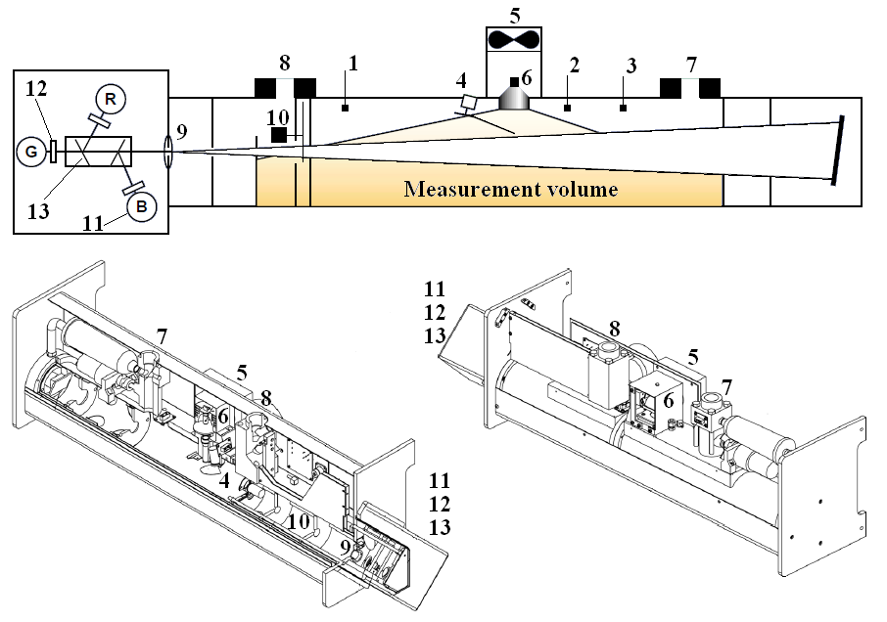
Figure 2.1. Nephelometer basic scheme. Temperature sensor (1), pressure sensor (2), temperature and humidity sensor (3), backscatter shutter (4), fan (5), lamp (6), inlet (7), outlet (8), lens (9), reference chopper (10), photomultiplier tubes (11), band pass filters (12) and dichroic filters (13). Image taken from the operation and service manual from TSI.

Nonidealities in wavelength sensitivity are due to the impossibility of measuring in a single wavelength, but rather in a narrow but finite wavelength range (which is also not exactly centred over the nominal wavelength). Errors due to these nonidealities are of the order of 2-3% [Anderson et al., 1996]. Nonidealities in angular sensitivity arise because on the one hand the illumination intensity is not perfectly cosine-weighted; on the other hand, as abovementioned, the geometry of the nephelometer only permits the photomultipliers to sense photons scattered from angles in the range of 7-170º (leading to so-called truncation error).

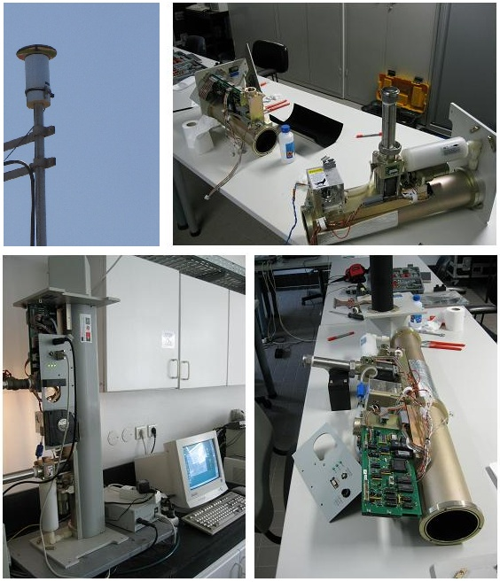
Figure 2.2. Nephelometer TSI-3563 installed at CGE facilities. Sampling inlet (upper left), instrument on operation (lower left) and under maintenance (upper and lower right).

For aerosol scattering, the scattering function is strongly dependent on the particle size. Therefore, the nephelometer nonidealities introduce particle size dependent errors that constitute an additional source of uncertainty. The dominant nephelometer’s nonideality is related to the forward scattering truncation from 0 to 7º which is increasingly important for large particles. Figure 2.3 shows the scattering and backscattering efficiencies computed with Mie theory for the full angular range (0-180º) and considering the truncation at both 7º and 180º. One observes that the decrease in the scattering efficiency for coarse particles is significant. On the contrary the backscattering is modestly affected as the two backscattering efficiency curves are quite analogous. The error for scattering and backscattering coefficients is modest (a few to 10%) for accumulation mode (sub-micrometer) particles and can increase up to 50% for coarse (supermicrometer) particles. In contrast, nephelometer measurements of σ_{bsp}(λ) remain quite accurate (well within ±10%) up to particles of diameters of at least 10 µm (Anderson et al., 1996).
Figure 2.3. Mie scattering and backscattering efficiencies for 550 nm and 1.33+0i refractive index.

Anderson and Ogren (1998) developed a correction scheme to account for the truncation errors and to reduce them, namely by using the wavelength dependence of the measurements (which also depends on the particle size); that correction is widely used. Recently, Müller et al. (2009) corroborated these corrections. Furthermore, Moosmüller and Arnott (2003) suggested on the possibility of bigger errors than expected in the nephelometer-derived scattering coefficients for absorbing aerosols due to changes in the scattering function. Recently, integrating spheres to measure scattering coefficients with minimal angular truncation have been developed (Varma et al. 2002; Abu-Rahmah et al. 2006) and cosine-weighted scattering sensors have been coupled to instruments that also measure extinction (Strawa et al. 2003). Both these methods have the potential to reduce the uncertainties in the scattering measurements, although neither is in widespread use. The Anderson and Ogren (1998) correction scheme is used in this work.
Also, relative humidity is one of the factors influencing the amount of scattered solar radiation by aerosol particles. If RH increases, then hydrophilic atmospheric particles tend to grow, due to water uptake, and scatter more light. The nephelometer measurements were also corrected for RH, even if the corrections were shown to be minor because of the heating of the sample within the measurement chamber. Details are presented in the appendix B.

Multi-Angle Absorption Photometer (MAAP)
The Multi-Angle Absorption Photometer (MAAP 5012) (Thermo ESM Andersen Instruments, Erlangen, Germany) measures the light absorption coefficient of aerosols, σ_{ap}(λ) at the wavelength of 670 nm (in units of m⁻¹). Aerosol particles are deposited on a quartz fibre filter; a laser (670 nm) illuminates the filter matrix perpendicularly and simultaneous measurements of radiation penetrating through the filter and scattered back at two detection angles are made. Figure 2.4 shows the equipment operating at CGE’s facilities. The determination of the aerosol absorption coefficient is made via radiative transfer calculations including the scattering effects from the filter matrix and the light scattering aerosol component. A two-layer system for the particle-loaded filter is considered: the aerosol-loaded layer of the filter and the particle-free filter matrix. Radiative processes inside the layer of deposited aerosol and between this layer and the particle-free filter matrix are taken into account separately. The two scattering measurements allow correction for multiple scattering processes involving the deposited particles and the filter matrix. A detailed description of the method is given by Petzold and Schönlinner (2004). Figure 2.5 shows the schematics of the MAAP instrument and figure 2.6 represents the radiation processes to be considered for its measurements and radiative computations.
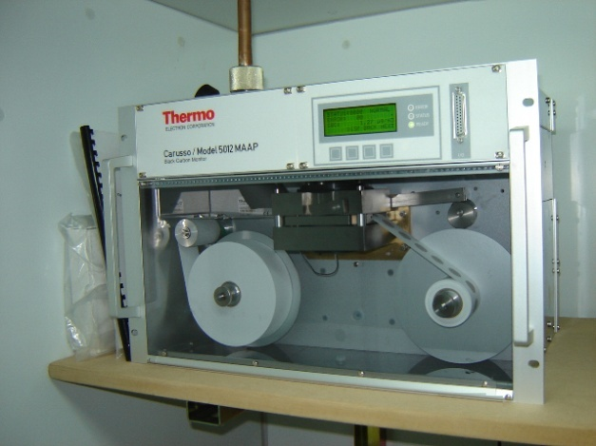
Figure 2.4. MAAP 5012 operating at CGE’s facilities.

At the present, the MAAP instrument appears to be the most reliable filter-based instrument for aerosol absorption coefficient measurements (Petzold et al., 2002, 2005; Petzold and Schönlinner, 2004; Sheridan et al., 2005; Hitzenberger et al., 2006). The study of Petzold et al. (2005) and Sheridan et al. (2005) showed that the absorption coefficients measured by the MAAP are in good agreement with those measured by photoacoustic spectrometry and simultaneous measurement of aerosol extinction and aerosol scattering. Furthermore, the MAAP filter-based method does not require calibration for the measurement of the aerosol absorption coefficient and doesn’t need post-measurement data corrections or parallel measurements of the aerosol light scattering coefficient (Petzold and Schönlinner 2004; Petzold et al., 2005). The total method uncertainty for the aerosol light absorption coefficient inferred from MAAP measurements is around 12% (Petzold and Schönlinner 2004; Petzold et al., 2005). The absorption coefficient measured by MAAP may be converted into Black Carbon mass concentration (BC in units of μgm⁻³) via the mass absorption efficiency (6.6 m²g⁻¹) set by the manufacturer. The relation between the absorption coefficient (Mm⁻¹) and Black Carbon mass concentration (µgm⁻³) is given by
(2.19)
The value for MAC that we used (6.6 m²g⁻¹ as recommended by the manufacturer), based in [Petzold et al., 2002; Petzold and Schönlinner, 2004], was obtained after comparative studies in different sites, namely a continental background site and an urban site, i.e., for “clean” and polluted conditions, respectively. An average ratio of methods, BC(optical)/BC(thermal) = 0.95±0.04 and R² = 0.965 for linear regression, were reported. The characteristics of our site fit somewhat in between, as it’s a small urban area, and the sampling site is close to the city core. Uncertainties in the aerosol absorption coefficient and in the BC mass concentration were mentioned to be 12% and about 25%, respectively. The MAAP measurements are absorption measurements. Therefore every material which absorbs at the MAAP wavelength contributes to the measurements of absorption coefficient and it’s considered as BC even if it’s not BC. This is another uncertainty but can be considered as small. More recently, comparison studies carried with a suite of BC methods, including MAAP [Hitzenberger et al., 2006] have shown good agreement, within their standard deviations, although in winter time less agreement was obtained between different techniques [Reisinger et al., 2008] .

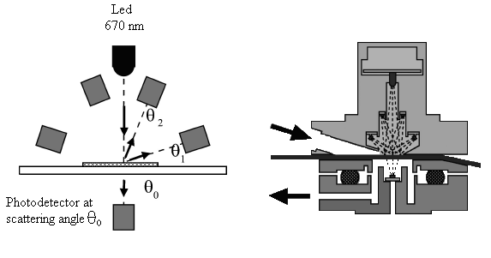
Figure 2.5. Optical sensor of the MAAP. Left: position of the photodetectors at detection angles θ₀ =0º, θ₁ =130º, and θ₂ =165º with respect to the incident light beam (λ MAAP = 670 nm). Right: layout of the MAAP sensor unit, where the arrows indicate the airflow through the sensor unit across the filter tape. Image adapted from Petzold et al. (2005).

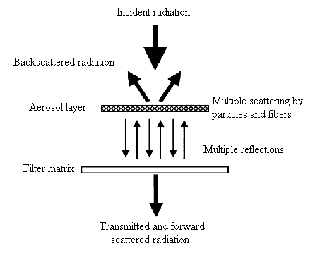
Figure 2.6. Schematic representation of radiation processes to be considered in the two-layer system consisting of an aerosol-loaded filter layer and the particle-free filter matrix. Image adapted from Petzold et al. (2005).

Tapered element oscillating microbalance (TEOM)
The TEOM monitor (Thermo Electron Corporation, East Greensbury, NY, USA) measures the aerosol mass concentration, M (units of μgm⁻³), at the ground surface in real time. Its time resolution represents an enormous advantage when compared with the typical 24 h integration time associated to the “traditional” gravimetric methods. Ambient air is transported to the instrument and subsequently exhausted. This circulation is maintained by a vacuum pump; in the meantime aerosol particles are retained in a filter located on the top of a vibrating element whose frequency is measured. The instrument computes the total mass which is accumulated on the filter (via the frequency measurement), the mass rate is calculated, and finally the mass concentration is obtained as the quotient of the aerosol mass increase to the total volume of air that passed through the filter for a certain time interval.
The TEOM comprises the following basic elements: detection unit (figures 2.7 and 2.9), control unit (figure 2.7) and a vacuum pump; the detection unit contains the mass transducer that measures the aerosol mass; the control unit contains most of the instrument’s electronics as well as the flow controllers.

Figure 2.7. TEOM’s detection unit. The mass transducer is enclosed within the black component (right picture) under controlled environment.

Figure 2.8. TEOM’s control unit.

Both the sampled air and the mass transducer are heated to a temperature of 50ºC. By doing so the effects of variations in ambient conditions are eliminated. On the one hand the natural frequency of the tapered element depends on its material properties which ultimately depend on the temperature. On the other hand, by keeping a 50ºC constant temperature the relative humidity is kept at very low values and any water that could be present in the particles is eliminated. Therefore one guarantees that there are no mass variations due to relative humidity variations. However, some volatile species are lost, namely some nitrates and organic compounds (Brink, 2004; Charron et al., 2004). Thus TEOM measurements were corrected after being compared with a gravimetric method. Details on the calibration of TEOM measurements are given in the Appendix D.
The filters used by TEOM (Pallflex TX40) (figure 2.9) are made of Teflon-coated glass fiber filter paper and they are hydrophobic. They have circular shape (1.3 cm diameter) with an effective area for collection of 5.3 cm² and a collection efficiency of nearly 100% (Lee and Mukund, 2001).

Figure 2.9. Pallflex TX40 filters, before and after being used (left), and mass transducer (within the detection unit) open during filter exchange operation.
The TEOM’s main particularity is the measurement of the aerosol mass collected in the filter. The transducer element is a hollow tube with one fixed end. The other extremity contains the filter. While the instrument is operating the system (tube+filter) vibrates at its natural frequency. This resonance frequency depends both on the bulk material and dimensions of the system and only changes as the aerosol mass deposited in the filter increases. The frequency decreases as the aerosol mass increases. An optoelectronic device converts these frequency changes into mass changes. A feedback system keeps the amplitude of oscillation constant, by feeding the system with the necessary energy to overcome damping. The system tube+filter behaves as an harmonic oscillator. For this simple system the mass, m, the frequency, f, and the spring constant, K, are related by the well known expression
(2.20)
Equation 2.19 can be written as
(2.21)
where .
The mass of the system includes the filter mass, m_{F}, the tube mass, m₀, and the aerosol mass, Δm, i.e.:
(2.22)
(Patashnick e Rupprecht, 1991) investigated on the validity of the TEOM behaviour as a harmonic oscillator by using test masses. With this configuration the frequency of oscillation depends only on m₀ (mass of the tube) and on Δm (test masses), and equation 2.21 becomes
(2.23)
A linear relation between f⁻² and m=m₀+Δm was found which validated the harmonic oscillator behaviour of the system. Δm is independent of both the filter and tube masses as the uncertainties associated to the measurements of these masses are eliminated (which is not the case of gravimetric systems where the filters are weighed before being used). The aerosol mass concentration is calculated via
(2.24)
with the knowledge of the volume of air that crossed the filter within the time interval Δt. Q is the air flow (m³s⁻¹) and V_{air} is the volume of air. The mass transducer has a minimum detection limit of 0.01 μg and a precision of ±1.5 μg/m³ for 1-hour averages.

Aerodynamic Particle Sizer (APS)
The Aerodynamic particle sizer (figure 2.10) is an optical counter which measures the particle (aerodynamic) diameter and the number concentration in 52 nominal size bins in the diameter range ~0.5–20 µm (thus providing size distributions) by determining the time-of-flight of individual particles in an accelerating flow field.
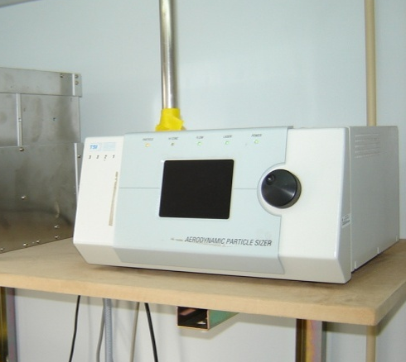
Figure 2.10. Aerodynamic Particle Sizer 3321 installed at CGE’s facilities.

Figure 2.11 depicts a schematic diagram of the aerosol flow within the instrument. The particles are confined to the centreline of an accelerating flow by sheath air. They then pass through two laser beams and scatter light. An elliptical mirror collects scattered light and focuses it onto a solid-state photo-detector, which converts the light pulses to electrical pulses. The velocity of each particle is obtained via the timing between the peaks of the pulses. Each time-of-flight is converted into an aerodynamic particle diameter by means of a calibration curve. The particles sizes are binned into 52 channels (in a logarithmic scale). The APS can measure concentrations up to 1000 particles cm⁻³ at 0.5 and 10 µm, with coincidence errors inferior to 5% and 10%, respectively. The minimum and maximum concentrations that can measure this instrument are 0.001 and 10 000 particles cm⁻³, respectively. For solid particles, counting efficiencies range from 85% to 99% (Volcken and Peters, 2005). APS was operated at 5 lmin⁻¹ flow rate and with data averaging time of 5 min. The particle number concentration for a certain channel, n, is obtained as
(2.25)
where c is the particle counts per channel, t is the sample time and Q is the air flow-rate. The total particle number concentration, N is simply the sum over all channels, given by
(2.26)
The number size distribution is conveniently written as dN/dlogD where dlogD is the logaritmic interval between two successive bins, i.e., logD_{i}-logD_{i-1}, and dN is the correspondent total particle number concentration between two successive bins.
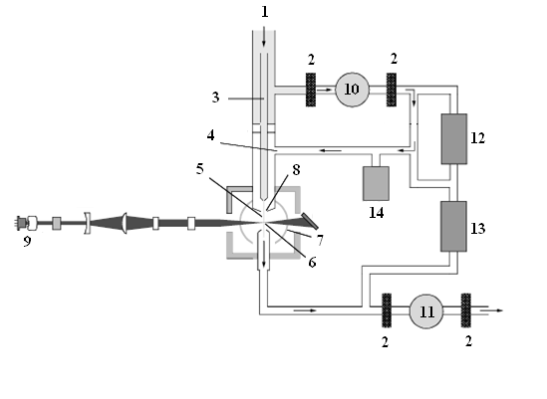
Figure 2.11. Aerosol Flow Through the APS Model 3321. Aerosol in (1), filters (2), inner nozzle/sample flow (1 lmin⁻¹) (3), outer nozzle/sample flow (4 lmin⁻¹) (4), total flow (5 lmin⁻¹) (5), detection area (6), elliptical mirror (7), accelerating orifice nozzle (8), collimated diode laser (9), sheath-flow pump (10), total-flow pump (11), sheath-flow pressure transducer (12), total-flow pressure transducer (13), absolute pressure transducer (14).

The APS is only used in the context of case studies because it was not operating continuously due to technical problems. Besides, no calibrations were performed and the calibration quality was unknown at the starting time of operation. Therefore the minimum data quality could not be assured and its information was essentially used qualitatively, in particular for comparing magnitudes of fine and coarse particles number concentrations that could help to validate different aerosol episodes. The instrument was calibrated only in November 2010.

Site description
Évora, Portugal (38.5N, 7.9W, 300 m a.s.l) is located in the south-western region of the Iberian Peninsula (figures 2.12 and 2.13). It’s a Portuguese municipality (~1300 km²) with less than 60000 inhabitants. More than 40000 inhabitants reside in the urban area of Évora city, which is the biggest one within a vast rural and sparsely populated region (Alentejo province), to the south of Tagus River and at 140 km southeast of Lisbon. The distance from the capital, Lisbon, is some 130 km. The regional landscape is of low altitude (average height below 250 m a.s.l.) and it consists primarily of soft rolling hills and wide plains. Mediterranean vegetation dominates; cork oaks, olive trees, wheat fields (and other cereals) or the occasional vine comprises the typical agricultural activities as well as grasslands for livestock.
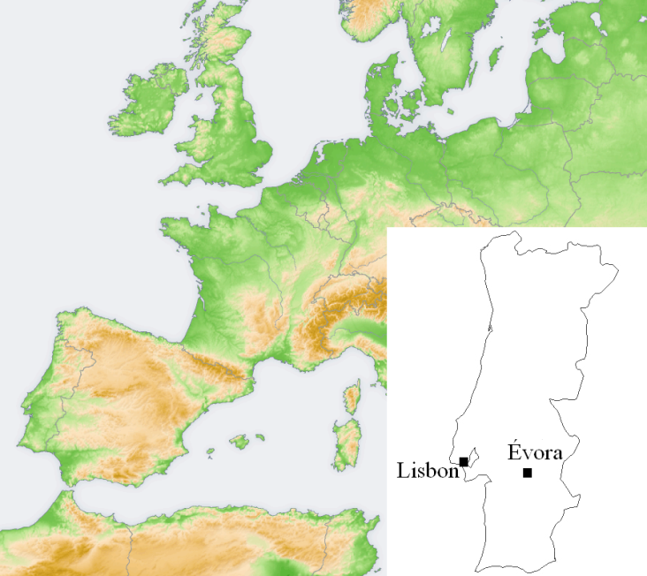
Figure 2.12. Location of Évora, within Portugal, in the western European continent. Source: http://www.ngdc.noaa.gov/mgg/shorelines/shorelines.html.

There are no polluting industries either in the city or in the region. Therefore the local aerosol production should be basically related to traffic circulation, kitchen stoves and civil construction. During the colder periods of winter (and fall) wood burning is often used for domestic heating. Regarding traffic circulation, the information obtained from the municipality is sparse; nevertheless it’s possible to estimate the number of vehicles entering in the city as being 12000-15000 day⁻¹. The traffic distribution along the day is characterized by morning and late afternoon peaks (Plano Director Municipal, Município de Évora, 2007) and minimum traffic circulation during the afternoon and, in particular, during night time (fig 2.14). The city spreads over a smooth prominence while its buildings aren’t elevated (mainly comprising one to three floors) thus allowing the city to be, in principle, well ventilated.
Figure 2.15 shows the seasonal frequency distribution of the wind direction and figure 2.16 shows the monthly temperature, relative humidity, wind speed and accumulated precipitation. The climate of Évora is characterized by being hot and dry in the summer and cold and wet in the winter. Similarly, precipitation shows clear seasonality, with maximum rainfall during fall and winter and minimum during summer. Analysis of wind speed data reveals that on average the highest wind speeds occur during spring and summer, with weaker winds in the winter and fall. The prevailing wind directions measured at the site are generally westerly and north-westerly, reflecting the direction of dominant winds in extra tropical latitudes where the Portuguese territory is located.

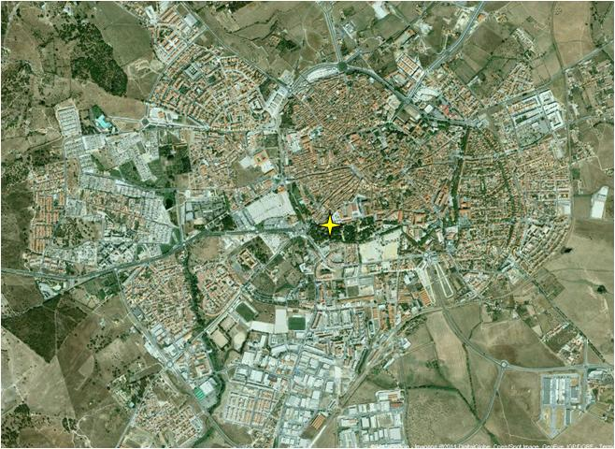
Figure 2.13. City’s view and location of the sampling site within the city of Évora (yellow star). Source Google maps.

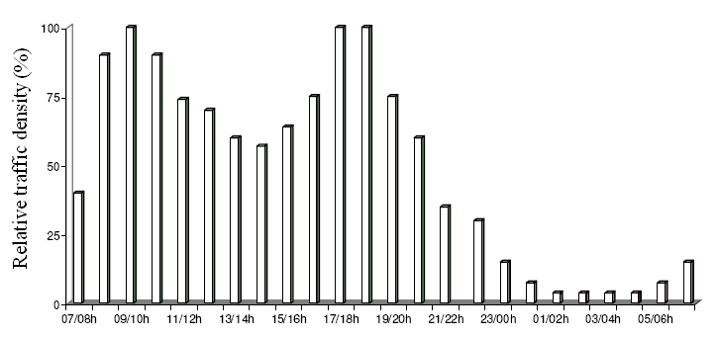
Figure 2.14. Relative magnitude of the hourly traffic density at Évora (adapted from Plano Director Municipal, Município de Évora, 2007).

Figure 2.15. Relative frequency of the wind direction measured at the Évora Geophysics Centre between 2002 and 2009 for the different seasons.

Figure 2.16. Monthly average (a) temperature, (b) relative humidity, (c) wind speed and monthly accumulated precipitation for the period of 2002-2009. The grey bars enclose the quartiles (P25 and P75) for temperature, relative humidity and wind speed.

Datasets
This thesis includes data from measurements performed in Évora until the end of 2009. However the lengths of the datasets are quite dissimilar for the different instruments because the equipments were installed sequentially in different periods and were not always available, mainly due to technical problems. In the case of the APS, its dataset was constrained to two smaller periods, when the equipment was available in parallel with the other ones. Figure 2.17 shows the temporal scheme of the measurements.

Figure 2.17. Temporal scheme of measurements performed with each of the instruments.

The nephelometer’s measurements comprise, by far, the longest dataset, as its operation started already in 2002. Next, in the beginning of 2006, the TEOM was installed and the MAAP started collecting data in April 2007. As aforementioned the APS was available for two not so long periods in 2006 and 2007 and therefore the analysis and interpretation of its data will be less deep and more importance will be given to it in the context of aerosol episodes that will be presented in Chapter 4.
In addition, meteorological data of the site (temperature, wind speed, wind direction and relative humidity) were measured during the whole period.
A summary of the different quantities mentioned in this thesis is now presented. Table 2.1 depicts the primary quantities that come up from the measurements as well as some additional ones derived from those measurements.

Name | symbol | comments
Scattering coefficients  λ = 450, 550, 700 nm | σ_{sp}(450)  σ_{sp}(550)  σ_{sp}(700) | Measured with the nephelometer. Units of m⁻¹.
Backscattering coefficients  λ = 450, 550, 700 nm | σ_{bsp}(450)  σ_{bsp}(550)  σ_{bsp}(700) | Measured with the nephelometer. Units of m⁻¹.
Backscatter ratio | b(450)  b(550)  b(700) | Computed with the scattering and backscattering coefficients (eq. 2.16).
Ångström exponent | α | Computed with the scattering coefficients (eq. 2.11).
Absorption coefficient  λ = 670 nm | σ_{ap}(670) | Measured with the Multi-Angle Absorption Photometer. Units of m⁻¹.
Extinction coefficient  λ = 670 nm | σ_{ep}(670) | Sum of the scattering and absorption coefficients (eq. 2.15). Units of m⁻¹.
Single scattering albedo | $$\overline{ω}$$ | Computed with the scattering and absorption coefficients (eq. 2.14).
Mass concentration | M | Measured with the Tapered Element Oscillating Microbalance. Units of µgm⁻³.
Black Carbon mass concentration | BC | Obtained via the absorption coefficient. Units of µgm⁻³.
Mass scattering efficiency  λ = 450, 550, 700 nm | E_{s}(450)  E_{s}(550)  E_{s}(700) | Computed with the scattering coefficients and mass concentration (eq. 2.17). Units of m²g⁻¹.
Black Carbon fraction | BC fraction | Ratio of BC mass concentration to total mass concentration, M.
Number concentration | N_{F}  N_{C}  N_{0.5-10} | Measured with the Aerodynamic Particle Sizer. Units of #cm⁻³
Size distribution | dN/dlogD | Units of #cm⁻³

Table 2.1. Summary of the aerosol properties measured and computed by means of the combination of the different instruments.

Aerosol properties measured at Évora
In this chapter the results obtained with the equipments and measurements described in the previous chapters are presented. We start with the analysis of the set of scattering properties measured with the nephelometer, since its measurements cover the largest period, from 2002 to 2009. Then we proceeds with the results regarding the properties measured with the other instruments, namely the TEOM the MAAP, whose measurements started in 2006 and 2007 respectively. Following, the temporal variations of a number of properties, at different timescales, are described and interpreted. For this, both seasonal data and daily variations are taken in account.
In the following chapter (4), a study on the influence of air mass history in the aerosol properties measured at Évora is presented, where the atmospheric circulation is translated into back-trajectories ending at Évora are related to the observed aerosol properties, and in chapter 5 several case studies are presented.

Overall results

3.1.1. Aerosol scattering properties measured at Évora.
Here, the general characteristics of the measured aerosol scattering properties measured with the nephelometer, concerning the whole period of measurements (2002–2009), are described. Tables 3.1 and 3.2 show several statistical parameters characterizing the spectral scattering, σ_{sp}(λ), and backscattering coefficients, σ_{bsp}(λ), as well as the derived Ångström exponent, α, and backscattering fraction, b(λ). Corresponding frequency distributions (of the hourly values) were obtained for σ_{sp}(λ), σ_{bsp}(λ), α and b(λ) and figure 3.1 depicts the results for the wavelength of 550 nm. The Ångström exponent is computed in the spectral range 450-700 nm, α₄₅₀₋₇₀₀. In the following, 550 nm and α₄₅₀₋₇₀₀ will be used as reference wavelength and wavelength range if not stated otherwise.
 | σ_{sp}(450)  (Mm⁻¹) | σ_{sp}(550)  (Mm⁻¹) | σ_{sp}(700)  (Mm⁻¹) | σ_{bsp}(450)  (Mm⁻¹) | σ_{bsp}(550)  (Mm⁻¹) | σ_{bsp}(700)  (Mm⁻¹)  (Mm⁻¹)
Num. data | 53746 | 53744 | 53744 | 53746 | 53746 | 53738
Mean | 60.7 | 45.0 | 31.8 | 7.0 | 5.6 | 4.9
St. Dev. | 64.5 | 46.2 | 30.1 | 6.8 | 5.5 | 4.6
Median | 44.6 | 33.3 | 24.3 | 5.4 | 4.4 | 3.8
P1 | 9.8 | 7.5 | 5.5 | 1.2 | 1.0 | 0.7
P5 | 14.8 | 11.5 | 8.5 | 1.9 | 1.6 | 1.3
P25 | 26.9 | 20.7 | 15.5 | 3.3 | 2.8 | 2.4
P75 | 75.8 | 55.7 | 39.1 | 8.8 | 7.1 | 6.1
P95 | 155.3 | 114.1 | 78.2 | 16.5 | 13.2 | 11.4
P99 | 252.0 | 185.8 | 127.1 | 27.1 | 21.4 | 18.4
Fitting parameters
x_{c} | 42.6 | 32.5 | 24.1 | 5.2 | 4.3 | 3.8
x_{c} St. Err. | 0.84 | 0.31 | 0.11 | 0.03 | 0.02 | 0.01
w | 0.71 | 0.70 | 0.68 | 0.68 | 0.66 | 0.68
w st. Err. | 0.02 | 0.01 | 0.003 | 0.005 | 0.004 | 0.003
A | 9.47 | 9.75 | 9.93 | 0.98 | 0.99 | 1.0
A st. Err. | 0.17 | 0.09 | 0.04 | 0.006 | 0.005 | 0.003

Table 3.1. Statistical parameters of the scattering and backscattering coefficients, at 450, 550 and 700 nm, and respective fitting parameters to lognormal distributions (see Appendix A for details in the statistical quantities).

 | α₄₅₀₋₇₀₀ | α₅₅₀₋₇₀₀ | α₄₅₀₋₅₅₀ | b(450) | b(550) | b(700)
Num. data | 53744 | 53744 | 53744 | 53686 | 53687 | 53686
Mean | 1.4 | 1.3 | 1.4 | 0.12 | 0.13 | 0.15
St. Dev. | 0.4 | 0.6 | 0.5 | 0.02 | 0.02 | 0.05
Median | 1.5 | 1.4 | 1.5 | 0.12 | 0.13 | 0.16
P1 | 0.2 | -0.2 | 0.01 | 0.07 | 0.08 | 0.08
P5 | 0.6 | 0.3 | 0.4 | 0.08 | 0.09 | 0.11
P25 | 1.2 | 1.0 | 1.1 | 0.10 | 0.11 | 0.13
P75 | 1.7 | 1.8 | 1.7 | 0.13 | 0.14 | 0.18
P95 | 1.9 | 2.2 | 2.1 | 0.15 | 0.17 | 0.22
P99 | 2.1 | 2.4 | 2.2 | 0.17 | 0.19 | 0.29
Fitting parameters
x_{c} | 1.14/1.63 | 1.12/1.75 | 1.08/1.65 | 0.12 | 0.13 | 0.15
x_{c} St. Err. | 0.17/0.01 | 0.23/0.04 | 0.33/0.03 | 2.86E-4 | 1.84E-4 | 3.68E-4
w | 0.84/0.46 | 1.12/0.68 | 1.01/0.62 | 0.04 | 0.04 | 0.06
w st. Err. | 0.18/0.03 | 0.22/0.10 | 0.31/0.07 | 6.12E-4 | 3.95E-4 | 8.18E-4
A | 0.04/0.06 | 0.06/0.04 | 0.05/0.06 | 0.01 | 0.01 | 0.01
A st. Err. | 0.01/0.01 | 0.03/0.02 | 0.03/0.03 | 1.35E-4 | 8.40E-5 | 1.27E-4

Table 3.2. Statistical parameters for the Ångström exponent, calculated for different wavelength ranges, and hemispheric backscatter function, at 450, 550 and 700 nm. The respective fitting parameters to normal distributions are shown below. In the case of α, a sum of two normal distributions was used.
Figure 3.1. Relative frequency distributions of hourly measurements of (a) scattering and (b) backscattering coefficients, at 550 nm, backscatter ratio, (c) Ångström exponent, α₄₅₀₋₇₀₀ and backscatter ratio at 550 nm. The solid lines represent the results of the fitting procedure. When the frequency distribution is multi-modal the dashed lines represent the individual modes and the solid line the composite distribution.
The frequency distributions are characterised by long right tails for σ_{sp}(λ) and σ_{bsp}(λ) while α is left skewed and b(λ) is well represented by a Gaussian distribution (even if only positive values are possible). For σ_{sp}(λ) and σ_{bsp}(λ) lognormal distributions were fitted while for α and b(λ) a sum of two normal distributions and one normal distribution were used, respectively. All the fittings were obtained with coefficients of determination (R²) higher than 0.99, at 95% confidence level (see appendix A for details on the distributions functions).
Hourly values of σ_{sp}(550) were found to be highly variable, ranging from values lower than 10 Mm⁻¹ (less than 5% of the data) up to the most extreme values above 2000 Mm⁻¹, which were recorded during the occurrence of a forest fire plume observed at the site in the summer of 2005. Despite this large range, in fact 75% of σ_{sp}(550) were below 56 Mm⁻¹. Figure 3.2 shows the complete time series with the hourly values of σ_{sp}(550). The mean and median σ_{sp}(550) values over the 8-year period were found to be 45 and 33 Mm⁻¹, respectively, while the mean and median σ_{bsp}(λ) values were 5.6 and 4.4 Mm⁻¹, respectively. The average (and median) backscattering fraction, at 550 nm, was about 0.13 for the whole period. If one considers daily values, the scattering coefficient, at 550 nm, varied between 9 and 782 Mm⁻¹ (on 23 August 2005) and the daily backscattering coefficient varied between 1.3 and 91 Mm⁻¹. Seinfeld and Pandis [1998] suggest values of scattering coefficient in the range of 23 to 57 Mm⁻¹ as being representative of clean to average continental background aerosol conditions (see table 3.3 for a set of values found in literature). At Évora, mean daily σ_{sp}(550) values were below 57 Mm⁻¹ in three quarters of the days (as the hourly values). It’s also worth to mention that almost one quarter of our measured daily σ_{sp}(550) values were lower than the lower limit of 23 Mm⁻¹. With this simple comparison in mind one can characterize the aerosol load at Évora as being essentially of moderate magnitude, from the aerosol scattering point of view.

Figure 3.2. Temporal evolution of the hourly values of the scattering coefficient (550 nm) for the period of 2002 to 2009 obtained with the nephelometer.

The values of α were mainly in the range of 0.2 to 2.0, with mean and median α, for the whole period, of 1.4 and 1.5, respectively. Also, more than 80% of the data was found to be higher than 1.0, which is commonly used as a threshold for considering scattering as being dominated by the sub-micrometer (α > 1) or by the super-micrometer (α < 1) fraction of the particles. These results in conjunction with the following analysis are a sign of the fact that the light scattering, in Évora, due to aerosols is, in general, dominated by sub-micrometer particles. Although no direct information is available from our measurements, one can estimate the sub-micrometer fraction of light scattering, SF, with the aid of information provided by other authors (see Carrico 2000; Sheridan et al., 2001; Doherty et al., 2005) and depicted in figure 3.3 for different environments; a good linear correlation (95% confidence level) between SF and α (R² = 0.89) is noticeable. The respective regression line has the values (±standard errors) of 0.39±0.03 and 0.08±0.03 respectively for the slope and intercept, i.e.
$SF=\left(0.39±0.03\right)α+0.08±0.03$ (3.1)
Considering a value of α = 1.5, then more than 67% of the scattering were caused by sub micrometer particles.

Figure 3.3. Fraction of light scattering by sub-micrometer particles versus Ångström exponent, after (Carrico 2000; Sheridan et al., 2001; Doherty et al., 2005). The regression line obtained in the linear fitting is also shown.

Place | σ_{sp} and α | Author
Clean Continental Background to average background | 23 to 57 Mm⁻¹ | Seinfeld and Pandis, 1998
Granada, Spain | σ_{sp}(550) = 60±30 Mm⁻¹  σ_{bsp}(550) = 9±6 Mm⁻¹  α = 1.5±0.3 | Lyamany et al., 2009
Valencia, Spain | σ_{sp}(550) = 97 Mm⁻¹  σ_{bsp}(550) = 8 Mm⁻¹  α = 1.5±0.3 | Esteve et al., 2009
Toulon, France | σ_{sp}(525) = 60 Mm⁻¹ | Saha et al., 2008
Northern Greece | σ_{sp}(550) = 65 Mm⁻¹ and α = 1.5 | Gerasopoulos et al., 2003
Israel | σ_{sp}(545) = 60±56 Mm⁻¹ | Derimian et al., 2006
Remote site in the Negev desert (Israel) | average (median) σ_{sp}(550) = 87±54 (75) Mm⁻¹ and α = 1.4±0.4 (1.5) | Andreae et al., 2002
Remote areas of Greece and Turkey | σ_{sp}(532) = 50 Mm⁻¹ and 45 Mm⁻¹ | Vrekoussis et al., 2005
Hungary | σ_{sp}(530) = 60 Mm⁻¹ | Molnár and Mészáros, 2001
Northern Finland | σ_{sp}(550) = 7.1±8.6 Mm⁻¹  α = 1.8±0.7 | Aaltonen et al., 2006
This work | average (median) σ_{sp}(550) = 42.5 (29.9) Mm⁻¹ and α = 1.4 (1.5)

Table 3.3. Summary of some measurements reported in the literature regarding long term periods (of at least one year and considering European sites).

Observations of both σ_{sp}(λ) and α were combined in figure 3.4 which depicts the probability density of σ_{sp}(λ) measurements and the respective values of α; it takes in the information depicted in the individual frequency distributions of figure 3.1 and contains the spectrum of the combinations of σ_{sp}(λ) and α. For the sake of a better resolution a maximum σ_{sp}(λ) of 350 Mm⁻¹ was used. Data above that value represents only less than 0.3% (in the case of σ_{sp}(450)) down to 0.06% (in the case of σ_{sp}(700)) of the total number of measurements. Figure 3.4 shows that the large α variability observed for lower values of σ_{sp}(450), is considerably reduced for σ_{sp}(450) larger than about 60 Mm⁻¹ (figure 3.4a); and as α becomes larger than 1 the cluster of data (full ellipse in fig. 3.4 ), which extends towards large σ_{sp}(450) values, corresponds to the situations where an enhancement of small particles led to an increase in the aerosol scattering, presumably of anthropogenic origin. As the 450 nm channel is more sensitive to the smaller particles than the other two channels it is used for tracing the pollution and forest fire aerosol events aerosols whenever the σ_{sp}(450) reach the value of 60 Mm⁻¹ and α > 1. A second cluster (dashed ellipse in fig. 3.4 )seems to form for α around 0 corresponding to an increase of the aerosol scattering due to large particles, most probably desert dust from the Sahara. In the 700 nm channel (figure 3.4c), which is more sensitive to larger particles, there is a marked decrease in the density of points, shortly after σ_{sp}(700) reach 30 Mm⁻¹. This can be used to consider this value as a threshold for events of desert dust from the Sahara, with the additional criteria of α <1.0. This second cluster is, by far, smaller (i.e. with less points and lower magnitudes of scattering coefficients) showing that strong dust events at the surface are not very common, a fact which was already suggested for this same site by Elias et al. (2006).
Figure 3.4. Probability density of the hourly scattering coefficients for the whole period at (a) 450, (b) 550 and (c) 700 nm versus Ångström exponent. The colour scale represents the density of points from blue, with less density, up to red with the highest density of points.

Following the discussion above, a simple separation scheme between different aerosol types was done by using thresholds based on absolute values of the spectral scattering coefficients and of the Ångström exponent; a previous classification scheme by (Elias et al., 2006) was based only in a summer period of measurements and half day averages were considered (instead of hourly), therefore an improved classification criteria was used. The clean/background situation is established for σ_{sp}(450) values lower than 60 Mm⁻¹ independently of the Ångström exponent; for σ_{sp}(450) above 60 Mm⁻¹ and α >1.0 the situation is considered as polluted, either anthropogenic or smoke from forest fires; the situations of α < 1.0 and σ_{sp}(700) > 30 Mm⁻¹ correspond to dust aerosols, namely transported from Sahara. The threshold values are provided in table 3.4. The clean/background measurements comprises almost two thirds of the data, while the other two types include 30.4% (pollution/forest fires) and 6.6% (desert dust).

Aerosol type | Measured optical properties
Clean/background | σ_{sp}(450) < 60Mm⁻¹ (any α)
Pollution and Forest fires | σ_{sp}(450) > 60Mm⁻¹ (α > 1)
Desert dust | σ_{sp}(700) > 30Mm⁻¹ (α < 1)

Table 3.4. Used criteria for different aerosol types in terms of spectral scattering coefficients and Ångström exponent.

3.1.2. Aerosol absorption properties/Black carbon, total aerosol mass concentration and other derived properties
Figures 3.5 to 3.7 present the frequency distributions of the aerosol absorption coefficient, σ_{ap}(670), (or alternatively the BC mass concentration, according to relation 2.18), the single scattering albedo,$\overline{ω}$, and the aerosol extinction coefficient at the wavelength of 670 nm, σ_{ep}(670), while the respective statistical parameters are shown in table 3.5. σ_{ep}(670) was computed as the sum σ_{ap}(670) + σ_{sp}(670), where the scattering coefficient at 670 nm was obtained via the Ångström exponent expression given by equation 2.11. The complete time series of the absorption coefficient and BC, measured with the MAAP, from 2007 until the end of 2009, is shown in Figure 3.8. The average and median values for σ_{ap}(670) over the nearly 3-year study were found to be 8.5 and 6.8 Mm⁻¹ respectively. Similarly to the distributions of σ_{sp}(550) and σ_{bsp}(550) in figure 3.1, σ_{ap}(670) is also right skewed, with 90% of the data ranging between 1.7 and 22 Mm⁻¹. Again, a lognormal distribution was fitted to the data. Concerning the single scattering albedo, three quarters of the data are above 0.7 with both average and median values close to 0.8. Its frequency distribution presents a tail to the left; that means that the main deviations towards lower values observed in $\overline{ω}$ should be related to a more absorbing aerosol of anthropogenic origin. This is caused by the increase of absorbing particles as figure 3.9 suggests; in spite of the variability present, a negative correlation between σ_{ap}(670) and $\overline{ω}$ is evident, and for the higher values of σ_{ap}(670) the corresponding ω₀(670) values are rarely above 0.70.

Figure 3.5. Relative frequency distribution of σ_{ap}(670) and BC. The solid line represents the results of the (lognormal) fitting.
Figure 3.6. Relative frequency distribution of $\overline{ω}$. The solid line represents the results of the fitting procedure. The dashed lines represent the individual modes.

Figure 3.7. Relative frequency distribution of σ_{ep}(670). The solid line represents the results of the fitting procedure.

 | σ_{ap}(670)  (Mm⁻¹) | $\overline{ω}$(670) | σ_{ep}(670)  (Mm⁻¹)
Num. data | 22127 | 18580 | 18580
Mean | 8.5 | 0.77 | 36.0
St. Dev. | 8.2 | 0.11 | 24.6
Median | 6.8 | 0.78 | 29.5
P1 | 0.8 | 0.45 | 7.8
P5 | 1.7 | 0.56 | 11.8
P25 | 3.894 | 0.70 | 19.9
P75 | 10.1 | 0.84 | 44.4
P95 | 22.3 | 0.92 | 82.1
P99 | 44.3 | 0.96 | 128.6
Fitting parameters
x_{c} | 6.4 | 0.70/0.82 | 29.6
x_{c} St. Err. | 0.07 | 0.16/0.01 | 0.2
w | 0.71 | 0.22/0.16 | 0.6
w st. Err. | 0.009 | 0.12/0.03 | 0.01
A | 0.98 | 0.02/0.03 | 9.87
A st. Err. | 0.01 | 0.03/0.03 | 0.07

Table 3.5. Statistical parameters for σ_{ap}(670), $\overline{ω}$(670) and σ_{ep}(670) (hourly values). The respective fitting parameters are shown below. Lognormal for σ_{ap}(670) and σ_{ep}(670) and sum of two normal for $\overline{ω}$(670). The number of data is different for σ_{ap}(670) and $\overline{ω}$(670) or σ_{ep}(670) because nephelometer and MAAP were not always measuring simultaneously.

Figure 3.8. Temporal evolution of the hourly values of the absorption coefficient (670 nm) for the period of 2007 to 2009. The right axis is scaled to show the equivalent BC mass concentration.
Figure 3.9. Probability density of the single scattering albedo versus the absorption coefficient.

Figure 3.10 shows the time series, for the period of 2006 to 2009, with the hourly values of aerosol mass concentration, M. In addition, we now refers to the BC data, instead of the absorption coefficient, in order to retrieve the BC fraction (to total mass M) and for comparing our results with some previous aerosol studies made in Portugal. Some basic statistical parameters are presented in Table 3.6 including the parameters of the lognormal fittings performed over the frequency distributions presented in figure 3.11 (see fig. 3.5 for the BC frequency distribution). The average values (± standard deviation) where found to be 1.3 ± 1.2 µgm⁻³ for BC mass concentration and 22.7 ± 16.1 µgm⁻³ for M; their median values are somewhat lower, nearly 1 and 19 µgm⁻³ respectively, as the distributions of both quantities are positively skewed. In terms of daily averages, BC was found to vary between 0.3 and 5 µgm⁻³, although in 80 % of days they were in the range of 0.5 - 2 µgm⁻³. Other long term averages (at least one year) from European sites, classified as urban, exhibit higher BC magnitudes, 1.4-2.9 µgm⁻³, as compiled by [Ramachandran and Rajesh, 2007]. In the case of kerbsides, the differences of the BC values relative to Évora can be higher up to a factor of six (3-9 µgm⁻³); less than 4% of daily BC values above 3 µgm⁻³ were measured at Évora. On the contrary, BC levels for natural sites were reported to be lower, in the range of 0.2-0.5 µgm⁻³, a type of magnitudes observed at Évora in only 6% of the daily values. Lyamany et al. [2010] reported an average BC value of 3.2 µgm⁻³ for the urban centre of Granada, which is located in the southeast of Iberian Peninsula with a population almost ten times larger than Évora’s. Published studies conducted in Portugal reported average values for different environments such as the remote Portuguese Azores islands in the middle of the Atlantic Ocean (0.07 µgm⁻³) [Oliveira, 2006], rural areas in continental Portugal (0.79-1.61 µgm⁻³) [Pio et al., 1996; Castro et al., 1999; Oliveira et al., 2007; Tsyro et al., 2007] or at urban environments (1.5-5.13 µgm⁻³) [Pio et al., 1997; Almeida et al., 2005]. The OPAC model [Hess et al., 1998] computes black carbon mass concentration values for different environments, namely for the continental type (0.5 µgm⁻³), the continental polluted (2.1 µgm⁻³) or the urban (7.8 µgm⁻³) environment types. The average BC fraction for the whole period of measurements at Évora was found to be 6.6 %, which is above the average values reported for rural sites (4-6%), or in the lower range of urban ones (5-10 %) and significantly lower than the BC fraction in kerbsides (9-17%) according to Putaud et al. [2010].
Concerning the values of M one can see that, for example, Putaud et al. [2010] reported median values for urban background sites as being in the range of 24 to 36 µgm⁻³, while for Évora, average and median M values of 24 and of 19 µgm⁻³, respectively, were previously obtained by Pereira et al. [2008] for the year of 2006, being similar to the values now obtained for the whole period until the end of 2009. A yearly average of 40 µgm⁻³ was obtained by Almeida et al. [2005] in the area of great Lisbon and a value of 64 µgm⁻³ in Oporto, while an average of 20 µgm⁻³ was reported [Yttri et al., 2007] at a remote rural site in Bragança, northeast of Portugal.

Figure 3.10. Temporal evolution of the hourly values of the mass concentration for the period of 2006 to 2009.

 | BC  (µgm⁻³) | M  (µgm⁻³) | BC fraction | E_{sp}(450)  (m²g⁻¹) | E_{sp}(550)  (m²g⁻¹) | E_{sp}(700)  (m²g⁻¹)
N | 22126 | 21577 | 11464 | 17623 | 17623 | 17623
Mean | 1.3 | 22.7 | 0.07 | 2.9 | 2.2 | 1.6
St. Dev. | 1.2 | 17.0 | 0.06 | 1.8 | 1.3 | 0.9
Median | 0.95 | 18.8 | 0.05 | 2.5 | 1.9 | 1.4
P1 | 0.12 | 1.4 | 0.01 | 0.7 | 0.6 | 0.4
P5 | 0.26 | 4.5 | 0.02 | 1.0 | 0.8 | 0.7
P25 | 0.59 | 11.4 | 0.03 | 1.7 | 1.4 | 1.0
P75 | 1.53 | 29.6 | 0.09 | 3.6 | 2.6 | 1.9
P95 | 3.38 | 52.9 | 0.17 | 6.4 | 4.6 | 3.2
P99 | 6.72 | 83.4 | 0.32 | 9.7 | 7.1 | 4.9
Fitting parameters
x_{c} | 0.96 | 20.45 | 0.05 | 2.47 | 1.85 | 1.37
x_{c} St. Err. | 0.01 | 0.49 | 3.08E-4 | 0.01 | 0.01 | 0.01
w | 0.74 | 0.79 | 0.645 | 0.52 | 0.47 | 0.43
w st. Err. | 0.01 | 0.02 | 0.0048 | 0.004 | 0.005 | 0.005
A | 0.4009 | 5.32 | 0.00962 | 0.48 | 0.48 | 0.47
A st. Err. | 0.0029 | 0.11 | 6.23E-5 | 0.003 | 0.004 | 0.005

Table 3.6. Statistical parameters for BC, M, BC fraction and E_{s}(λ) (hourly values). The respective fitting parameters to lognormal distributions are shown below.

Figure 3.11. Relative frequency distribution of M and BC fraction. The solid lines represent the results of the (lognormal) fittings.

Figure 3.12a shows the scattering coefficient, at 550 nm, versus the mass concentration hourly values; the slopes of the lines included in the figure can be interpreted as the mass scattering efficiency, whose variability reflects the variability in the aerosol composition and size distribution. For instance, fine mode particles have higher E_{sp} compared to coarse mode particles because smaller particles scatter light more efficiently, per unit mass, at visible wavelengths. This fact is visible in figure 3.12a in the clusters of data with higher magnitude extending close to the lines representing E_{s}(550) of 1 and 3 m²g⁻¹. They correspond to events of Saharan dust and forest fires (see chapter 5). The frequency distribution of E_{sp}(550) is depicted in figure 3.12b. Considering the whole period of measurements (2006-2009), the majority of the data (more than 80%) was in the range of 1 to 4 m²g⁻¹; the average and median E_{s}(550) were found to be 2.2 and 1.9 m²g⁻¹. These values are comparable to the range 1.7-2.2 m²g⁻¹ or to the average of 1.9 m²g⁻¹ for a “total mixed” (fine+coarse) aerosol reported by (Hand and Malm, 2007) in their extensive review of aerosol mass scattering efficiencies.

Figure 3.12. Scattering coefficient, at 550 nm, versus mass concentration (a) and relative frequency distribution of the mass scattering efficiency at 550 nm (b).

Seasonal variations of the aerosol properties

3.2.1. Seasonal variation of the scattering properties measured at Évora
Figure 3.13 shows the monthly aerosol scattering coefficient, at 550 nm, and Ångström exponent obtained at Évora between 2002 and 2009. Only months with at least two thirds of data coverage are considered here. A total of 75 months fulfill this requirement. The monthly median values of σ_{sp}(550) range from 22 up to 76 Mm⁻¹ whereas the mean values range from 27 up to 98 Mm⁻¹). The time-series of figure 3.13 shows that in general σ_{sp}(550) tends to peak during winter and also during summer periods. Less than one third of the months are characterized by median σ_{sp}(550) above 40 Mm⁻¹ and these months are basically concentrated in winter and summer seasons (19 in 23). The monthly median values of α vary between 1.5 and 2, where the highest values, ranging essentially between 1 and 2, are also in the same months referred above.

Figure 3.13. Monthly scattering coefficient, at 550 nm, and Ångström exponent measured at Évora between 2002 and 2009. Full symbols and open symbols represent the mean and median values, respectively, while the light gray bars enclose the quartiles (P25 and P75).

In contrast, the set of months with the lower monthly median values of σ_{sp}(550) are within spring, autumn (and some in summer) periods, with the corresponding monthly median values of α having a tendency to be also lower, ranging between 1 and 1.5.
The facts described above are in agreement with the pattern exhibited by the yearly cycles shown in figure 3.14. σ_{sp}(λ) displays a bimodal pattern with peaks in winter and summer (figures 3.14a-c) and with the former peak being more prominent. The winter maximum is achieved in January for both the median and mean value (50 Mm⁻¹ and 64 Mm⁻¹ respectively); in summer the median is higher in June (34 Mm⁻¹) while the mean has its maximum in August (56 Mm⁻¹). This is caused, to a large extent, by occasional increases in the aerosol load due to the forest fires smoke reaching Évora. The monthly variation of the Ångström exponent, exhibited in figure 3.15 follows a rather similar behavior and a reasonable positive correlation between monthly median σ_{sp}(550) and monthly α was found (R² = 0.52) as shown in figure 3.16. However, no correlation was found for the hourly values likely because for small timescales the variability of these two quantities of different nature dominates, even if at larger timescales an overall tendency is revealed. The maximum value of the monthly median α is also found in January (1.8) and a second one in both July and August (1.5). This means that the increase in the aerosol load is mainly associated with the enhancement of particles in the sub micrometer range, either with anthropogenic origin or forest fires smoke occurring in the summer season. The increase of σ_{sp}(550) in the winter period should result from the combination of local traffic and increased emissions from heating sources (mainly wood burning) and pollution transported to the site amplified by a lower boundary layer thickness due to the lower atmospheric temperatures at the surface during winter; convection intensity is reduced and consequently pollution dilution is suppressed. In summer, the forest fires are greatly responsible for the large input of particles detected at the site (Elias et al., 2006; Pereira et al., 2008) and account for a major increase in the aerosol scattering coefficients. The most intense smoke plumes were observed in August 2003 and particularly in August 2005 when hourly values of σ_{sp}(550) as high as 2000 Mm⁻¹ were measured. These two summer periods were the ones with the largest burnt areas ever recorded in Portugal (Autoridade Florestal Nacional, 2009). These facts are reflected in the mean σ_{sp}(550) peak value observed in August which appears in figure 3.13. The strong decrease in the number of forest fires and their intensity in 2007 and 2008 summers is perceptible in the σ_{sp}(550) values of figure 3.13, as no significant monthly peaks are visible in these periods; this led, for example, to a large difference in the monthly average and median values of σ_{sp}(550) between August 2005 (respectively 92 Mm⁻¹ and 39 Mm⁻¹) and August 2008 (respectively 28 Mm⁻¹ and 24 Mm⁻¹).
Also, the difference in the monthly Ångström exponent values between the winter and summer months is substantial, with monthly medians being in the range of 1.5-1.8 and 1.4-1.5 respectively; this is expected to be related with the dryness of the soils and well developed convection in the boundary layer during summer season which should enhance the presence of coarse soil material in the atmosphere. In contrast, during winter (typical rainy season) the relative amount of coarse material is expected to be lower, while the introduction of sub micrometer particles from wood combustion in the atmosphere in winter is more regular than the sporadic transport of smoke to Évora. Lyamani et al. (2008, 2009) and Saha et al. (2008) also reported annual cycles characterized by higher values of scattering coefficient in winter but with magnitudes significantly higher than the ones reported in this study for Évora (average σ_{sp}(550) = 84-90 Mm⁻¹ and α = 1.8 and average σ_{sp}(550) > 90 Mm⁻¹, respectively). In spite of the large difference in terms of aerosol concentration between Évora and Granada (and Toulon), in winter, the difference between the values of α are less important likely due to similarities in the origin of aerosol particles.
Figure 3.14. Monthly variation of the spectral scattering coefficients, σ_{sp}(450), σ_{sp}(550) and σ_{sp}(700). Full circles and open circles represent the mean and median values, respectively, while the light gray bars enclose the quartiles (P25 and P75).

Figure 3.15. Monthly variation of the spectral Ångström exponent. Full circles and open circles represent the mean and median values, respectively, while the light gray bars enclose the quartiles (P25 and P75).

Figure 3.16. Scatter plot with the monthly median α as a function of the monthly median σ_{sp}(550) for the months between 2002 and 2009.

3.2.2. Forest fires in summer and scattering measurements.
In the last few decades the phenomena of forest fires during summer has been a major problem in Portugal, in particular in the centre and northern regions. It has been considered that one of the main reasons is related with the population movement towards the major urban centres, mainly in the coastal areas; the lack of maintenance, the high atmospheric temperatures and very low relative humidity do the rest.
Significant areas of forests and agricultural fields were damaged, every year, mainly between June and September, with a large peak in August. In the recent decade the maximum values were achieved in the summers of 2003 and 2005. Figure 3.17 shows the total area burnt in each year since 2000. Until 2005 the burnt areas were well above 1×10⁵ ha, being three to four times larger in 2003 and 2005, and since 2006 a decrease is obvious until 2009.
Figure 3.17. Total area burnt in Portugal in the summers between 2000 and 2009. The data was taken from the Portuguese Bureau of Agriculture.

The smoke from biomass burning has obvious increases the aerosol load and consequently increases the atmospheric turbidity. During summer, the Azores high pressure system leads to winds from the north-western to northern sectors and consequently advection of smoke towards the southern regions, where Évora is located. Measurements of aerosol scattering were available since 2002. These data were crossed with information on forest fires monthly statistics available in the reports from the Portuguese Bureau of Agriculture (available at http://www.afn.min-agricultura.pt/portal/dudf/relatorios). As an example, figure 3.18 shows the daily values of σ_{sp}(550) and α obtained during August for the years of 2005 and 2008. During August 2005, large forest fires were occurring whereas they were almost absent in August 2008. The difference between the two years is noticeable both in σ_{sp}(550) and in α, with consistently higher magnitudes of both quantities in 2005, reflecting not only the higher aerosol load but also the aerosol population of relatively smaller size during 2005, consistent with particles produced in biomass burning and transported to the measurement site. Furthermore, the correlation between the monthly burnt areas and the monthly scattering coefficient, which is related with the aerosol load near the ground, is surprisingly good by noticing that the fires typically do not occur in the outskirts of the site where the measurements were made (fig 3.19). The correlation between α and burnt areas is fairly good, if we takes into account that the “separate” cluster of few points corresponds to the lower burnt areas; the respective values of α, around 1.5, indicate that the presence of sub micrometer particles is not an exclusive consequence of the forest fires.

Figure 3.18. Daily scattering coefficient (550 nm) and Ångström exponent for August 2005, when forest fires were frequent and 2008 when no significant forest fires were occurring.

Figure 3.19. Monthly mean scattering coefficient (550 nm) and Ångström exponent as a function of the monthly burnt area, between 2002 and 2009.

3.2.3. Seasonal evolution of BC, mass concentration and other aerosol properties
In section 3.2.1 the seasonal evolution of the scattering properties was assessed. Now we turn our attention to the other aerosol properties. The temporal evolution of BC reveals a clear cycle with the higher and lower magnitudes being observed in winter/fall and spring/summer periods, respectively, as figure 3.20 shows. The BC monthly averages are relatively constant between April and August, in the range of 0.8-1 µgm⁻³, and start to increase in September until the maximum is achieved in January (2.1 µgm⁻³), thus representing an increase by about a factor of two. In terms of seasonal averages, BC was found to be in the range of 0.9-1.1 µgm⁻³ in summer and spring whereas in the fall and winter seasons in the range of 1.5-1.8 µgm⁻³. Short term measurements of BC in Évora, performed during the first half of June 2006, within CAPEX campaign [Silva et al., 2007], exhibited an average (± SD) value of 1.0 ± 0.6 µgm⁻³ which is similar to what is reported here for that period of the year.
The factors contributing to this annual pattern were already discussed when scattering properties were analyzed and should be influenced (i) by the additional input of soot, during the colder period of winter (and fall), due to domestic heating; (ii) some increase in traffic due to worse weather conditions, although that quantitative information on traffic is not available to confirm this statement; (iii) besides these increased emissions related with human activities during the colder seasons there’s a reduced atmospheric dispersion as a result of low boundary layer height and more frequent temperature inversions, resulting in trapping of pollutants in a smaller volume. Hence the concentrations of particles near the ground are higher. In spring/summer the increase in convective activity due to the solar heating of the ground surface induces the opposite effect.

Figure 3.20. Monthly variation of the Black Carbon mass concentration and extinction coefficient, at 670 nm (2007-2009). Full circles and open circles represent the mean and median values, respectively, while the light gray bars enclose the quartiles (P25 and P75).

Similar seasonal variations were also observed in urban areas but not in natural background sites where no seasonal variations were observed [Novakov et al., 2005; Ramachandran and Rajesh, 2007]. To give some quantitative examples, Röösli et al. [1999] reported significantly higher magnitudes, 2.2-2.9 µgm⁻³ (for spring and summer) and 3.5-4.6 µgm⁻³ (during fall and winter), in Basel area, Switzerland, comparable to the results from [Lyamani et al., 2008, 2010] where an increase of 2.2 to 4-4.5 µgm⁻³ was observed between the summer and the winter season. In three Portuguese rural environments [Castro et al., 1999; Pio et al., 2007; Tsyro et al., 2007] reported increases from 0.3-0.65 µgm⁻³ (spring/summer) up to 1.1-1.7 µgm⁻³ (autumn/winter). [Castro et al., 1999; Pio et al., 2007] reported similar trends but in more polluted urban environments of Coimbra (1.8 up to 4.2 µgm⁻³) and Oporto (2.7 up to 5.3 µgm⁻³).
The seasonal evolution of M monthly values shows some increase during the warmer period (fig. 3.21) with influence of the advection of particles from forest fires occurring in the Iberian Peninsula mainly in the summer of 2006. However, since 2007 a remarkable decrease in both the number and the intensity of the summer forest fires and extent of the burnt areas [Autoridade Florestal Nacional, 2009] have been observed, when compared with previous summers. In addition, since the MAAP started to operate only in 2007 no obvious signal of forest fires smoke was observed in the BC measurements. Besides that, less dry summers don’t favor the emission and presence of regional mineral dust in the atmosphere (due to more humid soils and denser vegetation), which being typically coarse aerosols should have stronger influence on the measured mass concentrations. The monthly variation of the extinction coefficient, shown in figure 3.20 is in agreement with the BC monthly variation but presents an interesting feature. On the one hand, the decrease in the forest fire activity since 2007 is corroborated because no summer σ_{ap}(670) maximum is observed in figure 3.20. On the other hand the increase of σ_{ap}(670) observed in September 2007 can be explained on basis of the atmospheric dynamics occurring during large part of this month which suggests the advection of pollution from the continental areas, either Iberian or from the other European regions.

Figure 3.21. Monthly variation of M between 2006 and 2009. Full circles and open circles represent the mean and median values, respectively, while the light gray bars enclose the quartiles (P25 and P75).

The monthly variation of the BC fraction (fig. 3.22) follows the monthly variation of the BC concentration values, shown in figure 3.20, presenting a maximum seasonal magnitude in winter and a minimum in summer. January is the month with maximum median value above 10% while August presents a median BC fraction below 4%. In fact, all the months between March and September are characterized by median BC fractions lower or equal than 5%. As to the monthly variation of the single scattering albedo, its seasonal behavior (fig. 3.23) is relatively opposite to the BC fraction seasonal patern, varying from a maximum median value, above 0.81 in August to a minimum of 0.72 in winter when the predominance of absorbing aerosols is felt. Both quantities arise from combinations of different equipments and confirm the presence of a more absorbing aerosol during colder periods.

Figure 3.22. Monthly variation of BC fraction between 2007 and 2009. Full circles and open circles represent the mean and median values, respectively, while the light gray bars enclose the quartiles (P25 and P75).
Figure 3.23. Monthly variation of the single scattering albedo, $\overline{ω}$, between 2007 and 2009. Full circles and open circles represent the mean and median values, respectively, while the light gray bars enclose the quartiles (P25 and P75).

Figure 3.24 shows the hourly values of BC versus M for winter and summer, the most distinct seasons in terms of absorbing aerosols. Two clusters of data, one for summer (open circles) and the other for winter (black circles), are evident and a certain degree of correlation between BC and M is apparent (a third “desert dust cluster” is discussed below). During winter BC and M are fairly correlated (R² = 0.61), while for summer the correlation is weak (R² = 0.38) probably due to the larger importance of non absorbing material and lower levels of BC during the summer season.
The third “cluster” of data shown in figure 3.24 was recorded during a Saharan dust outbreak that occurred in 21-23 December 2007. The dust was observed at the surface and hourly values of M up to 270 µgm⁻³ where recorded. During this episode (a period of less than two days) BC variations show to be independent of M variations as they are not correlated at all (R² is nearly zero). The average value of M = 116 µgm⁻³ during this episode represents a noticeable increase in the aerosol load during this time, whereas BC values don’t show any particular evolution.

Figure 3.24. Scatter plot of the hourly BC versus M for winter and summer periods (a) and hourly values of BC and M during a desert dust episode in December 2007.

Figure 3.25. Monthly variation of the mass scattering efficiency (550 nm), E_{sp}(550), between 2006 and 2009. Full circles and open circles represent the mean and median values, respectively, while the light gray bars enclose the quartiles (P25 and P75).

Daily variations of the aerosol properties

3.3.1. Daily variations of the scattering properties measured at Évora
Daily patterns of the scattering properties are now analyzed in this section. Emphasis is given to median values in order to minimize the influence of extreme events, so local aerosol features can emerge. A distinction is made between the daily variations during the week days and the weekend, when anthropogenic activities are significantly reduced, in particular during Sunday. Daily variations for the different seasons are also presented. Figures 3.26 and 3.27 show the daily cycle of σ_{sp}(550) median values. A pattern is visible, with morning and late afternoon peaks, regarding the week days. This behavior is characteristic of urban areas (Lyamani et al., 2008; Andreae et al., 2008). The P25 and P75 curves also displayed show the same features and indicate consistency of this pattern. The morning peak is closely related to the enhanced traffic activity during morning rush hour and therefore is much less evident on Sundays when typically the city is much less active, in particular during morning period. Saturday is shown to be quite similar to the other week days, which is not surprising as the activities during this day are not significantly suppressed.
The boundary layer development along the day, together with the increase in convection provides conditions for particle dilution within a larger volume of air. This results in the decrease of σ_{sp}(550) at the surface during the afternoon and a minimum around 15:00 is always observed. In the late afternoon the combination of increased anthropogenic activity, due to traffic, and decrease of the boundary layer thickness lead again to the increase in σ_{sp}(550), which then decreases until the following day. The general features described above also show seasonal differences. Important differences between the colder and the other periods are related to boundary layer dynamics and to the additional anthropogenic activity associated with wood burning for heating purposes, besides the usual particle production by traffic activity during the entire year. These differences are visible in the patterns observed in figures 3.27, in particular between spring and winter. In spring, for instance, both morning and late afternoon peaks of σ_{sp}(550) values have similar magnitudes (about 33 Mm⁻¹); however, in winter the morning peak is not only considerably higher ( about 42 Mm⁻¹) than in spring, but also a large difference for the late afternoon peak is now visible. The magnitude of this second peak (nearly 65 Mm⁻¹) represents a twofold increase relative to spring conditions, and emphasizes the importance of wood burning, which typically begins in the late afternoon and is likely the main reason for the difference (by a factor of 1.5) to the morning peak in winter.
In spite of higher σ_{sp}(550) values in winter, at all times, two periods of the day with minimum values (early morning, 05:00-06:00 and middle afternoon, around 15:00) present the lowest differences in σ_{sp}(550) between winter and spring (< 3 Mm⁻¹). Moreover, the absolute minimum is achieved always in the middle afternoon. On the one hand, in both of these periods the source activities are reduced while the particle removal processes are always active; on the other hand, the dilution of particles is enhanced in the developed boundary layer which occurs in the afternoon, after the solar heating of the surface. Both these features contribute to the decrease in the particle load, independently of the season, and probably explain the “approach” of σ_{sp}(550) values in these periods of the day for the different seasons.
Regarding the daily variation of the Ångström exponent, the main characteristics observed are the magnitude of α in spring (1.2-1.3) being always lower than in winter (1.6-1.8) as shown in figure 3.28; the other seasons fall somewhat in between; secondly, in winter the correlation between σ_{sp}(550) and α appears to be consistent; this corroborates the connection between the aerosol load and its anthropogenic origin. In contrast, during spring the values of α reveal no particular trend (as suggested by the lack of correlation between σ_{sp}(550) and α).

Figure 3.26. Median daily variation of σ_{sp}(550) for the different days of the week. The respective quartiles, P25 and P75, are also shown.

Figure 3.27. Median daily variation of σ_{sp}(550) for the different seasons of the year. The respective quartiles, P25 and P75, are also shown.

Figure 3.28. Hourly median values of σ_{sp}(550) versus α based in the respective daily variations for spring and winter periods.

3.3.2. Daily variations of BC, mass concentration and other aerosol properties
The daily variation of Black Carbon mass concentration, BC fraction, total mass concentration, single scattering albedo and extinction coefficient are shown in figures 3.29 to 3.33 considering the different days of the week. In figures 3.29 to 3.32, (BC, BC fraction, M and $\overline{ω}$), the results for week days are assembled in the same figure due to their similarity. The same applies to σ_{ep}(670) although the daily variations for each day are shown in this case.
Concerning the BC and M median values, two maxima are present, one in the early morning and the other one in the evening, being both mainly related with the local traffic rush hours as aforementioned in the previous section; these BC peaks are more pronounced than the ones of the scattering coefficient previously shown (fig. 3.26), and also of the mass (fig. 3.31), likely due to the fact that Black Carbon in Évora can be used as a good tracer for traffic emissions because traffic is the main source. In fact, as Évora has no polluting industries and is not a big populated city, the traffic is basically the major local source. This is also clear from the observation of the synchronized peaks in the BC fraction and BC values. The lower levels of BC as well as of the BC fraction are attained at dawn and during the middle afternoon; during night time, until dawn, the reduction in particle production and their removal by deposition results in the decrease of the aerosol load; during middle afternoon, both the significant decrease in vehicular movement and the increase of the mixing layer height in this period lead to a higher dilution of particles at ground level and therefore to another minimum.
All seasons are characterized by these features as the diurnal variations are similar throughout the year although the amplitudes vary significantly from season to season and are modulated by the seasonal magnitudes of BC (higher in winter). Both quantities, BC and BC fraction are higher and with more pronounced variation in winter (spanning about 0.8-3.6 µgm⁻³ and 6-11% respectively) than in summer (spanning about 0.5-1.3 µgm⁻³ and 3-4 % respectively). This is in agreement with the former discussion on the increase of particle production in winter and on the boundary layer characteristics. This cycle is also observed in urban environments (Pohjola et al., 2002; Sharma et al., 2002; Latha and Highwood, 2006; Moorty and Babu, 2006; Lyamani et al., 2008, 2010). The influence of traffic in the BC levels is more obvious by observing the curves relative to week days and Sundays where the morning peak is nearly absent in both BC and BC fraction levels. The daily variation of the single scattering albedo (fig. 3.32) confirms the increase in the absorbing characteristics of the particles in the periods of the peaks. Also, a good negative correlation relates it with the BC fraction.
Figure 3.29. Median daily variation of BC for the different days of the week. The respective quartiles are also shown.

Figure 3.30. Median daily variation of BC fraction for different days of the week. The respective quartiles are also shown.

Figure 3.31. Median daily variation of M for the different days of the week. The respective quartiles are also shown.

Figure 3.32. Median daily variation of $\overline{ω}$ for different days of the week. The respective quartiles are also shown.

Figure 3.33. Daily variation of median values of extinction coefficient (670 nm) for the different days of the week. The respective quartiles are also shown.

Influence of air mass history on the aerosol properties
Airborne particles that are detected at a certain site may have been produced locally or transported from elsewhere. In this section the measured aerosol optical properties are associated to back trajectories paths in order to infer, in a simple way, on the influence of the emission sources on the aerosol load and type over Évora, at the surface. 5 day back trajectories arriving at the monitoring site, at 500 m asl (200m agl), were computed at 12:00 UTC for each day. The height of 500 m was chosen to represent the air masses sampled by the instruments, i.e., near the surface. The hourly averages (between 12:00 and 13:00) of measured quantities were used. By doing so, (i) trajectories arrival time corresponds to measurement time, (ii) the local aerosol influence is reduced and hence the possible influence of long range transport is enhanced.
In spite of their complexity and variability the back-trajectories were classified into five different types according to the sector of origin. Trajectories originating over the Atlantic Ocean were separated into two different types according to the time they travelled over the continent. Therefore, two levels of continental influence were distinguished. About half of the trajectories from the Atlantic were observed to arrive at Évora after a significant path over the Iberian Peninsula; a period of more than one day over land was considered for classifying these back trajectories as MIB (maritime and Iberian Peninsula) as opposed to the maritime trajectories, MT when they remained less than 24 h over the continent (usually by arriving at Évora through the western Portuguese coast). The purpose of the separation between MT and MIB trajectories was to study the influence of the air masses ageing over the Iberian Peninsula in the measured aerosol properties. The average residence times over the Iberian Peninsula were 10 and 46 h for the MT and MIB trajectories, respectively. The back trajectories classification also included the influence of Europe (EU), for air masses from the European continent (from Britain, Central Europe to the northern coasts of the Mediterranean Sea), of Africa (AF), for air masses originated in the African continent, and of the Iberian Peninsula (IB) itself, for air masses originated or staying mainly within the Spanish and Portuguese territories or closely.
Figure 4.1 shows the features abovementioned, including the frequency of occurrence that a trajectory passes over a certain geographic area as well as the average path for each set of trajectories. The sector with largest influence over the measurements site is the Atlantic area (MT and MIB types), with accumulated nearly 69 % of occurrence. The European sector contributes with 20 % while both the African and Iberian sectors contribute with almost 11 % of occurrence.
Figure 4.1. Probability density plots for back trajectories arriving at Évora, and average path for each trajectory category (lower right figure). The frequency of occurrence for each trajectory category is also shown.

Influence of air mass history in the scattering properties
Figures 4.2 to 4.4 show the relative frequency distributions of σ_{sp}(550), α and σ_{bsp}(550) according to the different trajectories classification while the correspondent average and median values are shown in the table 4.1. The difference in the respective aerosol properties seems to validate the separation between MT and MIB back-trajectories as statistically significant differences (at the 95% level) were found according to hypothesis tests. The values of σ_{sp}(550) are lower (and narrow distributed, essentially below 40 Mm⁻¹) for MT back-trajectories, but as soon as the air masses increase their continental influence (i.e. become MIB as there is more time for the airmass to be influenced by the continent) a fraction of σ_{sp}(550) values increase considerably. The Ångström exponent distribution is also shifted towards larger values and values lower than 1 become much less frequent. This simultaneous enhancement both in σ_{sp}(550) and α values points up that the increase in the aerosol load is related to the input of fine particles with Iberian origin, presumably in conjunction with the gradual deposition and loss of maritime coarse particles. Also the similarity between the median values of α for the MIB and for the EU and IB back-trajectories (1.6) and the increase in the σ_{sp}(550) values for the EU and IB trajectories (from about 29 Mm⁻¹ for MIB to 36 and 42 Mm⁻¹) corroborates the previous statements. Re-circulations of the air masses within the Iberian Peninsula, related with low advection conditions, induce the accumulation of pollutants and leads to the higher values of σ_{sp}(550) which characterize the IB trajectory regime. Concerning the African trajectories, they are also characterized by higher values of σ_{sp}(550). The frequency distribution of α includes again an important contribution of values below 1.0, which is consistent with the influence of coarse dust particles; however high α values, well above 1.0, still dominate (median = 1.4) and no obvious relation is observed between the values of σ_{sp}(550) and α; the highest values of σ_{sp}(550) correspond to values of α ranging from 0 up to 2. This means that when trajectories have African origin desert dust particles usually don´t dominate the aerosol at the ground or aren’t even present; in that case the higher aerosol loads are presumably caused by anthropogenic particles. This is in agreement with the long-range transport of mineral dust occurring frequently at high altitudes, as previously noticed by other authors (Elias et al., 2006; Derimian et al., 2006). More often than not the aerosol vertical distribution is not uniform during the desert dust events.
Figure 4.2. Relative frequency distributions of σ_{sp}(550) for each trajectory type (bin size = 10 Mm⁻¹).
Figure 4.3. Relative frequency distributions of the Ångström exponent for each trajectory type (bin size = 0.2).

Figure 4.4. Relative frequency distributions of σ_{bsp}(550) for each trajectory type (bin size = 10 Mm⁻¹).

σ_{sp}(550) | MT | MIB | EU | IB | AF
Mean | 23.0 | 36.9 | 42.8 | 54.2 | 62.7
SD | 15.1 | 27.2 | 30.1 | 44.0 | 35.5
Median | 19.7 | 28.9 | 36.4 | 41.7 | 50.8

α | MT | MIB | EU | IB | AF
Mean | 1.1 | 1.5 | 1.6 | 1.5 | 1.3
SD | 0.5 | 0.4 | 0.4 | 0.4 | 0.5
Median | 1.2 | 1.6 | 1.6 | 1.6 | 1.4

σ_{bsp}(550) | MT | MIB | EU | IB | AF
Mean | 2.8 | 4.8 | 5.5 | 6.4 | 7.5
SD | 1.5 | 3.1 | 3.2 | 4.1 | 3.7
Median | 2.5 | 4.0 | 2.9 | 5.1 | 6.5

Table 4.1. Average and median values of σ_{sp}(550), α and σ_{bsp}(550) for each trajectory type.

Influence of air mass history on the measurements of BC/absorption coefficient, mass concentration and other properties.
As noticed in the previous section the transition from MT to MIB trajectories was characterized by a very significant increase in the magnitude of aerosol scattering. As table 4.2 shows, the total aerosol mass, M, follows the same pattern. The median value of M increases significantly from about 11 up to 17 µgm⁻³, when comparing MT with MIB trajectories, and raises even towards higher values, 26-29 µgm⁻³, as considering the transition from the EU to the IB and/or to AF trajectories. However, the dependence of BC on the different trajectory types is smaller. No difference is apparent between the MT and the MIB trajectories (with similar mean BC value of 0.8 µgm⁻³ and BC medians of 0.7-0.8 µgm⁻³) and the differences between the “western” (MT and MIB) and “eastern” (EU, IB and AF, with BC in the range of 0.9-1.1 µgm⁻³) sectors are apparent but of relatively small magnitude. This suggests that in general the BC temporal variations at Évora are mainly controlled by local emissions. Also, the fact that the highest BC fraction mean value is associated to the Maritime regime appears to be the consequence of this fact. The air masses from the Atlantic tend to be associated to lower aerosol loads (Rodriguez et al., 2004; Almeida et al., 2005; Oliveira et al., 2007; Pereira et al., 2008; Lyamani et al., 2010). Therefore, if the local black carbon BC production is kept more or less constant and at low levels, the BC fraction should increase due to the lower aerosol mass concentration associated to the MT trajectories. Pio et al. [1996] measured black carbon mass concentrations associated to different air masses transported towards a northern Portuguese rural coastal site and observed large differences in their BC values (up to an order of magnitude, from ~0.2 to ~2.3 µgm⁻³ ) between maritime and continental air masses. Like our results, their “maritime samples” had BC (and other anthropogenic tracers) values higher than the BC concentrations found in remote oceanic locations which was attributed to the contamination of local emissions related with regional or mesoscale circulations. In a sub-urban area in the outskirts of Lisbon (20 km from the shoreline) the BC differences were found to be much lower (a factor of 1.5 between “maritime” and “continental” air masses) in a place surrounded by anthropogenic aerosol sources (Almeida et al., 2005). In this study lower factors, in the range of 1.1-1.4, were obtained between “maritime” and “continental” air masses.
In order to interpret this behavior in function of the different air masses ending in the measuring site Évora we have to consider that, on the one hand, Évora is within an urban area not far away from the local BC sources and on the other hand, bearing in mind that Évora is inland (140 km from the coast), all air masses are necessarily perturbed during its path from the coast before reaching Évora. This is likely an additional reason for the smaller differences found in the BC levels observed at Évora for the different trajectory types. This simple comparison, with the information available, suggests that the significance of long range transport of BC decreases with the increase in urban intensity (which might mask some particles transported from elsewhere) and with the increased distance to maritime influence (which is responsible for a "cleaner" atmosphere).

Figure 4.5. Relative frequency distributions of σ_{ap}(670) and BC for each trajectory type (bin size = 0.2 µgm⁻³ for BC).

Figure 4.6. Relative frequency distributions of M for each trajectory type (bin size = 5 µgm⁻³).

σ_{ap}(670) | MT | MIB | EU | IB | AF
Mean | 5.5 | 5.4 | 7.1 | 6.9 | 7.0
SD | 2.9 | 2.4 | 3.4 | 3.3 | 3.3
Median | 4.7 | 5.0 | 6.2 | 6.3 | 6.0

ω | M | MIB | EU | IB | AF
Mean | 0.74 | 0.77 | 0.79 | 0.79 | 0.80
SD | 0.10 | 0.08 | 0.07 | 0.10 | 0.08
Median | 0.76 | 0.78 | 0.80 | 0.79 | 0.82

M | M | MIB | EU | IB | AF
Mean | 12.5 | 18.8 | 21.4 | 27.8 | 37.7
SD | 8.6 | 11.4 | 13.6 | 16.6 | 31.7
Median | 10.7 | 16.5 | 17.6 | 25.5 | 29.2

BC | M | MIB | EU | IB | AF
Mean | 0.8 | 0.8 | 1.1 | 1.0 | 1.1
SD | 0.5 | 0.4 | 0.5 | 0.5 | 0.5
Median | 0.7 | 0.8 | 0.9 | 1.0 | 0.9

BC fraction | M | MIB | EU | IB | AF
Mean | 0.08 | 0.06 | 0.07 | 0.05 | 0.06
SD | 0.08 | 0.04 | 0.06 | 0.04 | 0.03
Median | 0.06 | 0.05 | 0.05 | 0.04 | 0.07

σ_{ep}(670) | M | MIB | EU | IB | AF
Mean | 22.6 | 25.6 | 38.2 | 36.5 | 40.3
SD | 9.9 | 14.1 | 21.9 | 19.2 | 18.3
Median | 19.6 | 22.7 | 34.0 | 31.1 | 37.2

E_{s}(550) | M | MIB | EU | IB | AF
Mean | 2.2 | 2.2 | 2.3 | 2.3 | 2.2
SD | 2.5 | 1.7 | 1.5 | 1.7 | 1.4
Median | 1.7 | 1.8 | 2.0 | 1.8 | 1.6

Table 4.2. Average and median values of σ_{ap}(670), ω, M, BC, BC fraction, σ_{ep}(550) and E_{sp}(670) for each trajectory type.

Case studies of aerosol events of different types
In this chapter, some case studies are described and aerosol properties are presented in order to characterize different aerosol types observed at Évora. The case studies cover Saharan dust events, aerosols from forest fires in summer and events of pollution transported from other European regions (i.e. beyond the Pyrenees) or from the Iberian Peninsula itself.
Only a few episodes are presented in order to take into account combined information of different instruments (until 2006 the nephelometer was the only instrument operating) and emphasis is given to strong events to characterize properties of transported aerosols. A good example is given by “strong” dust observations near the surface, which are scarce. During the time covered by this thesis, the nephelometer measurements show that during periods of air mass transportation from North Africa, dust plumes are either noticed only for a short period or the aerosol shows no dust characteristic whatsoever. Observations of dust plumes transported at high levels were already reported [e.g. Müller et al., 2003; Ansmann et al., 2003; Guerrero-Rascado et al., 2009], while Elias et al (2006), regarding this same site, had already pointed out that “(...) desert dust is rarely observed at the surface” and concluded that “The desert dust layer is transported in the free troposphere, above the boundary layer, and does not extend down to the surface, where fine particles of continental type dominate”.
A database of episodes appears in Appendix F. It’s perceptible that during the periods where North African air-masses influence is reported, the average optical properties are not characteristic of dust particles since the increase in the aerosol load is not strictly related to an important increase in coarse particles (namely the average Ångström exponent is usually of moderate or of high magnitude, i.e., around 1 or higher). This suggests the presence of either a mixture of aerosols, or that fine particles still dominate the aerosol population.

Observations of dust events at Évora
One of the dust outbreaks detected near the surface, for a significant time period, occurred in the end of May 2006. The presence of dust was followed by an aerosol event of pollution type. Figure 5.1 shows the time evolution of both scattering coefficient and mass concentration during this period and in figure 5.2 the Ångström exponent is depicted. The null wavelength dependence and low α values observed show that the dust plume was more intense between 27 and 29 May. In 27 May, within about four hours both σ_{sp}(550) and M have increased by a factor of four, to above 130 Mm⁻¹ and 140 µgm⁻³, respectively, while α decreased simultaneously due to the coarse particles arrival. The measured aerosol number concentrations depicted in figure 5.3 are in agreement; the coarse number concentration clearly follows the evolution of the former two quantities while the fine number concentration maintained a low magnitude until the end of 29 May. On 30 May, σ_{sp}(550) and M change their evolution: while the measured mass concentration starts a rather monotonically decrease, during the following days, the scattering coefficient does not follow that behavior, instead it shows an enhancement, as well as the Ångström exponent, which corresponds to an input of fine particles also visible in the fine mode concentration (although the coarse mode is still relatively high which suggests a mixed dust-polluted aerosol). The two main peaks observed in σ_{sp}(550), in 27 May and 31 May, correspond to Ångström exponents ~ 0.05 and ~1.1 respectively; consequently, one estimates that during the dust event’s highest intensity the coarse particles accounted for about 90% of the light scattering, while, latter during the 31 May σ_{sp}(550) peak, light scattering was roughly equally (~50%) due to both fine and coarse particles. The ratio of coarse to fine number concentration was about 1.3 and 0.13, respectively, for these same two periods having different aerosol populations.
Back-trajectories at several atmospheric levels arrive from the Saharan region since 26 May until 1 June; although on 30 May, the computed trajectories at 300 m already show re-circulations within the Iberia Peninsula, suggesting that the increase in the fine mode particles is related to the accumulation of pollutants or its transport at a regional scale.

Figure 5.1. Temporal evolution of the scattering coefficient (550 nm) and mass concentration in May/ June 2006.
Figure 5.2. Temporal evolution of the Ångström exponent in May/ June 2006.

Figure 5.3. Temporal evolution of the coarse and fine number concentrations in May/ June 2006.

Another dust event, which observed near the surface along two days, occurred in December 2007. Its maximum intensity was higher than the event of May 2006, as peaks in the scattering coefficient (550 nm) and mass concentration close to 220 Mm⁻¹ and 270 µgm⁻³ respectively (figure 5.4) were recorded. Again, the Ångström exponent shown in figure 5.5 decreased, consistently, towards values close to zero due to the input of coarse dust particles (figure 5.6) whose ratio to the fine mode number concentration also increased up to 1.8 during the episode’s peak.
Figure 5.4. Temporal evolution of the scattering coefficient (550 nm) and mass concentration in December 2007.
Figure 5.5. Temporal evolution of the Ångström exponent in December 2007.
Figure 5.6. Temporal evolution of the coarse and fine number concentrations in December 2007.

Observations of events of aerosols from forest fires
Previously the influence of summer forest fires in the aerosol loads at Évora, namely in the measured scattering coefficients along the last decade was pointed out (see section 3.2.2). It was also mentioned that the maximum measured scattering coefficients occurred during these events in August 2005, with observations of σ_{sp}(550) above 2000 Mm⁻¹. Figure 5.7 shows a Terra Modis image from this period where the smoke is visible and its advection towards southern regions is perceptible. The set of back-trajectories in the right side of the same figure confirms the transportation of smoke towards the southern regions of the country. This transport of smoke particles during this period was responsible for an outstanding enhancement in the scattering coefficients, and for a large wavelength dependency of the scattering coefficients, as α presented always high magnitude, above 1.5. Some exceptions occur during the periods with lower smoke aerosol concentration where α presented more variability, but still above 1. It’s worth to mention that the highest wavelength dependency (α>1.8) corresponds to the peaks in the σ_{sp}(550); these features are visible in figure 5.8.
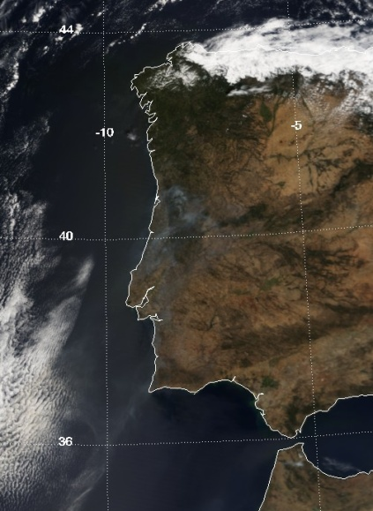
Figure 5.7. Terra Modis image from 23 August 2005 and set of back-trajectories computed for the period from 19 to 26 August 2005.
Figure 5.8. Temporal evolution of (a) scattering coefficient and (b) Ångström exponent in August 2005. Please notice the logarithmic scale in figure 5.8a

The first half of August 2006 was also characterized by significant forest fires in the centre and northern Portuguese regions. In particular during the second week of that month a significant amount of particles was transported to and detected at Évora. These high particle levels ended on 15 August, in coincidence with new synoptic conditions that led to precipitation in Portugal. Between 7 and 14 of August a total of seven days presented daily average mass concentrations above 50 µgm⁻³, which is the threshold value of daily PM₁₀ mass concentration according to the air quality legislation. Unfortunately the nephelometer broke down on the 8 of August, but a significant smoke plume was still recorded in parallel with the TEOM’s mass concentration measurements. Peaks in the scattering coefficient above 420 Mm⁻¹ and in the mass concentration close to the 160 µgm⁻³ were recorded (figure 5.9), while the Ångström exponent (not shown) was relatively constant, around 1.7, corresponding to an estimated contribution of 75% of light scattering due to fine particles (in agreement with the very significant increase in the fine mode concentration shown in figure 5.10). The ratio of coarse to fine number concentration decreased down to 0.06-0.08, even if an increase in the coarse fraction is apparent in figure 4.10. In fact, this enhancement in the coarse fraction was verified to correspond to the lower coarse size range, i.e. 1-2 µm.

Figure 5.9. Temporal evolution of the scattering coefficient (550 nm) and mass concentration in August 2006.

Figure 5.10. Temporal evolution of the coarse and fine number concentrations in August 2006.

Observations of events of continental polluted aerosols
One example of a period with significant levels of pollution observed at Évora is now presented. Figure 5.11 shows the hourly σ_{sp}(550) and M values between 28 November and 6 December 2007. Several peaks above 200 Mm⁻¹ and 70 µgm⁻³ were observed respectively in the scattering coefficient and mass concentration measurements. The Ångström exponent shown in figure 5.12 is relatively constant, around 2 or larger (average and median α are 2.1 during this period), which represents a contribution to scattering due to sub-micrometer particles of at least 90% (notice that a similar percentage was obtained, however for the coarse particles contribution to scattering during the dust events discussed in section 5.1). Therefore the enhancement in the aerosol load is clearly caused by a population of small particles. Accordingly, a very good positive correlation between σ_{sp}(550) and N_{F} was found, but not with N_{C} (figure 5.13). The temporary decrease in α observed on 3th of December (but still above 1) corresponds to a marked decrease in the aerosol load (in both fine and coarse modes), likely due to precipitation that occurred on that day. Figure 5.11 also reveals that the succession of observed peaks occur during nighttime, while the minimum values of both σ_{sp}(550) and M are found during the afternoon; this suggests the influence of the boundary layer in the dispersion of the pollutants during afternoon and the opposite effect during the night, as discussed in section 3.3 (concerning the daily variation of the aerosol properties). The variations of the Black Carbon mass concentration are in agreement with the σ_{sp}(550) and M variations. BC peaks, shown in figure 14, as high as 12 µgm⁻³ (or 80 Mm⁻¹ in terms of absorption coefficient) are visible in this figure being responsible for the significant increase in the BC fraction and in the decrease of the single scattering albedo, as a consequence of the input of this absorbing material. Figure 5.15 shows the (expected) good negative correlation between BC fraction and $\overline{ω}$.
These aerosol levels seem to be influenced by local sources (traffic plus biomass burning for private heating during these months) and also by possible advection of particles from other continental areas (of Europe and Iberia Peninsula) suggested by the back-trajectories paths depicted in figure 5.16. The European influence observed during the first three days of the abovementioned period was followed by back trajectories of MIB type which crossed the northern and western urban and industrial areas of the Iberia Peninsula.

Figure 5.11. Temporal evolution of the scattering coefficient (550 nm) and mass concentration in November/ December 2007.

Figure 5.12. Temporal evolution of the Ångström exponent in November/December 2007.

Figure 5.13. Scattering coefficient (550 nm) versus fine mode (a) and coarse mode (b) number concentration.
Figure 5.14. Temporal evolution of the Black carbon mass concentration in November/ December 2007.
Figure 5.15. BC fraction versus the single scattering albedo.

Figure 5.16. Set of back-trajectories, computed for the period between 28 November to 6 December 2007, showing the continental influence of the air masses arriving at Évora during this period.

Comparisons between the different aerosol types
In the previous sections a set of case studies were presented concerning aerosol events caused by dust outbreaks, forest fires and pollution. Table 5.1 summarizes the aerosol properties obtained near the ground surface for the different aerosol types, considering periods where the events were more intense; by doing so, we tried to make visible as much as possible each aerosol type and diminish the inherent variability caused by aerosol mixing. The information depicted in table 5.1 shows clear differences between the aerosol types, and emphasis is given to the intensive aerosol properties as the extensive properties, which depend on the aerosol concentration, can obviously vary widely. Therefore comparing them seems to not be particularly relevant. The Ångström exponent, about 0.2 for desert dust, can be thought as a reference value that characterizes dust conditions under medium-high dust loads. For the other aerosol types, α shows a large increase towards values close to 2, especially for the polluted aerosol. These different magnitudes of α, which illustrate the different wavelength dependence of the scattering coefficients, correspond to noticeably different contributions of fine and coarse modes to the scattering of light. They are also representative of the lower and upper ranges of α measured in Évora between 2002 and 2009. According to the estimations of SF, while the sub-micrometer particles dominated the scattering during the forest fire and pollution events (78-86% respectively) the contrary was observed during the dusty situations, with the scattering being controlled by the coarser particles (86%). The coarse to fine number concentration ratios, N_{C}/N_{F} (1.5 for desert dust, down to 0.05-0.09 for polluted and forest fire aerosols) are in agreement. The expected increase in the absorbing particles during pollution events is revealed; on the one hand there is an increase in the BC mass fraction, on the other hand, there is a decrease in the singe scattering albedo.

 | Desert dust | Forest fires | Pollution
σ_{sp}(450) (Mm⁻¹) | 122 | 463 | 209
σ_{sp}(550) (Mm⁻¹) | 120 | 322 | 145
σ_{sp}(700) (Mm⁻¹) | 114 | 211 | 87
α | 0.16±0.11 | 1.80±0.04 | 1.98±0.09
M (µgm⁻³) | 139 | 121 | 38
Es(450) (m²g⁻¹) | 0.89±0.10 | 3.83±0.18 | 5.90±1.90
Es(550) (m²g⁻¹) | 0.88±0.09 | 2.66±0.13 | 4.13±1.44
Es(700) (m²g⁻¹) | 0.83±0.10 | 1.74±0.08 | 2.48±0.91
N_{C}/N_{0.5-10} | 0.60±0.03 | 0.08±0.02 | 0.04±0.02
N_{C}/N_{F} | 1.5±0.20 | 0.09±0.02 | 0.05±0.02
SF | 0.14±0.12 | 0.78±0.09 | 0.86±0.11
BC (µgm⁻³) | 2.0 | - | 5.3
BC fraction | 0.01±0.004 | - | 0.14±0.05
σ_{ap}(670) (Mm⁻¹) | 13.5 | - | 35.3
$$\overline{ω}$$ | 0.91±0.03 | - | 0.73±0.09

Table 5.1. Average optical and physical aerosol properties for different aerosol types. These results account for the periods when each aerosol episode was more intense, in order to isolate, as much as possible, each aerosol type.

Figure 5.17 shows the aerosol scattering coefficient, at 550 nm, versus the aerosol mass concentration measured during events of different aerosol types, namely desert dust, forest fires and pollution. The different mass scattering efficiencies obtained for the different aerosol types (shown in table 5.1) are now represented in figure 5.17 as the slopes of σ_{sp}(550) versus M. The computed E_{s}(550) values of about 0.9 and 2.7 m²g⁻¹, respectively for desert dust and forest fires aerosols, are perceptible in figure 5.17a with the data extending below the lines representing 1 and 3 m²g⁻¹, respectively. It’s worth to notice the low variability of the represented values. With a linear fit to the data, slopes (mass scattering efficiencies) of 0.85 and 2.67 m²g⁻¹ were obtained, with very good correlation (R²=0.99) respectively for desert dust and forest fires aerosols. In particular, regarding the desert dust, Formenti (2000) had reported a mass scattering efficiency between 0.65 and 0.89 m²g⁻¹, which shows a good agreement with this work. Concerning the data for the polluted aerosols in (figure 5.17b), although the variability is much larger, it’s clear that the majority of the data is located between the lines corresponding to 2 and 5 m²g⁻¹ (or even above 5 m²g⁻¹ as is clearly perceptible in the figure).

Figure 5.17. Scattering coefficient (550 nm) versus mass concentration for (a) dust and forest fires and (b) pollution aerosols. The lines and respective slopes (m²g⁻¹) represent the mass scattering efficiencies.

Concluding remarks
In this thesis a data series of near surface in-situ measurements of aerosol optical and physical properties obtained during the last decade in a relatively small Portuguese city (Évora), have been analysed. Both scattering and absorbing aerosol properties together with aerosol mass concentration near the surface surface have been analyzed for the 2002-2009 period. Specific aerosol events, exceptionally strong and durable have also been analyzed allowing for the assessment of the climate relevant aerosol properties of different aerosol types reaching the region. One important benefit of the present study is the novel information obtained on the aerosol physical properties near the ground surface from a multitude of instruments and back-trajectory analyses, which fulfils a gap that was still remaining in the south western Iberia Peninsula and complement the information on the aerosol chemical properties existing from other authors for other similar sites of the Iberian Peninsula.
In general, the aerosol load in Évora, near the surface, can be considered as moderate, in particular taking in account the higher magnitudes that usually characterize the aerosol extensive properties at larger urban or industrial areas. The median values of the scattering coefficient (550 nm), mass concentration and absorption coefficient (670 nm) where found to be near 33 Mm⁻¹, 19 μgm⁻³ and 7 Mm⁻¹, respectively; the latter corresponds to a black carbon mass concentration close to 1 μgm⁻³, which accounted for about 5% of the total aerosol mass; moreover, a median single scattering albedo (at 670 nm) of 0.78 was obtained while the mass scattering efficiency (550 nm) was close to 2 m²g⁻¹; the aerosol population was, in general, characterized by a large fraction of particles in the sub-micrometer range. An overall contribution of almost 70% from these smaller particles for the scattering of light was estimated, which was based in the wavelength dependence of the scattering coefficients (given by the Ångström exponent, whose median value was found to be 1.5 for the whole period of measurements.
The temporal evolution of the aerosol properties, from daily to seasonal scales, was studied and both the influence of local and distant sources could be recognized. The city’s regular activity, corresponding to a large extent to the local traffic dynamics, could be noticed in the daily trends of the several aerosol properties; this influence was reflected in the measured aerosol scattering and absorption properties as well as in the measured mass concentration; a good identifier of this anthropogenic influence was the absorption coefficient (or the black carbon mass concentration derived from the absorption coefficient) whose variations where even more evident. This is expected since these absorbing particles should result essentially from mobile combustion sources whereas the whole aerosol population depends on a wide variety of sources. Regarding specifically the BC mass concentration, the local anthropogenic influence was clearly identified by looking at the differences between these measurements obtained during Sundays and in the other days of the week; to notice that consistent differences were also visible in other aerosol properties both in the extensive and intensive ones.
Concerning the seasonal cycle of aerosol properties in Évora and apart from the forest fires phenomena during the summer periods, the seasonal trend was characterized by a larger aerosol load in the colder season which was interpreted to be caused not only by the additional input of aerosols, particularly due to domestic heating, but also by the average atmospheric conditions, namely the lower boundary layer height and temperature inversions as well as lower wind speed during winter and fall. For instance, the median absorption coefficient during summer, 4-5 Mm⁻¹ increased up to 8-10 Mm⁻¹ during winter season, while the scattering coefficient (550 nm) reached maximum monthly values in winter, namely in January with average and median values of about 63.7 and 49.4 Mm⁻¹, respectively. The aerosol population also tends to be more absorbing which is corroborated by some decrease in the single scattering albedo from 0.79-0.82 during summer months down to 0.76-0.78 in winter months. Also, the black carbon fraction, in the range of 3-5% during the summer months increased up to 7-11% in winter. However this pattern, which was evident for both the scattering and absorption properties of the aerosols in Évora, was not clearly observed in the aerosol mass concentration. We think that the decrease in importance of re-suspended material during the more cold and wet seasons is responsible for masking that trend (in particular re-suspended dust giving a strong signal in the mass).
The large scale circulation was shown to have also a noticeable influence on the aerosol properties in Évora. This was done by relating computed back-trajectories, representing air masses paths, to the aerosol properties. The influence of particles from the relatively distant (summer) forest fires could also be recognized in the seasonal variation of the scattering properties whose dataset was long enough to include the most severe summer forest fires (they were responsible for the highest measured scattering coefficients, above 2000 Mm⁻¹, recorded during August 2005) and the following years, which, in contrast, exhibited a significant decrease (in particular concerning the burnt areas). For instance, the summer months of 2005 (the most severe summer), with average scattering coefficient (550 nm) and Ångström exponent in the range of 49-97 Mm⁻¹ and 1.6-1.7, respectively, experienced an aerosol load with totally different magnitude if compared with the summers of 2007 and 2008 (31-42 Mm⁻¹ and 1.2-1.6 for the same scattering properties).
The prevalence of westerly winds, coming from the Atlantic Ocean, was in general associated to lower aerosol loads. A further analysis also allowed noticing the influence of the continent in the air masses coming from the Atlantic Ocean which frequently resulted in the enhancement of the aerosol loads. For instance, the scattering coefficients were found to increase by a factor of 1.5 as well as their wavelength dependence. A comparable increase was observed in the mass concentration. The situations without dominant advective conditions, corresponding to back-trajectories of short length re circulating over the Iberian Peninsula, were related to even higher aerosol loads. This was also observed for situations characterized by advection from the other European regions to the east and Northeast of the Iberian Peninsula. The absorption coefficient (or the derived Black Carbon) showed less dependency from the large scale circulation as aforementioned for the scattering coefficients and the mass concentration. This should be related to the fact that the measurements were made in an urban environment were local production should dominates the levels of these absorbing particles. Measurements of this quantity in a rural site, away from anthropogenic sources and within this same region, should, in principle, clarify this issue and also elucidate on the actual magnitude of the local production both at the daily and seasonal scales.
The influence of North African was also reflected in higher aerosol loads where at the surface the signal of coarse mineral dust was not always evident. On the one hand, when the transportation of dust is made at higher atmospheric levels its detection by the in-situ instruments is not possible; on the other hand, the mixing with the other aerosol species present near the surface weakens the signal of these episodes (namely with the wavelength dependence of the scattering coefficients not being very low); in addition, the relatively low mass scattering efficiency of the dust particles also contributes to this point. For example, a 30 μgm⁻³ dust mass concentration, which is relatively high in this site, results in a scattering coefficient of 26 Mm⁻¹ (using the mass scattering efficiency obtained in this thesis), which is not particularly impressive.
Finally some aerosol case studies were presented from which climate relevant aerosol properties and parameters of different aerosol "types" could be fairly characterized, in particular the mass scattering efficiency, the single scattering albedo and the Ångström exponent. A consistent mass scattering efficiency value nearly 0.9 m²g⁻¹ (for 550 nm) was commonly obtained during different Sharan dust episodes. For aerosols from forest fires a mass scattering efficiency (550 nm) of 2.7 m²g⁻¹ was found; for situations of pollution events (industrial/traffic/urban) a larger variability in the mass scattering efficiency was found, but an important quantity of much larger values (up to values above 5 m²g⁻¹) could be observed. Concerning the single scattering albedo an average value of 0.73 was calculated for these situations, which is consistent with a more absorbing aerosol if compared with the desert dust (0.91). As to the Ångström exponent, distinct values were obtained for the more intense dust cases (~0.2) if compared to the other aerosols (~1.8 and 2 for forest fires and pollution).

References
Aaltonen, V., H. Lihavainen, V.-M. Kerminen1, M. Komppula1, J. Hatakka1, K. Eneroth2, M. Kulmala3, and Y. Viisanen. Measurements of optical properties of atmospheric aerosols in Northern Finland. Atmos. Chem. Phys., 6, 1155–1164, 2006.
Abu-Rahmah ,A., Arnott, W. P., and Moosmüller, H. (2006). Integrating Nephelometer with a Low Truncation Angle and an Extended Calibration Scheme, Meas. Sci. Technol. 17:1723–1732.
Allen, G., Sioutas, C., Koutrakis, P., Reiss, R., Lurmann, F. W. And Roberts, P., 1997. Evaluation of the TEOM method for measurement of ambient particulate mass in urban areas. Journal of Air and Waste Management Association 47, 682-689.
Almeida, S.M., Pio, C.A., Freitas, M.C., Reis, M.A., Trancoso, M.A., 2005. Source apportionment of fine and coarse particulate matter in a suburban area at theWestern European Coast. Atmospheric Environment 39, 3127–3138.
Almeida, S.M., Pio, C.A., Freitas, M.C., Reis, M.A., Trancoso, M.A., 2006. Source apportionment of atmospheric urban aerosol based on weekdays/weekend variability: evaluation of road re-suspended dust contribution. Atmospheric Environment 40 (2006) 2058–2067.
Alves, L.C., Reis, M.A., Freitas M.C. Air particulate matter characterisation of a rural area in Portugal. Nuclear Instruments and Methods in Physics Research B 136138 (1998) 941-947
Alves, C., A. Carvalho, and C. Pio, Mass balance of organic carbon fractions in atmospheric aerosols, J. Geophys. Res., 107(D21), 8345, doi:10.1029/2001JD000616, 2002.

Anderson, T.L., Covert, D.S., Wheeler, J.D., Harris, J.M., Perry, K.D., Trost, B.E., Jaffe, D.J., and Ogren, J.A., " Aerosol backscatter fraction and single scattering albedo: Measured values and uncertainties at a coastal station in the Pacific Northwest," J. Geophysical Research, 104, 26793-26807, 1999.
Anderson, T.L., Covert, D.S., Marshalll, S.F., Laucks, M.L, Charlson, R.J., Waggoner, A.P., Ogren, J.A., Caldow, R., Holm, R.L., Quant, F.R., Sem, G.J., Wiedensohler, A., Ahlquist, N.A., and Bates, T.S., "Performance characteristics of a high-sensitivity, three-wavelength total scatter/backscatter nephelometer," J. Atmospheric and Oceanic Technology, 13, 967-986, 1996.
Anderson,T.L., and Ogren, J.A., "Deteriming aerosol radiative properties using the TSI 3563 Integrating Nephelometer," Aerosol Science and Technology, 29, 57-69, 1998.
Anderson, T.L., Ogren, J.A., 1998. Determining aerosol radiative properties using the TSI 3563 integrating nephelometer. Aerosol Science and Technology 29, 57–69.
Andreae, T.W., Andreae, M.M., Ichoku, C., Maenhaut, W., Cafmeyer, J., Karniely, A., Orlovsky, L., 2002. Light scattering by dust and anthropogenic aerosol at a remote site in the Negev desert, Israel. J. Geophys. Res, 107, D2. doi:10.1029/2001JD900252.
Ansmann, A., Wagner, F., Müller, D., Althausen, D., Herber, A., von Hoyningen-Huene, W. and Wandinger, U (2002), European pollution outbreaks during ACE 2: Optical particle properties inferred from multiwavelength lidar and star-Sun photometry, J. Geophys. Res., VOL. 107, NO. D15, 10.1029/2001JD001109, 2002.
Ansmann, A., et al., Long-range transport of Saharan dust to northern Europe: The 11–16 October 2001 outbreak observed with EARLINET, J. Geophys. Res., 108(D24), 4783, doi:10.1029/2003JD003757, 2003.
APEG, 1999. Source apportionment of airborne particulate matter in the Unoted Kingdom. The First Report of the Airborne Particles Expert Group, Departement of Environment, Transport and the Regions, London. 157 pp.
Artiñano, B., Querol, X., Salvador, P., Rodrı´guez, S., Alonso, D.G., Alastruey, A., 2001. Assessment of airborne particulate levels in Spain in relation to the new EU-directive. Atmospheric Environment 35 (Suppl. 1), S43–S53.
Autoridade Florestal Nacional, 2009. Relatório - Áreas ardidas e ocorrências em 2008. Available at http://www.afn.min-agricultura.pt/portal.
Brink, H., 2004. Artefacts in measuring (the composition of) Particulate Matter in Europe: introducing INTERCOMP2000. Atmospheric Environment, 38, 6457.
Brockmann, J. E., 2001 – Sampling and Transport of Aerosols. In Baron P.A. e Willeke, K. “Aerosol Measurement. Principles, techniques and applications”. John Wiley and Sons, Inc. “2nd Edition, 2001.
Cappa, C. D., Lack, D. A., Burkholder, J. B., and Ravishankara, A. R.: Bias in filter based aerosol light absorption measurements due to organic aerosol loading: Evidence from laboratory measurements, Aerosol Sci. Technol., 42(12), 1022–1032, 2008.
Carrico, C. M., Rood, M. J., Ogren, J. A. (1998), Aerosol light scattering properties at Cape Grim, Tasmania, during the First Aerosol Characterization Experiment (ACE 1), J. Geophys. Res., VOL 103, NO D13, 16565-16574.
Carrico, C. M., M. J. Rood, J. A. Ogren, C. Neusüß, A. Wiedensohler, and J. Hintzenberg, Aerosol optical properties at Sagres, Portugal, during ACE-2, Tellus, Ser. B, 52, 694-715, 2000.
Carrico, C. M., P. Kus, M. J. Rood, P. K. Quinn, and T. S. Bates. Mixtures of pollution, dust, sea salt, and volcanic aerosol during ACE-Asia: Radiative properties as a function of relative humidity, J. Geophys. Res., 108(D23), 8650, doi:10.1029/2003JD003405, (2003).
Castro, L., C. Pio, R. Harrison, and D. Smith (1999), Carbonaceous aerosol in urban and rural European atmospheres: Estimation of secondary organic carbon concentrations, Atmos. Environ., 33, 2771–2781.
Charlson, R. J., S. E. Schwartz, J. M. Hales, R. D. Cess, J. A. Coakley, J. E. Hansen, and D. J. Hofmann, Climate forcing by anthropogenic aerosols, Science, 255, 423– 430, 1992.
Charlson, R. J., Anderson, T. L., and Rodhe, H.: Direct climate forcing by anthropogenic aerosols: quantifying the link between atmosphere sulfate and radiation, Contr. Atmos. Phys., 72, 79–94, 1999.
Charron, A., Harrison, R. M., Moorcroft, S., Booker, J., 2004. Quantitative interpretation of divergence between PM10 and PM2.5 mass measurement by TEOM and gravimetric (Partisol) instruments. Atmospheric Environment, 38, 415-423.
Deacon, A.R., Derwent, R.G., Harrison, R.M., Middleton, D.R., Moorcroft, S., 1997. Analysis and interpretation of measurements of suspended particulate matter at urban background sites in the United Kingdom. The Science of the Total Environment 203, 17–36.
Delene, D. J., and J. A. Ogren (2002),Variability of aerosol optical properties at four North American surface monitoring sites, J. Atmos. Sci., 59, 1135–1150.
Derimian, Y., Karnieli, A., Kaufmann, Y. J., Andreae, M. O., Andreae, T. W., Dubovik, O., Maenhaut, W., Koren, I., and Holben, B. N.: Dust and pollution aerosols over the Negev desert, Israel: Properties, transport and radiative effect, J. Geophys. Res., 111, D05205, 15 doi:10.1029/2005JD006549, 2006.
DETR, 1999. The First Phase Air Quality Review and Assessment: A summary. DETR, Welsh Office, Scottish Office, Department of Environment for Northern Ireland.
Dockery, D., Pope, A., 1996. Epidemiology of acute health effects: summary of time-series studies. In: Wilson, R., Spengler, J.D. (Eds.), Particles in our Air: Concentration and Health Effects. Harvard University Press, Cambridge, MA, USA, pp. 123-147.
Doherty, S. J., P. K. Quinn, A. Jefferson, C. M. Carrico, T. L. Anderson, and D. Hegg (2005), A comparison and summary of aerosol optical properties as observed in situ from aircraft, ship, and land during ACE-Asia, J. Geophys. Res., 110, D04201, doi:10.1029/2004JD004964.
Draxler, R.R., Rolph, G.D., 2003. HYSPLIT (Hybrid Single-Particle Lagrangian Integrated Trajectory) model access via NOAA ARL READY Website, NOAA Air Resources Lab., Silver Spring, MD.
Elias, T., A. M. Silva, N. Belo, S. Pereira, P. Formenti, G. Helas, and F. Wagner (2006), Aerosol extinction in a remote continental region of the Iberian Peninsula during summer, J. Geophys. Res., 111, D14204, doi:10.1029/2005JD006610.
Escudero, M., S. Castillo, X. Querol, A. Avila, M. Alarco´n, M. M. Viana, A. Alastuey, E. Cuevas, and S. Rodríguez (2005), Wet and dry African dust episodes over eastern Spain, J. Geophys. Res., 110, D18S08, doi:10.1029/2004JD004731.
Escudero, M., Xavier Querola, Anna Ávila, Emilio Cuevas. Origin of the exceedances of the European daily PM limit value in regional background areas of Spain Atmospheric Environment 41 (2007) 730–744.
Esteve, A.R., V. Estellés, M.P. Utrillas , and J.A. Martínez-Lozano. Statistical analysis of the scattering properties of atmospheric aerosols in Valencia (Spain) over a year. Geophysical Research Abstracts, Vol. 11, EGU2009-10209, 2009.
Freitas, C., 2006. Synoptic and Mesoscale Meteorological Patterns During PM Events in Lisbon Area. Master thesis, University of Évora, 189 pp.
Formenti, Paola, 2000. Measurements of Aerosol properties in the Troposphere. PhD Thesis. University of Utrecht. 186 pp. ISBN 90-393-2458-1.
Gerasopoulos, E., Andreae, M. O., Zerefos, C. S., Andreae, T.W., Balis, D., Formenti, P., Merlet, P., Amiridis, V., and Papastefanou, C.: Climatological aspects of aerosol optical properties in Northern Greece, Atmos. Chem. Phys., 3, 2025–2041, 2003.
Guerrero-Rascado, J. L., F. J. Olmo, I. Avilés-Rodríguez, F. Navas-Guzmán, D. Pérez-Ramírez, H. Lyamani, and L. Alados Arboledas. Extreme Saharan dust event over the southern Iberian Peninsula in september 2007: active and passive remote sensing from surface and satellite. Atmos. Chem. Phys., 9, 8453–8469, 2009.
Green, D., Fuller, G., Barrat, B., 2001. Evaluation of TEOM “correction factors” for assessing the EU Stage 1 limit values for PM10. Atmospheric Environment, 35, 2589-2593.
Hand, J. L., and W. C. Malm (2007), Review of aerosol mass scattering efficiencies from ground-based measurements since 1990, J. Geophys. Res., 112, D16203, doi:10.1029/2007JD008484.
Hansen, J., Sato, M., and Ruedy, R.: Radiative forcing and climate response, J. Geophys. Res., 102, 6831–6864, 1997.
Hatzianastassiou, N., B. Katsoulis, and I. Vardavas (2004), Global distribution of aerosol direct radiative forcing in the ultraviolet and visible arising under clear skies, Tellus, 56B, 51-71.
Heintzenberg, J., 1978. The angular calibration of the total scatter/backscatter nephelometer, consequences and applications. Staub-Reinhalt. Luft, 38, 62-63.
Heintzenberg, J. and Charlson, R.J., "Design and applications of the integrating nephelometer: A review," J. Atmospheric and Oceanic Technology, 13, 987-1000, 1996.
Hess, M., P. Koepke, and I. Schult (1998): Optical Properties of Aerosols and Clouds: The Software Package OPAC, Bulletin of the American Meteorological Society, 79 (5), 831- 844.
Hinds, W. C., 1999. Aerosol Technology properties, behaviour and measurement of airborne particles. John Wiley & Sons, Inc, 2nd Ed. 483 pp.
Hitzenberger, R., Petzold, A., Bauer, H., Ctyroky, P., Pouresmaeil, P., Laskus, L., and Puxbaum, H.: Intercomparison of thermal and optical measurement methods for elemental carbon and black carbon at an urban location, Environ. Sci. Technol., 40, 6377– 6383, 2006.
Horvath, H., 1996. Spectral extinction coefficients of rural aerosol in southern Italy—a case study of cause and effect of variability of atmospheric aerosol. Journal of Aerosol Science 27 (3), 437–453.
IPCC (2001), Climate Change 2001: The Scientific Basis; Contribution of the Working Group I to the Third Assessment Report of the Intergovern- mental Panel on Climate Change, edited by J. T. Houghton, Y. Ding, and D. J. Griggs, pp. 289– 348, Cambridge Univ. Press, New York.
Kaufman, Y. J., D. Tanré, H. R. Gordon, T. Nakajima, J. Lenoble, R. Frouin, H. Grassl, B. M. Herman, M. D. King, and P. M. Teillet (1997), Passive remote sensing of tropospheric aerosol and atmospheric correction for the aerosol effect, J. Geophys. Res., 102, 16,815–16,830.
King, M. D., Y. J. Kaufman, D. Tanre´, and T. Nakajima (1999), Remote sensing of tropospheric aerosols from space: Past, present, and future, Bull. Am. Meteorol. Soc., 80, 2229–2259.
King, A. M., Pless-Mulloni, T., Merefield, J., Stone, I., 2000. New directions: TEOMs and the volatility of UK non-urban PM10: a regulatory dilemma?. Atmospheric Environment, 34, 3209-3212.
Koloutsou-Vakakis, S., Carrico, C. M., Kus, P., Rood, M. J., Li, Z., Shrestha, R., Ogren, J. A., Chow, J. C., and Watson, J. G., Aerosol properties at a midlatitude Northern Hemisphere continental site, J. Geophys. Res., Vol 106, No. D3, 3019-3032, 2001.
Kotchenruther, R. A., Hobbs, P. V., and Hegg, D. A., Humidification factors for atmospheric aerosols off the mid-Atlantic coast of the United States, J. Geophys. Res., Vol 104, No. D2, 2239-2251, 1999.
Kunzli, N., Kaiser, R., Medina, S., Studnicka, M., Chanel, O., Filliger, P., Herry, M., Horak, F., Puybonnieux-Texier, V., Quenel, P., Schneider, J., Seethaler, R., Vergnaud, J. C., and Sommer, H.: Public-health impact of outdoor and traffic-related air pollution: a European assessment, Lancet, 356, 795–801, 2000.
Lack, D. A., Cappa, C. D., Covert, D. S., Baynard, T., Massoli, P., Sierau, B., Bates, T. S., Quinn, P. K., Lovejoy, E. R., and Ravishankara, A. R.: Bias in filter based aerosol absorption measurements due to organic aerosol loading: Evidence from ambient measurements, Aerosol Sci. Technol., 42(12), 1033–1041, 2008.
Latha, K.M., Highwood, E.J., 2006. Studies on particulate matter (PM₁₀) and its precursors over urban environment of reading, UK. Journal of Quantitative Spectroscopy & Radiative Transfer 101, 367–379.
Liousse, C., H. Cachier, and S. G. Jennings (1993), Optical and thermal measurements of black carbon aerosol content in different environments: Variations of the specific attenuation cross-section, Atmos. Environ., Part A, 27, 1203– 1211.
Lippmann, M., 1999. The 1997 US EPA standards for particulate matter and ozone. In: Hester, R.E., Harrison, R.M. (Eds.), Air Pollution and Health. Royal Society of Chemistry, pp. 75–99.
Lohmann, U. and Feichter, J.: Global indirect aerosol effects: a review, Atmos. Chem. Phys., 5, 715–737, 2005.
Lyamani, H., Olmo, F. J., and Alados-Arboledas, L.: Light scattering and absorption properties of aerosol particles in the urban environment of Granada, Spain, Atmos. Environ., 42, 2630–2642, 2008.
Lyamani, H., F. J. Olmo, and L. Alados-Arboledas, Physical and optical properties of aerosols over an urban location in Spain: seasonal and diurnal variability. Atmos. Chem. Phys. Discuss., 9, 18159–18199, 2009.
Lyamani, H., Olmo, F. J., and Alados-Arboledas, L.: Physical and optical properties of aerosols over an urban location in Spain: seasonal and diurnal variability, Atmos. Chem. Phys., 10, 239–254, doi:10.5194/acp-10-239-2010, 2010.
Magi, B. I., and P. V. Hobbs, Effects of humidity on aerosols in southern Africa during the biomass burning season, J. Geophys. Res., 108(D13), 8495, doi:10.1029/2002JD002144, 2003.
McComiskey, A., S.E. Schwartz, B. Schmid, H. Guan, E.R. Lewis, P. Ricchiazzi, and J.A. Ogren (2008), Direct aerosol forcing: Calculation from observables and sensitivities to in-puts, J. Geophys. Res., 113, D09202, doi:10.1029/2007/JD009170.
Mólnar, A., and Mészáros, E.: On the relation between the size and chemical composition of aerosol particles and their optical properties, Atmos. Environ., 35, 5053–5058, 2001.
Moorthy, K. K., and S. S. Babu (2006), Aerosol black carbon over Bay of Bengal observed from an island location, Port Blair: Temporal features and long-range transport, J. Geophys. Res., 111, D17205, doi:10.1029/2005JD006855.
Moosmuller, H., and Arnott, W. P. (2003). Angular Truncation Errors in Integrating Nephelometry, Rev. Sci. Instrum. 74(7):3492–3501.
Muckler, P., 1999. Test Report on the examination concerning the comparison of the concentration measuring instrument for airborne particulates TEOM Model 1400a, Revision B, from Rupprecht & Patashnick Co., Inc. with reference method for airborne particulates.
Müller, D., Ansmann, A., Wagner, F., Franke, K., and Althausen, D (2002), European pollution outbreaks during ACE 2: Microphysical particle properties and single-scattering albedo inferred from multiwavelength lidar observations, J. Geophys. Res., VOL. 107, NO. D15, 4248, 10.1029/2001JD001110, 2002.
Müller, D., I. Mattis, U. Wandinger, A. Ansmann, D. Althausen, O. Dubovik, S. Eckhardt, and A. Stohl, Saharan dust over a central European EARLINET-AERONET site: Combined observations with Raman lidar and Sun photometer, J. Geophys. Res., 108(D12), 4345, doi:10.1029/2002JD002918, 2003.
Müller, T., Nowak, A., Wiedensohler, A., Sheridan, P., Laborde, M., Covert, David S., Marinoni, Angela, Imre, Kornélia, Henzing, Bas, Roger, Jean-Claude, dos Santos, Sebastiao Martins, Wilhelm, Reinhard, Wang, Ya-Qiang and de Leeuw, Gerrit(2009). Angular Illumination and Truncation of Three Different Integrating Nephelometers: Implications for Empirical, Size-Based Corrections. Aerosol Science and Technology,43:6,581 — 586
Novakov, T., S. Menon, T. W. Kirchstetter, D. Koch, and J. E. Hansen (2005), Aerosol organic carbon to black carbon ratios: Analysis of published data and implications for climate forcing, J. Geophys. Res., 110, D21205, doi:10.1029/2005JD005977.
Oliveira, T. O aerossol carbonoso em atmosferas rurais e remotas da Europa. PhD Thesis. University of Aveiro, 226pp. 2006.
Oliveira, T., Pio, C., Alves, C., Silvestre, A., Evtyugina, M., Afonso, J., Caseiro, A., Legrand, M., 2007. Air quality and organic compounds in aerosols from a coastal rural area in the Western Iberian Peninsula over a year long period: characterisation, loads and seasonal trends. Atmos. Environ. 41, 3631–3643.
Paredes-Miranda, G., Arnott, W. P., Jimenez, J. L., Aiken, A. C., Gaffney, J. S., and Marley, N. A.: Primary and secondary contributions to aerosol light scattering and absorption in Mexico City during the MILAGRO 2006 campaign, Atmos. Chem. Phys., 9, 3721–3730, 2009, http://www.atmos-chem-phys.net/9/3721/2009/.
Patashnick, H. and Rupprecht, E. G., 1991. Continuous PM-10 Measurements Using the Tapered Element Oscillating Microbalance. Journal of Air and Waster Management Association 41 (8), 1079-1084.
Pereira, S., Wagner, F., and Silva, A. M.: Scattering properties and mass concentration of local and long range transported aerosols over the south western Iberian Peninsula, Atmos. Environ., 42, 7623–7631, 2008.
Pereira, S., Wagner, F., and Silva, A. M. Continuous measurements of near surface aerosols in the south-western European (Portugal) region in 2006-2008. Adv. Sci. Res., 1, 1–4, 2009.
Pereira, S., Wagner, F., and Silva, A. M. Seven years of measurements of aerosol scattering properties, near the surface, in the southwestern Iberia Peninsula. Atmos. Chem. Phys., 11, 17–29, 2011. doi:10.5194/acp-11-17-2011.
Pereira, S., Wagner, F., and Silva, A. M. Long term black carbon measurements in the southwestern Iberia Peninsula. J. Geophys. Res. manuscript 2011JD015657R. In discussion.
Pérez, C., S. Nickovic, J. M. Baldasano, M. Sicard, F. Rocadenbosch, and V. E. Cachorro (2006), A long Saharan dustevent over the western Mediterranean: Lidar, Sun photometer observations, and regional dust modeling, J. Geophys. Res., 111, D15214,doi:10.1029/2005JD006579.
Petzold, A., Kramer, H., Schönlinner, M., 2002. Continuous measurement of Atmospheric Black Carbon using a Multi-Angle Absorption Photometer. Environ Sci & Pollut Res, Special Issue 4 (2002), 78-82.
Petzold, A. and Schönlinner, M.: Multi-angle Absorption photometry-A new method for the measurement of aerosol light absorption and atmospheric black carbon, J. Aerosol Sci., 35, 421–441, 2004.
Petzold, A., Schloesser, H., Sheridan, P. J., and Arnott, W. P.: Evaluation of multi-angle Absorption photometry for measuring aerosol light absorption, Aerosol Sci. Technol., 39(1), 40–51, 2005.
Pio, C.A., Castro, L.M, Cerqueira, M.A., Santos, I.M., Belchior, F., Salgueiro, M.L., 1996. Source assessment of particulate air pollutants measured at the southwest European coast. Atmospheric Environment 30, 3309-3320.
Pio C.A., Legrand, M., Alves, C.A., Oliveira, T., Afonso, J., Caseiro A., Puxbaum H., Sanchez-Ochoa, A, Gelencse, A. Chemical composition of atmospheric aerosols during the 2003 summer intense forest fire period. Atmospheric Environment 42 (2008) 7530–7543.
Pohjola, M.A., Kousa, A., Kukkonen, J., Härkönen, J., karppinen, A., Aarnio, P., Koskentalo, T., 2002. The spatial and temporal variation of measured urban PM₁₀ and PM2.5 in the Helsinki metropolitan area. Water, Air and Soil Pollution: Focus 2, 189–201.
Prospero, J.M., 1999. Long-range transport of mineral dust in the global atmosphere: impact of African dust on the environment of Southeastern United States. Proc. Natl. Acad.Sci. USA 96, 3396}3403.
Putaud, J.P., Van Dingenen, R., Alastuey, A., Bauer, H., Birmili, W., Cyrys, J., Flentje, H., Fuzzi, S., Gehrig, R., Hansson, H.C., Harrison, R.M., Herrmann, H., Hitzenberger, R., Hüglin, C., Jones, A.M., Kasper-Giebl, A., Kiss, G., Kousa, A., Kuhlbusch, T.A.J., Löschau, G., Maenhaut, W., Molnar, A., Moreno, T., Pekkanen, J., Perrino, C., Pitz, M., Puxbaum, H., Querol, X., Rodriguez, S., Salma, I., Schwarz, J., Smolik, J., Schneider, J., Spindler, G., ten Brink H., Tursic, J., Viana, M., Wiedensohler, A., Raes, F. A European Aerosol Phenomenology - 3: physical and chemical characteristics of particulate matter from 60 rural, urban, and kerbside sites across Europe, Atmospheric Environment (2010), doi: 10.1016/j.atmosenv.2009.12.011.
Querol X., A. Alastuey, A. Lopez-Soler, F. Plana, J.A. Puicercus, E. Mantilla, J.L. Palau. Daily evolution of sulphate aerosols in a rural area, northeastern Spain-elucidation of an atmospheric reservoir effect. Environmental Pollution 105 (1999) 397-407.
Querol, X., Andres Alastuey, Sergio Rodriguez, Felicia Plana, Carmen R. Ruiz, Nuria Cots, Guillem Massague, Oriol Puig. PM10 and PM2.5 source apportionment in the Barcelona Metropolitan area, Catalonia, Spain. Atmospheric Environment 35 (2001) 6407–6419.
Querol, X., J. Pey, M. Pandolfi, A. Alastuey, M. Cusack, N. Pérez, T. Moreno, M. Viana, N. Mihalopoulos, G. Kallos, S. Kleanthous. African dust contributions to mean ambient PM10 mass-levels across the Mediterranean Basin. Atmospheric Environment 43 (2009) 4266–4277.
Quinn, P. K., D. J. Coffman, T. S. Bates, T. L. Miller, J. E. Johnson, E. J. Welton, C. Neusüss, M. Miller, and P. J. Sheridan, Aerosol optical properties during INDOEX 1999: Means, variability, and controlling factors, J. Geophys. Res., 107(D19), 8020, doi:10.1029/2000JD000037, 2002.
Ramachandran, S., and T. A. Rajesh (2007), Black carbon aerosol mass concentrations over Ahmedabad, an urban location in western India: Comparison with urban sites in Asia, Europe, Canada, and the United States, J. Geophys. Res., 112, D06211, doi:10.1029/2006JD007488.
Ramanathan, V., Crutzen, P. J., Kiehl, J. T., and Rosenfeld, D.: Aerosols, climate, and the hydrological cycle, Science, 294, 2119–2124, 2001.
Ramanathan, V., et al. (2001), Indian Ocean Experiment: An integrated analysis of the climate forcing and effects of the great Indo-Asian haze,J. Geophys. Res., 106, 28,410– 28,426.
Reisinger, P., Wonaschutz, A., Hitzenberger, R., Petzold, A., Bauer, H., Jankowski, N., Puxbaum, H., Chi, X., Maenhaut, W. Intercomparison of Measurement Techniques for Black or Elemental Carbon Under Urban Background Conditions in Wintertime: Influence of Biomass Combustion. Environ. Sci. Technol. 2008, 42, 884–889.
Rodríguez, S., X. Querol, A. Alastuey, and F. Plana, Sources and processes affecting levels and composition of atmospheric aerosol in the western Mediterranean, J. Geophys. Res., 107(D24), 4777, doi:10.1029/2001JD001488, 2002.
Röösli, M., G. Theis, N. Künzli, J. Staehelin, P. Mathys, L. Oglesby, M. Camenzind, and C. Braun-Fahrlander (2001), Temporal and spatial variation of the chemical composition of PM₁₀ at urban and rural sites in the Basel area, Switzerland, Atmos. Environ., 35, 3701–3713.
Saha, A., Mallet, M., Roger, J. C., Dubuisson, P., Piazzola, J., and Despiau, S.: One year measurements of aerosol optical properties over an urban coastal site: Effect on local direct radiative forcing, Atmos. Res., 90, 195–202, 2008.
Salter, L. F. e Parsons, B., 1999. Field trials of the TEOM and Partisol for PM10 monitoring in the St Austell china clay area, Cornwall, UK. Atmospheric Environment, 33, 2111-2114.
Sheridan, P. J., Delene, D. J., Ogren, J. A., Four years of continuous surface aerosol measurements from the Department of Energy’s Atmospheric Radiation Measurement Program Southern Great Plains Cloud and Radiation Testbed site, J. Geophys. Res., VOL 106, NO. D18, 20735-20747, 2001.
Schmidhauser, R., P. Zieger, E. Weingartner, M. Gysel, P.F. DeCarlo, and U. Baltensperger (2009). Aerosol light scattering at high relative humidity at a high alpine site (Jungfraujoch). European Aerosol Conference 2009. Abstract T047A07.
Schwab, J. J., Spicer, J., Demerjian, L., Ambs, J. L., Felton, H. D., 2004. Long-Term field characterization of tapered element oscillating microbalance and modified tapered element oscillating microbalance samplers in urban and rural New York State locations. Journal of Air and Waste Management Association 54, 1264-1280.
Sheridan, P. J., Arnott, W. P., Ogren, J. A., Anderson, B. E., Atkinson, D. B., Covert, D. S., Moosmüller, H., Petzold, A., Schmid, B., Strawa, A. W., Varma, R., and Virkkula, A.: The Reno aerosol optics study: An evaluation of aerosol absorption measurement methods, Aerosol Sci. Techol., 39, 1–16, 2005.
Silva, A. M., M. L. Bugalho, M. J. Costa, W. von Hoyningen-Huene, T. Schmidt, J. Heintzenberg, and S. Henning, Aerosol optical properties from columnar data during the second Aerosol Characterization Experiment on the south coast of Portugal. J. Geophys. Res., 107(D22), 4642, doi:10.1029/2002JD002196, 2002.
Silva, A.M., Maria João Costa, Thierry Elias, Paola Formenti, Nuno Belo, Sérgio Pereira. "Ground based aerosol monitoring at Évora, Portugal", Global Change Newsletter, Issue Nº 56, pp 6-9, December 2003.
Silva, A.M., Costa. M.J., Wagner, F., Bortoli, D., Pereira, S., Belo, N., Bugalho,L., Alados-Arboledas, L., Lyamani, H., Guerrero-Rascado, J.L., Kindred, D. and Smith, M., CAPEX – AEROPOR Overview: Objectives and first results. European Aerosol Conference 2007 Abstract T13A185.
Soutar, A., Watt, M., Cherrie, J. W., Seaton, A., 1999. Comparison between a personal PM10 sampling head and the tapered element oscillating microbalance (TEOM) system. Atmospheric Environment, 33, 4373-4377.
Strawa, A.W., Castaneda, R., Owano, T., Baer, D. S., and Paldus, B. A. (2003). The Measurement of Aerosol Optical Properties Using Continuous Wave Cavity Ring-Down Techniques, J. Atmos. Oceanic Technol. 20(4):454–465.
Subramanian, R., Roden, C. A., Boparai, P., and Bond, T. C.: Yellow beads and missing particles: Trouble ahead for filter based absorption measurements, Aerosol Sci. Techol., 41, 630–637, 2007.
Tanré, D., Haywood, J., Pelon, J., Leon, J.F., Chatenet, B., Formenti, P., Francis, P., Goloub, P., Highwood, E.J., Myhre, G., 2003. Measurement and modeling of the Saharan dust radiative impact: overview of the Saharan Dust Experiment (SHADE). J. Geophys. Res. 108 (D18). doi:10.1029/2002JD003273.
Targino, A.C., Noone, K.J., Öström, E., 2005. Airborne in situ characterization of dry aerosol optical properties in multi-source influenced marine region. Tellus 57B (3), 247–260.
Toledano, C., V. E. Cachorro, A. Berjon, A. M. de Frutos, M. Sorribas, B. A. de la Morena and P. Goloub. Aerosol optical depth and Angstrom exponent climatology at El Arenosillo AERONET site (Huelva, Spain). Q. J. R. Meteorol. Soc. 133: 795–807 (2007).
Toledano, C., V. E. Cachorro, A. M. de Frutos, M. Sorribas, N. Prats, and B. A. de la Morena (2007), Inventory of African desert dust events over the southwestern Iberian Peninsula in 2000–2005 with an AERONET Cimel Sun photometer, J. Geophys. Res., 112, D21201, doi:10.1029/2006JD008307.
Tsyro, S., D. Simpson, L. Tarrason, Z. Klimont, K. Kupiainen, C. Pio, and K. E. Yttri (2007), Modeling of elemental carbon over Europe, J. Geophys. Res., 112, D23S19, doi:10.1029/2006JD008164.
Varma, R., Moosmüller, H., and Arnott, W. P. (2003). Toward an Ideal Integrating Nephelometer, Opt. Lett. 28(12):1007–1009.
Volcken, J., Peters, T.M., 2003. Counting and particle transmissionefficiency of the aerodynamic particle sizer. Journal of Aerosol Science 36, 1400–1408.
Vrekoussis, M., Liakakou, E., Kocak, M., Oikonomou, K., sciare, J., and Mihalopoulos, N: Seasonal variability of optical properties of aerosols in the eastern Mediterranean, Atmos. Environ., 39, 7083–7094, 2005.
Xu, J., Bergin, M. H., Yu, X., Liu, G., Zhao, J., Carrico, C. M., and Baumann, K.: Measurement of aerosol chemical, physical and radiative properties in the Yangtze delta region of China, Atmos. Environ., 36, 161–173, 2002.
Yttri, K. E., Aas, W., Bjerke, A., Cape, J. N., Cavalli, F., Ceburnis, D., Dye, C., Emblico, M., Facchini, C., Forster, C., Hanssen, J. E., Hansson, H. C., Jennings, S. G., Maenhaut, W., Putaud, J. P., and Torseth, K..: Elemental and organic carbon in PM₁₀: a one year measurement campaign within the European Monitoring and Evaluation Programme EMEP, Atmos. Chem. Phys., 7, 5711–5725, 2007.
Wagner, F., D. Bortoli, S. Pereira, M.J. Costa, A.M. Silva, B. Weinzierl, M. Esselborn, A. Petzold, K. Rasp, B. Heinold, and I. Tegen (2009): Properties of dust aerosol particles transported to Portugal from the Sahara desert, 61 B Tellus, 61B (1), 297–30.

Appendix A. Some statistical definitions
i) The normal or Gaussian distribution whose probability density function is given by
(A1)
where A is the amplitude, w is the standard deviation and x_{c} is the mean.

ii) The lognormal distribution is a positively skewed and non negative distribution given by
(A2)
where A is the amplitude, w is the geometric standard deviation and x_{c} is the modal value. In aerosol science the lognormal distribution is widely used for characterizing aerosol size distributions
$\frac{dN}{dlogD}=\frac{N}{\sqrt{2π}{lnσ}_{g}}exp\left[-\frac{{\left(lnD-ln\overline{D}\right)}^{2}}{2{lnσ}_{g}}\right]$ (A3)
where N is the total aerosol particle number concentration, $\overline{D}$ is the median diameter, that is, the diameter for which exactly one-half of the particles are smaller and one-half are larger and σ_{g} is the geometric standard deviation.

iii) A percentile, Px, is the value of a variable below which a certain percent given by x of observations fall. For instance, P25 and P75, are also called first and third quartiles while the median corresponds to P50 (second quartile). P1, P5, P95 and P99 correspond to the 1st percentile, 5th percentile, 95th percentile and 99th percentile, respectively.

Appendix B. Nephelometer calibration
Calibration of the nephelometer consists in filling the instrument with gases of known but different scattering coefficients and adjusting the zero and span constants for the appropriate scattering values. The zero measurement is the measure of the scattering intensity from aerosol-free air and the instrument background, which is performed with the air filtered by the high efficiency filter. The instrument noise is assessed as the standard deviation of the zero baseline measurements in order to determine the detection limit of the nephelometer. The mean detection limit of the nephelometer amounts to 0.3 Mm⁻¹ as defined by a signal-to-noise ratio of 2. The instrument was calibrated about once a year using CO₂ as high span gas and filtered dry air as low span gas; the record of calibration constants is provided in Table B1. K₂ sets the total scatter calibration of the reference chopper and K₄ sets the backscatter calibration of the reference chopper, while K₁ and K₃ are constants to account for photon count input pulse width and Rayleigh scatter of air at 273 °K and 1013.25 mbar, respectively. A detailed discussion of the performance characteristics of this commercial instrument is given by Anderson et al. [1996].

Time | K2_{450nm} | K2_{550nm} | K2_{700nm} | K4_{450nm} | K4_{550nm} | K4_{700nm}
07/2001 | 4.166×10⁻³ | 4.040×10⁻³ | 4.056×10⁻³ | 5.017×10⁻¹ | 5.049×10⁻¹ | 5.405×10⁻¹
12/2002 | 4.213×10⁻³ | 4.036×10⁻³ | 4.554×10⁻³ | 5.000×10⁻¹ | 5.060×10⁻¹ | 5.900×10⁻¹
12/2004 | 5.042×10⁻³ | 4.879×10⁻³ | 4.660×10⁻³ | 5.070×10⁻¹ | 5.160E-01 | 5.320×10⁻¹
02/2006 | 5.573×10⁻³ | 5.280×10⁻³ | 5.239×10⁻³ | 5.254×10⁻¹ | 5.253×10⁻¹ | 5.145×10⁻¹
The nephelometer had a break down and some electronics were substituted
01/2007 | 8.635×10⁻³ | 8.472×10⁻³ | 8.535×10⁻³ | 5.245×10⁻¹ | 5.233×10⁻¹ | 4.511×10⁻¹
03/2008 | 9.620×10⁻³ | 9.340×10⁻³ | 9.550×10⁻³ | 5.180×10⁻¹ | 5.230×10⁻¹ | 4.530×10⁻¹
01/2009 | 1.053×10⁻³ | 1.018×10⁻³ | 9.943×10⁻³ | 5.249×10⁻¹ | 5.115×10⁻¹ | 4.562×10⁻¹

Table B1. Time evolution of the calibration constants, K₂ and K₄ (m⁻¹), at three wavelengths

Appendix C. Relative humidity correction for scattering measurements
Relative humidity (RH) is one of the factors influencing the amount of scattered solar radiation by aerosol particles [Horvath, 1996]. If RH increases, then hydrophilic atmospheric particles tend to grow, due to water uptake, and scatter more light. The light scattering humidification factor, f(RH), quantifies the influence of RH on σ_{sp}(λ). It is the ratio between σ_{sp}(λ) at high and low RH values. The low RH is usually considered to be lower than 40 % (Kotchenruther et al., 1999; Koloutsou-Vakakis et al., 2001; Maggi and Hobbs, 2003; Targino et al., 2005).
(2)
In order to assess the temporal variation of the scattering coefficients, the influence of RH on σ_{sp}(λ) should be eliminated.

Figure C1. Relative frequency distributions of measured ambient RH at the site and measured RH inside the nephelometer’s sensing chamber.

Figure C1 shows the relative frequency distributions of measured ambient RH values at the monitoring site and measured RH values inside the nephelometer’s optical chamber. The difference between the two measured RH values is clear: the lower and less variable RH values measured inside the nephelometer are due to the heating by the lamp in the measuring sensing chamber, whereas the ambient RH values comprise a large range of values. The RH values of the sampled aerosol are constrained mainly in the range of 30-50 %, with average of 40 % and standard deviation (SD) of 10 %. Therefore the measurements of σ_{sp}(λ) were performed essentially with the aerosol under dry conditions and the RH corrections are expected to have minor influence in the overall results that follow in next sections. This hypothesis was confirmed as the difference between the corrected and non corrected values was found to be insignificant, and below the detection limit, because only few data were taken under non-dry conditions. In spite of that, corrected values were still used.
Due to the lack of measured f(RH) for the sampling site, functions from the literature, corresponding to different aerosol types, were used. The prevailing aerosol population at the site is of continental type. Anthropogenic aerosols from local or long distant sources as well as smoke aerosols from forest fires and desert dust from Africa were also present. The f(RH) functions were chosen according to these aerosol types which were discussed in section 3.1.1; we then distinguished between measurements made under clean/background continental conditions (the most common situation) and under perturbed conditions. The correction functions for clean/background conditions were based on (Maggi and Hobbs, 2003). The correction functions for pollution data were based on (Carrico et al., 2000) whose results regard to “a continental site influenced by aerosol with anthropogenic origin”. They are very similar to the ones obtained by (Koloutsou-Vakakis et al., 2001) for polluted aerosol and (Maggi and Hobbs, 2003) for biomass burning plumes. Desert dust aerosols were considered as being hydrophobic (Carrico et al., 2003; Fierz-Schmidhauser et al., 2009); therefore no correction for RH was applied when it dominated the aerosol population.

Appendix D. Comparison between TEOM and HiVol sampler. TEOM calibration
TEOM operates at a temperature of 50ºC, which is sufficient to vaporize some semi-volatile material (namely ammonium nitrate and some organic compounds). The loss of volatile compounds has been considered the main reason for the TEOM underestimation of aerosol mass concentrations measurements. In regions were crustal material tends to be important, the differences tend to be lower than in regions where the fraction of volatile material is large [Salter and Parsons, 1999]. In fact, an empirical multiplicative factor of 1.3 was recommended to be used in TEOM equipments for air quality purposes [APEG, 1999], which was defined after comparative studies between TEOM and gravimetric methods [Ayers et al., 1999; Allen et al., 1997; Salter and Parsons, 1999; Soutar et al., 1999; Muir, 2000; King et al., 2000].
TEOM measurements were corrected by means of a comparison between its measurements and the ones obtained with a HiVol instruments (gravimetric method). Two campaigns were undertaken; the first occurred between April and December 2006 while the second occurred between August and October 2009.
The HiVol PM₁₀ sampler measures the mass concentration of aerosols with aerodynamic diameter smaller than 10 μm which were deposited into a filter (figure D.1). The sample is drawn into the instrument by a vacuum pump at 1.13 m³min⁻¹ flow-rate. Glass microfiber filters (20.3×25.4 cm) EMP2000 (Whatman International Ltd, England) were used and weighed with a Mettler Toledo AG245 analytical balance.
Figure D.1. HiVol aerosol sampler, Thermo Andersen PM₁₀, operating at CGE facilities.

Regression analysis was performed on the mass concentrations measured by the TEOM and HiVol in order to retrieve a correction scheme for correcting the TEOM data, as the following relation shows
(D.1)
where e are, respectively, the non-corrected and corrected mass concentrations measured with TEOM. Concerning the regression analysis, the independent variable is accounted by the HiVol measurements, , while the dependent variable is represented by . The results are shown in figure D.2. One notices that the relation between the measurements of both instruments is quite similar for the two periods, in the available range of mass concentration values.

Figure D.2. Mass concentration measured with TEOM versus mass concentration measured with HiVol. The fitting curve is also shown.

Parameter
slope | 0.60
Standard error of the slope | 0.02
intercept | -0.32μgm⁻³
Standard error of the intercept | 0.55μgm⁻³
Correlation coefficient (R) | 0.94
Coefficient of determination (R²) | 0.88

TableD.1. Regression parameters.

The regression line which is obtained with versus is
(D.2)
The correction function for the TEOM measurements is obtained making (as HiVol is the reference instrument), resulting in
or
Finally, using the values of the parameters obtained
(D.3)

 | 1/m | -b/a (μgm⁻³) | R
DETR, 1999 | 1.15-1.30 | -0.05-0.00 | 0.89-0.92
Salter and Parsons, 1999 | 1.55 | -6.09 | 0.94
Soutar et al, 1999 | 1.5 | 5.9 | 0.93
Green et al., 2001 | 1.33 | -5.14 | 0.91
Schwab et al., 2004 | 1.08-1.34 | 0.89-1.56 | 0.93-0.98
Muckler, 1999 | 1.31-1.46 | -2.02-4.24 | 0.98
APEG, 1999 | 1.3 | - | -
This work | 1.67 | 0.53 | 0.94

Table D.2. Comparison of the regression parameters with other studies.

Appendix E. Tables of monthly statistical results

Month | N | Mean | SD | P25 | Median | P75 | P1 | P5 | P95 | P99
Jan | 3459 | 88.9 | 73.3 | 39.2 | 68.7 | 114.7 | 9.3 | 18.3 | 225.4 | 354.0
Feb | 3399 | 81.2 | 73.3 | 31.1 | 59.8 | 108.2 | 7.4 | 13.5 | 211.2 | 368.9
Mar | 4904 | 53.9 | 41.5 | 28.1 | 43.4 | 66.7 | 9.9 | 15.2 | 127.6 | 195.0
Apr | 5421 | 46.9 | 35.9 | 23.9 | 35.8 | 55.9 | 9.4 | 14.3 | 122.8 | 181.8
May | 5099 | 44.8 | 30.5 | 23.8 | 35.3 | 55.5 | 11.4 | 15.2 | 108.1 | 155.7
Jun | 4763 | 64.2 | 42.4 | 32.2 | 52.9 | 87.0 | 14.1 | 18.9 | 143.2 | 188.1
Jul | 4853 | 62.0 | 52.5 | 27.0 | 46.9 | 79.9 | 11.3 | 15.2 | 160.0 | 244.7
Aug | 4123 | 75.7 | 155.9 | 25.8 | 44.7 | 82.5 | 9.7 | 13.8 | 199.8 | 466.3
Sep | 4109 | 54.7 | 40.3 | 25.9 | 42.9 | 70.1 | 10.0 | 14.5 | 134.6 | 189.8
Oct | 4311 | 48.8 | 38.1 | 23.5 | 37.2 | 62.1 | 8.7 | 13.2 | 124.3 | 181.4
Nov | 4121 | 60.1 | 51.3 | 26.0 | 43.7 | 75.4 | 9.8 | 14.3 | 164.1 | 258.4
Dec | 5184 | 64.0 | 49.2 | 29.8 | 50.8 | 82.9 | 7.9 | 14.7 | 159.6 | 251.1

Table E.1. Monthly statistics of σ_{sp}(450).

Month | N | Mean | SD | P25 | Median | P75 | P1 | P5 | P95 | P99
Jan | 3459 | 63.7 | 52.0 | 28.4 | 49.4 | 82.4 | 7.2 | 13.6 | 159.5 | 260.7
Feb | 3399 | 59.7 | 52.9 | 24.0 | 44.1 | 78.5 | 5.6 | 10.7 | 152.4 | 264.1
Mar | 4904 | 41.8 | 32.5 | 22.0 | 33.8 | 51.1 | 8.0 | 11.8 | 98.0 | 157.6
Apr | 5421 | 35.3 | 26.2 | 18.9 | 27.5 | 41.7 | 7.3 | 11.3 | 89.9 | 132.6
May | 5099 | 34.1 | 23.2 | 18.9 | 27.3 | 41.2 | 8.7 | 11.7 | 82.0 | 120.3
Jun | 4763 | 47.8 | 32.0 | 24.1 | 39.3 | 64.5 | 10.3 | 14.2 | 107.2 | 149.4
Jul | 4853 | 45.8 | 38.8 | 20.5 | 34.6 | 59.0 | 8.7 | 11.7 | 117.8 | 188.5
Aug | 4123 | 55.4 | 109.9 | 19.7 | 33.3 | 59.6 | 7.4 | 10.6 | 147.3 | 326.3
Sep | 4109 | 40.9 | 29.9 | 19.8 | 32.4 | 51.8 | 7.6 | 11.3 | 99.9 | 142.4
Oct | 4311 | 36.4 | 27.4 | 18.4 | 28.5 | 45.7 | 7.0 | 10.5 | 91.1 | 138.2
Nov | 4121 | 43.8 | 36.5 | 20.0 | 32.2 | 55.2 | 7.8 | 11.0 | 116.5 | 180.3
Dec | 5182 | 46.1 | 34.4 | 22.9 | 36.8 | 58.7 | 6.1 | 11.4 | 114.3 | 176.5

Table E.2. Monthly statistics of σ_{sp}(550).

Month | N | Mean | SD | P25 | Median | P75 | P1 | P5 | P95 | P99
Jan | 3459 | 41.2 | 32.5 | 19.3 | 32.7 | 53.5 | 5.0 | 9.4 | 101.6 | 163.8
Feb | 3399 | 41.4 | 35.4 | 17.7 | 31.2 | 54.3 | 3.9 | 7.8 | 104.2 | 176.4
Mar | 4904 | 32.2 | 26.3 | 16.5 | 25.5 | 39.2 | 5.8 | 8.5 | 76.4 | 131.3
Apr | 5421 | 26.1 | 17.9 | 14.6 | 21.0 | 31.2 | 5.5 | 8.6 | 63.9 | 90.7
May | 5099 | 25.5 | 17.2 | 14.5 | 20.7 | 30.4 | 6.3 | 8.7 | 58.7 | 92.8
Jun | 4763 | 34.1 | 22.8 | 17.3 | 27.9 | 45.1 | 6.9 | 10.2 | 76.1 | 105.3
Jul | 4853 | 32.5 | 27.3 | 15.1 | 24.5 | 41.0 | 6.2 | 8.8 | 81.8 | 133.9
Aug | 4123 | 38.5 | 66.8 | 15.1 | 24.7 | 41.3 | 5.2 | 8.1 | 101.3 | 215.5
Sep | 4109 | 29.8 | 20.2 | 15.3 | 24.8 | 37.7 | 5.4 | 8.7 | 69.1 | 98.8
Oct | 4311 | 26.3 | 18.6 | 14.1 | 21.5 | 32.3 | 5.3 | 8.0 | 62.8 | 95.5
Nov | 4121 | 30.3 | 24.2 | 14.4 | 23.0 | 38.4 | 5.7 | 8.0 | 77.6 | 114.0
Dec | 5182 | 30.8 | 22.0 | 16.3 | 25.2 | 38.8 | 4.1 | 8.3 | 72.6 | 116.6

Table E.3. Monthly statistics of σ_{sp}(700).

Month | N | Mean | SD | P25 | Median | P75 | P1 | P5 | P95 | P99
Jan | 3459 | 8.1 | 6.6 | 3.8 | 6.3 | 10.4 | 1.0 | 1.9 | 19.5 | 33.5
Feb | 3399 | 7.4 | 6.3 | 3.2 | 5.7 | 9.9 | 0.7 | 1.4 | 18.2 | 30.6
Mar | 4904 | 5.3 | 3.9 | 2.9 | 4.5 | 6.6 | 1.1 | 1.7 | 11.7 | 17.7
Apr | 5421 | 4.5 | 2.8 | 2.6 | 3.7 | 5.5 | 1.0 | 1.6 | 10.4 | 13.8
May | 5099 | 4.2 | 2.4 | 2.5 | 3.5 | 5.3 | 1.2 | 1.6 | 9.2 | 12.5
Jun | 4763 | 5.6 | 3.2 | 3.1 | 4.9 | 7.5 | 1.4 | 1.9 | 11.3 | 14.1
Jul | 4853 | 5.7 | 4.3 | 2.7 | 4.5 | 7.6 | 1.2 | 1.6 | 13.0 | 20.1
Aug | 4123 | 7.0 | 13.3 | 2.6 | 4.5 | 7.8 | 1.1 | 1.5 | 16.8 | 40.7
Sep | 4109 | 5.0 | 3.0 | 2.6 | 4.3 | 6.5 | 1.0 | 1.5 | 10.8 | 14.2
Oct | 4311 | 4.5 | 3.2 | 2.4 | 3.6 | 5.8 | 0.9 | 1.4 | 10.5 | 15.0
Nov | 4121 | 5.6 | 4.4 | 2.7 | 4.2 | 7.2 | 1.0 | 1.5 | 14.4 | 21.9
Dec | 5184 | 6.0 | 4.6 | 3.0 | 4.8 | 7.7 | 0.8 | 1.5 | 14.8 | 24.2

Table E.4. Monthly statistics of σ_{bsp}(550).

Month | N | Mean | SD | P25 | Median | P75 | P1 | P5 | P95 | P99
Jan | 3459 | 1.68 | 0.44 | 1.54 | 1.78 | 1.95 | 0.06 | 0.74 | 2.13 | 2.31
Feb | 3399 | 1.43 | 0.53 | 1.15 | 1.50 | 1.85 | -0.07 | 0.41 | 2.12 | 2.29
Mar | 4904 | 1.21 | 0.55 | 0.84 | 1.22 | 1.63 | -0.13 | 0.24 | 2.04 | 2.21
Apr | 5421 | 1.25 | 0.53 | 0.91 | 1.32 | 1.64 | -0.05 | 0.23 | 1.97 | 2.26
May | 5099 | 1.25 | 0.42 | 0.97 | 1.29 | 1.56 | 0.17 | 0.47 | 1.87 | 2.03
Jun | 4763 | 1.44 | 0.31 | 1.24 | 1.46 | 1.65 | 0.61 | 0.88 | 1.91 | 2.07
Jul | 4853 | 1.41 | 0.38 | 1.22 | 1.48 | 1.67 | 0.31 | 0.64 | 1.92 | 2.10
Aug | 4123 | 1.37 | 0.45 | 1.09 | 1.41 | 1.71 | 0.23 | 0.51 | 1.99 | 2.17
Sep | 4109 | 1.30 | 0.47 | 1.05 | 1.37 | 1.63 | -0.14 | 0.40 | 1.91 | 2.10
Oct | 4311 | 1.31 | 0.51 | 0.99 | 1.42 | 1.68 | -0.00 | 0.29 | 1.97 | 2.14
Nov | 4121 | 1.46 | 0.54 | 1.17 | 1.62 | 1.86 | -0.06 | 0.31 | 2.08 | 2.25
Dec | 5182 | 1.57 | 0.58 | 1.30 | 1.72 | 1.95 | -0.17 | 0.42 | 2.16 | 2.32

Table E.5. Monthly statistics of α450-700.

Month | N | Mean | SD | P25 | Median | P75 | P1 | P5 | P95 | P99
Jan | 3457 | 0.10 | 0.02 | 0.09 | 0.10 | 0.12 | 0.06 | 0.07 | 0.14 | 0.15
Feb | 3399 | 0.11 | 0.02 | 0.09 | 0.11 | 0.12 | 0.06 | 0.07 | 0.14 | 0.15
Mar | 4904 | 0.11 | 0.02 | 0.10 | 0.11 | 0.13 | 0.06 | 0.08 | 0.15 | 0.17
Apr | 5395 | 0.12 | 0.03 | 0.10 | 0.11 | 0.13 | 0.07 | 0.08 | 0.17 | 0.20
May | 5099 | 0.11 | 0.02 | 0.10 | 0.11 | 0.13 | 0.06 | 0.07 | 0.15 | 0.18
Jun | 4763 | 0.10 | 0.02 | 0.08 | 0.10 | 0.12 | 0.05 | 0.06 | 0.14 | 0.15
Jul | 4847 | 0.11 | 0.02 | 0.09 | 0.11 | 0.13 | 0.06 | 0.07 | 0.15 | 0.16
Aug | 4119 | 0.11 | 0.02 | 0.10 | 0.11 | 0.13 | 0.06 | 0.07 | 0.14 | 0.16
Sep | 4109 | 0.11 | 0.03 | 0.09 | 0.11 | 0.12 | 0.06 | 0.07 | 0.15 | 0.19
Oct | 4308 | 0.11 | 0.02 | 0.09 | 0.11 | 0.12 | 0.06 | 0.07 | 0.14 | 0.16
Nov | 4121 | 0.11 | 0.02 | 0.10 | 0.11 | 0.12 | 0.06 | 0.08 | 0.14 | 0.15
Dec | 5166 | 0.11 | 0.02 | 0.10 | 0.11 | 0.12 | 0.06 | 0.08 | 0.14 | 0.15

Table E.6. Monthly statistics of b(550).

Month | N | Mean | SD | P25 | Median | P75 | P1 | P5 | P95 | P99
Jan | 1465 | 13.8 | 13.5 | 5.4 | 9.8 | 17.4 | 0.6 | 1.3 | 42.2 | 69.8
Feb | 1209 | 11.1 | 9.6 | 5.5 | 8.4 | 13.1 | 0.7 | 2.0 | 28.4 | 47.6
Mar | 1436 | 8.0 | 7.6 | 4.0 | 6.1 | 9.6 | 1.1 | 1.8 | 18.3 | 40.2
Apr | 1559 | 6.3 | 4.9 | 3.0 | 5.0 | 8.3 | 0.6 | 1.3 | 15.7 | 25.4
May | 2191 | 6.8 | 4.9 | 3.6 | 5.7 | 8.8 | 1.1 | 1.7 | 14.8 | 26.5
Jun | 2055 | 6.4 | 3.9 | 3.6 | 5.5 | 8.3 | 0.9 | 1.7 | 13.6 | 19.4
Jul | 1917 | 5.3 | 3.6 | 3.0 | 4.6 | 6.6 | 0.9 | 1.4 | 11.7 | 17.8
Aug | 2132 | 5.6 | 3.9 | 3.2 | 4.7 | 6.7 | 0.9 | 1.5 | 12.3 | 19.6
Sep | 2012 | 8.4 | 6.4 | 4.3 | 6.7 | 10.3 | 1.1 | 2.1 | 20.0 | 31.5
Oct | 2210 | 9.7 | 8.3 | 4.8 | 7.6 | 11.5 | 1.1 | 2.4 | 24.5 | 41.9
Nov | 2064 | 11.1 | 11.1 | 4.6 | 7.8 | 13.6 | 0.9 | 1.9 | 32.8 | 60.2
Dec | 1877 | 11.5 | 11.0 | 4.8 | 8.6 | 14.1 | 0.5 | 1.8 | 30.2 | 58.1

Table E.7. Monthly statistics of σ_{ap}(670).

Month | N | Mean | SD | P25 | Median | P75 | P1 | P5 | P95 | P99
Jan | 660 | 0.74 | 0.14 | 0.67 | 0.76 | 0.84 | 0.32 | 0.48 | 0.94 | 0.98
Feb | 671 | 0.77 | 0.11 | 0.70 | 0.78 | 0.85 | 0.47 | 0.57 | 0.90 | 0.97
Mar | 1434 | 0.77 | 0.11 | 0.71 | 0.79 | 0.85 | 0.41 | 0.54 | 0.92 | 0.95
Apr | 1487 | 0.78 | 0.11 | 0.71 | 0.79 | 0.87 | 0.47 | 0.57 | 0.94 | 0.97
May | 1487 | 0.77 | 0.12 | 0.69 | 0.78 | 0.86 | 0.43 | 0.55 | 0.93 | 0.96
Jun | 1337 | 0.78 | 0.11 | 0.71 | 0.79 | 0.85 | 0.50 | 0.58 | 0.93 | 0.96
Jul | 1481 | 0.79 | 0.09 | 0.74 | 0.80 | 0.86 | 0.51 | 0.64 | 0.93 | 0.97
Aug | 2132 | 0.81 | 0.08 | 0.76 | 0.82 | 0.87 | 0.55 | 0.67 | 0.93 | 0.96
Sep | 2012 | 0.79 | 0.09 | 0.73 | 0.80 | 0.85 | 0.50 | 0.61 | 0.91 | 0.95
Oct | 2065 | 0.73 | 0.11 | 0.66 | 0.75 | 0.81 | 0.44 | 0.52 | 0.90 | 0.96
Nov | 1943 | 0.72 | 0.11 | 0.66 | 0.73 | 0.80 | 0.42 | 0.52 | 0.90 | 0.95
Dec | 1871 | 0.75 | 0.11 | 0.68 | 0.76 | 0.83 | 0.45 | 0.55 | 0.92 | 0.97

Table E.8. Monthly statistics of $\overline{ω}$(670).

Month | N | Mean | SD | P25 | Median | P75 | P1 | P5 | P95 | P99
Jan | 1809 | 19.7 | 14.6 | 9.4 | 16.4 | 26.6 | 0.8 | 2.9 | 47.0 | 69.0
Feb | 1512 | 20.8 | 16.2 | 10.1 | 17.5 | 26.9 | 1.1 | 3.3 | 49.1 | 78.8
Mar | 2105 | 21.8 | 13.5 | 11.8 | 19.1 | 29.3 | 1.8 | 5.2 | 46.9 | 61.4
Apr | 2569 | 19.8 | 12.6 | 11.1 | 17.1 | 25.4 | 1.8 | 4.8 | 44.1 | 63.5
May | 1874 | 23.2 | 21.1 | 11.2 | 17.8 | 28.1 | 1.7 | 4.7 | 58.1 | 105.6
Jun | 1394 | 24.0 | 14.0 | 13.1 | 21.5 | 31.9 | 2.1 | 5.9 | 52.1 | 65.9
Jul | 1455 | 24.8 | 17.5 | 11.5 | 21.0 | 34.3 | 1.3 | 3.9 | 61.0 | 76.8
Aug | 2141 | 28.6 | 22.0 | 13.3 | 23.6 | 37.7 | 1.8 | 4.7 | 70.7 | 106.2
Sep | 1711 | 25.9 | 17.6 | 12.1 | 20.9 | 37.5 | 1.5 | 5.0 | 58.9 | 77.2
Oct | 1687 | 20.8 | 12.5 | 11.3 | 18.6 | 28.0 | 1.4 | 4.9 | 44.1 | 56.2
Nov | 1345 | 21.8 | 16.9 | 10.2 | 17.2 | 28.6 | 1.0 | 4.3 | 54.7 | 78.5
Dec | 1975 | 22.0 | 20.1 | 11.7 | 18.4 | 26.0 | 1.8 | 4.9 | 46.3 | 106.6

Table E.9. Monthly statistics of M.

Month | N | Mean | SD | P25 | Median | P75 | P1 | P5 | P95 | P99
Jan | 1495 | 3.3 | 1.6 | 2.1 | 2.8 | 4.0 | 0.9 | 1.3 | 6.5 | 8.8
Feb | 1386 | 2.9 | 1.6 | 1.8 | 2.5 | 3.4 | 1.0 | 1.3 | 6.0 | 8.7
Mar | 2089 | 2.2 | 1.3 | 1.3 | 1.8 | 2.6 | 0.6 | 0.9 | 4.7 | 7.2
Apr | 2537 | 2.0 | 1.1 | 1.3 | 1.7 | 2.4 | 0.6 | 0.8 | 4.0 | 6.1
May | 1285 | 1.8 | 1.0 | 1.2 | 1.6 | 2.1 | 0.6 | 0.8 | 3.3 | 5.7
Jun | 937 | 2.0 | 1.1 | 1.3 | 1.7 | 2.4 | 0.5 | 0.8 | 3.9 | 5.8
Jul | 1169 | 1.7 | 1.1 | 1.1 | 1.5 | 2.0 | 0.4 | 0.6 | 3.4 | 6.8
Aug | 1570 | 1.7 | 1.1 | 1.1 | 1.5 | 1.9 | 0.4 | 0.6 | 3.3 | 6.8
Sep | 989 | 1.8 | 1.0 | 1.2 | 1.6 | 2.2 | 0.6 | 0.8 | 3.3 | 5.6
Oct | 1191 | 1.9 | 0.9 | 1.3 | 1.7 | 2.3 | 0.6 | 0.8 | 3.6 | 4.6
Nov | 1024 | 2.0 | 1.0 | 1.4 | 1.8 | 2.3 | 0.8 | 1.0 | 3.5 | 5.7
Dec | 1962 | 2.7 | 1.3 | 1.8 | 2.5 | 3.4 | 0.8 | 1.2 | 5.1 | 7.3

Table E.10. Monthly statistics of E_{sp}(550).

Month | N | Mean | SD | P25 | Median | P75 | P1 | P5 | P95 | P99
Jan | 1464 | 2.1 | 2.0 | 0.8 | 1.5 | 2.6 | 0.1 | 0.2 | 6.4 | 10.6
Feb | 1209 | 1.7 | 1.5 | 0.8 | 1.3 | 2.0 | 0.1 | 0.3 | 4.3 | 7.2
Mar | 1436 | 1.2 | 1.2 | 0.6 | 0.9 | 1.5 | 0.2 | 0.3 | 2.8 | 6.1
Apr | 1559 | 1.0 | 0.7 | 0.5 | 0.8 | 1.3 | 0.1 | 0.2 | 2.4 | 3.9
May | 2191 | 1.0 | 0.7 | 0.6 | 0.9 | 1.3 | 0.2 | 0.3 | 2.2 | 4.0
Jun | 2055 | 1.0 | 0.6 | 0.6 | 0.8 | 1.3 | 0.1 | 0.3 | 2.1 | 2.9
Jul | 1917 | 0.8 | 0.5 | 0.5 | 0.7 | 1.0 | 0.1 | 0.2 | 1.8 | 2.7
Aug | 2132 | 0.8 | 0.6 | 0.5 | 0.7 | 1.0 | 0.1 | 0.2 | 1.9 | 3.0
Sep | 2012 | 1.3 | 1.0 | 0.7 | 1.0 | 1.6 | 0.2 | 0.3 | 3.0 | 4.8
Oct | 2210 | 1.5 | 1.3 | 0.7 | 1.1 | 1.8 | 0.2 | 0.4 | 3.7 | 6.3
Nov | 2064 | 1.7 | 1.7 | 0.7 | 1.2 | 2.1 | 0.1 | 0.3 | 5.0 | 9.1
Dec | 1877 | 1.7 | 1.7 | 0.7 | 1.3 | 2.1 | 0.1 | 0.3 | 4.6 | 8.8

Table E.11. Monthly statistics of BC.

Month | N | Mean | SD | P25 | Median | P75 | P1 | P5 | P95 | P99
Jan | 900 | 0.13 | 0.11 | 0.07 | 0.11 | 0.17 | 0.01 | 0.02 | 0.32 | 0.63
Feb | 555 | 0.09 | 0.05 | 0.06 | 0.08 | 0.11 | 0.01 | 0.03 | 0.17 | 0.26
Mar | 665 | 0.06 | 0.06 | 0.03 | 0.05 | 0.07 | 0.01 | 0.02 | 0.16 | 0.30
Apr | 1298 | 0.06 | 0.06 | 0.03 | 0.05 | 0.07 | 0.01 | 0.02 | 0.13 | 0.27
May | 1109 | 0.06 | 0.07 | 0.03 | 0.04 | 0.07 | 0.01 | 0.02 | 0.18 | 0.36
Jun | 691 | 0.06 | 0.05 | 0.03 | 0.05 | 0.07 | 0.01 | 0.02 | 0.16 | 0.30
Jul | 651 | 0.05 | 0.05 | 0.03 | 0.04 | 0.06 | 0.01 | 0.02 | 0.12 | 0.28
Aug | 1391 | 0.04 | 0.05 | 0.03 | 0.03 | 0.05 | 0.01 | 0.02 | 0.10 | 0.20
Sep | 946 | 0.05 | 0.03 | 0.03 | 0.04 | 0.06 | 0.01 | 0.02 | 0.12 | 0.17
Oct | 1193 | 0.07 | 0.04 | 0.05 | 0.06 | 0.09 | 0.02 | 0.03 | 0.16 | 0.22
Nov | 1028 | 0.08 | 0.06 | 0.04 | 0.07 | 0.09 | 0.01 | 0.02 | 0.16 | 0.30
Dec | 1028 | 0.10 | 0.06 | 0.07 | 0.09 | 0.12 | 0.01 | 0.03 | 0.20 | 0.28

Table E.12. Monthly statistics of BC fraction.

Month | N | Mean | SD | P25 | Median | P75 | P1 | P5 | P95 | P99
Jan | 660 | 42.0 | 28.9 | 22.8 | 35.7 | 54.3 | 2.8 | 9.5 | 95.6 | 155.3
Feb | 671 | 51.3 | 35.0 | 25.6 | 42.1 | 71.5 | 5.4 | 11.6 | 120.8 | 176.4
Mar | 1434 | 36.5 | 25.6 | 19.5 | 30.0 | 45.6 | 8.2 | 11.3 | 85.5 | 136.9
Apr | 1487 | 29.3 | 15.5 | 18.8 | 25.6 | 35.0 | 9.6 | 12.4 | 59.9 | 84.3
May | 1484 | 30.7 | 14.9 | 19.5 | 27.4 | 38.2 | 9.1 | 12.8 | 60.7 | 78.2
Jun | 1337 | 28.2 | 13.7 | 19.2 | 25.1 | 33.4 | 8.8 | 12.2 | 57.5 | 78.0
Jul | 1483 | 29.1 | 21.8 | 16.7 | 24.1 | 36.6 | 7.0 | 11.0 | 63.0 | 86.5
Aug | 2132 | 31.3 | 17.5 | 18.6 | 27.9 | 39.4 | 7.7 | 11.2 | 66.0 | 87.8
Sep | 2012 | 41.1 | 26.5 | 21.5 | 33.8 | 52.9 | 8.8 | 13.4 | 91.9 | 123.5
Oct | 2069 | 36.2 | 22.5 | 20.8 | 31.0 | 44.3 | 8.2 | 12.0 | 82.0 | 119.3
Nov | 1943 | 38.7 | 27.7 | 20.6 | 31.1 | 47.1 | 7.8 | 11.1 | 97.8 | 142.5
Dec | 1875 | 45.5 | 32.8 | 24.4 | 36.8 | 57.1 | 5.5 | 13.0 | 107.5 | 177.2

Table E.13. Monthly statistics of σ_{ep}(670)

Appendix F. Data base of aerosol episodes observed between 2002 and 2009
A data base with aerosol episodes is here presented and a short description of the trajectories likely responsible for the enhancement of aerosol load is made; ranges of aerosol properties are shown, based on daily averages, and examples of back-trajectories representative of the periods are depicted.

Measurements  Ranges of aerosol properties in terms of daily averages | Comments
13-16 Apr 2002
σ_{sp}(550) = 77-151 Mm⁻¹.  α=1.6-1.7  b~0.10 | Trajectories with European influence related to an increase of the aerosol load with pollution characteristics.  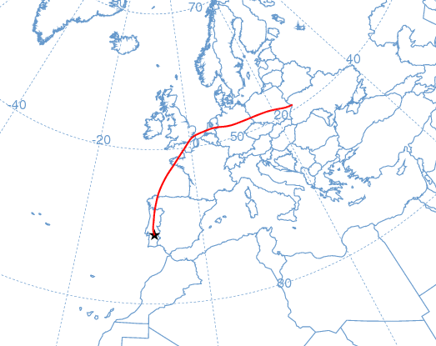
25-27 Apr 2002
σ_{sp}(550) = 63-130 Mm⁻¹.  α=1.4-1.8  b~0.10-0.13 | Trajectories also with European influence related to an increase of the aerosol load with pollution characteristics.  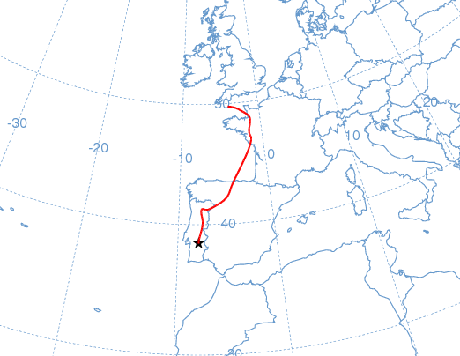
30 May-3 Jun 2002
σ_{sp}(550) = 58-97 Mm⁻¹.  α=1.4-1.6  b~0.11-0.13 | Mainly continental influence (MIB+ IB trajectories). Possible African influence in altitude, but with no dust signal at the surface.  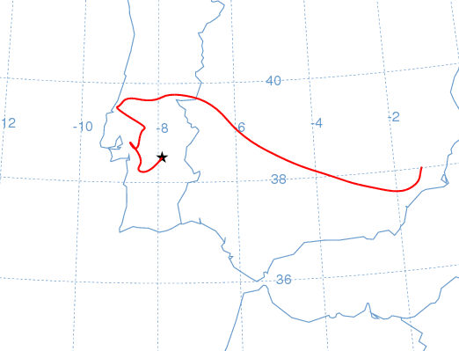
23-30 Jun 2002
σ_{sp}(550) = 63-106 Mm⁻¹.  α=1.3-1.5  b~0.10-0.12 | Trajectories of MIB / IB types of short length led to relatively high aerosol load of pollution or smoke from forest fires.  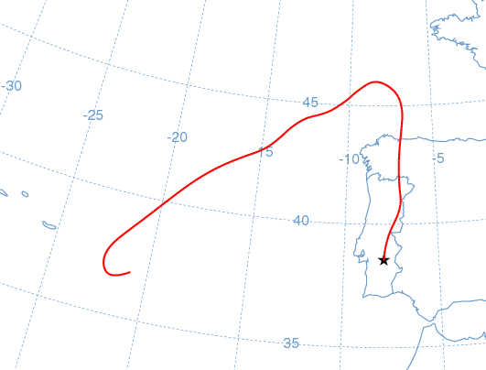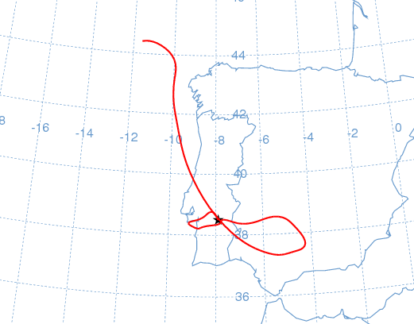
18 Jul-2 Aug 2002
σ_{sp}(550) = 94-229 Mm⁻¹.  α=1.4-1.9  b~0.09-0.16 | Trajectories of MIB and IB types and possible transportation of pollution/smoke from forest fires during this period. African influence in altitude but no dust signal was recorded at the surface.  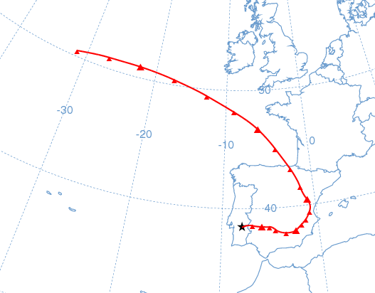
18-26 Mar 2003
σ_{sp}(550) = 54-89 Mm⁻¹.  α=0.7-1.1  b~0.11-0.13 | Trajectories with north African influence and several plumes with dust characteristics observed during this period.  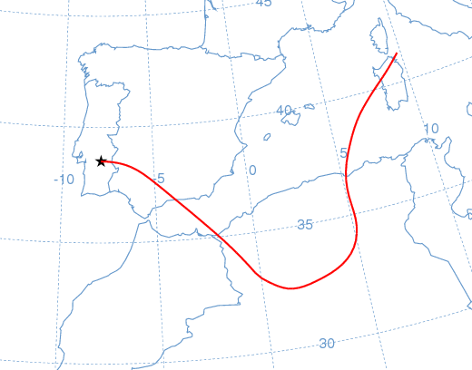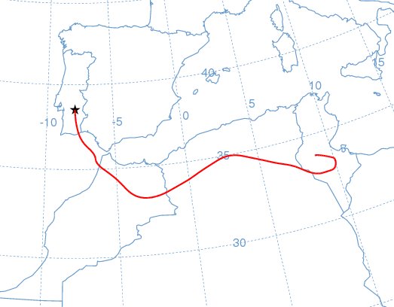
30-31 May 2003
σ_{sp}(550) = 46-60 Mm⁻¹.  Α=0.9-1.1  b~0.11-0.13 | Trajectories of short length as well as from Africa (in altitude). Short term dust plumes observed.  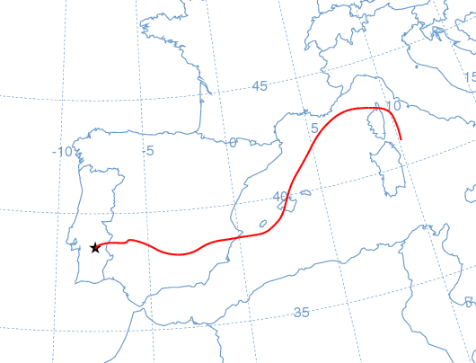
13-24 Jun 2003
σ_{sp}(550) = 53-95 Mm⁻¹.  α=0.6-1.2  b~0.09-0.13 | This period was characterized by Iberian and African influence. Some dust plumes were recorded as well as smoke from forest fires.  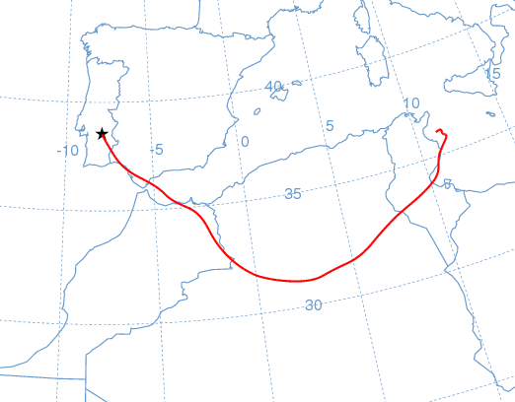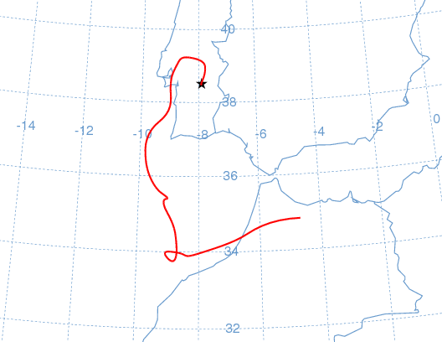
5-13 Jul 2003
σ_{sp}(550) = 63-196 Mm⁻¹. α=1.2-1.5  b~0.09-0.12 | Trajectories mainly with Iberian influence (IB and MIB) led to transportation of smoke from forest fires possibly mixed with pollution.  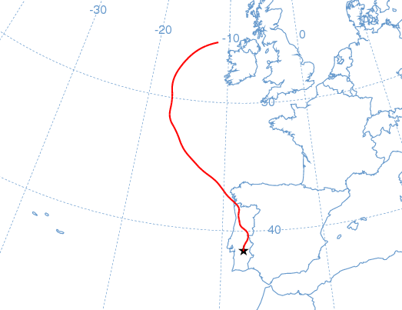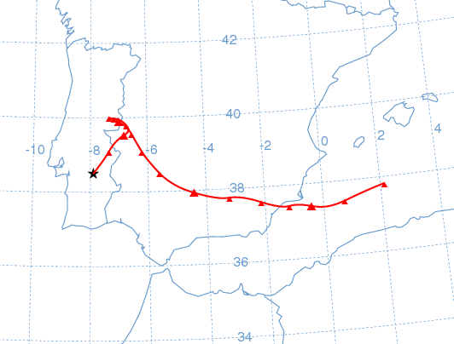
30Jul-14 Aug 2003
σ_{sp}(550) = 78-225 Mm⁻¹.  α=0.9-1.8  b~0.11-0.15 | Smoke from forest fires was transported towards the measurement site, as well as some dust plumes due to African influence in some periods.  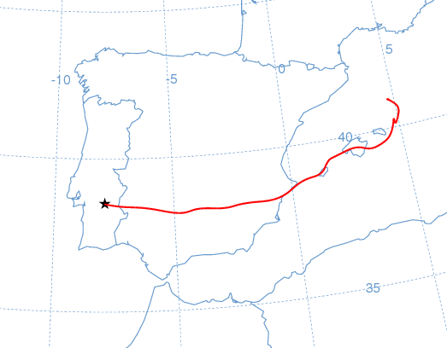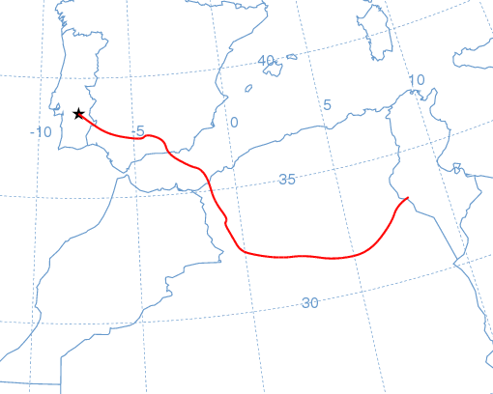
21-24 Aug 2003
σ_{sp}(550) = 88-188 Mm⁻¹.  α=1.1-1.3  b~0.08-0.09 | Observations of smoke from forest fires transported from northern regions in the context of MIB type trajectories.  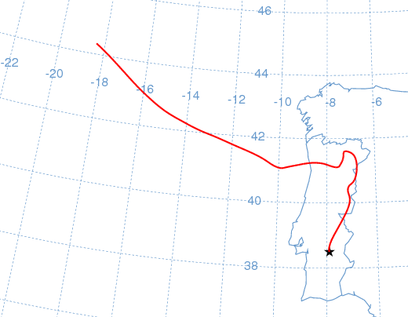
10-15 Oct 2003
σ_{sp}(550) = 45-123 Mm⁻¹.  α=1.5-1.8  b~0.10-0.14 | Periods with high aerosol load, likely pollution. Trajectories of IB and MIB types.  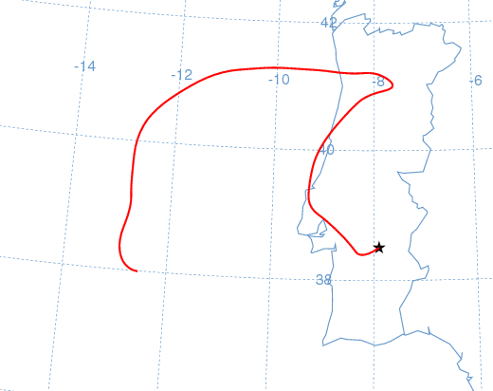
5-7-Nov 2003
σ_{sp}(550) = 68-75 Mm⁻¹.  α=1.0-1.4  b~0.12 | Plumes of desert dust observed during this period characterized by African influenced trajectories.  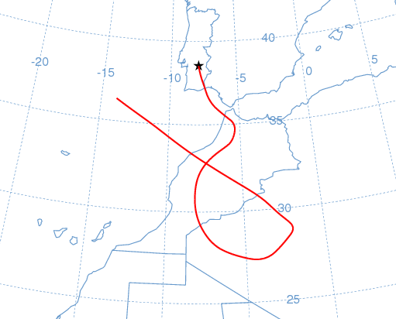
20-21 Nov 2003
σ_{sp}(550) = 77-95 Mm⁻¹.  α=1.1  b~0.12 | African as well as IB influenced trajectories. Observations of desert dust.  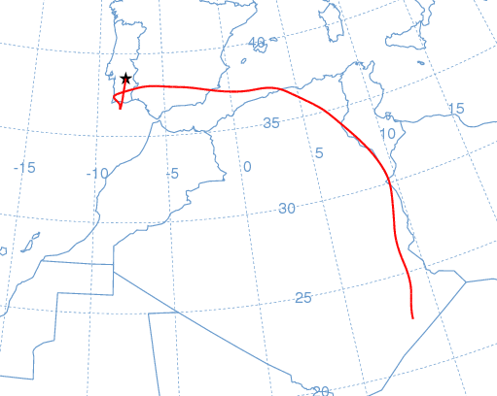
12-17 Dec 2003
σ_{sp}(550) = 59-98 Mm⁻¹.  α=1.5-1.9  b~0.10-0.15 | Trajectories of MIB type and observations of a polluted aerosol.  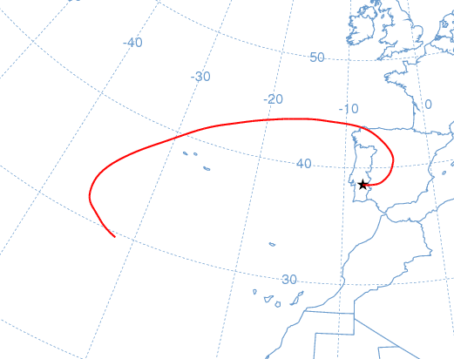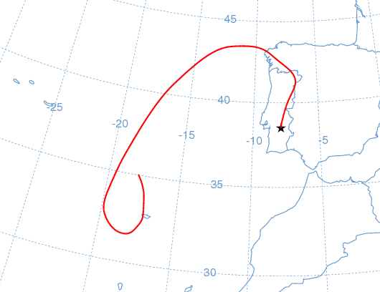
21-23 Jan 2004
σ_{sp}(550) = 118-159 Mm⁻¹.  α=1.7  b~0.12-0.14 | Trajectories of MIB type and high aerosol load with pollution characteristics.  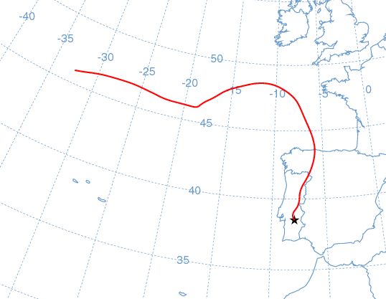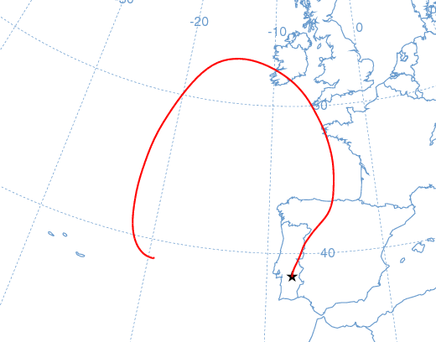
3-20 Feb 2004
σ_{sp}(550) = 68-280 Mm⁻¹.  α=1.3-1.7  b~0.10-0.12 | Long period with consistently high aerosol loads. During this period the trajectories were African influenced and of IB type. Latter influence from Europe. In spite of the African influence, the measurements suggest no clear influence of dust at the surface.  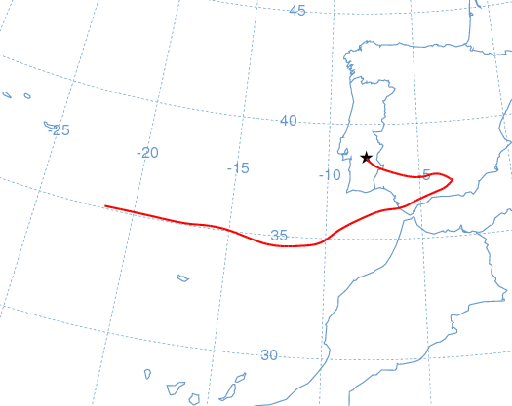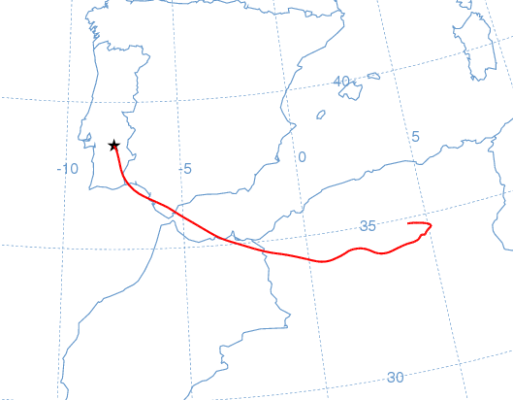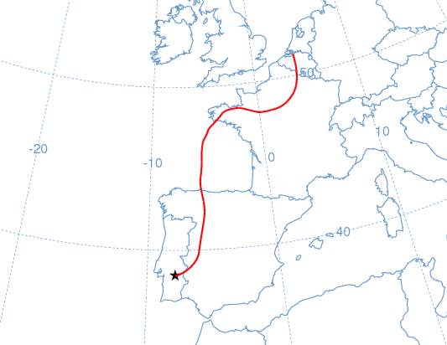
3-18 Mar 2004
σ_{sp}(550) = 31-127 Mm⁻¹.  α=0.7-1.8  b~0.10-0.14 | Period with trajectories influenced from Europe, IB and Africa. Several strong plumes of dust characteristics were observed during this period.  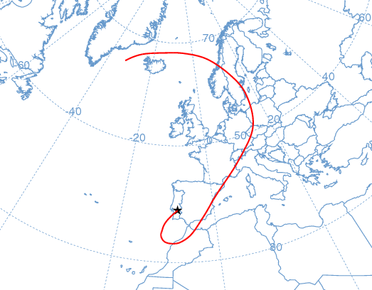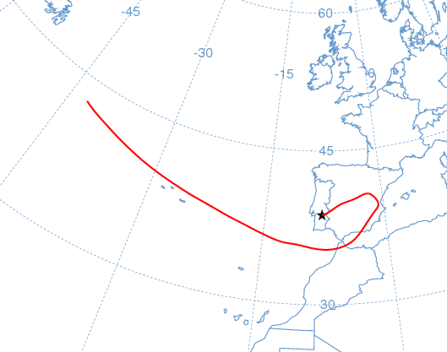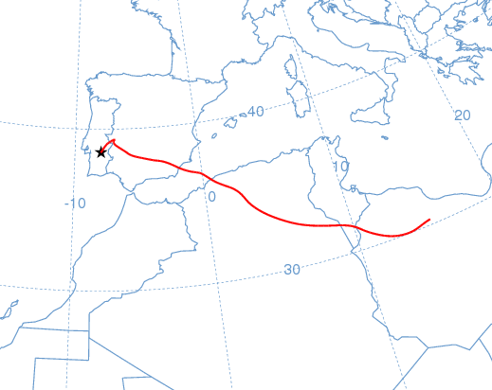
21-26 May 2004
Trajectories of AF and IB types. Some observations of desert dust.
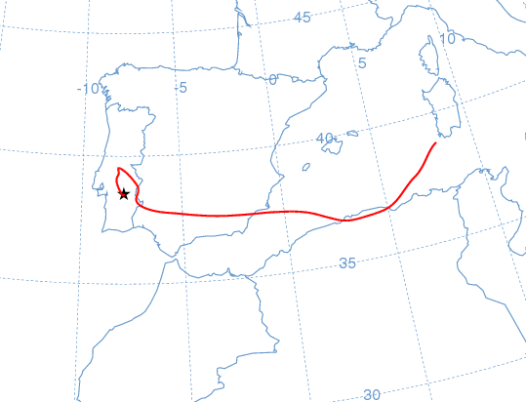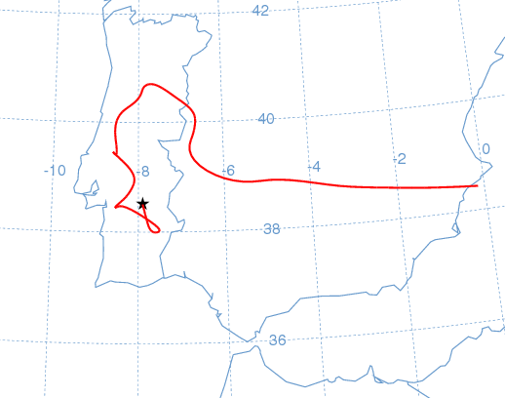
2-13 June 2004
σ_{sp}(550) = 60-136 Mm⁻¹.  α=1.3-1.7  b~0.09-0.12 | Trajectories of short length (IB) and AF influence mainly in altitude. Pollution and some observations of dust.  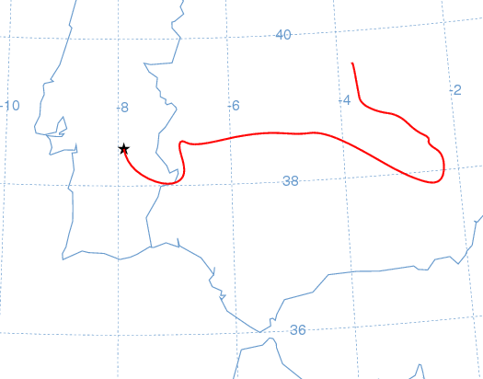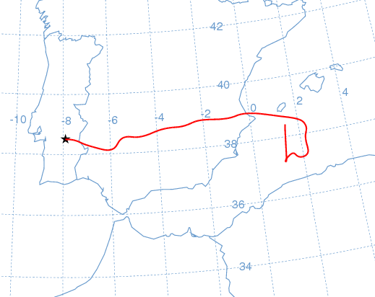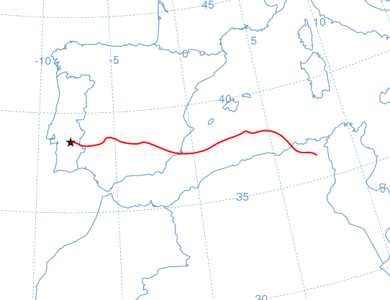
1-8 Oct 2004
σ_{sp}(550) = 63-105 Mm⁻¹.  α=1.7  b~0.10-0.13 | Trajectories with European and African influence during this period. Pollution and some short-term dust observations.  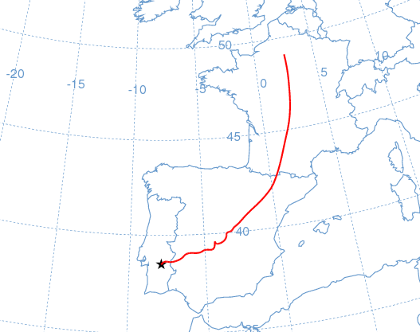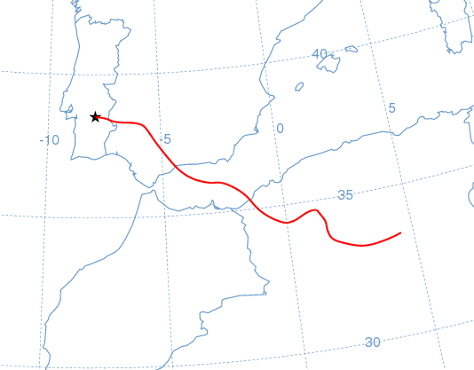
19-30 Nov 2004
σ_{sp}(550) = 66-181 Mm⁻¹.  α=1.5-1.8  b~0.09-0.12 | Trajectories of MIB and IB types and gradual influence from Africa. Pollution type aerosol during this period.  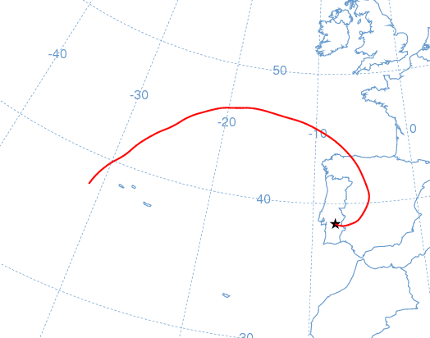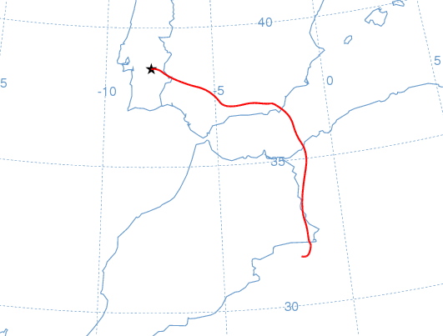
7-11 Dec 2004
σ_{sp}(550) = 79-108 Mm⁻¹.  α=1.9  b~0.12-0.14 | African and European influenced trajectories, but an aerosol of pollution type was observed during this period.  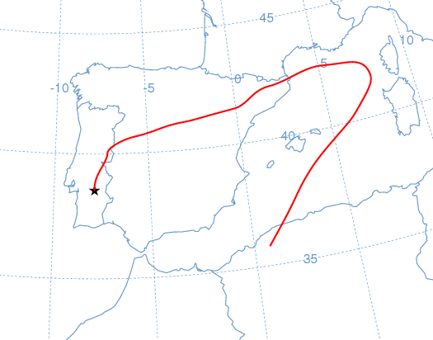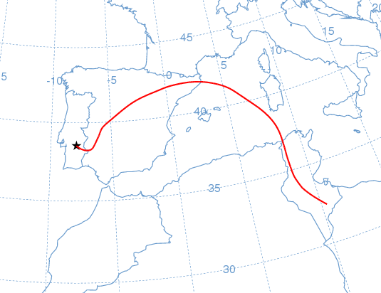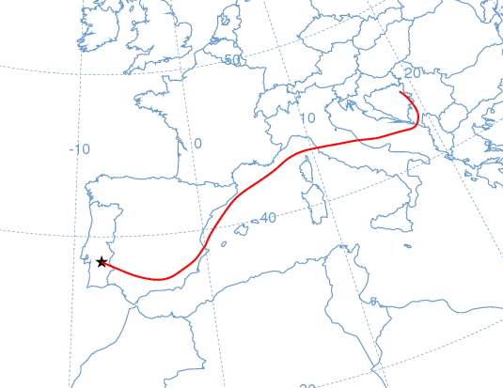
1-17 Jan 2005
σ_{sp}(550) = 67-138 Mm⁻¹.  α=1.9-2.0  b~0.11-0.14 | Long period with high aerosol loads and strong peaks of pollution. During this period the trajectories were of MIB type. Latter they were gradually arriving from Africa but no observations of dust were made.  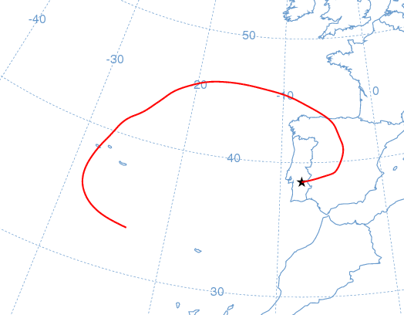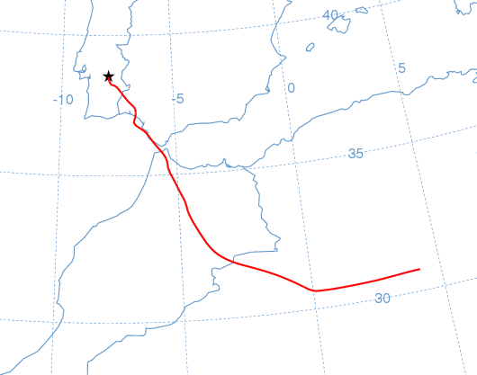
23-24 Jan 2005
σ_{sp}(550) = 112-133 Mm⁻¹.  α=2.0-2.1  b~0.13-0.15 | Trajectories of MIB type and pollution episode.  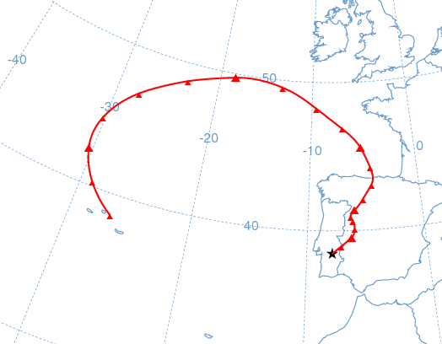
4-5 Feb 2005
σ_{sp}(550) = 87-108 Mm⁻¹.  α=2.0-2.1  b~0.15 | EU trajectories and pollution observations.  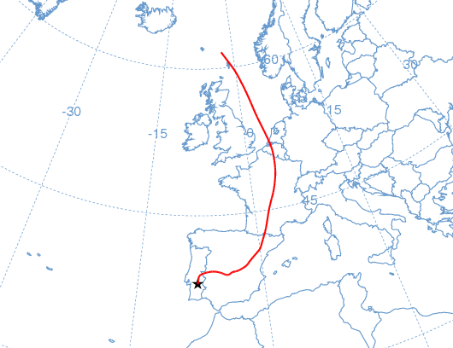
12-13 Feb 2005
σ_{sp}(550) = 91-100 Mm⁻¹.  α=1.8-2.0  b~0.12-0.14 | Trajectories of IB type, with short length. Pollution observations.  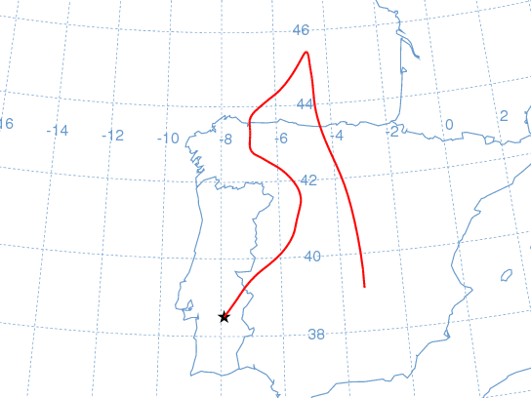
15-21 Mar 2005
σ_{sp}(550) = 63-143 Mm⁻¹.  α=0.5-1.3  b~0.10-0.12 | Mainly trajectories with African origin. Observations of dust aerosols during this period.  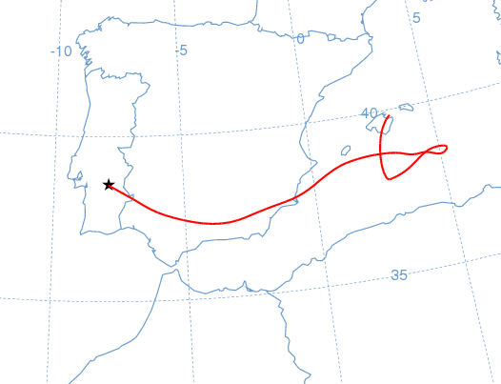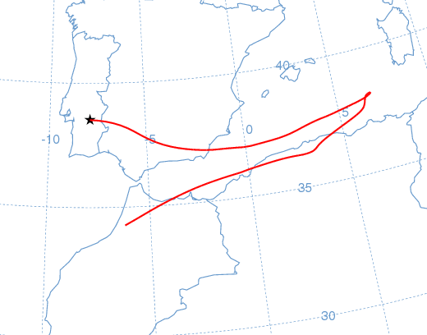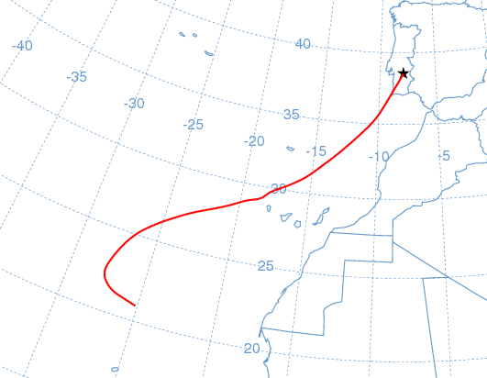
17-24 June 2005
σ_{sp}(550) = 55-109 Mm⁻¹.  α=1.5-1.8  b~0.09-0.14 | Trajectories of short length and observation of pollution/smoke aerosols.  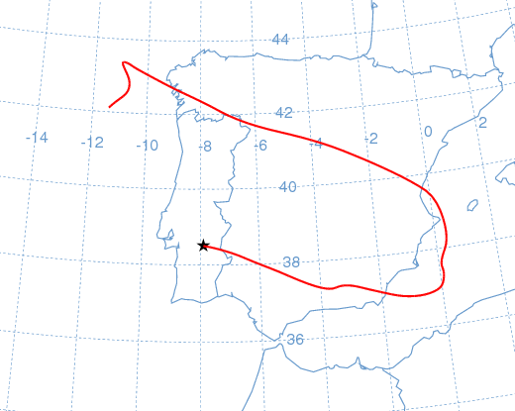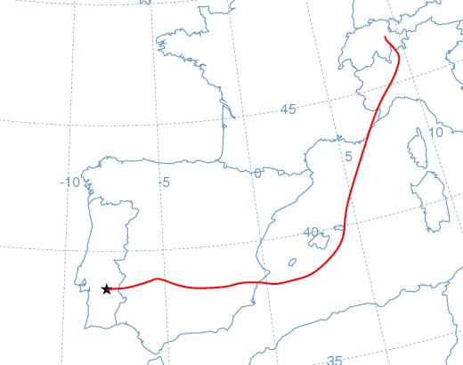
21-23 Jul 2005
σ_{sp}(550) = 56-91 Mm⁻¹.  α=1.6-1.7  b~0.10-0.14 | Trajectories of MIB type and African influence in altitude. Observation of pollution/smoke aerosols.  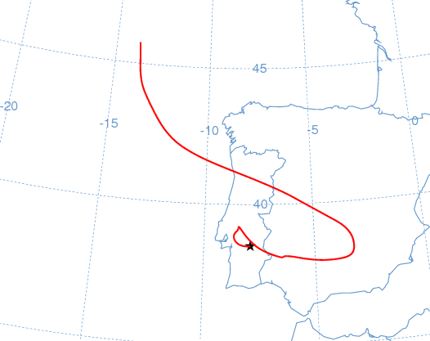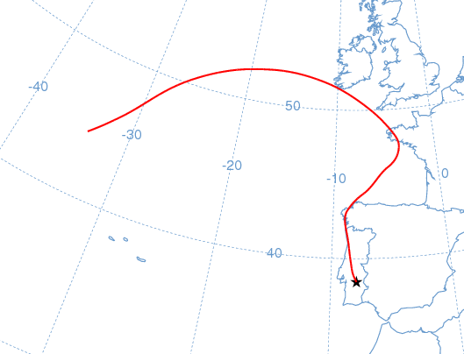
5-6 Aug 2005
σ_{sp}(550) = 56-129 Mm⁻¹.  α=1.6-1.7  b~0.12-0.15 | Trajectories with European influence and African influence in altitude. Observation of pollution/smoke aerosols.  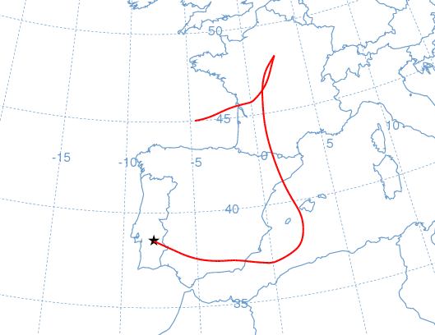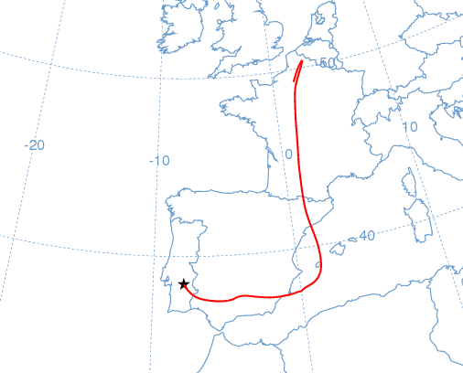
11-24 Aug 2005
σ_{sp}(550) = 46-782 Mm⁻¹.  α=1.7-1.9  b~0.10-0.15 | Trajectories of MIB, IB and EU types. Observations of strong smoke plumes during this period. Highest aerosol loads observed until now.  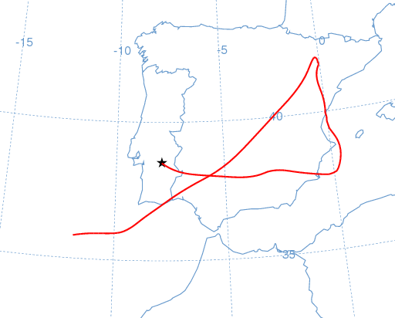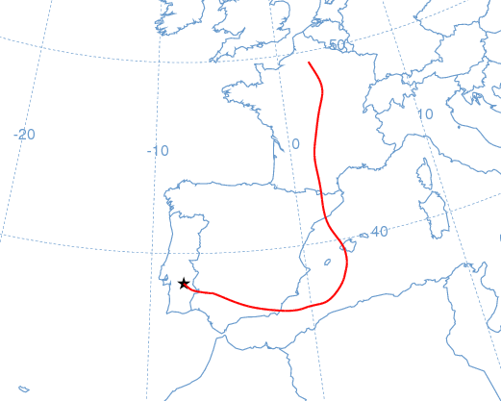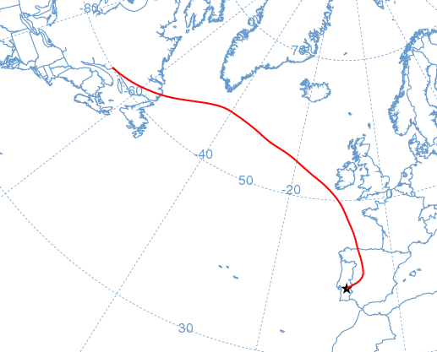
21-24 Jan 2006
σ_{sp}(550) = 93-137 Mm⁻¹.  α=1.7-1.8  b~0.10-0.11  M = 19-29 µgm⁻³ | Trajectories with European influence during this period and observations of pollution aerosols.  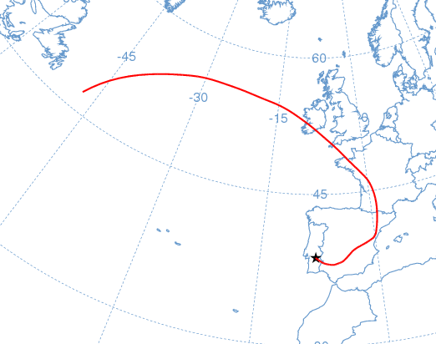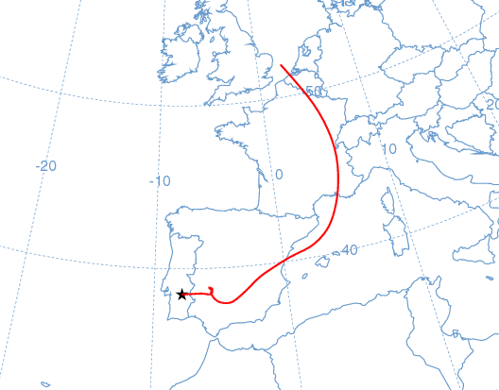
30 Jan-2 Feb 2006
σ_{sp}(550) = 66-117 Mm⁻¹.  α=1.9-2.0  b~0.11-0.15  M = 20-40 µgm⁻³ | Trajectories with European influence and later African influence. Aerosol of pollution type.  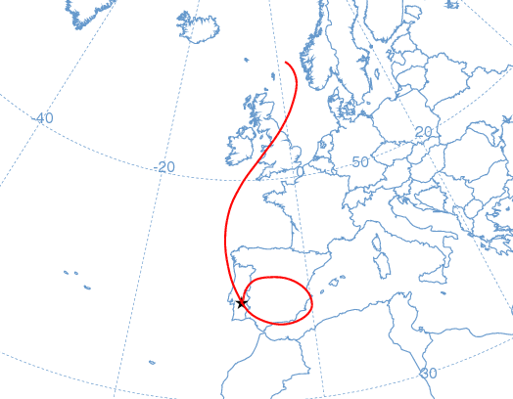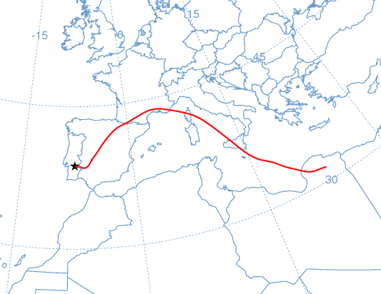
4-14 Feb 2006
σ_{sp}(550) = 77-129 Mm⁻¹.  α=1.2-1.8  b~0.11-0.14  M = 24-52 µgm⁻³ | Trajectories mainly with European influence. Also some African influence likely responsible for the observations of a short-term dust plume.  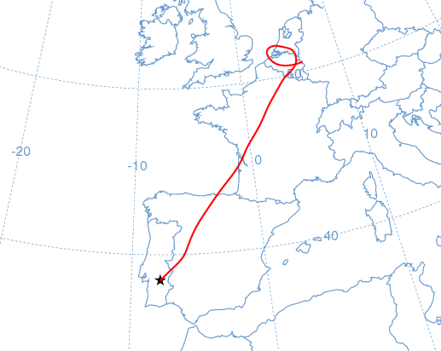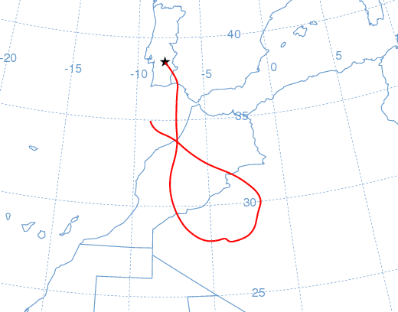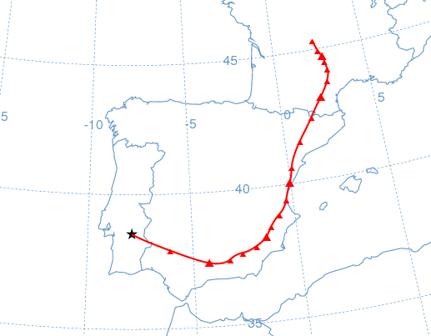
25-27 Apr 2006
σ_{sp}(550) = 70-98 Mm⁻¹.  α=1.2-1.3  b~0.11-0.12  M = 35-55 µgm⁻³ | Trajectories of IB type and African influence. Observations of a dust plume.  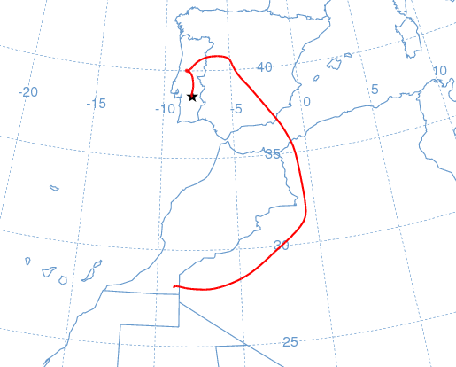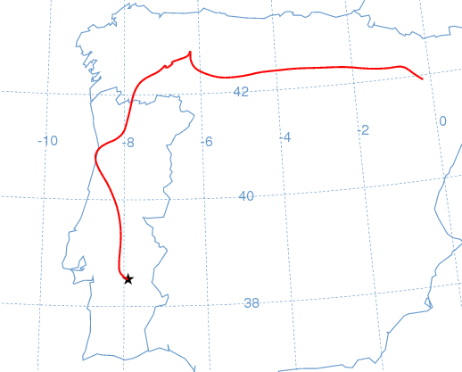
27 May-2 Jun 2006
σ_{sp}(550) = 56-105 Mm⁻¹.  α=0.2-1.3  b~0.10-0.14  M = 30-96 µgm⁻³ | Mainly African trajectories and circulation paths over the Iberian Peninsula. Observations of dust and polluted aerosols.  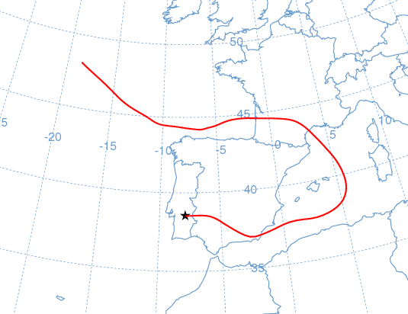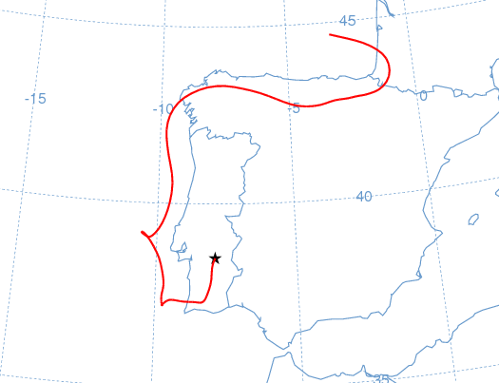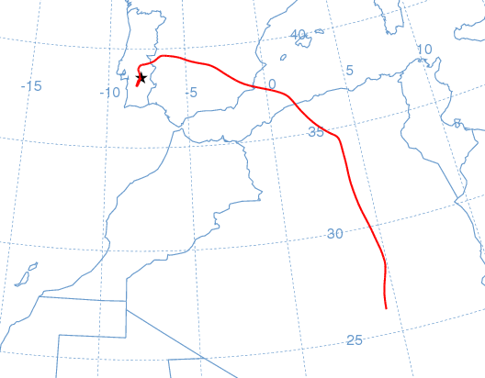
17-23 Jun 2006
σ_{sp}(550) = 44-123 Mm⁻¹.  α=1.4-1.5  b~0.09-0.13  M = 24-40 µgm⁻³ | Circulation paths over the Iberian Peninsula and trajectories of MIB type.  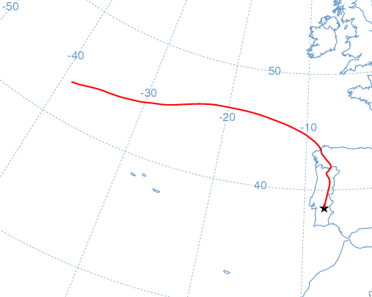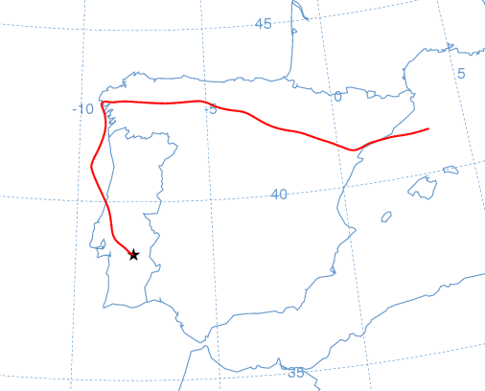
29 Jun-1 Jul 2006
σ_{sp}(550) = 62-133 Mm⁻¹.  α=1.5-1.7  b~0.10-0.12  M = 27-46 µgm⁻³ | Trajectories of MIB type.  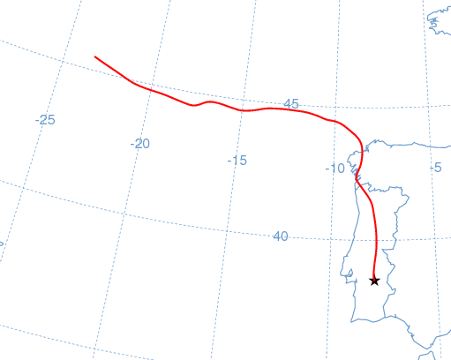
7-20 Jul 2006
σ_{sp}(550) = 53-103 Mm⁻¹.  α=0.7-1.6  b~0.10-0.14  M = 26-55 µgm⁻³ | Influence of the different regions during this period. African trajectories, circulations over the IB and European trajectories. Some dust plumes were observed during this period.  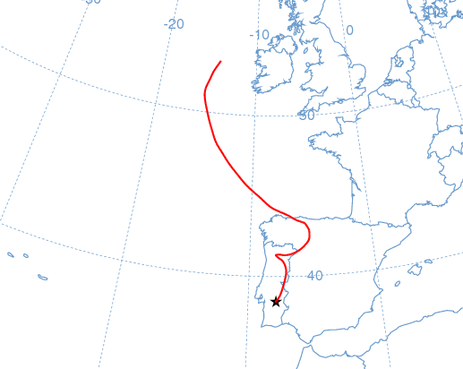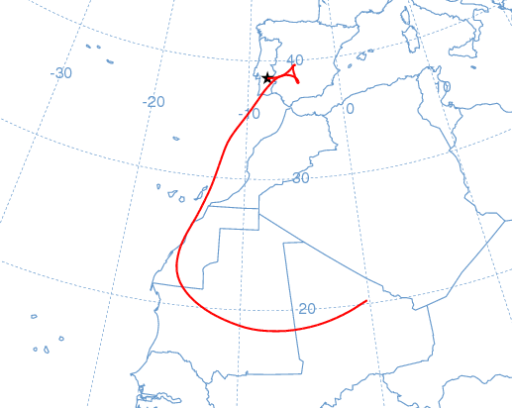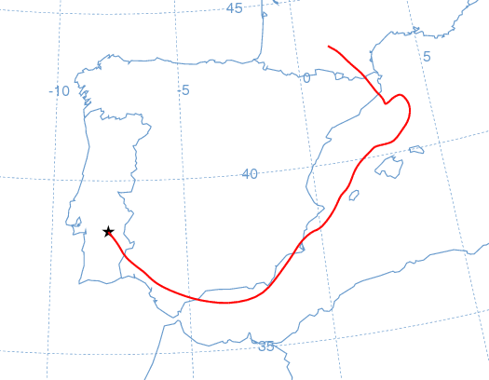
4-15 Aug 2006
σ_{sp}(550) = 50-182 Mm⁻¹.  α=1.4-1.7  b~0.13-0.17  M = 28-83 µgm⁻³ | Trajectories mainly of MIB type. Transport of smoke from forest fires towards the measurements site.  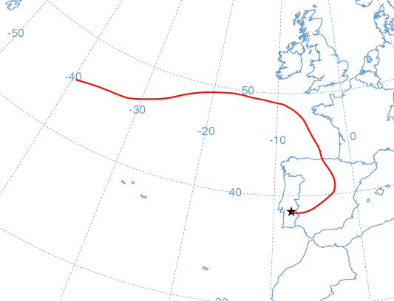
22-23 Aug 2006
M = 35-36 µgm⁻³ | Trajectories of MIB type with short length. Transport of smoke from forest fires towards the measurements site.  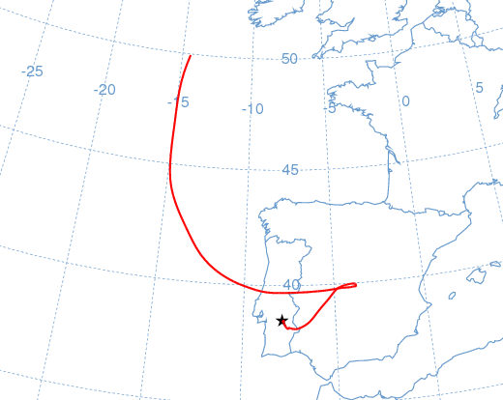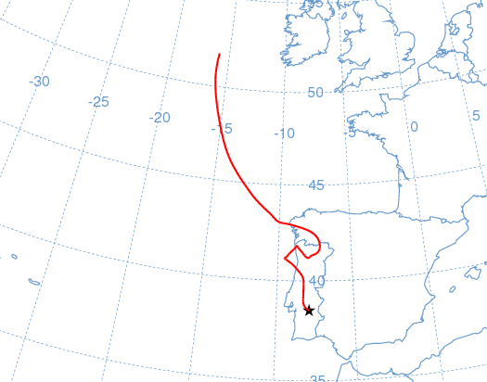
4-9 Sep 2006
M = 39-59 µgm⁻³ | Mainly trajectories of MIB and IB types. Possible influence from Africa in altitude.  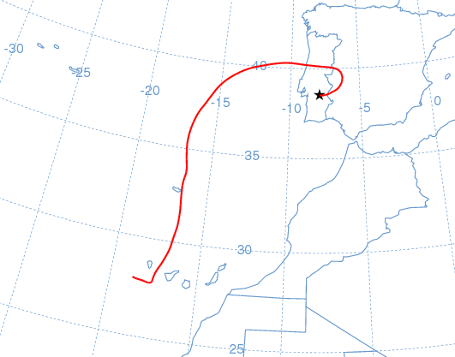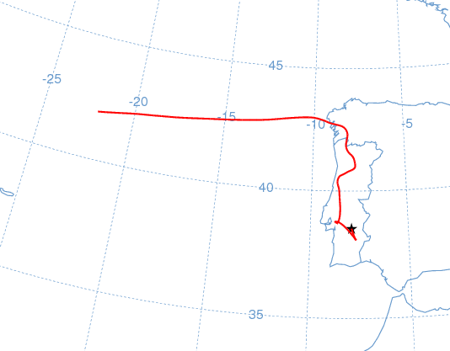
9-10 Oct 2006
M = 36-37 µgm⁻³ | Trajectories of MIB type and possible African influence in the aerosol load.  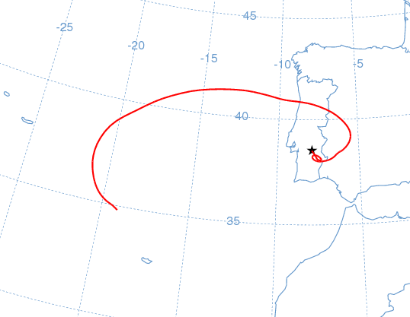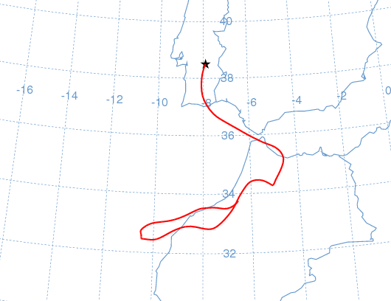
24 Nov 2006
σ_{sp}(550) = 52 Mm⁻¹.  α=0.4  b~0.10  M = 53 µgm⁻³ | African influence and observations of a strong dust plume during this day.  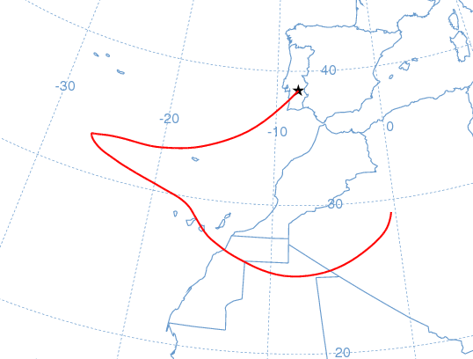
20-21 Jan 2007
σ_{sp}(550) = 74-199 Mm⁻¹.  α=1.4-2.0  b~0.09-0.13  M = 27-43 µgm⁻³ | Trajectories of MIB type. Observations of an aerosol of pollution type. African influence in altitude, but without influence at the surface.  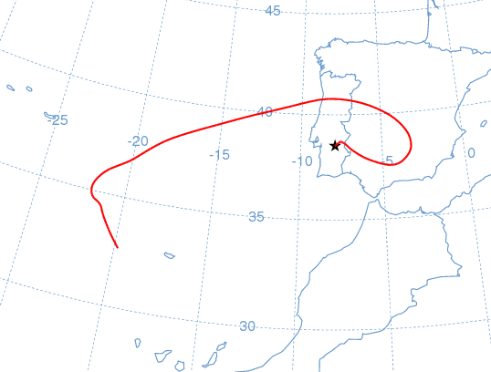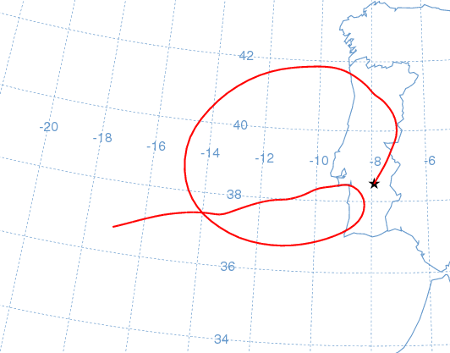
1-6 Feb 2007
σ_{sp}(550) = 67-93 Mm⁻¹.  α=1.9-2.1  b~0.11-0.16  M = 16-26 µgm⁻³ | Low advective conditions with trajectory re circulations over the IB leading to an increase in the pollution levels.  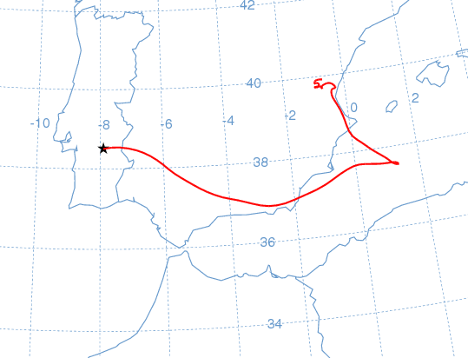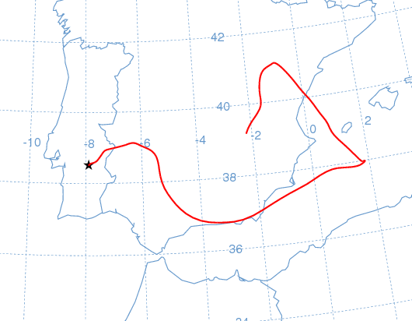
13-15 Apr 2007
σ_{sp}(550) = 79-92 Mm⁻¹.  α=1.8-2.0  b~0.11-0.12  M = 31-34 µgm⁻³ | Low advective conditions with trajectories influenced from European sector. Observations of some pollution peaks.  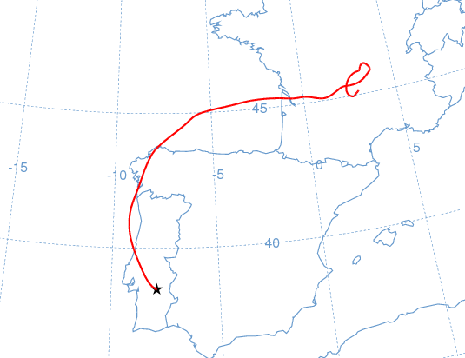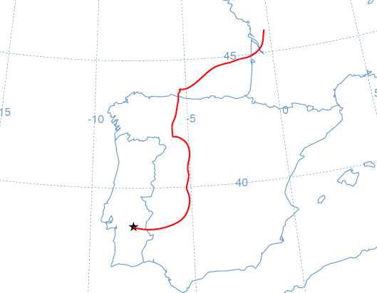
23-24 Apr 2007
σ_{sp}(550) = 59-89 Mm⁻¹.  α=1.2-1.5  b~0.13  M = 53-65 µgm⁻³ | European influenced trajectories of short length and possible African influence in altitude. Short-term dust plume observed.  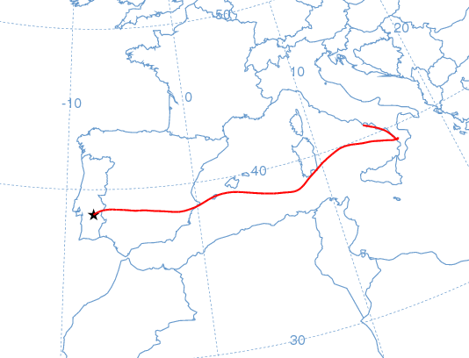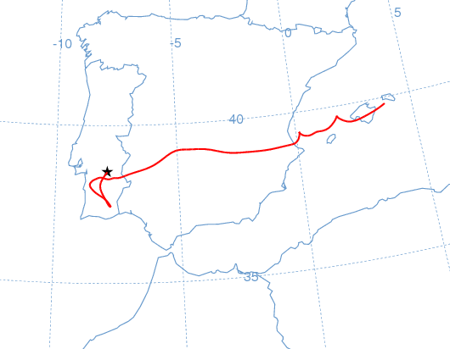
3-8 June 2007
σ_{sp}(550) = 57-88 Mm⁻¹.  α=1.6-1.9  b~0.10-0.14  M = --  σ_{ap}(670) = 5-11 Mm⁻¹.  BC = 0.8-1.7 µgm⁻³ | Trajectories of MIB type and gradual influence from European sector.  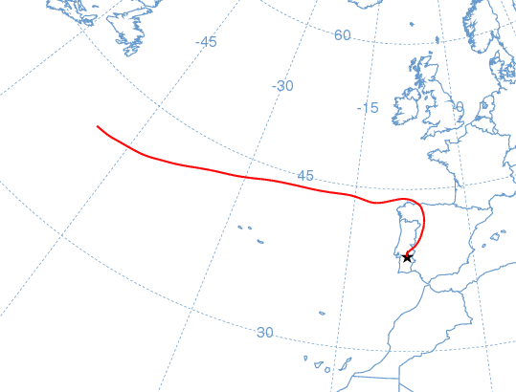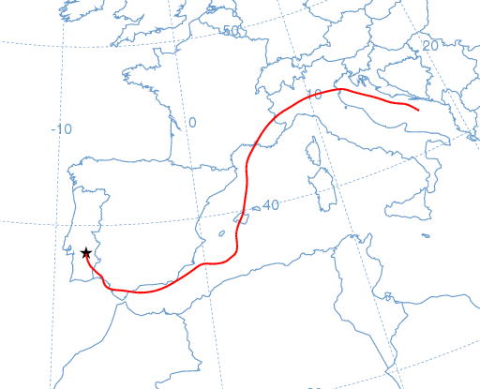
29-31 July 2007
σ_{sp}(550) = 50-81 Mm⁻¹.  α=1.1-1.6  b~0.09-0.15  M = 39-51 µgm⁻³  σ_{ap}(670) = 6-13 Mm⁻¹.  BC = 1-2 µgm⁻³ | Trajectories of MIB type and African influence in altitude. Short-term dust plume observed.  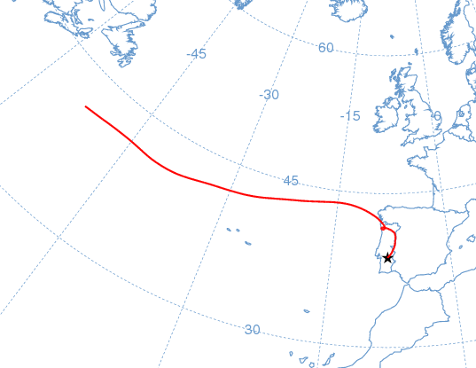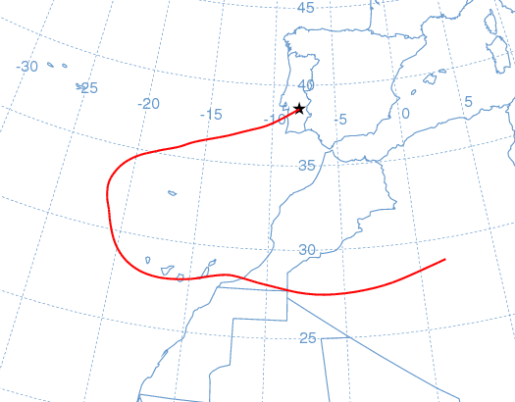
3-13 Aug 2007
σ_{sp}(550) = 54-101 Mm⁻¹.  α=1.0-1.9  b~0.10-0.16  M = 27-60 µgm⁻³  σ_{ap}(670) = 4-11 Mm⁻¹.  BC = 0.7-1.7 µgm⁻³ | Trajectories of short length around Iberian Peninsula and later trajectories of MIB type. Also some African influence.  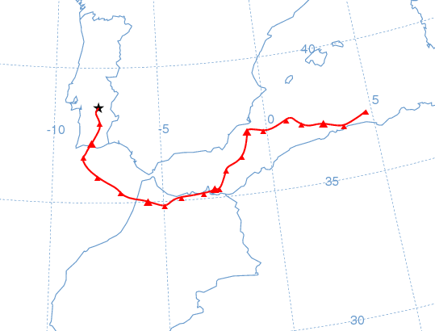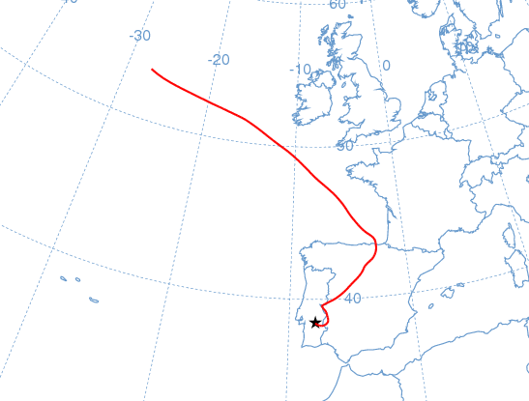
26-30 Aug 2007
σ_{sp}(550) = 50-73 Mm⁻¹.  α=1.3-1.8  b~0.12-0.14  M = 25-54 µgm⁻³  σ_{ap}(670) = 6-11 Mm⁻¹.  BC = 1-1.7 µgm⁻³ | Iberian re circulations and African influence visible in short-term dust plumes observed.  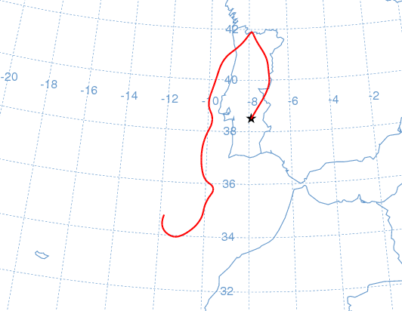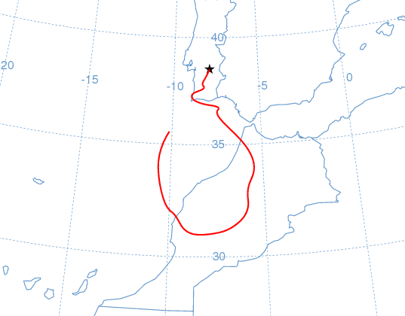
1-21 Sep 2007
σ_{sp}(550) = 50-129 Mm⁻¹.  α=1.4-1.9  b~0.10-0.14  M = 28-56 µgm⁻³  σ_{ap}(670) = 8-15 Mm⁻¹.  BC = 1.3-2.4 µgm⁻³ | Variety of trajectory types changing with European influence and also short trajectories within the IB. African influence in altitude, but no evidence of dust at the ground surface. Possibility of smoke from forest fires. In this period some forest fires were occurring after an insignificant forest fires season.  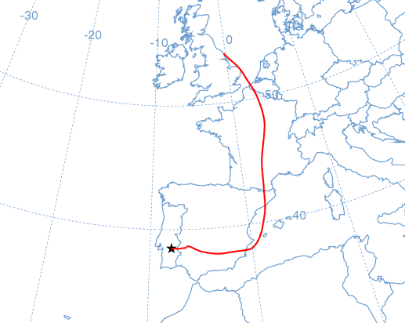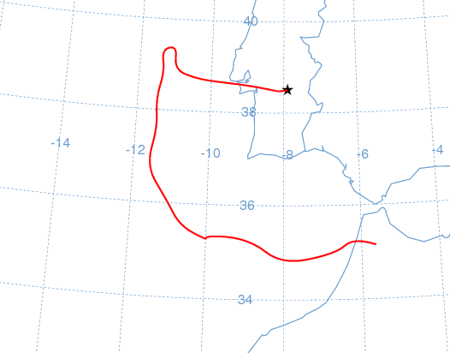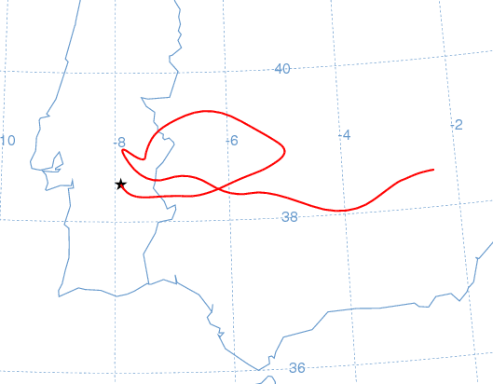
8-14 Nov 2007
σ_{sp}(550) = 50-136 Mm⁻¹.  α=1.8-2.0  b~0.14-0.15  M = 29-58 µgm⁻³  σ_{ap}(670) = 10-23 Mm⁻¹.  BC = 1.5-3.4 µgm⁻³ | Trajectories of MIB type and European influenced also.  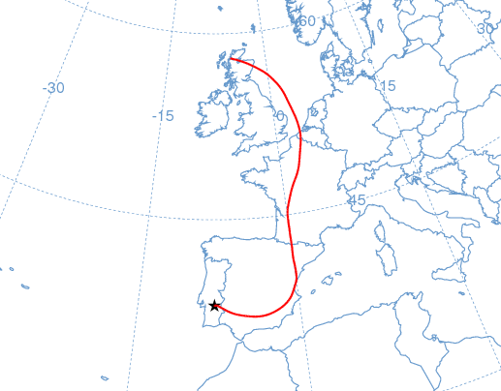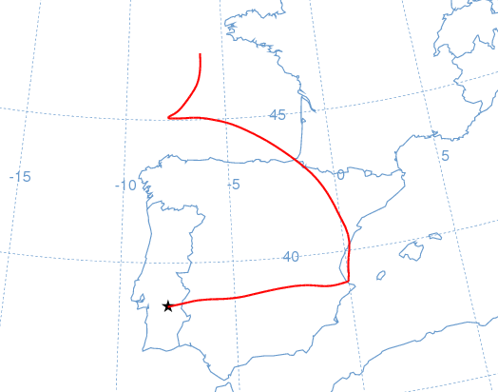
29 Nov-7 Dec 2007
σ_{sp}(550) = 50-122 Mm⁻¹.  α=1.4-2.1  b~0.11-0.14  M = 21-29 µgm⁻³  σ_{ap}(670) = 11-29 Mm⁻¹.  BC = 1.7- 4.4 µgm⁻³ | Trajectories of MIB type.  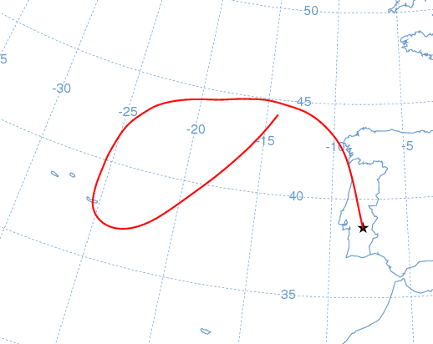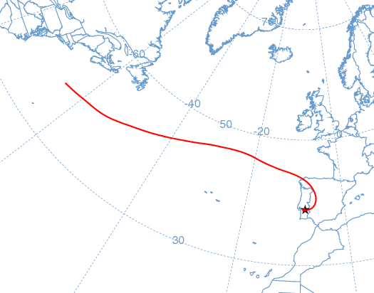
21-22 Dec 2007
σ_{sp}(550) = 68-119 Mm⁻¹.  α=0.5-0.9  b~0.13-0.14  M = 70-136 µgm⁻³  σ_{ap}(670) = 11-14 Mm⁻¹.  BC = 1.6-2.2 µgm⁻³ | Trajectories with African influence leading to a dust outbreak with a strong dust signal.  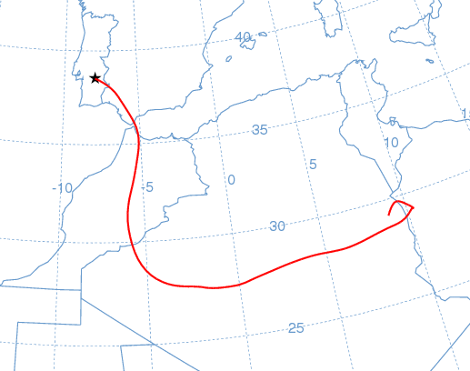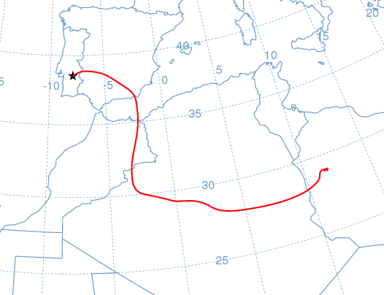
15-23 Jul 2008
σ_{sp}(550) = 39-100 Mm⁻¹.  α=0.7-1.7  b~0.10-0.17  M = --  σ_{ap}(670) = 6-11 Mm⁻¹.  BC = 0.9-1.7 µgm⁻³ | Variety of trajectories with different origins; African, European and re circulations within the IB. Several plumes with dust characteristics were detected during this period.  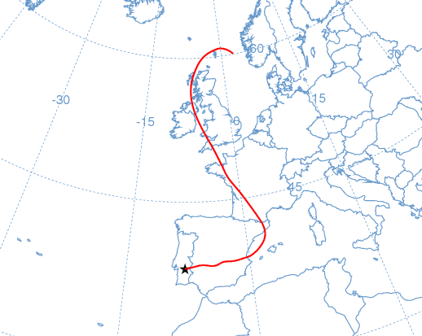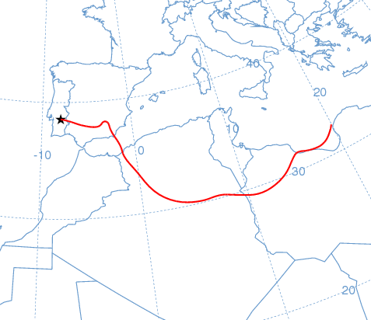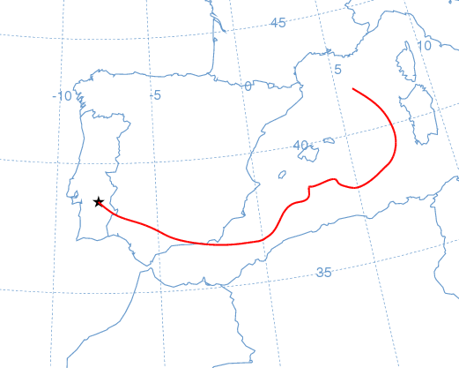
26-31 Aug 2008
σ_{sp}(550) = 45-57 Mm⁻¹.  α=1.1-1.4  b~0.10-0.12  M = --  σ_{ap}(670) = 5-9 Mm⁻¹.  BC = 0.7-1.4 µgm⁻³ | Trajectories of short length within the IB, related to low advective conditions and African influence. Some dust plumes were detected.  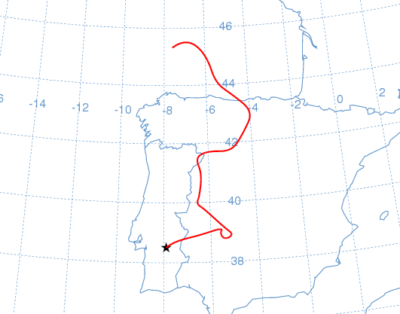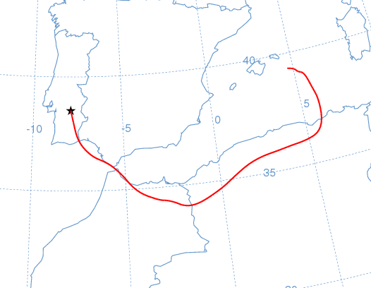
11-12 Oct 2008
σ_{sp}(550) = 61-74 Mm⁻¹.  α=0.4-0.6  b~0.11  M = --  σ_{ap}(670) = 6-7 Mm⁻¹.  BC ~ 1 µgm⁻³ | Trajectories of short length and African influence. Some dust plumes were detected.  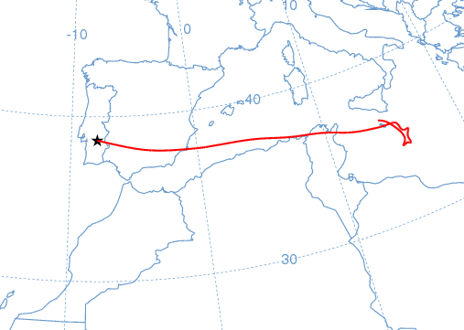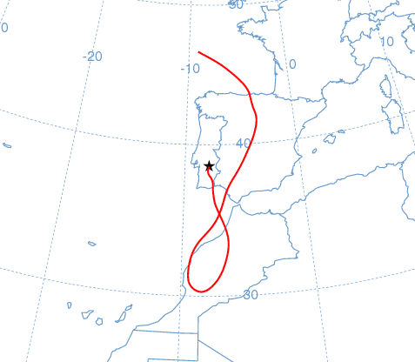
23-27 Dec 2008
σ_{sp}(550) = 67-108 Mm⁻¹.  α=1.8-2.0  b~0.12-0.15  M = 18-39 µgm⁻³  σ_{ap}(670) = --  BC = -- | African influence but no clear signal of desert dust near the ground surface.  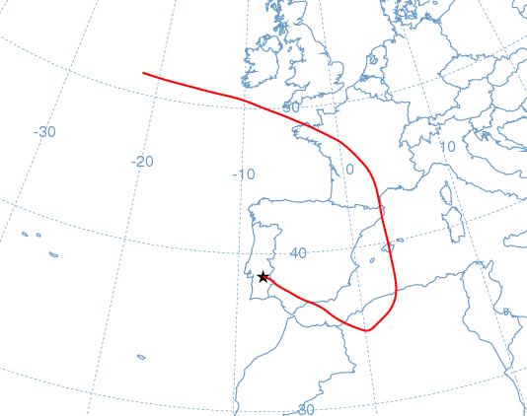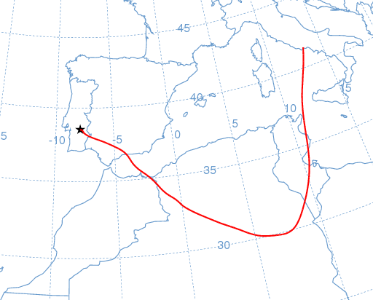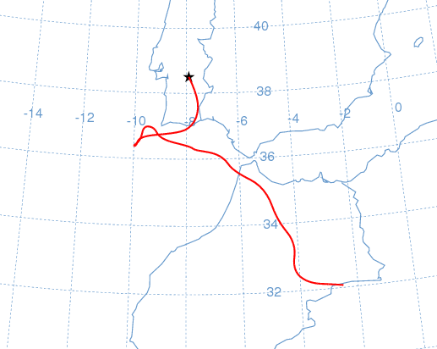
9-11 Jan 2009
σ_{sp}(550) = 62-79 Mm⁻¹.  α=1.8-1.9  b~0.13-0.16  M = 14-27 µgm⁻³  σ_{ap}(670) = 10-24 Mm⁻¹  BC ~ 1.5-3.7 µgm⁻³ | Trajectories with European influence.  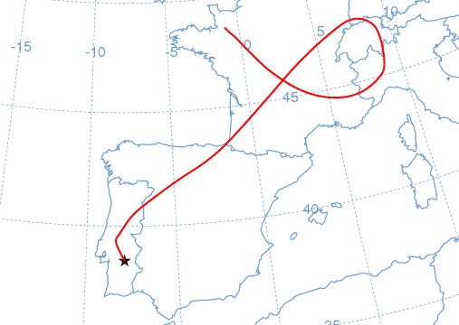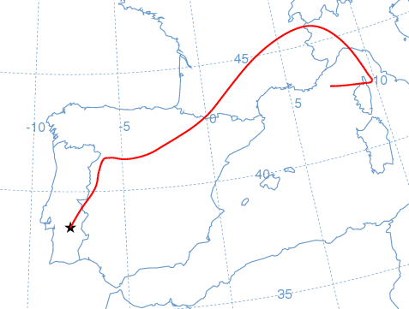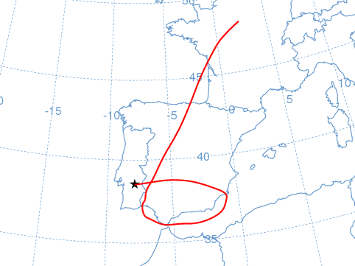
16 Feb-1 Mar 2009
σ_{sp}(550) = 43-107 Mm⁻¹.  α=0.8-1.3  b~0.10-0.14  M = 20-33 µgm⁻³  σ_{ap}(670) = 9-22 Mm⁻¹  BC ~ 1.3-3.3 µgm⁻³ | Trajectories with European influence as well as African influence.  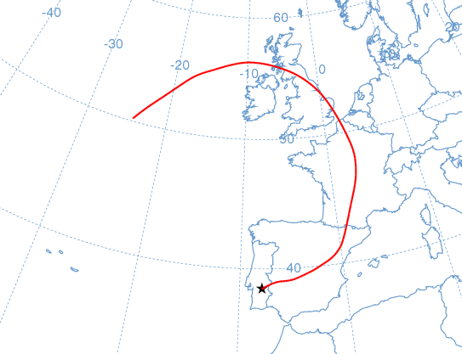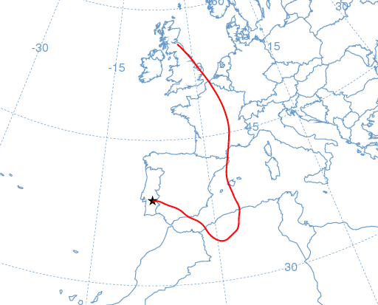
15-27 Mar 2009
σ_{sp}(550) = 40-111 Mm⁻¹.  α=0.1-1.0  b~0.12-0.15  M = 25-50 µgm⁻³  σ_{ap}(670) = 7-18 Mm⁻¹  BC ~ 1.0-2.7 µgm⁻³ | Trajectories with European influence as well as African influence.  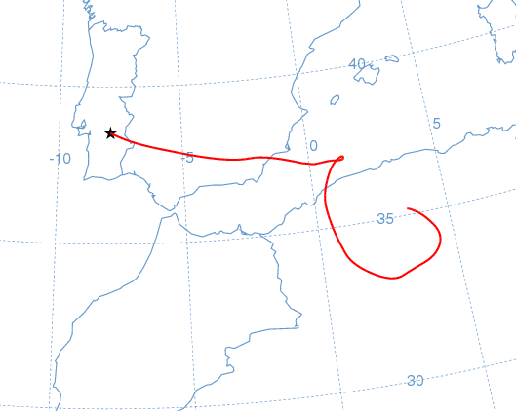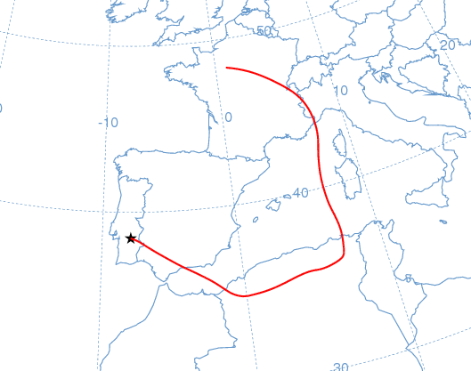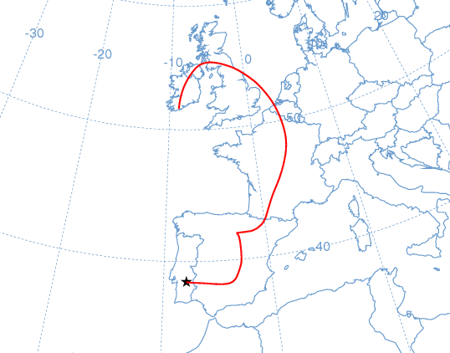
19-21 May 2009
σ_{sp}(550) = --  α=--  b~--  M = 32-46 µgm⁻³  σ_{ap}(670) = 3.3-9.4 Mm⁻¹  BC ~ 0.5-1.4 µgm⁻³ | Trajectories of MIB type.  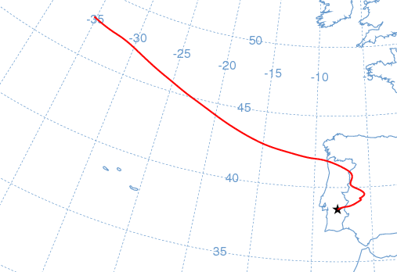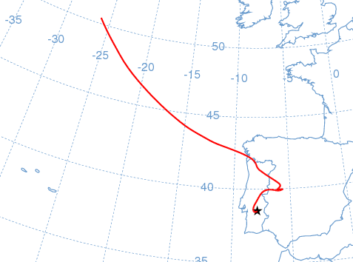
20-21 Jul 2009
σ_{sp}(550) = 32-37 Mm⁻¹.  α=0.8-1.0  b~0.14-0.15  M = 37-40 µgm⁻³  σ_{ap}(670) = 9-11 Mm⁻¹  BC ~ 1.4-1.7 µgm⁻³ | Trajectories of MIB type and African influence in altitude.  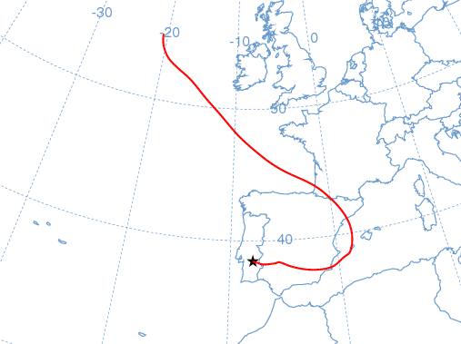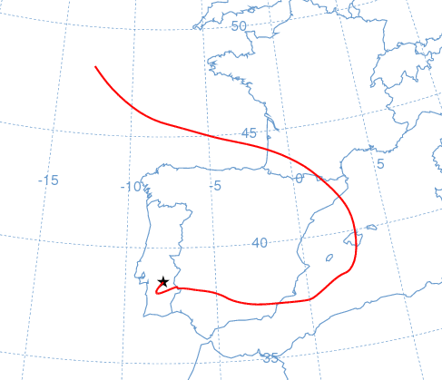
11-18 Aug 2009
σ_{sp}(550) = 31-63 Mm⁻¹.  α=1-1.4  b~0.11-0.16  M = 31-41 µgm⁻³  σ_{ap}(670) = 6-10 Mm⁻¹  BC ~ 0.9-1.6 µgm⁻³ | Trajectories with European influence as well as African influence.  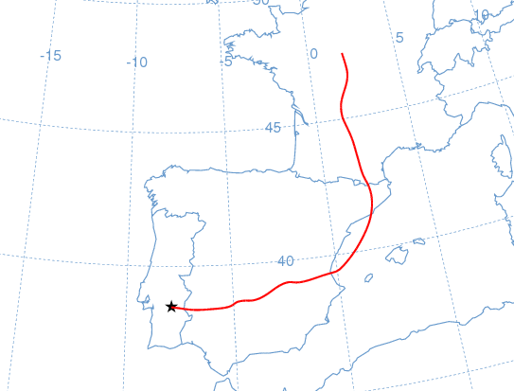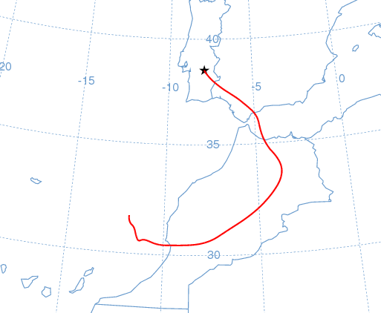
29-31 Aug 2009
σ_{sp}(550) = 39-62 Mm⁻¹.  α=0.8-1.2  b~0.12-0.15  M = 35-46 µgm⁻³  σ_{ap}(670) = 9-11 Mm⁻¹  BC ~ 1.4-1.7 µgm⁻³ | Low advective conditions. Possible African influence.  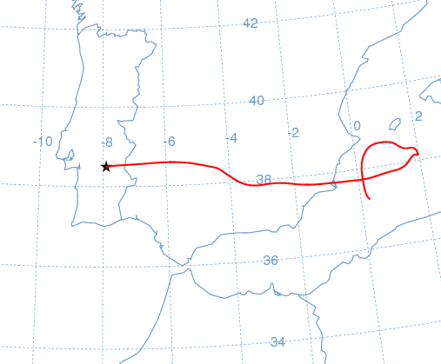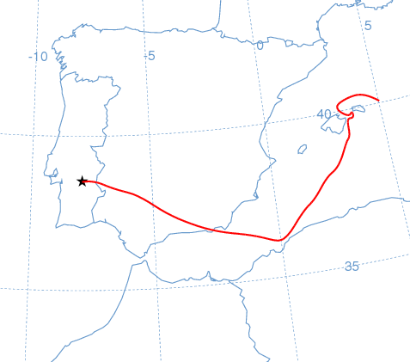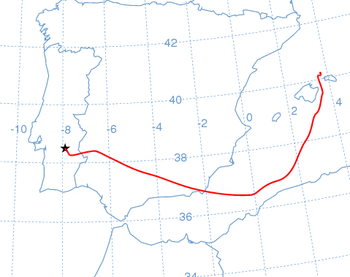
7-15 Sep 2009
σ_{sp}(550) = 42-94 Mm⁻¹.  α=0.8-1.3  b~0.10-0.14  M = --  σ_{ap}(670) = 9-14 Mm⁻¹  BC ~ 1.5-2.2 µgm⁻³ | Trajectories with European influence as well as African influence.  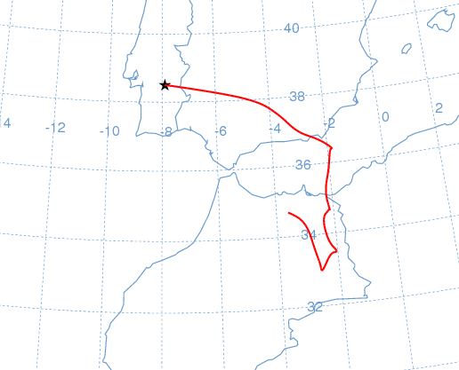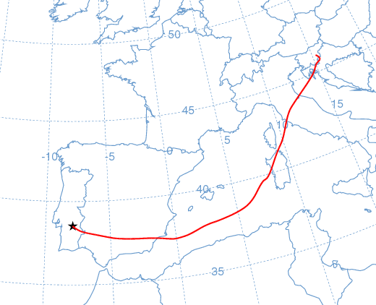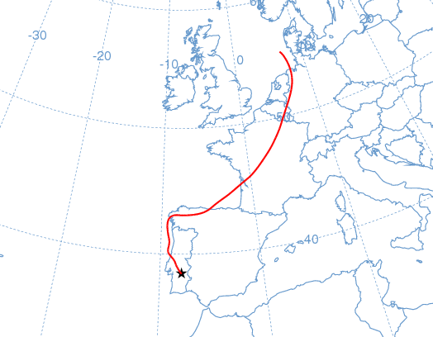
26 Sep-2 Oct 2009
σ_{sp}(550) = 37-78 Mm⁻¹.  α=1.1-1.4  b~0.10-0.13  M = 25-36 µgm⁻³  σ_{ap}(670) = 6-16 Mm⁻¹  BC ~ 0.9-2.4 µgm-3 | Trajectories with European influence as well as African influence.  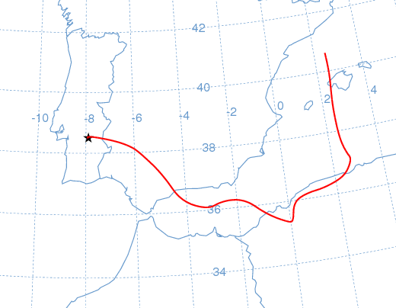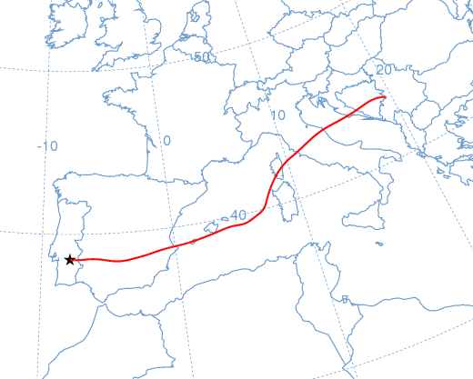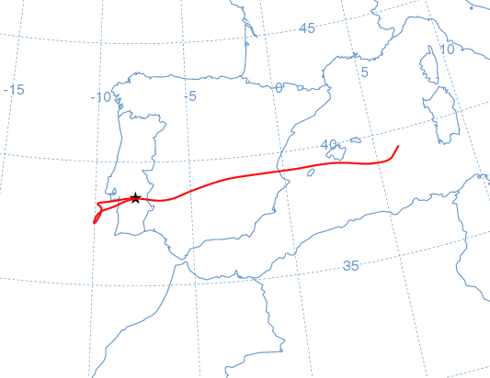
28-30 Oct 2009
σ_{sp}(550) = 37-65 Mm⁻¹.  α=1.2-1.3  b~0.12-0.15  M = 27-36 µgm⁻³  σ_{ap}(670) = 13-14 Mm⁻¹  BC ~ 2 µgm⁻³ | Trajectories with African influence and re circulation over the Iberian Peninsula.  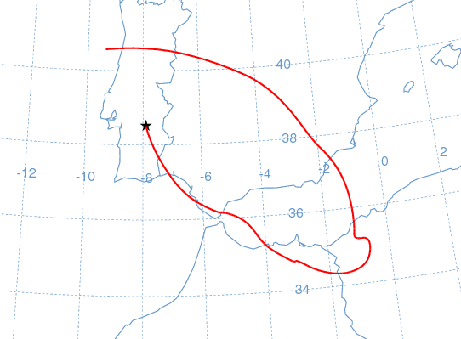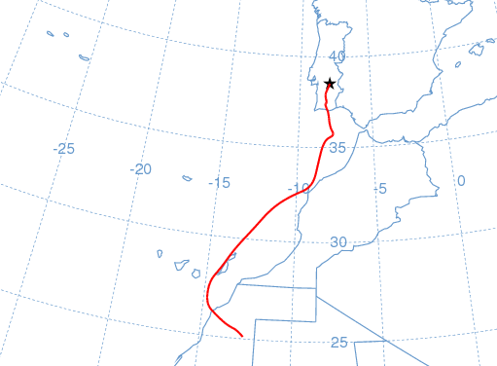
10-13 Dec 2009
σ_{sp}(550) = 56-78 Mm⁻¹.  α=1.3-1.6  b~0.10-0.13  M = 18-21 µgm⁻³  σ_{ap}(670) = 9-15 Mm⁻¹  BC ~ 1.3-2.3 µgm⁻³ | Sequence of trajectories of MIB type and African and European influenced.  