THE GARDEN AS A LAB
Where Cultural and Ecological systems meet in the Mediterranean Context



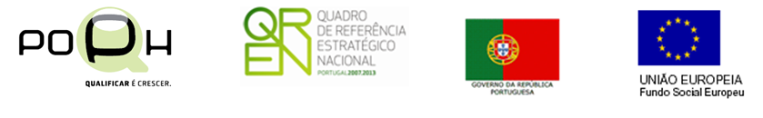


Coordination
Ana Duarte Rodrigues

Authors
Ana Cristina Tavares
Ana Duarte Rodrigues
Ana Luísa Soares
Carlos Pinto Gomes
Cristina Castel-Branco
Desidério Batista
Gerald Luckhurst
Inês Fontes
Maria Conceição Castro
Maria Freire
Maria Matos Silva
Maria Puy Alonso
Miguel Coelho de Sousa
João Nunes
Raquel Carvalho
Rui Sá Correia
Rute Sousa Matos
Teresa Chambel

Design| Conception|Layout
Maggy Victory

Printing and Finishing
Várzea da Rainha Impressores, S. A.

Published by
Centro de História da Arte e Investigação Artística
of the Universidade de Évora

Printed in Portugal|ISBN: 978-989-99083-3-8
Legal number |385284/14

THE GARDEN AS A LAB
Where Cultural and Ecological systems meet in the Mediterranean Context

Ana Duarte Rodrigues
Coordination

CHAIA
2014

TABLE OF CONTENTS

PREFACE by Ana Duarte Rodrigues 7

PART I – CULTURAL AND ECOLOGICAL MEDITERRANEAN LANDSCAPES
Ana Duarte Rodrigues
Sustainability in Alonso de Herrera’s treatise and the construction of the Mediterranean landscape 11

Maria Freire
Mediterranean landscapes: on the ecological and cultural foundations essential to the process of landscape transformation 29

Rute Sousa Matos and Desidério Batista
The multi-functionality and resilience of the Mediterranean landscape: the traditional vegetable gardens from the Southern Portugal and Northern Morocco
43

PART II – SUSTAINABLE GARDEN DESIGN
Raquel Carvalho, Maria Matos Silva, Cristina Castel-Branco, Inês Fontes, Ana Luísa Soares and Teresa Chambel
Historic Gardens as cultural and ecological sustainable models 63

Rui Sá Correia
Space Equaliser. Ecological perspective of a garden 81

Gerald Luckhurst
Monserrate: Sir Francis Cook and the acclimatisation of exotic plants in 1861
91

PART III – ECOLOGICAL PROPOSALS FOR GARDENS AND LANDSCAPE
Miguel Coelho de Sousa and João Nunes
Strategies for water management. A global irrigation model 111

Maria del Puy Alonso Martínez, Maria da Conceição Castro and Carlos Pinto-Gomes
Flowering meadows, a biodiverse alternative to lawns in Mediterranean urban spaces 129

Ana Cristina Tavares
Botanic Gardens - key actors in the conservation and sustainable use of rare medicinal plants 147

PREFACE by Ana Duarte Rodrigues

In garden and landscape studies, connections with gardens have traditionally been described in relation to aesthetics, pleasure-seeking, utility versus beauty, and displays of power, rather than as active sites of history of science and as a stage to solve future problems. Our aim is to invert this tendency and use historical knowledge of gardens and landscapes to solve issues on landscape sustainability, water management, and protection of endemic species. Furthermore, we seek that ecological and economic advantages are taken from that. At the same time, our ultimate goal is to protect our most precious heritage which is the Mediterranean landscape. If we think globally, there is no other landscape as fortunate as this. It is a privileged landscape that ought to be preserved and protected.
The purpose of this book is to add to the growing literature which aims to broaden our understanding of gardens and landscape beyond the traditional focus of elite landscapes, and deepen the study of kitchen gardens, prairies, vineyards and other key features of the Mediterranean landscape.
The multidisciplinary approach of art historians, landscape architects, biologists and horticulturalists gathered at the international colloquium “The Garden as a Lab where cultural and ecological systems meet in the Mediterranean context” held at the University of Évora on the 30th and 31st October 2014, coordinated by me and Aurora Carapinha, allowed us to go beyond disciplinary boundaries and provide a larger spectrum of analysis. Once more, I am grateful to CHAIA’s director, Professor Paulo Rodrigues and Professor Aurora for supporting this project.
I sincerely acknowledge all the authors who collaborated in this volume with their very innovative papers, chosen through a call for papers selection, and that have successfully delivered their works for publication in a record time. Hopefully, the novelty of research, methods and ideas presented here will have consequences in the future and delivered into cultural landscape heritage policy.
This work shows the lessons one can take from ancient agricultural treatises, from a time when any estate was self-sustainable, and use them in present cases. The management and allotment’s shape of kitchen-gardens described by Alonso de Herrera in 1513 can still be recognized in nowadays landscape of southern Portugal and northern Morocco.
Furthermore, the objective of this book is to show how sustainable practices have been used throughout time in landscape, but also how they were delivered in restoration projects of historic gardens and in contemporary landscape architecture projects. Finally, this collective work conveys a particular attention to sensitive topics such as the real risk of desertification of some of the Mediterranean areas. In view of this, all the issues linked with the lack of water and its interconnections with the choice of species suitable to the Mediterranean climate and the acclimatization of some others, are highlighted in this study.
The Garden as a Lab intends to be part of a wider movement which seeks to a better understanding on how to save water, species choice and heritage identity. The final target is to deliver knowledge into the field – stakeholders and policy makers – seeking for historic gardens and Mediterranean landscape sustainability and preservation for generations to come.

PART I – CULTURAL AND ECOLOGICAL MEDITERRANEAN LANDSCAPE

Ana Duarte Rodrigues
Sustainability in Alonso de Herrera’s treatise and the construction of the Mediterranean landscape

Maria Freire
Mediterranean landscapes: on the ecological and cultural foundations essential to the process of landscape transformation

Rute Sousa Matos and Desidério Batista
The multi-functionality and resilience of the Mediterranean landscape: the traditional vegetable gardens from the Southern Portugal and Northern Morocco

SUSTAINABILITY IN ALONSO DE HERRERA’S TREATISE AND THE CONSTRUCTION OF THE MEDITERRANEAN LANDSCAPE

Ana Duarte Rodrigues

Introduction

Gabriel Alonso de Herrera’s treatise on agriculture was published for the first time in 1513 and it is one of the most important books for our knowledge and understanding of the Mediterranean landscape. In this paper I seek to give an overview of Herrera’s Treatise of Agriculture content and scientific ambition. Furthermore, I want to stress the several editions and translations as evidence for its success; some sustainable principles already defended by Herrera; and the treatise’s impact for our acquaintance of the Mediterranean landscape on two major trends: vineyards and kitchen gardens.
Almost all questions of landscape have a historical component, and the use of historical methodology, with its focus on documents and ancient books, can complement the understanding of landscape through the close reading of individual sites in the course of site walking, maps and projects’ analizis, and add new dimensions to our understanding of sustainable landscapes. This is the ultimate goal of my historical study on agricultural treatises.
My research recognized key-features of the Mediterranean landscape in Herrera’s treatise and through its study I have better understood what human activities have gone to making terraces and kitchen gardens what they are in present days. Herrera’s approach corresponds to the growing interest in the development and practice of science through experimentation. My goal is to show that an agricultural treatise such as the one by Alonso de Herrera speaks to recent trends in other fields of knowledge and to current days.
In terms of methodology, I have studied the bibliography available, and I have focused on the many editions and translations of Herrera’s treatise to understand its reception. Finally, I have essayed the correspondence between Herrera’s treatise content on some main features of the Mediterranean landscape and the knowledge we have on an ecological history of the nature of Mediterranean Europe, following Grove and Rackham’s (2001) seminal work.
This study can help us to understand former dynamics of the Mediterranean landscape and its sustainable practices, and thereby defining abnormal present processes and help to recuperate them.

Gabriel Alonso de Herrera, a gardener (hortelano) with scientific attitude

Gabriel Alonso de Herrera (1470- c.1539), son of Lope Alonso de Herrera and Juana Gonzales, was born in Talavera de la Reina. He described his father in the first edition as a well educated and wise farmer, from whom he learned a lot (Arellano 2006: 13). He was raised in a wealthy environment because both Gabriel and his brothers studied for a long period of time reaching one of them the degree of professor at the University of Alcalá, and his other brother was a musician. Hernando Alonso de Herrera was professor of Grammar at the University of Alcalá de Henares, a recent university founded by Francisco Jiménez de Cisneros (1436-1517), usually called Cardinal Cisneros who had an important role in the development of Hernando and Gabriel’s career. Thus, Gabriel had access to the most advanced circle of intellectual social relationships of Spanish humanism. This explains how he was so familiar with classical, Moorish and Italian authors.
Furthermore, Gabriel Alonso de Herrera had a certain worldwide culture. He lived in Granada between 1492 and 1502 (Arellano 2006: 11-12), where he could have seen the gardens of Alhambra and Generalife and become aware of the Moorish art of gardens and agricultural practices. Herrera also travelled throughout France, Germany and Italy to become conscious of their agricultural practices (Arellano 2006: 12) and to match them with the classical authors of whom he was quite sentient.
Parallel to this cultural environment, one has to stress that Herrera was also working in the field as a gardener. The author of Obra de Agricultura had his own experience as a farmer: he had learned with his father and later he had tried many experiences in his own farm which will result in additions and modifications of later editions of his treatise. He was also responsible for the management of many “huertas” (Kitchen gardens), namely to Inigo López de Mendonza y Quinones (1440-1515), first Marquis of Mondéjar. For him, experience and practical knowledge were far more valuable than literate knowledge.
In view of this, Herrera was aware of Mediterranean gardens and landscapes aesthetics and technology because he travelled and visited them, he had experience in the field and he was up-to-date to the humanist circles of his time. Thus, all the circumstances were summed up to convey the best environment for Herrera’s treatise to be made.

Obra de Agricultura (1513), a landmark for landscape Mediterranean history

Cardinal Cisneros ordered Gabriel Alonso de Herrera to write a treatise on Agriculture to improve its development in Spain. The urgent need for this came with the expulsion of the Moors and the Christian’s incapacity to produce enough food to replace the lost production (Arellano 2006: 13). Cardinal Cisneros was archbishop of Toledo, general-inquisitor of Spain and he was twice at the head of the Spanish crown. This very powerful man was also a great patron of the arts and sciences. To promote Spanish agriculture, Cardinal Cisneros paid for the publication of Herrera’s Obra de Agricultura and offered it to farmers at his own expense. The patron of Alonso Herrera’s treatise shows well his own recognition as a great expert not only on agronomy, but also as an erudite able to write the first book on this subject in Castilian for farmers with the goal of developing and improving the productive capacity of Spanish agriculture. In fact, Herrera’s treatise was the first agricultural treatise written in vernacular language in European Renaissance. Although it means to be practical, instead of a theoretical work, this treatise shows the scientific scope of Alonso Herrera. First, because he had to create a specific scientific terminology on agricultural knowledge that had no precedents or guides in Castilian and, second, because it relies often on experimental work, on testing the classical authors and other authorities (Baranda 1989). As a result the seven editions published during his life are all different from one another because he introduced changes when his own experients carried on in his farm proved otherwise. It is important to underline the courage and at the same time the scientific attitude of Herrera whenever he puts on trial the classics, the most praised authorities during the Renaissance. He stands out: “Yo siempre me arrimo a la verdade”.
Herrera’s treatise is seen as a compendium which gathers all the agricultural knowledge of many civilizations of the Mediterranean such as the Roman and the Islamic. It quotes classic authors such as the Greek Theophrastus, and the Roman Cato, Varro, Columella, Palladius, Pliny, Virgil and the Italian Pier de Crescenzi. Besides the classic authors, the Hispano-Arabs authors were of high influence (DUBLER 1941) as well as his long experience of farming in Granada where all the Moorish practices were well embodied.

Fig. 1 Herrera, Libro de Agricultura (1546). BPE, Séc. XVI, nº 1033.
Fig. 2 Herrera, Libro de Agricultura (1551). BPE, Séc. XVI, nº 3590.

Herrera is understood as a legacy of Ibn Wafid (1008-1074) who wrote Compendium of Agriculture, the Moor Ibn Al-Awwam’s Book of Agriculture, and even of Ibn Luyun who in 1348 composed in verse The Book of the Beginning of Beauty and the End of knowledge which deals with the fundamentals of the Art of Agriculture. Indeed, the Hispano-Arabs were far more advanced in science and humanities than Christian Europe during medieval times and have succeeded with the acclimatization of African and Asian plants in the Mediterranean shore. Juan Estevan Arellano conveys the association of the scientific approach of Herrera with the knowledge of mediaeval treatises as the guarantee for his success and the reason why Cardinal Cisneros had chosen him (Arellano 2006: 12).
The text’s scientific character uses a systematic disposition: it is divided into six books. The first book focuses on general aspects of soil. It describes the types of land best suited to cultivating specific crops. Additionally, Herrera discusses when and how crops should be planted, weeded, and harvested.
The most important book is the second because it is on vineyards: an essential feature of the Mediterranean landscape. It deals with the soils, climates, and locations most favorable for vineyards, specifying which varieties of grapes lend themselves to different types of land. Herrera also addresses when and how to plant, weed, graft, and prune vineyards. Furthermore, the author reveals the attributes of wine and how to formulate it and provides advice for building a wine cellar.
The third book is on the cultivation of trees and he organizes it by alphabetic order to make it easier for consultants.
The fourth book is on the cultivation of kitchen gardens. This part of Herrera’s treatise provides information about kitchen gardens layout and their irrigation systems such as man-made ditches, or acequias. Moreover, it focuses on amending the soil with compost, green manure and animal manure.
The fifth book is on farm animals, and it includes a chapter especially dedicated to beekeeping and raising honey bees.
The sixth book presents the most beneficial times to execute agricultural tasks on a month-by-month arrangement based on phases of the moon and it stands that it helps to predict the good or bad years for cultivation. However, Herrera considers farmers could hardly use this knowledge taking into consideration erudite people such as scholars and doctors cannot. Nevertheless, Herrera’s treatise stands out as a primary source to sense the strong role astrology played in 16th century agriculture, as it continued to do until the 19th century as the almanaques are evidence of (Rodrigues 2014c).

The impact of Herrera’s treatise

Hernando Alonso de Herrera, Gabriel’s brother, evokes the great reception this book had. In his brother’s words: “the nobles abandoned the fables of chivalry to read this fascinating revelation of the real world, and the peasants themselves no longer meet in taverns on holy days but read and learn what they must do when they get back to work” (Casey 1999: 45). Despite the notorious exaggeration, it clearly shows that they thought the work had a very good reception by different social groups: it was a necessary and admired work.
Herrera’s treatise success can be evaluated by the amount of editions made: 14 editions published only in the 16th century; 15 editions in the 17th century; and 3 in the 18th century (Casey 1999: 45). After the first edition in 1513, during his life the author will supervise six editions of his treatise published in Alcalá de Henares, Toledo and Logrono. After the 1620 edition, Herrera’s treatise included the texts by Juan de Arrieta and Diego de Salinas on agriculture, Gonzalez de las Casas on growing silk, Luiz Mendez de Torres on bee-keeping, and Gregorio de los Rios on gardening. In view of this, it became a more complete treatise and able to compete with the recently published Olivier de Serres’ Théâtre d’Agriculture et Mesnages des Champs (1600). Furthermore, Herrera’s treatise on agriculture had several translations and was published in different parts of the world, such as in New Spain (Mexico) in the beginning of the 19th century. It was translated into Latin in 1557 which meant to become international in the 16th century; it was translated into Italian several times already in the 16th century; among other translations.
Herrera’s treatise was renowned and used throughout the whole northern Mediterranean shore. For example, it was the agricultural treatise with more circulation in Portugal during the Early Modern and Modern periods as it was shown in previous works on the circulation of art treatises in Portugal (Rodrigues 2011: 121). Thus far twenty-five copies of Herrera’s book were found in Portuguese libraries. Thirteen copies are of the 16th century and among these the 1546 edition stands out. Seven copies are of the 17th century, being three of the 1620 edition. Most of the copies found are at the National Library of Portugal where there are nine copies: one copy of the 1528 edition, the oldest copy found in Portuguese library collections; one copy of the 1546 edition; one copy of the 1569 edition; one copy of the 1584 edition which belonged to the Convent of Nossa Senhora da Graça in Lisbon; one copy of the 1620 edition; one copy of the 1818 edition and the other three of the 19th century. But other copies were found in the libraries of Ajuda, Mafra, Évora and Coimbra. A copy of the 1546 edition is at the library of the former palace and convent of Mafra, built by King D. João V, renowned for having created the best libraries in Portugal (Mafra, Necessidades and Coimbra). A copy of the 1620 edition belonged to the Company of Jesus and was held by the library of the Convent of Santo Antão. A copy of the 1677 edition was owned by the Necessidades’ library. At the library of the University of Coimbra five copies were found: one of the 1520 edition, one of the 1563 edition, one of the 1584 edition, one of the 1605 edition, and one of the 1677 edition. At the Public Library of Évora seven copies were found: two of the 1546 edition of which one belonged to the Convent of Serra de Ossa; one of the 1551 edition which belong to D. Jorge Corte Real; two of the 1563 edition; one of the 1620 edition and one of the 1677 edition. The book had such a good reception in Portugal, that part of it was translated into Portuguese by António Gamarra in 1841 and reedited in 1849.
Gabriel Alonso de Herrera’s treatise had a huge success in the Mediterranean world, taking into consideration the number of editions and translations made between the 16th and the 19th century. Besides that, one can point out it had a special impact on the Mediterranean landscape, not only because the book’s content approaches some of the Mediterranean landscape key features, but also because it had a much broader circulation in the Mediterranean countries. For example, just to have a comparison term: Herrera’s treatise was totally unknown in England until the middle of the 17th century (Rodrigues 2014a). The oldest copy that existed in this country by then was a copy owned by John Evelyn that was offered to him by the Earl of Sandwich, ambassador to Spain in 1665 (Greice-Hutchinsin 1988: 123-129). The edition given to John Evelyn is that of 1645 which is of particular interest because it contains the treatises by Juan de Arrieta and Diego de Salinas, Gonzalez de las Casas, Luiz Mendez de Torres, and Gregorio de los Rios on gardening, which was one of Evelyn’s passions. And Rios’ treatise could have been the reason for Evelyn’s interest instead of Herrera’s treatise on Mediterranean agriculture. However, Evelyn mentions Herrera in a letter to Doctor Stillingfleete written on August 4th 1668. He contradicts Herrera in what he said about chick peas and pumpkins cultivation. Herrera’s treatise was so focused on Mediterranean landscape that Evelyn did not find it important enough or interesting enough for English readers to translate it into English as he did with La Quintinie’s The compleat gard’ner (1693). This comparison with the circulation of Herrera’s treatise in England and the lack of interest towards it, in our opinion, it confirms Herrera’s frame which is the Mediterranean.

Herrera’s outputs for the Mediterranean landscape’s sustainability

As James Casey stands out: “The emphasis in these writings is more on fertility than on productivity – on the balance which one can achieve with nature rather than on its transformation” (Casey 1999: 45). Herrera clearly prefers sustainability to productivity because he stresses that “unfortunately, the failure of farmers to use each type of soil in the most suitable manner and not leave many lands uncultivated explains why Spain is so poor”(Herrera 2006: 36).
It is interesting to recognize that he already conveys ecological and sustainable principles: “Actually there is no better way to deal with the soil and climate deficiencies of some lands than to work with them, cultivating what is suitable, as Virgil affirms” (Herrera 2006: 35).
Herrera is also concerned in matching the suitable climate for each species. He says that:
“In hot areas, cultivate plants that grow well in heat. In clod regions, sow plants that will not freeze. In dry places, plant those that do not require much moisture or care. In humid areas, sow plants that need more moisture. In higher elevations or mountains, grow those that require more air. In valleys or lowlands, sow varieties that need protection from the wind. In shaded areas, plant those that require little sun. In sunny places, grow those that do not thrive in the shade.” (Herrera 2006: 35).
This variety characterizes Mediterranean landscape and that is why Herrera considers all situations and says that we can profit from all of them. This is also the reason why Herrera’s treatise is so important for our understanding of the Mediterranean landscape. He says “accordingly, lands not suited for wheat can be used for herbs, orchards, or many other useful crops, each with its own distinctive attributes” (Herrera 2006: 35-36). However, it is noticed that people should not expect or force to take more from land than what it is able to provide naturally. We clearly recognize Herrera was striving to work in harmony with nature, using traditional irrigation methods to transform drought lands into fertile ones. Another measure shows his concern with sustainability. He prefers not to cultivate the soil for a year to prevent exhaustion. Alternatively, he expects to be able to cultivate it in the following year. As we can confirm by his own words: “If soil is only somewhat thin, the best remedy is to let it lie fallow for one year and produce in the next, alternating as necessary”(Herrera 2006: 35).
In terms of sustainability, water is not a major concern for Herrera. The quality of the water it is a stressed issue, but to save water it is not the foremost problem.
Herrera embodies sustainable rational and uses it in every circumstances and that is why we can learn so much from him. Even when he talks about the estate’s walls he defends organic materials because they are safer, cheaper, and more resistant, and if they burnt, they rebirth.
And through the whole book we sense that land should be taken care as the human body, following the principle of adequacy to each body and personality (humor). It is easily recognizable in Herrera’s treatise the principles of sustainability and ecology- to be in harmony in nature and to have suitable species for each land. The idea of a garden as a lab had its highest moment when Herrera mentions how different groups of people should be organized in a city, just like vegetables in a kitchen garden: each quality in its best suitable location. Thus, a garden can even be the laboratory for what can be made in the macro-scale of the city.

An inestimable source to study Mediterranean landscape

Herrera is ecologically minded, as we have seen, and teaches us a great lesson on how to treat certain landscapes of the Mediterranean. Herrera’s words are also an invaluable source for the understanding of the Mediterranean landscape construction.
A. T. Grove and Oliver Rackman consider terraces “most conspicuous features of Mediterranean cultural landscapes, and among the least understood”(Grove and Rackman 2001: 107).
When they were made and why nobody knows anymore, but Grove and Oliver Rackman point out Boccaccio’s Decameron as the first written record on this, concluding it was not that common in the 14th century Italy. The same authors quote a text by Antonio Casena who writes about Genoese landscape in 1558 and conclude terracing was not itself unusual or an innovation in the second half of the 16th century in this area of Italy. In the gap between these two texts, Herrera’s treatise specifically talks about it and he dedicates a great volume of his work to vineyard cultivation, which is ideally terraced. Another document pointed out by these authors is a Spanish document from 1528 describing tahullas of land and it also mentions bancal which is still used for a terrace in Spain. Then they say “such terms were usual in the 1520s; presumably they meant the terraced fields, irrigated and fertilized by floodwater, still in use today and attributed to the medieval Arabs” (Grove and Rackman 2001: 113).
This was certainly the historical moment to develop this key-feature of the Mediterranean landscape. The reason why I affirm it is because it has all to do with vineyards which need root penetration and cultivation on terraces benefit roots to get at stored moisture.
The other key-feature of the Mediterranean landscape Herrera talks about is the kitchen-garden (“las huertas”). He mentions their square form and how they were irrigated through that pattern. Herrera points out the vegetable garden’s location as the most important factor to guarantee the hortelano’s success if one’s goal is to have a productive farm. Thus, Herrera provides a framework, such as the importance of the surroundings water courses and of a wise stewardship of water resources; the soil type; the use of manure to improve soil organic matter; and that it should be near a village to guarantee an honest income.
Finally, Herrera describes the countryside as a garden which Mediterranean landscape still is when compared with other areas of the globe:
“… en los árboles no hay tanto trabajo como en las vinas y hay más provecho y deleite; en las frutas placer; ver la frescura de las hojas, los colores y olores de diversas maneras de flores, la variedad de los sabores en la multitud de las fructas, sombras en verano, músicas suavíssimas de paxaritos que gorjean en los árboles...” (Herrera 1818: 99). The Mediterranean landscape is still a privileged locus with a lot of variegated genius, but needs our protection.

Conclusion

Alonso de Herrera’s treatise is a landmark on agriculture writings not only because it is a compendium which gathers all the knowledge developed so far on the Mediterranean shore, but also because at the same time it divulged a model of farming through the whole Mediterranean landscape. In view of this, it is one of the best primary sources to study the Mediterranean landscape: its features, its climate, its layout, its colors, its forms and concepts, such as the “huerta” and the “jardine” (a false distinction in the Iberian Renaissance).
It was a very successful book, translated into many different languages and with various editions throughout the whole Modern period until the 19th century. This shows it had a good reception, especially in the geographic area of the Northern bank of the Mediterranean. Thus, the ideas, concepts, techniques, knowledge and management advices stressed by Herrera were spread in the region. I believe the reason why is the specific content of the book – vineyards and kitchen gardens -, which are two of the key features of the Mediterranean landscape, but also widely interesting in economic terms.
Alonso de Herrera contains a lot of lessons that might be useful for us in the present. He was ecologically minded and the rational behind the whole book shows his concerns with sustainability, with good management and at the same time his scientific attitude. He trusted more in his own experience than in authorities’ words. During the Renaissance to question the classics and be able to surpasse them was quite rare.
Alonso de Herrera’s treatise lines up with Olivier de Serres in France, Agostino Gallo in Italy, Heresbach in Germany and Hartliben in England as the most influential authors on agronomy of the 16th and 17th centuries in Europe. Nevertheless, it is the most influential for the Mediterranean landscape and because of that a privileged source to understand some present features in both shores of the Mediterranean Sea and I believe an important guide to learn how to preserve it. It is also in the genealogy of Serres, Duhamel and Rozier’s treatises, usually considered the outstanding European treatises and much more renowned and studied than Herrera. It is our aim to contradict this tendency and hope that new studies will come forward after this.

Bibliography and Primary Sources

Primary Sources

ALONSO DE HERRERA, Gabriel (1513), Obra de Agricultura copilada de diversos auctores, de mandado del muy illustrey reverendissimo senor el cardenal de Espana arcobispo [Francisco Ximenez] de Toledo, Alcalá de Henares: en casa de Arnao Guillén de Brocar.
Idem (1520), Obra de Agricultura...., Toledo: Arnao Guille de Brocar.
Idem (1528), Libro de Agricultura: que es de labrança y criança y de muchas otras particularidades y puechos de las cosas del campo/compliado por Gabriel Alonso de Herrera. Nuevamente corregido y anadido en muchas cosas muy necessarias y pertenescientes al presente libro. Fue impressa en la muy noble insigne y muy leal cibdad delo, Grono: en casa de Miguel de Eguia.
Idem (1546), Libro de Agricultura copilado por Gabriel Alonso de Herrera. Nuevamente corregido y anadido en muchas cosas necessarias. Toledo: en casa de Fernando de Santa Catalina.
Idem (1551), Libro de Agricultura, Toledo: Juan Ferrer.
Idem (1557), Libro di agricoltura utilissimo, tratto da diversi auttori. Novamente Venuto A Luce, Dalla Spagnuola nell’Italiana linqua traportato, Venetia: per Michel Tramezzino.
Idem (1563), Libro de agricultura: que es de la labrança y criança, y de muchas otras particularidades y provechos de campo, Valladolid: por Francisco Fernandez de Cordoua: Juan Despinosa.
Idem (1568), Agricoltura: tratta da diversi antichi et moderni scrittori/dal Sig. Gabriello Alfonso d’Herrera et tradotta di lingua spagnuola in volgare italiano da Mambrino Roseo da Fabriano. Nella quale si contengono le regole, i modo, & l’usanze che si osseruano nell’arare la terra, piantar le vigne & gli alberi, governare i bestiami, & fare ittimamente cioche all’agricoltura..., Venetia: per ordine di F. Sansovino.
Idem (1569), Libro de Agricultura, Medina del Campo: por Francisco del Canto.
Idem (1584), Libro de Agricultura, Medina del Campo: por Francisco del Canto: a costa de Iuan Boyer, mercador de libros.
Idem (1592), Agricoltura: tratta da diversi antichi et moderni scrittori/ dal Sig. Gabriello Alfonso d’Herrera et tradotta di lingua Spagnuola in Italiana da Mambrino Roseo da Fabriano; nella quale si contengono le regole, i modi, & l’usanze che si osservano nell’arrare la terra, & piantar levinge & gli alberi, governare i bestiami, & fare ottimamente cioche all’agricoltura..., Venetia: Appresso Nicolò Polo.
Idem (1598), Obra de agricultura copilada de diversos auctores, de mandado del muy illustrey reverendissimo senor el cardenal de Espana arcobispo [Francisco Ximenez] de Toledo. Aora nuevamente anadidos los dialogos de la fertilidad de Espana, compuestos por Juan de Arrieta, Madrid: por Luis Sanchel.
Idem (1605), Libro de agricultura... que trata de la labrança de los campos y muchas particularidades y prouechos suyos, Pamplona: por Mathias Mares.
Idem (1620), Agricultura general que trata de la labranza del campo, y sus particularidades, Madrid: Alonso Martin.
Idem (1677), Agricultura general, que trata de la labranza del campo, y sus particularidades, Madrid: en la imprenta de Bernardo Herbada.
Idem (1818), Agricultura General de Gabriel Alonso de Herrera, corrigida segun el testo original de la primera edicion publicada en 1513 por el mismo autor, y adicionada por la Real Sociedad Economica Matritense, Madrid: Imprenta Real. http://bibdigital.rjb.csic.es/spa/Libro.php?Libro=258
Idem (1841), Nova arte que ensina a criar, tratar, esculher, e curar cabras, borregos, ovelhas, porcos, bois, e vacas. Traduzido do Hespanhol em Portuguez por Antonio Gamarra, Lisboa: na typ. De Mathias José Marques da Silva.
Idem and Martínez Carreras, José Urbano (1970), Obra de Agricultura, Madrid: Ediciones Atlas.
Idem (2006), Ancient Agriculture: Roots and Application of Sustainable Farming, compiled by Juan Estevan Arellano, Canada: Ancient City Press http://books.google.pt/books?id=H17NS2hPSAAC&pg=PA12&lpg=PA12&dq=Gabriel+Alonso+Herrera+translated+into+Italian&source=bl&ots=YqyRiqFeP8&sig=46dG1rIptTFAx2PX608WVXUelTE&hl=pt-PT&sa=X&ei=EZROVImiCdHvaOeCgtgE&ved=0CB8Q6AEwAA#v=onepage&q=Gabriel%20Alonso%20Herrera%20translated%20into%20Italian&f=false
La QUINTINIE, Jean (1693), The Compleat Gard’ner, or, directions for cultivating and right ordering of fruit-gardens and kitchen-gardens: with divers reflections on several parts of husbandry: in six books. .. to which is added, his treatise of orange-trees, with the raising of melons, omitted in the French editions: made English by John Evelyn Esquire, illustrated with copper plates, London: Printed for Mathew Gillyflower and James Partridge.

Bibliograhy

BARANDA, Consolación (1989), “Ciencia y Humanismo: La Obra de Agricultura de Gabriel Alonso de Herrera (1513)”, in Criticón, 46, pp. 95-108.
CAPUANO, T. (1995), Texto y concordancias de la “Obra de agricultura” de Gabriel Alonso de Herrera. Madison: Hispanic Seminary of Medieval Studies.
CASEY, James (1999), Early Modern Spain: A Social History, New York: Routledge.
DUBLER, C. E. (1941), “Posibles fuentes árabes de la Agricultura general de G. A. Herrera”, in Al Andalus, VI, pp. 135-156.
FRADEJAS, J. (1984), “Dolor de Espana en Gabriel Alonso Herrera”, in Estudios sobre el Siglo de Oro. Homenaje al profesor Francisco Ynduráin, Madrid: Ed. Nacional, pp. 229-244.
GROVE, A. T. and RACKHAM, Oliver (2001), The Nature of Mediterranean Europe. An Ecological History, New Haven and London: Yale University Press
RODRIGUES, Ana Duarte (2011), “O conhecimento teórico ao alcance de arquitetos e Jardineiros em Portugal durante a Idade Moderna”, in Tratados de Arte em Portugal/Art Treatises in Portugal, Lisboa: Scribe, pp. 119-144.
Idem (2014a), “O saber da arte dos jardins em circulação na Europa (1500-1900)”, in Mobilidade e Circulação: Perspectivas em História da Ciência e da Tecnologia, Alice Santiago e Pedro Raposo (org.), CHAM e CIUCHT, pp. 87-93.
Idem (editor) (2014b), Uma história de jardins. A sua Arte na Tratadística e na Literatura, Lisboa: BNP/CHAIA, 2014.
Idem (2014c), “Pequenos livros para Jardineiros: os Almanaques”, in Helena Pires et al. (ed.), Jardins – Jardineiros – Jardinagem, Braga: Centro de Estudos de Comunicação e Sociedade, Universidade do Minho, 2014, pp. 78-87. ISBN 978-989-8600-22-6
http://www.lasics.uminho.pt/ojs/index.php/cecs_ebooks/article/view/1924/1849
SALTINI, Antonio (1984), Storia delle scienze agrarie, vol. I, Bologna, pp. 213-231.

MEDITERRANEAN LANDSCAPES: ON THE ECOLOGICAL AND CULTURAL FOUNDATIONS ESSENTIAL TO THE PROCESS OF LANDSCAPE TRANSFORMATION

Maria Freire

Introduction

Landscape means an area, as perceived by people, whose character is the result of the action and interaction of natural and/or human factors (EC, 2000) – thus, it is the result of the fusion between Nature and Culture. Landscape is "(...) a biological and organic whole in which each element that composes it, influences and is influenced by others in a cyclical movement, determined by the 'environment' and recreated by 'Man'." (Telles, 2002: 73). Landscape - which provides the answer to issues of utility (space for food production, resource and recreational source), symbolic (space for exaltation of the human spirit) and moral responsibility (towards Nature and Culture) – is, for this, understood as a holistic concept. It involves the interrelation of cultural (historical, social and economic), aesthetic (sensitive), ecological and ethical (moral) domains. Those which drive the landscape architect point of view are emphasized in this paper.
Our focus is on the Mediterranean landscapes. Landscapes that are a living testimony of the past and that have significant biodiversity - inspiring basis of reinvention of present landscapes and with influence to build the landscapes of the future. Moreover, the structure and content associated with the Mediterranean landscapes are particularly significant for Portugal, given the similarities recognized among us - declared in some particular attributes or natural influences, such as climate, geomorphology, the rareness of good soils or the covering plants, and also in other cultural attributes, such as ways of living, traditional agricultural systems, vernacular architecture or the art of gardens.
The aim of the paper is to make an approach to the characteristics and values of Mediterranean landscapes, highlighting the ecological and cultural foundations linked with the concept of landscape, in order to express guiding strategies for landscape transformation. In this sense, we begin to understand the specificities that support the identity of Mediterranean landscapes, identifying its characteristics and challenges, and to conclude it with the basis that should rule the process of landscape transformation. These are intrinsically linked with the concept of landscape - related with the values associated with natural and cultural components and with the people’s perception and the values they attribute to them – expressed through unity, diversity and complexity.

Specific features of Mediterranean landscapes

The Mediterranean region is characterized by "(...) an elongated east-west fossa between two continental masses: south Africa, with its mountain ranges and arid plateaus, with simple and heavy contours; north Europe, projecting into the sea a series of peninsulas and islands, with a fine and intricate design." (Ribeiro 1987: 1). Indeed, such geographical position corresponds to a region that includes hinterlands, inland seas and coastal zones, of contact between them, which receives influences and generates reciprocal relations (Fig.1).
Fig. 1. Mediterranean region (Source: Google earth; image date 10/04/2013)
In a brief reading, we can say that the Mediterranean basin is a diverse region in the landscaping point of view, with multiple landscapes, an expression of millennial coexistence between nature and human civilizations.
Among the components more significant in the Mediterranean basin are the natural characteristics relating with the presence of sea and with the combination of some natural factors (Ribeiro 1987; Drain 1998):
- A vast sea and a long coastline (winding and jagged), with peninsulas and archipelagos, gulfs and coves; and clear and warm water;
- A varied relief and also varied soils (reflecting the geological and topographic irregularities); and a long summer, hot and dry and mild winter, with low rainfall; a set of conditions that determine the existence of a rich vegetation.
Among the cultural components are the specificities linked with the different societies and ways of living. They have transformed the physical and biological support, that is, the landscape as an expression of the Men living. It includes several spatial forms, distinctively organized by human communities, and structural and morphological elements which are the result, among other things, of the different functional spaces (living space, work and meeting space, production and redistribution areas, protection and recreation), of routes (paths, roads and itineraries), division and ownership of property (public and private) and of the administrative boundaries. In this context, the historical, social and economic domains are evidenced, founded in the interaction between land use and functions, expressing the organization of society and the knowledge and values associated with landscape.
At once, the above-mentioned natural basis (physical and biological) created conditions for the development of agro-pastoral societies. These societies began the transformation of a natural space in a cultural landscape, linking the nature of the soil, the climate and the demands of production and consumption, with agricultural crops and techniques, and with other sensible needs. The transformation occurred gradually - opening glades, introducing agricultural activities, using resources, and by the construction of dwelling spaces (Fig. 2). These landscapes are distinct from others, not only in its design but also in the traditional agricultural systems, in the rhythm of agricultural work, and in the more expressive presence of some cultures and trade dynamics - landscapes with physical traces of the past and with natural structures and elements - a whole with significant biodiversity and ecological balance.

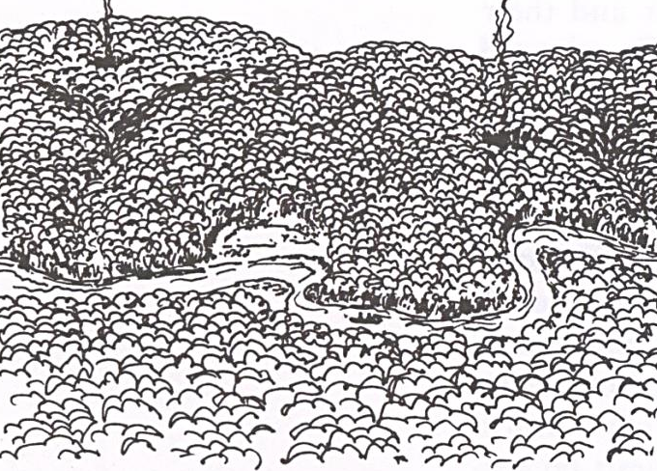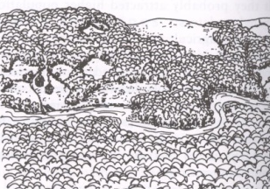
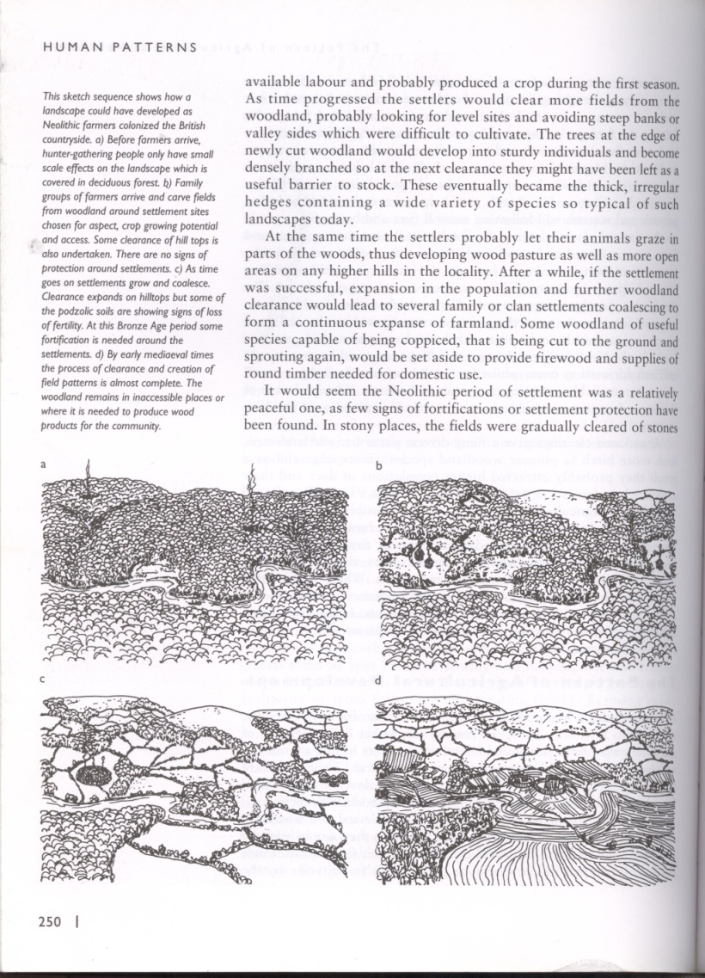
Figure 2. Drawings of landscape patterns - evolution over time (Font: Bell, 1999: 250)
The traditional landscape pattern represents a diverse and irregular grid - a puzzle of fragments with different cultures, uses and functions - drawing a structure and an organization of spaces, species and economic activities highly intricate. Gardens, orchards, uncultivated spaces, fields of grain, woodlands, cork oak woodlands, grasslands, urban areas, commercial ports, among other spaces, are mainly designed to support subsistence needs (production system), but also to social benefits (recreation) and protection functions (safeguarding the natural systems) (Fig. 3). These are accompanied with an intense and differentiated compartmentalisation (that ensures the biological balance and physical stability, performed with fencerows, hedgerows, shelterbelts, terraces, drainage channels and the water courses and roadsides) and with a land ownership that includes small and large property, and with rainfed and irrigated crops.
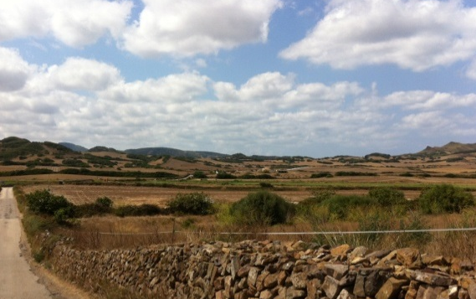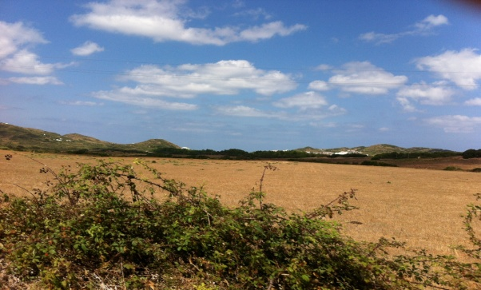

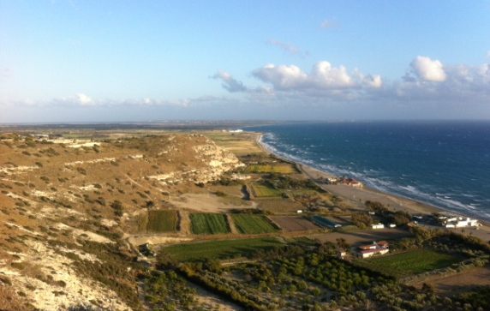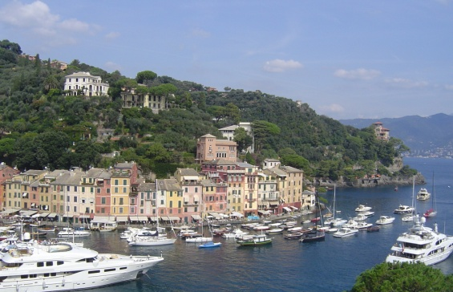

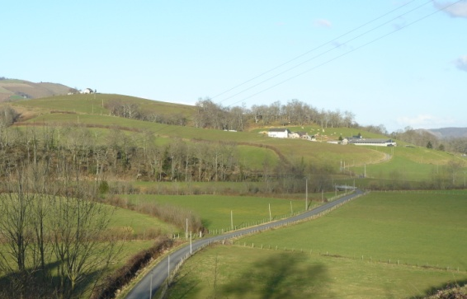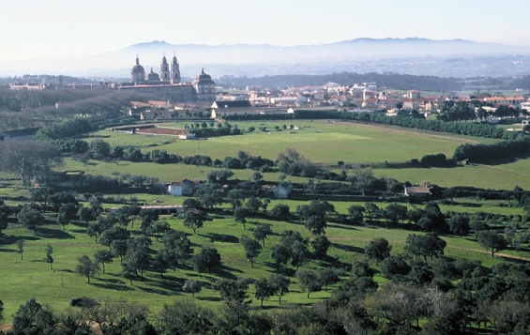

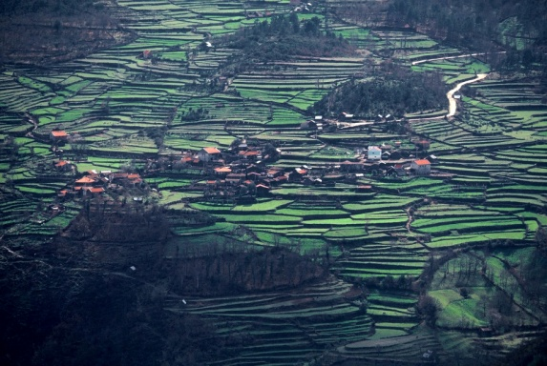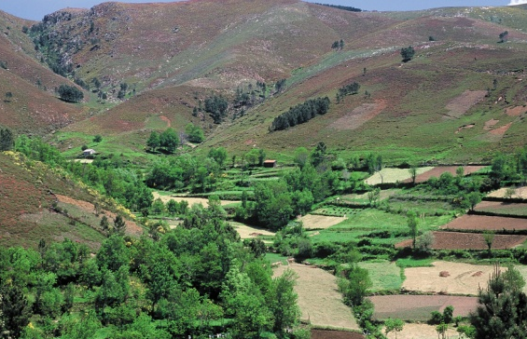

Fig. 3. Photographs of mosaics of Mediterranean landscapes;from left to right, Spain (2), Cyprus (1), Italy (1), France (1) and the last three pictures, Portugal. Photos by Maria Freire and AA et al., 2004.

Those more specific requirements of agricultural work result from the combination of relief conditions and limitations of soil and climate, given the varied and ancient selection of crops. In the Mediterranean context, arable lands are more limited, scattered and very demanding in maintaining its fertility, against a background of poor, thin and sloping soils, which is aggravated by the lack of water in the soil (in the great part of the year) and by torrential streams in the rainy season (conditions that promote erosion and soil degradation). The climate irregularities cause many problems and few benefits, particularly associated with floods and drought, declared in the removal and reuse of sludge and sediments and oblige an original use of water. These situations led to the development of cropping strategies and techniques of infiltration, conduction and storage of water for irrigation. Thus, the traditional cultural practices are related with the continued presence of polyculture, associated with the utilization of water for irrigation and cultural care marked by the seasons’ rhythm.
Vineyards and olive groves are the most common crops, those that ensure higher productivity and usefulness (Fig. 4). These cultures have a very significant performance in the Mediterranean region's economy since ancient times.
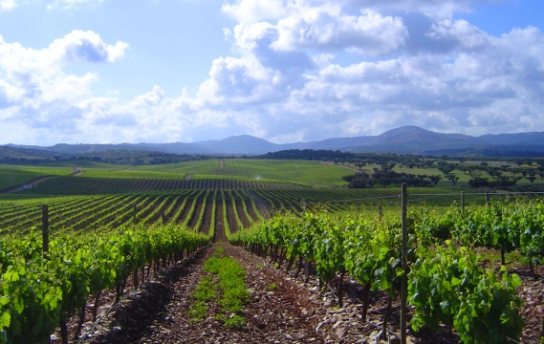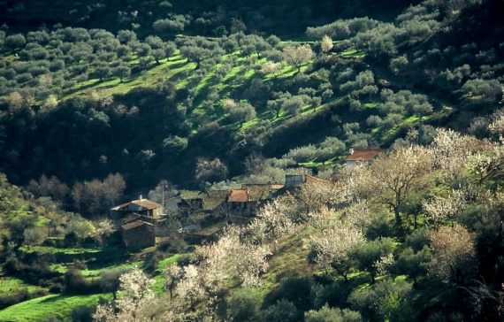
Fig. 4. Photographs of vineyard and olive grove. Photos by Maria Freire and AA et al., 2004

Thus, human needs dictated a rural agricultural economy and an insignificant maritime economy; nevertheless, the coast and the great sea had an important role in the relationship between people and the unity of the Mediterranean (Ribeiro 1987; Braudel 1995; Horden & Purcell 2000). The dominant agricultural economy is revealed in the inland territories, which exhibit a wise construction of equilibrium - where human activities are harmonized with the natural zoning and regeneration of life. Different organized spaces and structures are associated with different activities and functions in a process that inevitably involves some destruction of flora and exploitation of natural resources.
The settlements are expressed predominantly as an agglomeration, justified by defence needs and on the cultural matrix. Reasons why the site is linked with high position places, near the most fertile areas, and the settlements are a spatial, social and economic whole, with strong interdependencies between the city and the countryside.
In short, the landscapes are based on a complex structure, where natural and cultural contrasts are very significant, the human pressure is old and fertility is basically the result of a constant construction of Man. It is expressed, in space and time, in the mentioned landscape pattern – fragmented, diverse and intricate, determined by the combination of exceptional natural and cultural conditions:
- Rough relief (mountains, hills or plateaus), articulated with small basins and lowlands (coastal or plains, more fertile, early occupied); a morphology that determines different ecological situations (dry and wet systems) characterized by irregular distributions of soil, water and vegetation; as a result there are distinct land uses and diverse visual change of perspectives;
- High average temperature, irregularity of temperature and precipitation (short and violent periods of rain), constant brightness (expressed in the clear and bright sky and in the purity and transparency of the atmosphere); this climatic characteristics are determinant to the occurrence of specific species (of plants and animals) and to lifestyles marked by the rhythms of the seasons;
- Water is the most crucial natural factor in the construction of landscapes; the drainage and the infiltration are strongly conditioned by the topography and by the irregular distribution of rain; as a result, we can see a compelling care in storing, driving and water use, especially critical due to the morphology of the terrain, slopes and soil types;
- Varied and rich spontaneous vegetation, dominated by trees and shrubs, evergreen species and adapted to dryness; also a wide variety of agricultural plants, spontaneous and gradually introduced, which give expression to a mixed cropping extending through time;
- A set of natural conditions - relief, soil, water, climate and vegetation - which favoured agriculture as the dominant way of living;
- Concentrated settlements, spread, related with safety reasons, land fertility and the cultural system (extensive and intensive); and also a vernacular architecture, which is adapted to climatic conditions, consistently materialized in space and time;
- An old human activity (of hard and incessant work) responsible to shaped sites and built places, which enriched the vegetation and transformed the landscapes, sensible to the preservation of the ecological equilibrium dynamics (more fragile);
- Scenic values, strongly influenced by the variety of natural factors, which are expressed through the relief, vegetation, water and climate, but also through the architectural and archaeological heritage. A combination that expresses a particular aesthetic splendour - the beauty linked with the order and light - exceptionally expressed in the scale and landscape design, in the contrasts (of matter, shape and colours), in the diversity of ambiances and emotions, in memory and animation of the people, among other things.
In general, these are specificities based on biological and physical richness, on the sedimentation of history and culture in space, on the ecological fragility and on the originality of lifestyles (Demangeot 1970; Ribeiro 1987; Braudel 1995; Drain 1998). It is expressed in the Nature, simultaneously fragile and very difficult to be worked, in the variety of relief, in the oscillation of climate, in the presence of the variety of soils and in the accommodation of the biological complexity. And, simultaneously, it is expressed in the encounter of cultures and times, manifested in the subjects, shapes and functions that govern the construction of landscape - an ancient history, declared in prosperity and intensity of human presence over time, and in the confrontation between cultures and societies.
As a result of the combined interpretation of these elements, some authors (Ribeiro 1987; Braudel 1995; Jabouille 1996; Drain 1998; Horden & Purcell 2000; Telles 2002) identified unity and diversity as key figures in the construction of the structural and compositional properties of the Mediterranean landscapes. Given this understanding, in conjunction and coordination of factors associated to Mediterranean landscapes, it becomes inevitable to add the value that expresses the complexity. So, unity, diversity and complexity - natural and cultural - are identified among the most significant values in the Mediterranean landscapes identity, clearly those that have demonstrated more consistency, in space and time. Following Gonçalo Ribeiro Telles, these values are expressed in interconnected natural and cultural systems concerning the concept of landscape – an area that "(...) was being built and developed by the persistent action of successive generations, who were recreating landscape in slow and gradual adaptation to the environment and to the circumstances of life." (Telles 2002: 75).

Recent dynamics: simplification of the countryside, increasing of urban sprawl and changing of lifestyles

As we have seen, landscape is an expression of economic and social organization based on natural support. During great part of human history, the human presence was marked by a relative balance between Man and Nature (based on a limited and balanced occupation of the territory and use of resources). However, in the last century (and particularly in the last decades) the evolution of societies, the economy and the changing of values, led to significant changes in lifestyles, with significant consequences in the simplification of the countryside and in the growth of urban sprawl.
In this process, we can see the continuity of some ancient human activities and the introduction of many others, often compromising the sustainability of the landscape, breaking the architectural and landscape heritage and the natural and cultural authenticity - destroying, or simply decreasing drastically, the diversity and the biological and physical complexity, the consistency of uses and functions and the identity. Among these changes are evident: the destruction of vegetation; the degradation and/or loss of soils; the massive urbanization; the tourism and recreational pressure; the density of big structures and infrastructures construction; the intense exploitation of resources; the abandonment of fields and, in particular, of the traditional agricultural systems; the pollution; the strong presence of exotic species; the increase of monoculture and forced crops; the desertification; the depopulation of the interior areas and the high concentration of population and activities in coastal and metropolitan areas; the cultural uniformity; the property speculation; the disqualification of urban areas and the general degradation of the quality of life, among other changes and evolutions (Fig. 5). In general, these transformations are particularly linked with the improvement of mobility/accessibility, the increased urbanization, the rapid globalization and also as consequences of some calamities/natural occurrences (Antrop 2005).
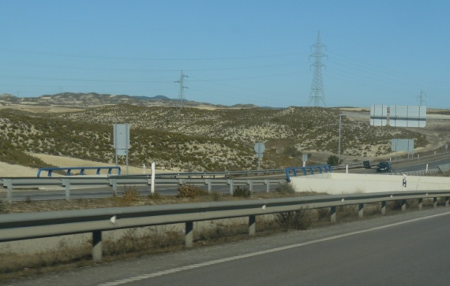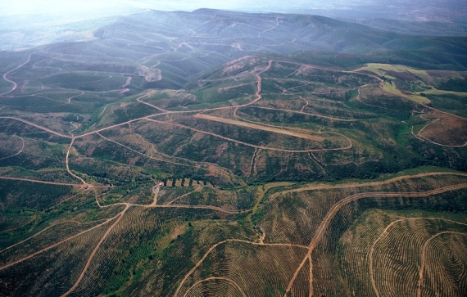

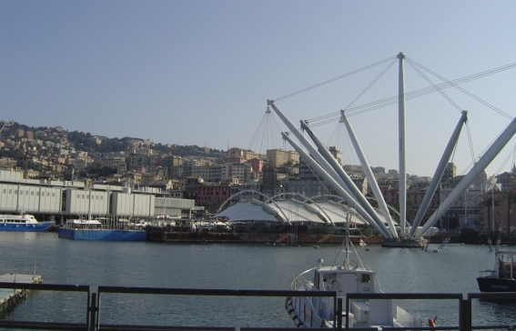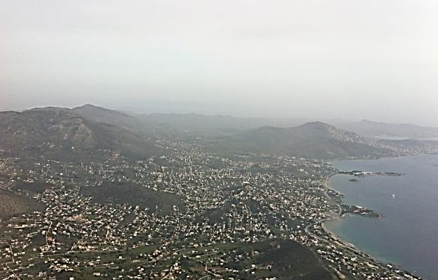

Fig. 5. Photographs of landscapes showing the simplification and homogenisation of the countryside and the urban sprawl; from left to right Spain, Portugal, Italy and Greece. Photos by Maria Freire and AA et al., 2004.

This dynamic, although common to the most of the landscapes in contemporaneity, has a great meaning in the Mediterranean context - where, as we have seen, the history is old and the biodiversity is high, the ecosystems are fragile and the balances are delicate, and where there is a consensus about the idea of a certain originality in the way of building landscapes. A whole set of reasons that can be seen as the generators factors of some fascination associated with the Mediterranean region, as it is confirmed by the attraction and continuous human pressure (multiple human settlements and, more recently, the strong tourist vocation and massive urbanization) with more significant consequences when we compare with the values identified.

Mediterranean landscapes: an archive of the past and inspiring basis for future

Our approach to the Mediterranean landscapes – with the aim to best know and valorise them - is thus inevitably grounded in the values and challenges they express and in the meaning they have in the Portuguese context. On one hand, we have the values represented in the unity, diversity and complexity, combining ecological, cultural, aesthetic and ethical domains. On the other hand, we have the conflict that the recent socio-economic dynamic put in evidence. This set of circumstances lead us to the main conceptual foundations, which should inform the sustainable development and landscape design in the context of the Mediterranean landscapes.
This means attitudes and actions of landscape transformation based on the understanding of the functioning of the natural system, translated in the cooperation with Nature (simultaneously rich and fragile); procedures that necessarily integrates the principles of ecology in the organization of space, in the maintenance of a dynamic balance and temporal stability, in the increasing of biological diversity and genetic potential, and of life (Telles 1993; Cabral 1993). These natural foundations should be still harmonized with the understanding of cultural foundations, including the social, historical and spiritual domains (as we saw, exceptionally sedimented in the intelligent, sensitive and very old construction of landscapes), as a response to current needs of Man.
Thus, it is essential the simultaneous inclusion of functional (utilitarian and ecological), formal and sensitive aspects, related with the enrichment of the unit, the diversity and the complexity – the values of excellence, associated with the structure, content, composition and significance of the Mediterranean landscapes. A multifaceted approach, linked with the multi-functionality, which is central to the landscape concept (Freire 2011).
So, we need to develop landscape planning and design practices that are aware and consider the dynamic and contrasts of Mediterranean landscapes, improving the continuity and articulation within and between systems (natural and artificial), both at large and small scale. Moreover, those practices should provide the creation of diversified, flexible and intricate patterns as well as hierarchical networks, which promote the variety of life experiences and the diversity and intensity of biological life. In such landscapes ‘habitats’ should be associated with more opportunities for exchanges, more biodiversity and fertility and also more cultural diversity - which are illustrative of the different landscape mosaics, based on the natural and traditional zoning. Such richness corresponds to the development of ecological structures, combined with cultural structures, which avoid the monotony and uniformity and where the formal, structural and content qualities are valued, and expressed in unity, diversity and complexity. A whole that is offered to the exploration of the senses and to the opportunities of a free participation, increasing the cooperation between landscape human communities and Nature, a landscape more open to fantasy and imagination.
Consequently, a landscape design and management strategies where occurs production, protection and recreation spaces - answering to utilitarian, ecological, biological, historical and social functions; a concept that is related with the idea of sustainability and authenticity as regulating factors of transformation. In conclusion, a landscape construction emphasising an intrinsic feature of the landscape is denied in the contemporaneity (Freire 2011).

Bibliography

ABREU, A., CORREIA, T. & OLIVEIRA, R. (2004). Contributos para a Identificação e Caracterização da Paisagem em Portugal Continental. Lisboa: Direcção-Geral do Ordenamento do Território e Desenvolvimento Urbano.
ANTROP, M. (2005). Why landscapes of the past are important for the future? Landscape and Urban Planning, 70, 21–34.
BELL, S. (1999). Landscape: pattern, perception, and process. London: Taylor & Francis.
BRAUDEL, F. (1995). O mediterrâneo e o mundo mediterrâneo. Lisboa: D. Quixote.
CABRAL, F. (1993). Fundamentos da arquitectura paisagista. Lisboa: Instituto de Conservação da Natureza.
CONSELHO DA EUROPA (2000). Convenção Europeia da Paisagem. Estrasburgo.
DEMANGEOT, J. (1970). La méditerranée. Milieu et traditions. Finisterra, Lisboa, vol. V, 9, 126-130.
DRAIN, M. (1998). Les specificities du paysage méditerranéen. In J. Abellán & F. Fourneau (Eds.). El Paisaje Mediterráneo (pp. 21-32). Granada: Universidad de Granada & Junta de Andalucía.
FREIRE, M. (2011). Para uma diferente aproximação ao ensino do projeto de arquitetura paisagista. PhD Thesis. Évora: Universidade de Évora.
HORDEN, P. & PURCELL, N. (2000). The Corrupting Sea. A Study of Mediterranean History. Oxford: Blackwell.
JABOUILLE, V. (1996). O Mediterrâneo Antigo - Unidade e Diversidade. Lisboa: Edições Colibri.
RIBEIRO, O. (1987) (1ª ed. 1967). Mediterrâneo, ambiente e tradição. Lisboa: Fundação Calouste Gulbenkian.
TELLES, G. R. (1993). Preamble of book Fundamentos da arquitectura paisagista. In F. Cabral. Fundamentos da arquitectura paisagista. Lisboa: Instituto de Conservação da Natureza, 17-21.
TELLES, G. R. (2002). A perca da complexidade da paisagem portuguesa. Jornal Arquitectos, 206, 73-78.
WWW:<URL http://whc.unesco.org/fr/carte-interactive/ (Accessed in 28/10/2014).
WWW:<URLhttp://maps.eea.europa.eu/EEABasicViewer/v3/index.html?appid=07661dc8a5bc446fafcfe918c91a1b1b&displaylegend=true&embed=true (Accessed in 28/10/2014).

THE MULTI-FUNCTIONALITY AND RESILIENCE OF THE MEDITERRANEAN LANDSCAPE: THE TRADITIONAL VEGETABLE GARDENS FROM THE SOUTHERN PORTUGAL AND NORTHERN MOROCCO

Desidério Batista and Rute Sousa Matos

Introduction

The Mediterranean landscape is the result of the historical accumulation of successive human interventions on the territory. As a social and cultural product, the Mediterranean landscape constitutes the result of the enormous and thousand-year-old effort of adaptation of the human communities to the circumstances of the environment in search of subsistence, but also, of beauty. The ancient texts confirm that the changes operated by Man in the landscape, in its economic viability and social utility were considered as something beautiful, an aesthetic attribute that connoted with an organized and harmonious landscape, is based on a deep relationship between resilience and beauty. In this continuous and permanent project of landscape transformation, an important culture based on the experience of traditional agriculture as a primordial activity of landscape construction has a special meaning and relevance. This experience constitutes a solid basis over which the historical process of occupation and spatial organization is to be (re)interpreted, considering the profoundly intricate relationship between population, water and agricultural practice. The interdependence between these three variables is related to the natural conditions of the landscape and the resulting characteristics of the action of Man.
The vegetable gardens are the testimony of the different strategies developed by Man when faced with diverse natural factors and distinct economic and social situations of each time, to ensure their survival, but also their enjoyment and visual delight. In the Mediterranean region the importance and the role kitchen gardens played and still play in the evolution of its landscape of intense and ancient human occupation is noticeable. Both in southern Europe and northern Africa, vegetable gardens are the result of successful experiences and knowledge transmitted between peoples and generations, constituting cultural legacies directly related to the sustainability and resilience of the Mediterranean landscape.
The present investigation starts from the contextualization of the vegetable garden in the Mediterranean landscape and proceeds to the study of its characterization in mountainous areas in the south of Portugal and in the north of Morocco, considering the different themes that interrelate human settling, land exploration and the use of water resources in the development of a landscape and an agricultural activity that, as basis of a rural economy, is deemed essential for the long-term development of both Nature and Society.

The Mediterranean Basin: landscape unity and diversity

Although it occupies a reduced area that corresponds to only one hundredth of the earth’s surface, the Mediterranean region plays a distinguished role in the history of the planet and in the history of mankind (Braudel 1983: 23). Its landscape translates the uninterrupted interaction between the natural and anthropic processes, the basis of its individuality and singularity as the birthplace of a distinct civilization. A compendium of the natural and cultural history of the region, the Mediterranean landscape distinguishes itself both as a biophysical unit mainly defined by its geographical position, its climate and topography, and as a cultural unit settled throughout centuries from the confluence of different peoples and societies, and the respective exchange of experiences. Indeed, “… both in its physical landscape as well as in its human landscape, the Mediterranean… presents itself… as a system where everything mixes and recomposes itself into an original unit” (Braudel 1995: 620). From the conjugation and interrelation of both dimensions, ecologic and cultural, results the Mediterranean landscape unit that comes from an historical process of occupation and territorial organization that is based simultaneously in an ancient and dense network of urban centers and in the rural organization associated with a diversified agricultural mosaic linked to the promiscuity of the dry land and irrigation crops, but also to the woods and pastures. In this sense, the Mediterranean, source of cultures and a privileged space of the evolution of the western culture, appears to us as a unique space where cultures do not only overlap each other, but also influence and interact with each other, thus forming a unit where even their most disparate differences are a part of it.
The foundations of that unit, which integrates diversity and localism, are directly related with a historical model of spatial organization in which the clear distinction between the compact inhabited nuclei and the surrounding rural landscape, sprinkled with familiar agricultural explorations, determine a denominator common to the whole basin: the Mediterranean agricultural civilization that expresses itself both through the cultures that have spread from one end of the region to the other, and through the agricultural practices with its constancy of characters in space and time (Ribeiro 1991: 11).
As the starting and meeting point of the influences of civilizations, the Mediterranean is the place where the constant struggle of the communities (against the topography, drought, infertility of the soil, insalubrity) forges a landscape in which the diversity of the natural characteristics allowed the development of different strategies of exploration and use of the land. At the same time, these conducted to a successive transformation of the landscape evolving into a multifunctional, profoundly humanized landscape. In this landscape, the population, the water and the agriculture, in their interdependence, constitute themselves as the cornerstones of a rank of experiences that, between permanence and change, consecrates a cultural and landscape identity which is associated to an essential heritage to the universal culture.

The Mediterranean landscape: water, agriculture and population

The Mediterranean, where Portugal is inserted, offers great landscape richness and diversity. The strategies of cultivation specific from this region, developed to feed the population under hash and austere contexts, have positively contributed to this diversity. Systems for the use of the land, vulnerable and complex, were focused on the continuity of the agricultural production taking maximum advantage from the annual climate variations. This was acquired by maintaining the balance of nutrients, using the natural resources, the mineral and water cycles, and the complexity and diversity of the landscape. This is translated through an agro-forestry-pastoral mosaic which, although with regional variants, is a common trait to both margins of the Mediterranean. The agricultural pattern based on the Mediterranean triad: wheat, vineyard and olive tree alternate with the pastures, the woods and the vegetable gardens. If the bread, the wine and the olive oil have always constituted the basis of the Mediterranean rural economy, consisting the great majority of its agriculture in the mass production of said products, having the olive tree as the only cultivation of worldwide importance that is confined to the Mediterranean region (Ribeiro 1991:14), also the production of fruit (namely nuts), greens, legumes and vegetables also have a role and a fundamental importance both in the Mediterranean diet and in the configuration of the landscape. In it, the dry land and the irrigation crops combine themselves into a heterogeneous chess of which results a rich variety of products that constitutes the ideal of the Mediterranean people(s) and the construction of a landscape closer to their dream.
Throughout history, the Mediterranean Basin has always been associated to an ideal quality of life developed and maintained from a balance between abundance and need (Aronson 2008: 33). Intrinsic to the traditional model of occupation and spatial organization that underlies it, a cultural matrix can be found which translates an inter-relation, fruitful and long-lasting, between the human settling, the presence of water, and its use for the development of an intensive agriculture, beyond the purposes of defense and communication. If it is true that the sparse rural population always accompanies irrigation, it is also true that all vegetable gardens have their own city (Ribeiro 2011:79). This symbiosis between the inhabiting and the production of food, considering a strategy of survival drawn from the presence and the use of the water resources (and fertile soil as well), is recurrent in the history of the humanization of this territory. Both to the north and the south of the Mediterranean, besides the agricultural practices of dry land crops that constitute an adaptation of skillful procedures, yet cautious, to the edapho-climatic conditions, one turns to irrigation as a courageous way of beating a challenge in a context of aridity and dryness: to water agricultural crops which, without watering, would never produce anything. This need to subtract agriculture to a total dependence of the climate and the rainfall system is at the basis of the typology of space that witnesses another side of the Mediterranean agricultural civilization: the vegetable garden.

Vegetable garden(s) in landscape and the landscape of the Mediterranean vegetable gardens

Associated to the colonization of the territory, since early times, the kitchen garden consubstantiates the soil fertility and the availability of water in the definition of a nutritional limit of which the survival of the population, be it focused or scattered, seems to depend. As a complement or supplement of the tree, bush or arable dry land crops, of which they contrast, the irrigated lands appear by work of man through a specific understanding of the landscape. Certain arid affinities of the topography are favorable to the installation of irrigation and to the construction of the vegetable garden, often after the drying of the lands, their flattening or terracing, namely foothill plains, grasslands, areas adjacent to bodies of water and hillsides or slopes with favorable sun exposure. In general, the irrigation is installed where getting water is made on the surface going from a rugged topography (mountain, mountain range) to a flat terrain (lowland, Vega) and to slopes, on hillsides or the source of water collection is at underground level (grasslands, floodplains). In both cases, irrigation comes from necessity. All the Mediterranean irrigation comes from necessity (Ribeiro 2011: 75) and there is another landscape associated to it, the landscape of the kitchen garden, and another way of living in the rural area, based on an intensive and thorough agriculture. It is to this mastery, naturally limited, of the water resources for the irrigation of the vegetable garden, through the use of complex resources and structures in getting and distributing the water (ponds, mills, irrigation ditches, waterwheels, wells, tanks, water streams, gutters) to the increase of the diversity of the sowed or planted species. Furthermore, it is important to the increase of productions, that the consolidation of an historical process of occupation and land exploration and superior ways of material and spiritual life in the Mediterranean region are due. Here, rural life represents one of two contrasting sides: dry land, with their ingenious ways of adaptation to the lack of water, and irrigation that, thanks to the most rich and admirable set of collection, transport, storage and water distribution techniques, makes possible an entirely artificial agriculture (Ribeiro 1989: 226).
The water culture as the basis of an agriculture of proximity, of daily cares and thorough work, paints a distinct landscape, the landscape of the vegetable garden that, in the context of aridity and scarcity of the resources of the region, assumes a transcendent significance in terms of both social-economic benefits, as well as ecological and environmental benefits to it associated. The pattern of small property that is characteristic of the Mediterranean vegetable garden determines that it should be fractioned into tony plots where diverse crops are juxtaposed or overlapped, all watered: the trees and the vines, the cereals and the pastures, the vegetables and the legumes. The kitchen garden originates the production of fruits and greens, the production of meat and milk, but also of manure that is indispensable to the irrigated crops. On the other hand, it also suggests the architecture of production associated to the water, namely windmills and watermills and the hydraulic patrimony that organizes and supports it. The landscape of the vegetable garden is the result of a thorough and meticulous art of construction of plots and water streams, opening waterways and ditches, plantation of fruit trees and hedges, forking, weeding, watering and collecting fruits and vegetables. An authentic exercise of gardening that approaches the poly-culture of irrigation and the landscape of the kitchen garden to the Garden of Eden where a river watered every kind of delightful trees and delicious fruits to be eaten underlies the traditional horticultural practice.
The image, spatial organization and uses of the vegetable garden link man to earth in his conciliation with Nature and in his struggle for subsistence, but also in the creation of beauty. The horticultural art constructs a multifunctional landscape, useful and beautiful, and a living and evolving patrimony that, in the context of the needs and scarcity of the Mediterranean acquires a greater significance as structures of social and ecologic sustainability.

The traditional vegetable gardens of the Western Mediterranean: multi-functionality and resilience of the landscape

Within the capabilities of the multi-functionality of the Mediterranean landscape, actions that combine functions of production (of food and biomass) with functions of regulation of the ecosystems and with functions of information on nature, geology, patrimony and aesthetics emerge. In this sense, combinations of production of food, inhabitation, leisure, water management, nature conservation and valuing of the culture, coexist inside the same system of land’s use (Matos 2011: 79). The landscape multi-functionality of the kitchen gardens integrates several functions in the same space considering: production of cereal, dairies, milk, honey, wood; protection and conservation of the soil, water, patrimony, environment, recreation; and leisure connected to rural tourism, agro-tourism and ecotourism.
The landscape of the vegetable garden perfectly demonstrates the will of the human communities to build, with the available resources, a life and production project that cares about the conservation and perpetuation of the natural resources. In order to build the vegetable gardens, the terraces, the oak groves, there were centuries of obstinate, yet passionate, observations of the development of the plants, of the growth of the animals, of the water seepage. We are before the act of conceiving doing and feeling that converts itself into vital experience (Assunto 1973: 17) that translates, in turn, to the understanding of the multi-functionality of the landscape.
The Mediterranean created a civilization that, while being capable of fighting against topography and water: Acqua, ora vita, ora morte (Braudel 1983: 74) has organized rural life around dry land crops and practices, but also of irrigated crops that have their maximum expression in the vegetable garden. The vegetable garden and irrigation, associated to a diversity of structures and hydraulic elements, complete the face of the Mediterranean agrarian civilization, highlighting the construction of an expressive multifunctional landscape and of a singular rural heritage. This landscape and this heritage acquire a transcendent relevance in the mountainous areas both as an historic legacy and as a strategy of survival in a context of scarcity of natural resources, namely fertile soil and water, but also human resources. The mountainous landscape in the Portuguese southern territory and in the inferior third of the Riff massif, in its Mediterranean component, reflects this process of exploration of the land in which the populations and Nature established, since early, profoundly intricate bonds and relations that find in the kitchen gardens a significant example of perpetuation and resilience of a singular, living and evolving landscape.

Vegetable gardens in Southern Portugal: the case of riverside vegetable gardens in mountainous areas

The mountain ranges of Algarve, except the one in Monchique, correspond mainly to mountainous lands of schist, with a Mediterranean position, craggy topography and modest altitude, intercepted by a branched hydrographic network where the sparse, but precious, alluvial deposits and the possibility of getting water justify the presence of vegetable gardens. Apart from the mountain range of Monchique where the crops are irrigated with a characteristic system of flowerbeds and hedges stretch, on terraces, through the hills, in the mountain range of Caldeirão the vegetable gardens are confined to the margins of watercourses, often intermittently, or squeezed in their narrow adjacent areas.
The riverside kitchen gardens of the western mountain range of Algarve constitute a singular example of land exploration that, given the dryness and aridity of the territory where they are, combines soil fertility, water management and scarce population as basis of a differentiated landscape pattern. This is determined by association of the settlement in the form of montes (that correspond to villages in the mountainous areas of higher altitude or to scattered buildings in the lower areas, in the transition to Low Algarve) to small properties (strips of land, fences, vegetable gardens), to the more fertile lands and water access, as a condition to guarantee the diverse fundamental resources to the traditional economy of subsistence that has always been a characteristic of this territory. It is this historic model of landscape organization that consubstantiates the interdependence between the house and the irrigated crops that we briefly approach in the study cases of the riverside vegetable gardens of Odeleite, in Castro Marim, having in consideration a previous investigation (Costa and Batista 2013), and in the stream of Gafa, in Tavira.
In both cases the construction of a riverside vegetable garden bore the careful execution of a dry stone brick wall associated with a drainage ditch for the waters that seeped from the hills or associated to both the support of the riverbanks by restricting its course and raising the quota of crop lands safe from floods, and the vegetable garden irrigation system.
In all kitchen gardens, irrigation, bucket by bucket, takes advantage of the proximity of the stream, where often in the summer the bed has to be dug in search of water, or the presence of a well, but also of tanks and waterways. The access to water has significantly conditioned the geometry of the land strips which translated into narrow sheets of crops, perpendicular or parallel to the stream given the greater or lesser surface of the irrigated lands. In the first case, the landscape of the kitchen garden is organized from the rectilinear geometry of the structure in an array of narrow strips of land, that guarantee to each family of the village of Fortes the access to water from wells to the irrigation of vegetables like tomato, bell pepper, green beans, cabbage, but also potato, sweet potato, corn and broad beans, alternated with vineyards and olive groves, and sometimes cereal crops as well (Costa and Batista 2013: 36). The spatial organization of the vegetable garden(s) reveals the singularity of the circumstances that are at its (their) origin. On the one hand, the change of the river bed of Odeleite that liberated a former meander and its transformation into a floodplain, through a slow and continuous deposition of sediments and organic matter. And, on the other hand, the appropriation that the population does of this floodplain that allows most families to ensure their subsistence through the production of food, fundamentally horticultural products, olive oil, wine and also bread.
As center of the circle of good lands, it is from the village, located on a small hill of schist, that the floodplain is occupied through a radial and elongated agrarian structure which will allow man to access, from its own home, land and water. It will be through this intricate interrelation established between inhabitation and the working land, in a daily basis and thorough, that after drying it via drainage of rainwater by means of construction of a gutter and the opening of wells for irrigation, that a new landscape is created: the landscape of the vegetable gardens of Fortes (Costa and Batista 2013: 36).

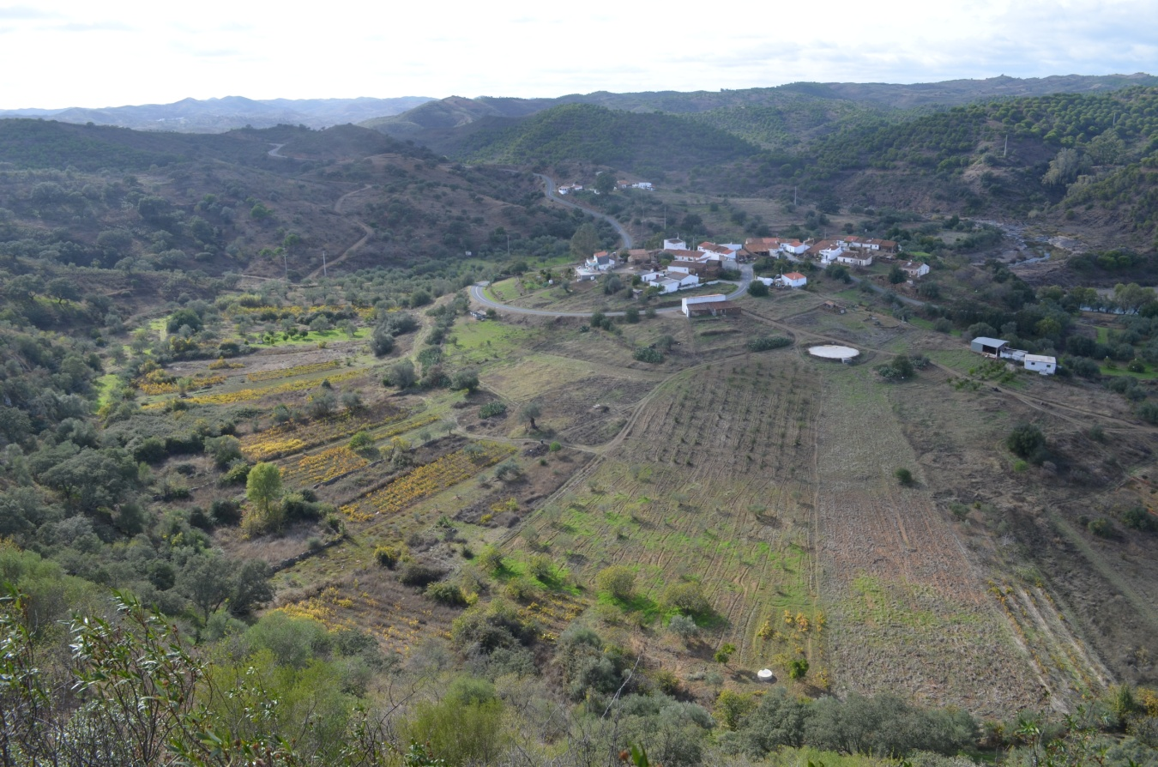
Fig.1 – The landscape of the horticultural gardens of the Fortes village

In the case of the vegetable gardens of the stream of Gafa, the dispersion of the buildings along the route of the water determines that the narrow sheets of irrigated crops accompany it, materializing a continuous hallway of small kitchen gardens. Here, the interdependence between the house, in this case isolated and implanted on the superior third of the hill, and the vegetable garden, in this case parallel to the watercourse taking full advantage of the scarce flat lands squeezed between the riverbed and the steep cliffs, is repeated. The survival of one depends on the presence of the other, from a process of land occupation and exploration that certifies the usual strategy of subsistence in mountain context which translated, historically, into a mixed agriculture – tree, bush, arable – of dry land and irrigation which includes, in general, sowing lands, thorn orchards, fruit trees and vineyards (Cavaco 1976: 75).
The housing, scattered along the line of water, appears as the fundamental place from which landscape and rural economy is organized, considering the characteristic pattern of small property and the traditional Mediterranean poly-culture based on the association of dry land and irrigation crops.
Through an intense agriculture exploration which associates, almost always, tree plantations (citrus, apricot tree, pomegranate tree), bushes (vineyard), greens (broad beans and peas) and vegetables, the riverside horticultural hallway demanded the construction of a loose stone wall which defines sometimes both banks of the watercourse for dozens of meters, associating to its support function, water distribution ending in a gutter. The construction of the support walls and/or waterways has as its objective to stop both the erosion of the riverbanks and the loss of the scarce fertile soil, as well as the flood of the crops or its destruction given the violence of the floods in certain times of the year, and also to allow the circulation of water by gravity and its use in the watering of the vegetable garden.
Understood as a precious good both for the frail family economy, and to their diet, the kitchen gardens and irrigated crops justify the construction of that infrastructure and hydraulic structures (wells, tanks, waterways) of which they depend for the production of food for themselves and for direct sale of the surplus in the nearest traditional markets. To the production of cabbages, green beans, cucumber, bell pepper, tomato, pumpkin, carrot, but also fruits, in the vegetable garden, it is added the production of honey, eggs and goat cheese as a fundamental complement in the context of a subsistence strategy directly linked to the sustainable use of the land.
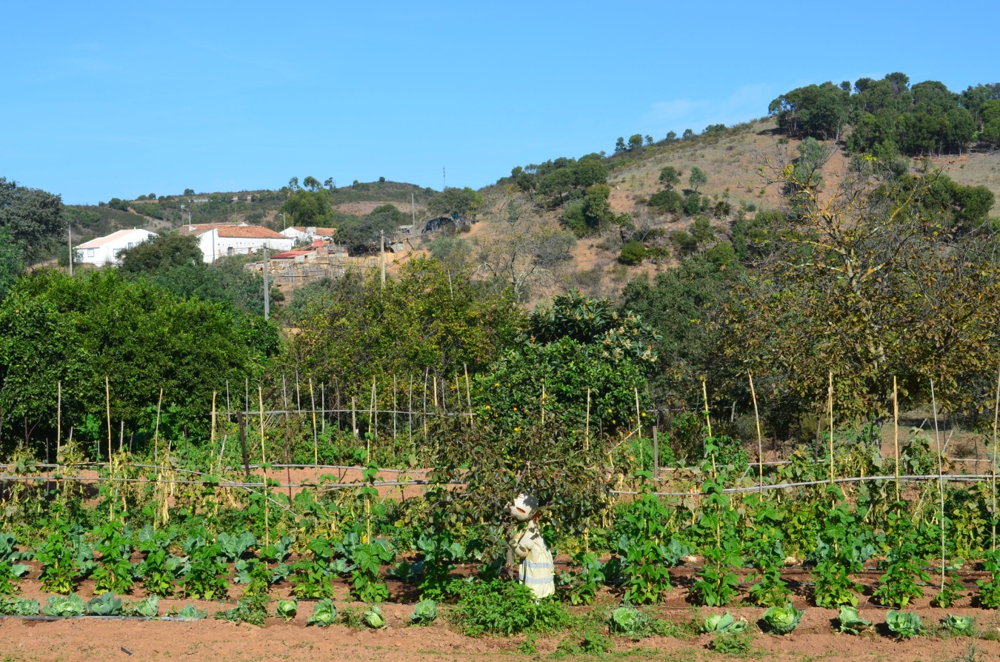
Fig.2 – The traditional riverside kitchen garden

Considering the increasing social and biophysical desertification the mountain range of Algarve faces, the presence of vegetable gardens, although scattered and scarce, holds a significance and a fundamental importance in the perpetuation of life (biological and human) and in their consecration as multifunctional structures of permanent diversity, and social-economic and landscape sustainability.

Vegetable gardens in the Riff of Northern Morocco: the case of ephemeral or seasonal kitchen gardens
The image, organization, diversity of uses and of irrigated crops of the vegetable gardens in the mountain range of Riff, reflect a model of land exploration that translates the specificity of the biophysical conditionings (relief, soil, water, climate) and cultural ones (agricultural techniques, hydraulic techniques and structures, diet) of the mountain areas. This is where the craggy topography and rigorous climate, the irregularity of the rain and the torrential regime, and also the food habits and social-cultural traditions, determine common traits to both margins of the Mediterranean, as well as singularities in spatiality, ambience and in the uses of the vegetable gardens in both sides of the banks.
The historic interchange of vegetable species and irrigation techniques between the eastern and western Mediterranean, between the European and the Maghrebian banks, justifies the affinity and the common denominators of the traditional kitchen gardens between the mountains of southern Portugal and northern Morocco. Here, man develops as strategy of subsistence, or even of survival, that originates the construction of perhaps the most peculiar vegetable gardens in the region. The seasonal or ephemeral community gardens of the Oued Nekor valley, in the Mediterranean side of the Riff, to the north of the coastal city of Al Hoceima, materialize, in their essence, the idea of landscape as a dynamic system in permanent mutation that expresses the spatial and temporal interaction of man with Nature, in all its diversity and creativity.
In the struggle against scarcity and necessity of local resources that characterizes the context of aridity and dryness in which he lives, the Berber farmer creates the possibility of diversifying and increasing food production. Furthermore, this is allied to the cycles of Nature in the shaping of a new, yet temporary, landscape, the landscape of the humid system of the kitchen garden, inscribed in the dry and hot season of the mountainous territory during the summer period. Through the adaptation to the harsh and severe circumstances of the means, and through intergenerational wisdom and experience related to the management and rational use of the soil and water, the populations collectively built a space of sharing for the fruits, cereal and vegetable production, as well as for cattle pastures.
Wisely and patiently, man controls the variable regime of river Nekor (with a significant hydrographic basin), with impetuous floods between October and the middle of May and a long dry period for the rest of the year. Taking advantage of the four hottest months of the year in which it does not rain and, therefore, there are no floods, the farmer occupies the previously flooded riverbed, filled with nutrients and organic matter from the slimes put there by the floods during the rainy season. He enriches the flat and fertile, suitable for irrigation land with adding manure every year. As such, the access to water becomes a key-factor of which depends the success of the annual crops which, every summer, the vegetable garden provides. Depending directly on the mountain as a source of water, man obtains this precious resource both for consumption and irrigation, through the spillway of the river upstream of the area where he lives and practices horticulture, where the water falls by gravity through a system of canals to the house and the vegetable garden.
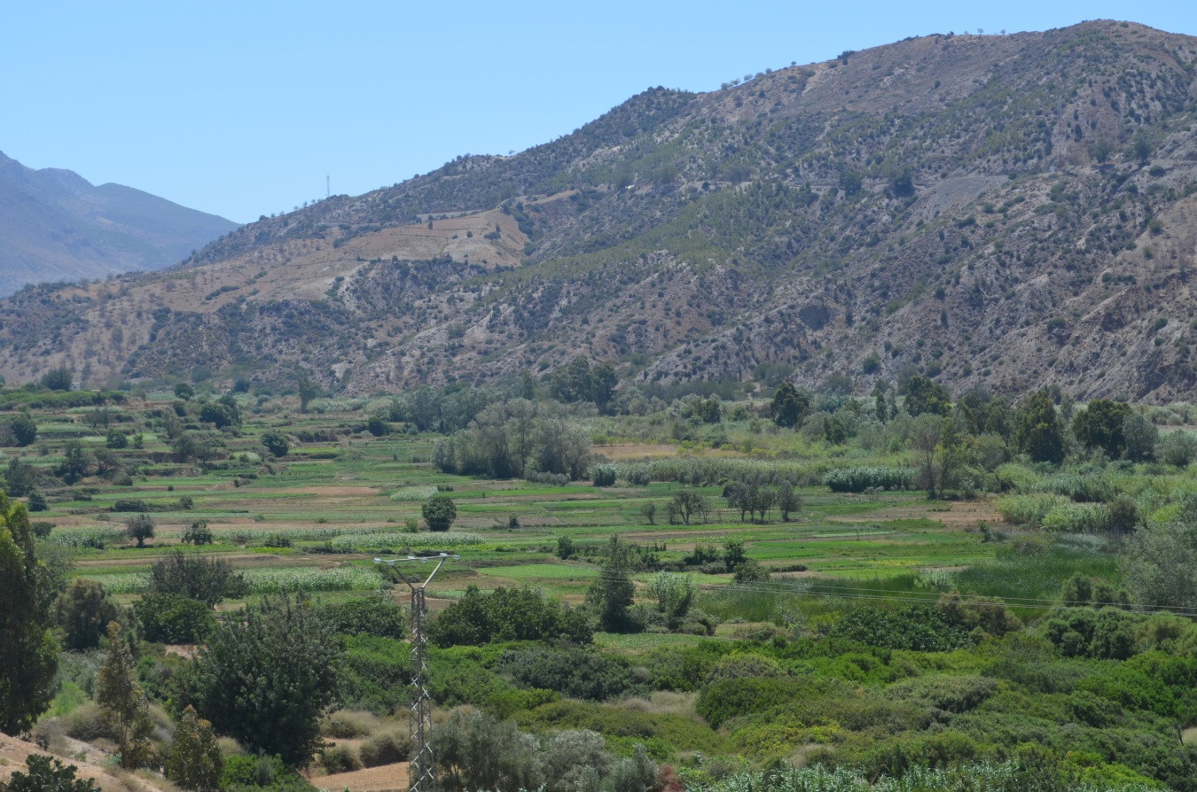
Fig. 3 – Community gardens set out along a bed river with fertile soil and water.

The common origin of the water and the sharing of its use in a common space of agricultural production implicate the association of its beneficiaries and a great rigor in the use of water. On the contour at the bottom of the hill that delimitates the upper part of the irrigated lands, a trough was built which runs through all its extension and, passing through small floodgates, the water is conducted in gutters until the land plots to be irrigated. This way, water assumes an essential role in the design of the kitchen garden as a vital and reverberating element, and as a structuring and backbone element of the ephemeral landscape.
To it joins a geometrical chess with many different irrigated crops squeezed together associated to both a high number of farmers and to the idea of subsistence that underlies the division of the “valley” into an equal distribution of the fertile land per family.
In the seasonal vegetable gardens of the Nekor river, in Morocco, man produces in the four months of the hot season, for immediate consumption or for food throughout the year, a vast array of horticultural products like potato, tomato, carrot, eggplant, artichoke, but also cereals, like corn and wheat, or fruits like figs, pomegranates or persimmon.
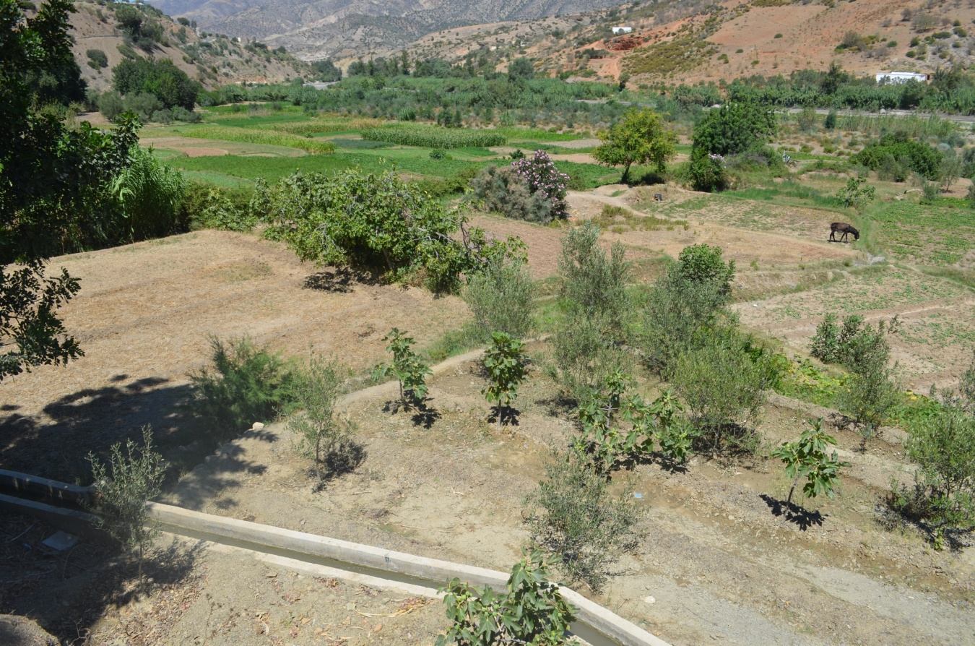
Fig.4 – The irrigation of the horticultural garden with a system of canals.
The high fertility of the soil and the permanent availability of water for irrigation allows a significant increase of production, even providing two seasonal harvests in the crop rotation regime, in years when rainfall does not cause floods and extends the period for farming to five or six months.
Horticulture practiced in the previously flooded riverbed just during the dry season brings the mark of the climate, irrigation type and local diet. In view of this, many vegetable garden products are common to the whole Mediterranean diet of which names, of Arabic origin, testify the contamination between the two banks of the Mare Nostrum: badhinjama (beringela in Portuguese, eggplant), al-khássa (alface in Portuguese, lettuce), and the isfannariya (cenoura in Portuguese, carrot), among others.
Albeit intermittently the vegetable garden alternates with the rushing river that makes it disappear during the rainy season in these parts of the Mediterranean and it is also here responsible for the introduction of elements of ecological, social-cultural and aesthetic diversity. This associated to its occasional presence in spatial and temporal terms grants it the dimension of a real oasis, considering the semi-arid territory where it is located. Also here, or especially here, the kitchen garden links man to land in his conciliation to Nature and in his struggle for subsistence, building a socially useful landscape and a living patrimony that is renewed every summer, acquiring a greater significance as a structure of social sustainability and landscape resilience associated to the condition of survival and a warranty of collective identity.
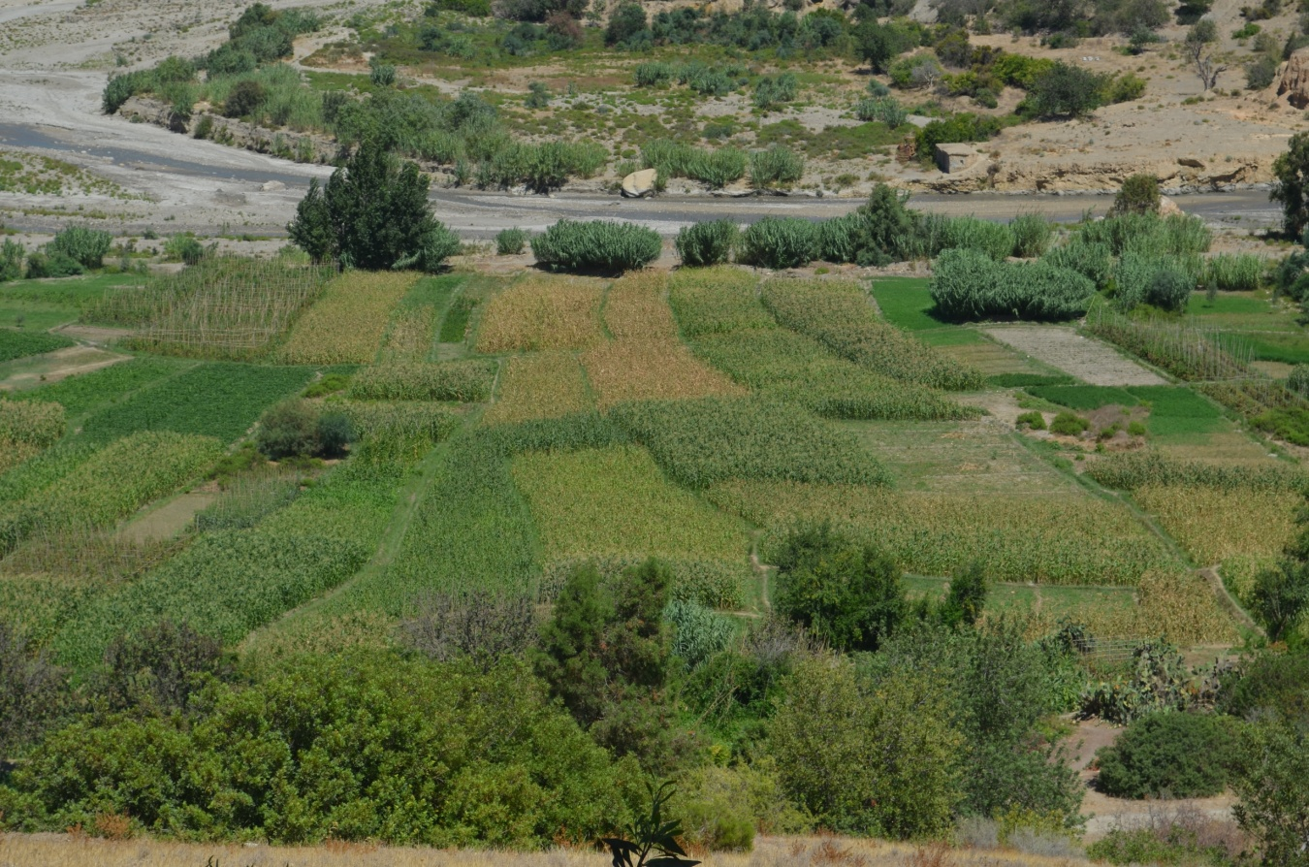
Fig.5 – The kitchen gardens in the bed river on the Summer time.
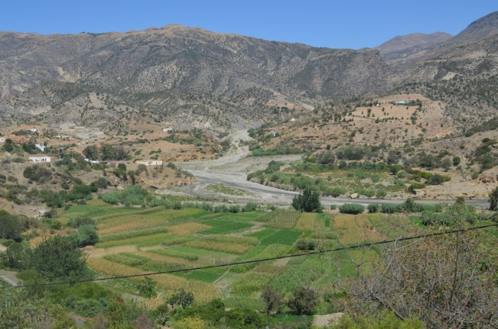
Fig.6 – Horticultural garden of the Nekor river near Tammelaht: A diversity of green tones and textures.
Conclusion
The landscape is spatially and visually dominated by mountain in the Mediterranean Basin. In it, the irrigated crops comprehend, throughout History, a decisive importance. Frequently confined to well-delimitated parcels on the side of a watercourse or associated to a seasonal dimension adjusted to the torrential regime, vegetable gardens are traditionally inscribed in an economy of subsistence set on a scarcity and need of resources, and in a complex calendar of land exploration. Albeit the distinctive traits that mark each of the mountainous areas in this region, the existence of a common model of spatial occupation and organization which is based on the profoundly intricate relation between water, agricultural practice and population is surprising. As such, the identification and characterization of the riverside vegetable gardens that are typical in southern Portugal and northern Morocco were considered the basis for the (re)interpretation of the historical process of construction and transformation of the landscape. In both cases, the kitchen garden links man to land in his conciliation with nature and in his struggle for subsistence, constructing a multifunctional landscape, socially useful and aesthetically beautiful, and living and evolving rural heritage which contributes to the sustainability and resilience of the Mediterranean landscape, in the context of the mountainous territory.

Bibliography

ARONSON, Shlomo (2008), Aridscapes. Designing in harsh and fragile lands, Barcelona: Gustavo Gili.
ASSUNTO, Rosário (1973), Paesaggio e l´estetica. Natura e storia (vol.1). Nápoles: Giannini Editore.
BRAUDEL, Fernand (1983), O Mediterrâneo e o Mundo Mediterrânico na Época de Filipe II (1947) (vol.I), Lisboa: Publicações D. Quixote.
Idem (1995), O Mediterrâneo e o Mundo Mediterrânico na Época de Filipe II (1947) (vol.II), Lisboa: Publicações D. Quixote.
CAVACO, Carminda (1976), O Algarve Oriental. As vilas, o campo e o mar (vol.1), Faro: Gabinete do Planeamento da Região do Algarve.
COSTA, Miguel R. and BATISTA, Desidério, “O Lugar e a Horta na Montanha. O caso de Fortes na Serra do Algarve”. In TORRES, Cláudio et al. (2013), Hortas Tradicionais no Sul de Portugal – Uma Perspectiva Histórica, Mértola: Campo Arqueológico de Mértola, pp.28-45.
MATOS, Rute S., (2011), A Reinvenção da Multifuncionalidade da Paisagem em Espaço Urbano – Reflexões, PhD Thesis in Landscape Arts and Tecniques presented to the University of Évora (Portugal).
RIBEIRO, Orlando (1989), Opúsculos Geográficos. I Volume. Síntese e Métodos, Lisboa: Fundação Calouste Gulbenkian.
RIBEIRO, Orlando (1991), Portugal. O Mediterrâneo e o Atlântico, Lisboa: Livraria Sá da Costa Editora.
RIBEIRO, Orlando (2011), Mediterrâneo. Ambiente e Tradição, Lisboa: Fundação Calouste Gulbenkian.

PART II – SUSTAINABLE GARDEN DESIGN

Raquel Carvalho, Maria Matos Silva, Cristina Castel-Branco, Inês Fontes, Ana Luísa Soares and Teresa Chambel
Historic Gardens as cultural and ecological sustainable models

Rui Sá Correia
Space Equaliser. Ecological perspective of a garden

Gerald Luckhurst
Monserrate: Sir Francis Cook and the acclimatisation of exotic plants in 1861

HISTORIC GARDENS AS CULTURAL AND ECOLOGICAL SUSTAINABLE MODELS

Raquel Carvalho, Maria Matos Silva, Cristina Castel-Branco,
Inês Fontes, Ana Luísa Soares, Teresa Chambel

Introduction

Most Portuguese historic gardens embody the qualities of cultural and ecological Mediterranean landscapes. They constitute living examples from which to learn how to conserve the harmony and balance in a sustainable management.
In 2006, the Portuguese Association of Historical Gardens (APJH) was granted a European funding (EEA Grants) for the restoration of twelve representative Portuguese historical gardens under the project Restoration of Gardens’ Hydraulic Systems, Walls and Trails. Within three years (from 2007 to 2010), multidisciplinary design teams lead by Landscape Architects thrived to fulfil the established objectives, such as the renewal of gardens as areas of artistic intervention and, simultaneously, as ecosystems manipulated by man. This process was carried out by rationally taking advantage of the garden’s natural resources and through the improved quality and management of its water systems in order to progressively raise the level of ecological sustainability.
So far, this project allowed to learn, systematize, compare and share (Castel-Branco 2010) great examples of hydraulic systems that simultaneously combine ecology, agriculture, leisure and aesthetic value.
A global perception of historic gardens as living monuments and works of art that should be admired, defended and preserved is a rare situation. Few cultures have created mechanisms to perpetuate their heritage value. But why are these gardens important models for the future? Two significant reasons stand out: first, because they contribute to the sense of place and identity of communities enhancing socio-cultural heterogeneity while the world is facing globalization and subsequent cultural homogenization. They contain part of the history of a place or region which, in the case of well-preserved gardens, can still be read from its composition and ornament. Secondly, the garden’s components (Portuguese gardens examples, for instance) such as water systems, built features or vegetation diversity are unique sources of important ecological knowledge. They offer us lessons about sustainability on how to collaborate with Nature to make outdoor comfortable and beautiful places.
One of the sources of the uniqueness of these historic gardens are the hydraulic systems that maximize water resources, using animal, wind power or simply gravity energy for collection, distribution and final destiny. These systems furthermore combine ornamental features revealing engineering complexity in the use of water with a print of their owners’ culture and tastes.
Arab and roman wisdom use of water, particularly for irrigation in agriculture, is part of the Portuguese culture. Water gathered from mines, extracted through complex lifting systems, stored in cisterns and tanks, was distributed around gardens. As from the 15th century, water, even prior to fulfilling its purpose of irrigation, was placed in the service of art and deployed to create refined spaces of comfort and beauty in the Portuguese garden. During the Renaissance “ [the garden] use happily mingles with its meaning of it is with the water element that these two factors excel…latter spread through the whole of Europe, the ornamental use of water in gardens carries both a symbolic program and new technology, serving the human pleasures and celebrating His control over Nature (Correia et al. 1994: 69).
This paper shall now focus on a restoration project of some Portuguese historic gardens that reveal this Mediterranean character in the use of water and vegetation. The original water collection, storage and distribution systems were surveyed and registered and became guidelines for the restoration projects and future sustainable design solutions.
This paper will aim to further analyze four of the twelve intervened gardens, namely Quinta das Machadas (Setúbal), Quinta das Lágrimas (Coimbra), Cloister of the Bom Sucesso Convent (Lisbon) and University of Coimbra Botanical Garden (Coimbra). More specifically, it is intended to assess the evolution of the gardens ecological, cultural and managing characteristics, comparing their current status with their registered circumstances prior and right after the end of the project, in 2007 and 2010 respectively.

The EEA Grants project

The EEA grants “Financial Mechanism of the European Economic Space – EEA Grants” program was a crucial opportunity to restore and preserve cultural heritage as they opened a financial support for ecology and culture.
The historic gardens dispersed across the extent of Portugal are key elements where ecology and culture cross. It has been difficult to preserve and maintain them as their owners struggle with maintenance costs due to the high price of labour and no revenue from the gardens (Castel-Branco 2010: 131).
The Portuguese Association of Historical Sites and Gardens (APJSH) submitted in 2006 an application and won a funding for the restoration of twelve representative Portuguese historic gardens under the project Restoration of Gardens’ Hydraulic Systems, Walls and Trails where 60% of costs were supported by EEA grants (Norway).
APJSH deemed the recovery of garden hydraulic systems, walls and trails to be the crucial factor to the investment application given the importance of water for the survival of gardens in hot, dry summer climates. The main objectives included the renewal of gardens as areas of artistic intervention and, simultaneously, as ecosystems manipulated by man, rationally taking advantage of natural resources and re-introducing balanced water management systems able to progressively raise the level of ecological sustainability. This paper presents the advantages that this restoration has reached for the owners and the local communities.
APJSH members were consulted - mostly garden owners - and those who applied had to contractually agree to meet 40% of the total project cost for their garden and, on project completion, keep it open to the public for a minimum of five years. The restoration projects were coordinated by Cristina Castel-Branco (then President of the APJSH) and from 2007 to 2010, twelve projects and works were developed by multidisciplinary design teams lead by Landscape Architects as project directors with experience in landscape heritage and restoration, finishing with a book as final product to register and spread Portuguese Heritage Garden Art and Mediterranean “Ars cooperative Naturae”.

Methodology

For the EEA grants project, the working methodology was based upon the principles contained in the Florence Charter (THE FLORENCE CHARTER 1981) and under other international heritage defence conventions. These principles approach the historical garden as a monument and recommend its restoration and conservation taking into account all the respective legal heritage requirements.
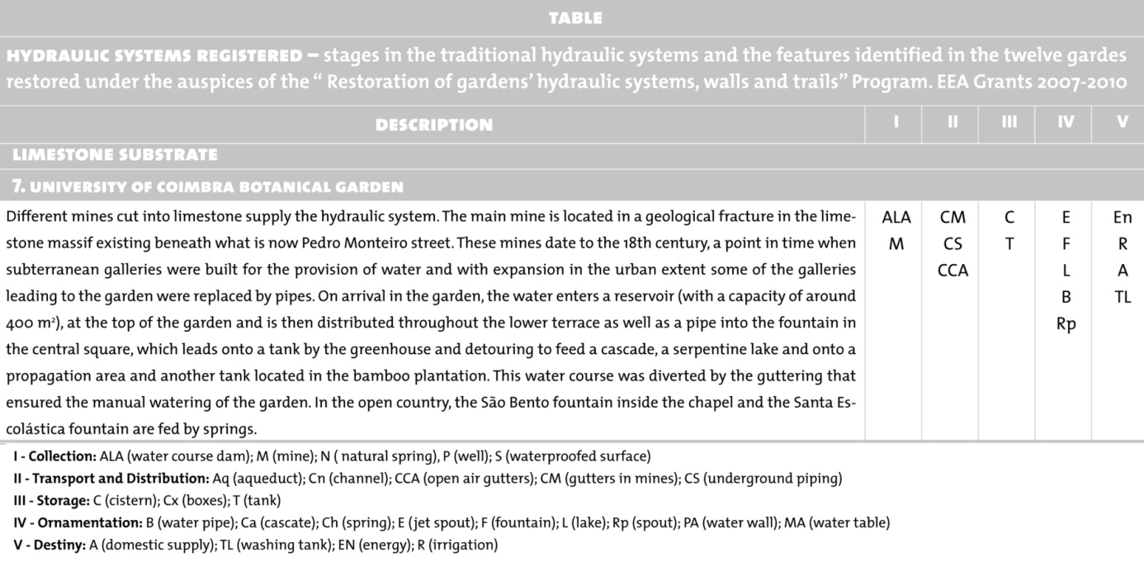
Fig. 1. Example of the Hydraulic Systems Registered Table, 2010.

After studying the twelve gardens dispersed nationwide, the data collection phase could be initiated, with the survey of the hydraulic system, walls and trails – materials, components and linkages. Given the varied range of, a particular attention was given to the hydraulic system details like mines, springs, wells, waterwheels, aqueducts, canals, channels, open air gutter pipes, suspended gutters, subterranean buried pipes, cascades, fountains, spouts, cisterns, and tanks among other features. The survey was complemented with prospection works, validating or discovering hydraulic linkages and features.
The water features were analyzed and a table was developed (fig.1) in order to organize and summarize according to their function and geologic substrate. Five classes were established: collection (I), transportation and distribution (II), storage (III), ornamentation (IV) and destiny (V) - and alongside come the corresponding features identified in each garden.
Once the data was collected and registered, priority areas of intervention were selected, regarding the owners’ available budget, featuring physical conservation state and heritage value.
For this paper, it was intended to assess the evolution of these gardens ecological, cultural and managing characteristics, comparing their current status (2014) with their registered circumstances prior and right after the end of the project, in 2007 and 2010 respectively.

The four case-studies

The twelve gardens studied are distributed across all of Portugal (including Azores) (fig. 2) and display a varied range of solutions within the various classes previously described. They are also distributed across limestone, basalt and granite substrate, forming a representative range of the types of water solutions found in the country. All the gardens have a private owner except Coimbra Botanical Garden which is owned by the Faculty of Science and Technology of the University of Coimbra.
With the intent to stress the representative aspects particularly related to the Mediterranean character of these gardens and these systems and furthermore aiming to analyze the evolution in both private and public properties examples, including private places that embrace public/social events, four gardens were selected out of the original twelve, namely:
- University of Coimbra Botanical Garden, Coimbra
- Quinta das Lágrimas, Coimbra
- Cloister of the Bom Sucesso Convent, Lisbon
- Quinta das Machadas de Cima, Setúbal

Fig. 2. The twelve gardens localization and the four case-studies.

University of Coimbra Botanical Garden

The Garden is located in the city’s historical centre, on a slope leading down to the right hand bank of the Mondego river and is structured into two zones: a terraced formal garden, covering around three hectares and ten hectares of woodland that is spread along the slope.
The decision to build the Garden, took place in 1772 when William Elsden, in cooperation with Dalla Bella, set out the initial garden design in accordance with instructions handed down by Vandelli. Within the following years, the implementation of an hydraulic system enabled the garden to be irrigated. The work continued through to completion of the lower level terrace in 1790 with its wall separating the São Bento hedgerow, the lake, central fountain and the system of water channels. By the 20th century, there was a significant botanical enrichment of the garden with plants brought in from the then colonies.

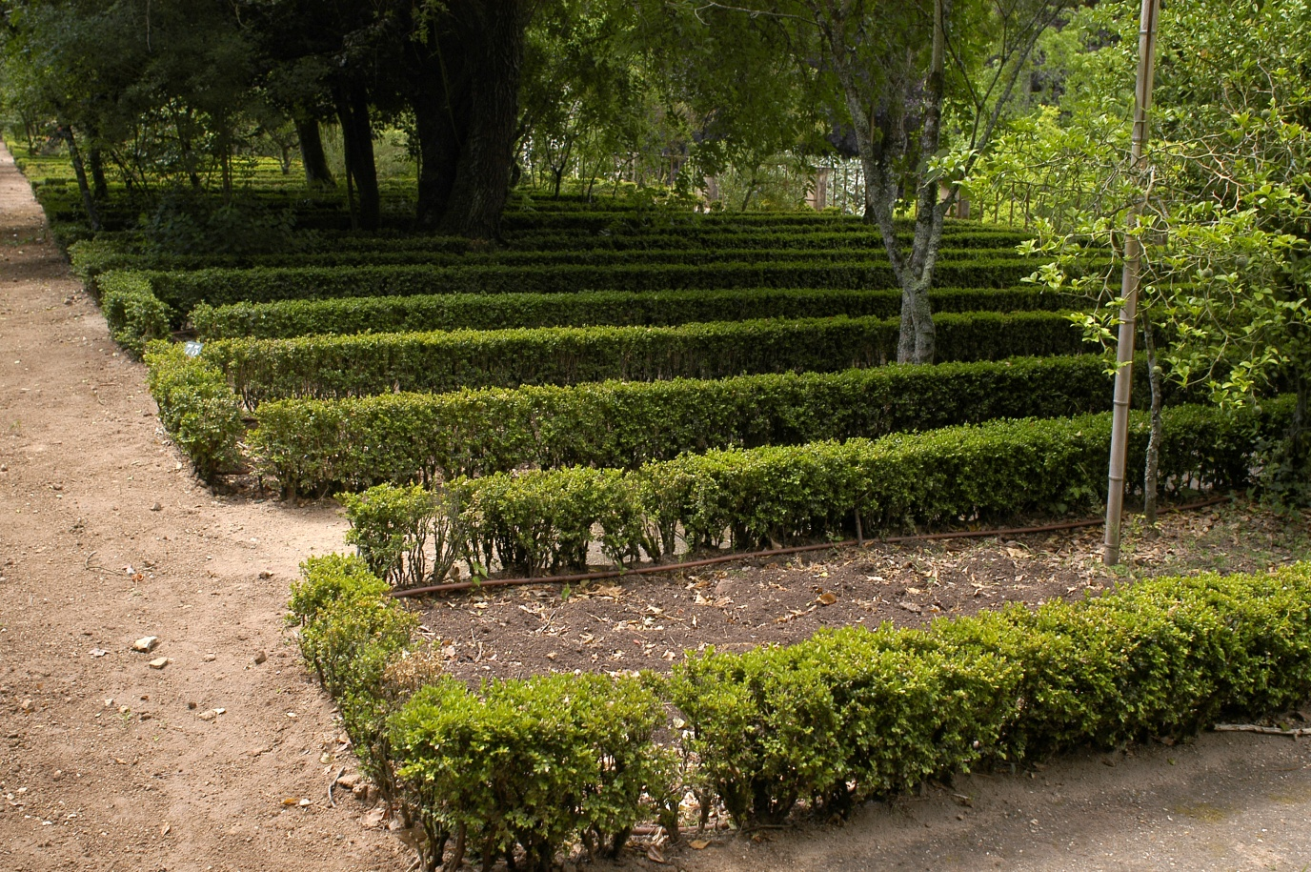
Fig. 3. Automatic watering, 2010. © António Sacchetti

This “Restoration of gardens hydraulic systems, walls and trails” project incorporated two facets:
1) Taking advantage of the waters from the mines and a well through the introduction of an automated watering system connected to a meteorological station and their exploration, with the following steps:
- Recovery of the underground water system and re-collection of water for irrigation / automatic watering (fig.3);
- Installation of an automatic watering / irrigation system with recourse to the located dripping technique so as to optimize and raise the standard of water management;
- Opening up of a water-drill in the lower garden section so as to minimize the lack of water storage capacity.
2) Cleaning and surveying the Santa Escolástica Fountain and the mines in the woodland.
In regards to the latter facet, at the outset the Santa Escolástica (fig.4) – three bicos Fountain was enveloped by vegetation - which was cleared away so as to allow the analysis and mapping of water transport system and evaluate its respective state of preservation. The set displayed similarities with a chapel existing in the forest, entitled the São Bento Fountain. The two buildings appear in city plans from the 19th century and it is probable that both predate the planting of the forest.
In regards to the former, the three objectives set were all achieved:
- reduction in the amount of water wasted;
- reduction in the consumption of commercially supplied water;
- expanding the extend of coverage.
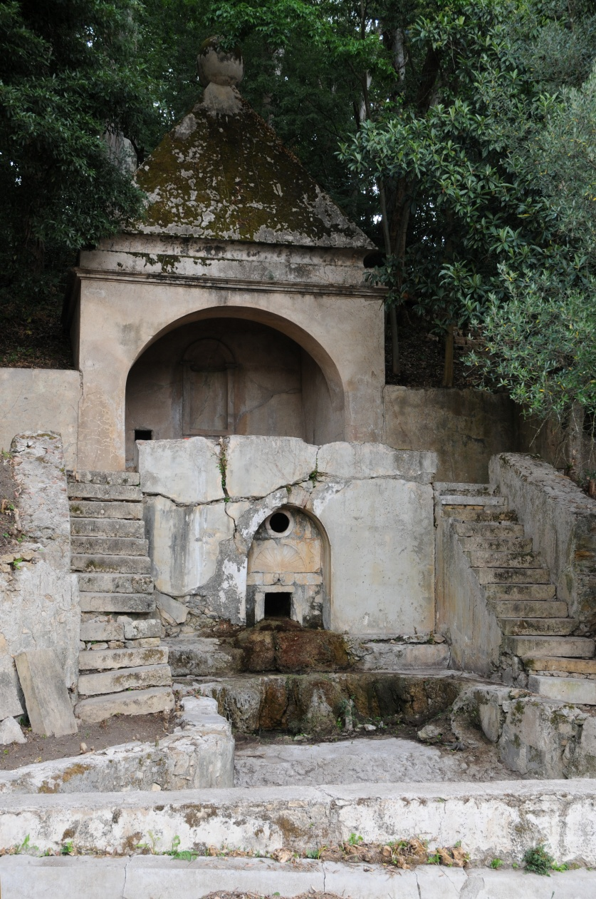
Fig. 4. Santa Escolástica Fountain, 2010. © António Sacchetti

The Heritage hydraulic system was registered and restored with the EEA grants project. The University of Coimbra Botanical Garden, in relation to water supply, is now self-sustainable, using an automatic irrigation system that allowed to save 40.000€/year in water and labour work with a 60.000€ investment.

Quinta das Lágrimas, Coimbra

The most important feature of Quinta das Lágrimas’ landscape, in Coimbra, has always been the water, springing from the earth and the rocks, on the bottom of the steep slopes that surround the western side of the property, or flooding its flat area, yearly, coming from the Mondego river, invading the land and leaving behind a calm and reflecting lake. During those moments the place is more like a waterscape with the house set on an island and the trees reflecting on the water, which also granted it its uniqueness.
By the early 90’s of last century the Alarcão Júdice family, owners of this 20ha property in Coimbra since 1730, decided to keep the farm and Palace in the family, restore it and turn it into a Hotel. In 10 years it became the famous Quinta das Lágrimas Hotel and the gardens visited by 45.000 people a year. By 2005 they decided to invest in the gardens and ACB Ltd was called in to restore the medieval garden and design a new contemporary space which became the Camões Hill, an amphitheatre composed by a lake, stone benches and grass prepared to receive about a thousand people for cultural events (fig.5).
The Camões Hill project sought to respond to the core mission of the Inês de Castro Foundation: to raise awareness about the romance of Pedro and Inês, a theme explored by many artists down through the centuries whether in concerts, operas, plays, painting, films and poetry. Hence, ACB Ltd proposed to design a large open air amphitheatre where music could be enjoyed in summer with quality musicians against a backdrop of trees, water and the view to the Coimbra “acropole” and thereby combining the pleasure of music with the view of an enjoyment nature at dusk. Hence, the gently sloping stage, alongside the lake gradually transforms into a balcony of dispersed seating and intensifying into four final rows as if in a cinema and finishing at the top with a lawn completely overseeing the surrounding landscape. The benches define archways and contrast against the grass given both the white of their stone and the shadows cast over the grass and conjugating a range of always different angles due to the movement of the sun. This is the application of the principle of land art: clearly manifesting an aesthetic intention through the presence of natural processes.

Fig. 5 – Quinta das Lágrimas, Camões Hill, 2008. © António Sacchetti

This artistic intention had to conciliate with a technical problem of water excess that presented a real problem as it flooded the new hotel building spa and swimming pools. Just like it had been done in the 16th century the water was retained and stored in a reservoir, the drainage and storage project was designed by ACB Ltd in accordance with the locally prevailing characteristics. The open air amphitheatre was designed simultaneously with a buffer basin protecting against winter floodwaters, downstream to the Lágrimas fountain, to avoid any flooding of the new SPA building (2004) designed by Gonçalo Byrne.
The intervention, financed by EEA Grants and the Inês de Castro Foundation, combined two wishes into a unique project.
Filled by gravity with the waters of the millenary Lágrimas spring, a round lake was placed, 18 metres in diameter this generated a new water reserve thus complying with the EEA Grants objective: capturing the locally available water and making it available for irrigation and aesthetic purposes (Castel-Branco 2010: 97). Hence, the seating was installed in rising rows of sections and at intervals to create strips of grass to ensure the permeability of the soil. Ecologically nothing is lost and aesthetically much is gained (fig. 6).
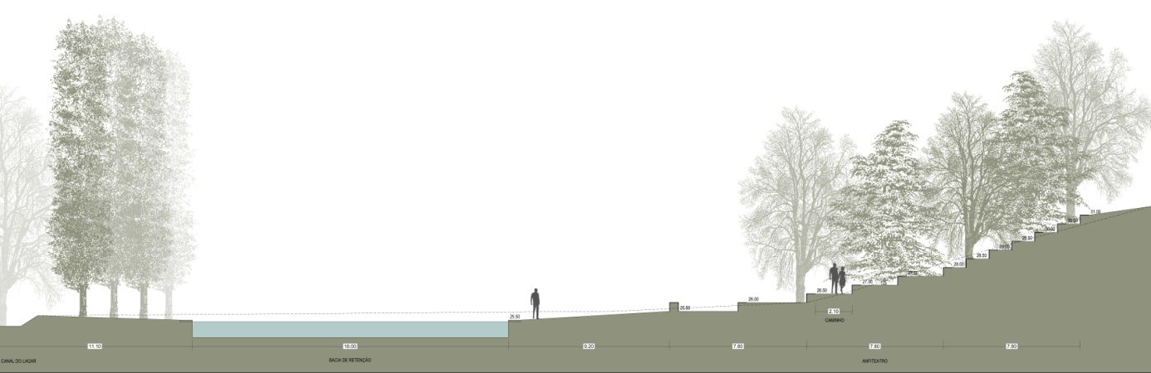
Fig. 6. Camões Hill, cross-section of benches, lake and sequoias. Sketch by Miguel de Sousa, 2008.
The amphitheatre was designed to be an integral part of the garden, but also to have its own life for summer performances and a festival was created for this purpose. Every year in July for ten days the Festival das Artes presents music, theatre, dance and poetry and the amphitheatre comes alive with its stage, artists and public experiencing a moment when music is intertwined into the garden. The actor Diogo Infante has coined that aesthetic experience “In July all the paths lead to the festival of Arts in Coimbra. Then, Quinta das Lágrimas becomes the supreme heaven where history, art and nature in communion are in perfect harmony. It is a great pleasure to share that moment”.

Cloister of the Bom Sucesso Convent, Lisbon

The Bom Sucesso Convent was constructed between 1645 and 1688 nearby Bom Sucesso beach, in Belém, Lisbon. In 1997, the convent was classified as a Property of Public Interest by the Decree 67/97, of 31 of December.
The Cloister of the Bom Sucesso Convent has a lake at the center covered with zigzagging blue and white tiles as the pinnacle of the convent church. This lake contains a central waterspout and eight lateral jets on the vertices.
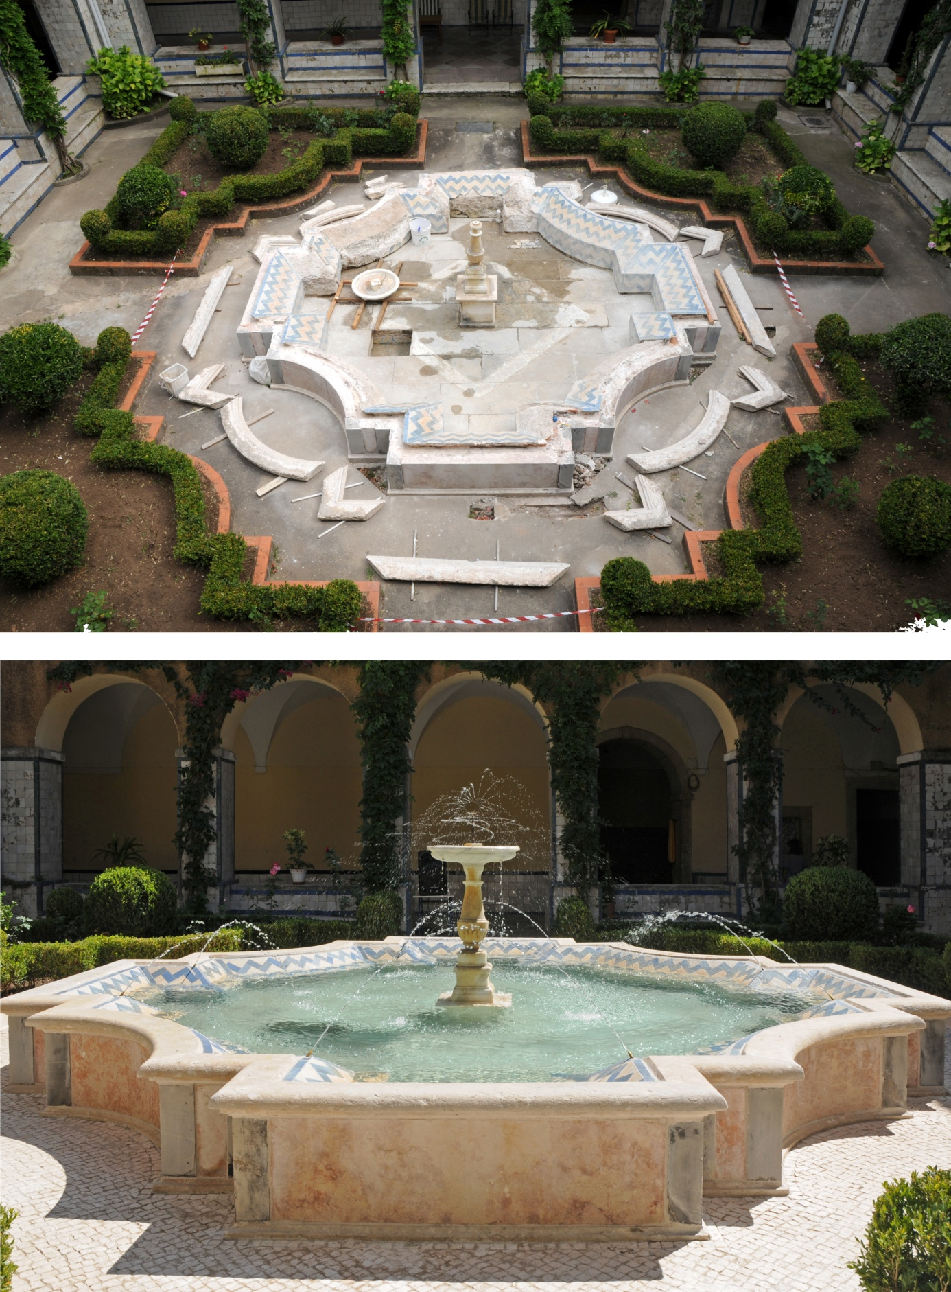
Fig. 7. Convent cloister during and after the restoration of the central fountain’s hydraulic system, 2010. © António Sacchetti
The central spout emerges out of a worked marble bowl resting upon a high stand. At its center, there is a copper piece that rotates circularly under the pressure of the water to distribute it out over the lake.
Originally, the water supply of the Cloister was ensured by a mine. In June 1942, the water no long ran in the cloister due to the urbanization of Restelo. Since June 1942, the water supply has been made by the local water company.
Before the restoration project, in 2010, the central spout had no pressure and the jets did not work because the pipes were losing water.
Beyond the lake, the pathways were covered by concrete and flower beds walls topped with tiles of brick. The diversity of all these materials created a spatial dissonance.
The restoration project sought to restore the cloister pavements, drainage, flower bed walls and the historical hydraulic system of the artificial fountain (fig.7).
The concrete pavements were substituted by small cobbles and the flower bed walls by beaten and worked limestone.
Furthermore, the drainage system was inefficient and the water from the Convent roof was being channelled down onto the cloister floor. This situation was corrected by connecting the guttering into buried drainage pipes and with surface runoff funnelled into channels that were set into the cobbles which surround the main flower beds and lead to the drains.
Specifically regarding the hydraulic system restoration, new copper tubes were installed in parallel to the former lead piping maintaining the latter in situ. Considering the main spout, in order to guarantee water supply, connection tubes were replaced by new LDPE tubes leaving the existing ones for record.
After the restoration, the Convent sisters’ invested in a lightning system so they can use the cloister at night. This may be considered an indicator of success by the increase and diversification of the uses of the cloister.
Since 2010, the celebrations in the cloister of Bom Sucesso Convent have increased (Fado night, finalist parties, and others). The convent sisters’ confided that part of their community time is spent in the contemplation of the water effects which were previously unknown to them.

Quinta das Machadas de Cima, Setúbal

Quinta das Machadas de Cima is located at Baixa de Palmela near Setúbal, in fertile alluvium lands. It was acquired around 1760 from Ordem de Santiago by Jacob Friederich Torlade, consul of the Hanseatic League, who wished to export Sado salt and citrus fruit to the countries around the Baltic Sea. The estate’s location and topography were particularly adequate for this purpose as its aquifer resources were able to irrigate a six hectare orchard from solely two wells and two tanks.
From 1860 to 1980, Quinta das Machadas estate was part of a major property that included Quinta das Machadas de Cima (the “upper” Machadas) and Quinta das Machadas de Baixo (the “low” Machadas). In the 19th century the orange production took over half of the estate, and a grid of irrigation channels and pathways with benches, pergolas and niches was introduced. The rest of the planted area included an olive grove, cork oaks, vines, pines and vegetable gardens. Since them, Quinta das Machadas embodies the Mediterranean character of historic gardens. It combines native vegetation with ingenious traditional hydraulic systems, merging productive agriculture with leisure gardens.
In 2006, given the poor conservation state of the hydraulic system, the current owner, Hugo O’Neil, was particularly motivated to join the Portuguese Association of Historical Gardens (AJH) in its joint application for the EEAGrants project. The restauration of the original water system, which included elements of collection, storage and distribution, was therefore developed and implemented. In a brief description, water is drawn from the wells into tanks and from the tanks it enters channelling systems that spread out the water into the orchard plots.
Following the recommendations from The Venice Charter (THE VENICE CHARTER 1964), whenever possible, traditional elements were restored through the use of original materials and authentic documentation. In the case of this project, only the water collection system, which was previously made through animal power, was substituted by a pumping system. All its other components enable water to work by gravity alone (fig.8).
The ornamental features add complexity to the water engineering but also introduce aesthetic and cultural values as well as different functions such as rest areas. For example, in one of the most interesting recovered hydraulic set, an embrechados fountain links a water wheel to the prominent tank of Thor; this former, with its stone statues and water games, which would surprise guests as they approached the tank, gives an ornamental print to the main function of water retention. This assemblage, which resides below two notable plane trees, furthermore includes a leisure area composed by a refreshing zone with facing benches and stone tables.
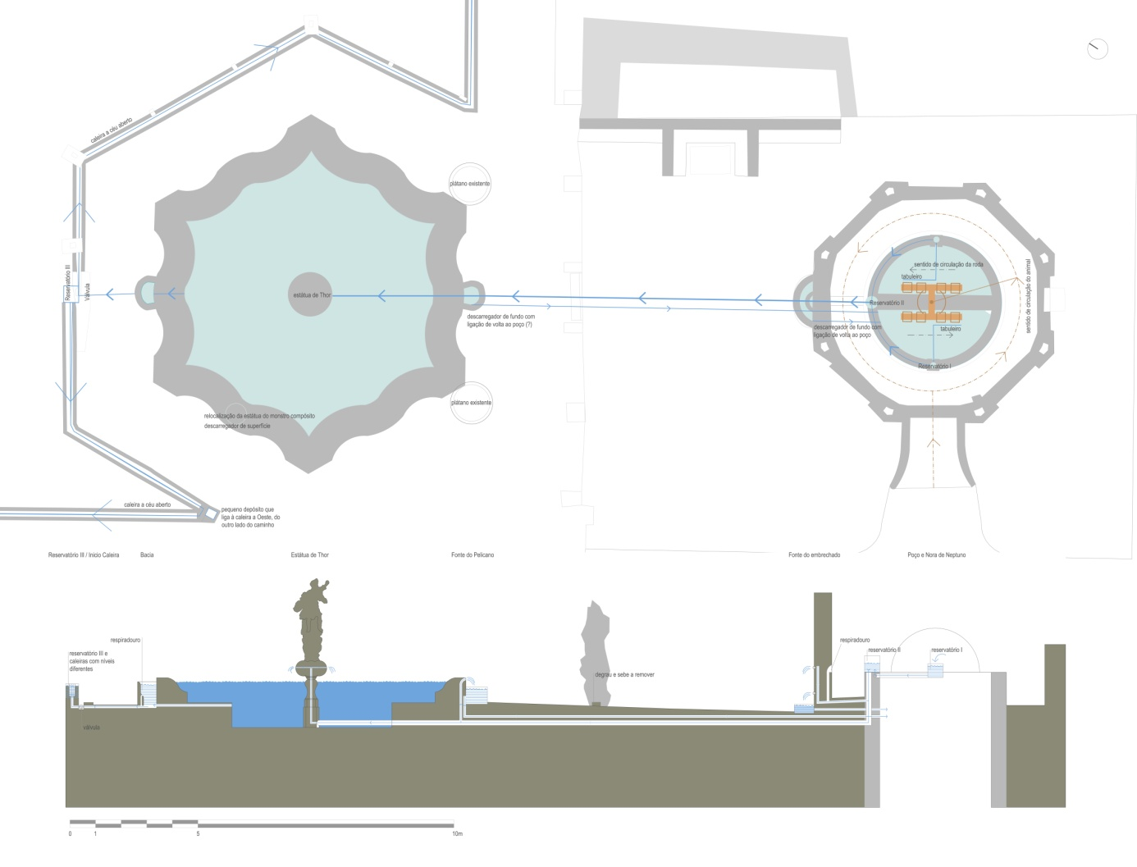

Fig. 8. Plan view and section of the hydraulic connections: well, embrechados fountain, Thor tank and the gutter system. Sketch by Raquel Carvalho and Maria Matos Silva during surveying work, 2009.

Almost everywhere this water journey can be acknowledged. It is one of the greatest values of Quinta das Machadas, which cyclically invigorates its identity.
Four years have passed since our intervention. By monitoring the system’s evolution, including its associated functions, more can be learned by this experience. From a recent visit to the estate, one could observe that the original irrigation system was still in good condition and, most importantly, it was fulfilling its purpose. New orchards of oranges were planted in the previously empty plots and all productive landscape was irrigated with water from the wells and tanks. Moreover, new uses arose such as a half hectare of vegetable gardens. During the visit, in a conversation with its owner, we could further understand how important this restauration was for the dissemination of the traditional Portuguese heritage, and in particular, for the valorisation of Quinta das Machadas. On the one hand, the fact that he could open his renewed farm and its gardens to the public (touristic or institutional) allowed him to invigorate established associations and integrate new networks. Synergy processes that, on the other hand, may be crucial for the proper management and maintenance of such cultural patrimony.

Conclusions

The EEA grants allowed to learn and share traditional Portuguese ingenious hydraulic systems. When comparing the twelve gardens, one can note that each water phase has different facets depending on the place’s respective location, geology and topography. Water wheels, for example, can only be found in flat, limestone regions (CASTEL-BRANCO 2010: 132).
Assessing the evolution from 2010 to 2014 in four of the twelve gardens, it was possible to initiate some reflections:
- The gardens’ restoration and the premise of opening to the public (touristic or institutional) enabled the dissemination of the traditional Portuguese heritage while boosting the gardens’ valorisation and management;
- Some owners added new cultural functions around the renewed gardens, revitalizing this inherent characteristic of historic gardens. In particular, the Festival das Artes at Quinta das Lágrimas or the Noite de Fados at the cloister of Bom Sucesso Convent.
- Although the biodiversity component was not measured, the act of bringing back the water element may be considered a starting point as it increased the presence of birds and promoted the implementation of productive cultures;
- By improving the drainage systems, unused existing water, such as natural springs, wheels or roofs’ rainwater, was recovered. Automatic irrigation systems and flood prevention infrastructures furthermore brought effectiveness in water management and expenses in labour works.
The management of these gardens should assure their full potential in relation to its intrinsic values as well as those that could be additionally created. The challenge resides on finding the right strategy which is able to preserve heritage while supporting other development aims, “Landscapes of the past can not be brought back, but ways how valuable elements and areas can be preserved and become embedded functionally in the modern urbanized and globalized society must be studied.”(ANTROP 2005: 12)

Acknowledgments

The authors would like to acknowledge the teams who worked for three years in the EEA grants project; in particular, landscape architects Miguel Coelho de Sousa, Inês Pereira de Lima, Marta Malheiro, Bernardo Magalhães e Menezes, the engineers Jorge Froes and Francisco Manso for their hydraulic and irrigation technical support, and to the construction companies involved in the prospection and restoration works: EJR Lda, Alfredo & Carvalhido, Aquafluxo, Salvador, Albino & Fernandes , Silva & Pintos, Construções Castanheira & Joaquim, Dryas, Forte & Gomes, Vibeiras, Chão Bom, Jeka, Conservação e Restauro, Lda and Árvores & Pessoas — Gestão da Árvore no Espaço Urbano. Furthermore a very special thanks to the gardens’ owners and the photographer António Sacchetti.

Bibliography

ANTROP, Marc (2005) «Why landscapes of the past are important for the future.» Landscape and Urban Planning, Vol. 70, Nº.1-2, 2005, pp.21-34. http://www.sciencedirect.com/science/article/pii/S016920460300207X
CASTEL-BRANCO, Cristina, ed. (2010) Water in Portuguese Gardens, Lisbon: Scribe.
CORREIA, et al. (1994) Os Quatro Rios do Paraíso, Lisboa: Publicações Dom Quixote.
HISTORIC GARDENS - THE FLORENCE CHARTER (1981). ICOMOS-IFLA International Committee for Historic Gardens. Adopted by ICOMOS in December 1982, Florence. http://www.international.icomos.org/charters/gardens_e.pdf
INTERNATIONAL CHARTER FOR THE CONSERVATION AND RESTORATION OF MONUMENTS AND SITES - THE VENICE CHARTER (1964). IInd International Congress of Architects and Technicians of Historic Monuments, Adopted by ICOMOS in 1965, Venice. http://www.icomos.org/charters/venice_e.pdf

SPACE EQUALIZER. ECOLOGICAL PERSPECTIVE OF A MEDITERRANEAN GARDEN

Rui sá Correia

While the relationship between Man and the landscape used to be essentially spatial, in modern times this relationship has become more temporal. Therefore, it is clear that the spatial relationship that connected them through an understanding of the characteristic mechanisms of the landscape has deteriorated throughout Man’s history. They once coexisted in a symbiotic relationship, recreated today in a virtual reality and corridors, which because of the speed they entail, detract from perception of the space which is travelled through in a flash.
Man is no longer a biological organism, but a bionic body, making machines extensions of the human condition. This results in a false sensory perception of landscape and, as a consequence, also of the feeling it should evoke in us. Through this bionic body, we recreate our perceptive, sensory and emotional capacities, changing our perception of spatial and temporal dimensions and, consequently, of the cognitive dimension. We perceive the landscape and become emotionally involved with it through virtual journeys we go on through the virtual space of the Internet. We watch television programmes about far-flung corners of the world that we come to believe we know, travelling in cramped compartments at dizzying speeds across a landscape offered in a succession of frames inducing motion sickness.
We currently do not live in a space, but in a temporal dimension not in keeping with the human condition, hindering the establishment of a relationship with the spatial dimension. There was a time when this relationship presupposed both contemplation and interpretation of the guiding mechanisms of landscape, resulting from the need for a carefree attitude in which time is suspended.
The way in which we appropriate landscape reveals how we relate to it. At one time, urban agglomerations were juxtaposed with the landscape, respecting its natural mechanics. However, today the relationship urban settlements have with the landscape is one of extortion, where infrastructures interfere with natural flows, hampering their circulation, and where urban voids, intended for interpersonal relationships, are today spaces destined to be occupied by the main protagonist in this web which is a city: the automobile.
Naturalised landscape and agricultural landscape are frequently pushed to the outskirts of the expanding city or to distant places where production costs are assumed to be lower. For the sake of economic concepts, we erase the local identity and instead emphasise a global culture that lacks identity.
We slowly initiate the decimation of the landscape, threatening its continuum, giving way to monotonous, monochromatic and monotextured landscapes, divested of diversity, dysfunctional, fragmented and ultimately unsustainable.

The creation of the garden

Man’s stance in relation to the natural landscape is spatially expressed in the creation of a garden.
According to Carapinha (1995: 12), this space is “(...) the formalisation of a primordial and imaginary landscape, as an emotional and spiritual reaction, an aesthetic valuation of natural elements – and, as such, an artistic and poetic expression of Man before Nature – it is designed and constructed as a purification of the landscape, a sublimation of natural elements, the celebration of a landscape idea in a precise moment and space and the revelation of the landscape’s immanent aesthetic qualities. It is nature idealised, humanised and transfigured into a pure and disinterested (and, as such, aesthetic) object of contemplation.”
The garden, as the formalisation of the landscape, materialises the temporal dimension in a confined space. It is, therefore, an instant formalised in a safe and comfortable space in constant transformation.
Also in the Mediterranean reality, forms of the garden and landscape have accompanied the cognitive, emotive and perceptive evolution of Man. If the relationship Man currently establishes with the landscape is an imposition of his will and necessity, then, naturally, the garden will continue that tendency.
In the distant past, the Mediterranean garden served the purposes of leisure and production, where plants were chosen for their appearance, but also because of their capacity to provide food. Today, that same garden has become a space that releases us from our environmental obligations, resulting in a slow loss of the identity that characterises it. The contemporary Mediterranean garden is designed, as Domingues (2009:47) alleges regarding landscape, as a space of “chlorophilatry”, where the prerogative is that it is green, which should release us from our responsibilities to the natural mechanisms of the landscape as well as to the traditionally fruitful identity of the Mediterranean.
It is, therefore, essential that we accept the Mediterranean identity as not only a cultural advantage, but also as a stronghold of the local identity which clearly enriches the entire universality that increasingly brings us closer together.
The following is a case study of a residential garden within the Mediterranean landscape and which design respects local characteristics, recreating infrastructures that ensure storage, and distribution of water and the irrigation for a range of plants, where business and pleasure, leisure and productivity coexist.

The project

Preliminary programme
The owner’s requirements included an area for the production of vegetables and fruit for family consumption and leisure areas. Although not necessarily a requirement, the possibility was mentioned of constructing a swimming pool or above ground tank to be enjoyed by the family, particularly the children.
Environmental preservation was the owner’s underlying premise, with a special focus on the preservation and conservation of water resources. The owner suggested that all the water necessary for the maintenance of outdoor areas, including watering and filling the swimming pool or tank, should come from the well, resulting in a substantial reduction in water costs.
An intimate character for the entire space was also presented as a requirement, and the solutions presented should create a visual and physical barrier between the garden and neighbours.

Characterisation

The residential garden in this project is located in Póvoa de Bustos, an urban area with strong agricultural traditions, located approximately 25 kilometres from the city of Aveiro.
The outdoor area is comprised of two spatial units: a courtyard and a garden, currently used for vegetable production. This garden visually relates to the surrounding landscape to the north and borders with the outdoor areas of other homes to the east and west.
The courtyard is the preferred entrance to the house and connects the house on the east to other separate structures (wine cellar, storage areas, office and laundry room) to the west. Being an open space, it serves as a compluvium, since rainwater from the roof drains into the courtyard. However, there is in fact no suitable rainwater drainage network and rainwater drains by gravity into the street or the garden. It is important to emphasise the relationship between the open courtyard and the sky, since this is practically the only source of natural light in almost all the rooms in the house.
The vegetable garden, which is more or less flat, is currently used for the production of vegetables and a few ornamental species, without any organisational structure. To the west, near the limit of the intervention area, there is a well from where the water used for irrigation is taken. The irrigation system does not meet the needs of the garden. Watering is done by hand and often does not reach the entire area. Consequently, not all the plants are sufficiently watered. The reception area for the garden, to the south, connects directly to the courtyard and is enclosed by two walls of the same height as the building, defining an area with an intimate character.
In conclusion, the intervention area does not present significant constraints that might hamper the solutions conceived. However, the views to the east and west of the garden are not favourable. In turn, it must be noted that the visual relationship established to the north with the surrounding agricultural landscape should be emphasised. Figure 1 illustrates the main characteristics and constraints in the intervention area.

Courtyard
Garden
Well
Fig. 1. Characterisation of the intervention area

The Proposal

Over the years, the characteristics of the Mediterranean landscape have led to the perfecting of architectural devices that offer solutions for its specific constraints. Lack of water is the most common constraint in the Mediterranean garden, and has also been formalised through intricate storage infrastructures and water channelling for irrigation. These devices that solve the problem of lack of water also incorporate other functions of a more pleasurable nature, creating ambiences that enrich our sensory experience of the garden. Water often contributes to the thermal regulation of the garden, additionally offering sensory experiences, namely through touch, hearing and vision.
The principal objectives of this SPACE EQUALISER project are to solve the problems associated with lack of water and to preserve this natural resource. To this effect, a traditional irrigation system was recreated through which the water is channelled by gravity through irrigation channels and later distributed using watering systems in the various beds, using a flood irrigation method. A rainwater drainage network was defined to channel water into the water storage tank, which during months of drought can meet the irrigation needs of the plants in the garden and also supply the proposed leisure infrastructures.
The existing well was the solution that best fulfils the objective of storing water, since it does not imply the added costs associated with building an infrastructure for this purpose. A system for channelling rainwater in the courtyard will therefore supply water for this tank. This water will later be used for both irrigation and filling this well. Figure 2 is a schematic diagram of the drainage of rainwater to the well used as a water storage tank.

Fig. 2. Schematic diagram of the channelling of rainwater to the water storage tank.

To ensure gravity irrigation and considering that the intervention area is levelled, not presenting different heights, differences in height must be created.
Land modelling was not an appropriate solution because it would contradict the natural topography of the surrounding landscape, which does not present significant slopes. Therefore, considering that there was an abundance of construction material left over from the restoration of the house, the solution was to create raised beds. This solution had several advantages: the creation of different heights which will facilitate the channelling gravity of water; the building of walls around the intervention area, enclosing the space and consequently reinforcing its safety for users; enhancement of the sensory relationship (smell, vision and touch), which the user of the garden will establish with the plants; thermal regulation of the garden through evaporation of the water in the irrigation channels which will give the entire space a characteristic ambience; compartmentalisation of the garden into small areas for vegetable production. Figure 3 shows the raised beds, which, giving structure and compartmentalising the garden, define three distinct areas.

Resting/leisure area
Production area
Reception area

Fig. 3. Structure defined by the raised beds and the relationship established between the different spatial units.

In spite of the spatial characterisation, as illustrated in figure 1, showing two spatial units, the courtyard and the garden, connected both visually and physically, the need to compartmentalise the garden is fundamental. Therefore, to the south, a reception area is established for the garden, which acts as a resting/leisure area and is directly related to the courtyard. In the north end of the garden, an area is established for vegetable production.
The first spatial unit, the courtyard, measuring approximately 163 m², functions as a reception in the residential area, given that the preferred entrance to the home is in the courtyard. Taking into consideration the importance of connecting various compartments located in this residential area, to the west, it was established that the entire area should be covered with impermeable paving, which would result in a substantial reduction in water loss due to infiltration. This water could later be channelled to the holding tank.
With an area of 133m², the second spatial unit is defined as a resting/leisure area and is established through the use of a semi-permeable deck and a small grassy area which marks the entry into the garden. The intimate character of this leisure area is ensured through the side walls which are the same height as the building. However, to prevent excessive sun exposure, a pergola with stainless steel cables will be installed. Once it has been covered by climbing plants, the pergola will not only ensure comfort in this area, but will also be an example of a characteristic feature of Portuguese gardens, creating unmatched luminosity. The irrigation tank serves as an alternative to a traditional swimming pool because its construction involves lower costs than that of a pool. It also fulfils the need to create a water tank to distribute water along the irrigation channels and the water in this leisure feature is also due to be regularly replaced. This area is notable for the presence of water features, the two large tanks to the east and the west. The fact that these tanks are located in areas that are higher than any of the raised beds means that water drainage will occur through gravity, as illustrated in figure 4.

Fig. 4. Schematic diagram of the direction of the water flow along the irrigation channels.

The third spatial unit, intended for vegetable and fruit production, is established in an area of approximately 271m², with a permeable ground surface (firmly compacted natural soil) and the raised beds which establish relationships of height that enable water to drain by gravity. At the centre of the vegetable garden there are two structures which, although they resemble the beds, are in fact covered and act as garden furniture.
Each spatial unit has distinct uses and fulfils distinct functions. However, the connection between them is clear, through the physical and visual relationship between them and through the constant presence of water in all the spaces.
Given that the vegetable garden is a laboratory, where agricultural experiments are conducted and where different plant species are cultivated, according to the needs of its users, the deliberate decision was taken not to draw up precise planting plans. This stimulates interactive creativity between the users and the space. However, a document was drawn up with the conceptual proposal charactering several plant species which are appropriate for a kitchen garden. This laboratory space can thus be recreated in accordance with the needs and requirements of the users. Nevertheless, in the courtyard, the planting of a Cupressus sempervirens tree is proposed. Due to its structure, it does not affect the light in this space and in fact emphasises the strong relationship between the space and the sky. Figure 5 presents the general plan, with a special focus on the recommended surfaces (impermeable, semi-permeable and permeable), but also on the areas where herbaceous plants, shrub and trees should be planted.
Fig. 5. General plan of the residential Mediterranean garden.

Conclusion

The Mediterranean landscape presents complex characteristics that are often not respected by those who directly or indirectly transform it. Numerous architectural features have arisen in response to the diverse characteristics of the Mediterranean region, its soil, climate and crops. The most influential characteristic is water. Mediterranean gardens have always been built around the need to channel and store water for irrigation. They have been enriched by infrastructures that provide unmatched sensory experiences, where water functions not only as an environmental temperature regulator, but also as the element that brings users closer to the space, awakening their senses: touch, vision, hearing, smell and taste.
As the landscape has become formalised through elements which distance themselves from our sensory experience, the Mediterranean garden has also become structured according to a perspective that does not match the characteristics of the Mediterranean landscape. Therefore, it is essential for this paradigm to change, based on the empirical knowledge that has been established throughout history and always respected the biophysical characteristics of such a landscape as complex, diversified and luxurious as the Mediterranean landscape. In this case study, after fully comprehending the guiding mechanisms of the landscape surrounding this garden, customised solutions were developed to fulfil the needs of its users, interpreting its genius loci and, above all, respecting the constraints of the space, namely lack of water, a characteristic often observed in Mediterranean landscapes.

Bibliography

CARAPINHA, Aurora (1995), Da essência do Jardim Português, PhD Thesis on Landscape Architecture presented to the University of Évora, Évora.
CARERI, Francesco (2002), Walkscapes. Walking as an aesthetic practice, Barcelona, Editorial Gustavo Gili.
CARITA, Hélder and CARDOSO, Homem (1998), Tratado da Grandeza dos Jardins em Portugal ou da originalidade e desaires desta arte, Lisboa, Bertrand Editora.
CAUQUELIN, Anne (2008), A Invenção da Paisagem, Lisboa, Edições 70.
COLAFRANCESCHI, Daniela (2007), Landscape + 100 palavras para habitarlo, Barcelona, Editorial Gustavo Gili.
TIBERGHIEN, Gilles A. (2001), Nature, Art, Paysage, Actes Sud / École Nationale Supérieure du Paysage / Centre du Paysage.
VIRILIO, Paul (2000), A Velocidade de Libertação, Lisboa, Relógio d’Água Editores.

MOSERRATE: SIR FRANCIS COOK AND THE ACCLIMATISATION OF EXOTIC PLANTS IN 1861

Gerald Luckhurst

Sir William Thiselton-Dyer, assistant director of the Royal Botanic Gardens at Kew, addressing the Royal Colonial Institute in 1880, made a succinct description of the aims and function of the Victorian botanic garden:

a garden in which a vast assemblage of plants from every accessible part of the earth's surface is systematically cultivated — imitating as far as possible their various physical conditions of growth — for the purpose of showing visitors (Thiselton-Dyer 1880: 273).

Some years earlier, when in 1856 Sir Francis Cook (1817-1901) obtained the property of Monserrate, in Sintra, Portugal, it is clear that these objectives were already firmly established in his mind. As described by Sir John Charles Robinson in 1886, Monserrate as a whole was conceived as a showplace to be visited. The garden was laid out with collections of plants defined by their geographical origin: Australia, Mexico, Africa, New Zealand, Peru, China and Japan. (Robinson 1886: 11) This was not systematic cultivation with the rows and beds of the classic botanical garden, but an attempt to bring together 'the floral wealth of every land', by recreating the landscapes of 'Himalaya far,' 'Penang's sweet borders wild', the 'languid shores of fair Japan' the gardens of Cashmere and 'the flowery land of Old Cathay' (Cargill 1870: xxiv, 1, 54).
These poetical descriptions from Dr. John Cargill's Fairylife belie the scientific purpose behind Francis Cook's garden, but this was quickly recognised by professional botanists who visited the garden. Dr David Moore, director of the Dublin Botanic Garden and his brother, who held the homologous position at Sydney, when visiting in 1867 compared Monserrate to the Great Winter Conservatory at Kew, now known as the Temperate House. Moore acknowledged that it was 'a thousand times larger' than the plant house and had that Monserrate had no need of glass to cultivate its exotic plants. (Moore, Charles 1868; Moore, David 1870: 247) Professor Thomas Croxon Archer, director of the National Museum of Scotland, recognised the garden of Tree Ferns at Monserrate as a piece of natural landscape transported by Francis Burt, Cook's gardener, halfway across the world:

Proceeding onwards, we came to a ravine in the new mountain side up which our path led, and here a new delight awaited me. I seemed to have left the garden grounds, and to have reached a bit of pure nature untouched by the hand of man. But it was not so, for here Mr Burt’s skill had most cunningly displayed itself. The gully was narrow and deep, the only pathway up it, on the right, was interrupted with fallen rocks, and trees of various kinds festooned with wild climbing plants; but the left side, and part of the right, presented such a scene as only could be found in Australia or some of the Polynesian islands (Archer 1870: 419).

Through collaboration with the Royal Gardens at Kew and other botanic gardens, Cook was able to accumulate what was considered the largest diversity of botanical species of any garden in Europe:

Although it is impossible to conceive a garden more tasteful and beautiful in every respect, its chief merit is not horticultural, but botanical ; for it contains within its wide extent a greater variety of rare trees and shrubs, succulent plants, palms, ferns, &c., than any garden in Europe, except Kew ; but, again, it surpasses that garden in the fact that, whereas all the choicest treasures of the latter are closely packed together under glass-roofs, the whole of the plants at Montserrat have no other covering than the azure sky above (Archer 1870: 414-15).

The archives of the Royal Botanic Gardens at Kew conserve correspondence between Francis Cook and Sir Joseph Hooker and contain registers of plants expedited to Monserrate over the period 1861-1906. Plants were also sent from Monserrate to Kew: 22 June 1861, Cook sent three packages of orange trees and 11 March 1879, he offered various species of bamboo and Arundo donax 'Variegata' for the Palm House (MSS Director's Correspondence).
By example of these exchanges of plants, this chapter will examine the first of the recorded lists of plants sent to Monserrate. It is dated 4 April 1861, and registered in the Outwards Book, 1860-1869, folio 73. The list enumerates 74 species and provides an interesting window upon Cook's interests and ambitions for his garden at the beginning of his experimentation. Monserrate was to become an important garden of acclimatisation for the introduction of plants to Portugal. As the years progressed the gardeners working at Monserrate came to realise the great potential for cultivating temperate and subtropical plants in the Sintra climate. Recognizing at the same time the limitations of the location, this knowledge was obtained through a process of trial and error:

Mr. Cook is always adding to his stock of plants; at first he planted at venture, now he knows pretty well what the winds and his other enemies will allow him to grow (Carmichael 1885b: 390).

The success of this approach is demonstrated by the number of the plants from the 1861 list that are still cultivated in the present-day gardens of Monserrate.
Plants were imported from all over the globe. The geographical provenance of species included in the 1861 list covers four continents: Africa, Asia, Central and South America and Australia. Asian plants form the largest group with 21 species; this is followed by Australasian plants with 19 species, 17 African species and 15 from Central and South America. One species, Pteris cretica 'Albolineata', was a cultivated variety of fern derived from a species of wide distribution throughout the warm areas of the Old World continents. The predominance of Asian and Australasian plants probably reflects the activities of Kew's network of collectors working throughout the British Empire. Later as Cook widened his Portuguese connections the number of South American plants grown at Monserrate increased dramatically. It is known that plants were later sent from the botanic gardens of Rio de Janeiro, amongst others (Robinson 1886: 11).
Examples of African plants sent to Monserrate included many plants from the Cape area of Southern Africa. This had been first explored botanically in the late seventeenth century, initially by the Dutch who collected mainly succulent and bulbous plants. Francis Masson (1741-1805) the first of Kew's plant hunters, collected Cape plants from 1772 - 1775, during which time he sent over 500 species of plants from South Africa to England (Gunn and Codd 1981: 25, 60). The first African plant on the Monserrate list was Clivia nobilis, named by John Lindley for the Duchess of Northumberland of 'the noble family of Clive'. It had been first collected at Quagga flats near the Great Fish River, in the Eastern Cape, by James Bowie in 1822 (Van der Linde 2003; Lindley 1828: 1182). Imantophyllum miniatum, now known as Clivia miniata (Lindl.) Regel, was also introduced to Monserrate in 1861. It is commonly grown today in Sintra gardens and has been replanted in large numbers during restoration work to the Tree Fern Valley. Strelitzia sp. Madagascar, was the description given to an otherwise unidentified African plant from the list. The most likely candidate for this specimen would be Ravenala madagascariensis Sonn., the only member of the Strelitziaceae that grows in Madagascar. This plant has been planted recently at Monserrate during the establishment of the 'Mexico' garden, but failed to establish due to winter cold.
Asian plants, were as we have seen principally from areas of British influence. Plants from Burma, Nepal, Sikkim and other areas of India feature heavily on the list. The botanic station of Calcutta was the first of the British Indian gardens of acclimatisation. Established in 1786, it not only imported potentially valuable plants for the sub-continental economy, but send dried specimens and live plants back to Kew (Roxburgh and Carey 1814: i-vii). Amongst the latter were several species of Thunbergia, one of which Thunbergia grandiflora was sent to Monserrate in 1861. Two other species T. laurifolia and T. Harrisii were also sent at the same time. These two names are now considered synonymous with Thunbergia laurifolia Lindl., a species from Burma and the Malay peninsula. Specimens of T. grandifolia have recently been planted at Monserrate but have proved difficult to establish in the open. The Moore brothers had seem this vine growing on the balustrade surrounding the palácio (Moore 1870: 247). Thunbergia mysorensis grows in the cold greenhouse and when sufficient plants have been propagated will be tried outside. A centennial plant of Thunbergia coccinea grows on a pergola alongside the former coach house, which now houses the café, shop and offices for the technical division of Parques de Sintra (Oates 1929: 93). Beaumontia grandiflora, grown at Calcutta under the synonym Echites grandiflora Roxb. since 1811, was sent to England in 1818 where it first flowered in June 1825 (Roxburgh and Carey 1814: 20; Lindley, 1825: 911). The plant sent to Monserrate in 1861 has been lost, but this species has in recent years been re-established at Monserrate. It now grows on the retaining wall below the entrance terrace of the palácio, but has yet to flower.
Central and South American Plants contribute greatly to the botanical interest of Monserrate today, in particular the collections of Fuchsia, Begonia and many members of the family Bromeliaceae give an exotic look to the plantings of the Fern Valley, whilst the garden of 'Mexico' is of course largely dedicated to plants of Central American origin. Perhaps the original inhabitants came from this first introduction of plants from Kew in 1861. There were four species of Agave: A. jacquiniana (A. vivipara L.), A. Yuccaefolia (A. spicata Cav.) A. pugioniformis (Agave macroacantha Zucc.) and A. densiflora (Agave obscura Schiede ex Schltdl.). All these have been replanted in the present-day Mexican garden, along with Dasylirion acrotrichum and Furcroya vivipara (probably Furcraea parmentieri (Roezl ex Ortgies) García-Mend., though the Plant List gives Furcraea tuberosa (Mill.) Aiton., a quite distinct plant, as the botanical synonym) (García-Mendoza, A. 2000). Furcraea parmentieri has long been established as an important plant in Sintra gardens. Since this is such a tenacious survivor, and a prolific producer of vegetative offspring, it is almost certain that all the plants growing today in Sintra are a clonal population descended from the original introduction. This species is now considered an endangered species in its Central Mexican habitat due to habitat destruction by fire (Almeida-Leñero et al 2014). One more Mexican plant featured on the list Centradenia floribunda. A related species, Centradenia inaequilateralis (Schltdl. & Cham.) G. Don, is grown today in several locations around the garden.
From the list of 1861 there are two species of passionflowers, Passiflora floribunda, now known as Passiflora sexflora Juss., and Passiflora laurifolia. This last produces delicious fruits. It is unlikely that these species survived their acclimatisation since they belong to more tropical climes. Passion flowers were however greatly esteemed at Monserrate and later descriptions describe the balustrade surrounding the palácio wrapped with Passiflora mollisima and Passiflora manicata (Moore 1870: 247). Sir John Charles Robinson described scarlet passion flowers and roses that ran 'for 100 ft. [30m.] or so ahead among the trees, matted together in glorious and bewildering confusion' (Robinson 1886: 11). Archer described the roofless compartments of the ruined folly as covered with the 'thickly intertwined stems and foliage of Tacsonia mollisima, from which depended a profusion of its golden egg-shaped fruits just in perfection' (Archer 1870: 427). These fruits were packed up and sent to Francis Cook's house on Richmond Hill, another sign of the ease with which plant materials were sent to and fro between England and Portugal at this time. Today a wide variety of hybrid garden cultivars of passion flower are grown at Monserrate, a collection of species would make a valuable addition the garden's biodiversity.
Gunnera scabra, now named Gunnera tinctoria Mirb. is a striking plant from Chile, with enormous leaves. Plants from the original introduction survived until the 1980s but were lost during clearing work in the 90s. There is a small clump, recently established, of Gunnera manicata Linden ex Delchev growing alongside the first ornamental lake. Another plant from Chile, listed in 1861 as Saxe-Gothia conspicua (Saxegothaea conspicua Lindl.), a conifer named for Prince Albert, presumably failed to establish itself.
Finally, the last of the South American plants, a small group of flowering shrubs from Brazil was also included in the shipment: 2 species of Calliandra, C. brevipes (Calliandra selloi (Spreng.) J.F. Macbr.) and Calliandra Tweediei which bear flowers like feathery pompoms; Stifftia chrysantha whose pompoms are yellow; Rhexia glandulosa with diminutive flowers by comparison, this shrub was first grown at Malmaison in the early nineteenth century.
Of Australasian species the 1861 list contains plants from both Australia and New Zealand and one species from New Caledonia, Euphorbia Breynii, now known as Breynia disticha J.R.Forst. & G.Forst. This last is still grown in gardens in Portugal, especially Madeira, but has been lost to Sintra gardens. Most often seen as the variegated cultivar 'Nivosa', it was first described by Forster in 1776 (Forster and Forster 1776: 146). From New Zealand there is a plant listed as Aralia crassifolia. The source of some confusion to botanists this small tree has two distinct morphological phases. So distinct are they that each was originally given a separate botanical name. This is the adult phase of the plant now known as Pseudopanax crassifolius (Sol. Ex A. Cunn.) C. Koch. The juvenile phase was named by Solander on Captain Cook's voyage as Xerophylla longifolia. The two forms were grown as distinct species at Kew as late as 1867 (Laing and BLACKWELL 1907: 308). Rubus australis, amusingly named the Swamp Lawyer was another New Zealander on the list. It is a type of bramble with orange yellow fruits. Thankfully this not survives to become one of Monserrate's invasive species. Only one other species from New Zealand was included, this was named as Arundo conspicua, the Toe toe, a type of New Zealand Pampas grass now correctly identified as Cortaderia toetoe Zotov. No further reference was made to this plant, whereas the true Argentine Pampas Grass appears frequently in photographs and descriptions of Francis Cook's garden.
Considering now the Australian species from the list only one of the plants from the 1861 has survived from the original introduction, but it is one of the most significant species in today's garden. This was the cycad then named with the misnomer Catakidozamia Macleayi. The plant is described as Katakidagamia Macleayii by John Cargill in Fairylife, poor Francis Burt could not manage this tongue-twister:

His species this: away! away!
'That which importeth, say me, say,
His genus! - never canst thou! Nay!'
Muttered Vertumnus, 'Cat and Kid -
All else from fitful memory hid?' (Cargill 1870: 320)

The plant was much admired by king Dom Fernando II, himself a plant collector, and still grows at the top of the lawn below the palácio. Many plants have been vegetatively propagated from this original and grow throughout the garden. They are all male. A new generation of these cycads now known as Lepidozamia peroffskyana Regel have been raised from seed sent by Gary Bridge of Seedworld Australia (New South Wales) in the hope of providing "some pretty young females for the old bull." (email correspondence 3 March 2010). In other correspondence with the Palm and Cycad Society of Australia it has been suggested that the Monserrate specimen, which has seven heads of foliage, is the oldest and largest cultivated specimen surviving anywhere in the world. The original introduction, named at the St. Petersburg Botanic Garden in 1857, was destroyed by bombing during WWII (Regel 1857: 184). The oldest plants in St. Petersburg today date from 1967 (Vytopil).
Some Australian plants from the list that had been lost to cultivation at Monserrate have now been reintroduced. These include Dianella caerulea which now grows along the edges of the stream that flows through 'Mexico' and species of Banksia planted with other Proteaceae on the ridge to the south of the Rose Garden, the particular species of this genus, cited in the 1861 as a Dryandra sp. has not been determined. Another genus from this family, Grevillea, was represented until recently by an old specimen of G. robusta A. Cunn. ex R. Br. This plant growing in Dr. Cargill's Bed died recently due to an attack of honey fungus. The list contained the species Grevillea bauerii along with its variety "buxifolia" now separately identified as Grevillea buxifolia (Sm.) R.Br. Both have yet to be reintroduced to the garden. Hearmogia virgata (now Baeckea utilis F.Muell. ex Miq.,) from Victoria Australia, is sometimes encountered in Portuguese gardens today and will soon be reintroduced also.
Two species of Australian plant sent from Kew in 1861 were originally obtained from Tasmania. Dacrydium Franklinii, a conifer from Tasmania would be an interesting addition to today's garden, especially since there is an old tree from the same genus, Dacrydium cupressinum Sol. ex Lamb, that is declining in health. Tasmania aromatica whose modern accepted synonym is Drimys lanceolata (Poir.) Baill.) has also been lost. The Chilean species Drimys winteri thrives in the Queen's Fern Valley at Pena suggesting that this Tasmanian species should be given another opportunity in Sintra gardens.
One of the prime interests of Francis Cook was the acclimatization of economically important plants. He was particularly proud of the role he had played in the introduction of Eucalyptus species to Portugal:

He is one of the first experimenters with these trees. He has planted an extensive wood of them; the average height of the trees in which is 60 feet [18 metres]. This growth is a matter of fifteen years [from 1870-1885] (Carmichael 1885a: 801).

The 1861 list contains 6 species of Eucalypts, including the now ubiquitous Eucalyptus globulus, first introduced to Portugal about 1830 (Goes 1962). Also listed are E. rostrata (Eucalyptus camaldulensis Dehnh.) which produces a dense red timber that is one of the most durable woods known and Eucalyptus viminalis a softer wood used for furniture making. All three of these species survive at Monserrate, the latter two probably from original plantings.
Other plants of economic interest included Aralia papyifera [Tetrapanax papyrifer (Hook.) K. Koch]. This is the rice paper plant, known in Europe as the support for Chinese watercolour paintings since the 1820s, but introduced to England as a living plant only in 1853 when sent by Sir John Bowring, British Consul at Canton to Sir Joseph Hooker at Kew (Hooker 1850; Nesbitt 2010). This plant had been lost to the botanical collection at Monserrate but has been successfully reintroduced, a large plant flourishes next to the lower ornamental lake and at the time of writing (November 2014) is in full flower. Though of negligible economic interest today, the plant is widely cultivated for its dramatic foliage. Another economically valuable plant from Asia that was lost to Monserrate collections is Rhus succedanea, source of lacquer and Japan wax, and known for its brilliant autumn colour. Despite these attributes this plant is unlikely to be reintroduced to the garden since, as its modern botanical name, Toxicodendron succedaneum (L.) Kuntze indicates, the tree is a highly noxious weed that can cause severe dermatitis. Cook also tried to introduce coffee, Coffea arabica L., to his garden, though it seems unlikely that he would have succeeded. Young plants recently introduced survive the winters under cold glass, but have failed to establish in the open ground. Bananas, another good imperial produce, were also attempted. The 1861 list contains references to Musa textilis, a species from the Philippines known as the Manila Hemp. This plant was described by Thomas Archer in 1853 as a fibre plant used for cordage and fine muslin fabrics (Archer 1853: 159-60). Another banana sent from Kew at the same time was Musa glauca (Ensete glaucum (Roxb.) Cheesman), the snow banana of Nepal. This plant produces fruit that is fed to pigs, but is generally grown in gardens due to its winter hardiness (Quattrocchi 2012: 1569). A plant grown from seed in 2010 now grows near the first ornamental lake at Monserrate. Other bananas that are grown successfully today include a clump of silver bananas, Musa × paradisiaca L., that regularly produces fruit, and the East African Ensete ventricosum, originally grown in the Tree Fern Valley.
As can be seen the information that can be garnered from this single manuscript document from the Kew archives provides a great deal of information about the early development of Francis Cook's garden at Monserrate and has already informed work to restore his plant collections. A great deal of work remains to be done if Monserrate is to return to its position as one of Europe's foremost collections of exotic plants growing in the open air.

Kew 1861 | author | published | current name and author | published | family | origin
Passiflora floribunda | Passiflora floribunda Lem. | Flore des Serres et des Jardins de l'Europe 4: 335b. 1848. | Passiflora sexflora Juss. | Annales du muséum national d'histoire naturelle 6: 110, pl. 37, f. 1. 1805. | Passifloraceae | Florida eastern Mexico to Ecuador
Passiflora laurifolia |  |  | Passiflora laurifolia L. | Species Plantarum 2: 956. 1753. | Passifloraceae | Guianas, West Indies, Trinidad Venezuela, Peru and Brazil
Gunnera scabra | Gunnera scabra Ruiz & Pav. | Fl. Peruv. i. 29. t. 44. f. a.  i. 29. t. 44. f. a. | Gunnera tinctoria Mirb. | Histoire naturelle, générale et particulière, des plantes 10: 141. 1805. | Gunneraceae | Chile: southern Andean range
Clivia nobilis |  |  | Clivia nobilis  Lindl. | Bot. Reg. 14: t. 1182. 1828 | Amaryllidaceae | Eastern Cape, near Port Elizabeth
Imantophyllum miniatum |  |  | Clivia miniata  (Lindl.) Regel | Gartenflora 13: , pl. 434. 1864. | Amaryllidaceae | Kwazulu-Natal, Eastern Cape, Mpumalanga and Swaziland
Aralia crassifolia |  |  | Pseudopanax crassifolius (Sol. Ex A. Cunn.) C. Koch |  | Araliaceae | New Zealand
Aralia papyrifera | Aralia papyrifera Hook. | Hooker's Journal of Botany and Kew Garden Miscellany 4: 50, 53, pl. 1-2. 1852. | Tetrapanax papyrifer (Hook.) K. Koch | Wochenschrift für Gärtnerei und Pflanzenkunde 2: 371. 1859. | Araliaceae | Taiwan
Dianella caerulea |  |  | Dianella caerulea Sims | Botanical Magazine 15: , t.505. 1801. | Xanthorrhoeaceae | S. New Guinea to E. & SE. Australia
Dianella sp. S. Australia |  |  | Dianella sp. |  | Xanthorrhoeaceae | South Australia
Strelitzia sp. Madagascar |  |  | Ravenala Madagascariensis Sonn. | Voy. Indes Orient. 2: 223 1782 | Strelitziaceae | Madagascar
Dacrydium Franklinii | Dacrydium franklinii Hook. f. | London Journal of Botany 4: 152, t. 6. 1845. | Lagarostrobus franklinii - (Hook.f.)Quinn. | Australian Journal of Botany 30(3): 316. 1982. | Podocarpaceae | wet southwestern corner of Tasmania, Australia
Arundo conspicua | Arundo conspicua G.Forst. | Fl. Ins. Austr. 9. 1786 | Cortaderia toetoe Zotov | New Zealand Journal of Botany 1: 85. 1963. | Poaceae | New Zealand
Tritoma uvaria | Tritoma uvaria (L.) Ker Gawl. | Botanical Magazine 20: t. 744. 1804. | Kniphofia uvaria (L.) Oken | Allg. Naturgesch. 3(1): 566 (1841). | Xanthorrhoeaceae | South Africa: SW. Cape Prov.
Pteris cretica albo-linearis |  |  | Pteris cretica var. albolineata Hook. | Bot. Mag., plate 5194 (1860) (RHS accepted name) | Pteridaceae | tropical and warm Old World
Stephanophysum baikiei | Stephanophysum baikiei Hook. | Bot. Mag. 85: t. 5111. 1859 | Ruellia baikiei ( Hook. ) N.E.Br. | Suppl. Johnson's Gard. Dict.: 999 (1882) | Acanthaceae | Niger West Africa
Thunbergia laurifolia |  |  | Thunbergia laurifolia Lindl. | Gard. Chron. (1856) 260. | Acanthaceae | Burma,  Malay Peninsula,
Thunbergia Harrisii |  |  | Thunbergia laurifolia Lindl. | Gard. Chron. (1856) 260. | Acanthaceae | Burma,  Malay Peninsula,
Thunbergia grandiflora |  |  | Thunbergia grandiflora Roxb. | Hort. Bengal. 45; Fl. Ind. iii. 34. | Acanthaceae | India (Calcutta)
Catakidozamia Macleayi | Catakidozamia macleayi Miq. | Verslagen en Mededeelingen Koninklijke Akademie Vigintipedalia 3 1869 | Lepidozamia peroffskyana Regel | Bulletin de la Société Impériale des Naturalistes de Moscou 30(1) 1857  1857 | Zamiaceae | Australia: roughly between Gympie, Queensland and Taree, New South Wales.
Daphne indica rubra |  |  | Daphne indica L. | Sp. Pl. 1: 357. 1753 | Thymelaeaceae | Asia
Murraya exotica |  |  | Murraya paniculata |  | Rutaceae | SE Asia to Australia
Beaumontia grandiflora |  |  | Beaumontia grandiflora Wall. | Tentamen Florae Napalensis Illustratae 1: 15-16, pl. 7. 1824. | Apocynaceae | Himalaya to Vietnam
Diospyrus sp. Natal |  |  |  |  | Ebenaceae | Natal, South Africa
Calliandra brevipes | Calliandra brevipes Benth. | Journal of Botany, being a second series of the Botanical Miscellany 2(11): 140-141. 1840. | Calliandra selloi (Spreng.) J.F. Macbr. | Contributions from the Gray Herbarium of Harvard University 59: 5. 1919. |  | Brazil, Uraguay, Argentina
Calliandra Tweediei |  |  | Calliandra tweediei Benth. | Journal of Botany, being a second series of the Botanical Miscellany 2(11): 140. 1840. |  | Brazil
Stifftia chrysantha |  |  | Stifftia chrysantha Mikan | Del. Bras. i. I. t. 1. | Asteraceae | Brazil
Rhexia glandulosa |  |  | Rhexia glandulosa Bertol. | Novi Commentarii Academiae Scientiarum Instituti Bononiensis 4: 415-416. 1840. | Melastomaceae | Guatemala
Nephelium Longan | Nephelium longan (Lour.) Hook. |  | Dimocarpus longan Lour. | Flora Cochinchinensis 1: 233-234. 1790. | Sapindaceae | South and south east Asia to Australia
Dasylirion acrotrichum |  |  | Dasylirion acrotrichum (Schiede) Zucc. | Abh. Math.-Phys. Cl. Königl. Bayer. Akad. Wiss. 3: 228 (1843). | Asparagaceae | Mexico
Rhyncospermum jasminoides | Rhyncospermum jasminoides Lindley | J. Hort. Soc. London 1: 74. 1846 | Trachelospermum jasminoides (Lindl.) Lem., nom. cons. | Jard. Fleur. 1: t. 61 (1851). | Apocynaceae | WS. & S. Japan to Indo-China
Euphorbia Breynii |  |  | Breynia disticha J.R.Forst. & G.Forst. | Char. Gen. Pl.: 73 (1775). | Phyllanthaceae | New Caledonia, Vanuatu
Streptocarpus Rexii | Streptocarpus rexii ( Bowie ex Hook.) Lindl. |  | Streptocarpus rexii Lindl. | Bot. Reg. 14: t. 1173. 1828 | GESNERIACEAE | South Africa - Cape Province, KwaZulu-Natal
Barosa foetidissima [Barosma foetidissima] | Barosma foetidissima Bartl. & H.L. Wendl. | Beitrage zur Botanik 1: 118. 1824. | Agathosma foetidissima (Bartl. & H.C.Wendl.) Steud. | Beitr. Bot. 1: 118 1824 | Rutaceae | South Africa
Dregea virgata | Dregea virgata Eckl. and Zeyh. | Enum. Pl. Afric. Austral. 3: 351. 1837 | Notobubon laevigatum (Aiton) Magee | Taxon 57: 356 2008 | Apiaceae | Cape of Good Hope
Protea cynaroides |  |  | Protea cynaroides (L.) L. | Mant. Pl. Altera 190. 1771 | Proteaceae | South Africa
Rhus succedanea | Rhus succedanea L. | Mant. Pl. Altera 221. 1771 | Toxicodendron succedaneum (L.) Kuntze | Revis. gen. pl. 1:154. 1891 | Anacardiaceae | Japan Vietnam
Furcroya vivipara | Furcraea vivipara auct. | Gardener's Chronicle & Agricultural Gazette 1869: 587. 1869. | Furcraea parmentieri (Roezl ex Ortgies) García-Mend. | Boletín de la Sociedad Botánica de México 66: 115-119, f. 2. 2000. | Asparagaceae | Mexico
Agave jacquiniana | Agave jacquiniana Schult. ex Hook. | Botanical Magazine t. 5097. 1859. | Agave vivipara var. vivipara | Agave vivipara L.  Sp. Pl. 1: 323. 1753 | Asparagaceae | Mexico to C. America
Agave Yuccaefolia | Agave yuccaefolia DC. ex Redoute |  | Agave spicata Cav. | Anales Ci. Nat. 5: 261 (1802). | Asparagaceae | Mexico (Hidalgo)
Agave pugioniformis | Agave pugioniformis Zucc. | Nova Acta Phys.-Med. Acad. Caes. Leop.-Carol. Nat. Cur. 16(2): 676 (1833) | Agave macroacantha Zucc | Nova Acta Phys.-Med. Acad. Caes. Leop.-Carol. Nat. Cur. 16(2): 676 (1833). | Asparagaceae | Mexico (Puebla, Oaxaca)
Agave densiflora | Agave densiflora Hook. | Bot. Mag. 83: t. 5006 (1857). | Agave obscura Schiede ex Schltdl. | Linnaea 18: 413 (1844). | Asparagaceae | Mexico (Oaxaca, Puebla, San Luis Potosí, Tamaulipas, Veracruz)
Musa glauca | Musa glauca Roxb. | Hortus Bengalensis, or a catalogue . . . 19. 1814. | Ensete glaucum (Roxb.) Cheesman | Kew Bulletin 2(2): 101. 1948. | Musaceae | EC. Nepal to Papuasia
Musa textilis |  |  | Musa textilis Née | Anales Ci. Nat. 4: 123 (1801). | Musaceae | Philippines
Coffea arabica |  |  | Coffea arabica L. | Sp. Pl.: 172 (1753). | Rubiaceae | SE. Sudan, SW. Ethiopia, N. Kenya (Mt. Marsibit)
Olea ilicifolia | Olea ilicifolia Hassk. | Cat. Hort. Bot. Bogor. Alt.: 118 (1844). | Osmanthus heterophyllus (G.Don) P.S.Green | Notes Roy. Bot. Gard. Edinburgh 22: 508 (1958). | Oleaceae | C. & S. Japan to Taiwan
Olea paniculata |  |  | Olea paniculata R.Br. | Prodr. Fl. Nov. Holl.: 528 (1810). | Oleaceae | Indian Subcontinent to SW. Pacific
Olea paniculata | Olea paniculata Roxb., | Fl. Ind. 1: 104 (1820) | Chionanthus ramiflorus Roxb. | Fl. Ind. 1: 106 (1820). | Oleaceae | Trop. & Subtrop. Asia to SW. Pacific
Argania sideroxylon | Argania sideroxylon Roem. & Schult. | Syst. Veg. 4: 502 (1819), | Argania spinosa (L.) Skeels | Bull. Bur. Pl. Industr. U.S.D.A. 227: 28 (1911). | Sapotaceae | S. Morocco, W. Algeria, N. Western Sahara, N. Mauritania
Centradenia floribunda |  |  | Centradenia floribunda Planch. | Flore des Serres et des Jardins de l'Europe 5: t. 453. 1849. | Melastomaceae | Mexico Guatemala
Gardenia fortunei | Gardenia fortunei hort. |  | Gardenia jasminoides J.Ellis 'Fortuniana' | Philos. Trans. 51(2): 935 (1761). | Rubiaceae | Indo-China to S. Japan
Thibaudia pulcherrima | Thibaudia pulcherrima Wall. ex Hook. | Bot. Mag. 73: t. 4303. 1847  73: t. 4303 1847 | Agapetes pulcherrima ( Wall. ex Hook. ) Hook.f. | Gen. Pl. [Bentham & Hooker f.] 2(2): 571. 1876 | Ericaceae | Himalayas
Torenia hirsuta |  |  | Torenia hirsuta Willd. | Sp. Pl., ed. 4 [Willdenow] 3(1): 266. 1800 | Linderniaceae | Ind. or.
Erythrina sp. Sikkim |  |  | Erythrina indica Lam. | Encycl. (Lamarck) 2(1): 391. 1786 | Fabaceae | Sikkim
Rubus australis |  |  | Rubus australis G.Forst. | Fl. Ins. Austr. 40. 1786 | Rosacae | New Zealand
Nandina domestica |  |  | Nandina domestica Thunb. | Nov. Gen. Pl. [Thunberg] 1: 14. 1781; Fl. Jap. 147. 1784. | Berberidaceae | China, Japan
Eucalyptus globulus |  |  | Eucalyptus globulus Labill. | Voy. Rech. Pérouse 1: 153 (1800). | Myrtaceae | New South Wales to Tasmania
Eucalyptus rostrata | Eucalyptus rostrata Schltdl. | Linnaea 20: 655 (1847), | Eucalyptus camaldulensis Dehnh. | Cat. Horti Camald., ed. 2: 20 (1832). | Myrtaceae | Australia
Eucalyptus viminalis |  |  | Eucalyptus viminalis Labill. | Nov. Holl. Pl. 2: 12 (1806). | Myrtaceae | SE. Australia to SE. Queensland
Eucalyptus sp. “Blue Gum” |  |  |  |  | Myrtaceae
Eucalyptus 2 other sps. |  |  |  |  | Myrtaceae
Othona (Euryopsis) pectinata |  |  | Euryops pectinatus Cass. | Dict. Sci. Nat., ed. 2. [F. Cuvier] 16: 51. 1820 | Asteraceae | South Africa
Indigofera decora |  |  | Indigofera decora Lindl. | Journ. Hort. Soc. i. (1846) 68. | Fabaceae | China, Japan
Dryandra sp. |  |  | Banksia ser. Dryandra (R.Br.) A.R.Mast & K.R.Thiele |  | Proteaceae | southwestern corner of Western Australia
Grevillea Bauerii | Grevillea Bauerii hort. |  | Grevillea baueri R.Br. | Trans. Linn. Soc. London 10(1): 173. 1810 | Proteaceae | New South Wales
Grevillea Bauerii "buxifolia" |  |  | Grevillea buxifolia (Sm.) R.Br. | Transactions of the Linnean Society of London, Botany 10 1810 | Proteaceae | New South Wales
Saxe-Gothia conspicua |  |  | Saxegothaea conspicua Lindl. | Journ. Hort. Soc. vi. (185) 258; et in Lindl. & Paxt. Flow. Gard. ii.(1851-52) 111. | Podocarpaceae | S. Chile, Argentina
Ceanothus africanus | Ceanothus africanus L. | Species Plantarum 1: 196. 1753. | Noltea africana (L.) Rchb. f. | Cat. Horti Vindob. 2: 385 1842 | Rhamnaceae | Cape of Good Hope
Hearmogia virgata | Harmogia virgata ( J.R.Forst. & G.Forst. ) Schauer | Linnaea 17: 238. (1843). | Baeckea utilis F.Muell. ex Miq., | Ned. Kruidk. Arch. 4: 150 (1856). | Myrtaceae | Victoria, Australia
Tasmania aromatica | Tasmannia aromatica R.Br. | Syst. Nat. [Candolle] 1: 445. 1817 | Drimys lanceolata (Poir.) Baill. | Histoire des Plantes 1 1868 | Winteraceae | Tasmania and Southeastern Australia
Podocarpus elongatus | Podocarpus elongatus (Ait.) L'Herit. ex Pers. |  | Podocarpus elongata L'Hér. ex Pers. | Syn. Pl. (Persoon) 2(2): 580. 1807 | Podocarpaceae | South Africa. Winter-rainfall Western Cape .
Callistemon sp. S. Australia |  |  | Callistemon R.Br. | App. Flind. Voy. ii. 547 (1814). | Myrtaceae | South Australia
Aphelexis spectabilis | Aphelexis spectabilis hort. | Loddiges cat.? Aphelexis humilis var. macrantha Paxton, Paxton's Magazine of Botany 15 1849 | Helichrysum humile Less. | Syn. Gen. Compos. 322. 1832 | Asteraceae | Cape of Good Hope
Phygelius capensis |  |  | Phygelius capensis E. Mey. ex Benth. | Companion to the Botanical Magazine ii: 53. 1836. | Scrophulariaceae | Cape of Good Hope

Primary Sources and Bibliography

Manuscript Sources:

Kew: The Royal Botanic Gardens, Library, Art and Archives, Director's Correspondence, English Letters 1858-1861, vol 83, entry no. 90, 11 March 1879.
Kew: The Royal Botanic Gardens, Library, Art and Archives, Outwards Book 1860-1869; 1861, fol. 73, entry no. 40.

Printed Sources:

ALMEIDA-LEÑERO, Lucía MONDRGÓN, Ana María, LUDLOW_WIECHERS, Beatriz, and AGUILAR-ZAMORA, Verónica, (2014). 'La Comunidad de Furcraea parmentieri, una especie amenazada en el centro México' Polibotánica, Mexico: Escuela Nacional de Ciencias Biológicas, no. 37, pp. 25-46.
ARCHER, (1853), Profitable plants, or popular economic botany, London, George Routledge.
ARCHER, (1870), 'Botanical notes of a Journey through Spain and Portugal', Transactions and Proceedings of the Botanical Society of Edinburgh, vol 10, pp. 407-408.
CARGILL, John (1870), Fairylife and Fairyland, a lyric poem communicated by Titania through her secretary, Thomas of Ercildoune, sometime of Eildon, Scotland, and called, when inhabiting this Earth, 'The Rhymer' and 'True Thomas', London: L. Booth.
Carmichael, C.A.M. (1885a), 'Eucalypti in South Portugal', The Gardeners' Chronicle, 20 June 1885, p. 801.
Carmichael, C.A.M. (1885b) 'Montserrat', The Gardeners' Chronicle, 26 September 1885, pp. 389-391 and 3 October 1885, p. 426-427.
FORSTER, Johann Reinhold and FORSTER, Johann Georg Adam, Characteres Generum Plantarum, London: B. White, T. Cadell, & P. Elmsly, 1776.
García-Mendoza, A. (2000) 'Revisión taxonómica de las especies arborescentes de Furcraea (Agavaceae) en México y Guatemala', Bol. Soc. Bot. México 66: 113–129.
GOES, Ernesto (1962) Os eucaliptos em Portugal, Lisboa: Ministério da Economia, Secretaria de Estado de Agricultura, Direcção Geral dos Servicos Florestais e Agrícolas.
GUNN, Mary and CODD, L.E.W. (1981), Botanical Exploration Southern Africa, Pretoria: Botanical Research Institute.
Hooker, W.J. (1830), 'Some account of the substance commonly known under the name of rice paper', Botanical Miscellany vol 1, pp. 88–91.
Hooker, W.J. (1850), 'Chinese ‘rice-paper,’ or Bok-Shung', Hooker’s Journal of Botany, vol 2, pp. 27–29.
Hooker, W.J. (1852), 'Rice-paper of China', Hooker’s Journal of Botany , vol 4, pp. 347–351.
Hooker, W.J. (1853), 'The rice-paper plant', Hooker’s Journal of Botany vol 5, pp. 79–84.
Hooker, W.J. (1856), 'Aralia papyrifera. Rice-paper plant', Curtis’s Botanical Magazine, t. 4897.
Laing, Robert Malcolm and BLACKWELL, Ellen W. (1907), Plants of New Zealand, Christchurch, Wellington: Whitcombe and Tombs, 1906.
LINDLEY, John, (1828), 'Clivia nobilis', The Botanical register: consisting of coloured figures of Exotic Plants, Cultivated in British Gardens; with their History and Mode of Treatment, London: Printed for James Ridgway, vol 14, t. 1182. <http://www.botanicus.org/page/133271>
MOORE, Charles (1868), Report from the Director of the Botanic Gardens, Sydney on the State and Management of the Orange Plantations in Spain and Portugal, Sydney: Thomas Richards, Government Printer.
MOORE, David (1870), 'Intelligence: Botanical and Horticultural Notes, made on a journey through parts of the South of France, Spain, and Portugal, during the Autumn of 1867', The Journal of the Royal Dublin Society, Dublin: Hodges, Foster & Co., 1870, Volume 5, pp. 241-255.
Nesbitt, Mark, Prosser, Ruth and Williams, Ifan, (2010), ' Rice paper Plant, The Gauze of Gods and its products', Curtis's Botanical Magazine, vol. 27 (1), pp. 71–92.
Oates, Walter (1929), 'Monserrate' The Gardeners' chronicle: a weekly illustrated journal of horticulture and allied subjects, London: Gardeners' Chronicle, 3 August 1929, pp. 47-49; 90-93.
QUATTROCCHI, Umberto (2012), CRC World Dictionary of Medicinal and Poisonous Plants: Common Names, Scientific Names, Eponyms, Synonyms, and Etymology, Boca Raton, Florida: CRC Press.
REGEL (1857), 'Zwei neue Cycadeen' Bull. Soc. Imp. Naturalistes Moscou, vol 1, p. 184.
ROBINSON Robinson, John Charles (1886), 'An English landscape garden in Portugal (from an occasional correspondent)', The Times, 28 December 1886, p. 11.
ROXBURGH, William, and CAREY, William, (1814), Hortus Bengalensis or a catalogue of the plants growing in the Honourable East India Company's garden at Calcutta, Serampore: Printed at the Mission Press, 1814.
Thiselton-Dyer, William Turner, (1880), 'The Botanical Enterprise of the Empire', Proceedings of the Royal Colonial Institute, vol 11, p. 273.
VAN DER LINDE, John (2003), 'History of Clivia', Clivia Society Newsletter, vol 12, no. 4. <http://www.cliviasociety.org/history/>
VAN DER LINDE, John (2002), 'History of Clivia', Clivia Society Newsletter, no. 4. <http://www.cliviasociety.org/history/>
Vytopil, Jan, Cycads in Russia, St. Petersburg Botanical Garden <http://www.cykasy.cz/English/Cycads_in_Russia.html>

PART III – ECOLOGICAL PROPOSALS FOR GARDENS AND LANDSCAPE

Miguel Coelho de Sousa and João Nunes
Strategies for water management. A global irrigation model

Maria del Puy Alonso Martínez, Maria da Conceição Castro and Carlos Pinto-Gomes
Flowering meadows, a biodiverse alternative to lawns in Mediterranean urban spaces

Ana Cristina Tavares
Botanic Gardens - key actors in the conservation and sustainable use of rare medicinal plants

STRATEGIES FOR WATER MANAGEMENT. A GLOBAL IRRIGATION MODEL

Miguel Coelho de Sousa e João Nunes

Current state of landscape planting irrigation in arid and semi-arid climates
Recent large scale urban developments in several Mediterranean and arid regions has lead to an increasing demand for vast landscaped areas, facing adverse environmental conditions and implying, therefore, large inputs of energy and resources. Water is the scarcest one.
Contemporary landscape design in these regions has underestimated, usually, local constraints. As rainfall is much lower than common ornamental plantings’ considerable evapotranspiration, intensive irrigation based on groundwater has been supplied. Despite its heavy utilization over the last years, groundwater still provides the majority of the irrigation water. However, water levels have been declining and water quality deteriorating. Natural recharging rates have been hugely exceeded, threatening short term sustainability of these recent urban communities.
Most countries in the Mediterranean and in the Middle East are already aware and concerned. The Abu Dhabi Emirate, for instance (a country where the authors have been working), has one of the highest water consumption rates per capita in the world and is, therefore, taking an effort to manage water use for landscape and minimize the use of non-renewable resources. The irrigation for parks, gardens and recreational areas, accounts for 7.9% of total water use. Recharge to the aquifers in the Emirate is estimated at only 4% of the total current water use (Abu Dhabi Water Resources 2002: 6). Despite this evidence, landscape planting design still relies on large-scale supply of water and its management practices still waste huge amounts of this scarce resource: preference for exotic species; unbalanced ratios of intensive water demanding landscaping typologies and extensive, less demanding ones; overuse of sprinkler irrigation when localized irrigation would be more efficient; daily instead of nightly irrigation.
Besides the indispensable increase on the use of recycled water, it is essential for landscape design to update both the concept and the irrigation practices, rejecting the conventional approach introduced from wetter regions, in order to drastically decrease water budgets.

Irrigation water as a scarce resource – examples of valued, respected and sustainable use

Vernacular techniques
Man has been developing water harvesting techniques for millennia. The more scarce water is, the more inventive those techniques.
Although they were originated with an empirical basis and, therefore, not very systematic, time has cleared them and, today, they continue to be essential support for the study of irrigation water.
We do believe that this sort of techniques must be further studied and adapted as ecological inspirations for contemporary landscape design.

Moisture capture
After the conquest of Palermo, Italy, in 831, Sicilian agriculture took advantage of the relevant scientific knowledge brought by the Islamic civilization. Remaining from this heritage, the “giardini panteschi” are self-sufficient agronomic systems typical of Pantellaria, a Mediterranean island located between Sicily and Tunisia. They consist of circular dry stone walls (8-12 m diameter; 3-4 m high and 1.3 m width) which protect the inner cultivated area, creating an ideal microclimate (Agricoltura Sostenibile a Pantelleria n.d.). The volcanic stone not only prevents everlasting strong winds from damaging the crop (usually orange trees, which otherwise would not be able to reach its maturity height) but it also captures the night dew. During the night, when warm and humid winds coming from the sea face these colder walls, water condenses and is absorbed by the porous stone. Throughout the day, the stone walls collect and take this precious water to the root zone, where it is slowly released (BRAMBILLA 2008) (Figure 1).

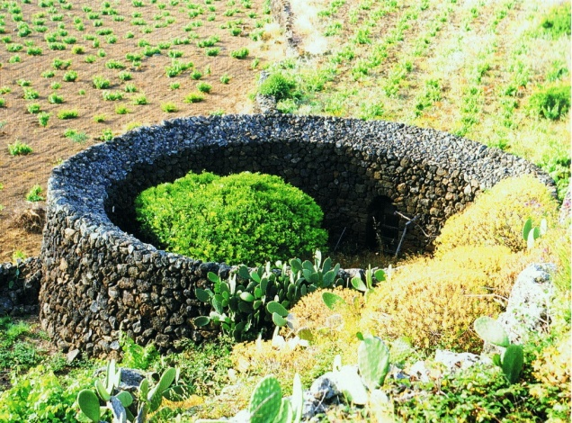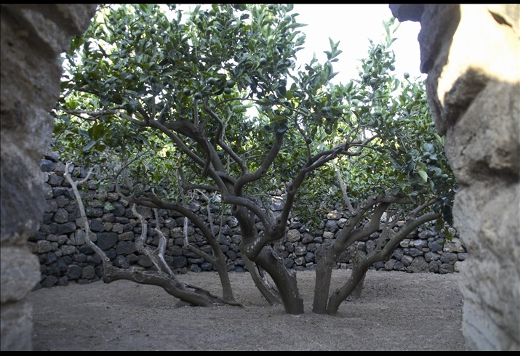
Fig. 1. Circular dry stone walls in Sicily, Italy, provide wind protection and moisture capture.
In the vineyards of La Gería, in Lanzarote Island (Canarias, Spain), single vines are planted in pits 4-5 m wide and 2-3 m deep, with low, curved volcanic stone walls around each pit. This technique is designed to harvest rainfall during summer storms, to capture overnight dew and to protect the plants from the winds (Figure 2).
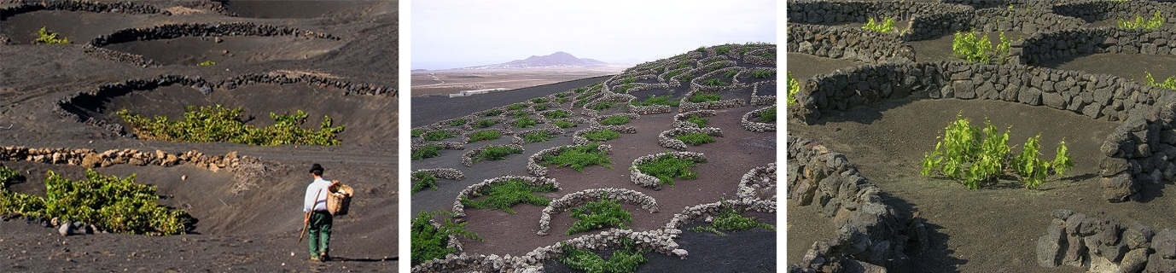
Fig. 2. La Gería’s vineyards, Lanzarote, Spain. Planting pits surrounded by stone walls provide wind protection and moisture capture, and harvest winter rainfall.
Dew and fog capture has proved to be an effective way to collect water for irrigation. Contemporary techniques, such as fog fences constructed in Yemen or South Africa, retained 4.5 litres of water per square meter. In the Abu Dhabi Emirate, for instance, summer conditions are ideal for fog capture (containing about 0.05 grams of water per cubic meter), as prevailing winds from the Persian Gulf bring hot and humid air to the coastal regions – 22 grams of water per kilogram of air (Columbia University 2010: 99).

Water harvesting
Water harvesting is a technique based on the combination of a large runoff contributing area and a small water collecting basin, in a ratio depending on precipitations, on the amount of water needed in the collecting basin and on the accepted degree of drought risk (Sardo & Hamdy n.d.: 4).
Archaeological surveys in the Negev Desert, Israel, showed that ancient Nabateans’ techniques could harvest, annually, one cubic metre of rainwater from 16 m² of surface area. Rainwater was captured from nearby steep and rocky unproductive areas, collected in water channels and distributed to the lower cultivated lands by gravity. The average proportion of the catchment area to field area was about 20:1, which meant an annual moisture increment that was double or triple what the average annual precipitation would have been, making the cultivation of cereals, orchards and vineyards feasible (Aronson 2008: 111-112).

Innovative methods of landscape irrigation

Irrigation water needs of landscape plantings in California - The Landscape Coefficient Method (LCM)
In agricultural systems, water is applied to produce a crop. Whether being tomatoes, beans, or apples, growers apply water to optimize yield and quality. In landscape systems, health, appearance, and growth are of greatest interest. Irrigation is managed to sustain plant defense systems; to achieve desired canopy densities and colour; to generate desired growth; and to produce flowers and fruits (in some species). Irrigation is not used to produce a harvestable crop in landscapes. Because of this difference between landscape and agricultural systems, it is believed that landscapes can, and should, be managed at a lower irrigation level than that needed for crop production (California Department of Water Resources 2000: 12).
LCM is an innovative method of estimating irrigation needs of landscape plantings in California’s Mediterranean climate. Unlike conventional methods derived from agronomic practices, which intend to maximise growth rates and outputs by replacing (or even overcoming) the maximum amount that can be lost via evapotranspiration, LCM comes up with the challenge of supplying a minimum amount of water (inducing a controlled extent of hydric stress), just enough to keep landscaping plantings growing healthy and with a reasonable appearance (California Department of Water Resources 2000: 10). Water needs are estimated through the evaluation of specific landscape factors, such as multiple-species planting, planting density and microclimate. Based on research, observation and field experience, a species evaluation list has been developed, allowing this sustainable method to be applied and updated all over the region.
Results of investigations at the University of California revealed that irrigation substantially below referential evapotranspiration (20 to 60 % accordingly to the species and the climate zone) can be applied to establish Mediterranean shrubs and plant covers with no apparent drought-related injury (California Department of Water Resources 2000: 52) (Sachs 1991: 19).

A global model for efficient irrigation
The following model of water management consists of a mathematical reasoning of evaluation and validation, based on the confrontation between principles and practices of irrigation and their follow-up to the stage of getting the results:
design principles + management practices ↔ results (< ETP and < annual precipitation)
Table 1. Design principles, Management practices and results
Design principles | + | Management practices | ↔ | Results
Strategic plant selection |  | Induction of hydric stress |  | Water supply below evapotranspiration
Plant grouping according to similar water requirements |  | Localized irrigation |  | Water supply below  local precipitation
Extensive, low-density planting |  | Water storage improvement

Microclimatic regulation

Run-off control

External compensating areas
It is important to stress at this phase that this model is still in early stages of development. For this reason, it is considered that more specific measures of action may be presented briefly, as well as results of the integrated combination of those measures.
Throughout this study, the term ‘efficient irrigation’ will be used to refer not merely to a high yield of the applied amount of water (as broadly referred due to the productive, agronomic tradition), but rather to a sustainable, landscape planting oriented approach, resulting from an integrated appliance of environmentally certified landscape design and hydraulic engineering procedures.

Efficient irrigation oriented landscape design principles

Strategic plant selection: native, drought adapted, species
In Mediterranean regions, landscape design should consider, by default, the use of native species (or species from other Mediterranean, semi-arid and arid zones) for the majority of the planting areas. Regularly used ornamental species from exotic origins (with sub-tropical and temperate climates) should indeed become an exception.
Besides helping to promote both the local distinctive landscape character and biodiversity, this design principle takes advantage of innate adaptive growth and lifecycle strategies against shortage of water (Aronson 2008: 39-42):
i) Drought avoidance: annuals (survival of the plant community instead of individual specimens) and bulbs(fast growing and early maturity of the aerial part of the plant, soon after the wet season until the following temperature and dryness increase, while the subterranean part, protected by the soil layer, lives on collecting nutrients).
ii) Drought tolerance: resistance to transpiration (reduced leaf surface area, grey coloured reflective leaves, reflective hairs, resinous leaf coatings, self-shading geometrical arrangement of leaves or dormancy during periods of extreme water stress) and shallow and wide root systems in order to collect surface moisture or rainwater instantly and efficiently.
iii) Succulence: round shape (smallest surface to volume), internal water storage (under a waxy water-proof skin), Crassulacean acid metabolism photosynthesis (which allows plants to separate the stages of light absorption and biosynthesis - at night - and lessen water losses to one-tenth).
Many Mediterranean plant species can also be considered to sustainably introduce variety into arid landscape plantings, as they present many of the pointed strategies: dying in summer (annual plants), hiding below ground (geophytes), double root system (sub superficial/deep), reducing transpiration (sclerophyllous plants), summer dormancy (leaves’ loss in summer), reducing exposed surfaces (modified branches and leaves, like thorns and spines), sheltering from heat (hairy plants and grey foliage), capturing moisture from the air, conserving water (succulent plants), salt, wind, cold and drought: balls and cushions (Filippi 2007: 24).

Plant grouping according to similar water requirements: hydro-zones
Planting design in dry climates should aim for efficient water use by strategic plantation to plant communities of similar water requirements, which can help to inform how, where and when irrigation is needed (PROAP 2011: 7). Therefore, planting design should follow the setting of a sequence of hydro-zones – landscaped areas having plants with similar water needs that are served by one irrigation valve or set of valves with the same schedule (California Department of Water Resources 2000: 145). Hydro-zones should take in account the available water budget (and also its predicted evolution in the medium and long-term); the intended landscape carrying capacity; the relative importance of the plantings’ appearance; and the expected average distance to the user.
Table 2. Water efficient landscape worksheet: example of a sustainable approach to planting design for a Mediterranean region (adapted from Model Water Efficient Landscape Ordinance s.d.: 29).

hydrozone type | valve  no. | irrigation method | water budget | carrying capacity | planting´s appearance | distance to user | % of total water budget | % of irrigated area | % of landscape area
high water use plants | - | - | • | • | • | • | 5% | 3% | 5%
moderate water use plants | - | - | • | • | • | • | 10% | 7% | 10%
low water use plants | - | - | • | • | • | • | 35% | 30% | 15%
very low water use plants | - | - | • | • | • | • | 50% | 60% | 30%
no water use plants  after establishment | - | - | - | • | • | • | - | - | 40%

Extensive, low-density planting
The simulation of new public spaces, adapted to different types of uses, has raised the need to clearly distinguish intensive green areas from extensive ones. Intensive areas, with high density planting, plentiful irrigation and greater carrying capacity, usually breed leisure zones. On the other hand, extensive areas occupy greatest surface of the green areas, and have almost no irrigation. These sorts of areas operate mainly as big urban scenarios.
Using the same treatment, i.e., the same energy investment, in both scenic and intensive use spaces is clearly unsustainable, financially and ecologically. When considering a near-zero carrying capacity of scenic areas, the need to change design principles and strategies, to prioritize efficiency, becomes clear.
The establishment of a close relation between water management and planting techniques, such as the maximization of the plantation distances between hedges (always keeping the sensation of a continuous green cover surface), the minimization of the planting tiers (reducing transpiring leaf surface area), or the use of inert groundcovers is essential.
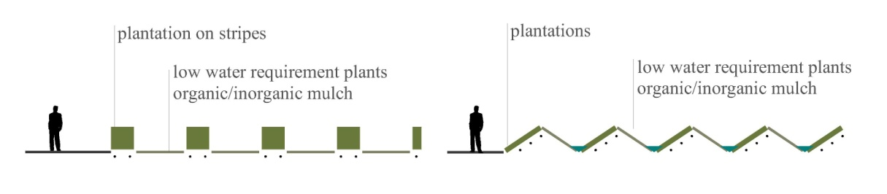
Fig. 3. Efficient irrigation. Reduction of green cover by terrain modeling and plantation on stripes, maintaining visual effect of green continuum (PROAP 2011: 7).

Microclimatic regulation
Protection from sun and wind provides an important decrease in water losses through evaporation and transpiration.
Both natural and built shade elements reduce air temperature by limiting on the one hand, direct solar radiation and, on the other hand, indirect radiation from ground surfaces exposed directly to sunlight.
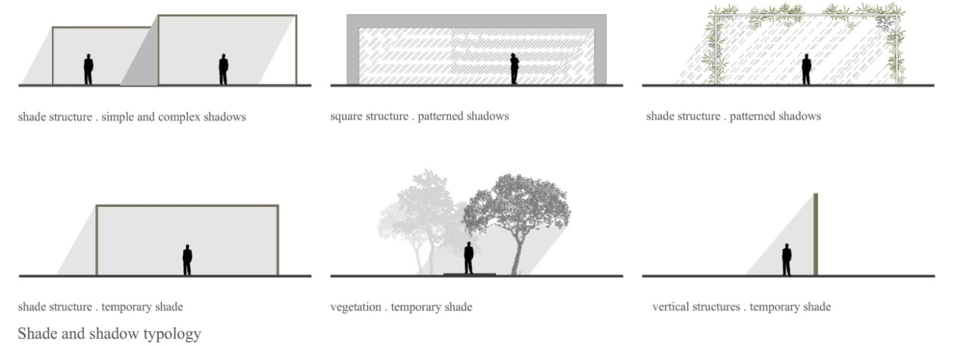
Fig. 4. Microclimate regulation with shade (PROAP 2011: 9).
“[...] variations in climate significantly affect plant water loss. Experiments in Seattle and Washington, USA, found that a planting in a paved area can have 50% greater water losses than a planting of the same species in a park setting. Other studies in California found that plants in shaded areas lost 50% less water than plants of the same species in an open field condition. This variation in water loss caused by microclimate conditions needs to be accounted for in a coefficient used for landscape plantings”. (California Department of Water Resources 2000: 11)
Strong winds, often carrying sand and salt, can be reduced locally, through a careful design approach, by taking advantage of the shielding effect of buildings, walls, screens and hedges, which allow non-tolerant plants to be grown nearby.

Run-off control
In urban landscapes, stormwater runoff from sealed and asphalted pavements should be channelled to planted swales and retention basins. In order to avoid water run-off and to provide its infiltration in extensive areas, some agronomic practices can be adapted to landscape plantings.
Different solutions can be proposed, depending on the solution’s ratio cost/endurance. Among the semi-permanent solutions, the one suggested by Vallerani, in which several deep furrows are interrupted by crescent-shaped pits, where rain water is collected, seems to be fast to implement, efficient in terms of water harvesting and cheap (costs range from 20 to 60 US $/ha), when compared to other solutions. In terms of its endurance, this system is expected to last five years, approximately (Sardo & Hamdy n.d.: 5).
This solution can also be applied to flatlands, through the creation of an artificial slope between the furrows, thus conveying water into them.
Other solutions, perhaps cheaper and less durable, can be mentioned, such as the microbasins, otherwise called diked furrows or tied ridges. In this case, furrows are dammed in the fall after the harvest time, that is, when there are no cultural practices. Microbasins capture the rainfall during the winter season, thus conveying all the precipitation water into the soil. It is important to refer that evapotranspiration losses are not considered, as they are usually in winter. In springtime microbasins can be easily removed with the first soil cultivation, proving that this solution lasts one single season. However, and despite their short lifetime, microbasins can be highly effective especially in salt leaching, since experiments have demonstrated that runoff can be reduced to zero, provided that they are correctly sized.
According to Hamdy (Hamdy n.d.: 4), microbasins technique seems to be very important when it comes to aquifer enrichment, overland flow elimination and consequently erosion control.

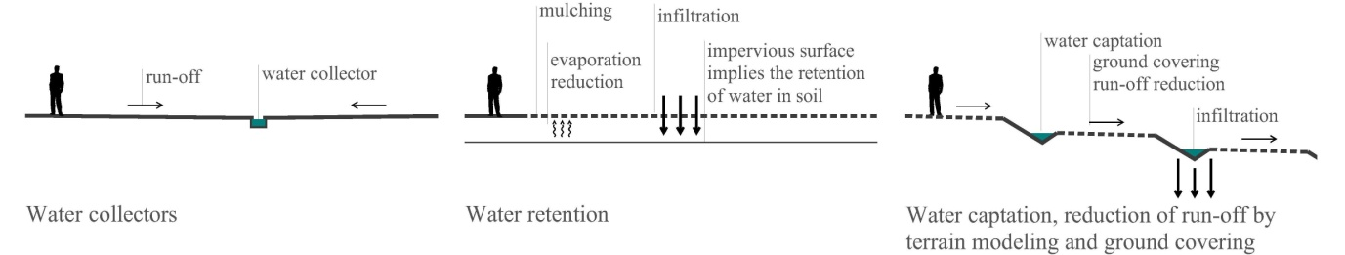
Fig. 5. Run-off control (PROAP 2011: 6).

External compensating areas
Landscape projects often focus on confined areas where water and other resources’ consumption cannot be balanced by the areas’ recharge capacity. Therefore, the “attaching” of external, extensive vast areas to the more intensive ones, has been proved to be an ecologically efficient method of compensation: run-off control, infiltration promotion, water and rainwater harvesting, can take place in an effective, large-scale way.

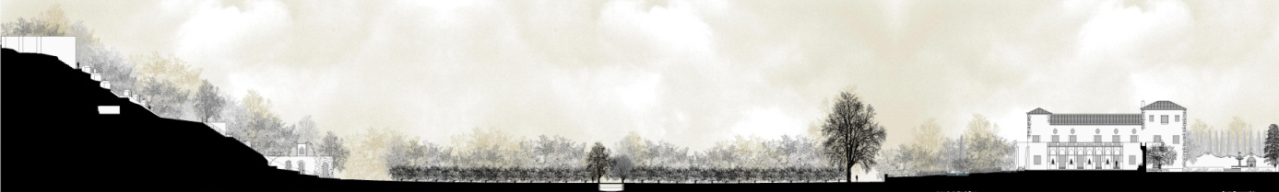
Fig. 6. Paço de Belas, Quinta do Senhor da Serra, Sintra, Portugal. Historical gardens often depend on vast external compensating wood areas where water is harvested and channelled (Castel-Branco 2010: 116-117).

Efficient landscape irrigation practices

Induction of hydric stress
Sustainable planting in arid regions (strictly considered) should not depend on irrigation. However, current landscape expectations and functions in public space require initial inputs of water during establishment, and later, a minimum supply to avoid serious levels of water stress resulting in irreversible damage. Therefore, not only should most efficient irrigation techniques and equipment be applied, but also water budgets should be decreased to minimum levels.
The induction of hydric stress to landscape plantings – one of the most significant current discussions in this field – aims to reduce water uses, besides avoiding injury symptoms related to excess water, reducing soil erosion, and cutting down the cost of weed removing. It consists of providing deliberately and successively water supply indexes below the evapotranspiration indexes inherent to each species, soon after establishing, throughout an adaptation period preceding full reduction, always aiming for acceptable landscape performances. Low and irregular irrigation (i.e. uneven frequency, duration and quantity) promotes root developing, which in turn, increases plant autonomy and resiliency (the ability to recover from a shock or disturbance, for instance, water stress and related pests). Nevertheless, some studies point that susceptibility to insect attack and injury may increase with water stress (California Department of Water Resources 2000: 59).
“Cerastium required irrigation at rates of 50%-75% ET during the establishment season (1991) for optimum appearance. During the second year, appearance was similar at rates of 25% to 100% ET, while visual appearance was poorer at 0% ET” (Staats & Klett 1995: 182).
Careful study, selection and use of drought tolerant plants are essential. Native species from Mediterranean, semi-arid and arid regions can maintain health and appearance without irrigation after they become established. They are already adapted to natural hydric stress. Many of them are suitable for landscape planting in public spaces, and should be used instead of exotic, more demanding species, provided that: they get a minimum water supply whenever maximum allowed stress levels occur; they are correctly grouped in hydro-zones; they are planted more densely, in hedges or massy clusters, and also mixed with other species, for more interesting visual appearance and effects.
This technique has been studied within the scientific community as a possible solution to reduce water consumption in vegetation with purely ornamental functions.

Localized irrigation
Localized irrigation methods, such as drip irrigation, apply water at low rates, keeping the soil around the roots near field capacity, saving water (due to reduced evaporation compared to wind affected sprinkler irrigation), preserving soil structure, and making control of pests and weeds easier. Furthermore, grey water use is possible and safe, as well as the addition of fertilizers and pesticides.
However, in dry climates, zones of salt accumulation may occur near the root zone, and if the wetted zone is not extended throughout the growing period, root development may be inadequate and disproportionate, when compared to plant’s aerial development (Verbeten 1998: 10). Therefore, it is believed that efficient drip irrigation should imply irregular water allocations (uneven frequency, duration and quantity) and continuous relocation since establishing until early maturity stages, in order to follow and even promote root growing.

Water storage improvement
Adding organic material to the soil facilitates water storage for direct use by plant roots. Therefore, planting compost should be carefully adapted and, at least, all landscape green waste should be incorporated on site, improving nutrient recycling and inhibiting soil heating. Special chemicals sprayed on sandy soil can improve its water retention (Aronson 2008: 46). However, in hot and dry climates organic materials and polymers break down quickly. On the other hand, addition of minerals, such as clay or similar, provides a permanent soil restructuring and increases ability to hold moisture. In UAE, where this procedure has already been tested and evaluated, it is proved that it enables sustaining landscape plantings with long lasting gaps between irrigation events: every three days in summer and every seven days in winter (Abu Dhabi Urban Planning Council n.d.: 213).
Replacing plant cover by mulching in extensive landscape areas decreases water needs and losses. Organic mulching is believed to be the most efficient: “[…] desert soils covered with organic mulches were found to have lower water evaporation rates and less amplitude in the pattern of diel temperature fluctuations than those covered with inorganic mulch” (Singer & Martin 2009: 166). Nevertheless, inorganic mulching from nearby origin (stone chippings, gravel, pebble, quarry waste), may be effective as well, besides adding different colours and textures to groundcovers.
The use of layers with different levels of permeability in selected soil depths (to decrease the water infiltration towards the deeper soil horizon) has also been tested as a real strategy to incorporate into innovative landscape principles, by reducing water consumption, increasing water use and enabling more suited mechanisms of drip irrigation (Aronson 2008).

Efficient water irrigation synthesis. Example of query tools

When incorporating in landscape architecture’s sustainable practices not only the solutions within this paper’s proposed global model, but other possible solutions operating on water irrigation efficiency mechanisms as well, comparative analysis on different integrated solutions, adapted to distinct desired carrying capacities, different uses and different use’s intensity become quintessential.
The figure shown below demonstrates how these sort of models can be transformed into easy and efficient query tools not only within landscape architecture’s context, but for all professional fields that somehow deal with water irrigation systems and water management as well, both in private and public spaces.
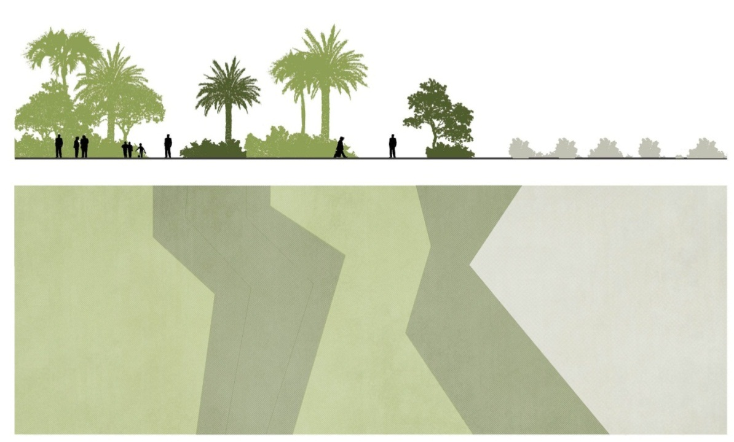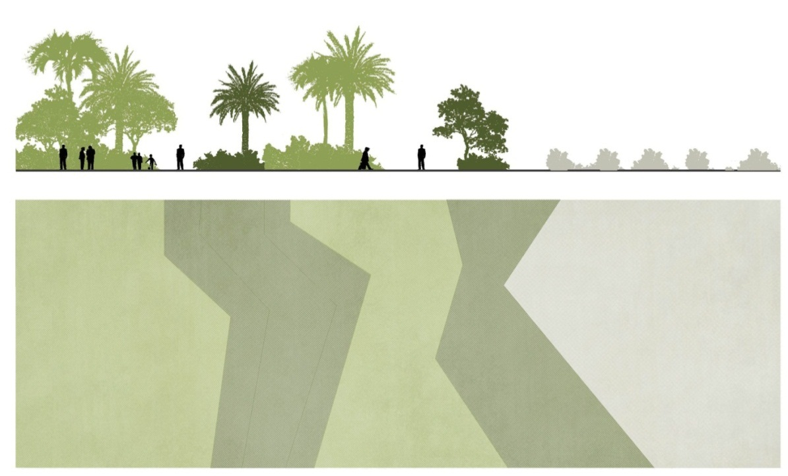
plant selection | high water use plants (high density plantation) | low water use plants  (medium density plantation) | high water use plants  (high density plantation) | low water use plants  (medium density plantation) | no water use plants (after establishment)
irrigation rate | ● | ● | ● | ● | ●
user frequency | ● | ● | ● | ● | ●
carrying capacity | ● | ● | ● | ● | ●
observers’ distance | ● | ● | ● | ● | ●
Fig. 7. Efficient water irrigation synthesis.

Conclusions and considerations

This paper focuses on the awareness that landscape planting irrigation in Mediterranean and dry regions must break up with typical agronomic methods of fully evapotranspiration restitution to optimize output.
The model developed along this research is expected to provide a real sustainable and global new approach to landscape planting irrigation, aiming not only to keep water supply below evapotranspiration rate, but rather below local precipitation rate. In the last case, it becomes important to acknowledge that external compensatory areas may be required, in terms of water infiltration and harvesting.
Though still in embryonic development, field experiments taking place in Lisbon, Portugal, suggest that these goals are likely to be achieved in the Mediterranean, and also in more arid regions, provided the development of a deep knowledge of local native species with aesthetical and functional landscape value; the testing of controlled but severe extents of hydric stress; and finally the consideration of external, vast compensating areas, where rainfall infiltration and water harvesting can take place.
Further research is required in order to deepen this proposed model’s mathematical expression with comparative systematic data, ecological design principles and sustainable managing practices, thus offering major water savings and rewarding environmental certification ratings.
By incorporating the sustainable practices within this document in wider landscape design solutions, landscape architecture can actually enhance landscapes’ performances, especially in terms of efficient irrigation, in dry regions worldwide, therefore changing dry landscape’s paradigms.
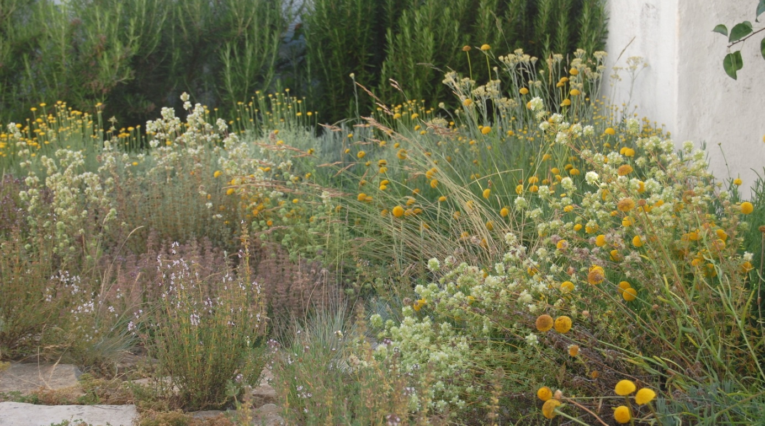
Fig. 8. Experimental dry garden, Lisbon, Portugal.

Bibliography

Abu Dhabi Urban Planning Council (n.d.), Abu Dhabi Public Realm Design Manual, Abu Dhabi.
Abu Dhabi Water Resources (2002). Abu Dhabi Water Resources Statistics.
Agricoltura Sostenibile a Pantelleria. (n.d.) http://www.donnafugata.it/pagine/agricoltura-sostenibile-pantelleria.aspx
Aronson, Shlomo (2008), Aridscapes Designing in harsh and fragile lands, Barcelona: Editorial Gustavo Gili, SL.
Model Water Efficient Landscape Ordinance (s.d.), California Code of Regulations, Title 23. Waters, Division 2. Department of Water Resources, Chapter 2.7. Model Water Efficient Landscape Ordinance. http://www.water.ca.gov/wateruseefficiency/docs/MWELO09-10-09.pdf
California Department of Water Resources (2000), A Guide to Estimating Irrigation Water Needs of Landscape Plantings in California: University of California Cooperative Extension.
CASTEL-BRANCO, Cristina, ed. (2010), A água nos jardins portugueses, Lisboa: Scribe.
Columbia University (2010), “Sustainable Water Management. Assessment and Recommendations for the Emirate of Abu Dhabi”, School of International and Public Affairs, Master of Public Administration in Environmental Science and Policy, Workshop in Applied Earth Systems.
BRAMBILLA, Carlo (2008), «Ecco il segreto dell' acqua nel giardino di Pantelleria», La Repubblica, 13th September 2008. http://ricerca.repubblica.it/repubblica/archivio/repubblica/2008/09/13/ecco-il-segreto-dell-acqua-nel-giardino.html
Filippi, Olivier (2007), The Dry Garden Hanbook - plants and practices for a changing climate, London: Thames & Hudson Ltd.
Hamdy, Atef. (n.d.), Drought Preparedness and Mitigation in the Mediterranean Region.
PROAP (2011), Modular Landscapes in Arid Climates. Redefining Sustainability in Public Space, Lisboa.
Sachs, Roy M. (1991), “Stress-adapted landscapes save water, escape injury in drought”, California Agriculture, November-December 1991, pp. 19-21.
SARDO, Vito, & Hamdy, Atef. (n.d.), Drought Mitigation: the Sustainable Use of Saline Water for Irrigation in the Mediterranean Region.
Singer, Cathrine & Martin, Chris A. (2009, September), “Effect of Landscape Mulches and Drip Irrigation on Transplant Establishment and Growth of Three North American Desert Native Plants”, Journal of Environmental Horticulture, pp. 166-170.
Staats, David., & Klett, James E. (1995, December), “Water Conservation Potential and Quality of Non-turf Groundcovers versus Kentucky Bluegrass under Increasing Levels of Drought Stress”, Journal of Environmental Horticulture, 13(4), pp. 181-185.
Verbeten, Elke (1998), “Irrigation in arid and semi-arid environments”, IMAROM Interaction between Migration, Land & Water Management and Resource Exploitation in the Oases of the Maghreb, Working Paper Series no. 1 May 1998. http//:www.frw.uva.nl/IMAROM

FLOWERING MEADOWS, A BIODIVERSE ALTERNATIVE TO LAWNS IN MEDITERRANEAN URBAN SPACES

Mª del Puy Alonso Martínez, Maria da Conceição Castro e
Carlos Pinto-Gomes

In the landscape of urban green spaces, planting design determines the structure of parks and gardens, their form and potential use, regardless of the scale of the project. The morphological properties and spatial distribution of vegetation condition the visual impact and the resulting aesthetic experience. The parks and gardens of our cities and, by extension, green spaces are most often the places where people interact with 'nature' (Dunnett & Hitchmough, 2004).
The three criteria identified as being necessary for a good planting design, ensuring that it contributes to a better quality of life in cities are; functionality, the link with the environment or ecology, and aesthetics (Robinson, 2006). Landscape architecture projects work with dynamic processes and a high degree of uncertainty (Prominski, 2005; Corner, 2001). Once constructed they are subject to changes that occur over time, in such a way that the plant communities in the initial design proposal are modified in species composition and coverage, due as much to the natural dynamism of their life cycle, as to their interaction with living organisms, including man, and with the environment. As a result the landscape will change with the seasons and over the years, responding to complex ecological processes and human management (Clément, 2007; Dunnett, Swanick & Woolley, 2002; Dunnett & Hitchmough, 2004).
There are three main problems associated with current urban planning for green spaces in Spain; high maintenance costs, excessive water consumption and underuse, often related to the extensive use of lawns as in neighbouring Mediterranean countries (Castro and Ponte-e-Sousa, 2012).
It is the design and objectives of the use of these areas more than the spaces themselves that are called into question. A change in traditional concepts of green spaces is called for where they begin to be considered as a network of free spaces (Fariña and Naredo, 2010). A key issue in addressing these spaces is their multi-functionality, and the consequent need to replace the concept of a residual amorphous green space with one that responds to current challenges (Matos, 2010). One of the structural elements of the landscape that play a major role in landscape projects is groundcover. Faced with a public demand for year-round green areas, little care has been taken in the specification of groundcover species in many of the green spaces in new urban developments in Spain. In many cases this has been done taking for granted the need for watering and maintenance associated with lawns, often justifying their implementation merely on grounds of aesthetics or low initial planting costs.
Considerable progress has been made in the design of efficient irrigation systems and in new technologies for reducing water and energy consumption. However relatively little research associated to the search for alternatives to grass lawns has been carried out. In Europe whose relationship with nature and its landscapes is increasingly fragmented there are few innovative projects based on the promotion of biodiversity and valuing the dynamic nature of the Mediterranean landscape.

A brief history of the use of lawns
The use of cut prairies as a structural element of the landscape in landscape projects dates back to the seventeenth century when André Le Nôtre designed the Vaux le Viconte Gardens in Maincy, France for Nicolas Fouquet. Prairies were used again in Versailles, where they were given the name Tapis vert, to mark the central axis leading to the Grand Canal, directing the sight towards the sculpture of Apollo. Although the lawns of that era were not like current lawns, as their appearance was not as homogenous and they contained a greater diversity of species, their maintenance required systematic manual mowing to maintain their ornamental qualities. However they did not require the irrigation that would have been necessary elsewhere in drier climes such as Southern Europe (Filippi, 2011).
When the landscape style pioneered by the Englishman William Kent burst onto the scene in the eighteenth century, it broke with the marked geometric structure of the French Baroque garden and lawns once again became the protagonists of any naturalist designs in the art of gardening. The English School, with Capability Brown at its head, made lawns fashionable among the British aristocracy. With views of extensive lawns, gently rolling hills and abundant water dominated by a manor house with infinite landscapes bordered by lawns and woods. From England the fashion would reach the properties of the most influential figures in the United States. From their beginnings, the main drawback of lawns was the need for frequent mowing. In 1868 the lawnmower was invented in England and the first manual spiral lawnmower reached the United States of America. In 1919 the lawnmower engine became available and increasingly affordable for middle class American families. As the affordability of lawns increased they became a popular fixture among the middle classes, as can be seen from the sale of lawnmowers in the United States between 1950 and 1974 (increasing from 1 to 7 million) (Filippi, 2011).
During the nineteenth century the fashion for lawns also reached Southern Europe, despite the limiting weather conditions and distinct gardening and landscape traditions that require better adapted solutions (Rubió i Tudiri, 2006). From 1970 lawns become indispensible and their use spreads rapidly thanks to developments in the irrigation technology industry. From this time the landscape becomes homogenized and simplified, becoming an ideal image for residents of Southern Europe as well as their northern neighbours (Filippi, 2011). In fact, quality standards for what we now understand as a lawn; a surface of a homogeneous green, uniform throughout the year, fine textured and well trimmed, were brought in after the Second World War. These standards were consolidated at the same time as fertilizer chemicals, pesticides and selective herbicides appeared on the market due to the development of intensive agriculture and were also applied to these plant surfaces (Filippi, 2011).
The economic and environmental costs associated with lawns in the Mediterranean climate are essentially due to the need to irrigate with quantities of up to 2,000 l/m² of water a year in the most extreme cases (Filippi, 2011). Furthermore lawn maintenance is highly demanding in terms of nutrient requirements (nitrogen, phosphorus and potassium), root aeration, lawn mowing and edging and application of selective herbicides for the removal of broadleaf species where high quality lawns are demanded. On the other hand, quality grass lawns usually contain no more than 3 or 4 grass species. The need for continual cutting impedes the formation of ears and therefore seeds, enhancing the vegetative reproduction of the plants. In this respect they are of limited attraction to wildlife and thus, of little interest from the point of view of biodiversity.

Biodiversity in urban green spaces. Contemporary landscape architecture projects in Europe
Advances in the 1960s in the science of ecology permeated urban landscape policy and practice in Central and Northern Europe (Woudstra, 2004). From the 1990’s, various landscape architects have developed their approaches to planting design, incorporating ecological criteria focused on the design of the groundcover of extensive areas, often looking to promote biodiversity and reduce the maintenance costs of urban green spaces. This has been helped in recent decades by a growing concern about the continued loss of biodiversity and increased interest among the population in ecology (Ecosystems and Biodiversity, the role of cities, 2005; Montes et al., 2011). Each of these landscape architects has their particular approach. Some examples are given below.
Peter Latz does not plan what vegetation to use in his landscape projects, simply leaving the plants to colonize the old structures of the post-industrial landscapes (Silva 2003). In his project for Druisborg’s old steel works, wildflower meadows and woods occupy the space in a chaotic manner, permitting the expression of the force of nature. He takes advantage of the old factory structures and of the old railroad tracks to shape the space, creating different areas for gathering, walkways at various levels and viewpoints along them. He defines his projects as an archetypal dialogue between the domesticated and the wild.
Another German landscape architect, Heiner Luz, combines concerns for ecology with aesthetic considerations. He uses both native and cultivated plant species and their varieties. He studies the morphological aspects of plants and works with few elements resulting in clear and simple projects. His references are communities of wild vegetation, where only a few dominant species are responsible for the overall appearance and seasonal changes in the landscape. However, the floral diversity of his projects depends on species that associate with dominant ones. If we get down to detail, we can see that unity and harmony prevail within diversity (Luz, 2001). Luz selects a limited number of species, ensuring the longest possible flowering periods and then incorporates other species creating diversity in the landscape.
In England, James Hitchmough and Nigel Dunnett have focused their research since the early 90s on the design of flowering meadows with great visual impact. Their aims include the promotion of biodiversity, creation of habitats for local wildlife; reduction of planting and maintenance costs; and for the meadows to remain attractive for several months a year in order to respond to social expectations (Hitchmoug & Dunnett, 2004). While Hitchmough adheres to the aesthetic of American flowering meadows, choosing mostly broadleaf species, forbs, with the only maintenance being annual mowing, Dunnett works with annuals. Given the limited availability of wild flora of interest in Britain, both use exotic species as well as native ones (Dunnett & Hitchmough 2004, Hitchmough, 2008). The seed mixtures they use contain a limited number of species (10 at most), of which some must be long flowering and reliable in terms of their ability to germinate. Their flower meadows are maintained over time by means of self-seeding.
Gilles Clément has worked from 1979 as a Landscape Architect and professor at The Versailles National School of Landscape Architecture. His particular way of approaching landscape design departs from the natural dynamics of abandoned spaces. Creator of the concept of le jardin en movement (the garden in motion), he is interested in 'following the natural flow of the plants' in order ‘to do as much as possible for and least against' to enhance biodiversity and enhance the biological quality of the soil with the least possible maintenance and fewest resources (Clément, 2007). Clément has made numerous interventions following these principles since his first project in La Vallee where he started by acquiring an abandoned field to create his own garden, respecting the ecological, structural and aesthetic changes that occurred over time, with small interventions on his part. Clement first applied this concept in André-Citroën Park, Paris (1986), which was inaugurated in 1999. Other examples include Matisse Park in Lille (1990) or more recently the Tecnoforum esplanade (2008), in Rochelle.
In landscape design whose groundcover is appropriate in the Mediterranean context, it is important to note that the dynamics of these meadows, with regard to their immediate aesthetic appearance will differ from examples found in Central and Northern Europe. The annual rainfall characteristic of the Mediterranean determines the adaptation of plants and is reflected in the landscape characteristic of this region: green in autumn, in flower in spring and golden in summer. This singularity typical of the Mediterranean landscape is, on the other hand, that which confers upon it, in our view, its greatest appeal and brand identity.

Case study
In this section two cases are presented in which we have begun to study the dynamics of two meadows designed and sown in the Mediterranean in an attempt to draw conclusions that are valid for the specific planting for groundcover in this context.
The two case studies presented here were carried out in the town of Illescas (Toledo). One in a newly created city park north of the town and the other on a roundabout located in the green space of a new industrial park currently being developed (Figure 1).
Both case study areas are located in the heart of the Castilian plateau, at an altitude of around 600 m above sea level. The climatic area corresponds to the continental Mediterranean eucontinental subtype, and both areas are located in the Mesomediterranean bioclimatic (annual temperature 15.4ºC) of ombroclimate on the borderline between dry and semiarid (annual rainfall 357 mm / year) (Rivas Martínez, 1983; 1987; 1999). Located on basic soils (pH = 8 in the Northern zone, pH = 9, in the Southern zone), to the north the soils are detrital Quaternary silts and sandy reddish arkosic sands from the degradation of the Griñon-Las Rozas ramp; while in the South it is a Tertiary transition area from the middle to lower Miocene, characterized by micaceous sands, silts and limestones (Middle Miocene) evaporite and carbonate set of plasters and gypsum-lower Miocene marls medium loamy soils with low permeability, low organic matter (<1%). In both cases previous farming use has resulted in bare soils with no vegetation cover, with the exception of the typical field, or arvense vegetation cover adapted to constant tillage.
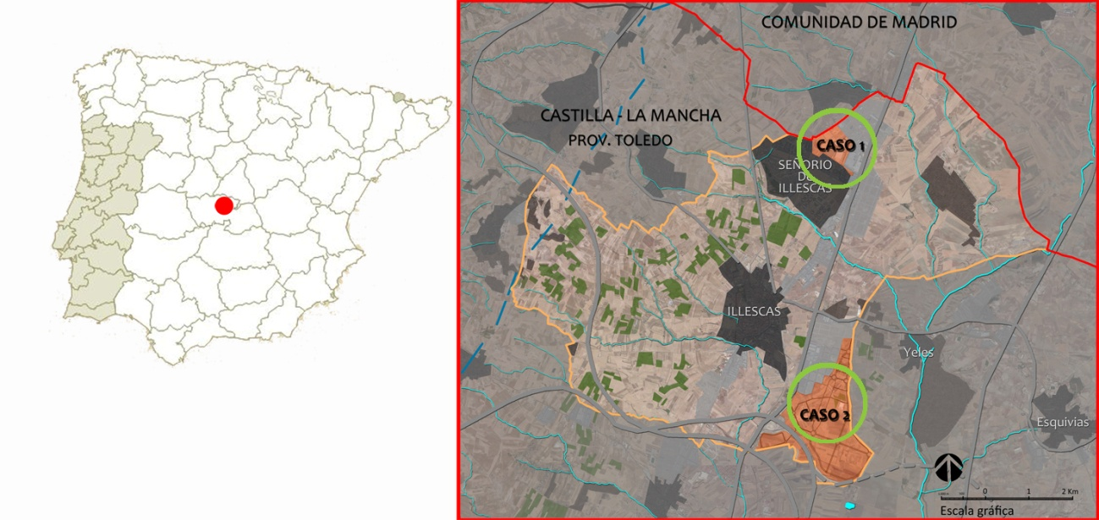
Fig. 1. Location of area of case study. Source: adapted aerial photograph.

The climax vegetation in this area corresponds to holm oak or kermes oak shrubland (Kermes continental) and xeric pine forests of Aleppo pine (Pinus halepensis) (Izco, 1984; Rivas Martínez, 1987 and Sainz, 2010). The stages of substitution are inland scrub basophiles (rosemary, thyme, gorse, salvia, lavandula and spartium).
Currently, the existing vegetation is of anthropic origin. In the urban areas this has resulted from rapid residential growth incorporating ornamental tree and shrub species into the environment. In the agricultural areas it is the result of the ancient dryland farming techniques applied to the production of barley and olive crops.

Case study 1. Semi-perennial meadow in an urban park
In an urban park designed in 2009, the groundcover of all the inaccessible areas (5.5 ha) was sown with a mixture of herbaceous and woody plants adapted to local soil and climate conditions in a proportion of 88% and 12%, respectively, in order to initiate the processes of ecological succession. The seed mix was made up of pioneer species of grasses such as Agropyron cristatum and Dactylis glomerata, and leguminous plants including Medicago sativa and Onobrychis viciifolia to add nitrogen to the soil and maintain the green aspect of the meadow for most of the year even in the absence of irrigation. Sowing was carried out in October 2011. During 2013 the only maintenance carried out was a mowing in late September. Between 2013 and 2014 we monitored the evolution of this meadow, making monthly visits to record its appearance, coverage and floral composition (using the phytosociological method adapted from Braun-Blanquet). We compared the data obtained from two 6x4m plots: an experimental plot (plot 1) that was sown with the project mixture and a control plot (white) on which the mixture had not been sown. A photographic record was compiled and data was recorded about the presence of insects (butterflies) along a selected route through the park.
The results obtained for coverage and floral composition of the two plots are given in Table 1. The floral inventory and relative coverage of the plot was recorded in April, the month of maximum plant growth. The numerical relationship refers to the percentage of coverage with respect to total surface area following the Braun-Blanquet nomenclature:
5: 75-100% ; 4: 50-75%; 3: 25-50%; 2: 10-25%; 1: 1-10% y + < 1%
Table 1.- Evolution of coverage and floral composition. Case study 1 (2014)
 |  | Plot 1 | White | Plot 1 | White | Plot 1 | White
 | Date | 27/02/2014 |  | 27/03/2014 |  | 28/04/2014
 | Coverage | 95% | 40% | 99% | 60-70% | 100% | 90%
 | Average height (cm) | 30 | <5 | 40 | <5 | 60 | 15
 | General dominant colour | green | soil | green | green | green -white | green -yellow
1 | Medicago sativa |  |  |  |  | 3
2 | Moricandia arvensis |  |  |  |  | +
3 | Onobrychis viciifolia |  |  |  |  | +
4 | Anthemis arvensis |  |  |  |  | 4
5 | Calendula arvensis |  |  |  |  | +
6 | Carduus bourgeanus |  |  |  |  | + | 1
7 | Diplotaxis virgata |  |  |  |  |  | 1
8 | Erodium cicutarium |  |  |  |  |  | +
9 | Echium plantagineum |  |  |  |  |  | +
10 | Plantago coronopus |  |  |  |  |  | +
11 | Silybum marianum |  |  |  |  |  | +
12 | Avena barbata |  |  |  |  | +
13 | Bromus diandrus |  |  |  |  | 1 | 4
14 | Bromus rubens |  |  |  |  | +
15 | Bromus hordeaceus |  |  |  |  | +
16 | Hordeum murinum subsp. leporonium |  |  |  |  | +
17 | Lolium perenne |  |  |  |  | +

A comparison of the evolution of the coverage of both plots highlights the difference between the two. In the case of the plot sown with the project seed mix almost 100% of the surface is covered in February, while in the plot that was not sown, on the same date there is only 40% coverage. The unsown plot only reaching 90% coverage in late April. This is primarily due to the type of species found: an abundance of hemicryptophytes (perennials) in the first case (Medicago sativa) and therophytes (annuals) in the second, where short cycle grasses dominate. Other aspects that differentiate the two plots are pasture height (30 to 60cm in the first case, less than 15 cm in the second), the duration of the green colour (which remains in the first case, whereas in the second it only lasts until the end of May). In terms of species composition and their relative cover, differences are also observed: in the first where leguminous plants and composites dominate, compared to the white plot where grasses dominate.
The results of the recording of the seasonal fluctuations in the park throughout the seasons and their relation to the presence of insects are given in Figure 2, where the greater abundance in May and June of butterflies and other pollinators (different species of bees, hornets and wasps) stands out.
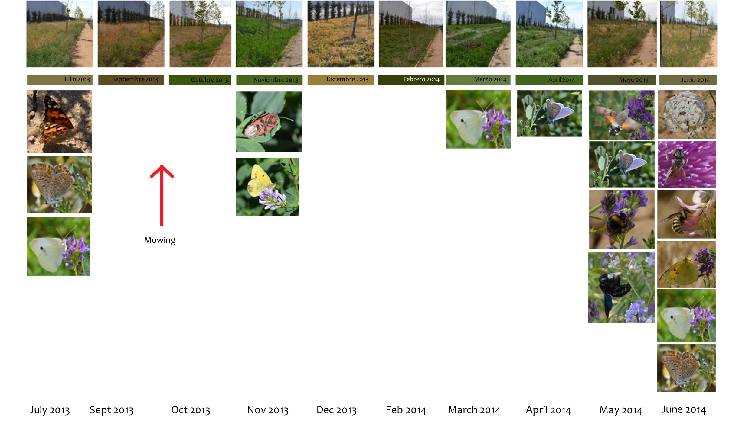
Fig. 2. Evolution of the meadow and the presence of insects.

Case study 2. Meadow with annuals on a roundabout
The second case study presented is the experimental sowing of a roundabout in a new industrial development to the east of the town of Illescas, on the border with the municipality of Yeles (Toledo). The roundabout measures nearly 6,000 m² with olive trees transplanted from neighbouring plots on half of this area.
The idea behind the treatment of this roundabout, as with the two other roundabouts (Figure 3), was to emulate the adjacent crop fields, incorporating flora typical of these environments to help develop an understanding of the local dynamics of the landscape and its relation to agriculture. One of these roundabouts was used to assess ruderal plant communities adapted to anthropic environments, frequently disregarded as 'weeds' and which often constitute the few remaining refuges for wildlife in these areas of intensive agriculture.
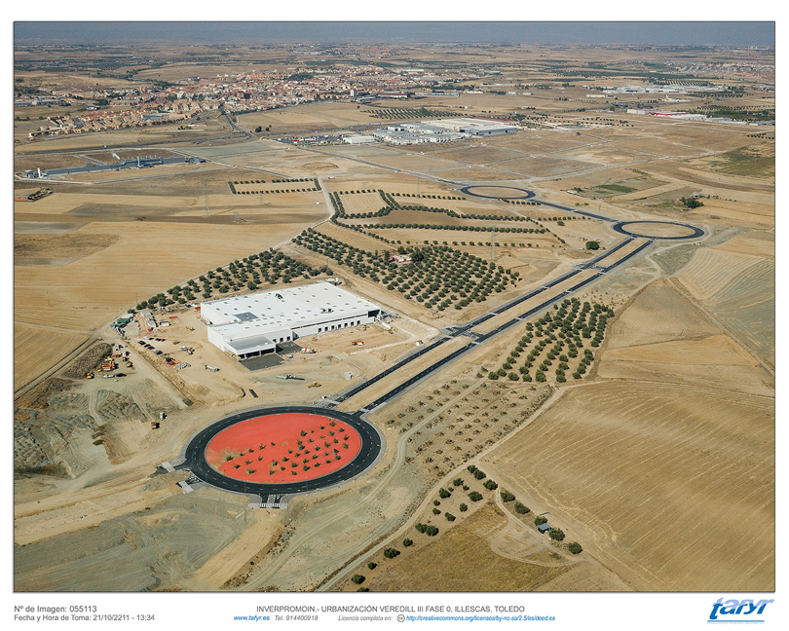
Fig. 3. Aerial photograph. Source: tafyr.
These plant communities include species of flower, above all spring flowering plants, in addition to other earlier or later flowering species of great beauty, which attract pollinators.
In 2012 a first sowing was done with a standard mixture used in the cultivation of organic olive groves and incorporating species that attract pollinators and beneficial insects. This first trial presented an unacceptable appearance to the developer by late May in the spring of 2013 and it was thus mowed. In the autumn of 2013 the ground was ploughed again and prepared for a second sowing, to be carried out in December of that year, with a mixture of seeds designed to correct the previous one and which took into account the following: the average height of the meadow was to be less than 50-70 cm to allow for better visibility of the olive grove, the maximum possible duration of flowering and maximum presence of species attractive to pollinators. The seed mixture contained 45% leguminous plants, 20% grasses and 25% composites as the main families.
As with case study 1, the zone was visited on a monthly basis to compile a photographic record of the general appearance of the roundabout and the adjacent olive grove. A 6x4m plot on the roundabout was selected to carry out an inventory of the species present, changes in coverage and presence of insects. The results are given in Table 2.
Table 2.- Evolution of coverage and floral composition. Case study 2 (2014).
 |  | Plot | White | Plot | White | Plot | White | Plot | White
 | Date | 27/02/2014 |  | 27/03/2014 |  | 28/04/2014 |  | 12/05/2014
 | Coverage | <1% | 5% | 1% | 10% | 70% | 80% | 70-80% | 0%
 | Average height (cm) | <2 | <2 | <5 | <5 | 10-20 | 40-50 | 50 | -
 | Dominant colour | soil | soil | soil | soil | green-yellow | green -blue | green yellow | soil
1 | Carduus bourgeanus |  |  |  |  |  | 5
2 | Sonchus asper |  |  |  |  |  | +
3 | Calendula arvensis |  |  |  |  |  |  | 2
4 | Diplotaxis virgata |  |  |  |  |  |  | 1
5 | Matricaria camomilla |  |  |  |  |  |  | 2
6 | Chrysanthemum coronarium |  |  |  |  |  |  | +
7 | Coriandrum sativum |  |  |  |  |  |  | 1
8 | Diplotaxis erucoides |  |  |  |  |  |  | 1
9 | Echium plantagineum |  |  |  |  |  |  | +
10 | Papaver roheas |  |  |  |  |  |  | +
11 | Erodium cicutarium |  |  |  |  |  |  | +
12 | Medicago orbicularis |  |  |  |  |  |  | +
13 | Trifolium resupinatum |  |  |  |  |  |  | +
14 | Borago officinalis |  |  |  |  |  |  | +
15 | Centaurea cyanus |  |  |  |  |  |  | +
16 | Salvia verbenaca |  |  |  |  |  |  | +
17 | Diplotaxis catholica |  |  |  |  |  |  | +
18 | Calendula officinalis |  |  |  |  |  |  | +
19 | Avena barbata |  |  |  |  |  |  | +
20 | Lolium perenne |  |  |  |  |  |  | +
21 | Bromus matritensis |  |  |  |  |  |  | +

Despite it having been a good year for autumnal rains the results demonstrate a failure of species to germinate until well into spring. This may have been the result of planting in December. Coverage measured 70-80% in April, both in the case of the roundabout and in the adjacent olive grove. In the latter the abundance of thistles (Carduus bourgeanus) resulted in the decision taken by the developer to plough the land in early May.
The differences in composition and morphology of the meadows that resulted from the standard seed mixture and the other seed mixture selected can be clearly seen by comparing the pictures taken in April 2013 and April 2014. In 2014 a more homogeneous meadow is achieved, allowing better visibility of the olive grove.
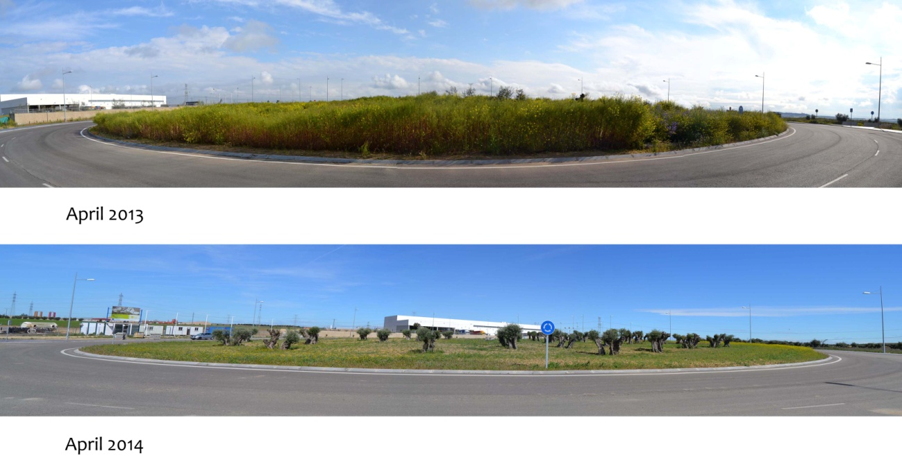
Fig. 4.Appearance of the roundabout in April 2013 and April 2014.

In the floral inventory, carried out in May 2014, in comparison with the adjacent olive grove, where thistles cover the whole area, a remarkably large number of species were identified on the roundabout plot.
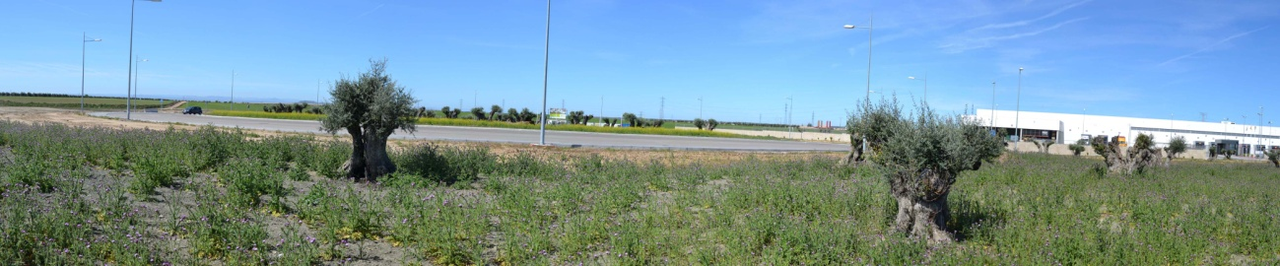
Fig. 5. View of the olive grove adjacent to the roundabout (in the background) dominated almost exclusively by thistles (Carduus bourgeanus) (May 2014).
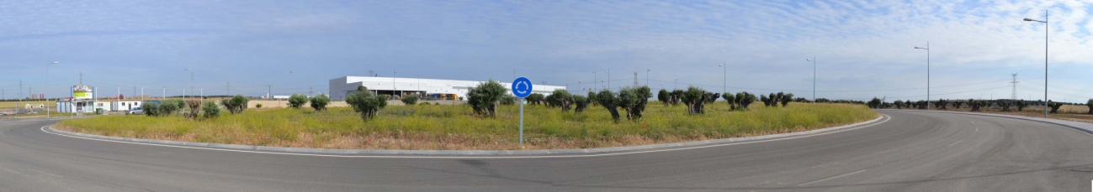
Fig. 6. General view of the roundabout. The dominant colour is the yellow of Calendula and Diplotaxis (May 2014).
Secondly the lack of leguminous plants and grasses present in the 2013 mix is notable, with flower species dominating. With regards to the duration of flowering, we observed that a few species were responsible for the general colour on the roundabout despite the flowering being quite brief (April-May). These species are Calendula arvensis and officinalis, Matricaria camomilla, together with species from the genus Diplotaxis.
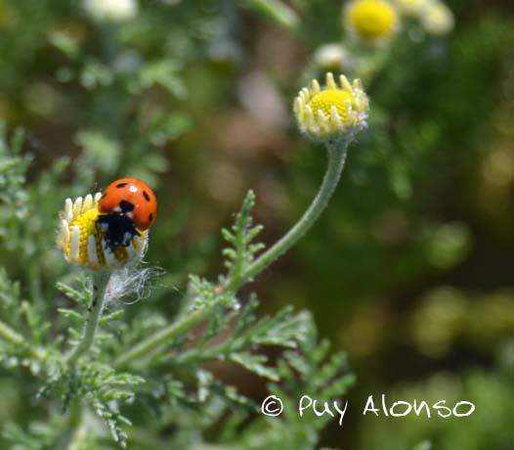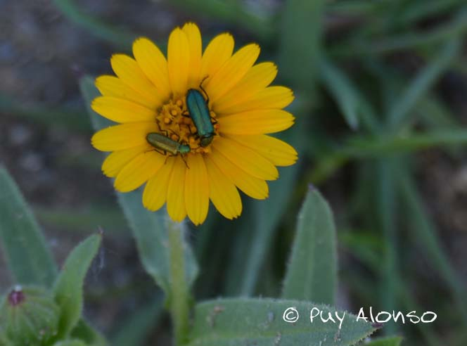
Fig. 7. Coccinella septempunctata on Matricaria arvensis.
Fig. 8. Insects from the family Melyridae on Calendula arvensis

The presence of pollinators or small insects is unsurprisingly limited to these months of flowering (April-May), establishing the presence of bees, ladybirds and other beetles but few butterflies, possibly due to the frugality of flowering.
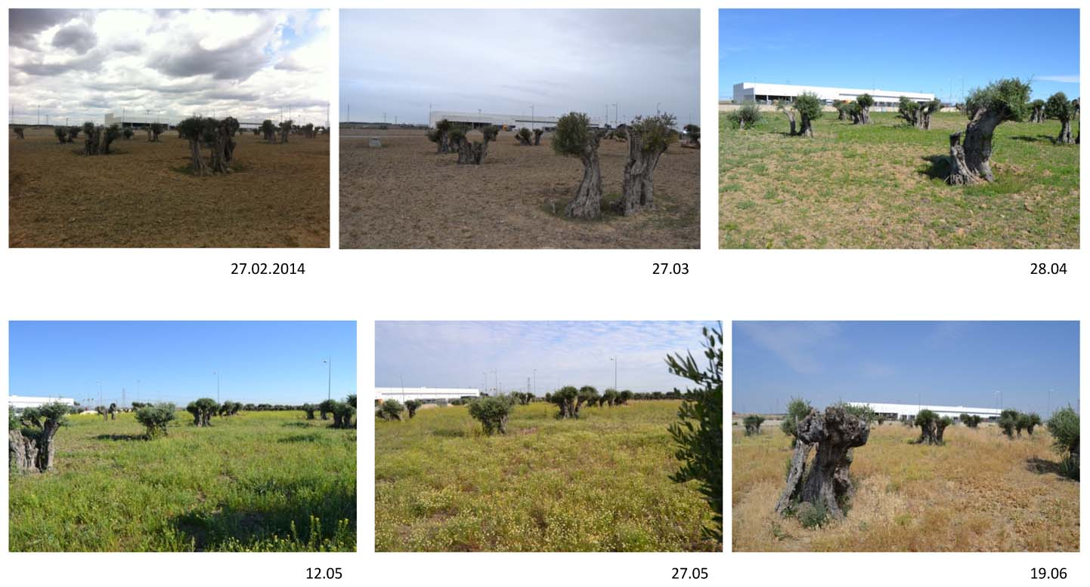
Fig. 9. Monitoring of the control plot (February – June 2014).

Final considerations
In the Mediterranean region, given the importance of its broad biodiversity to the European context and the opportunities this provides, it is necessary to review the way plant groundcover projects for large areas are planned, to incorporate ecological criteria and the preservation and promotion of biodiversity, in addition to other criteria of a functional and aesthetic nature.
For these design proposals to be accepted by the public and serve as spaces for biodiversity, we feel that the seed mixtures should essentially consist of flower species with strong visual impact and a homogeneous height, and should avoid the inclusion of grasses. This will additionally result in design proposals that are not only more attractive in terms of biodiversity but from the point of view of their acceptance to the public.
Such groundcover can consist of perennial or semi-perennial meadows, or meadows using annual species adapted to conditions of constant disturbance or stress. We feel that it is not the use of commercial seed mixtures that should be limited but rather that there should be an improvement in the specific design of those mixes based on the objectives of each project. Due to the wide variety of Mediterranean flora we support giving priority to native species, but do not rule out other species that may be adapted or naturalized, provided that the selected species are not invasive or may alter neighbouring habitats. The use of local species also encourages us to value our landscape and its natural dynamics, thus contributing to a change of mentality in public preferences.
Increasing the biodiversity associated with flowering meadows and, as a consequence their aesthetic appeal, may also foster awareness of ecology, thus optimising the educational potential of these green areas.
Of the two cases studied, case 1 appears to provide the greatest opportunity to attract pollinating insects, particularly butterflies. The maintenance of these meadows should be adapted to the life cycle of these insects if their presence is to be encouraged.
Experimenting with mixtures of flower species is proposed, reducing the number of species in the mixture, gambling on a higher proportion of 2-3 particularly high impact species and always sowing in early autumn.

Bibliography
CASTRO, María Conceição and PONTE-E-SOUSA, C. M. C. (2012), «Lawns and ornamental meadows as an alternative in the South Europe, In World in Denmark 2012». Universtiy of Copenhague. Departament of Geosciencies and Natural Resource Management. Landscape and Architecture Planning. http://ign.ku.dk/english/research/landscape-architecture-planning/landscape-architecture-urbanism/world-in-denmark/world-denmark-2012/papers/filer/lawns-castro.pdf.
CLÉMENT, Gilles (2007), Le jardin en mouvement. (1ª ed. 2001), Lassay-les-Châteaux: Sense et Tonka.
CORNER, James (2001), Lifescape, Fresh Kills Reserve, Staten Island, New York. Prepared by Field Operation for the City of New York. In: http://www.nyc.gov/html/dcp/pdf/fkl/fien1.pdf. [Consulted on 10-10-2014].
DUNNETT, Nigel et al. (2002), Improving Urban Parks, Play Areas and Open Spaces, London: Department of Landscape, U. Sheffield, Department for Transport, Local Government and the Regions.
DUNNETT, Nigel (2003, 12 abril), «Park Life», The Telegraph, http://www.telegraph.co.uk/gardening/gardenstovisit/3310080/Park-life.html.
DUNNETT, Nigel and HITCHMOUGH, James (Ed.) (2004), The Dynamic Landscape: the ecology, design and management of urban naturalistic vegetation, London: E. & F. N. Spon.
Ecosystems and Biodiversity. The Role of Cities. (2005, septiembre), Nairobi : UNEP&UN-HABITAT, http://www.unep.org/urban_environment/PDFs/Ecosystems_and_Biodiversity_Role_of_Cities.pdf.
FARIÑA, José and NAREDO, José Manuel (2010), Libro Blanco de la Sostenibilidad en el Planeamiento Urbanístico Español, Madrid: Ministerio de Vivienda, Gobierno de España.
FILIPPI, Olivier (2011), Alternatives au gazon, Arles: Actes Sud.
HITCHMOUGH, James (2008), «New approaches to ecologically based, designed urban plant communities in Britain: do these have any relevance in the United States?». Cities and the Environment. I, 2,: article 10. http://digitalcommons.lmu.edu/cate/vol1/iss2/10/.
IZCO, Jesús (1984), Madrid Verde, Madrid: Instituto de Estudios Agrarios, Pesqueros y Alimentarios.
JELLICOE, Geofrey and Susan (2000), El paisaje del hombre. (1ª ed. 1995), Barcelona: Editorial Gustavo Gili.
LUZ, Heiner (2001), «The principle of dominant species», Topos, 37, 16-21.
MATOS, Rute (2010), A Reinvenção da Multifuncionalidade da Paisagem em Espaço Urbano – Reflexões, PhD Thesis on Landscape Architecture presented to the University of Évora, Évora.
MONTES, Carlos et al. (2011), La Evaluación de los Ecosistemas del Milenio de España. Síntesis de resultados, Fundación Biodiversidad. Ministerio de Medio Ambiente, y Medio Rural y Marino.
PROMINSKI, Martin (2005), «Designing landscape as evolutionary systems», Design Studies, 8 (3), 25-34.
RAPOSO, Mauro (2013), O Interesse das Séries de Vegetação no Projeto em Arquitectura Paisagista (Distrito Évora), Master Thesis on Landscape Architecture presented to the University of Évora, Évora..
RIVAS MARTÍNEZ, Salvador (1983), «Pisos bioclimáticos de España», Lazaroa, 5, 33-44.
RIVAS MARTÍNEZ, Salvador (1987), Nociones sobre Fitosociología, Biogeografía y Climatología. In: M. Peinado & S. Rivas-Martínez (Eds.), La vegetación de España, Alcalá: Universidad de Alcalá, 19-45.
RIVAS MARTÍNEZ, Salvador, LOIDI ARREGUI, Javier (1999), «Bioclimatology of the Iberian Peninsula», Itinera geobotanica, 13, 41-47.
ROBINSON, Nick (2004), The planting design handbook, Hants: Ashgate Publishing Limited.
RUBIO I TUDURÍ, Nicolás (2006), El jardín meridional, Barcelona: Tusquets editores.
SAINZ OLLERO, Helios and SÁNCHEZ DE DIOS, Rut (2011), «La diversidad de los paisajes españoles», Memorias R. Soc. Española de Historia Natural, 2ª ép., 9, 109-155.
SAINZ OLLERO, Helios et al. (2010), «La cartografía sintética de los paisajes vegetales españoles: una asignatura pendiente en geobotánica», Ecología, 23, 249-272.
SILVA, María Salomé Cruz (2003), As plantas no jardim do século XX na tradição ocidental, Bachelor Thesis on Landscape Architecture presented to the University of Évora, Évora.
WOUDSTRA, Jan (2004), The changing nature of ecology: a history of ecological planting (1800-1980), In Nigel Dunnett & James Hitchmough (Eds.), The Dynamic Landscape: the ecology, design and management of urban naturalistic vegetation, London: E. & F. N. Spon, 23-54.

BOTANIC GARDENS – KEY ACTORS IN THE CONSERVATION AND SUSTAINABLE USE OF RARE MEDICINAL PLANTS

Ana Cristina Tavares

Introduction

The increasing threats to biodiversity loss require measures to reverse this trend, being phytodiversity the basis of life on Earth and vital to the functioning of ecosystems. Conservation of priority species is critical, particularly taxa at higher risks, such as endemics, restricted to very special habitats.
Wild plants offer a wealth of services and goods of essential livelihood value, asking for alertness on the balance between to conserve and to consume. The educative and conservation activities of botanic gardens and similar institutions are crucial to connect people with nature, raising awareness of issues related to access to wild plant resources, the sharing of benefits from their use and the need for their sustainability. On this context, a study with the Apiaceae family in the University of Coimbra Botanic Garden is described, as an example for conservation and valuation of endangered plants collections.
The Apiaceae are aromatic and medicinal plants producing essential oils, with potential secondary bioactive metabolites and are represented in the Iberian Peninsula by several endemic taxa. Micropropagation techniques with protocols for ex situ, in vitro and in situ multiplication were developed to recover the Iberian Apiaceae endemism in Portugal, as well as the characterization and the antifungal activity of their essential oils, investigating the intrinsic properties of these rare taxa promoting their interest and value.
A similar scientific design can be followed for the conservation through a sustainable practice of other endangered taxa and the construction of an “Exotic Garden with Native Plants” is proposed, providing ecological and cultural systems meet “as a Lab”. This collection, knowledge and resources on the endemic Portuguese Apiaceae can be a first contribute, enabling to sustain Mediterranean wild places and rare plants.
Under the “Garden as a Lab” Colloquium goal and perspective, ecology, landscape preservation and environment protection are the thematic context for this presentation, regarding Botanic Gardens as key actors in the conservation and sustainable use of rare medicinal plants.
Considering key actors, we mean both plants and people, as garden are not made by themselves, depending on People for creation, and, even more important, for maintenance.
In reality, the crucial starting point of any garden is not to have a garden - is to keep the garden. A broader problematic can be redirect from this viewpoint, so corresponding to Plants and People action or else Biodiversity and Conservation.

A brief framework

International environmental networks like Botanic Gardens Conservation International (BGCI) , and others (Heleno et al. 2014: 1; Sutherland et al. 2013: 6) currently arising, are improving new studies to (cor)respond to challenges on several pressing questions to (re)solve World perturbing evidences, such as: “More than half of humanity now lives in urban areas, leading to a growing disconnection from nature and decreasing health and well-being and... we must continue to focus on securing a future for threatened plant species and their habitats whilst engaging with wider audiences and strengthening the contribution of botanic gardens to ecological restoration” [cited in BGCI’s Strategic Plan (BGCI)].
The criteria for conservation must consider priority plants to preserve and are currently untitled the 3 E’S – Endemic, Endangered and Economic – the three categories mostly endangered and to firstly protect. This design can be interpreted as taken from an anthropocentric point of view, yet realistic, as also people depend on plants, for nutrition, in a primordial level, and the “Economic” group integrate important taxa on this issue.
It is known that ¾ of the world's population goes hungry and one in eight people in the world will be hungry tonight – this corresponding to 870 million people (Black et al. 2013: 382). Surprisingly, a mere nine crops account for three quarters of the plant kingdom's and of a possible 80,000 species of edible plants, no more than 150 species are widely cultivated. Of those, only 12 provide about 80 per cent of our food and still nowadays corn bread feeds a third of Humanity and rice is life for 3 million people in Asia and Africa (Walker 1995: 160).
While many species are going threatened and must be protected, much of the knowledge and study of the vast majority is yet to be done. Both efforts need to be concurrently done and Botanic Gardens and similar institutions play important role on this mission and also to restore the importance of plants in the diet, through an educative process against marketing and consumption that are responsible for a kind of a current “hidden hunger”. People should know and be aware that, especially for children, not only calories are important, but vitamins, micronutrients, minerals, that can be easily achieved with a diverse and natural nutrition (Dyson 1999: 5929).
There are some species of social and economic importance, as Avena sativa, Beta vulgaris, Malus domestica, Trifolium repens that are increasingly threatened by changes in land use, loss and fragmentation of habitats. A balance between to cultivate and to conserve must be urgently undertaken and another kind of plants play important role - the Crop Wild Relatives (CWR), the wild plant relatives to cultivated plants (Tavares-dos-Santos 2012: 4). These have high benefits regarding the resistance to pests and diseases and promoting the increased of productivity: “As rich sources of genetic diversity, the progenitors and kin of today’s food crops hold great promise for improving production in agriculture’s challenging future” (Colin et al. 2014: 1).
Climate changes have also a critical impact in the diversity of CWR and so their culture and conservation represents a direct value to society and Europe, where the Mediterranean regions present 20,000 to 30,000 species potential useful to society and a large diversity in CWR (Tavares-dos-Santos 2012: 7).

Diverse conservation of plant diversity

Botanic gardens and others similar institutions consider conservation to be one main goal of their mission. The Millenium Seed Bank, at Wakehurst Place, Royal Botanic Gardens of Kew, holds a collection of more than 24,000 threatened species conserved ex situ and preview that 25% of the world’s plants will be preserved by 2020 and the seeds conserve are used for research into food, agriculture, forestry, health and ecosystem repair.
The Eden Project, a park where Science meets Art and Technology in Live Theatre of Plants and People, promote the understanding and responsible management of the vital relationship between plants, people and resources, leading to a sustainable future (Blewitt 2004: 175). This garden, located in a degraded area resulting of the conversion of an exhausted quarry, demonstrates that it is possible to retrain and improve the environment and launches a new look to the world and our place in it, exploring positive futures, showing how much can be accomplished when people work together. Eden is a symbol and a model of regeneration, by answering to the main challenges of retrain degraded areas and make environment become more rich and healthy.
The Botanic Garden of Coimbra undergoes the conservation of living plants collection, herbarium and seed bank, developing conservation Projects, supporting classes, projects and research, holding an educational service and training (Tavares 2011a: 10; Tavares 2011b: 8). Science Education was performed by knowledge and study, preservation, dissemination, enjoyment and sustainable use of living plants collection, being the Garden used as a natural Lab providing excellent and unique resources (Tavares 2014; Tavares et al. 2015).

Conservation and sustainable use of medicinal plants

The Apiaceae are aromatic plants with potential medicinal use and are present in the Medical School of the Botanic Garden of Coimbra (Tavares et al. 2010: 4), among many other examples to know and better appreciate in vivo, some of them being more or less common, to consider, as follows.
When we think of medicinal plants, we think of herbs, and we think of tea. But we should know that every tea is an infusion, but not every infusion is tea. There is only a true tea-plant, depending on the oxidation of the tea-plant leaves, we have the white, green, red or black tea-plant, from China, Camellia sinensis (L.) Kuntze. The active components are present in the leaves, and are xanthine (alkaloids: caffeine, theobromine, theophylline) and catechins (phenolic compounds, tannins), being the digestive activity the main medical use.
Another plant, the rare and ancient taxon, Taxus baccata L., the yew, belonging to Taxaceae family and to the Portuguese flora. The active source is present in the leaves by the constituents taxane - a precursor of taxol (the industrial name is placlitaxel), that is a diterpene obtained by hemi-synthesis of 10-desacetilbacatinaIII (taxane). The species Taxus brevifolia is native from the United States of America (USA), and it is a CWR of Taxus baccata, and was previously condemned to extinction, as trees were cut down for the extraction of the active components of this species that, in this case, were found in the trunk. Now, as an evidence of the great importance and significance of CWR plants, the parent Taxus baccata and the new knowledge on the medicinal proprieties of the leaves could “solve” this problem, as in this case the leaves bearing the active chemical constituents can be produced and replaced by the tree, annually. The main medical uses is the anti-mitotic activity, especially in the treatment of ovarian and breast cancer.
The Echinacea purpurea (L.) Moench, from the Asteraceae family, is an exotic species also from the Flora of the USA. The active constituents of the leaves are polysaccharides, alkaloids and phytosterol. The main proprieties are the anti-inflammatory and immuno-stimulating action and it is mainly used in the treatment of colds and in respiratory and urinary infections.
As a last example, a very much common and frequent Apiaceae from the North to the South of Portugal, the Foeniculum vulgare Miller, the fennel. The active components are in the roots and in the fruits of the bitter variety and the main chemical constituents are phytosterols, coumarins and essential oils. The medical proprieties are very efficiently used in mild dyspepsia, gastrointestinal constraining, and flatulence, even applied in treatments of very young children, and generally in cough and bronchitis. This Portuguese Apiaceae is one of the world “top ten” plants used in phytotherapy.
In the Iberian Peninsula, the Apiaceae (with the ancient scientific name of Umbelliferae) are represented by 83 genera (Castroviejo et al. 2003: 14), with 107 species from Continental Portugal and 13 Iberian endemic taxa indicated to Portugal (Tavares-dos-Santos 2012: 19).
To sustaining wild places and plants, endangered and endemic taxa, these one that are very rare for restricted to very specific habitats and geographic regions, a Project for the conservation and valuation of the Iberian endemic Apiaceae in Portugal was undertaken, for the knowledge, study, preservation, dissemination, exploitation and a sustainable use, trying to “finding natural solutions for sustainable livelihoods and human well-being”, as also reinforced by BGCI action.

Iberian endemic Apiaceae in Portugal

In this context, it was decided to study the Iberian endemic Apiaceae with representation in Portugal, identifying fourteen taxa belonging to eleven genera (Angelica, Bunium, Conopodium, Daucus, Distichoselinum, Eryngium, Ferula, Ferulago, Laserpitium, Seseli, Thapsia), 13 endemic taxa from Portugal and Spain and one endemism restricted to Portugal, Daucus carota subsp. halophilus. This taxon and Angelica pachycarpa, Distichoselinum tenuifolium and Seseli montanum subsp. peixotoanum have a more restricted distribution (Table 1).
Prioritizing sustainable harvesting of the most endangered species, through the study of Floras, herbarium specimens and other available information, we have proceeded to the location, identification, conservation, and enhancement of thirteen of the taxa, being Bunium macuca subsp. macuca the only taxon left to trace (Castroviejo et al. 2003: 10).
For that, we have made the recognition of locations and representation in Portugal, in more than 150 field trips from North to South and the respective voucher specimens were deposited in the COI Herbarium (Tavares-dos-Santos 2012: annexes).
Studying Floras and other related documents and consulting expertise taxonomist, taxa were localized and by field work evidences we could conclude the existence of fifteen endemic Iberian Apiaceae rare taxa in continental Portugal, recommending to be preserved under different priority criteria (Table 1).

Table 1: Iberian endemic Apiaceae in Portugal: Geographical distribution and final priority conservation criteria*

Taxa | Localized provinces | Priority conservation criteria | Evaluated localities
1. Eryngium galioides | Ag | Group 1 – RARE in Portugal | Nave do Barão
2.1. Eryngium duriaei subsp. duriaei | BA | Group 1 – only present above 1.700 meters high | Serra da Estrela
2.2. Eryngium duriaei subsp. juresianum | Mi BL DL. | Group 2 | Serra da Freita  Açor  Gerês  Mata da Margaraça
3. Daucus carota subsp. halophilus | Costa SW, Ag BAl E. | Group 1 | Cabo S. Vicente  Arrifana  Cabo Sardão  Cabo Carvoeiro  Cabo da Roca  Cabo Espichel
4. Bunium macuca subsp. macuca | AAl. | Group 1 – extint? | Not localized.
5. Conopodium subcarneum | BA TM. | Group 1 – localized in very small populations. | Serra da Arada  Serra da Nogueira, Bragança
6. Conopodium majus subsp. marizianum | AAl Ag BA BAl BB BL DL E Mi (R) TM. | Group 3 | Tabuaço  Serra da Freita  Lousã  Montemuro
7. Seseli montanum subsp. peixotoanum | TM. | Group 1 | Alimonde  Samil
8. Angelica major | BA BB Mi TM. | Group 2 | Serra da Estrela
9. Angelica pachycarpa | Berlenga Islands-E. | Group 1 | Berlenga
10. Ferula communis subsp. catalaunica | AAl Ag BA BAl BB BL E R TM. | Group 3 | Guarda  Évora  Loulé  Óbidos
11. Ferulago capillaris | BA Mi TM. | Group 1 – very small populations in very specific habitats. | Celorico da Beira  Guarda  Gerês
12. Distichoselinum tenuifolium | Ag. | Group 1 | Moncarapacho  Espargal  Burgau
13. Laserpitium eliasii subsp. thalictrifolium | Mi. | Group 1 - small populations in very specific habitats. | Gerês  Bragança
14. Thapsia minor | BL DL. | Group 2 – in very small populations. | Mucelão  Queimadela  Piódão, Açor

Source: Tavares-dos-Santos, 2012: 221.
*The abbreviations of the table 1 corresponde to the code for Portuguese provinces of the Flora Iberica (Castroviejo et al., 2003: 1): AAl - Alto Alentejo; Ag - Algarve; BA - Beira Alta; BAl - Baixo Alentejo; BB - Beira Baixa; BL - Beira Litoral; DL - Douro Litoral; E - Estremadura; Mi - Minho; R - Ribatejo; TM - Trás-os-Montes e Alto Douro. The conservation priority criteria: group 1 – only present in one Portuguese province or exclusively in Portugal; group 2 - present in 2 to 4 Portuguese provinces; group 3 - present in 5 or more Portuguese provinces.

The evaluation of the life cycle and phenology are decisive for a sustainable harvesting. Flora and Herbaria vouchers detailed data are crucial information, not only for a correct taxonomic identification, but also to easier the geographical localization of taxa. Based on this knowledge 11 taxa were collected to include in the seed bank, from which six were new included taxa, for the first time in the seed bank of the Botanical Garden of Coimbra. To improve conservation conditions of this Portuguese Apiaceae rare collection, replica samples were also send to the Portuguese Bank of Germoplasm (Braga) and to the Millennium Seed Bank of Kew Botanic Gardens (London) (Tavares et al. 2012: 13). An ex-situ collection was also implemented at the Botanic Garden of the University of Coimbra with plants obtained from seeds, and from the in vitro culture of the four priority taxa, as described in table 2 (Tavares et al. 2010b: 47).
Another point of great importance was regarding to Daucus carota subsp. halophilus, the exclusive Portuguese endemism and a taxon only present in Portugal, that is one of the four CRW taxa of the cultivated carrot, Daucus carota L. subsp. sativus (Hoffm.) Schubl, so demanding an indispensable accurate care with the correct taxonomic identification, especially difficult when working in field conditions.
For the morphological characterization of the taxa, and given the great taxonomic complexity of the Apiaceae family, complementary methodologies such as morphology, optical and scanning microscopy, flow cytometry and essential oils characterization were used to distinguish the endemism D. carota subsp. halophilus (Brot.) A. Pujadas from the other three D. carota subspecies native of Portugal: D. carota subsp. carota, D. carota L. subsp. maximus (Desf.) Bal., and D. carota subsp. gummifer (Syme) Hook. (Tavares et al. 2014: 222).
To emphasize the importance of a correct taxonomic identification, and most of times not easy to achieve, similar studies were carried out with another taxon, Eryngium duriaei, to distinguish between Eryngium duriaei subsp. duriaei and Eryngium duriaei subsp. juresianum. (Tavares et al. 2013: 611).

Micro-propagation: technology for in vitro culture and multiplication

For the most vulnerable species protocols of micro-propagation were established for large scale propagation. Different types of explants (shoot tip, leaf segments, petioles and roots) were tested as well as different techniques of micro-propagation: shoot proliferation, somatic embryogenesis and organogenesis. In the conditions tested, propagation was achieved both by shoot proliferation and by somatic embryogenesis (table 2) (Tavares et al. 2010b: 47).

Table 2: Results of optimized protocols for micro-propagation of the four most vulnerable endemic taxa of Iberian endemic Apiaceae, represented in Portugal.
Micropropagation protocols (hormone type, concentration and explants type) | Four most vulnerable endemic taxa in Portugal/ geographical localization in Portugal
 | Seseli montanum subsp. Peixotoanum/ IP and Port: TM. | Angelica pachycarpa/ IP and Port: E-Berlenga. | Distichoselinum tenuifolium/ IB and Port: Ag. | D. carota subsp. halophilus/ Only in Port: SW coast, Ag BAI E.
Somatic embryogenesis | 0.1 mg/L 2,4-D  leaves | 0.1 mg/L 2,4-D  leaves | 1 mg/L 2,4-D  leaves | 1 mg/L 2,4-D  leaves
Meristematic multiplication | 2 mg/L BA  Caulinar apex | 2 mg/L BA  Caulinar apex | 2 mg/L BA  Caulinar apex | 2 mg/L BA  Caulinar apex
Organogenesis | - | - | 2 mg/L BA  leaves | -

Source: Tavares-dos-Santos, 2012: 180.

The conditions for ex-situ acclimation in greenhouses and outdoor conditions in Coimbra Botanical Garden and also in situ, at Algarve, in the habitat natural conditions for Daucus carota subsp. halophilus (the Apiaceae taxon exclusively endemic in Portugal), have been successfully achieved. Plants of the four most vulnerable endemic taxa of Iberian endemic Apiaceae, represented in Portugal, resulting from micropropagation techniques, could complete the life cycle and producing viable seeds (Tavares et al. 2010b: 47).
Characterization of essential oils: added value to preserve

The essential oils are complex mixtures of natural volatiles compounds showing various biological activities found in all major plant groups. The main functions in plants are for pollinators attraction, predator’s defense, stress protection, plant-microorganisms relation and hydric balance regulation. Essential oils constitute raw material for the pharmaceutical, agro-alimentary, perfumery and cosmetic industry or chemical synthesis, known since antiquity to possess antimicrobial properties. Various biological activities can be performed as antibacterial, antifungal, antioxidative, and anti-inflammatory.
The essential oils characterization of some taxa, namely Daucus carota subsp. halophilus were undertaken using the umbels of the mother-plants (Tavares et al. 2008: 129).
Also Distichoselinum tenuifolium, Seseli montanum subsp. peixotoanum and Eryngium duriaei (two subspecies: Eryngium duriaei subsp. duriaei and Eryngium duriaei subsp. juresianum) and still Thapsia minor were characterized and some of their biological activities evaluated trying to make these taxa more interesting for conservation purposes (Tavares-dos-Santos 2012: 26). The oils were studied in plants with different stages of development, with the goal of identifying the stage of the greater production of essential oil or oils of particular composition. An evaluation of the antifungal activity of essential oils was made for the scientific validation of popular uses and eventual evaluation of its industrial potential, being the antifungal activity specially undertaken against yeasts, dermatophyte and Aspergillus strains.
Essential oils that showed higher antifungal activity were those of Daucus carota subsp. halophilus, with high levels of elemicine and larger capacity against dermatophytes and Cryptococcus neoformans. Distichoselinum tenuifolium and Thapsia minor also revealed antifungal proprieties, being myrcen and geranyl acetate the major chemical compound of the oil, respectively (Tavares-dos-Santos 2012: xxi).
The analysis of the essential oils also showed to be an interesting tool for chemotaxonomic diagnostic in the assessment, certification and taxonomic clarification of two taxa, Daucus and Eryngium, confirming asarone as a marker for Daucus carota subsp. maximus and α-neocallitropsene, as a chemical component unique of Eryngium duriaei subsp. juresianum (Tavares-dos-Santos 2012: xxii).

Biodiversity and conservation by connecting people with nature

We believe that the most important new idea it is driving Man to the environment as a starting point for the World sustainability. Connecting People with Plants reality and knowledge, is the best way for them to understand and adopt the sustainable use of natural resources and making this without the destruction of habitats. Especially young children should be yearly educated under this understanding and behavior principle. “If we teach children to the variety and significance of living things in the world as a reality, you need not speak them of acceptance to any kind of diversity, simply coexistence” (Tavares et al.: 2015).
Botanic gardens and similar institutions are privilege institutions to visit and learn on natural science and the most adequate scenarios to perform Education on Science to any people, using the living resources and collections, adapting the teacher or educator discourse to the group audience (Tavares and Silva 2014: 71). The aromatic and medicinal plants of the Medical School in Coimbra Botanic Garden are used to graduation outdoors classes of Pharmaceutical Sciences high level Course, as a really “Garden as a Lab”. Also the same collection and setting is used for knowledge dissemination and awareness for good practices to all publics, concerning the care of People for Plants and the improvement of literacy and education, on a broad sense of the word.
“Botanic gardens offer excellent opportunities for people to experience nature first hand. Collectively botanic gardens engage with more than 250 million visitors annually and have the potential to reach larger numbers and more diverse audiences. As a result of our work, all botanic gardens will be able to access our resources in support of public engagement programmes that help to reconnect people with nature” (cit. in BGCI’2014 action Plan).

Future perspectives

Fulfilling the “Garden as a Lab” main goal, “on solutions of ecological and cultural significance for Mediterranean landscapes vernacular and more recent traditional rural landscape in Iberian Peninsula”, we intended to have performed “some different ideas to discuss new solutions for ecological landscapes which could and should be experimented in a smaller scale”. Under these principles we propose a Project, to consider the construction of a Mediterranean Garden with Iberian endemism, and with particular relevance and representativeness of Portuguese endemic taxa, such as an “Exotic Garden with Native Plants”, with the mission of promotion of knowledge, study, preservation, dissemination and sustained use of rare plants.
The presented approach on the conservation and sustainable use of rare medicinal plants and specifically the knowledge and resources on the Iberian endemic Apiaceae present in Portugal, proposes to be a first contribution to that Project, the “Exotic Garden with Native Plants”, hopefully depending and demanding to further linkage of several synergies and disciplines, concerning the management of landscape and natural heritage.

Bibliography

BLACK, Robert, VICTORIA, Cesar, WALKER, Susan, UAUY, Ricardo (2013), The Maternal and Child Nutrition Study Group. Maternal and Child Nutrition. The Lancet Editor. Vol. 382, Issue 9890, pp. 427-451, United Kingdom. doi:10.1016/S0140-6736(13)60937-X. http://www.thelancet.com/series/maternal-and-child-nutrition
BLEWITT, John (2004), The Eden Project - making a connection. Museum and society,
2 (3) 175-189.
CASTROVIEJO Santiago, LAÍNZ, Mateo, LÓPEZ CONZÁLEZ, Georgio, MONTSERRAT, Pablo, MUÑOZ GARMENDIA, Francisco, PAIVA, Jorge, VILLAR, Luis (2003), Flora Ibérica, Plantas vasculares de la Península Ibérica, e Islas Baleares, vol. X, Araliaceae-Umbelliferae. Eds. Real Jardín Botánico, C.S.I.C. Madrid.
COLIN, K Khoury, DEMPEWOLF, Hannes, CASTAÑEDA-ÁLVAREZ, Nora (2014), Wild Relatives. The Scientist Magazine, p.1.
http://www.the-scientist.com/?articles.view/articleNo/40026/title/Wild-Relatives.
DYSON, Tim (1999), World food trends and prospects to 2025. Proc Natl Acad Sci U S A. 96(11), pp. 5929–5936.
HELENO, Ruben, GARCIA, Cristina, OLESEN, Jens (2014), Ecological networks: delving into the architecture of biodiversity. Biol. Lett. 10:201320131000. http://dx.doi/10.1098/rsbl.2013.1000
SUTHERLAND, William, AVELING, Rosalind, WATKINSON, Andrew (2013), A horizon scan of global conservation issues for 2014. Trends in Ecology & Evolution xx: 1-8. http://dx.doi.org/10.1016/j.tree.2013.11.004
TAVARES, Ana Cristina (2011a), Um programa educativo sustentável: Jardim Botânico da Universidade de Coimbra (1997-2010). Monograph. Life Sciences Department Library. University of Coimbra: Coimbra.
http://www.uc.pt/jardimbotanico/projetos/inquire/Modulo1/rec_teoricos/Um_PROGRAMA_EDUCATIVO_sustentavel_JBCOI_10.pdf
TAVARES, Ana Cristina (2011b), À descoberta do mundo das plantas: um roteiro do Jardim Botânico da Universidade de Coimbra. Lisboa: Editora Fonte da Palavra, Lda.
http://www.fontedapalavra.com/ana-cristina-tavares.html
TAVARES, Ana Cristina (2014), Educação em Jardins Botânicos: 16 anos de experiência. Manuscript submitted for publication.
TAVARES, Ana Cristina, GONÇALVES, Maria José, CAVALEIRO, Carlos, CRUZ, Maria Teresa, LOPES, Maria do Carmo, CANHOTO Jorge, SALGUEIRO, Lígia (2008), Essential oil of Daucus carota subsp. halophilus: chemical composition, antifungal activity and citotoxicity. JEthnopharmacology. 119, pp. 129-134.
TAVARES, Ana Cristina., LOUREIRO João, CASTRO, Sílvia, COUTINHO, António, PAIVA Jorge, CAVALEIRO, Carlos, SALGUEIRO, Lígia, CANHOTO, Jorge (2014), Assessment of Daucus carota L. (Apiaceae) subspecies by chemotaxonomic and DNA content analysis. Biochnemical Systematics and Ecology, 55, pp. 222-230.
TAVARES, Ana Cristina., LOUREIRO João, CAVALEIRO Carlos, SALGUEIRO, Lígia, CANHOTO, Jorge, PAIVA, Jorge (2013), Characterization and distinction of two subspecies of Eryngium duriaei J. Gay ex Boiss., an Iberian endemic Apiaceae, using flow cytometry and essential oils composition. Plant Systematics and Evolution, 299, pp. 611-618.
TAVARES, Ana Cristina, SALGUEIRO, Lígia, CANHOTO Jorge (2010b), In vitro propagation of the wild carrot Daucus carota L. subsp. halophilus (Brot.) A. Pujadas for conservation purposes. In Vitro Cell. Dev. Biol.-Plant, 46, pp. 47-56.
TAVARES, Ana Cristina, SALGUEIRO, Lígia, CANHOTO, Jorge, PAIVA, Jorge (2012), Iberian endemic Apiaceae: a reassessment for conservation purposes in Portugal. Studio Botanica, 29, pp. 13-37.
TAVARES, Ana Cristina, SILVA, Susana (2014), The valuable role of educators. O/El Botânico – Revista da Associação Ibero-Macaronésica de Jardins Botânicos, 8, pp. 71-73. http://www.elbotanico.org/revista8.html
TAVARES, Ana Cristina, SILVA, Susana, BETTENCOURT, Teresa (2015), Advantages of Science Education Outdoors through IBSE methodology, in Inquiry-Based Learning for Science, Technology, Engineering, and Math (STEM) Programs: A Conceptual and Practical Resource for Educators, Vol. 4, Emerald Group Publishing (forthcoming).
TAVARES, Ana Cristina, ZUZARTE, Mónica, SALGUEIRO, Lígia (2010a), Plantas Aromáticas e Medicinais da Escola Médica do Jardim Botânico da Universidade de Coimbra. (2ª ed.). Coimbra: Imprensa da Universidade de Coimbra.
http://www.uc.pt/imprensa_uc/catalogo/naturanaturata/plantas
TAVARES-DOS-SANTOS, Ana Cristina (2012), Conservação in vitro e ex situ e valorização de endemismos ibéricos das Apiaceae portuguesas. Ph-D Thesis on Physiology presented to the Faculty of Sciences and Technology of the University of Coimbra. Coimbra. http://www.eumed.net/tesis-doctorales/2013/acpts/index.htm
WALKER, Harlan (1995), Disappearing Foods: Studies in Foods and Dishes at Risk: Scribe. Pg. 160. Proceedings of the Oxford Symposium on Food and Cooking by Harlen Walker (Editor), Prospect Books (UK).

PhD in Art History, CHAIA/University of Évora, amr@uevora.pt and CHAM/FCSH/UNL and UAç. arodrigues@fcsh.unl.pt.
Gabriel Alonso Herrera, Obra de Agricultura/copilada de diversos auctores por Gabriel Alonso de Herrera de mandado del muy illustre y reverendissimo Senor el cardenal de Espana arcobispo de Toledo, Alcala de Henares: Arnao Guillen de Brocar,1513, of which there is a facsimile made in 1818 that can be consulted online at http://bibdigital.rjb.csic.es/spa/Libro.php?Libro=258. In this paper I will privilege the English translation: Gabriel Alonso de Herrera (2006), Ancient Agriculture: Roots and Application of Sustainable Farming, compiled by Juan Estevan Arellano, Canada: Ancient City Press, whenever it makes no difference to the scientific explanation.
“(…) que valió al Herrera poeta el renombre de divino, no pocas florido y armonioso como las composiciones de su hermano el músico, y siempre persuasivo y elocuente como los discursos del otro hermano llamado el orador filósofo” (Preface of Herrera 1818: XVIII).
Alhambra gardens in Granada were founded by Mohamed ben Al-Hamar (Muhammad I) in 1238 when he conquered the city. After him, Yusuf I y Muhammad V were the kings who built more palaces and gardens in this place. Alhambra and Generalife are outstanding examples of Islamic art of gardens.
“Entre 1513 y su muerte, Herrera siguió experimentando en el campo, a juzgar por las numerosas correcciones y matizaciones que introduce en ediciones posteriores. Valga como muestra la adición al final del Cap. VII, Libro V (no senalada en la edición de Martínez Carreras): “Doctrina es que no estoy bien con ella. Lo uno porque no concierta con lo que Plicio dice... aunque no hago dello mucho caso, que bien puede un experto saber más que un muy letrado. Yo siempre me arrimo a la verdad, en cuanto yo la puedo alcanzar, aunque la diga quien quiera” (Baranda 1989: 101). He also talks about his own experience as a farmer: “Labro yo mis olivas…” (Herrera 1818: 115).
Title created by King D. Fernando in 1512. This family became one of the most important noble houses of Spain during the Early Modern and Modern periods.
“No me espantan murmuraciones de otros que dicen que mas sabe cualquier rústico labrador en las cosas del campo, que supieron Columela, Plínio, Caton, Palladio y aquel doctísimo Marco Terencio Varron, á quien en saber Sant Augustin sobre todos los romanos da corona” (Herrera 1818: 3).
After the death of King D. Filipe I of Spain (1478-1506) and after the death of King D. Fernando II de Aragon (1452-1516), Cardinal Cisneros ruled Spain.
“El Cardenal, ansioso de difundir este tesoro de luz y de prosperidad, se apresura á multiplicarlo con la prensa á espensas proprias, y ofrece á la imitacion de la posteridad un medio nuevo de propagar rapidamente los conocimientos útiles, repartiendo gratuitamente entre los agentes del cultivo inumerables egemplares.” (Herrera 1818: XV)
Cf. “Because farmers could derive far greater utility from the land than they do currently, in the following sections I will elaborate on numerous topics that can potentially enhance their knowledge about types of crops and methods of cultivation to attain greater productivity.” (Herrera 2006: 36).
Cf. “(…) according to Cato, when pear trees are in bloom” (Herrera 2006: 38).
Cf. “According to Theophrastus and Varro, it is most productive to plow during hot weather” (Herrera 2006: 38).
Cf. “Crecentino, Columella, and Palladius assert that soil can be seriously damaged if it is plowed or dug up when it is either very wet or very dry” (Herrera 2006: 37).
As it is recognized by Arellano: “Herrera, empapado de la doctrina de Teofrasto, del agrónomo hispano-romano, de Plínio y demas griegos y latinos (...)” (Arellano 2006: XV). Cf. “The precise number of times soil should be plowed before sowing varies somewhat with location and type of soil. According to Pliny, in Turcany lands are so hard and full of weeds that they are plowed nine times before being sown.” (Herrera 2006: 38).
Cf. “Despite all the benefits of burning the land cited by Virgil in his Georgica, he omitted an important one: if the roots of weeds and plants burn, the ashes will fertilize the soil” (Herrera 2006: 37-38).
“Los árabe-hispanos, entregados á las ciencias y letras, mientras el resto de la Europa yacia en un letargo casi absoluto, reintegraron á la olvidada agricultura en el lleno de sus preminencias y de su dignidad, y cifrando por fin la suya propia en la fuerza del arado y de la azada, de tal manera se esmeraron en aclimatar por nuestros valles y llanuras meridionales las plantas preciosas del Africa y del Asia; con tanta inteligencia manejaron los peculiares y delicados cultivos que estas exigian, y tan felizmente aplicaron á mejorar los anteriormente establecidos su ingenio y peregrinas luzes, que lograron muy pronto no solo regenerar cuantas ramificaciones comprendia en sí la economía rústica de Higino y Columela, sino llevarlas todavía mas adelante hasta un punto de perfeccion y de primor desconocidos hasta entonces, y en que solo bajo de algun otro respeto se ha llegado despues á igualarles ó escederles.” (Preface of Herrera 1818: XIX).
Acequia is an element of the hydraulic system used in Spain of Arabic origin. Acequias are watercourses created by the community, such as gravity chutes or flumes. Most of them are open ditches with dirt banks. Herrera describes the utility of an acequia in an estate: “Se quieren poner cambroneras hagan una Buena acequia Honda hasta la rodilla, y pongan alli Barbados de cambrones: esto se haga en princípio del invierno, y cubran luego de tierra el acequia. Si la heredad es cerca de rio, y el agua se teme que romperá y robará la tierra, ó entrará por la heredad, y que la danará, plantan junto con el agua sauces, álamos blancos, que tengan fuerza del agua, que no rompan la tierra ni hagan dano á la heredad (...)” (Herrera 1818, vol. III: 9).
Cf. “Undoubtedly, farmers could acquire beneficial knowledge from astrology, permitting them to predict the characteristics of forthcoming seasons, but we cannot expect uneducated farmers to attain such knowledge when numerous scholars and medical doctors who should be aware of this information know almost nothing about it.” (Herrera 2006: 42-43).
The editions published during his own life were: Alcalá de Henares: en casa de Arnao Guillén de Brocar, 1513; Toledo: Arnaio Guillén de Brocar, 1520; Alcalá de Henares: Miguel Deguía, 1524; Toledo: [s.i.], 1524; [Zaragoza?: Jorge Coci], 1524; Logrono: Miguel Deguía, 1528; Alcalá de Henares: Juan de Brocar, 1539.
There is an edition of Gabriel Alonso de Herrera (1832), Noticias necessarias para formar un suplemento à la obra de agricultura de Herrera que se está reimprimiendo, Mexico, which prooves it.
Gabriel Alonso de Herrera [1557], Agricoltura tratta da diversi antichi et moderni scrittori, da sig. Gabriello Alfonso d’Herrera et tradotta di lingua spanuola in volgare italiano da Mambrino Roseo da Fabriano, [Venise]: Michel Tramezzino (published again in 1568, Venetia: per ordine di F. Sansovino; in 1577, Venetia: V. Bonelli; and in 1592, Venetia: Nicolò Polo.
This copy is now at the Biblioteca do Palácio Nacional da Ajuda, 38-XIII-7. Nevertheless, the provenance of this book was the former college where “Aula da Esfera” took place.
This copy is now at the Biblioteca do Palácio Nacional da Ajuda, 38-XIII-8. However, we are able to know the provenance because it is written: «Ex-Bibliotheca Congregationis Oratorii apud Regiam Domum B. M. Virginis de Necessitatibus. Lit. Num.».
“[...]the descriptions of their Gardens onely which you have sent me; and as I looke upon it, and esteeme it a treasure, so I shall make use of it in my Hortulan Work, as absolutely the most shining and cultivated part of it, without daring to alter, or embase the Style, which is natural, and illustrious, and becoming your Lordship nor needed I an Interpreter for the Characters, which are faire, and legible throughout every sheet./And as I have ben exceedingly affected with the Descriptions, so have I ben greatly instructed in the other particulars your Lordship mentions; and especially, rejoice that your Excellency has taken care to have the Draughts of the Places, Fountains, and Engines for the irrigation and refreshing their Plantations, which may be of singular use to us in England: And I question not but your Excellency brings with you a collection of Seeds; such especially, as we may not have commonly in our Country […] I hope your Lordship will furnish your selfe with Melon-Seedes, because they will last good almost 20 years; and so will all the sorts of Garavances, Calabazos, and Gourds (what ever Herrera affirme) which may be for divers Oeconomical Uses.[…](footnote 8: Gabriel Alonso de Herrera, Agricultura general (Madrid, 1646; a presentation copy from Mountagu, Eve. B.35). “Garavances” are probably “garbanzos” (chick peas) and “Calabazos”, gourds or pumpkins.”, in The Letterbooks of John Evelyn, edited by Douglas D. C. Chambers and David Galbraith: 460-461 (consulted on the 10th October online at http://books.google.pt/books?id=WUNRBQAAQBAJ&pg=PA461&dq=Gabriel+Alonso+de+Herrera+John+Evelyn&hl=pt-PT&sa=X&ei=GlFvVLfFIIjtas-vgYgP&ved=0CCAQ6AEwAA#v=onepage&q&f=false).
“(...) y estas cercaduras naturales ó vivas son mas seguras, de menos costa y de mas tura que otras ningunas, y si por caso se queman tornan á nascer.” (Herrera 1818, vol. III: 7). Later he explains: “Son varias las especies de vejetales que se emplean ó pueden servir para formar setos vivos con que cerrar las heredades; y como no todos pueden prevalecer indistintamente en todas partes, se tendrá cuidado de elegir los mas á propósito y mas adaptables á cada clima y terreno. Regularmene se prefieren para este fin los vejetales que forman matorrales espesos, que se unen, que cierran bien, que esan muy guarnecidos y poblados de tallos y ramas en la parte inferior, y que se mantienen achaparrados (...)” (Herrera 1818, vol. III: 10). And he gives an example very useful for our own climate: “Finalmente, en los climas mas ardientes de Espana se cierran las haciendas con las plantas de pira y de tuna, que ademas de vejetar en los terrenos mas áridos se espesan en poco tiempo, y forman unas cercas impenetrables” (Herrera 1818, vol. III: 10).
“Por ende conviene que, como en los pueblos bien regidos están repartidos los oficios, en un cabo mercaderes, en otro plateros, por sí los herreros, los libreros en otra calle... y aun los que no son de una ley no están juntos, que a un cabo viven los cristianos, a otro los moros, a otro los judíos; benedito sea Dios que quitó ya en Espana esta división, por la mano de vuestra senoria que procuró la universal conversi´n de los moros en Castilla; y con este mismo celo de traer todas las ovejas al corral de Cristo se dispuso con mucho peligro a tomar milagrosamente la cibdad de Orán, por donde se ja abierto la puerta a que el católico rey nuestro don Fernando en persona passe allende a conquistar los enemigos de la fe” (Herrera 1818: 111).
The first mention of terracing is in Boccaccio when he describes the Valley of the Ladies in Decameron. What is interesting about the description is that “these slopes… on the side of the south… were all full of vines, olives, almond-trees, cherry-trees, figs…”(Grove and Rackman 2001: 113). Grove and Rackman analyze this description like this: “this is a work of fiction and does not claim to be any actual place; the terraces are those of formal gardens rather than of farmland. It is more likely that Boccaccio knew about terraced gardens than that he invented the idea. However, the need for careful description suggests that terracing was unusual around fourteenth-century Florence: his readers were more familiar with the terraced seats of Roman theatres than with terraced landscapes.”, because Boccacio says “the slopes of these little mountains descended as if stepped toward the plain, as in theatres the tiers are seen in successive order from the top to the bottom, always decreasing their circumference” (Grove and Rackman 2001: 113).
Thus, Antonio Casena writing about Varese in Liguria (near Genoa), in 1558, says of his vineyard of Bersignana: “this had been an unenclosed, abandoned field for sowing, in which there were neither vines, nor trees, nor any things wild or tame, nor the slightest trace of management, being pasture for all the animals. In the year of our salvation 1557 I had it all constructed in 56 days, being helped by the men of [nine named hamlets]” (Grove and Rackman 2001: 113). Grove points out that there is nothing in this description which suggests that terracing itself was unusual or an innovation.
“(...), y se van formando montocitos para poderlos llevar con comodidade á los cuadros ó bancales donde han de trasplantarlo.” (Herrera 2001: 192).
“en seguida se nivela, dejándole el descenso ó caida correspondiente para que las aguas corran con facilidad, y se pueden dar los riegos con poco trabajo: despues se acuartela todo el terreno; quiero decir que se reparte y subdivide en cuadros, canteros y eras: hecho esto, se senalan las caceras maestras ó principales que conducen el agua, y despues las secundarias y parciales, que sirven para regar los canteros y eras de cada cuadro ó cuartel” (Herrera 1818: 46).
“Pero quando se trata de formar la huerta del modo mas ventajoso y lucrativo, porque se considera como una finca productiva, entonces es preciso tener presentes algunas advertencias para no malograr el tiempo, el trabajo y el dinero. El dueno debe ante todas cosas atender al objeto ó fin que se propone, y con arreglo á esto ha de escoger el parage mas aventajado para hacer la huerta, examinando con la mas detenida reflexion las ventajas é inconvenientes que ofrece el local, su esposicion y situacion, la calidad de la tierra, la mas ó menos abundancia de agua para los riegos, la facilidad de poderse proporcionar los estiércoles necesarios para abono y beneficio de la huerta, y la immediacion ó proximidad á las grandes poblaciones para poder tener un despacho pronto y seguro de todos sus productos, y que se vendan con estimaciony á precios arregalados, que le dejen un interes ó ganancia proporcionada á su trabajo é industria” (Herrera, 1818, vol. III: 5).
Department of Landscape, Environment and Planning (DPAO), School of Science and Technology (ECT), Centre for Art History and Artistic Research (UE-CHAIA), University of Évora (UE) Apartado 94 – 7002-554 Évora Portugal; 00351 266 745334 mcmf@uevora.pt
It can be confirmed, namely, in the heritage classified by UNESCO and in classified reserves and natural areas, including Natura 2000 (Europe-wide network of sites). Cf http://whc.unesco.org/fr/carte-interactive/ http://maps.eea.europa.eu/EEABasicViewer/v3/index.html?appid=07661dc8a5bc446fafcfe918c91a1b1b&displaylegend=true&embed=true
‘Montados’, the tradicional agro-sylvo-pastoral system in the Iberian Península, called ‘montado’ in Portugal.
Expressed in the opening of glades (linked with pastoralism and agriculture) and in the extraction of firewood, pastures, woods, fruits, berries, oils, gums, perfumes, dyes, fibres and minerals, among other components or materials (Ribeiro 1987).
Such as hard, small, bright and fragrant leaves.
Elucidated in wild species of olive, fig, carob, flax, legumes and some pasture grasses and in the introduced, well adapted, wheat, barley, rice, orange tree, lemon tree, apricot tree, cane sugar, potatoes, corn, between others (Ribeiro 1987).
Because of incorrect practices (in agricultural and forestry) and due to the frequency and extent of fires.
Resulting from incorrect agricultural practices, urbanization and waterproofing.
For example: roads, railways, dams, ports, and airports, among others.
Desidério Batista is PhD Landscape Architect, professor at the Universidade do Algarve. Rute Sousa Matos is PhD Landscape Architect, professor at the Universidade de Évora.
Raquel Carvalho, Senior Landscape Architect at ACB Paisagem studio and PhD student of the Doctoral Program in Landscape Architecture and Urban Ecology, Lisbon University. Maria Matos Silva, Ph.D student at Universitat de Barcelona with a full doctoral scholarship attributed by the Portuguese Foundation for Science and Technology (FCT). Cristina Castel-Branco, Associate Professor of Landscape Architecture chairing Master and PhD classes, Instituto Superior de Agronomia, Lisbon University. Landscape Architect and Managing partner of ACB Paisagem Studio. Inês Fontes, Researcher at CEG/IGOT - Universidade de Lisboa. Graduated in Landscape Architecture and with a MSc. on GIS and Modeling applied to Territorial Planning. Ana Luísa Soares, Landscape Architect and professor at Instituto Superior de Agronomia in Landscape Architecture, Lisbon University. Teresa Chambel, Senior Landscape Architect and owner of SCHARCH studio.
Cabral Caldeira speech at the London Institute of Landscape Architecture, 1966, “We just induce and try to convince nature to collaborate with us. That is what the ancients called ars cooperative naturae.” in Teresa Andresen, Francisco Caldeira Cabral, 1993, p42-43, LDT, 2001.
Following the outline designed by Cristina Castel-Branco, there followed nine months of intense labour in conjunction with Miguel Coelho de Sousa, and the hydraulic engineer Jorge Fróis to present the project to the client and the Portuguese Association of Gardens and Historical Sites, which had applied the Quinta das Lágrimas hydraulic system to the Recovery of Hydraulic Structures, Walls and Garden Pavements project, under the auspices of the EEA Grants Program. The contractor was selected — the company Vibeiras with the work then taking place over a five month period finishing on July 2008.
Orally transmitted at Festival das Artes 2013 (www.festivaldasartes.com), Coimbra.
A fountain with different spring dripping stones along a vertical wall decorated with inlaid shells, broken porcelain and glasses. Nomenclature atributed by Jorge DIAS and Fernando GALHANO – Aparelhos de Elevar a água de Rega. Junta de Província do Douro-litoral. Porto, 1953
Rui Sá Correia is Landscape Architect at INOUTSIDE. rui.sacorreia@inoutside.pt.
Gerald Luckhurst is Landscape Architect at Parques de Sintra-Monte da Lua, S.A.
João Nunes, Landscape Architect, PROAP - Landscape Architecture (joao.nunes@proap.pt). Miguel Coelho de Sousa, Landscape Architect, PROAP - Landscape Architecture (miguel.sousa@proap.pt).
Data has been obtained through different projects’ research in Abu Dhabi Emirate.
Mª del Puy Alonso Martínez - Irati Proyectos, sl – Departamento de Paisagem, Ambiente e Ordenamento – Escola de Ciências e Tecnologia (Universidade de Évora). Maria da Conceição Castro – Departamento de Paisagem, Ambiente e Ordenamento – Escola de Ciências e Tecnologia (Universidade de Évora): ICAAM. Carlos Pinto-Gomes - Departamento de Paisagem, Ambiente e Ordenamento – Escola de Ciências e Tecnologia (Universidade de Évora): ICAAM.
Faculty of Sciences and Technology of the University of Coimbra, Centre of Pharmaceutical Studies, University of Coimbra, Calçada Martim de Freitas, 3001-455, Coimbra, Portugal, actavar@bot.uc.pt
BGCI’s Strategic Plan: http://www.bgci.org/global/5yrplan/ (Accessed 10th Ocotber 2014).
Millenium Seed Bank Partnership: http://www.kew.org/science-conservation/millennium-seed-bank (Accessed 10th Ocotber 2014).
Apiaceae Project in University of Coimbra Forum: http://www.uc.pt/iii/ForumIIIUC_2011 and Video: http://www.youtube.com/watch?v=PryNy-IUahQ (Accessed 10th Ocotber 2014).

