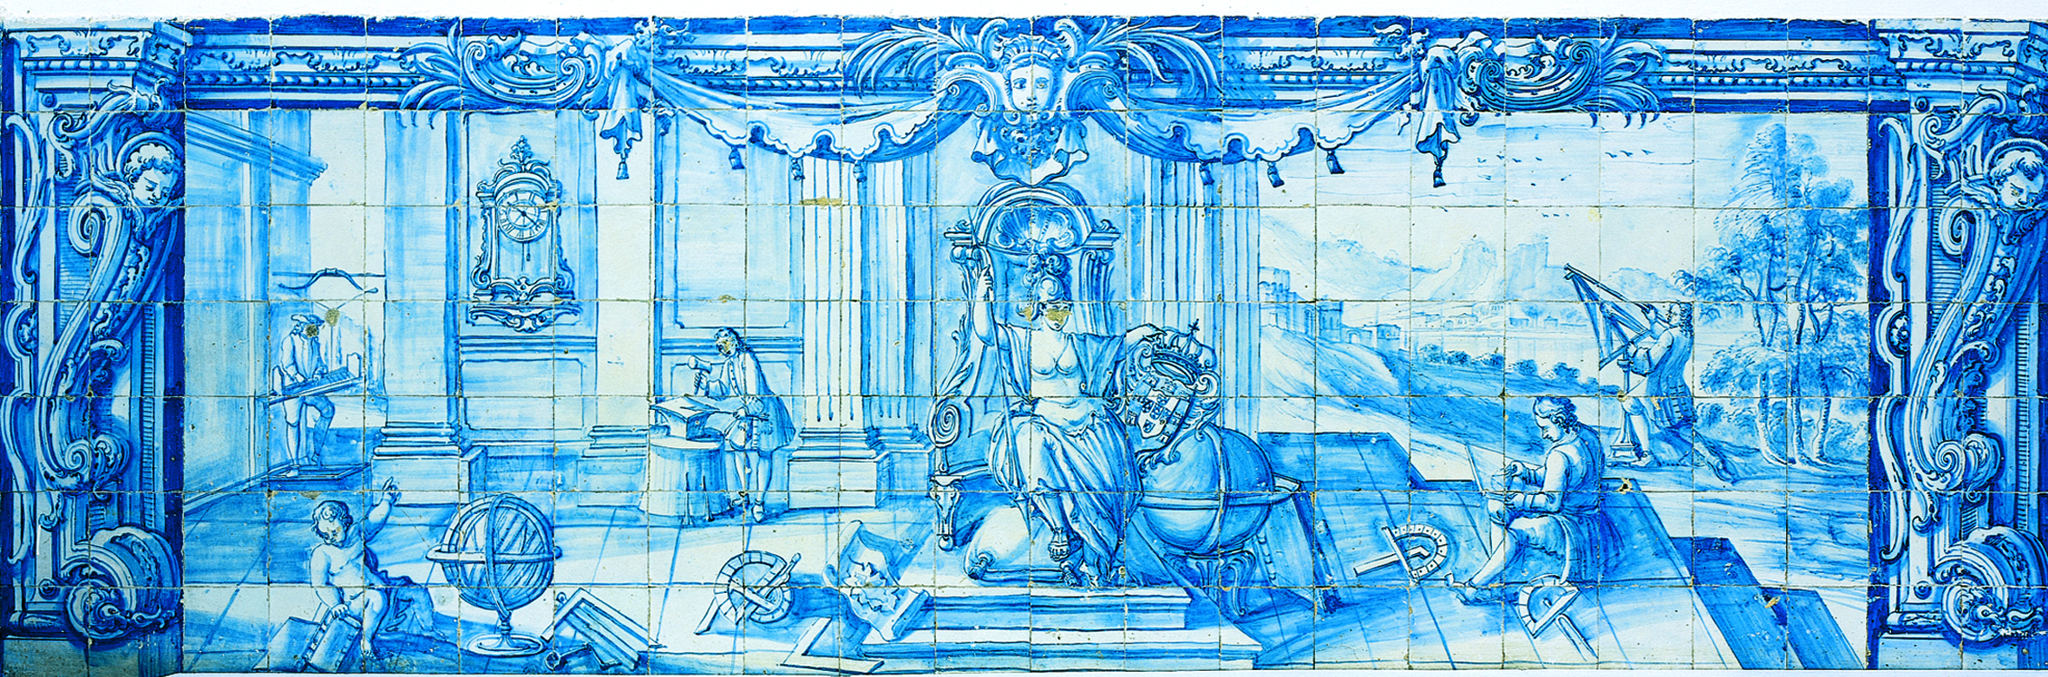
Application of
Continuous Flow Systems
Studies on the Catalytic Intramolecular Arylation
ORIENTADOR (A/ES): Professor Doutor Anthony J. Burke
Doutor Kerry Gilmore
Hugo Ricardo Matos Viana
Tese apresentada à Universidade de Évora
para obtenção do Grau de Doutor em Química
Especialidade: Química Orgânica
Esta tese não inclui as críticas e sugestões feitas pelo júri
ÉVORA, Novembro 2015
INSTITUTO DE INVESTIGAÇÃO E FORMAÇÃO AVANÇADA

“This thesis includes the critics and suggestions made by the jury.”

I dedicate this work to my family and true friends

Acknowledgments

During the last few years, I worked with a fantastic and extraordinary group of professionals. Without exception, all of the elements contributed to the successful conclusion of this thesis, and without them, things would have been undoubtedly much more difficult. They helped and supported me whenever frustration, discontent or pessimism tried to take over. For this and much more, I cannot overlook to recognise and show my gratitude to the following people:
- Professor Anthony Joseph Burke, for believing in me and giving me this chance. I thank you for your professional and personal guidance, your advice and your continuous encouragement throughout all these years. The enthusiasm and dedication you demonstrate for scientific research is unmatched. Your vast knowledge and incisive insight have been extremely inspirational and contributed for my personal growth. I sincerely thank you for your support in both professional and personal aspects. It was an honour working with you.
- My laboratory co-workers, for the countless precious encouragement, discussions, suggestions and advices on my work. Your outstanding commitment to the group revealed to be inspiring and contributed for the constant and unified atmosphere that surrounded our laboratory.
- Professor Peter Seeberger, for giving me the chance to work with his team at Max Planck Institute. With this, you provided me the opportunity to experience a different laboratory environment, in which I learned new things almost every day.
- The group at Max Planck Institute, mainly Dr. Kerry Gilmore for your warm welcome into your group. In addition, I have to thank you for your professional and personal guidance, which contributed immensely to my individual growth. Furthermore, I would like to thank Dr. Camille Correa, for the time and patience she expended on me. I couldn´t have done any of the work without your both exceptional knowledge, extraordinary commitment and impeccable professionalism.
- Sandrine da Silva Cruz, for always being there for me. I also want to thank you for listening to me, supporting me and encouraging me whenever I needed. I couldn´t have done any of this without you being by my side. You are a true friend, and I want you to know how much I appreciate you. You´re the best!!!
- My parents, my brothers and my close friends namely João Silva, David Sá, Carlos Vale, Helder Matos, Vitor Azevedo, Davide Cruz, for all the love and friendship they have been giving me throughout all these years. In addition, I want to thank you for your support, understanding and for always being there for me. I love you all.
- All the people that directly and indirectly helped me accomplish this work including, Dr. Albertino Goth for all the ¹H NMR studies, the technicians Deolinda and Aida for assisting me in the laboratory and Margarida Freixial for the help concerning administrative issues.
- The project – INMOLFARM - funded by FEDER under the INALENTEJO program ALENT-07-0224-FEDER-001743. “We acknowledge funding from the Fundação para a Ciência e Tecnologia (FCT) for support through strategic project - PEst-OE/QUI/UI0619/2014”, and the PhD scholarship granted by them to me.

Abstract

Currently, neurodegenerative diseases like Alzheimer’s (AD) and Parkinson’s disease (PD) represent an important worldwide health problem.
Over the last number of years, there have been many advances in the field of metal catalysed reactions. The palladium-catalysed intramolecular nucleophilic addition of arylborons and aryl halides to ketones constitutes an important methodology for the synthesis of chiral cycloalkanols.
Our main objective was the development of a new efficient protocol for accessing the 1-aminotetralin and 1-aminoindane skeletons (Chapters 3 and 4). A secondary goal was to obtain robust and reliable enantioselective versions of these reactions (Chapters 3 and 4). Numerous aldehyde substrates were synthesized and various cyclization reactions were carried out using these substrates (Chapter 3). We also compared the effectiveness of conducting these reactions under continuous flow conditions, with those carried out under batch conditions. Furthermore, some of our 3,3-dimethylchroman-4-ones and 3,3-dimethylchroman-4-ols were tested against AChE and BuChE enzymes. Chapters 1 and 2 contain literature reviews of this material.
We also report the attempted synthesis of a library of substituted 3-hydroxy-3-phenylbenzofuran-2(3H)-ones derived from a series of α-keto o-bromoaryl- and o-pinacolboranearyl ester substrates (Chapter 4). For the synthesis of the α-keto ester substrates, we looked at two different methodologies. Eight α-keto ester substrates were synthesized in very high or excellent yields. We also studied the cyclization reaction with 1-bromonaphthalen-2-yl 2-oxo-2-phenylacetate as our model substrate. Unfortunately, these attempts were unsuccessful and no cyclic product was obtained.
Additionally, we successfully developed a new methodology for the direct oxidative esterification of aldehydes (Chapter 5). Using this methodology, we synthesized nine new diether-esters in very good to excellent yields, which were subsequently tested for both AChE and BuChE inhibition. We also presented a strategy for the synthesis of interesting polyether macrocycles that includes the borylation of the synthesized diether-esters and a Suzuki-Miyaura coupling.

Resumo

Estudos sobre a arilação intramolecular catalítica – Aplicação de sistemas de fluxo contínuo

Atualmente, doenças neurodegenerativas como a doença de Alzheimer (DA) e a doença de Parkinson (DP) representam um problema importante de saúde em todo o mundo.
Ao longo dos últimos anos, tem havido muitos avanços no campo das reações catalisadas por metais. As reações de adição nucleofílica intramolecular catalisadas por paládio, de arilboronados e de haletos de arilo a cetonas, constituem uma metodologia importante para a síntese de ciclo-álcoois quirais.
O nosso objetivo principal foi o desenvolvimento de um novo protocolo eficiente para aceder a esqueletos de 1-aminotetralinas e 1-aminoindanos (capítulos 3 e 4). Um objetivo secundário era obter versões enantiosseletivas robustas e fiáveis dessas reações (capítulos 3 e 4). Numerosos aldeídos foram sintetizados e várias reações de ciclização foram realizadas utilizando estes substratos (capítulo 3). Também comparamos a eficácia da realização destas reações sob condições de fluxo contínuo com aquelas realizadas sob condições de “batch”. Algumas das nossas 3,3-dimetilcroman-4-onas e dos nossos 3,3-dimetilcroman-4-ols foram testados contra a AChE e BuChE. Os capítulos 1 e 2 contêm alguma literatura sobre este material.
Também relatamos a tentativa de síntese de uma biblioteca de 3-hidroxi-3-fenilbenzofuran-2(3H)-onas substituídas, derivadas de uma série de α-ceto ésteres e de ésteres de o-bromoaril- e o-pinacolboranaril (capítulo 4). Para a síntese de α-ceto ésteres, testamos duas metodologias diferentes. Oito α-ceto ésteres foram sintetizados com rendimentos muito elevados ou excelentes. Também estudamos a reação de ciclização usando 1-bromonaftalen-2-il-2-oxo-2-fenilacetato como substrato modelo. Infelizmente não obtivemos nenhum produto cíclico.
Adicionalmente, desenvolvemos com sucesso uma nova metodologia para a esterificação oxidativa direta de aldeídos (capítulo 5). Usando esta metodologia, sintetizamos nove di-éter-ésteres novos com rendimentos muito bons a excelentes, que foram posteriormente testados para inibição da AChE e da BuChE. Também apresentamos uma estratégia para a síntese de macrociclos de poliéteres interessantes, que incluí a borilação dos di-éter-ésteres sintetizados e um acoplamento Suzuki-Miyaura.

Abbreviations

Acac Acetylactetone
ACh Acetylcholine
AChE Acetylcholinesterase
AD Alzheimer´s Disease
API Active Pharmaceutical Ingredient
Ar Aromatic group
byp 2,2´-bipyridine
B₂pin₂ Bis(pinacolato)diboron
BnCl Benzyl chloride
BuChE Butyrylcholinesterase
Cat Catalyst
ChAT Cholineacetiltransferase
Cod 1,5-Cyclooctadiene
DCM Dichloromethane
DMF N,N´-Dimethyl formamide
DMSO Dimethyl sulfoxide
dppf Bis(diphenylphosphino)ferrocene
dppp 1,3-Bis(diphenylphosphino)propane
ee Enantiomeric excess
EDG Electron-donating group
ESI Electrospray ionization
EtOAc Ethyl acetate
EtOH Ethanol
EWG Electron-withdrawing group
Hex Hexane
HFIP Hexafluoroisopropyl
HMDS 1,1,1,3,3,3-Hexamethyldisilazane
H₂O₂ Hydrogen peroxide
HPLC High-performance liquid chromatography
IBX 2-iodoxybenzoic acid
Me Methyl
Nap Naphthyl
NHC N-Heterocyclic carbene
NMR Nuclear Magnetic Ressonance
PD Parkinson disease
PCC Pyridinium chlorochromate
Ph Phenyl
PNP N[2-P(CHMe₂)₂-4-methylphenyl]₂⁻
PMP 1,2,2,6,6-Pentamethylpiperidine
ppm Parts per million
q Quartet
r.t. Room temperature
s Singlet
SOL Sulphur-based olefin ligands
t Triplet
TBAAc Tetrabutylammonium acetate
TBHP tert-butyl hydroperoxide
THF Tetrahydrofuran
TLC Thin Layer Chromatography
TOF Turnover frequency
S_{N}2 Bimolecular nucleophilic substitution

Index

Dissertation Overview 1
New advances in catalytic intramolecular arylation reactions 3

1. Transition Metal Catalysis: Palladium-Catalysed Coupling Reactions 7
1.1 Introduction 9
1.1.1 The role of transition metals in chemical processes 9
1.1.2 The roots of cross-coupling reactions 10
1.1.2.1 Historical perspective 10
1.1.2.2 Origins of transition metal catalysts 12
1.1.2.3 Homo and stoichiometric cross-coupling processes 14
1.2 Growth of Palladium Mediated Catalysis 14
1.2.1 The introduction of palladium element 14
1.2.2 Palladium chemistry 15
1.2.3 Carbopalladation 16
1.2.4 Palladium complexes as cross-coupling catalysts: The Heck-Mizoroki reaction 18
1.2.5 The cyclic Heck-Mizoroki reaction 20
1.3 Investigation of the Coupling Partner 22
1.3.1 The Migita-Stille coupling 22
1.3.2 The Suzuki-Miyaura coupling 22
1.3.3 The Hiyama-Hatanaka cross-coupling 23
1.4 First Carbon-Heteroatom Couplings 26
1.4.1 The Miyaura borylation reaction 26
1.4.2 The Buchwald-Hartwig coupling reaction 28
1.5 Conclusions 29

2. Metal-Catalysed Arylations with Carbonyl Compounds 31
2.1 Introduction 33
2.1.1 Metal-catalysed α-arylation of carbonyl compounds 33
2.1.2 Metal-catalysed addition of aryl halides to carbonyls 35
2.1.3 Metal-catalysed addition of arylboronic compounds to carbonyl and imine groups 37
2.2 Conclusions 46

3. Palladium-Catalysed Cyclizations 49
3.1 Introduction 51
3.1.1 Current synthetic methodologies and target molecules 51
3.1.2 Rasagiline and neurodegenerative diseases 55
3.2 Flow Chemistry 56
3.2.1 The establishment of flow chemistry 56
3.2.2 The main advantages of continuous flow systems 60
3.2.3 Catalysis in flow chemistry 62
3.3 Results and Discussion 65
3.3.1 Our approach 65
3.3.2 Synthesis of the o-haloaryl ether substrates 66
3.3.2.1 Initial approaches 66
3.3.2.2 Synthesis of substituted 3-(2-bromophenoxy) alcohol derivatives 70
3.3.2.3 Variation with a naphthyl scaffold 71
3.3.2.4 Variation with heteroaromatic scaffolds 72
3.3.3 Oxidation of the alcohol derivatives 76
3.3.3.1 General considerations 76
3.3.3.2 Synthesis of the aldehyde derivatives 78
3.3.4 Synthesis of non-gem-dimethyl aldehyde derivatives 80
3.3.4.1 Alternatives to PCC oxidation reactions 80
3.3.4.2 Synthesis of the allyl aryl and heteroaryl ether derivatives 81
3.3.4.3 Synthesis of aldehyde derivatives through Lemieux-Johnson oxidation 82
3.3.5 Metal-catalysed borylation reactions 84
3.3.5.1 A view into borylation processes 84
3.3.5.2 Palladium-catalysed borylation of aryl halides and sulfonates 87
3.3.5.3 Synthesis of the borylated derivatives 89
3.3.6 Palladium-catalysed intramolecular nucleophilic additions 95
3.3.6.1 Intramolecular nucleophilic additions in general 95
3.3.6.2 Solé´s work: possibilities for divergence 97
3.3.6.3 Study on the direct intramolecular cyclization of (2-bromophenol)-aldehydes 100
3.3.6.4 Synthesis of 3,3-dimethylchroman-4-one and 3,3-dimethyl chroman-4-ol derivatives 110
3.3.7 Flow chemistry 114
3.3.7.1 Comparing batch and continuous flow systems 114
3.3.7.2 Transfer to continuous flow systems 115
3.3.8 Obtaining enantioenriched cycloalkanol derivatives – asymmetric catalysis 120
3.3.8.1 The first approach: in situ formation of the metal based chiral catalyst 121
3.3.8.2 Application of the Corey-Bakshi-Shibata (CBS) asymmetric reduction 122
3.3.9 Biological assays 125
3.3.9.1 Preliminary AChE and BuChE inhibition assays 125
3.4 Conclusions 128
3.5 Experimental Section 130
3.5.1 General observations 130
3.5.1.1 Reagents and solvents 130
3.5.1.2 Detection, purification and characterisation of the synthesized compounds 130
3.5.2 Synthesis of arylethers via phenol etherification 131
3.5.2.1 General procedure 131
3.5.2.2 Synthesis of 3-(2-bromophenoxy)-2,2-dimethylpropan-1-ol (4a) 132
3.5.2.3 Synthesis of 2-(2-bromophenoxy)ethanol (4b) 133
3.5.2.4 Synthesis of 3-(2-bromophenoxy)propan-1-ol (4c) 133
3.5.2.5 Synthesis of 3-(2-bromo-4,5-difluorophenoxy)-2,2-dimethylpropan-1-ol (4d) 134
3.5.2.6 Synthesis of 2-(2-bromo-4,5-difluorophenoxy)ethanol (4e) 135
3.5.2.7 Synthesis of 2-(2-bromo-4,5-difluorophenoxy)ethanol (4f) 135
3.5.2.8 Synthesis of 3-bromo-4-(3-hydroxy-2,2-dimethylpropoxy) benzonitrile (4g) 136
3.5.2.9 Synthesis of 3-bromo-4-(2-hydroxyethoxy)benzonitrile (4h) 136
3.5.2.10 Synthesis of 3-bromo-4-(3-hydroxypropoxy)benzonitrile (4i) 137
3.5.2.11 Synthesis of 3-(2-bromo-4-methylphenoxy)-2,2-dimethylpropan-1-ol (4j) 138
3.5.2.12 Synthesis of 2-(2-bromo-4-methylphenoxy)ethanol (4k) 139
3.5.2.13 Synthesis of 3-(2-bromo-4-methylphenoxy)propan-1-ol (4l) 139
3.5.2.14 Synthesis of 3-(2-bromo-4-methylphenoxy)propan-1-ol (4m) 140
3.5.2.15 Synthesis of 2-(2-bromo-5-fluorophenoxy)ethanol (4n) 140
3.5.2.16 Synthesis of 3-(2-bromo-5-fluorophenoxy)propan-1-ol (4o) 141
3.5.2.17 Synthesis of 3-(2-bromo-3-methoxyphenoxy)-2,2-dimethylpropan-1-ol (4p) 142
3.5.2.18 2-(2-bromo-3-methoxyphenoxy)ethanol (4q) 142
3.5.2.19 Synthesis of 3-(2-bromo-3-methoxyphenoxy)propan-1-ol (4r) 143
3.5.2.20 Synthesis of 3-((1-bromonaphthalen-2-yl)oxy)-2,2-dimethylpropan-1-ol (6a) 144
3.5.2.21 Synthesis of 2-((1-bromonaphthalen-2-yl)oxy)ethanol (6b) 144
3.5.2.22 Synthesis of 3-((1-bromonaphthalen-2-yl)oxy)propan-1-ol (6c) 145
3.5.2.23 3.5.2.23 3-((3-bromonaphthalen-2-yl)oxy)-2,2-dimethylpropan-1-ol (6d) 146
3.5.2.24 2-((3-bromonaphthalen-2-yl)oxy)ethanol (6e) 146
3.5.2.25 3-((2-bromopyridin-3-yl)oxy)-2,2-dimethylpropan-1-ol (8a) 147
3.5.2.26 2-((2-bromopyridin-3-yl)oxy)ethanol (8b) 147
3.5.2.27 3-((2-bromopyridin-3-yl)oxy)propan-1-ol (8c) 148
3.5.2.28 3-((7-bromoquinolin-8-yl)oxy)-2,2-dimethylpropan-1-ol (8d) 149
3.5.2.29 2-((7-bromoquinolin-8-yl)oxy)ethanol (8e) 149
3.5.2.30 3-((7-bromoquinolin-8-yl)oxy)propan-1-ol (8f) 150
3.5.3 Synthesis of the aldehyde derivatives through PCC oxidation reactions 151
3.5.3.1 General procedure 151
3.5.3.2 Synthesis of 3-(2-bromophenoxy)-2,2-dimethylpropanal (9a) 151
3.5.3.3 Synthesis of 3-((1-bromonaphthalen-2-yl)oxy)-2,2-dimethylpropanal (9b) 152
3.5.3.4 Synthesis of 3-(2-bromo-4,5-difluorophenoxy)-2,2-dimethylpropanal (9c) 153
3.5.3.5 Synthesis of 3-(2-bromo-3-methoxyphenoxy)-2,2-dimethylpropanal (9d) 153
3.5.3.6 Synthesis of 3-(2-bromo-4-methylphenoxy)-2,2-dimethylpropanal (9e) 154
3.5.3.7 Synthesis of 3-(2-bromo-5-fluorophenoxy)-2,2-dimethylpropanal (9f) 155
3.5.3.8 Synthesis of 3-((2-bromopyridin-3-yl)oxy)-2,2-dimethylpropanal (9g) 155
3.5.3.9 Synthesis of 3-((3-bromonaphthalen-2-yl)oxy)-2,2-dimethylpropanal (9h) 156
3.5.4 Synthesis of allyl aryl and heteroaryl ether derivatives 156
3.5.4.1 General procedure 156
3.5.4.2 Synthesis of 1-(allyloxy)-2-bromobenzene (10a) 157
3.5.4.3 Synthesis of 2-(allyloxy)-1-bromonaphthalene (10b) 158
3.5.4.4 Synthesis of 2-(allyloxy)-3-bromonaphthalene (10c) 158
3.5.4.5 Synthesis of 1-(allyloxy)-2-bromo-4-methylbenzene (10d) 159
3.5.4.6 Synthesis of 4-(allyloxy)-3-bromobenzonitrile (10e) 160
3.5.4.7 Synthesis of 1-(allyloxy)-2-bromo-3-methoxybenzene (10f) 160
3.5.4.8 Synthesis of 1-(allyloxy)-2-bromo-4-fluorobenzene (10g) 161
3.5.4.9 Synthesis of 2-(allyloxy)-1-bromo-4-fluorobenzene (10h) 162
3.5.4.10 Synthesis of 1-(allyloxy)-2-bromo-4,5-difluorobenzene (10i) 162
3.5.4.11 Synthesis of 3-(allyloxy)-2-bromopyridine (10j) 163
3.5.4.12 Synthesis of 8-(allyloxy)-7-bromoquinoline (10k) 164
3.5.5 Synthesis of aldehyde derivatives through Lemieux-Johnson Oxidation 164
3.5.5.1 General procedure 164
3.5.5.2 Synthesis of 2-(2-bromophenoxy)acetaldehyde (11a) 165
3.5.5.3 Synthesis of 2-((1-bromonaphthalen-2-yl)oxy)acetaldehyde (11b) 165
3.5.5.4 Synthesis of 2-((1-bromonaphthalen-2-yl)oxy)acetaldehyde (11c) 166
3.5.5.5 Synthesis of 2-(2-bromo-3-methoxyphenoxy)acetaldehyde (11d) 167
3.5.5.6 Synthesis of 2-(2-bromo-5-fluorophenoxy)acetaldehyde (11e) 167
3.5.5.7 Synthesis of 2-(2-bromo-4,5-difluorophenoxy)acetaldehyde (11f) 168
3.5.5.8 Synthesis of 2-((2-bromopyridin-3-yl)oxy)acetaldehyde (11g) 168
3.5.6 Synthesis of 3,3-dimethylchroman-4-one and 3,3-dimethyl chroman-4-ol derivatives 169
3.5.6.1 General catalytic procedure 169
3.5.6.2 Synthesis of 3,3-dimethylchroman-4-one (13a) 170
3.5.6.3 Synthesis of 7-fluoro-3,3-dimethylchroman-4-one (13b) 170
3.5.6.4 Synthesis of 3,3,6-trimethylchroman-4-one (13c) 171
3.5.6.5 Synthesis of 3,3-dimethyl-2H-benzo[g]chromen-4(3H)-one (13d) 171
3.5.6.6 Synthesis of 6,7-difluoro-3,3-dimethylchroman-4-one (13e) 172
3.5.6.7 Synthesis of 5-methoxy-3,3-dimethylchroman-4-one (13f) 172
3.5.6.8 Synthesis of 3,3-dimethylchroman-4-ol (14a) 173
3.5.6.9 Synthesis of 3,3-dimethyl-3,4-dihydro-2H-benzo[g] chromen-4-ol (14b) 174
3.5.6.10 Synthesis of 7-fluoro-3,3-dimethylchroman-4-ol (14c) 174
3.5.7 Other attempted reactions 175
3.5.7.1 General procedure for the alkylation of o-boronophenol substrates (1a) and (1b) (Schemes 3.6 and 3.8) 175
3.5.7.2 General procedure for the borylation of compounds (4a), (4c), (6e), (9a), (9b) and (11a) (Schemes 3.24, 3.25, 3.26, 3.27, 3.28, 3.30, 3.31 and 3.32) 175
3.5.7.3 General procedure for the palladium-catalysed reactions in continuous flow systems (Schemes 3.39-3.41) 176
3.5.7.4 General procedure for the synthesis of the chiral cyclic alkanol (14a) (Scheme 3.42) 176
3.5.7.5 General procedure for the reduction of cyclic ketone (13a) with CBS-oxazaborolidine reagent (Scheme 3.43) 177
3.5.7.6 General procedure for the attempted reduction of cyclic ketone (13a) with CBS-oxazaborolidine reagent (Scheme 3.44) 177
3.5.8 Biological assays 177

4. Metal-Catalysed Coupling Reactions 179
4.1 Introduction 181
4.1.1 Metal-catalysed intramolecular addition to ketones 182
4.2 Results and Discussion 187
4.2.1 Synthesis of the precursors 187
4.2.2 Metal-catalysed borylation of α-keto esters 191
4.2.3 Metal-catalysed intramolecular arylations of α-keto esters 195
4.3 Conclusions 198
4.4 Experimental Section 200
4.4.1 General observations 200
4.4.1.1 Reagents and solvents 200
4.4.1.2 Detection, purification and characterisation of synthesized compounds 200
4.4.2 Synthesis of the 2-oxo-2-phenylacetyl chloride (17) 201
4.4.2.1 General procedure 201
4.4.3 Synthesis of the α-keto ester substrates (18a)-(18h) 201
4.4.3.1 General procedure 201
4.4.3.2 Synthesis of 2-bromophenyl 2-oxo-2-phenylacetate (18a) 202
4.4.3.3 Synthesis of 2-bromo-4,5-difluorophenyl 2-oxo-2-phenylacetate (18b) 203
4.4.3.4 Synthesis of 2-bromo-4-methylphenyl 2-oxo-2-phenylacetate (18c) 203
4.4.3.5 Synthesis of 2-bromo-5-fluorophenyl 2-oxo-2-phenylacetate (18d) 204
4.4.3.6 Synthesis of 2-bromo-3-methoxyphenyl 2-oxo-2-phenylacetate (18e) 205
4.4.3.7 Synthesis of 2-bromo-4-fluorophenyl 2-oxo-2-phenylacetate (18f) 205
4.4.3.8 Synthesis of 3-bromonaphthalen-2-yl 2-oxo-2-phenylacetate (18g) 206
4.4.3.9 Synthesis of 1-bromonaphthalen-2-yl 2-oxo-2-phenylacetate (18h) 207
4.4.4 Other attempted reactions 207
4.4.4.1 General procedure for the attempted esterification of 2-bromo phenol phenylpyruvic acid using MIBA as activating agent (Scheme 4.12) 207
4.4.4.2 General procedure for the attempted borylation of 1-bromo naphthalen-2-yl 2-oxo-2-phenylacetate using palladium catalyst (Scheme 4.14) 208
4.4.4.3 General procedure for the attempted borylation of 1-bromo naphthalen-2-yl 2-oxo-2-phenylacetate using nickel catalyst (Scheme 4.15) 208
4.4.4.4 General procedure for the attempted arylation of 1-bromo naphthalen-2-yl 2-oxo-2-phenylacetate (18g) (Schemes 4.17 and 4.18) 209
4.4.4.5 General procedure for the attempted arylation of 1-bromo naphthalen-2-yl 2-oxo-2-phenylacetate (18g) using different conditions (Scheme 4.19) 209

5. Metal-Catalysed Coupling Reactions 211
5.1 Introduction 213
5.1.1 The oxidative esterification of alcohols with aldehydes 215
5.1.1.1 Metal free oxidative esterification of alcohols with aldehyde 215
5.1.1.2 Transition metal-catalysed oxidative esterification of aldehydes to esters 219
5.1.2 Oxidative esterification between two alcohols 226
5.1.2.1 Direct oxidation of primary alcohols to dimeric esters 226
5.1.2.2 Metal-catalysed oxidative esterification between two different alcohols 228
5.2 Results and Discussion 231
5.2.1 New PCC promoted oxidative esterification of primary alcohols – synthesis of diether-esters 231
5.2.2 Proposed mechanism 236
5.2.3 PCC promoted oxidative esterification of alcohols – evaluating the reaction scope 238
5.2.4 Additional reactions in the scope of the oxidative esterification 240
5.2.5 Synthetic route to macrocycle drug-like molecules from diether-esters 243
5.2.6 Biological assays 250
5.1.6.1 Inhibition assays on AChE and BuChE 250
5.3 Conclusions 252
5.4 Experimental Section 253
5.4.1 General observations 253
5.4.1.1 Reagents and solvents 253
5.4.1.2 Detection, purification and characterisation of synthesized compounds 253
5.4.1.3 ¹H NMR kinetic experiments 254
5.4.2 Direct synthesis of esters via PCC oxidative esterification 254
5.4.2.1 General procedure 254
5.4.2.2 Synthesis of 2-(2-bromophenoxy)ethyl 2-(2-bromophenoxy)acetate (20a) 255
5.4.2.3 Procedure using Lewis Acids 255
5.4.2.4 Synthesis of 2-(2-bromo-5-fluorophenoxy)ethyl 2-(2-bromo-5-fluorophenoxy)acetate (20b) 256
5.4.2.5 5.5.2.5 Synthesis of 2-(2-bromo-4,5-difluorophenoxy)ethyl 2-(2-bromo-4,5-difluorophenoxy)acetate (20c) 257
5.4.2.6 Synthesis of 2-(2-bromo-4-methylphenoxy)ethyl 2-(2-bromo-4-methylphenoxy)acetate (20d) 258
5.4.2.7 Synthesis of 2-((1-bromonaphthalen-2-yl)oxy)ethyl 2-((1-bromonaphthalen-2-yl)oxy)acetate (20e) 259
5.4.2.8 5.5.2.8 Synthesis of 2-((2-bromopyridin-3-yl)oxy)ethyl 2-((2-bromopyridin-3-yl)oxy)acetate (20f) 260
5.4.2.9 Synthesis of 2-(2-bromo-4-cyanophenoxy)ethyl 2-(2-bromo-4-cyanophenoxy)acetate (20g) 260
5.4.2.10 Synthesis of 2-((3-bromonaphthalen-2-yl)oxy)ethyl 2-((3-bromonaphthalen-2-yl)oxy)acetate (20h) 261
5.4.2.11 Synthesis of 2-((2-bromopyridin-3-yl)oxy)ethyl 2-((2-bromopyridin-3-yl)oxy)acetate (20i) 262
5.4.3 Borylation of 2-(2-bromophenoxy)ethyl 2-(2-bromophenoxy)acetate (20a) 263
5.4.3.1 General procedure 263
5.4.3.2 Synthesis of 2-(2-(4,4,5,5-tetramethyl-1,3,2-dioxaborolan-2-yl)phenoxy)ethyl 2-(2-bromophenoxy)acetate (24a) 263
5.4.4 Procedure for the Suzuki-Miyaura coupling of 2-(2-(4,4,5,5-tetramethyl-1,3,2-dioxaborolan-2-yl)phenoxy)ethyl 2-(2-bromo phenoxy)acetate (24a) 264
5.4.4.1 Synthesis of 9,10-dihydrodibenzo [h,j] [1,4,7] trioxacy cloundecin-7(6H)-one (25a) 264
5.4.5 Other attempted reactions 265
5.4.5.1 General procedure for the attempted synthesis of 3-bromo propyl 2-(2-bromophenoxy)acetate (22a) (Scheme 5.23) 265
5.4.5.2 General procedure for the attempted synthesis of N-benzylbenzamide (22b) (Scheme 5.23) 265
5.4.5.3 General procedure for the scope of the oxidative esterification with PCC (Scheme 5.24) 266
5.4.5.4 General procedure for the attempted borylation of compound (20a) (Scheme 5.27) 266
5.4.5.5 General procedure for the attempted Suzuki-Miyaura coupling of (24a) (Scheme 5.29) 266
5.4.6 Biological assays 267

Bibliography 269

Index of Figures

Figure 1.1 ……………………………………………………………… 12
Figure 1.2 ……………………………………………………………… 13
Figure 1.3 ……………………………………………………………… 16

Figure 2.1 ……………………………………………………………… 33

Figure 3.1 ……………………………………………………………… 52
Figure 3.2 ……………………………………………………………… 53
Figure 3.3 ……………………………………………………………… 54
Figure 3.4 ……………………………………………………………… 54
Figure 3.5 ……………………………………………………………… 56
Figure 3.6 ……………………………………………………………… 58
Figure 3.7 ……………………………………………………………… 59
Figure 3.8 ……………………………………………………………… 59
Figure 3.9 ……………………………………………………………… 63
Figure 3.10 ……………………………………………………………… 71
Figure 3.11 ……………………………………………………………… 73
Figure 3.12 ……………………………………………………………… 77
Figure 3.13 ……………………………………………………………… 77
Figure 3.14 ……………………………………………………………… 78
Figure 3.15 ……………………………………………………………… 78
Figure 3.16 ……………………………………………………………… 82
Figure 3.17 ……………………………………………………………… 83
Figure 3.18 ……………………………………………………………… 84
Figure 3.19 ……………………………………………………………… 87
Figure 3.20 ……………………………………………………………… 89
Figure 3.21 ……………………………………………………………… 98
Figure 3.22 ……………………………………………………………… 99
Figure 3.23 ……………………………………………………………… 105
Figure 3.24 ……………………………………………………………… 111
Figure 3.25 ……………………………………………………………… 113
Figure 3.26 ……………………………………………………………… 114
Figure 3.27 ……………………………………………………………… 115
Figure 3.28 ……………………………………………………………… 123
Figure 3.29 ……………………………………………………………… 127
Figure 3.30 ……………………………………………………………… 127

Figure 4.1 ……………………………………………………………… 181
Figure 4.2 ……………………………………………………………… 187
Figure 4.3 ……………………………………………………………… 193
Figure 4.4 ……………………………………………………………… 194

Figure 5.1 ……………………………………………………………… 213
Figure 5.2 ……………………………………………………………… 224
Figure 5.3 ……………………………………………………………… 234
Figure 5.4 ……………………………………………………………… 235
Figure 5.5 ……………………………………………………………… 244
Figure 5.6 ……………………………………………………………… 247
Figure 5.7 ……………………………………………………………… 247
Figure 5.8 ……………………………………………………………… 248

Index of Schemes

Scheme 1.1 …………………………………………………………… 11
Scheme 1.2 …………………………………………………………… 17
Scheme 1.3 …………………………………………………………… 17
Scheme 1.4 …………………………………………………………… 19
Scheme 1.5 …………………………………………………………… 20
Scheme 1.6 …………………………………………………………… 21
Scheme 1.7 …………………………………………………………… 23
Scheme 1.8 …………………………………………………………… 24
Scheme 1.9 …………………………………………………………… 26
Scheme 1.10 …………………………………………………………… 27
Scheme 1.11 …………………………………………………………… 29

Scheme 2.1 …………………………………………………………… 35
Scheme 2.2 …………………………………………………………… 36 Scheme 2.3 …………………………………………………………… 37 Scheme 2.4 …………………………………………………………… 37 Scheme 2.5 …………………………………………………………… 38 Scheme 2.6 …………………………………………………………… 38 Scheme 2.7 …………………………………………………………… 39 Scheme 2.8 …………………………………………………………… 39 Scheme 2.9 …………………………………………………………… 40 Scheme 2.10 …………………………………………………………… 40 Scheme 2.11 …………………………………………………………… 41 Scheme 2.12 …………………………………………………………… 42 Scheme 2.13 …………………………………………………………… 42 Scheme 2.14 …………………………………………………………… 43 Scheme 2.15 …………………………………………………………… 43 Scheme 2.16 …………………………………………………………… 44 Scheme 2.17 …………………………………………………………… 45 Scheme 2.18 …………………………………………………………… 45

Scheme 3.1 …………………………………………………………… 55 Scheme 3.2 …………………………………………………………… 62
Scheme 3.3 …………………………………………………………… 64 Scheme 3.4 …………………………………………………………… 66 Scheme 3.5 …………………………………………………………… 67 Scheme 3.6 …………………………………………………………… 68 Scheme 3.7 …………………………………………………………… 68 Scheme 3.8 …………………………………………………………… 69 Scheme 3.9 …………………………………………………………… 69 Scheme 3.10 …………………………………………………………… 70 Scheme 3.11 …………………………………………………………… 72 Scheme 3.12 …………………………………………………………… 74 Scheme 3.13 …………………………………………………………… 74 Scheme 3.14 …………………………………………………………… 75 Scheme 3.15 …………………………………………………………… 75 Scheme 3.16 …………………………………………………………… 79 Scheme 3.17 …………………………………………………………… 80 Scheme 3.18 …………………………………………………………… 81 Scheme 3.19 …………………………………………………………… 81 Scheme 3.20 …………………………………………………………… 83 Scheme 3.21 …………………………………………………………… 85 Scheme 3.22 …………………………………………………………… 86 Scheme 3.23 …………………………………………………………… 86 Scheme 3.24 …………………………………………………………… 89 Scheme 3.25 …………………………………………………………… 90 Scheme 3.26 …………………………………………………………… 91 Scheme 3.27 …………………………………………………………… 91 Scheme 3.28 …………………………………………………………… 92 Scheme 3.29 …………………………………………………………… 92 Scheme 3.30 …………………………………………………………… 93 Scheme 3.31 …………………………………………………………… 93 Scheme 3.32 …………………………………………………………… 94 Scheme 3.33 …………………………………………………………… 97 Scheme 3.34 …………………………………………………………… 101 Scheme 3.35 …………………………………………………………… 102 Scheme 3.36 …………………………………………………………… 102 Scheme 3.37 …………………………………………………………… 110 Scheme 3.38 …………………………………………………………… 112 Scheme 3.39 …………………………………………………………… 116 Scheme 3.40 …………………………………………………………… 116 Scheme 3.41 …………………………………………………………… 117 Scheme 3.42 …………………………………………………………… 121 Scheme 3.43 …………………………………………………………… 123 Scheme 3.44 …………………………………………………………… 124

Scheme 4.1 …………………………………………………………… 183
Scheme 4.2 …………………………………………………………… 183 Scheme 4.3 …………………………………………………………… 184 Scheme 4.4 …………………………………………………………… 184 Scheme 4.5 …………………………………………………………… 185 Scheme 4.6 …………………………………………………………… 185 Scheme 4.7 …………………………………………………………… 185 Scheme 4.8 …………………………………………………………… 186 Scheme 4.9 …………………………………………………………… 186 Scheme 4.10 …………………………………………………………… 187 Scheme 4.11 …………………………………………………………… 188 Scheme 4.12 …………………………………………………………… 189 Scheme 4.13 …………………………………………………………… 189 Scheme 4.14 …………………………………………………………… 190 Scheme 4.15 …………………………………………………………… 192 Scheme 4.16 …………………………………………………………… 193 Scheme 4.17 …………………………………………………………… 195 Scheme 4.18 …………………………………………………………… 196
Scheme 4.19 …………………………………………………………… 196

Scheme 5.1 …………………………………………………………… 214 Scheme 5.2 …………………………………………………………… 215 Scheme 5.3 …………………………………………………………… 216 Scheme 5.4 …………………………………………………………… 217 Scheme 5.5 …………………………………………………………… 218 Scheme 5.6 …………………………………………………………… 219 Scheme 5.7 …………………………………………………………… 220 Scheme 5.8 …………………………………………………………… 221 Scheme 5.9 …………………………………………………………… 222 Scheme 5.10 …………………………………………………………… 222 Scheme 5.11 …………………………………………………………… 223 Scheme 5.12 …………………………………………………………… 224 Scheme 5.13 …………………………………………………………… 226 Scheme 5.14 …………………………………………………………… 227 Scheme 5.15 …………………………………………………………… 227 Scheme 5.16 …………………………………………………………… 228 Scheme 5.17 …………………………………………………………… 229 Scheme 5.18 …………………………………………………………… 229 Scheme 5.19 …………………………………………………………… 230 Scheme 5.20 …………………………………………………………… 231 Scheme 5.21 …………………………………………………………… 236 Scheme 5.22 …………………………………………………………… 238 Scheme 5.23 …………………………………………………………… 240 Scheme 5.24 …………………………………………………………… 242 Scheme 5.25 …………………………………………………………… 245 Scheme 5.26 …………………………………………………………… 245 Scheme 5.27 …………………………………………………………… 248 Scheme 5.28 …………………………………………………………… 249 Scheme 5.29 …………………………………………………………… 249

Index of Tables

Table 3.1 ……………………………………………………………… 95
Table 3.2 ……………………………………………………………… 103
Table 3.3 ……………………………………………………………… 104
Table 3.4 ……………………………………………………………… 108
Table 3.5 ……………………………………………………………… 109
Table 3.6 ……………………………………………………………… 118
Table 3.7 ……………………………………………………………… 127

Table 4.1 ……………………………………………………………… 191
Table 4.2 ……………………………………………………………… 197

Table 5.1 ……………………………………………………………… 232
Table 5.2 ……………………………………………………………… 233
Table 5.3 ……………………………………………………………… 239
Table 5.4 ……………………………………………………………… 251

Dissertation Overview

“I am among those who think that science has a great beauty. A scientist in his laboratory is not only a technician: he is also a child placed before natural phenomena which impress him like a fairy tale.”

Marie Curie

New advances in catalytic intramolecular arylation reactions

Nowadays, neurodegenerative diseases like Alzheimer’s (AD) and Parkinson’s disease (PD) represent an important worldwide health problem and thus there has been a need for new more effective drugs for their treatment. Molecules bearing a 1-aminotetralin or 1-aminoindane skeleton are particularly attractive, some examples being Amgen’s BACE-1 inhibitor for targeting AD and Rasagiline for treating PD.
Over the last number of years, there have been many advances in the field of metal catalysed reactions, leading to the development of highly efficient and reliable synthetic methodologies. Among these reactions, the palladium-catalysed intramolecular nucleophilic addition reactions of arylborons and aryl halides to ketones has drawn a lot of attention, since it constitutes an important methodology for the synthesis of chiral cycloalkanols, which are present in many key target molecules. We in fact have investigated in this body of work, novel the metal-catalysed intramolecular nucleophilic addition reactions of arylborons and aryl halides to ketones and aldehydes. In fact, until now there have been two reports on cyclizations with the latter. The first two chapters concern the state of the art of metal catalysed coupling reactions and metal catalysed carbonyl and enolate arylations (α-arylations in the case of the enolates).
Our main objective was the development of a new efficient protocol for accessing the 1-aminotetralin and 1-aminoindane skeletons, involving cyclizations to key cycloalkanol intermediates (Chapters 3 and 4). A secondary goal was to obtain robust and reliable enantioselective versions of these reactions (Chapters 3 and 4). Numerous aldehyde substrates were synthesized in very high or excellent yield using several reactions and strategies. In addition, various cyclization reactions were carried out using these substrates, under a variety of different conditions (Chapter 3). By varying the conditions, we could preferentially either 3,3-dimethylchroman-4-ones or 3,3-dimethylchroman-4-ols. We also carried a study to compare the effectiveness of conducting these reactions under continuous flow conditions with those carried out under batch conditions. We established that due to the specific nature of the catalytic process, batch conditions were preferred. Some of our 3,3-dimethylchroman-4-ones and 3,3-dimethylchroman-4-ols were tested against AChE and BuChE enzymes, however obtaining poor results.
We also report the attempted synthesis of a library of substituted 3-hydroxy-3-phenylbenzofuran-2(3H)-ones derived from a series of α-keto o-bromoaryl- and o-pinacolboranearyl ester substrates (Chapter 4). Up until now, the corresponding α-keto o-bromoarylamide substrates have been used with success to give 3-substituted 3-hydroxyoxindoles. For the synthesis of the α-keto ester substrates, we looked at two different methodologies; the direct amidation of carboxylic acids catalysed by MIBA, reported by Hall and co-workers and the classical methodology of forming esters using alcohols or phenols and acyl chlorides, followed by a nucleophilic addition / elimination mechanism. Only the latter methodology provided us with the desired products. Eight α-keto ester substrates were synthesized in very high to excellent yields. Based on previous literature reports from the groups of Kündig and Shibasaki, using α-keto o-bromoarylamide substrates, we studied the cyclization reaction with 1-bromonaphthalen-2-yl 2-oxo-2-phenylacetate as our model substrate using a series of Rh catalysts and various reaction conditions. Unfortunately, these attempts were unsuccessful and the main product in almost all cases was the ether cleavage product, 1-bromonaphthalen-2-ol, which presumably was formed via a reductive cleavage mechanism. Since aryl esters are more labile to reductive cleavage than aryl amides, this was a significant problem in the former system. Although only one model substrate of the eight compounds available was studied, we presumed that the same would occur with the other seven α-keto esters.
During this research, we also successfully developed a new methodology for the direct oxidative esterification of aldehydes, obtained in situ from oxidation of specific primary alcohols: this protocol provided interesting diether-ester products (Chapter 5). Using this efficient methodology, we synthesized nine new diether-esters in very good to excellent yields, which were subsequently tested for both AChE and BuChE inhibition without any success. In addition, we also studied a new synthetic strategy for the synthesis of interesting polyether macrocycles with potential biological activity, which included the borylation of the synthesized diether-esters and a subsequent in situ Suzuki-Miyaura coupling to obtain the correspondent macrocycle. This molecule was also tested against both AChE and BuChE enzymes.

1. Transition Metal Catalysis: Palladium-Catalysed Coupling Reactions

“I have not failed. I've just found 10,000 ways that won't work.”
Thomas A. Edison

1.1 Introduction
  - 1.1.1 The role of transition metals in chemical processes

Transition metals are special elements in chemistry. The reason for this is that they have a significant number of available d-orbitals either, filled or empty, with suitable energy for interaction with a wide variety of functional groups of organic compounds. Even simple alkenes and carbon monoxide (CO) ignored by metal ions like Na⁺ and Mg²⁺ and considered relatively unreactive, coordinate to transition metals.
Organometallic chemistry originated in the 1840s with the work of Frankland, who synthesized the first organozinc compounds. After this, the next breakthrough was Grignard’s work on organomagnesium compounds, which quickly became part of the organic chemist´s toolbox. Transition metals were applied in two different contexts:
- In industry, where the main objective was the development of lucrative processes, leading to important consumer chemicals. Here, there was very little or no understanding of the reaction mechanism. Examples included alkene metathesis and hydroformylation.¹
- In academia, with an emphasis on understanding the reaction. One early example was the discovery of Ni(CO)₄ by Ludwig Mond, in the late 19th century. This remarkable compound, which is a gas under normal conditions, is made from solid metallic nickel.¹

The key step on the use of transition metals came at the end of the 19th century, when Sabatier finely divided metals such as nickel, palladium or platinum for catalysing the hydrogenation of alkenes. Yet, the major turning point came after the determination of the structure of ferrocene by Wilkinson, as this offered the chemists a stable organometallic compound to study. Assisted by progresses in instrumentation, it was during this period that chemists were able to study organotransition-metal complexes comprehensively and understand the ground rules of their reactivity.¹
Consequently, the use of these kinds of metals would allow synthetic chemists to do reactions that were very difficult or in most cases impossible. They also permitted the development of a new set of synthetic methodologies and allowed greater control over the selectivity of the reactions.

  - 1.1.2 The roots of cross-coupling reactions
1.1.2.1 Historical perspective

A coupling reaction in organic chemistry is a universal term for a selection of reactions where two hydrocarbon fragments are coupled with the help of a metal catalyst. Cross-coupling history commenced in the 19th century, with earlier discoveries involving the conceptually related metal-mediated homo coupling processes.
In the 1970s, innovation in the field of transition metal catalysis (see Section 1.1.2.2) took an important step, with important contributions from Beletskaya, Corriu, Kumada, Kochi, Murahashi, Sonogashira, Stille, Trost, Tsuji, Akio Yamamoto, Heck, Negishi and Suzuki.² These contributions established that carbon atoms in all hybridization states (but dominated by the sp² carbon), undergo C-C bond forming reactions under palladium catalysis.²
As a consequence, coupling reactions under milder conditions and lower metal loadings were developed using more efficient catalytic systems and by incorporating a wide variety of ligands, with different steric and electronic properties. These ligands ultimately led to the discovery of new cross-coupling reactions, generating other bonds (i.e. C-N, C-O, C-P, C-S, and C-B).²
The issue of chemoselectivity is of decisive significance in cross-coupling reactions, since a number of possible side reactions (i.e. homo coupling, isomerization, β-hydride elimination and functional group interferences) must be avoided in order to develop a generally practical method for use in organic synthesis.²
As observed and noted by Snieckus and Colacot in their recent review², the development of the coupling chemistry outlined above, may be contemplated to occur over three periods or waves, after the discovery of cross-coupling as a concept (Scheme 1.1):²
- 1st wave: investigation of the metal catalysts capable of promoting these transformations in a selective fashion;
- 2nd wave: expansion of the coupling partner scope;
- 3rd wave: the continuous improvement and extension of each reaction type through ligand variation, accommodating wider substrate scope, by reaction optimization and fine tuning.
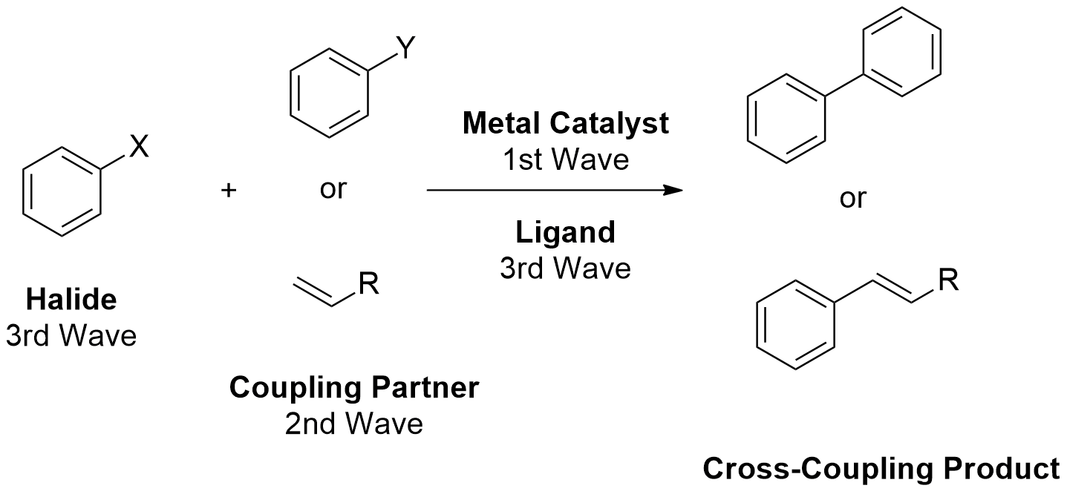
Scheme 1.1: The coupling waves as defined by the reaction component.²

Figure 1.1 shows the origin of these chemistry household-name reactions and their evolution throughout the last century.²

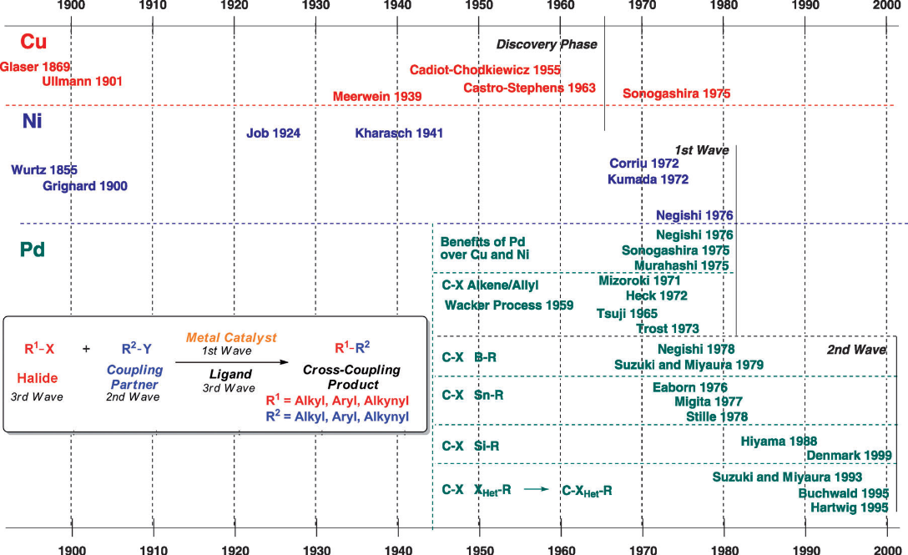
Figure 1.1: Representation of the timeline and discovery of metal-catalysed cross-coupling reactions. We acknowledge Wiley VCH for permission to reproduce this diagram.²

  - 1.1.2.2 Origins of transition metal catalysts

Dobereiner discovered the phenomenon of catalysis in 1823, although the Swedish chemist J. J. Berzelius first introduced the term “catalysis” in 1836. Theoretically and under ideal conditions, during the reaction the catalyst is not consumed; therefore, it can be re-used in an infinite number of cycles (Figure 1.2).³ Consequently, catalytic processes have the potential to be environmentally friendly, as well as very cost effective. Transition-metal catalysts also increase the rate of reactions by opening up new molecular pathways. For example, the formation of esters by the reaction of a carboxylic acid and an alcohol does proceed, albeit at a snail’s pace, even in the presence of a strong acid. However, in the presence of a transition metal catalyst, the rate of the reaction is greatly increased.
While there are numerous industrial catalytic processes presently operating, there is still a demand for more environmentally friendly chemical processes, employing ecological and robust catalysts. Due to this demand, the field of catalysis has received massive attention across all fields of chemistry.³

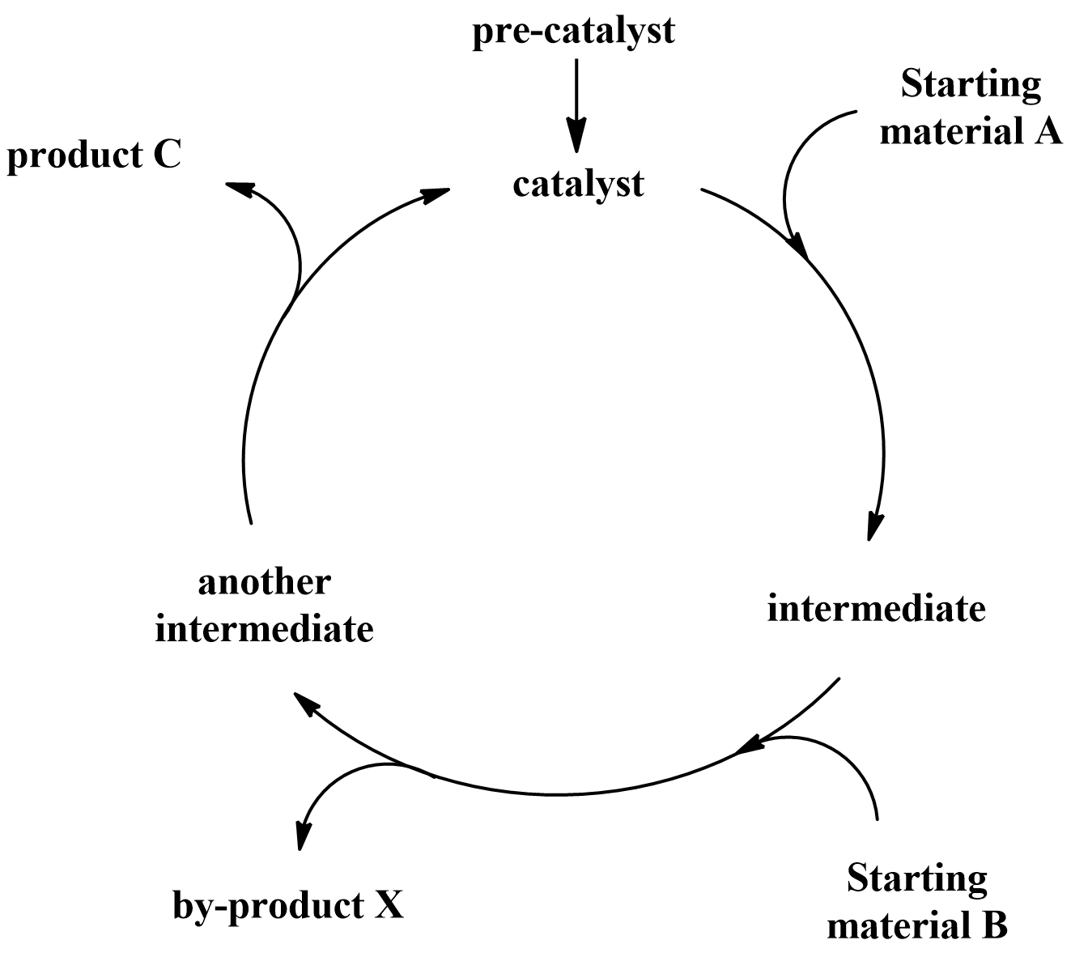
Figure 1.2: Representation of a general catalytic cycle.

We can roughly divide catalysis into several different subgroups, depending on the nature of the actual catalyst. Some of the major individual areas are biocatalysis, Lewis-acid/base catalysis, organo-catalysis and transition metal catalysis. These four types of catalysis may be further subdivided into homogeneous or heterogeneous catalysts.

1.1.2.3 Homo and stoichiometric cross-coupling processes

The development of metal-catalysed cross-coupling reactions begins with some of the oldest known transformations in organic chemistry, (i.e. stoichiometric metal-promoted homo couplings), thus the first examples of coupling (the use of metals to assemble carbon-carbon bonds between appropriately functionalized sp, sp², or sp³ centres) are found in the 150-year old literature.²
Without delving into a comprehensive review of transformations during this period, a discussion of the origins of cross-coupling is incomplete without a description of the initial stoichiometric processes that set the foundation for the later discoveries. With this knowledge, the modern chemist will appreciate the problems faced in the achievement of the original results and more clearly understand and respect the progress throughout the development of cross-coupling reactions.

  - 1.2 Growth of Palladium Mediated Catalysis
  - 1.2.1 The introduction of palladium element

Reconstructing post-world war II Europe required materials. A surging need for cheap sources of plastics and precursor fine chemicals accompanied the economic boom., As part of this effort, chemists at Wacker Chemie´s central research institute led by Walter Hafner, began on a mission to synthesize ethylene oxide from ethylene, on exposure of a stream of ethylene and oxygen to a bed of palladium on charcoal. However, the distinctive pungent smell produced suggested the production of acetaldehyde. This observation and its eventual refinement into a commercial process (Wacker process), established the importance of palladium as a metal for the synthesis of organic compounds.

  - 1.2.2 Palladium chemistry

Up until the 1970´s, the palladium element was used mainly in reduction and oxidative reactions, with the palladium-catalysed hydrogenation and the Wacker oxidation being two illustrative examples. However, over the last few decades, palladium has appeared as one of the most useful metals in organic synthesis, essentially for the formation of carbon-carbon bonds. The easy availability of two stable oxidation states (0 and +2) and the readily reversible interconversion between these, as well as the ready availability of palladium-containing species having simultaneously one or more empty and filled nonbonding orbitals, are a few of the significant factors that are responsible for the flexibility and utility of palladium complexes as catalysts. Palladium easily participates in reductive elimination, carbometalation, migratory insertion, and nucleophilic substitution (Figure 1.3), leading to carbon-carbon bond formation.¹³
While reductive elimination is supposed to be an extremely important step in the palladium-catalysed cross-coupling developed since the mid-1970s, carbopalladation is the key step in the Heck-Mizoroki reaction. The Tsuji-Trost reaction is an example of carbon-carbon bond forming processes containing nucleophilic attacks on organic ligands of palladium complexes. Finally, migratory insertion accounts for the great majority of carbonylative carbon-carbon bond formation.^{5, 11}

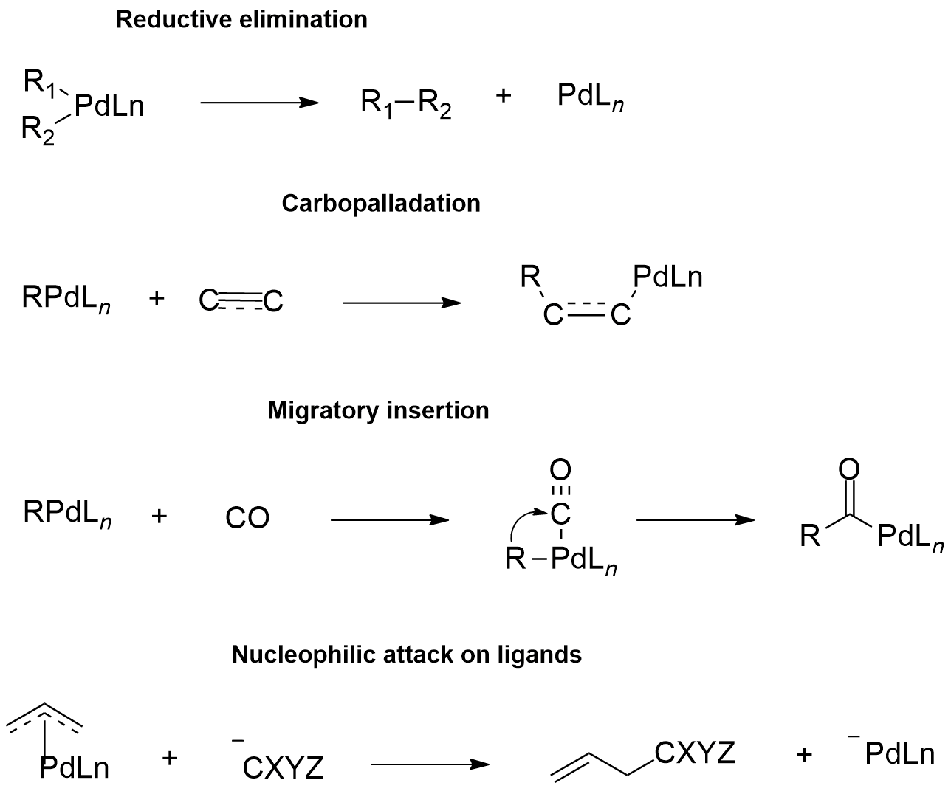
Figure 1.3: Major reactions occurring on a palladium metal center.¹¹

1.2.3 Carbopalladation

Carbopalladation may be defined as a process that involves addition of the Pd-carbon bond to the double or triple bonds of alkenes, alkynes, allenes, conjugated dienes and other carbon-carbon multiple bonds, including arenes and carbonyl compounds. Scheme 1.2 shows the typical courses of carbopalladation with alkenes, alkynes, conjugated dienes and allenes.¹²

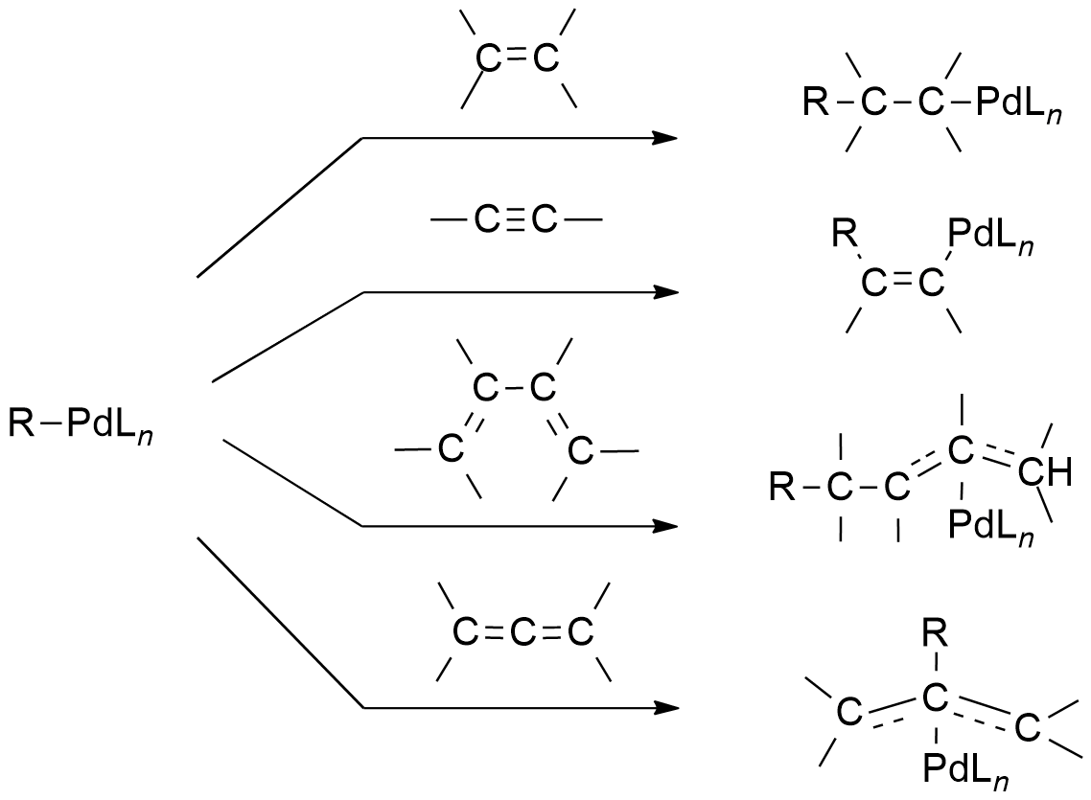
Scheme 1.2: Classic pathways of carbopalladation with various unsaturated groups.¹²

One of the first studies on carbopalladation was the palladium-catalysed cyclo-oligomerization reactions of alkynes. These type of reactions are very limited regarding synthetic applicability and are not readily adaptable to the selective synthesis of natural products and other unsymmetrical molecules.¹⁷
In 1968, Heck reported the reaction of organomercury compounds and related organometallic compounds with alkenes in the presence of stoichiometric palladium(II) complexes, which led to the substitution of a vinylic or allylic hydrogen with a carbon group (Scheme 1.3).

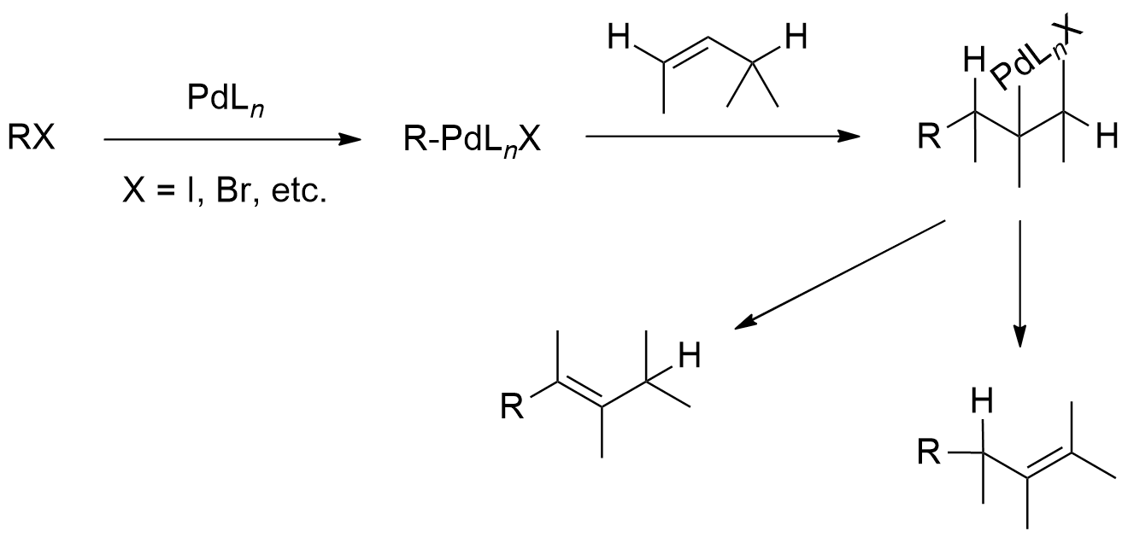
Scheme 1.3: Representation of the catalytic version of the Heck reaction.¹⁸

There are some important common features associated with this class of reaction, namely:
- Considering the mainly electrophilic nature of d⁸ organopalladium(II) derivatives, the reaction is normally accelerated by electron-donating substituents on the alkenes, and decelerated by electron-withdrawing substituents;
- The strict syn stereochemistry of carbopalladation exists in essentially all the known cases. The reversibility of carbopalladation has not been observed, and when decarbopalladation occurs, it also appears to be a strictly syn process.¹⁹

Consequently, it is realistic to view syn-selective carbopalladation and decarbopalladation as concerted addition and elimination processes, in which synergistic interactions between the π and π* frontier orbitals of alkenes or alkynes and an empty orbital of palladium or a palladium-carbon bonding orbital are critical. Essentially, the same interpretation using the Pd-H bond in place of the Pd-C bond, may be applied to the strict syn addition and elimination processes observed in hydropalladation and dehydropalladation.¹⁸

1.2.4 Palladium complexes as cross-coupling catalysts: The Heck-Mizoroki reaction

In 1968, Fitton and co-workers established the first oxidative addition product from the reaction of a Pd(0)-(PPh₃)₄ catalyst with an aryl halide substrate. At the same time, simultaneous discoveries by Heck^{18,} and Mizoroki (Scheme 1.4) showed the coupling reactions of aryl, benzyl and styryl halides with alkenes employing palladium(II) catalysis and established the Heck-Mizoroki reaction.

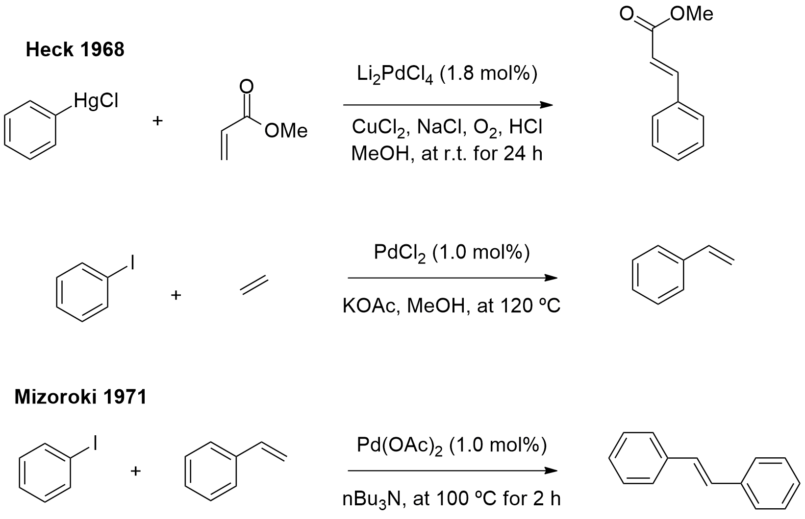
Scheme 1.4: The first palladium(II)-catalysed couplings.^{18, 21, 22}

Mechanistically speaking, the Heck-Mizoroki-reaction diverges from most other reported cross-coupling reactions on one vital aspect: the absence of an obligatory pre-formed organometallic species as one of the coupling partners.² Furthermore, at this point in the history of coupling only this reaction was free from the requirement of a transmetalation step. Consequently, the Heck-Mizoroki-reaction could be classified as a formal vinylic C-H activation process (a type of reaction in which a carbon–hydrogen bond is cleaved and replaced with a carbon-X bond, where X is usually carbon, oxygen, or nitrogen).²
1.2.5 The cyclic Heck-Mizoroki reaction

The development of the cyclic version of the Heck reaction began in the late 1970s. All of the examples described before 1983, concerned the synthesis of heterocyclic rings, as shown in Scheme 1.5.

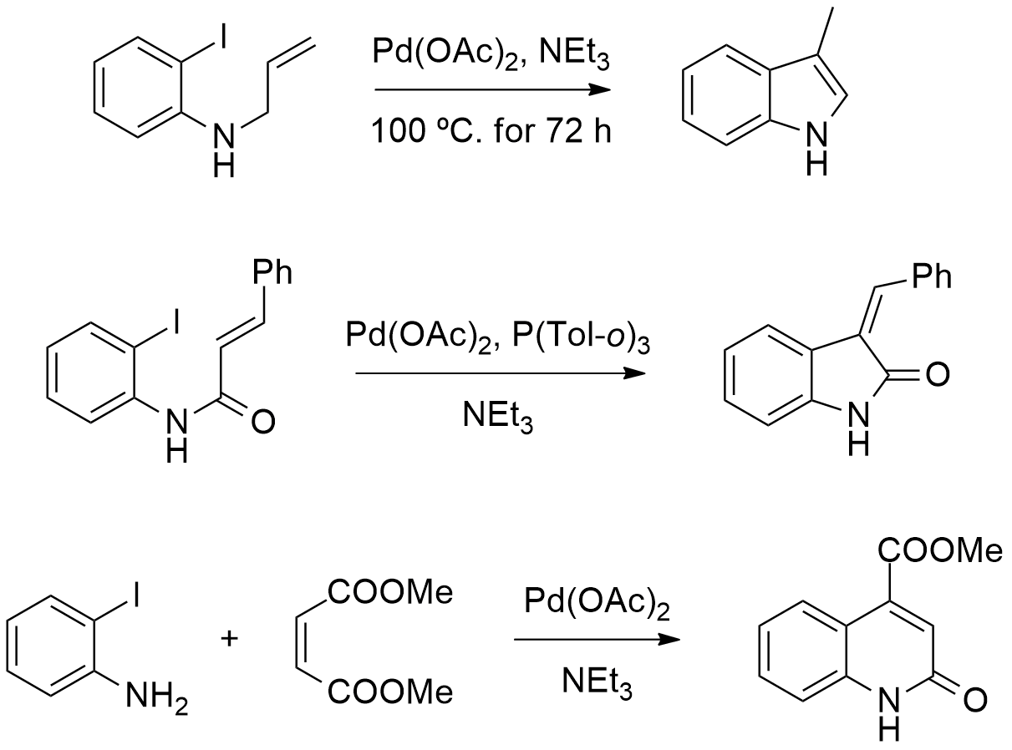
Scheme 1.5: Representation of the cyclic version of the Heck-Mizoroki reaction.²³

The relatively few applications of this reaction for the synthesis of complex natural products, during its first decade, may be due in part to the relatively low yields reported in the initial studies. Consequently, significant advances in the synthesis of carbocycles, via the cyclic Heck-Mizoroki reaction, were further delayed until the late 1980s.¹⁸ Heck, Grigg, and Negishi, reported several examples (Scheme 1.6).

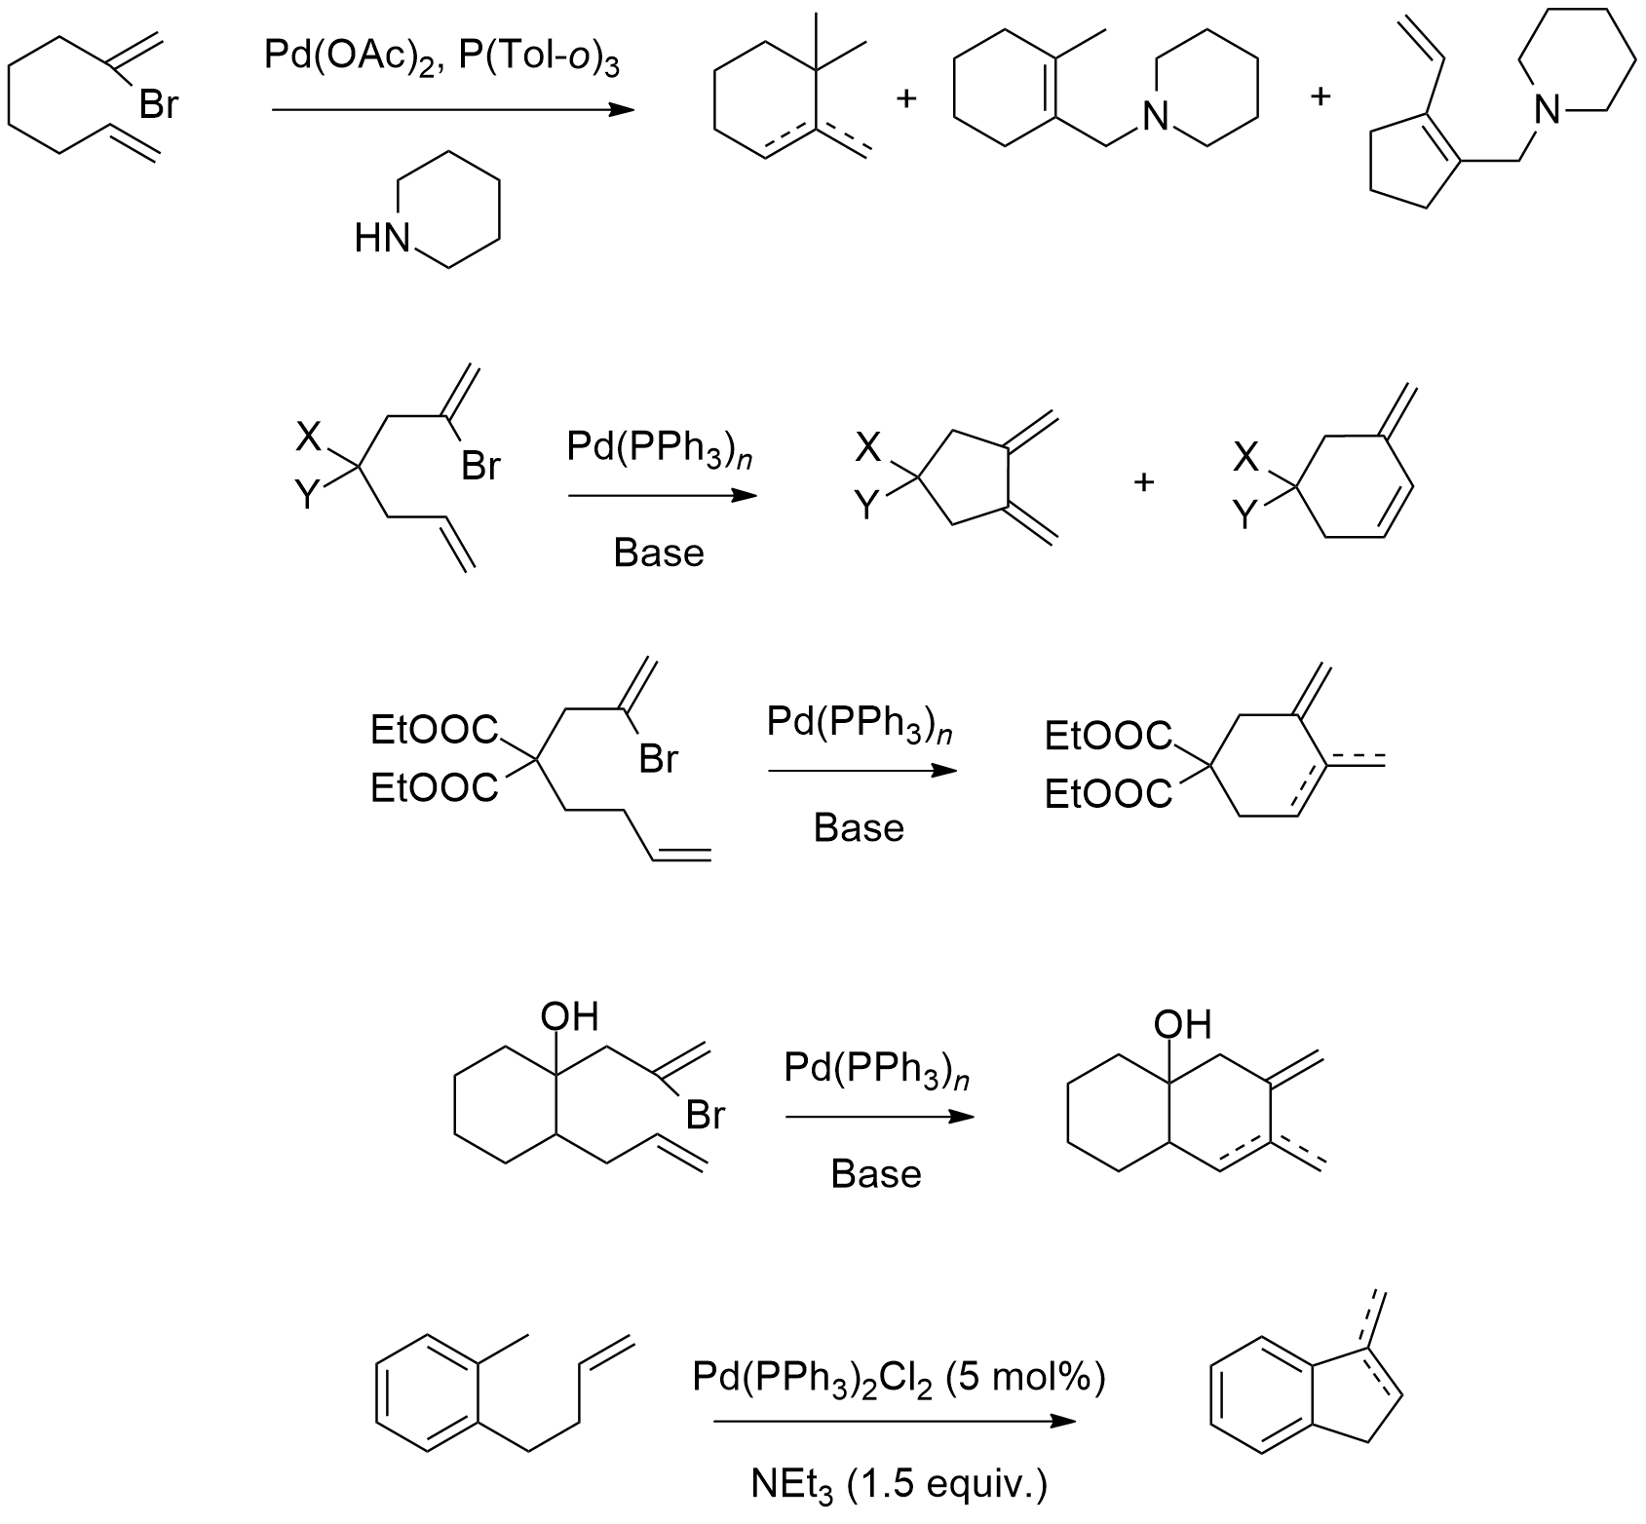
Scheme 1.6: Some examples of the synthesis of carbocycles, via the intramolecular Heck-Mizoroki reaction. ^{24, 25, 26}

  - 1.3 Investigation of the Coupling Partner

In order for the cross-coupling reaction to be useful, it should be relatively straightforward and require only a small amount of catalyst. Moreover, the reaction conditions and reagents, particularly the organometallic partner, should tolerate a wide variety of functional groups so that tedious protection-deprotection reactions are not necessary, while bearing low levels of toxicity.

  - 1.3.1 The Migita-Stille coupling

In 1976, Eaborn reported the first palladium-catalysed cross-coupling of aryl iodides using organo-distannanes as coupling partners (Scheme 1.7). However, these authors reported that the homo coupling of the aryl halide component was an important side reaction.²⁸ One year later, Migita extended Eaborn´s work to the cross-coupling of aryl bromides using organotin reagents as coupling partners (Scheme 1.7), and finally, in 1978, Stille and Milstein reported the synthesis of ketones by coupling aryl chlorides with organotin (Scheme 1.7), under milder reaction conditions than those described by Migita and Kosugi.

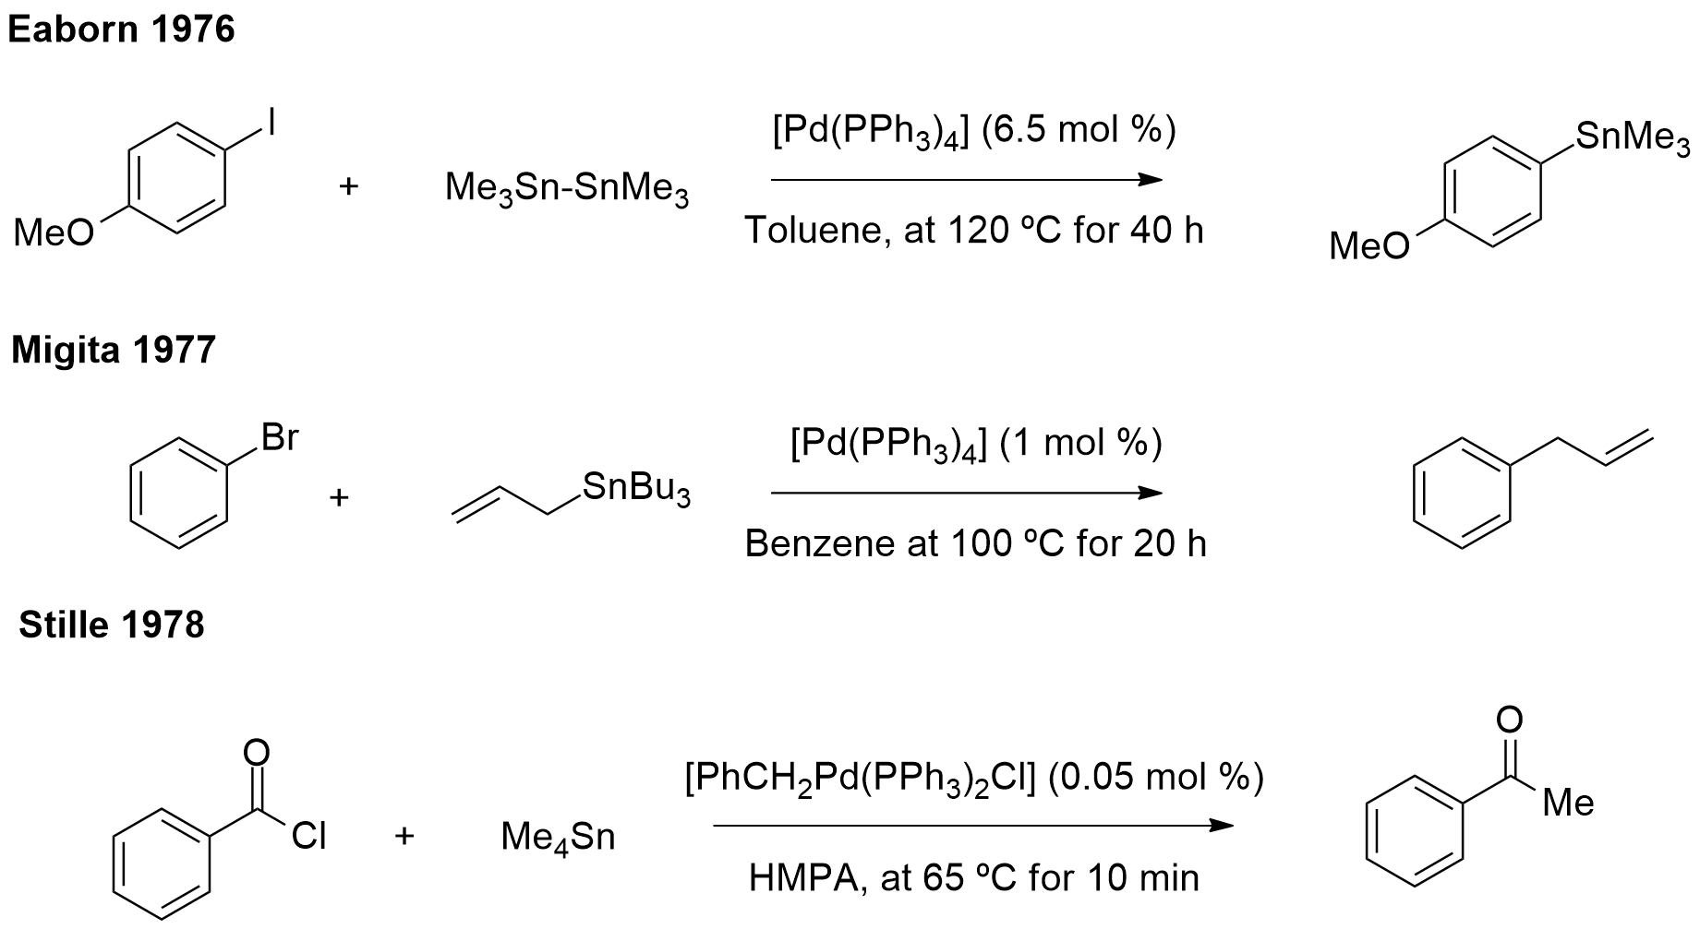
Scheme 1.7: Important stannane coupling reactions.^{28, 29, 30}

These developments demonstrated that organotin reagents could be employed as efficient coupling partners. Later, Stille explored and tuned this reaction, developing it into a highly versatile methodology exhibiting extraordinarily broad functional group compatibility. Unfortunately, the main handicap of the Migita-Stille reaction is the toxicity of the organotin reagents.

1.3.2 The Suzuki-Miyaura coupling

In 1975, the discovery by Heck, that boronic acids are capable cross-coupling partners when stoichiometric quantities of palladium are used, came as an alternative to the employment of the toxic organotin compounds. Still, it would be Suzuki´s experiments that confirmed that this chemistry could be moved into catalytic territory. Among other positive aspects, Suzuki-Miyaura coupling shows a number of useful features such as:
- It can be easily handled, usually requiring only air-and moisture-stable organoboron starting materials;
- It possesses mild and convenient reaction conditions;
- It involves easy removal of less-toxic inorganic by-products.

These aspects, between others, make the Suzuki-Miyaura coupling reaction particularly useful for industrial applications. Subsequently, in 1979, Suzuki described the palladium-catalysed cross-coupling between 1-alkenylboranes and aryl halides (Scheme 1.8).

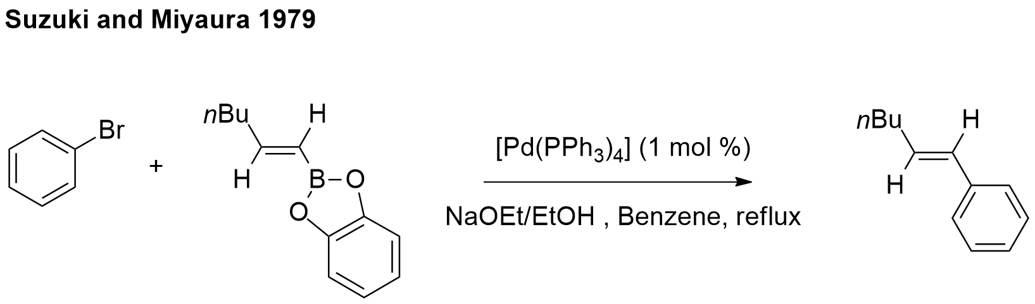
Scheme 1.8: Suzuki–Miyaura coupling.³⁴

On the other hand, the specific nature of the organoboron species can have a deep effect on the effectiveness of a given transformation. For example, the C-B bond has low polarity (the difference in electronegativity 2.55 for carbon and 2.04 for boron) and therefore alkyl boron compounds (i.e. trimethylborane) are in general more stable that boron trihalides (i.e. boron trifluoride). In addition, the mixed aqueous/organic solvent systems normally employed in Suzuki-Miyaura reactions, may lead not only to proto-de-boronation as a function of the electronic and to the steric nature of the substrate, but it can also disturb the nature of the boron reagent itself.

1.3.3 The Hiyama-Hatanaka cross-coupling

Later, the Hiyama-Hatanaka coupling gave a more environmentally friendly and safe option than the organoboron, organozinc and organostannane reagents revealed in prior discoveries. In 1982, Kumada described the employment of organo-penta-fluorosilicates in palladium-catalysed cross-coupling reactions. At the same time, Hallberg revealed the coupling of vinyl-trimethylsilane. Following this development, in 1988, Hiyama and co-workers described the palladium and nickel-catalysed coupling of organosilanes with aryl halides and triflates, activated by the presence of a fluoride source in the reaction mixture (Scheme 1.9)., The presence of tris(dimethylamino)sulfonium di-fluoro-trimethylsilicate or CsF was essential to activate the organosilane towards transmetalation, by the formation of silicate intermediates. This finding was followed by studies on other silicon derivatives, specifically the siloxanes of Denmark and DeShong, among others.

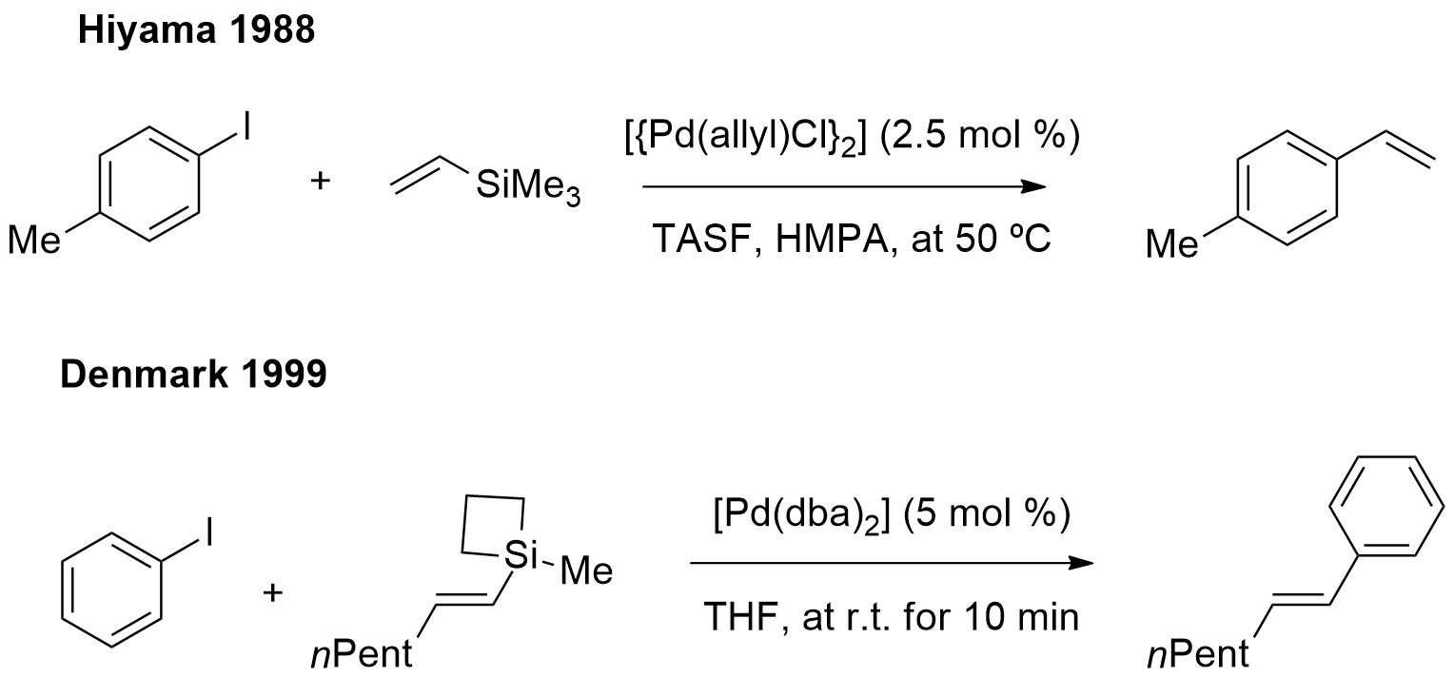
Scheme 1.9: Cross-coupling reactions using organosilane reagents.^{37, 40}

  - 1.4 First Carbon-Heteroatom Couplings
1.4.1 The Miyaura borylation reaction

While dimeric organometalloids, such as hexamethyldisilane and hexamethyldistannane had been established as appropriated coupling partners, the analogous use of boron compounds holding a B-B bond was unknown between 1970 and 1990. Perhaps prejudice due to the fact that the boron compounds have a relatively high bond energy has precluded investigation in this area.
In 1993, Miyaura and Suzuki reported the addition of a boron ester across a triple bond, using a platinum catalyst and a diborane as a coupling partner.⁴⁴ Soon after, Miyaura and co-workers reported that bis(pinacolato)diboron reagent (B₂pin₂) experienced coupling with aryl halides to form arylboronates, using Pd(dppf)Cl₂ (dppf=1,1’ bis(diphenylphosphino)ferrocene). In addition, the use of KOAc as a base (one of the best bases to achieve a selective cross-coupling) proved to be indispensable in avoiding consumption of the product by the competing Suzuki-Miyaura reaction. Stronger bases such as potassium carbonate or phosphate give biaryl by-products, arising from further coupling of the product with aryl halides.⁴⁵ Following this development, in 1997, Masuda described a significant modification of the latter procedure by using alternate pinacolborane/triethylamine conditions. This advance reduced the waste in the formation of the C-B bonds and established a new era in the development of a series of catalytic carbon-heteroatom bond forming processes (Scheme 1.10).⁴⁶

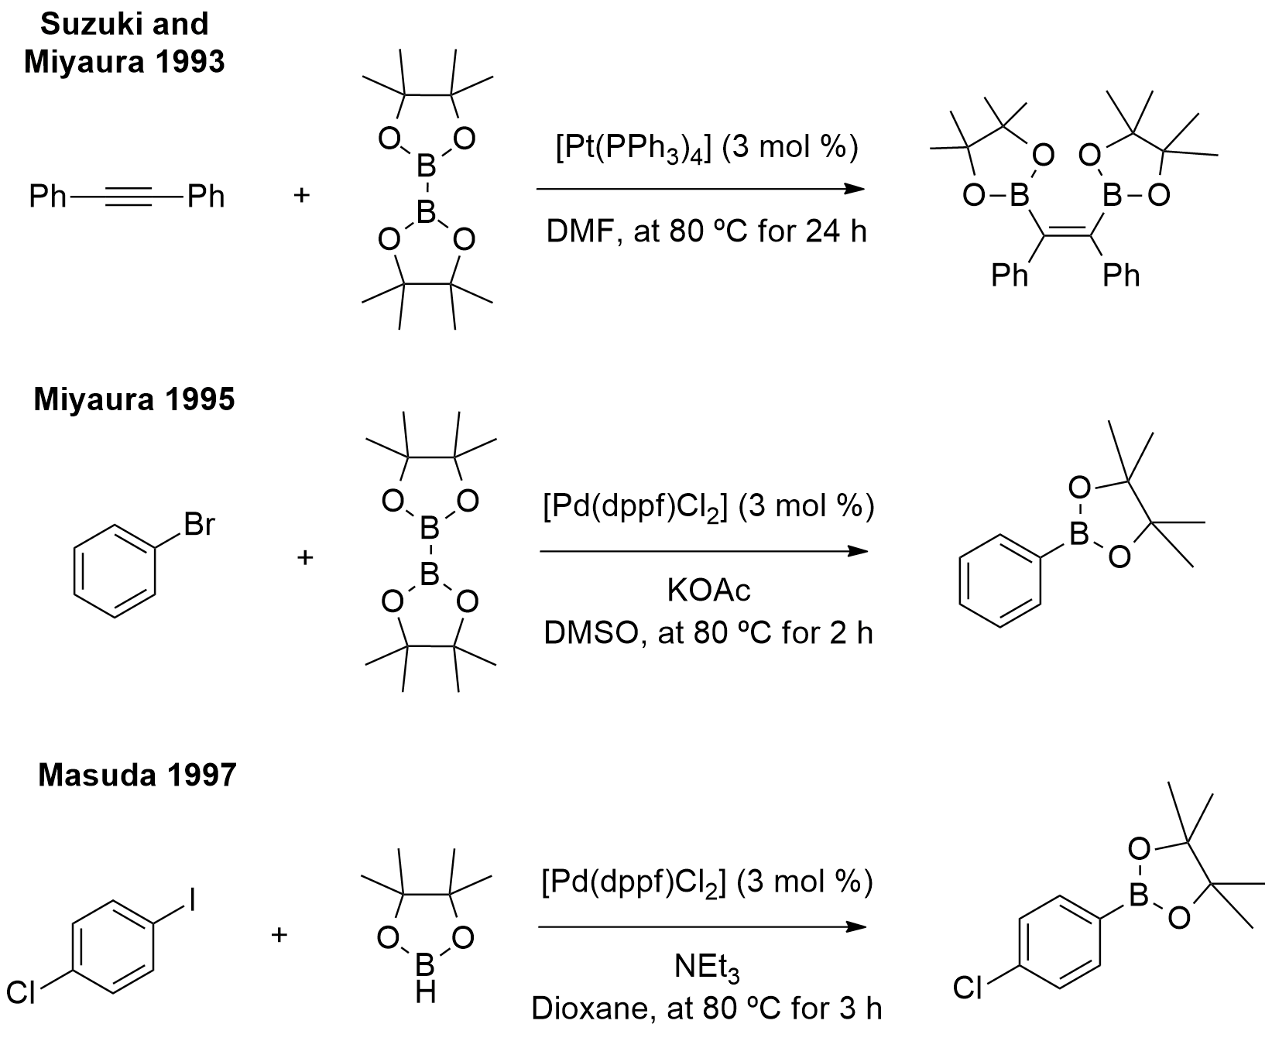
Scheme 1.10: Suzuki-Miyaura and Masuda borylation coupling reactions.^{44, 45, 46}

1.4.2 The Buchwald-Hartwig coupling reaction

On the other hand, in 1983, Migita and co-workers revealed the first palladium-catalysed formation of C-N bonds, although this process required the use of stoichiometric amounts of moisture-sensitive tributyltin amide reagents, along with heating at high temperatures. These issues, combined with concerns of cost, toxicity and lack of potential utility, encouraged efforts at developing innovative conditions that permitted coupling with a free amine.⁴⁷
The earliest hint of the possibility that a free NH amine could be an appropriate coupling partner is found in a paper published by Yagupol´skii (Scheme 1.11). As it was published in a Russian journal, this work remains widely unknown and the study itself lacked several control experiments to eliminate the possibility of an alternative S_{N}Ar reaction, to rationalize the result.
However, in 1995, Buchwald ^{a)} and Hartwig^{49 b)} independently substituted the Migita amidotin reagent with a free amine and a strong base such as LiHMDS (HMDS=1,1,1,3,3,3-hexamethyldisilazane) or NaOtBu and thus the very important C-N cross-coupling reaction was born (Scheme 1.11). Soon after and rapidly, conditions were established which advanced these first practical C-N coupling results and led to the establishment of C-O bond forming cross-coupling processes.^{49 c), d), e)}

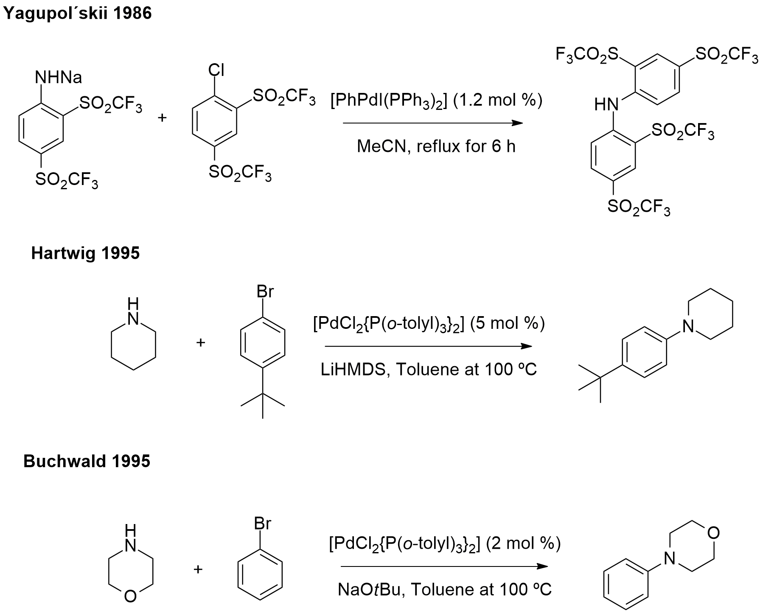
Scheme 1.11: The Yagupol´skii and Buchwald–Hartwig cross-couplings.^{48, 49}

  - 1.5 Conclusions

Transition metals are singular elements in chemistry because of their electronic properties, which enable them to interact with a wide variety of organic molecule functional groups. At the end of the 19th century, Sabatier made a key development when he divided varied metals, including nickel, palladium and platinum. Nevertheless, the real breakthrough came with the synthesis and structural determination of ferrocene by Wilkinson that opened up the field of organometallic chemistry, which is heavily based on transition metals.
The first cross-coupling reactions were reported at the end of the 20th century, with the refinement of the earlier reported metal-catalysed homo coupling processes. The evolution of transition metal catalysed cross-coupling reactions is considered by some to have occurred over three different periods or waves.
Of the transition metals, it is palladium that has shown so much versatility and application. Until the 1970s, palladium catalysis was predominantly used in reduction and oxidative reactions, but over the last five decades, this element has acted as one of the most versatile metals in organic synthesis, participating in different types of reactions, such as reductive eliminations, migratory insertions, carbometalations and nucleophilic substitutions, leading to carbon-carbon bond formation. Palladium has been used in notable reactions such as, the Corriu-Kumada reaction, the Sonogashira-Hagihara reaction, the Migita-Stille coupling, the Suzuki-Miyaura coupling and the Hiyama-Hatanaka cross-coupling. New methodologies, such as the Miyaura borylation and the Buchwald-Hartwig coupling embody the first carbon-heteroatom coupling type reactions and have shown much application in chemical synthesis to date.
In most cases, the catalytic process that involve palladium can be environmentally friendly, as well as very cost effective and although there are currently various industrial catalytic processes available, there is still a demand for even more environmentally friendly chemical processes, employing green and robust palladium catalysts.
Overall, these important developments in the realm of synthetic methodology has provided a panoply of new chemical products, which have been of considerable benefit to our society. Besides, these developments have revolutionized the way chemists conceptualize and construct molecules, allowing them to be obtained more efficiently and sustainably.

2. Metal-Catalysed Arylations with Carbonyl Compounds

“To raise new questions, new possibilities, to regard old problems from a new angle, requires creative imagination and marks a real advance in science.”
Albert Einstein

  - 2.1 Introduction
2.1.1 Metal-catalysed α-arylation of carbonyl compounds

Until 1997, the rare palladium-catalysed couplings of enolates with aryl or vinyl halides reported in the literature, usually required preformed zinc or tin enolates and involved only acetates or methyl ketones. The successful metal-mediated coupling of enolates was achieved through the employment of stoichiometric quantities of nickel complexes., , Figure 2.1 shows the generally accepted catalytic cycle for the palladium-catalysed addition of enolates to aryl halides.⁵⁴

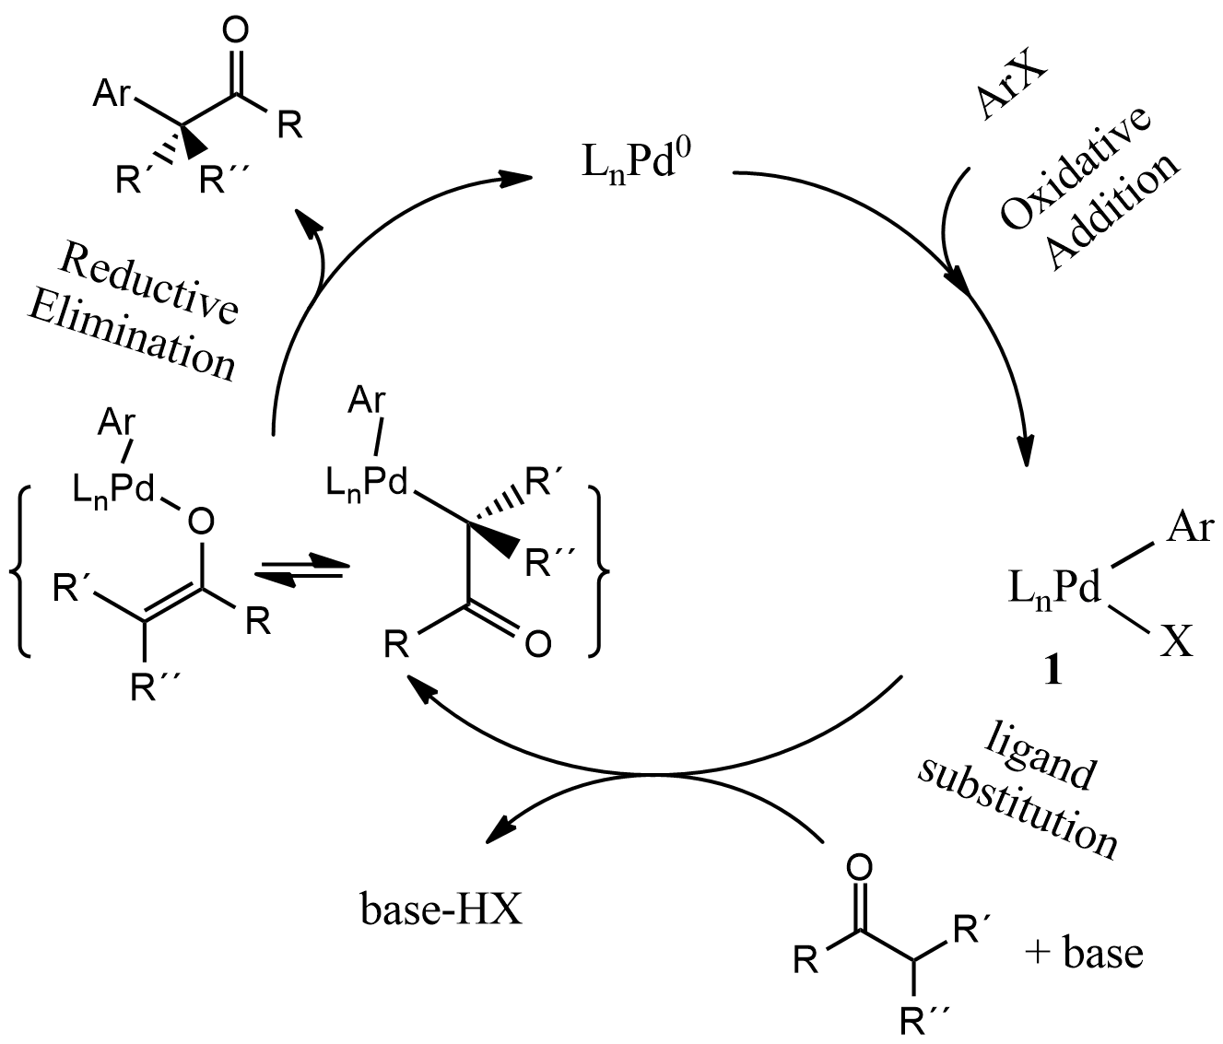
Figure 2.1: Generally accepted catalytic cycle for the palladium-catalysed addition of enolates to aryl halides.⁵⁴

We can describe the cycle as it follows: oxidative addition of an aryl halide to a Pd(0) complex is expected to form an arylpalladium(II) halide complex. Substitution of the coordinated halide by an enolate nucleophile and subsequent reductive elimination from the resulting palladium enolate complex would form the α-aryl ketone, ester or amide and regenerate the Pd(0) complex that started the cycle. However, in order to develop the coupling of enolates with aryl halides following this mechanism, one had to overcome several challenges.⁵⁴
For example, the pKa values of mono- and dicarbonyl compounds in organic solvents vary from 12 to 35 and these variable electronic effects can have a large influence on the reaction chemistry. Additionally, alkali metal enolates are frequently generated and allowed to react at low temperatures. Yet, cross-coupling is conducted typically at high temperatures and thus uncatalyzed condensation of the enolate could occur before the desired catalytic coupling.⁵⁴ Moreover, transition metal C-bound enolates, other than those from methyl carbonyl compounds, bear β-hydrogens and elimination of these could compete with reductive elimination to form the desired coupled product.⁵⁴ Regardless of these hurdles, the palladium-catalysed arylation of carbonyl compounds turned out to be a valuable and universal synthetic method.
In 1997, Hartwig Buchwald and Miura described simultaneously the palladium-catalysed direct coupling of ketones with aryl bromides. This method exhibited a high degree of regioselectivity and functional group tolerance. The scope of the reaction could be enlarged to encompass ketones, diketones, amides, esters, aldehydes, etc., when more efficient catalysts were used. There was also the development of the enantioselective α-arylation reaction.

2.1.2 Metal-catalysed addition of aryl halides to carbonyls

In 1987, the first cross-coupling reaction of acyl chlorides with either aliphatic or aromatic Grignard reagents in the presence of a catalytic amount of tris(acetylacetonate)iron(III) (Fe(acac)₃) was reported. After this discovery, this same reaction was conducted using a Ni(dppe)Cl₂ catalyst. In 2000, Kabalka and co-workers reported the synthesis of aliphatic and aromatic ketones via coupling trialkylboranes with acyl halides, using a Suzuki-Miyaura reaction. In 2001, Huang et al. reported for the first time a nickel-catalysed coupling of aryl iodides with aldehydes to give the corresponding ketones (Scheme 2.1).

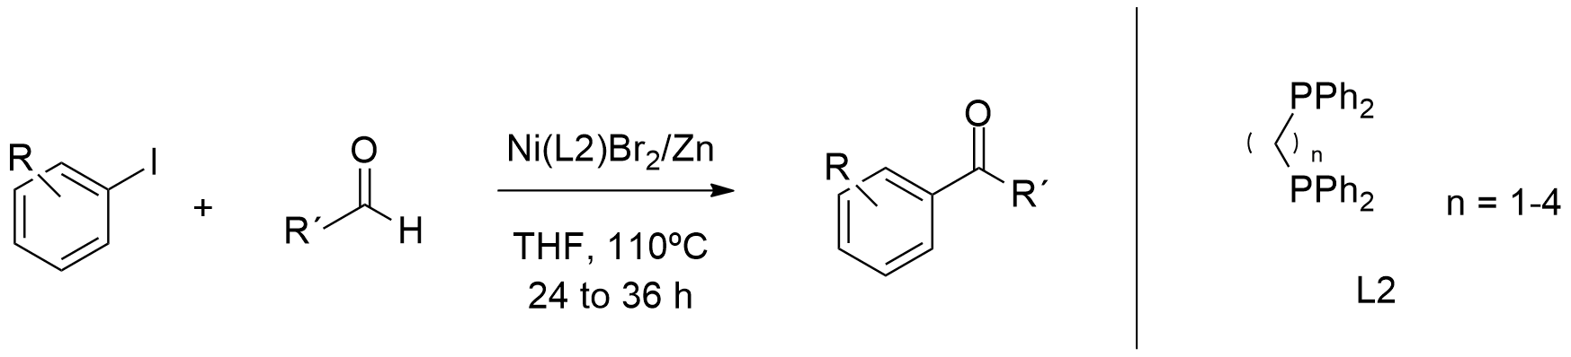
Scheme 2.1: Nickel-catalysed coupling of aryl iodides with aldehydes, reported by Huang et al.⁶⁸

This convenient one-pot synthesis of ketones was reported to involve both addition of the aryl group to the aldehyde carbonyl group and the β-hydride elimination of the alkoxide intermediate.⁶⁸ (This process indeed has been of considerable importance in our work, see Chapter 3).
It was also reported that the intermolecular version of the metal-catalysed addition of aryl halides to carbonyls requires bimetallic systems, or occurs via a Heck-type mechanism, by means of Pd-amine cooperative catalysis.
Although scarcely studied, the intramolecular palladium-catalysed direct acylation of aryl halides with aldehydes was successfully employed in the preparation of benzocyclobutenones^{70 a)} (Scheme 2.2) and in the synthesis of a variety of azaheterocycles, starting from 2-iodoanilines.

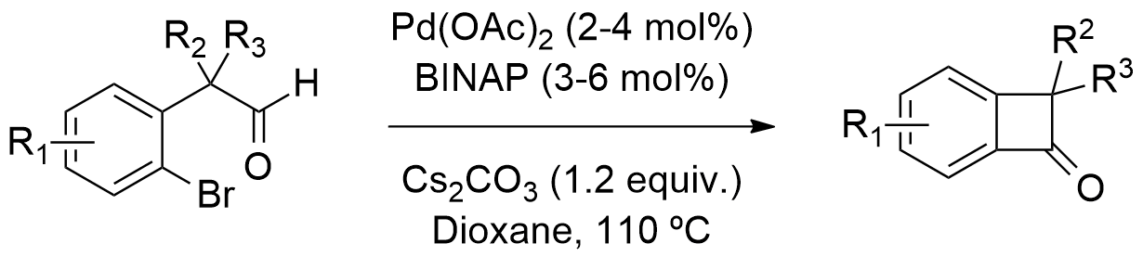
Scheme 2.2: Palladium-catalysed synthesis of benzocyclobutenones.^{70 a)}

Solé et al. described the synthesis of isoquinolin-4-ols, by palladium-catalysed intramolecular nucleophilic addition of aryl iodides to aldehydes (Scheme 2.3). (Further studies by this group are discussed in Chapter 3).

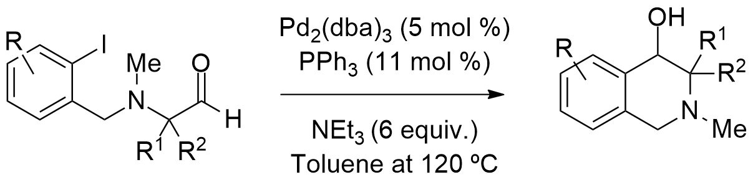
Scheme 2.3: Palladium-catalysed intramolecular nucleophilic addition of aryl iodides to aldehydes as reported by Solé et al.⁷³

Our group also investigated the transition metal-catalysed additions of aryl bromides to activated ketones. The results of these studies are discussed in Chapter 4.

2.1.3 Metal-catalysed addition of arylboronic compounds to carbonyl and imine groups

Metal-catalysed addition of organometallic reagents to carbonyl groups is a straightforward strategy for the construction of optically active tertiary alcohols. In 1998, Miyaura et al. reported the first rhodium-catalysed addition of organoboronic acids to aldehydes (Scheme 2.4).

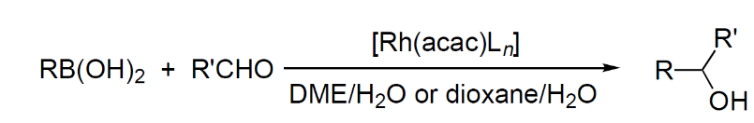
Scheme 2.4: Miyaura’s rhodium-catalysed addition of organoboronic acids to aldehydes.⁷⁵

Subsequently, in 2004, Pucheault et al. reported the use of a Rh catalyst for the catalytic cross-coupling reaction of potassium aryltrifluroboron reagents to arylaldehydes to afford diaryl ketones, via a Heck-type mechanism (Scheme 2.5). The authors suggested a mechanism that includes the insertion of the carbonyl bond into an arylrhodium(I) species, followed by a β-hydrogen elimination to provide the ketone and the rhodium hydride, thus not providing any secondary alcohols.⁷⁶

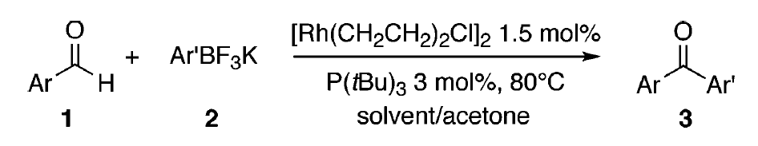
Scheme 2.5: Pucheault´s catalytic aldehyde arylation using potassium aryltrifluroboron reagents.⁷⁶

In 2011, Low et al. described the enantioselective rhodium(I)-catalysed cyclization of arylboron compounds onto ketones. This process allowed the synthesis of various five-, six- and seven-membered aza- and oxacarbocycles and illustrated the utility of sulfinamide-alkene, TADDOL-derived phosphoramidites and dienes as chiral ligands, for rhodium-catalysed intramolecular additions of arylboron compounds (Scheme 2.6).

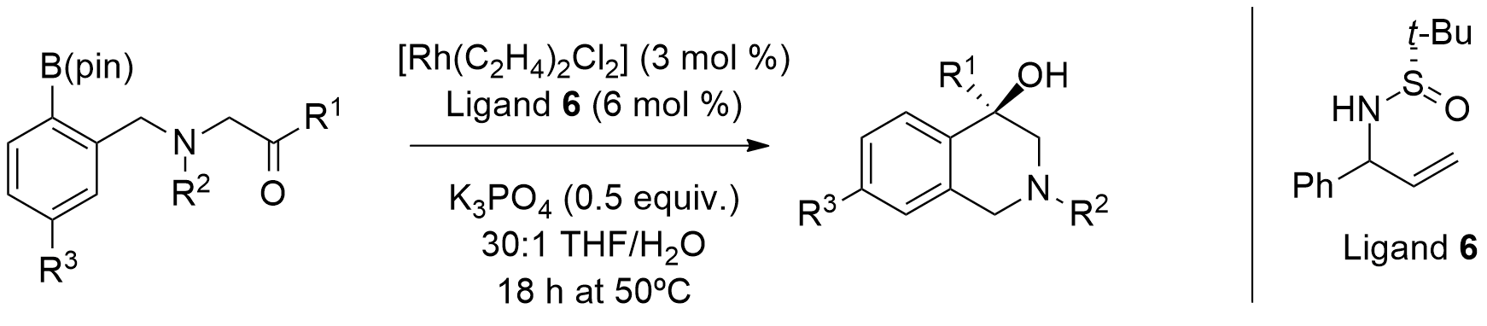
Scheme 2.6: Enantioselective Rh(I)-catalysed cyclization of arylboron compounds onto ketones described by Low et al.⁷⁷

In 2012, Gallego and Sarpong described a rhodium(I)-catalysed enantioselective intramolecular arylation of unactivated ketones with aryl pinacolboronic esters (Scheme 2.7).

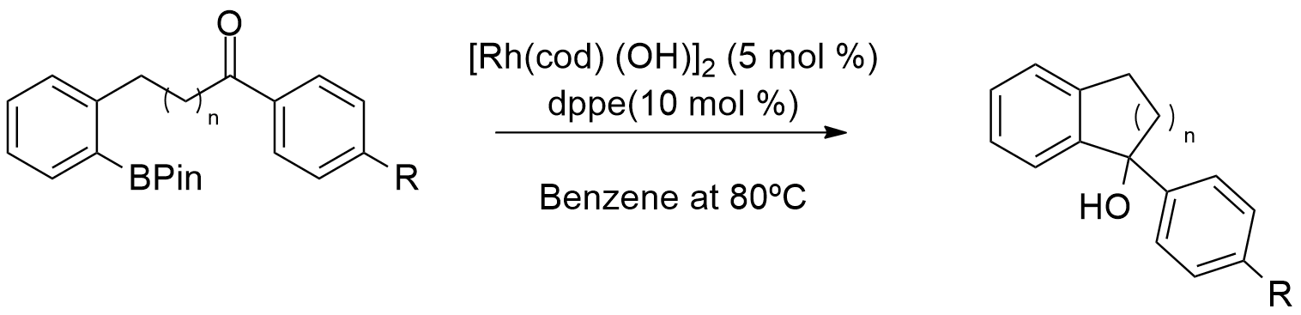
Scheme 2.7: Gallego´s rhodium(I)-catalysed enantioselective intramolecular hydroarylation of unactivated ketones.⁷⁸

In the same year, Liao et al. reported the rhodium(I)-catalyzed asymmetric addition of arylboronic acids to NH isatins (Scheme 2.8).

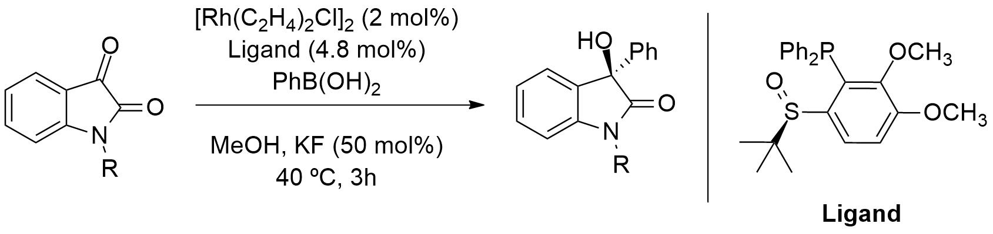
Scheme 2.8: Rhodium(I)-catalyzed asymmetric addition of arylboronic acids to NH isatins reported by Liao et al.⁷⁹

Marques et al. described the metal-catalysed intramolecular cyclization of amido(hetero) arylboronic acid derivatives through an efficient three-step synthetic approach (borylation, deprotection and cyclization) to provide isoquinolinones and derivatives (Scheme 2.9). The authors reported that the borylated intermediate could be obtained using a combination of Pd(dppf)Cl₂ and NEt₃ in 76% yield. Furthermore, using conditions described in Scheme 2.9, the cyclic product could be obtained in 86% yield.⁸⁰

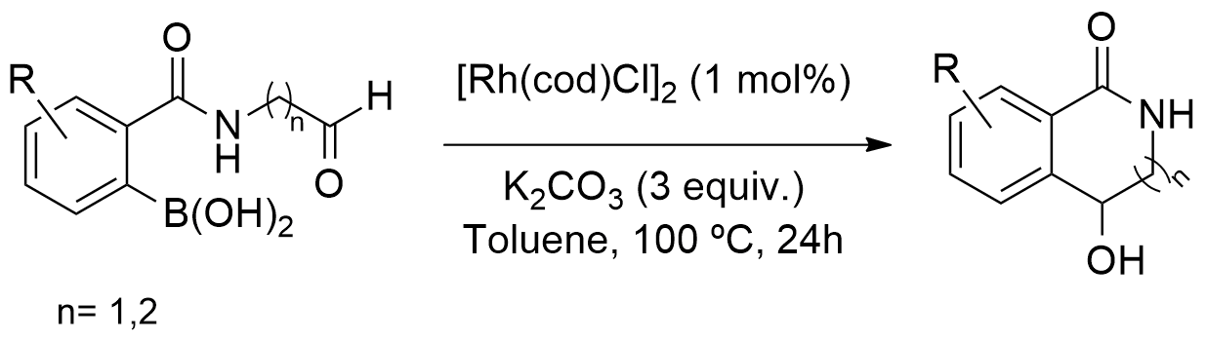
Scheme 2.9: Burke and co-workers metal-catalysed intramolecular cyclization of amido(hetero) arylboronic acids.⁸⁰

Also in 2015, Peixoto described in her PhD dissertation, the successful one-pot palladium-catalysed borylation and addition of arylboronic esters to imines (Scheme 2.10).
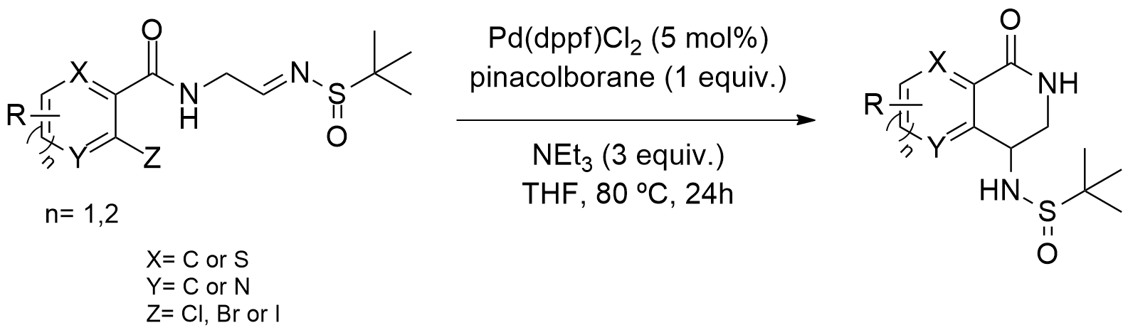
Scheme 2.10: One-pot palladium-catalysed borylation and addition of arylboronic esters to imines reported by Peixoto.⁸¹

The author reported that the best yield (52%) for cyclic product was obtained employing the substrate bearing no substituents in the benzene ring. Furthermore, even though the presence of substituents in the benzene ring decreased the yield of the reaction, their position didn´t seem to affect the yield of the reaction.⁸¹
Regarding the employment of palladium catalysts in this type of transformations, in 2005, Yamamoto et al. showed that palladium(0) complexes (when coordinated with phosphane ligands) catalyse the 1,2-addition of arylboronic acids to aldehydes, in the presence of base and a catalytic amount of chloroform (Scheme 2.11). ^{a)}

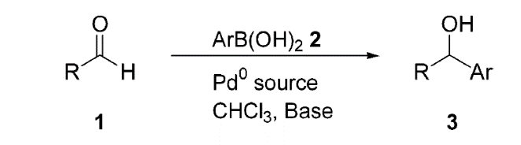

Scheme 2.11: Yamamoto´s 1,2-addition of arylboronic acids to aldehydes.^{82 a)}

Employing these conditions, only secondary alcohols were obtained. Moreover, the authors reported that chloroform was crucial in this reaction, because it is involved in the formation of a dichloromethyl-coordinating palladium(II)phosphane intermediate, which is generated from the oxidative addition (coordinate bonding) of chloroform to the initial phosphane-coordinated palladium(0) complex. This intermediate subsequently produces a hydroxyl palladium(II) species by counter anion exchange. After this, transmetalation between the arylboronic acid and the hydroxyl palladium(II) species occurs to generate an arylpalladium(II) intermediate. The insertion of the aldehyde into the carbon-palladium bond provides the palladium alkoxide. Finally, the palladium alkoxide complex is hydrolysed to produce the corresponding alcohol.^{82 a)}
In 2006, Liu and Lu reported the synthesis of optically active cycloalkanols through the employment of a cationic palladium complex that catalysed the enantioselective intramolecular addition of arylboronic acids to ketones, as shown in Scheme 2.12.

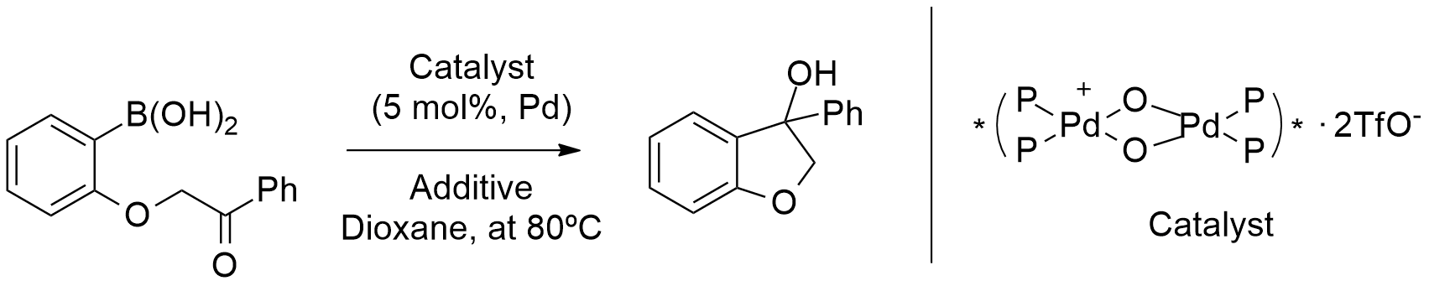
Scheme 2.12: Liu and Lu's intramolecular addition of arylboronic acids to ketones.⁸³

The authors reported that by employing an anion exchange resin (Amberlite IRA 400 (OH)) as the additive, they successfully furnished the cyclization product in good yield with high enantiomeric excess (85% yield, 82% ee).⁸³
Later, in 2007, Lin and Lu reported the one-pot synthesis of unsymmetrical triarylmethanes through a cationic palladium(II)/bipyridine-catalysed addition of arylboronic acids to arylaldehydes (Scheme 2.13). Employing this methodology, a molecule containing three kinds of aryl rings with different electron density was constructed.⁸⁴

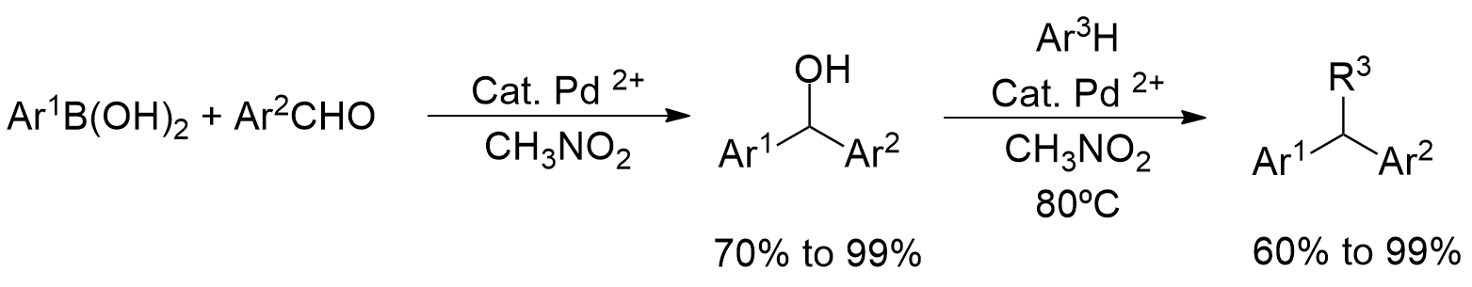
Scheme 2.13: Lin and Lu´s one-pot palladium-catalysed synthesis of unsymmetrical triarylmethanes.⁸⁴

One year later, Qin et al. reported the efficient one-pot synthesis of diaryl ketones from aldehydes via palladium-catalysed reaction of arylboronic acids, using a combination of PdCl₂ and P(1-Nap)₃. This system promoted the arylation of aldehydes to furnish secondary alcohol products (Scheme 2.14).

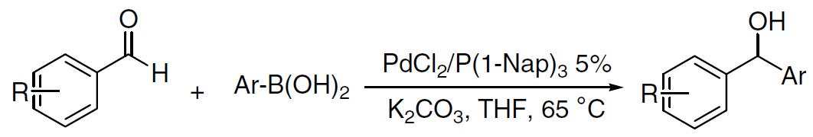
Scheme 2.14: Synthesis of diaryl ketones from aldehydes, reported by Qin et al.⁸⁵

In the same year, Kuriyama et al. described the 1,2-addition of aryl-and alkenylboronic acids to aldehydes catalysed by a palladium/thioether-imidazolinium chloride system, as shown in Scheme 2.15. Despite the fact that there is no reference to the asymmetric versions of these reactions, the authors found that 1,2-addition of aryl-, heteroaryl- and alkenylboronic acids to aromatic, heteroaromatic and aliphatic aldehydes, was catalysed by 0.005-2.0 mol % of the palladium/thioether-imidazolinium chloride system quite efficiently.⁸⁶
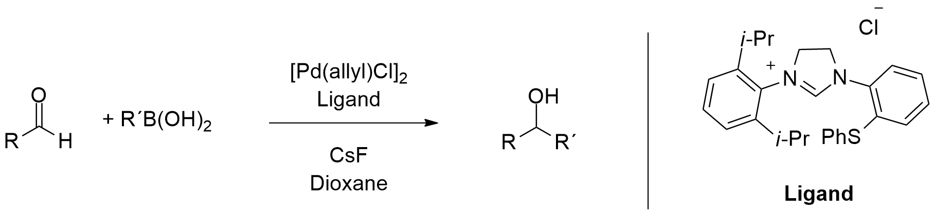
Scheme 2.15: Kuriyama´s palladium-catalyzed 1,2-addition of aryl- and alkenylboronic acids to aldehydes.⁸⁶

In 2009, Qin et al. reported the palladium-catalysed asymmetric addition of arylboronic acids to N-benzylisatin (Scheme 2.16).

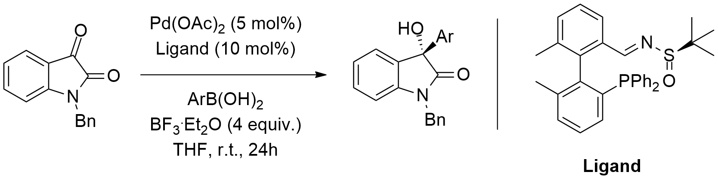
Scheme 2.16: Palladium-catalysed asymmetric addition of arylboronic acids to N-benzylisatin reported by Qin et al.⁸⁷

This particular example is interesting as it involved the addition to a cyclic ketone system that was activated by an adjacent carbonyl group. Many examples of this type of addition with arylboron reagents to isatin derivatives are known. As mentioned above, in Chapter 4 we discuss the intramolecular arylation of activated acyclic ketones.
In 2011, Li and co-workers reported the catalytic asymmetric addition of arylboronic acids to isatins using C₂-symmetric cationic N-heterocyclic carbenes Pd²⁺ diaqua complexes as catalysts (Scheme 2.17). With this work, the authors have developed a concise synthetic route to enantiopure tetra-ortho-substituted phosphane imine ligands with a biphenyl backbone. Moreover, they described the ﬁrst asymmetric additions of arylboronic acids to N-benzylisatin to provide 3-aryl-3-hydroxyoxindoles in moderate yields and enantioselectivities.⁸⁹

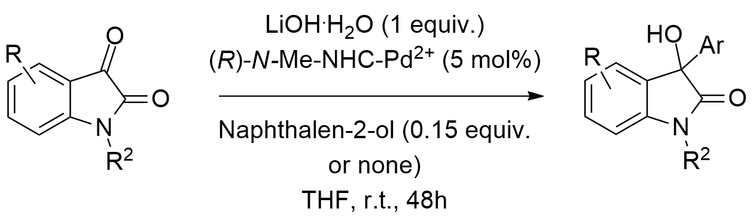
Scheme 2.17: Catalytic asymmetric addition of arylboronic acids to isatins reported by Li et al.⁸⁹

In 2015, Qiu et al. reported the iridium-catalysed asymmetric addition of arylboronic acids to isatins (Scheme 2.18). They also reported the synthesis of a class of novel chiral-bridged biphenyl phosphoramidite ligands. This work embodied a remarkable development, since it described for the first time the enantioselective addition of arylboronic acids to isatins, using iridium catalysts.⁹⁰

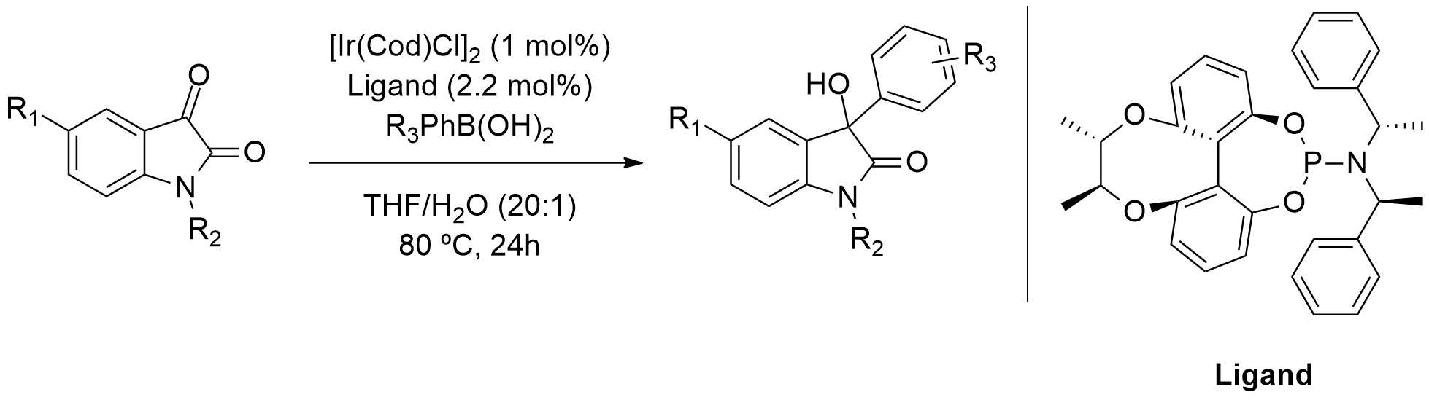
Scheme 2.18: Iridium-catalyzed asymmetric addition of arylboronic acids to isatins as reported by Qiu et al.⁹⁰

Regarding the enantioselective addition of arylboronic acids to isatins, all the metals described here provided the cyclic products in very good yields and ees.

  - 2.2 Conclusions

The first “more exotic” palladium-catalysed couplings of enolates with aryl or vinyl halides were reported in 1997 and typically required preformed zinc or tin enolates, including acetates or methyl ketones. Semmelhack reported the first successful metal-mediated coupling of enolates using stoichiometric quantities of nickel complexes. In 1998, Miyaura et al. reported the first metal-catalysed addition of organometallic reagents to carbonyl groups, with a rhodium-catalysed addition of organoboronic acids to aldehydes. Furthermore Pucheault et al. reported the first catalytic cross-coupling reaction of organometallic reagents with arylaldehydes to afford diaryl ketones, via a Heck-type mechanism.
Until 2001, the existing methods for direct synthesis of ketones from alkyl or aryl halides were scarce and usually required a multistep process. Oxidation of the corresponding secondary alcohols, using more than stoichiometric amounts of chromium as the oxidizing agent or the Friedel-Crafts reaction in the presence of AlCl₃, represented two of the most employed methodologies. The first successful report of the coupling of organometallic reagents with acyl chlorides using transition metals as catalysts, was published in 1987 and involved a cross-coupling reaction of acyl chlorides with either aliphatic or aromatic Grignard reagents, in the presence of a catalytic amount of Fe(acac)₃. Later in 1999, Kabalka et al. reported the synthesis of aliphatic and aromatic ketones via coupling of trialkylboranes with acyl halides, using a Suzuki-Miyaura reaction. Following this, in 2001, Huang et al. reported the first nickel-catalysed coupling of aryl iodides with aldehydes.
The intramolecular palladium-catalysed direct acylation of aryl halides with aldehydes has been efficaciously used for the preparation of benzocyclobutenones and for the synthesis of a variety of azaheterocycles, starting from 2-iodoanilines. Palladium catalysts can also be used to synthesize isoquinolin-4-ols via intramolecular nucleophilic addition of aryl iodides to aldehydes, as reported by Solé and co-workers.
Inspired and encouraged by these previous discoveries and developments, our group focused on the development of a new methodology for the synthesis of analogues of rasagiline, which might be used in the treatment of both Parkinson’s and Alzheimer’s diseases.

3. Palladium-Catalysed Cyclizations with Aryl Compounds

“Do the best you can until you know better. Then when you know better, do better.”
Maya Angelou

  - 3.1 Introduction
  - 3.1.1 Current synthetic methodologies and target molecules

During the past years, numerous metal-catalysed reactions have substantially expanded the organic chemists’ toolbox, leading to the development of highly efficient and reliable synthetic methodologies. Vital among these strategies, are those permitting the generation of different compounds from common building blocks, varying either the active catalysts or reaction conditions. Considering this, including that aldehydes are one of the most versatile synthons available in organic chemistry, it is not surprising that over the last years, several alternative C-C bond-forming methods have appeared, based on the insertion of aldehydes into late transition metal-carbon bonds.
Over the last decade, between the diversity of accessible synthetic methodologies, the palladium-catalysed intramolecular nucleophilic addition reactions of arylborons and aryl halides to aldehydes has attracted interest. Consequently, currently, this methodology constitutes a powerful methodology for the synthesis of di-aryl-methanols and other key target molecules. Many cyclic chiral amines and alcohols (cycloalkanols) have shown to be biologically active. Up to 45% of the molecules that chemists are currently developing as pharmaceuticals contain a chiral amine unit and many of these are cyclic. Well-known examples of these type of molecules include Sertraline, Indatraline, Cromakalin, (Figure 3.1), as well as Cetirizine and Rasagiline, etc.

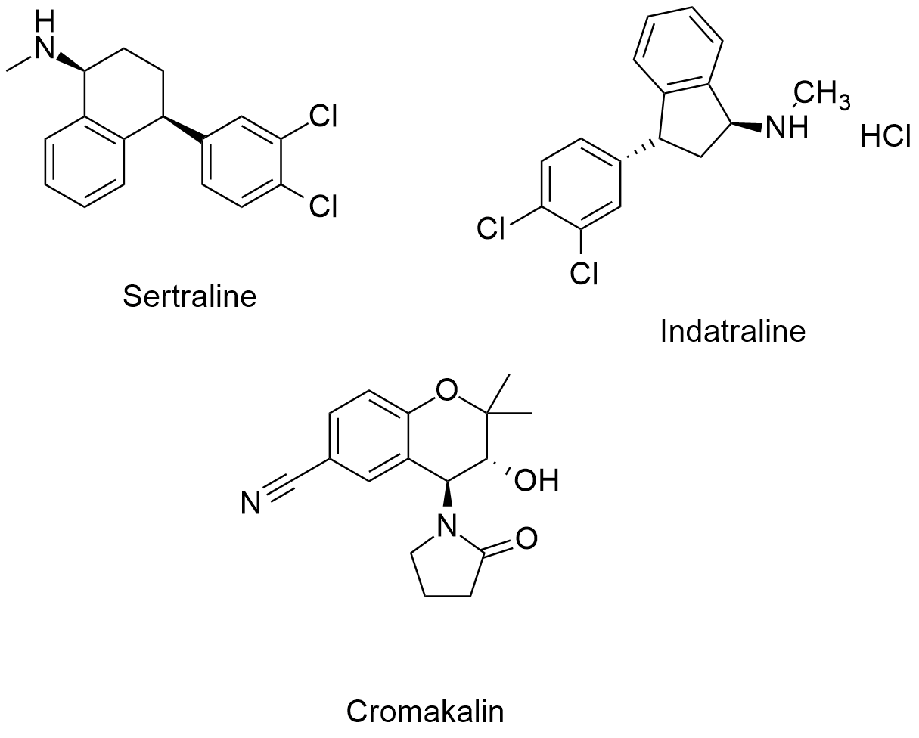
Figure 3.1: Some cyclic chiral amines.⁹⁶

In the case of medicinal compounds containing a cycloalkanol unit, some examples include compound PH46A, which is currently under clinical trials for inflammatory bowel diseases and 4-hydroxy-1-tetralone, a natural product obtained from Ampelocera edentula that showed activity against cutaneous leishmaniasis. In addition, this unit is also present in a variety of other natural products like catalponol, epicatalponol, isocatalponol, junglanoside A and isohinanolone (Figure 3.2).

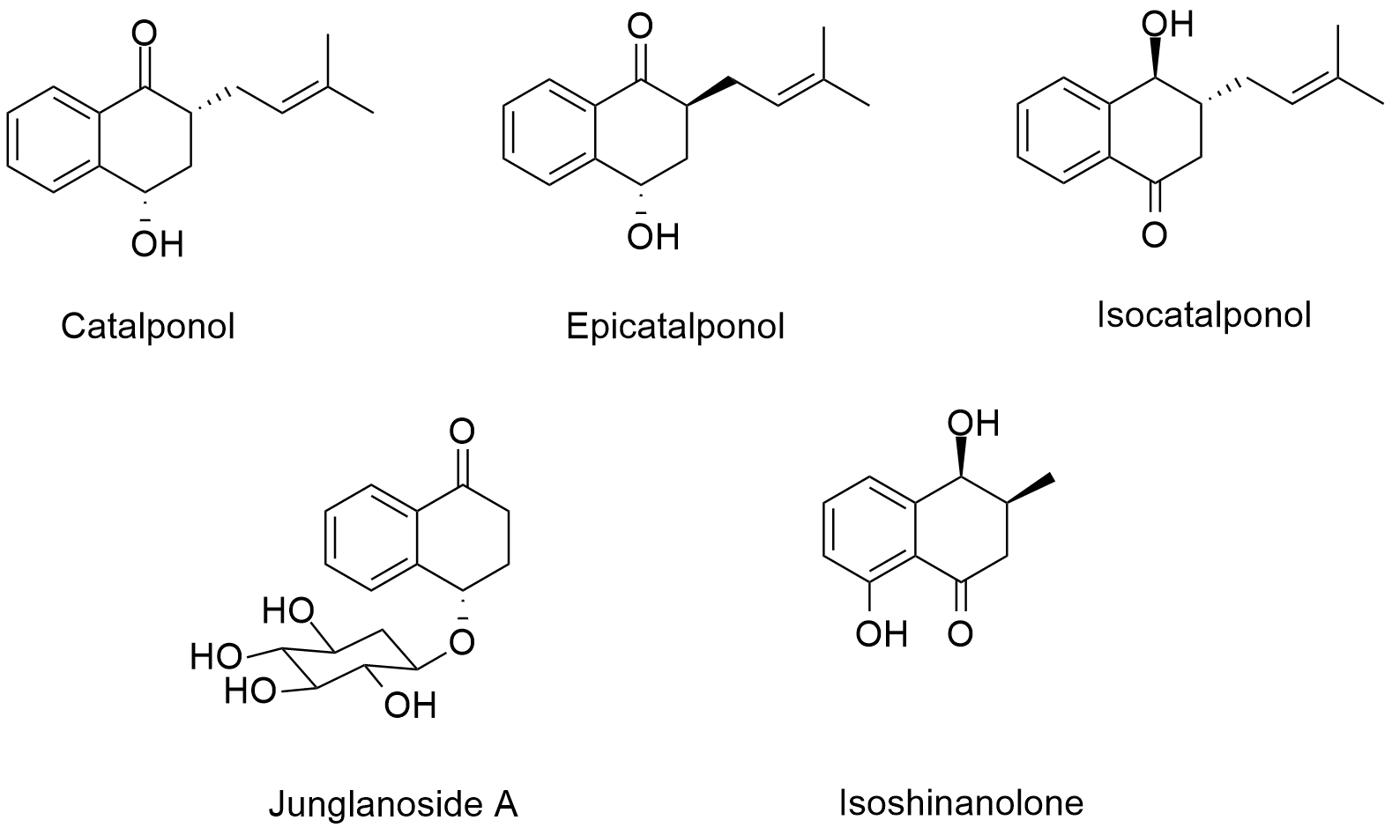
Figure 3.2: Some natural occurring cycloalkanols.⁹⁹

In modern organic chemistry, one of the most important goals is to induce chirality during chemical synthesis. Amongst the several available methods to address this challenge, the employment of chiral catalysts is a particularly attractive strategy, since enantiomeric control is often reached by a simple combination of a specific metal with a chiral ligand.
Currently, the leading industrial process used for the synthesis of chiral amines and alcohols is through catalytic asymmetric hydrogenation of ketimine or ketone substrates. Pfizer has employed this methodology for the preparation of sertraline hydrochloride. Additionally, Sepracor reported the stereoselective reduction of a sulfinamide intermediate with 9-BBN, for the large-scale production of (1R,4S)-4-(3,4-dichlorophenyl)-1,2,3,4-tetrahydronaphthalen-1-amine, a compound that is structurally analogous to sertraline. However, this procedure is not catalytic, thus large quantities of 9-BBN are required. Recently, Mylan generics patented an industrial process used for the preparation of rasagiline. In this procedure racemic 1-aminoindan is resolved with 2,3,4,6-di-O-isopropylidene-2-keto-L-gulonic acid, in which the (R)-enantiomer is alkylated with propargyl chloride. (R)-N-benzyl-1-indanamine (racemic version, Figure 3.3) can be synthesized through chiral resolution with (R,R)-tartaric acid (Figure 3.4) to deliver rasagiline and its salts. Nonetheless, there was a problem with waste production, since 50% of the product batch is discarded.

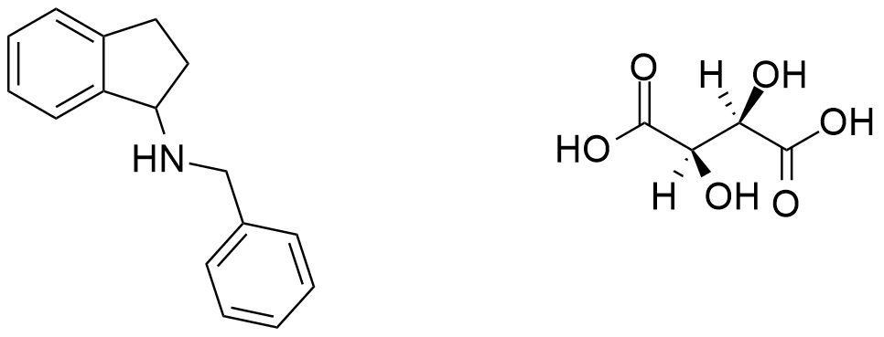
Figure 3.3: Structure of N-benzyl-1-indanamine.

Figure 3.4: Structure of (R,R)-tartaric acid.

In addition, biocatalytic processes are becoming more and more frequent for accessing new drug compounds. In the case of the synthesis of chromanol 293B (IKS-Channel blocker) a completely different approach was employed, as the team carried out an epoxide ring opening. Finally, for the synthesis of the potent psychoactive compound Indatraline (Lu 19-005) a multi-step protocol was employed. This included an enantioselective carbenoid C-H insertion, a cyclization to provide a key benzo-cyclo-pentanone intermediate, followed by a K-Selectride reduction of the alcohol and a final substitution of the activated OH group with methylamine to provide the final product (Scheme 3.1). However, issues like reactor dilution and the limited enantiomeric specifity of enzymes (generally only give one of the enantiomers) make such methods less advantageous.

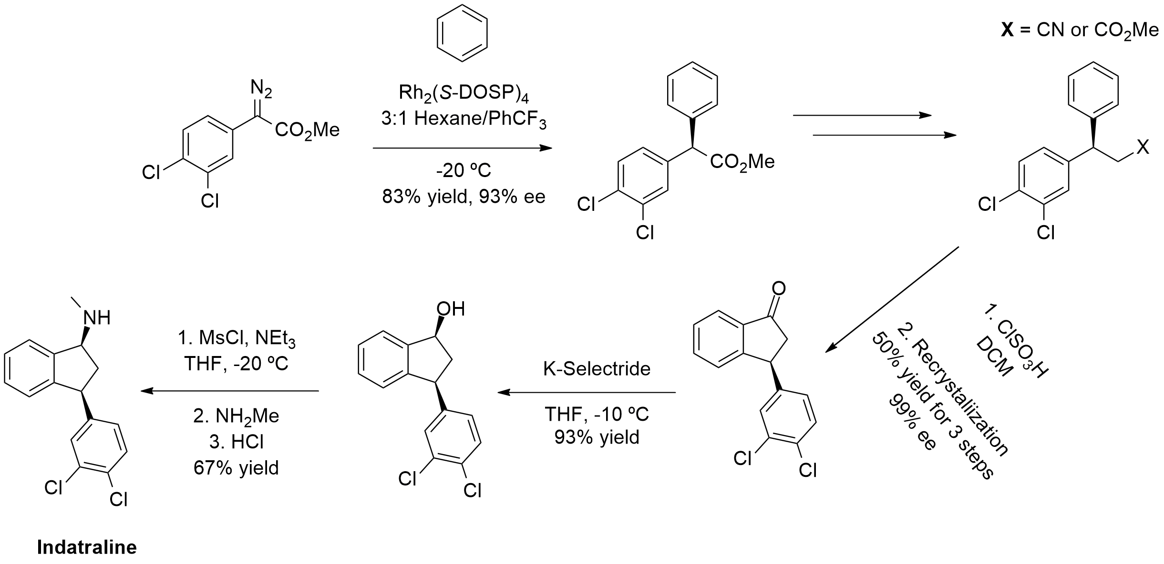
Scheme 3.1: The methodology for the synthesis of Indatraline reported by Davies et al.¹⁰⁶

  - 3.1.2 Rasagiline and neurodegenerative diseases

Currently, neurodegenerative diseases are one of the most important worldwide health issues. Consequently, there has been a recent push in the research and development of new drugs containing cyclic chiral amines (1-aminotetralins) and cycloalkanols at their molecular cores. Rasagiline (Figure 3.5) represents such an example, since it acts as an irreversible selective inhibitor of monoamine oxidase-B (MAO-B) and was approved for the treatment of Parkinson´s disease.

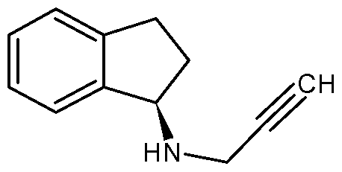
Figure 3.5: Structure of Rasagiline.

However, since these drugs are particularly expensive, new and inexpensive alternatives are desired. In this project, we were interested in developing a novel catalytic cyclization procedure, which provide us, between others, 1-aminotetralin derivatives.

  - 3.2 Flow Chemistry
  - 3.2.1 The establishment of flow chemistry

Nowadays more than ever, our world depends on synthetic materials in areas ranging from pharmaceutical and agrochemicals to polymers, paints, pigments, perfumes and food additives of all kinds. However, making these substances comes at a cost to our planet, in terms of resource depletion and pollution. For a sustainable future, we need to invest and develop new methods for making these valuable materials.
Specifically regarding the instrumentation involved, methods that are more efficient are required. In addition, procedures that operate with lower quantities of solvents, with lower energy consumption and with an emphasis on renewable feedstocks are also desirable. The ability to rapidly optimise chemical processes and reduce the unit operations involved in the downstream work-ups, will have a major impact on how we produce these substances.
In flow chemistry, a chemical reaction is carried out in a continuously flowing stream rather than in batch production. In other words, pumps move different fluids into a tube, where they contact one another. If these fluids are reactive, a reaction takes place. Typically, this technique uses micro reactors and similar instrumentation. Furthermore, these procedures naturally result in improved scale-up of reaction sequences and provide a level of continuity not previously experienced by current synthesis practices. Continuous flow chemical synthesis in millimetre or submillimetre systems has advanced rapidly over the past decade, with applications in the fields of nanomaterials, fine chemicals and pharmaceuticals. This progress has been driven by the potential benefits of continuous synthesis, particularly the increased levels of safety offered by these methods. The small reaction scales, coupled with the enhanced heat and mass transfer, enable highly exothermic reactions to be conducted safely. Additionally, continuous flow systems remove headspace issues and avoid build-up of reactive or toxic intermediates. Flow systems also permit experiments on well-defined samples, at conditions not easily accessed by conventional means, such as high pressures and temperatures. Continuous operation implies steady state operation imparting robustness, stability and scalability. Additionally, synthesis applications and reactions are naturally enhanced by automated optimization, as well as mechanistic and kinetic information gained from integrating reaction components with sensors, actuators and automated fluid handling.¹¹⁴ In continuous flow systems, time in the reactor (residence time) becomes equivalent to batch volume and production can be measured by increasing time, without changing mixing efficiency as in batch, which would otherwise affect yields.¹¹⁴ Generally, flow systems have a tendency to be easier to scale, than the mixing challenges and reduced heat transfer constraints presented when scaling batch processes.¹¹³ Generally, a flow chemistry system consists of the components illustrated in Figure 3.6.

Figure 3.6: General components of a typical flow chemistry system.¹¹³

Furthermore, over the past decade, flow chemistry technology has advanced significantly, from individual laboratories producing their own devices to the world wide infra structure of vendors of individual devices and complete systems in metals, polymers and ceramics.
Usually, reagents are delivered between the μl min⁻¹ and mL min⁻¹ range, by syringe and/or high-precision liquid chromatography (HPLC) pumps. However, it is important to select chemically compatible syringes, seals and pump heads.¹¹⁴ Common flow chemistry systems possess a mixing component to guarantee rapid mixing of reagents, before entering the reactor. There are two types of micro-mixers: active and passive.¹¹⁵ In some designs, the mixing unit is part of the micro reactor.
Moreover, micro reactors are either micro structured devices composed of glass, silicon-glass, ceramic or stainless steel and made by micro-fabrication techniques (Figure 3.7) or tubes of fluorinated polymers or stainless steel (Figure 3.8).¹¹⁴

Figure 3.7: Illustrative examples of some micro reactors.¹¹⁴

Figure 3.8: Two examples of tube-based micro reactors.¹¹⁴

Micro structured devices can include mixing units, flow distributors, multiple channels and means for immobilizing catalyst particles, while the tube-based systems are often simpler to operate and maintain. This type of system can be created from standard tubing, connectors and simple syringes or HPLC components.¹¹⁴
Several commercial systems have been developed to enable scale-up of flow chemistry procedures to production levels. Production systems keep the heat and mass advantages of micro reactors by introducing heat transfer layers between each reactor plate and by employing static mixers on each plate.¹¹⁴ A quenching component has to be placed at the exit of the micro reactor, to guarantee that the reaction does not continue in the tube connecting the reactor. If the reaction is thermally activated, it may be sufficient to cool down the reactor effluent. Otherwise, a quench stream has to be introduced in the outlet.¹¹⁴ Online measurements include the reaction temperature and the outlet concentrations, which can be determined by UV-visible, infrared and Raman spectroscopy, as well as HPLC. Work-up techniques are needed to implement continuous multistep synthesis. Continuous distillation and extraction systems, known for their commodity in chemical production, can also be used at production scale. Recently, there has been a considerable progress in the development of miniaturized extraction and distillation units for laboratory scale.

3.2.2 The main advantages of continuous flow systems

Since the beginning, laboratory chemical synthesis has been carried out in standardized glassware and scientists have predominantly not changed the equipment. In contrast, continuous flow processes are typically found in the industrial environment of chemical and biotechnological production.
There are some key differences between batch and flow processes, with respect to production time and yield. In batch production, reaction time is calculated by how long a vessel is held at a given temperature, whereas in flow chemistry, the volume of the reactor and the bulk flow rate are crucial parameters to calculate reaction time. Stoichiometry in flow reactors is determined by the concentration of reagents and the ratio of their flow rate, while in batch processes, this is defined by the concentration of the chemical reagents and their volumetric ratio.¹²² Since miniaturized bench-sized flow systems are now commercially available, continuous flow processes can be operated in a common laboratory. Key issues, such as facile automation, reproducibility, safety and process reliability due to constant reaction parameters (time, temperature, efficient mixing, amount of reagents and solvent, etc.), can be addressed and guaranteed. When pressure-resistant flow reactors are used, the reaction temperature can be far above the solvent´s boiling point up to supercritical conditions. A particular reaction can be accelerated and the production rate increased simply by providing higher flow rates.¹²² Multistep reaction sequences are conducted in a completely different fashion in flow compared to batch processes. By using several micro-structured flow reactors in a linear arrangement, a continuous multistep process can be assembled. In addition, reagents are introduced into the stream of reactants anywhere in the flow system, at precisely the time that is required for the reaction.¹²²
Furthermore, chemistry can be combined with packed-bed materials that are chemically functionalized with catalysts / reagents or for exploiting purification concepts with solid phase scavengers, chromatographic separation or liquid / liquid extraction.¹²² Other important fields of application in flow chemistry are the combination with photochemical reactions, as well as continuous synthesis using hazardous gases such as ozone, CO or NO as reactants.¹²²
Finally, scale-up of a given reaction can be quickly achieved with little or no process development work, by changing the reactor volume or by running several flow reactors in parallel, as long as the flow rates are recalculated to achieve the same residence times.¹²²

  - 3.2.3 Catalysis in flow chemistry

Catalysis is a resourceful synthetic tool used to increase the efficiency and selectivity of reactions. Nevertheless, the identification of suitable reaction conditions (i.e. catalyst type and loadings) can be extremely difficult, time consuming and substantial quantities of precious material can be consumed. Considering this, micro flow reactors are extremely useful as they allow rapid screening of catalysts towards an array of substrates, while reducing the volume of catalysts required. Another example of the advantages associated with executing catalysed processes under continuous flow conditions, is the Cu / Pd catalytic system for decarboxylative biaryl synthesis described by Underwood and Gooßen (Scheme 3.2).

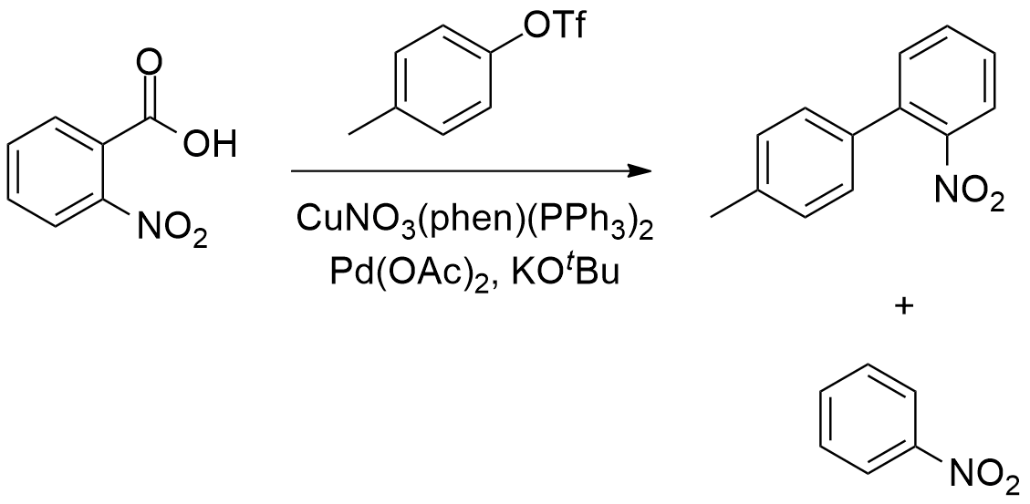
Scheme 3.2: Decarboxylative biaryl synthesis performed under flow conditions, reported by Underwood and Gooßen.¹²⁴

When attempted under batch conditions, minimal C-C bond formation was observed (6%), with proto-decarboxylation dominating to afford nitrobenzene as the major product. When the same reaction was performed under the exact same conditions in a tubular flow reactor, 4´-methyl-2-nitro-1,1´-biphenyl was isolated in 71% yield, with no nitrobenzene formation observed. The authors indicated that in the batch reactions performed in this study, the presence of KO^{t}Bu inevitably leaded to protodecarboxilation.¹²⁴
To accomplish palladium-catalysed C-N cross-coupling reactions under flow conditions, has proven to be challenging due to the formation of inorganic salts that are insoluble in non-polar solvents (typically used for these transformations). The formation of precipitates usually leads to generally clogging of the microchannels. Naber and Buchwald reported a biphasic amination reaction carried out in toluene and water, which could solubilize both the organic and inorganic salts. However, the use of immiscible liquid phases resulted in slug flow, which reduces greatly the mixing efficiency. Nevertheless, this problem could be overcome with the employment of packed bed reactors filled with stainless steel spheres (60-125 mm). After this modification, the mixing of both two phases was significantly improved (Figure 3.9).¹²⁶ Furthermore, it was established that the mixing efficiency is dependent of the flow rate, with higher flow rates providing the most efficient mixing.

Figure 3.9: Mixing of fluid elements in a packed bed reactor. ¹²⁶

Therefore, in order to increase the efficiency of palladium-catalysed C-N cross-coupling reactions in continuous flow systems, Jensen, Buchwald and co-workers studied the mechanisms that lead to microchannel blockage. It was established that particle-to-particle interactions could lead to the formation of larger aggregates, which ultimately form a ‘bridge’ across the microchannel. This clogging mechanism is called bridging and is enhanced with the presence of particles with larger diameters.¹²⁸ Nevertheless, the authors found that applying ultrasonic irradiation, they could break these agglomerates apart and reduce the average particle size diameter, which eliminated clogging due to bridging. Next, the optimized system was used in the palladium-catalysed amination reaction of aryl chlorides, aryl bromides and aryl triflates (Scheme 3.3).

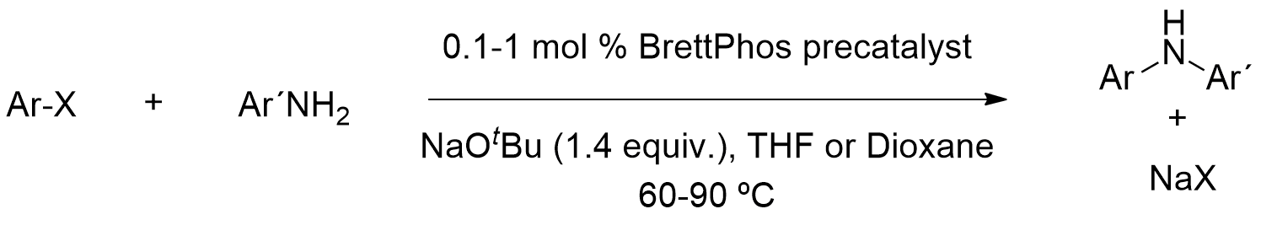
Scheme 3.3: Buchwald´s formation of diarylamines in continuous flow synthesis. ¹²⁹

Due, in part to the increased mass and heat-transfer in microfluidics, a higher activity was observed in flow compared to batch, at short residence times (i.e. 20 s). In specific cases, the formation of inorganic salts could be avoided when soluble organic bases and polar solvents were employed.
  - 3.3 Results and Discussion
  - 3.3.1 Our approach

We explored a catalytic arylating cyclization route to obtain a diversity of structures based on the Rasagiline core. Our plan is described in Scheme 3.4. This methodology included an initial etherification of ortho-bromo substituted phenol substrates with different aliphatic bromo-alcohols, to provide several 3-(2-bromophenoxy) and 3-(2-iodophenoxy) alcohol derivatives (steps A-C, Scheme 3.4). For economic reasons, we decided to focus only on the bromo substituted phenols. The next step involved the oxidation of the alcohols to the corresponding aldehydes, as this functional group represented a key part in the synthesis of the final products. Subsequently, the aldehyde substrates were to be borylated (step A) providing the precursors to use in the cyclization reactions (step B) to provide the desired cycloalkanol derivatives. Finally, these derivatives were to be functionalized to provide a plethora of lead compounds, including 1-aminotetralin derivatives (Scheme 3.4).¹³¹ The last step C, could be done through the employment of two different methodologies; by converting the alcohols into the corresponding halides or sulfonates, performing a nucleophilic substitution by an azide and subsequent reduction of the azide to the amine or by employing the Mitsunobu reaction with hydrozoic acid (HN₃) or equivalent, converting the alcohol to an azide and subsequently reducing it to an amine.

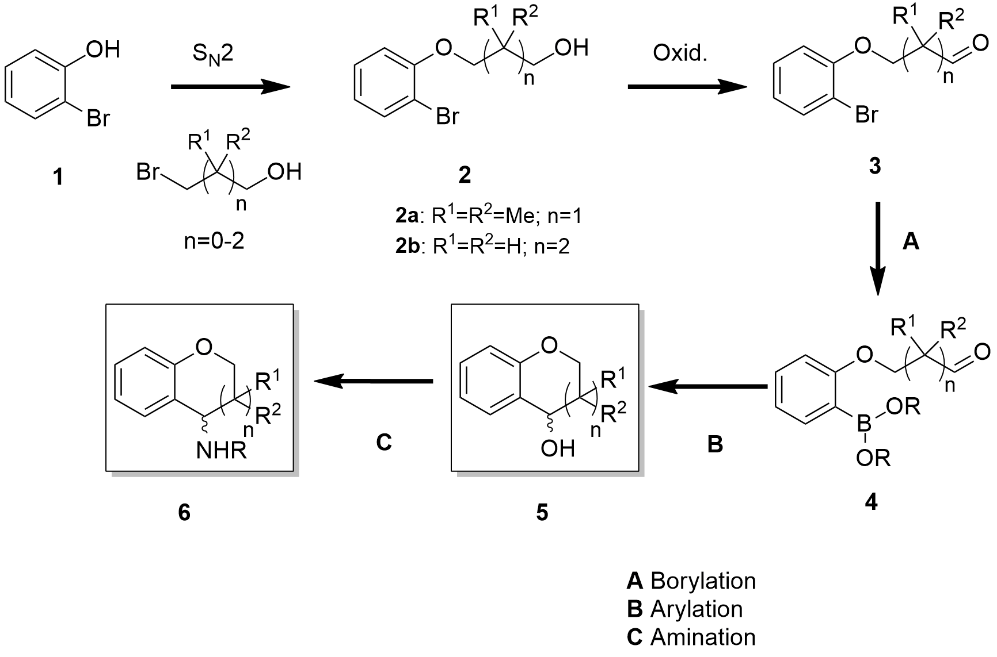
Scheme 3.4: Our synthetic strategy.¹³¹

3.3.2 Synthesis of the o-haloaryl ether substrates
3.3.2.1 Initial approaches

Ethers are a vital class of organic compounds that contain an ether group. They are used widely as active pharmaceutical ingredients (APIs), some important examples being like vancomycin and teicoplanin amongst others. One of the most common procedures for the preparation of ethers is the Williamson synthesis. This method involves the treatment of an alcohol with an alkyl halide in the presence of a strong base (i.e. an alkoxide). In the mechanism, the deprotonated alcohol displaces the halide in an S_{N}2 reaction process (Scheme 3.5).

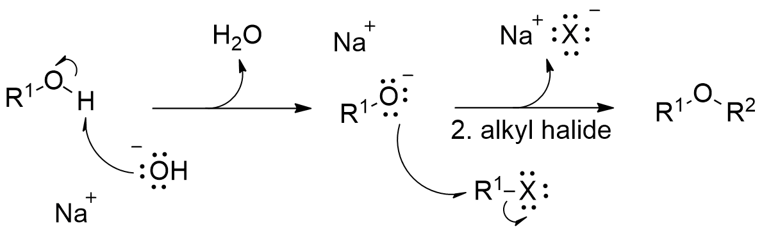
Scheme 3.5: The mechanism of the Williamson synthesis of ethers.¹³³

In industry, this method is often accomplished using organic solvents or phase-transfer catalysts under reflux conditions, in the presence of a strong base. However, this synthesis is only effective when primary alkyl halides are involved, since both secondary and tertiary alkyl halides lead to competing elimination reaction side-products., , ,
As an alternative, we also tested some variations of the synthetic strategy shown in Scheme 3.4. This included the attempted o-alkylation of some commercially available phenolicboronic acids and esters. Consequently, we attempted to alkylate (2-hydroxyphenyl)boronic acid (1a) and 2-(4,4,5,5-tetramethyl-1,3,2-dioxaborolan-2-yl)phenol (1b) with 4-chlorobutan-1-ol, using NaH as a base, in DMF, for 18h, in order obtain the corresponding borylated alcohols (2a) and (2b), as shown in Scheme 3.6.

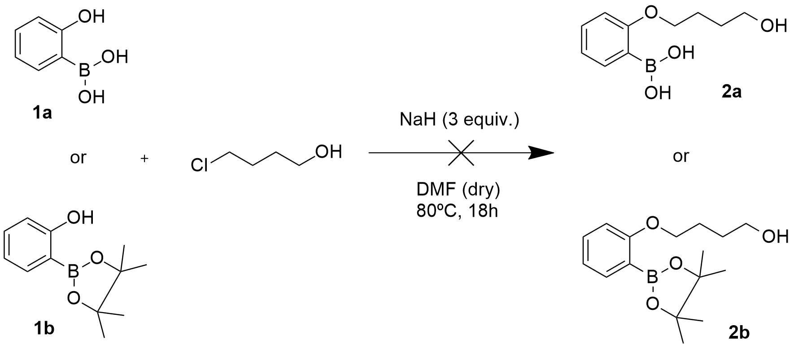
Scheme 3.6: Attempted alkylation of o-boronophenol substrates (1a) and (1b).

Unfortunately, both of these reactions failed to give the desired alkylated products. ¹H NMR analysis of the reaction mixtures showed merely the presence of starting material. Next, we tried changing 4-chlorobutan-1-ol to 4-chlorobutanal, under the same conditions (Scheme 3.7).

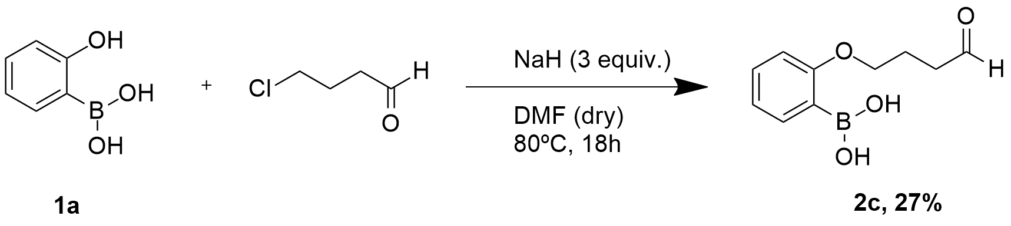
Scheme 3.7: Alternative attempted alkylation of (2-hydroxyphenyl)boronic acid (1a).

This time the formation of the product (2c) was observed in moderate yield (27%). There were chemoselectivity issues, since the nucleophile could attack either the carbonyl group or the C-Cl carbon in 4-chlorobutanal. We observed formation of practically the same amount of both (2c) and an unidentified secondary product.
Considering the reaction of (2-hydroxyphenyl)boronic acid (1a) with 4-chlorobutan-1-ol (Scheme 3.6), we screened a number of different conditions. Initially, we changed the base from sodium hydride to potassium carbonate (Scheme 3.8).

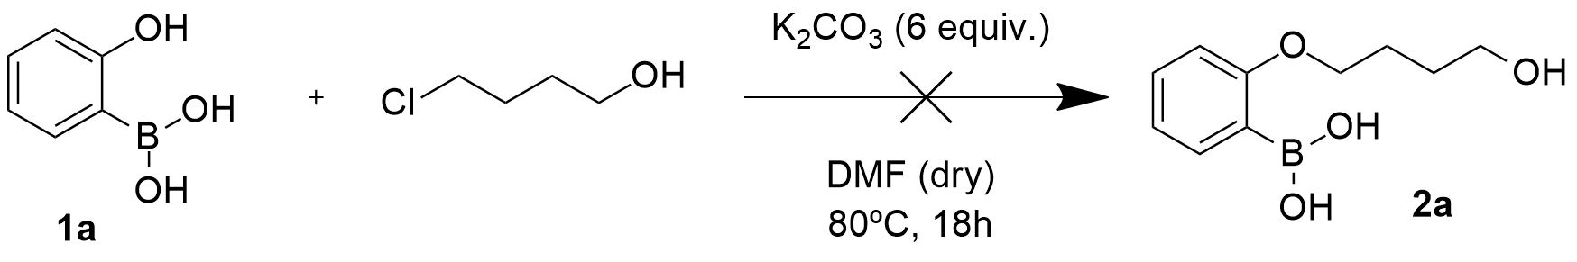
Scheme 3.8: Attempted alkylation of (2-hydroxyphenyl)boronic acid (1a) with K₂CO₃.

Unfortunately, this reaction didn´t work as we detected only the presence of substrate (1a) in the ¹H NMR spectrum of the crude mixture. Next, we changed the solvent to both methanol (MeOH) and acetonitrile (MeCN). In both of these reactions, there was very little product formation, as discerned from the ¹H NMR spectra of the crude mixtures.
Considering the outcome of these reactions, we decided to return to the original plan of using non-borylated o-halophenolic substrates. This time, we opted to use a combination of potassium carbonate in DMF. When we reacted 2-bromophenol (3a) with 3-bromo-2,2-dimethyl-1-propanol using Kazemi´s conditions, we successfully synthesized compound (4a) in 83% yield (Scheme 3.9).

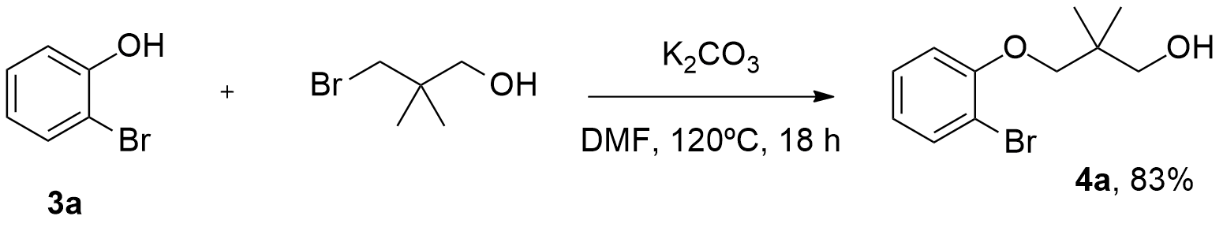
Scheme 3.9: Synthesis of 3-(2-bromophenoxy)-2,2-dimethylpropan-1-ol (4a) using conditions reported by Kazemi et al.¹³⁹

3.3.2.2 Synthesis of substituted 3-(2-bromophenoxy) alcohol derivatives

After having discovered the conditions to successfully alkylate our o-halophenol substrates,¹³⁹ we examined the scope of this methodology reacting numerous substituted 2-bromophenols with 3 aliphatic 1-bromo alcohols (Scheme 3.10). The corresponding 3-(2-bromophenoxy) alcohols (4a)-(4r) were obtained in very good to excellent yields (Figure 3.10).

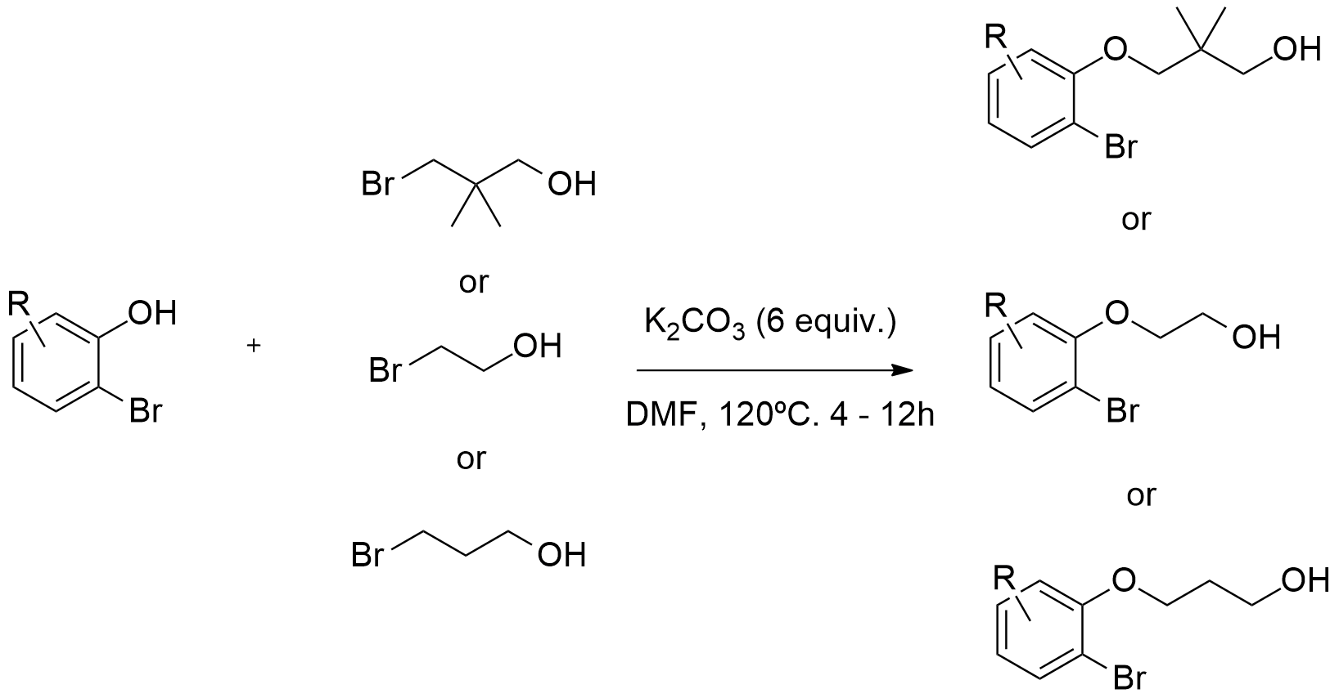
Scheme 3.10: General synthesis of substituted 3-((2-bromophenoxy)oxy) alcohol derivatives (4a)-(4r).

Figure 3.10: Synthesized 3-((2-bromophenoxy)oxy) alcohol derivatives (4a)-(4r).

3.3.2.3 Variation with a naphthyl scaffold

Additionally, we decided to vary the aromatic core of our substrates by introducing a naphthalene unit and reacted 1-bromonaphthalen-2-ol (5a) and 3-bromonaphthalen-2-ol (5b) under the same conditions described in Scheme 3.9. Again, the reaction worked well providing us five (bromonaphthalen-2-yl)oxy alcohol derivatives (6a)-(6e) (Scheme 3.11). To our knowledge, this is the first time this methodology was employed to synthesize this type of compound.

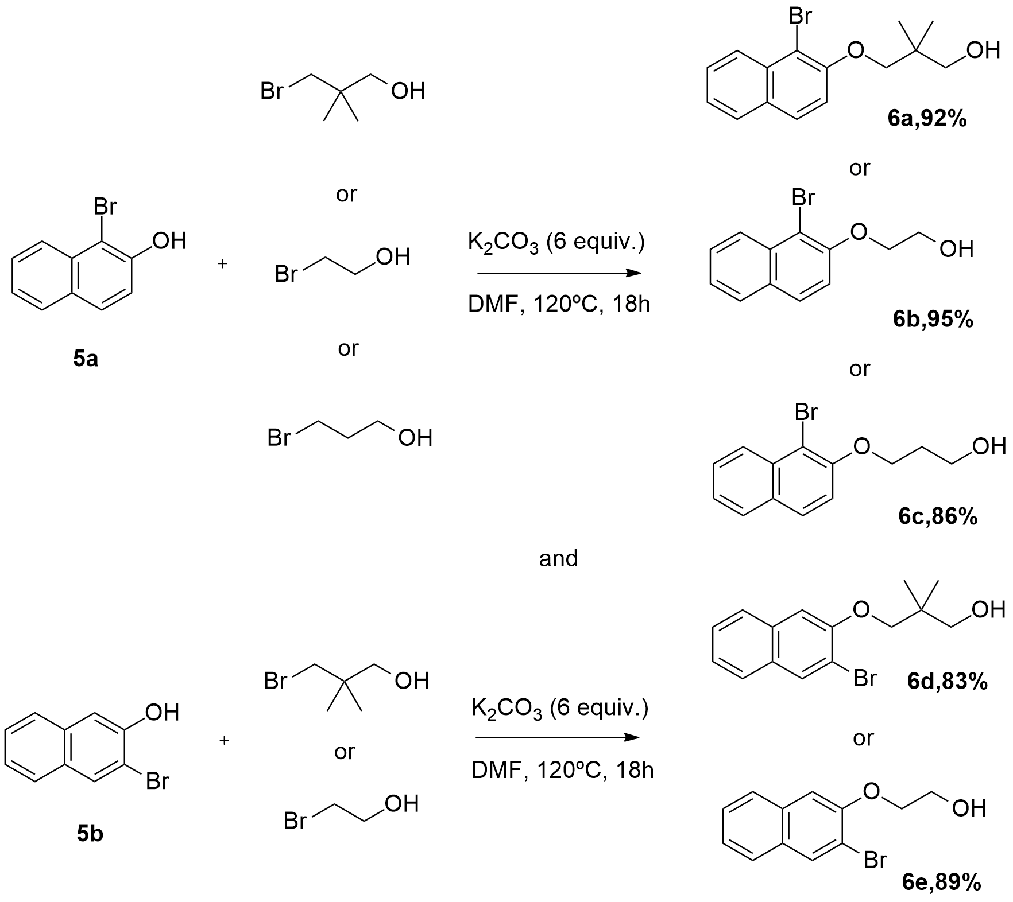
Scheme 3.11: Synthesis of ((bromonaphthalen-2-yl)oxy) alcohol derivatives (6a)-(6e).

3.3.2.4 Variation with heteroaromatic scaffolds

The pyridine ring is described as one of the simplest, yet most important, heteroaromatic structures known in organic chemistry. It is a natural occurring scaffold, which can be found in important molecules such as the vitamins niacin and pyridoxine, the ubiquitous redox system NADP/NADPH and a number of alkaloids, including nicotine and epibatidine, all exhibiting a wide range of biological activities. As a result, the pyridine ring is used in many pharmaceutical (Figure 3.11) and agrochemical products. This fact can be explained by the reason that simple pyridines quickly undergo metabolism via oxidation or methylation pathways, forming the corresponding pyridinium ions., While many of these metabolites are potentially highly toxic to humans, they can be quickly excreted from the body through the kidneys. Therefore, with a good knowledge of their pharmacokinetic and distribution profile, pyridines can be used as efficient pharmaceuticals.

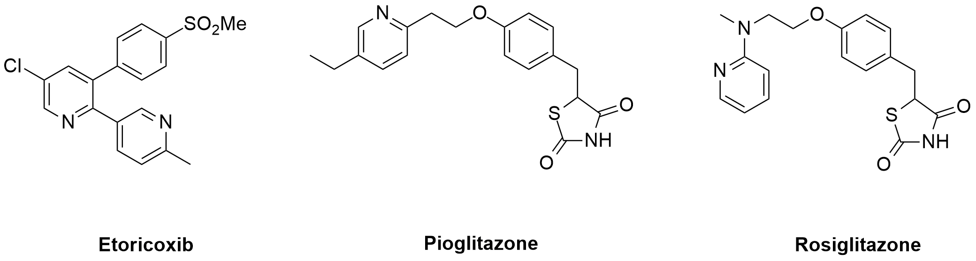
Figure 3.11: Some pharmaceuticals containing a pyridine unit.

Besides, pyridines can be changed in order to become stronger against metabolic transformations, whether by increasing their functionalization or by electronically altering them, in order to avoid direct oxidation. Nonetheless, the modern trend in structural optimisation of pyridine containing lead compounds, is to frequently replace the ring with a bioisostere, such as a methylisoxazole, isothiazole or oxadiazole. ,
Using conditions described previously (Scheme 3.9), we reacted some commercially available pyridines and quinolines, namely 2-bromo-3-pyridol (7a), 7-bromo-8-hydroxyquinoline (7b), 3-bromo-4-hydroxyquinoline (7c) and 3-bromo-4-hydroxy-8-methoxyquinoline (7d), with 3 aliphatic 1-bromo alcohols (Schemes 3.12 - 3.15).

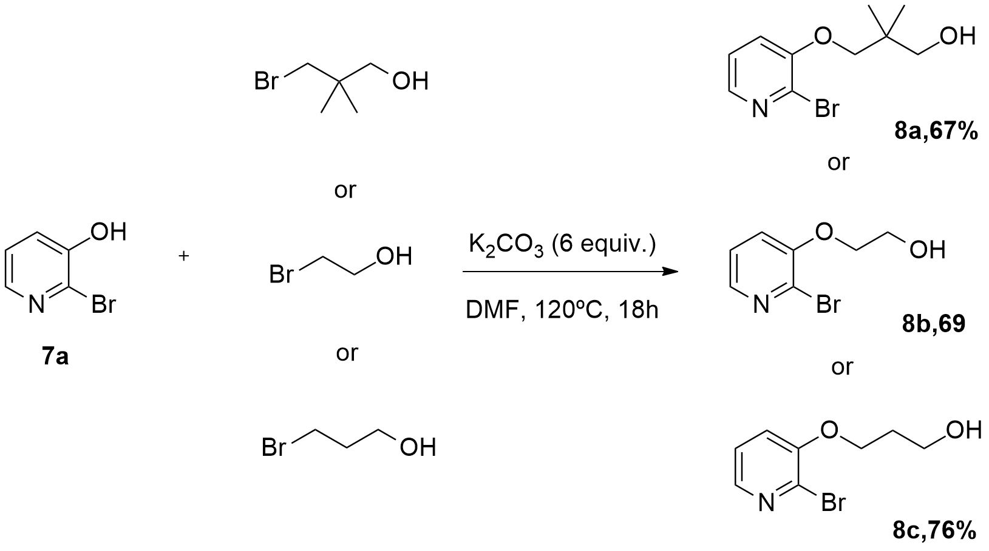
Scheme 3.12: Synthesis of ((2-bromopyridin-3-yl)oxy) alcohol derivatives (8a)-(8c).

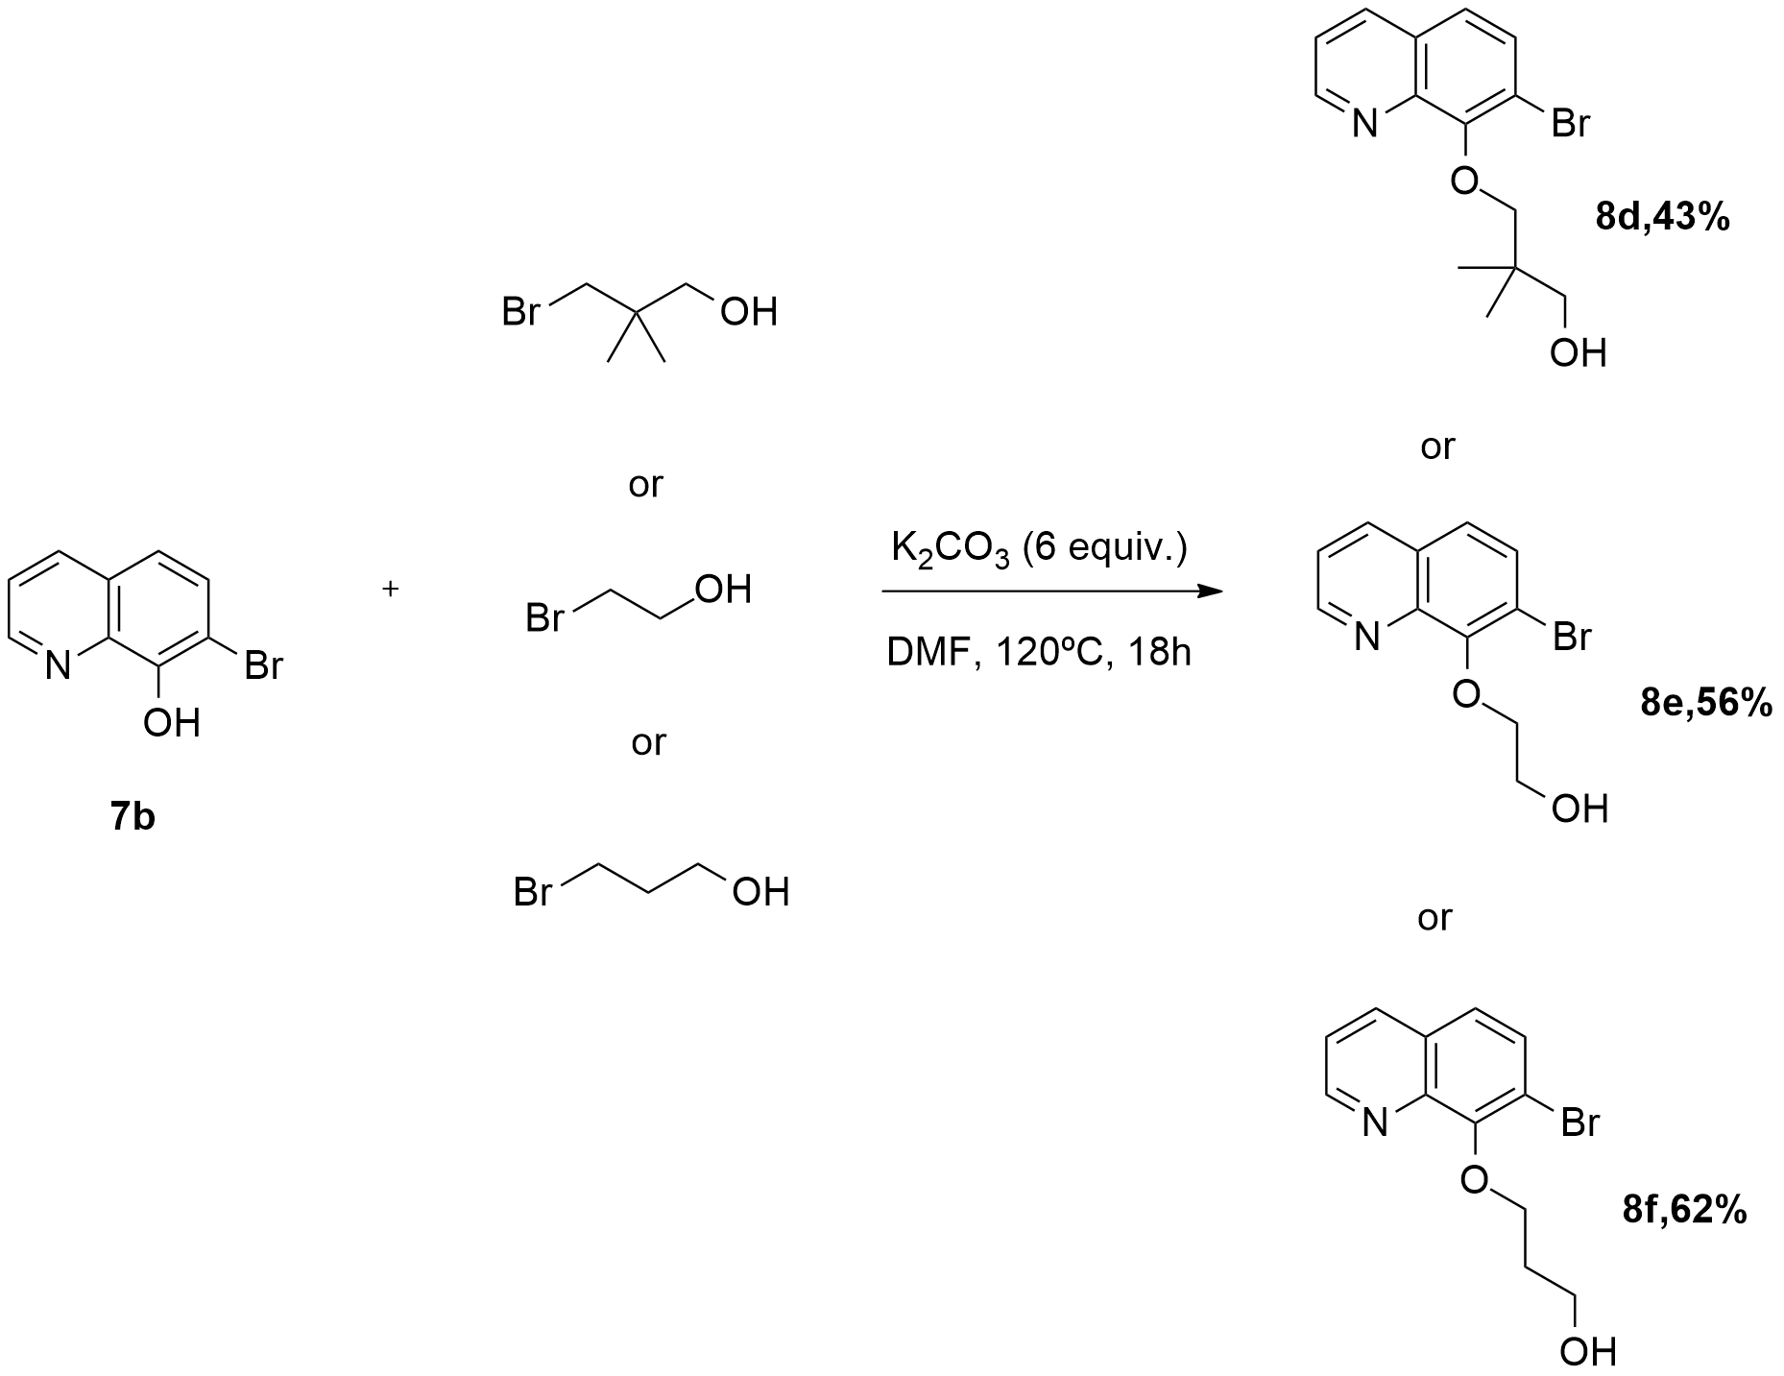
Scheme 3.13: Synthesis of ((7-bromoquinolin-8-yl)oxy) alcohol derivatives (8d)-(8f).

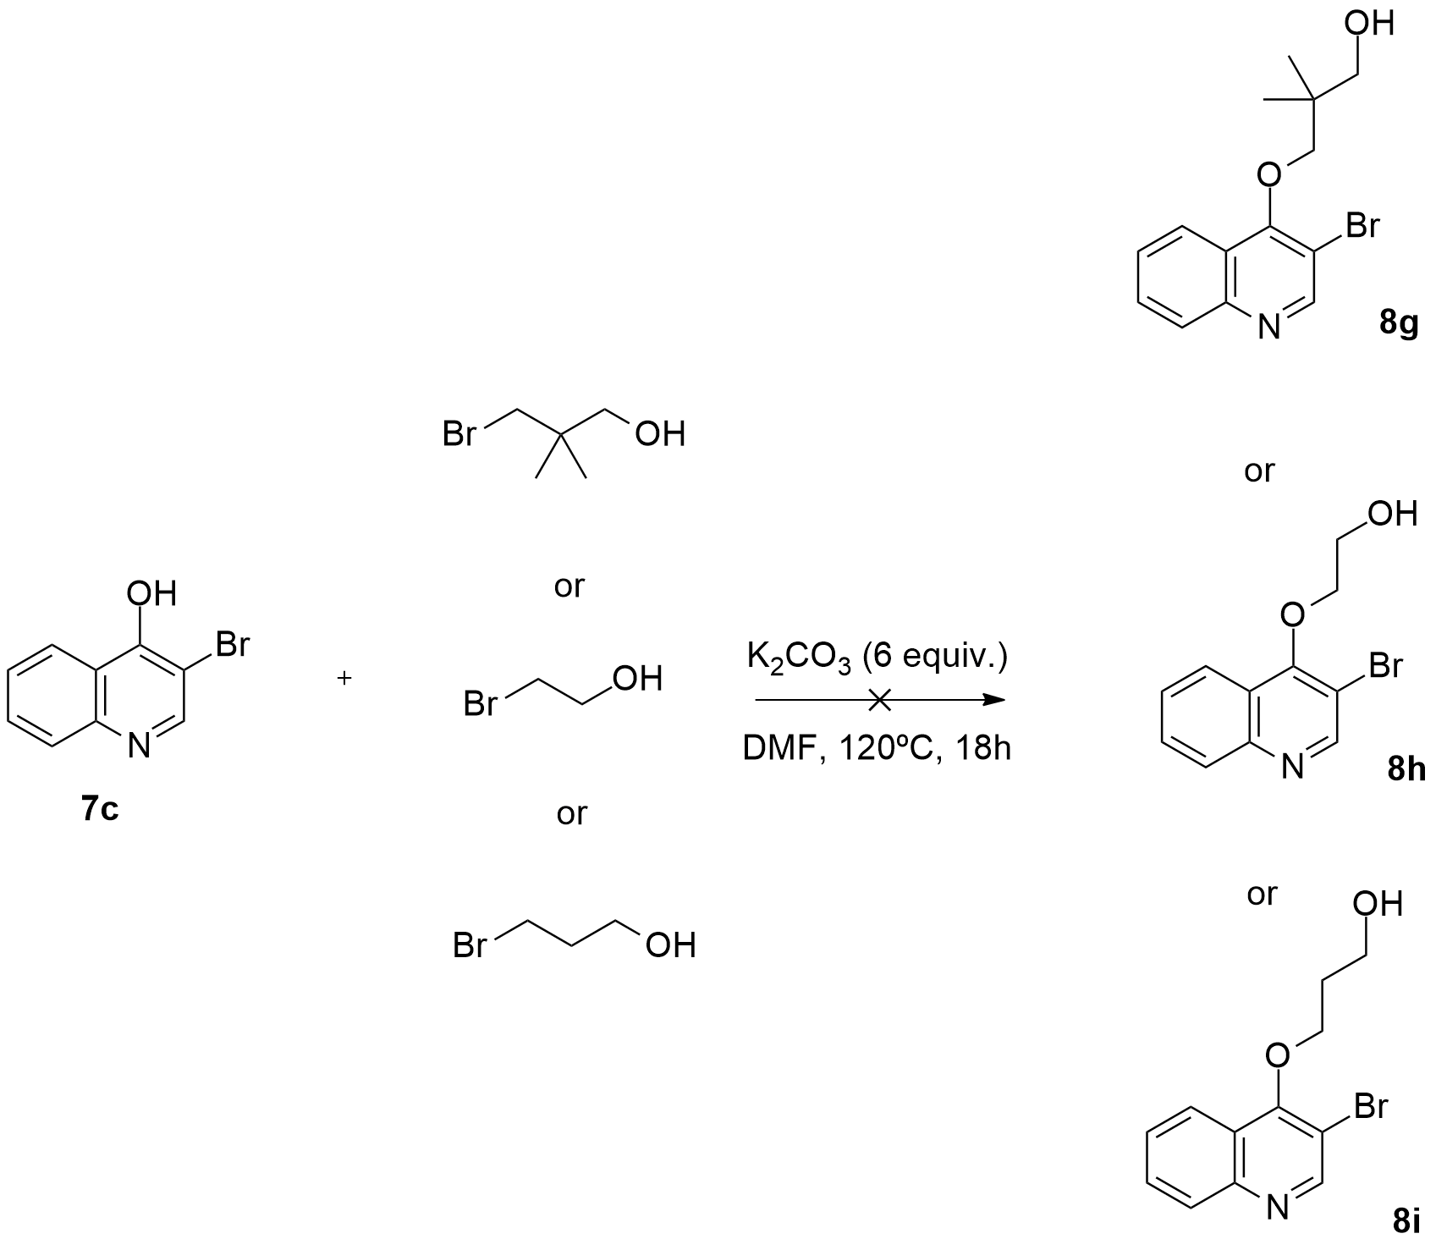
Scheme 3.14: Attempted synthesis of ((3-bromoquinolin-4-yl)oxy) alcohol derivatives (8g)-(8i).

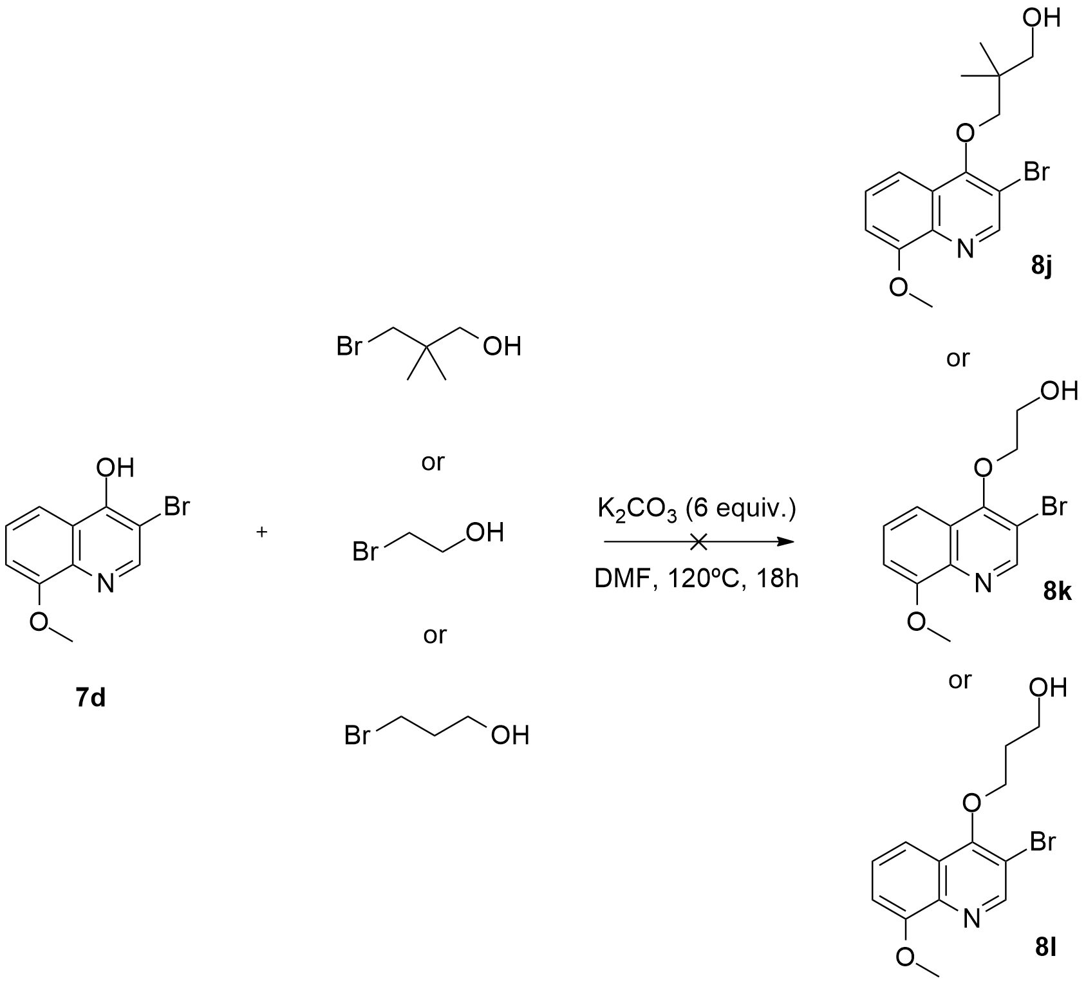
Scheme 3.15: Attempted synthesis of ((3-bromo-8-methoxyquinolin-4-yl)oxy alcohol derivatives (8j)-(8i).

Despite the lower yields when compared with former reactions, the reactions with 2-bromo-3-pyridol and 7-bromo-8-hydroxyquinoline worked well. On the other hand, the reactions with 3-bromo-4-hydroxyquinolines and 3-bromo-4-hydroxy-8-methoxyquinolines were unsuccessful. We can probably explain this outcome by examining the structure of -bromo-4-hydroxyquinoline and 3-bromo-4-hydroxy-8-methoxyquinoline. These molecules undergo tautomerism to give the ketone form. Furthermore, they prefer to exist in the carbonyl form, since this has the advantage of a strong C=O bond. In this state, the oxygen is unable to perform an efficient nucleophilic substitution, because it lacks of sufficient electron density. Regarding 2-bromo-3-pyridol and 7-bromo-8-hydroxyquinoline this situation is slightly different, since these molecules only exist in the ‘phenol’ form. Consequently, when the highly nucleophilic oxygen gets deprotonated by a base, it can easily perform the nucleophilic attack. Once again, as far as we know, it is the first time that pyridine and quinoline scaffolds are used in this type of transformation.

  - 3.3.3 Oxidation of the alcohol derivatives
  - 3.3.3.1 General considerations

The oxidation of alcohols to aldehydes and ketones is a standard transformation in organic chemistry, since both aldehydes and ketones are important functionalities. In addition, aldehydes and ketones do not have the same extensive commercial availability or stability of alcohols. Furthermore, the synthesis of aldehydes involves a significant overreaction problem (i.e. their further oxidation to carboxylic acids), which can only be controlled by selecting the correct oxidant. Therefore, it is not surprising that several methodologies for the oxidation of primary and secondary alcohols to aldehydes and ketones are still being developed and improved.
The emphasis has been given mostly to catalytic reactions, such as the tetrapropylammonium perruthenate oxidant developed by Ley and Griffith, in the 1990s (Figure 3.12), the use of Pyridinium Chlorochromate (PCC) (Figure 3.13), and the more recent palladium-catalysed oxidations employing atmospheric oxygen as the terminal oxidant.

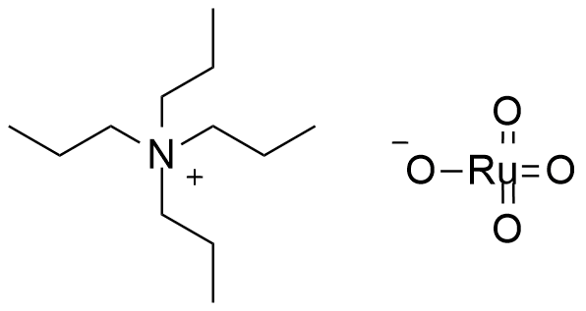
Figure 3.12: Tetrapropylammonium perruthenate oxidant.¹⁴⁶

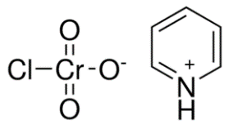
Figure 3.13: PCC reagent.¹⁴⁷

Evidently, entirely metal-free oxidations also have much potential as environmentally friendly processes, principally, if the oxidants can be readily recovered and recycled. Examples of such metal-free systems that can be used in these types of oxidations are the TEMPO-catalysed system, using bleach as stoichiometric oxidant, the Dess-Martin periodinane reagent (Figure 3.14), its more user-friendly version 2-iodoxybenzoic acid (IBX) (Figure 3.15) , and the Swern oxidation, along with its numerous variants. ,

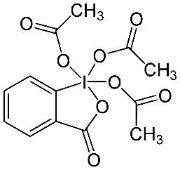
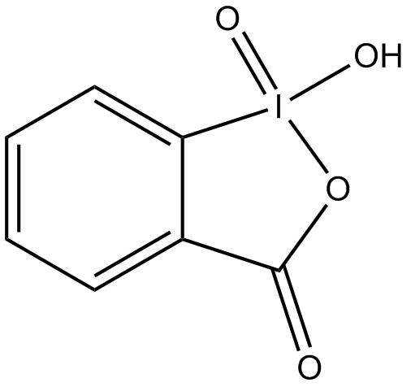
Figure 3.14: Dess-Martin periodinane. ¹⁵⁰
Figure 3.15: IBX reagent.¹⁵¹

3.3.3.2 Synthesis of the aldehyde derivatives

We initially screened a variety of oxidation conditions, including the TEMPO-catalysed oxidation, the Dess-Martin periodinane oxidation, the Swern oxidation and the oxidation with PCC. The latter reaction was the only to provide the aldehyde product in excellent yields (91% to 98%) (Scheme 3.16). As for the other reactions, none of them provided us the aldehyde product in satisfactory yields (only in the range 15% to 53%).
We applied and adapted a procedure using PCC as the oxidizing agent to some of our previously obtained alcohol derivatives.¹⁴⁷ This protocol included the use of two equivalents of PCC, in DCM, at room temperature, for several hours (Scheme 3.16). This type of reaction generates a tar-like residue (composed of chromium byproduct deposits with pyridine) that sticks to the product that can complicate the work-up, thus reducing the yield of the reaction. Nevertheless, the addition of an inert adsorbent, such as celite, silica gel or molecular sieves, solves this problem by allowing the sticky byproduct to adsorb to the surface, hence making the work-up easier. In our case, we chose to add celite (at a loading of twice the mass of PCC).
Interestingly, we observed that this reaction only worked when hindered gem-dimethyl containing substrates were employed. If we used linear non-bulky molecules, the reaction didn´t work. Instead, the alcohol substrate underwent an oxidative esterification providing the correspondent esters (Scheme 3.16). (See Chapter 5, for further details). Probably, the oxidation of gem-dimethyl alcohol substrates didn´t provide the corresponding ester products, because of the proximity of the gem-dimethyl group to the carbonyl group. In fact, the presence of a nearby bulky group could create steric hindrance, thus inhibiting the attack of the alcohol to the aldehyde.

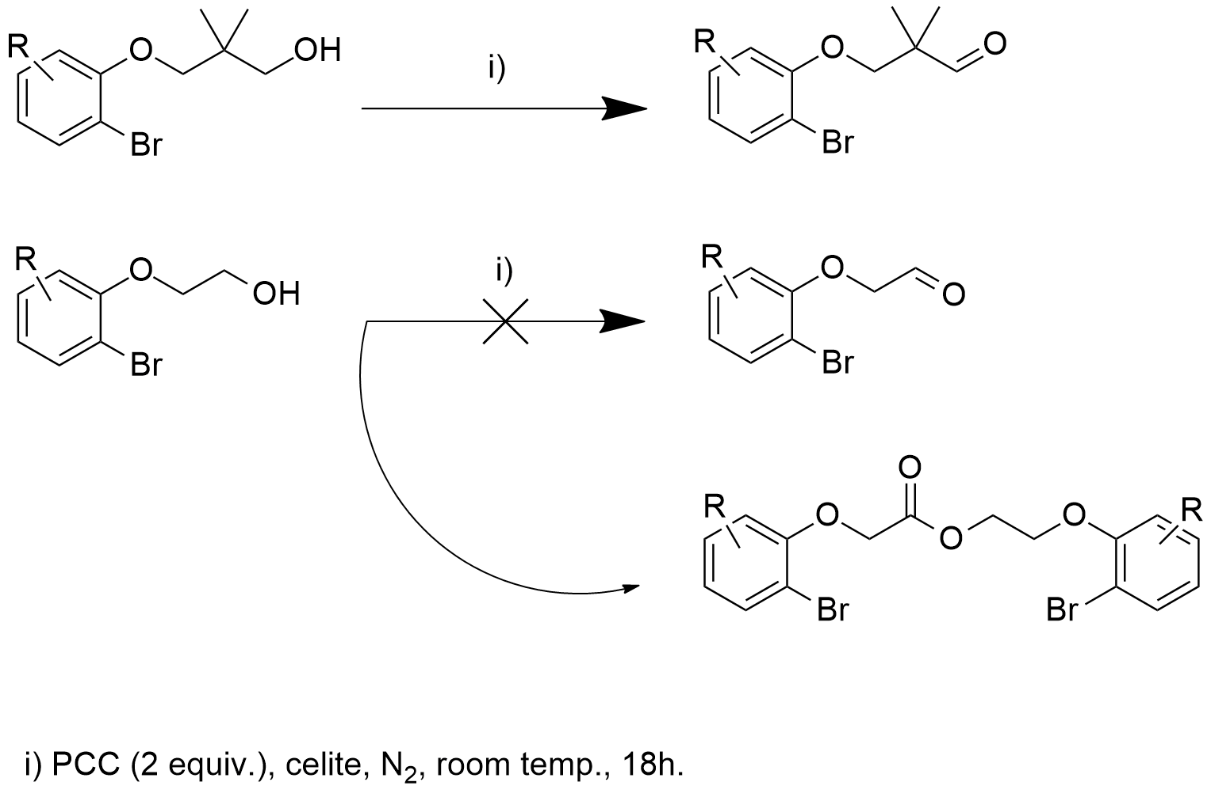
Scheme 3.16: Oxidation of hindered and linear alcohol substrates using PCC.

In Scheme 3.17, we show a number of aldehydes synthesized employing this methodology.

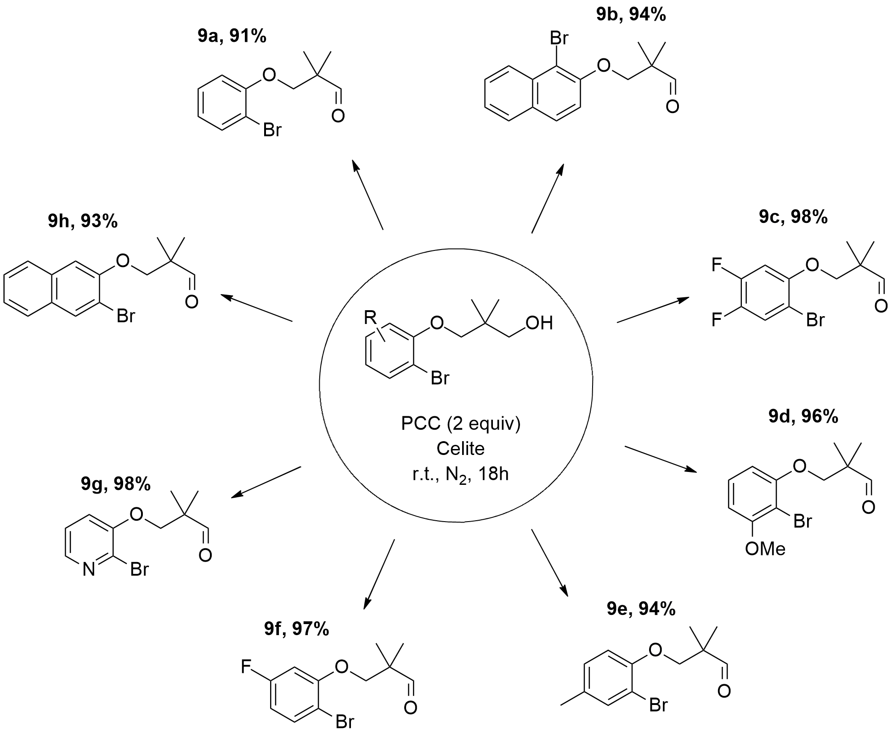
Scheme 3.17: Synthesis of aldehyde derivatives (9a)-(9h) using PCC.

  - 3.3.4 Synthesis of non-gem-dimethyl aldehyde derivatives
  - 3.3.4.1 Alternatives to PCC oxidation reactions

As mentioned above, the PCC oxidation reactions in which non-gem-dimethyl substrates were used, did not provide any aldehyde products. Instead, they provided unexpected ester products. After a methodical and careful interpretation of the ¹H and ¹³C NMR spectrum, it was clear that the alcohol substrate was undergoing oxidative esterification to provide the corresponding ester (See Chapter 4). To our knowledge, this outcome had never been reported previously. In order to circumvent this problem we turned to another methodology. The Williamson ether synthesis adapted for the preparation of allyl phenyl ethers, associated with the Lemieux-Johnson oxidation, seemed the appropriate choice, since in theory these two methodologies could easily provide us the desired aldehyde derivatives, with a reduced number of synthetic steps (Scheme 3.18).

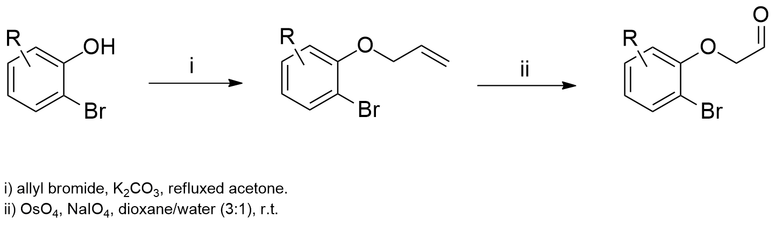
Scheme 3.18: Our strategy for the synthesis of aldehyde derivatives.

3.3.4.2 Synthesis of the allyl aryl and heteroaryl ether derivatives

The first step was to adapt the Williamson methodology to our system. Consequently, 2-bromophenol (3a) was reacted with allyl bromide and K₂CO₃, in refluxed acetone.¹⁵⁵ After 4 hours, TLC analysis showed that the substrate (3a) was completely converted in 1-(allyloxy)-2-bromobenzene (10a), in excellent yield (Scheme 3.19).
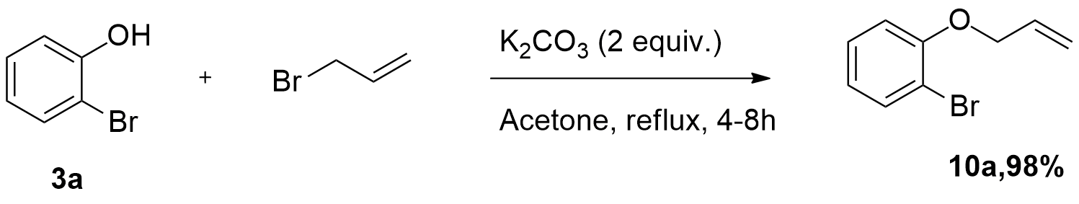
Scheme 3.19: Synthesis of 1-(allyloxy)-2-bromobenzene derivative (10a).

This methodology¹⁵⁵ was repeated for several substituted aromatic and heteroaromatic commercially available o-halophenols, therefore providing several new allyl aryl and heteroaryl ethers (10a)-(10k), in excellent yields (Figure 3.16).
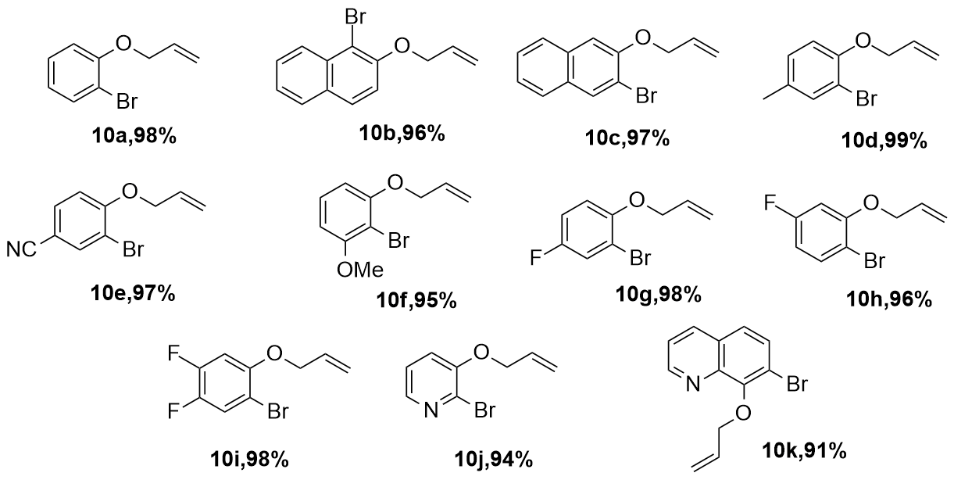
Figure 3.16: Synthesized allyl aryl and heteroaryl ether derivatives (10a)-(10k).

3.3.4.3 Synthesis of aldehyde derivatives through Lemieux-Johnson oxidation

In order to transform the previously synthesized allyl aryl and heteroaryl ethers (10a)-(10k) into their aldehyde derivatives, we had to cleave them oxidatively using the Lemieux-Johnson oxidation method.¹⁵⁶
Under this procedure, an olefin undergoes oxidative cleavage to form two aldehyde or ketone units. This reaction proceeds in a two-step manner, beginning with the dihydroxylation of the alkene by osmium tetroxide, followed by an oxidative cleavage by periodate. An excess of periodate must be used in order to regenerate the osmium tetroxide, therefore, allowing it to be used in catalytic amounts. The Lemieux-Johnson reaction stops at the aldehyde stage of oxidation, thus producing the same results as ozonolysis. The general mechanism of this oxidation reaction is shown in Figure 3.17.¹⁵⁶

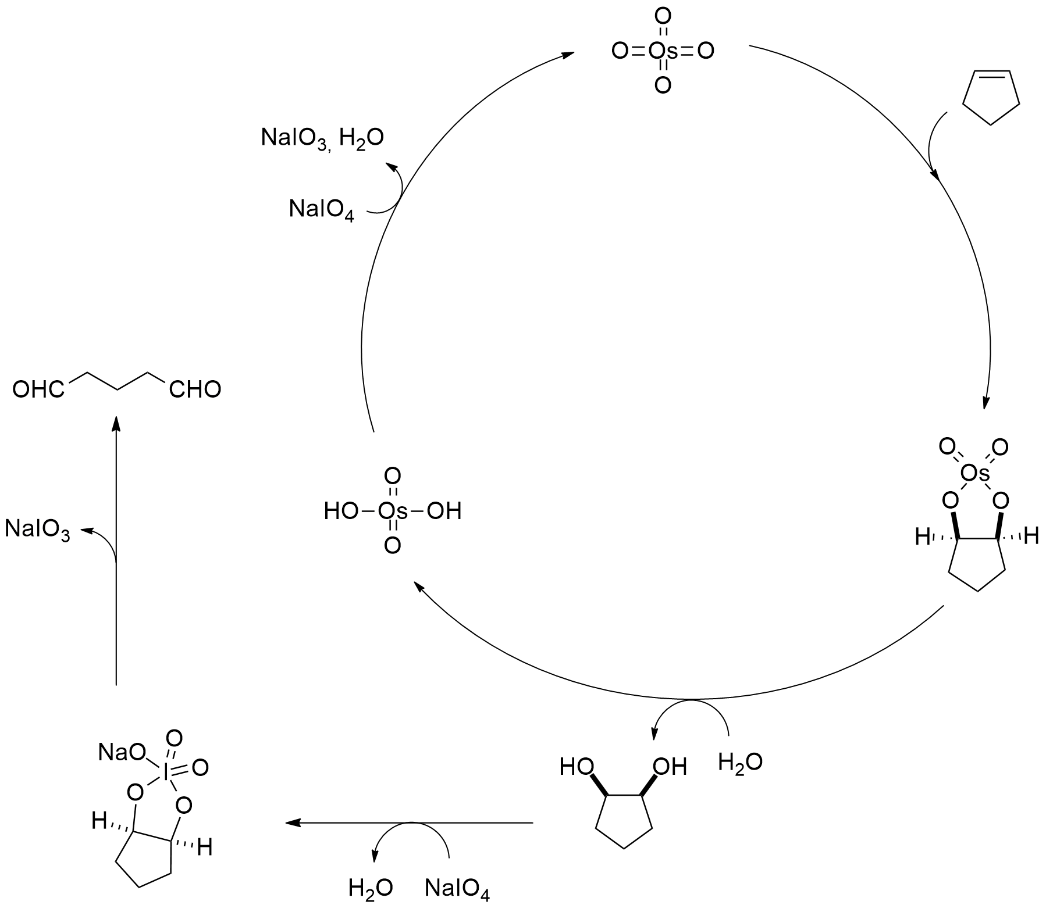
Figure 3.17: General mechanism of the Lemieux-Johnson oxidation. ¹⁵⁶

By reacting compound (10a) with a catalytic amount of osmium tetroxide, in a mixture of dioxane/H₂O (3:1) and subsequent treatment with sodium periodate, provided the corresponding aldehyde derivative (11a) (Figure 3.18), in good yield (Scheme 3.20).

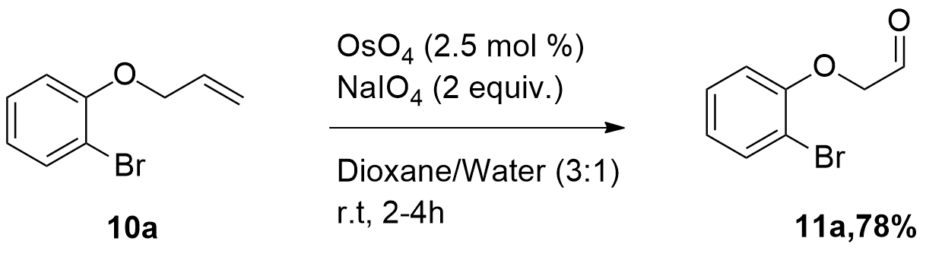
Scheme 3.20: Synthesis of 2-(2-bromophenoxy)acetaldehyde (11a).

In order to obtain a library of linear non-hindered aldehydes, a range of different substrates was similarly tested. Following the same procedure, we synthesized six additional non-gem-dimethyl aldehyde derivatives (11b)-(11g), in good yields (Figure 3.18).
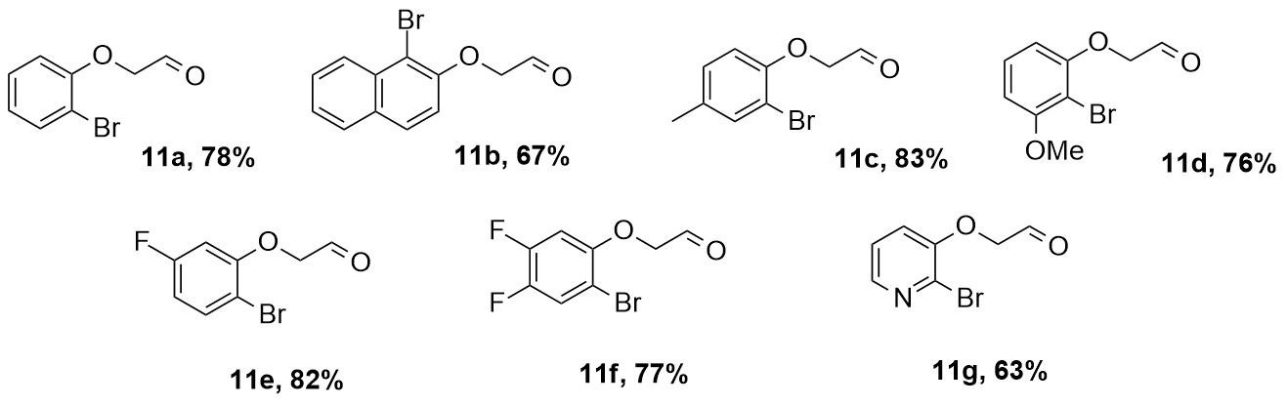
Figure 3.18: Synthesized aldehyde derivatives (11a)-(11g).

  - 3.3.5 Metal-catalysed borylation reactions
  - 3.3.5.1 A view into borylation processes

In 2010, the Nobel Prize for Chemistry acknowledged the incontestable importance of palladium-catalysed cross-coupling reactions. Suzuki-Miyaura cross-coupling reaction took the prize as one of the most important convergent methodologies for the synthesis of biaryl compounds, which are vital structural motifs and can be found in a number of biologically active and pharmaceutically valuable compounds.
It is commonly well accepted that the organoboron nucleophile can be employed as a useful coupling partner for aromatic carbon-carbon bond formation. Therefore, over the past decades synthetic chemists have been actively developing convenient methods, for accessing these synthetically useful organoboron-containing molecules. Common preparation of arylboronic acids or boronate esters were typically accomplished via halogen-metal exchange of aryl bromides or iodides with arylmagnesium or-lithium reagents and consequent trapping with trialkylborates. Yet, this direct pathway is incompatible with base-sensitive functional groups (i.e. aldehyde, ketone, nitrile, etc.). Consequently, further protection and deprotection of the arylboronic acids or boronate esters are usually necessary using this synthetic route. Recently, highly selective metal-catalysed borylation reactions of aryl halides and sulfonates with alkoxyboranes were discovered (Scheme 3.21).

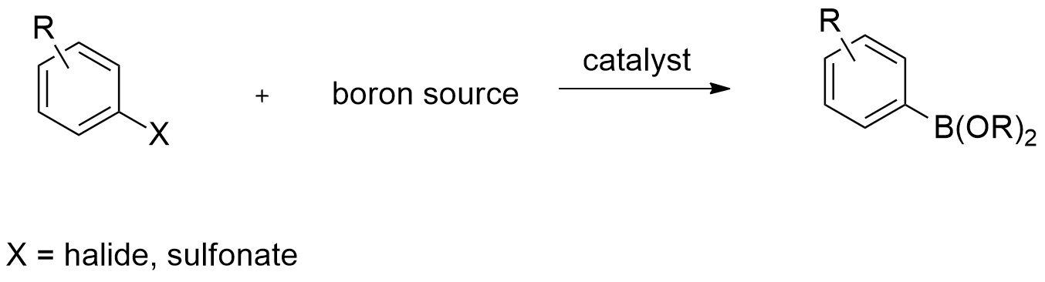
Scheme 3.21: Common protocol for the borylation of aryl halides.¹⁶¹

The first examples of the palladium-catalysed borylation of aryl halides with bis(pinacolato)diborane (B₂pin₂) were reported in 1995, by Miyaura (Scheme 3.22).⁴⁵

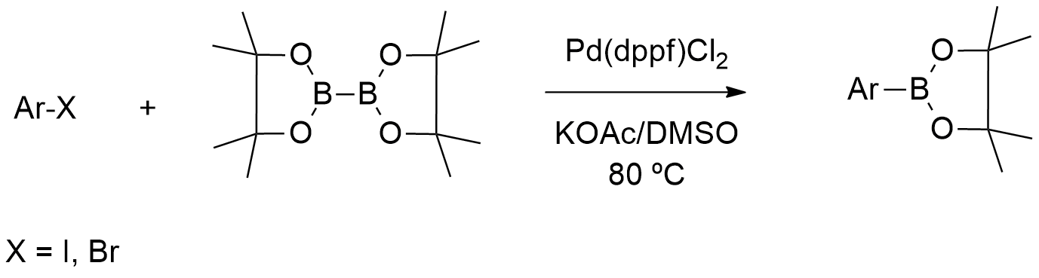
Scheme 3.22: Miyaura´s palladium-catalysed borylation of aryl halides.⁴⁵

In 1997, Masuda described the preparation of aryl boronates from aryl halides and 4,4,5,5-tetramethyl-[1,3,2]dioxaborolane (pinacolborane), using palladium complexes (Scheme 3.23).⁴⁶

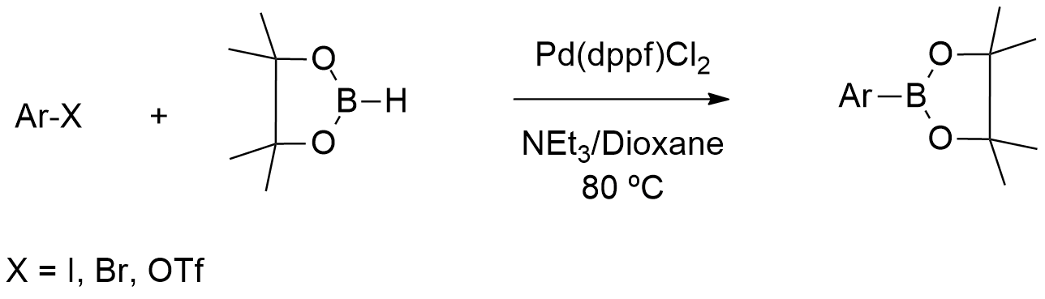
Scheme 3.23: Masuda´s palladium-catalysed borylation of aryl halides.⁴⁶

For the first time, Masuda´s procedure allowed the use of hydroboranes in the palladium-catalysed coupling reaction with aryl halides, to afford the corresponding arylboronates. Unquestionably, dialkoxyboranes are more attractive, since they are readily accessible and cheaper than diboron reagents.⁴⁶
Since then, a number of metal-catalysed processes have emerged, employing palladium, nickel and copper complexes for the conversion of aryl iodides and bromides into their corresponding boronate esters. Unfortunately, only a limited group of catalytic systems were found to be active for the borylation of aryl chlorides.

3.3.5.2 Palladium-catalysed borylation of aryl halides and sulfonates

The proposed catalytic cycle for the borylation of aryl halides reported by Miyaura (Figure 3.19), starts with the oxidative addition of the aryl halide to a palladium(0) complex to produce a transpalladium(II) complex Ar-Pd(II)-X. This species then undergoes ligand exchange to produce an acetoxopalladium intermediate. The high reactivity of the acetoxopalladium complex towards the transmetalation, with bis-organodiboron compounds, can be credited to the high reactivity of the Pd-O bond, which can be considered a soft acid and a hard base, as well as to the high oxophilicity of the boron center. One of the diboron atoms can be datively coordinated by a free alkoxy ion and consequently be activated for the transfer of the organoboron nucleophile to the palladium metal. Finally, reductive elimination of the arylboronate Ar-B(OR)₂ takes place along with the catalyst regeneration.¹⁶²
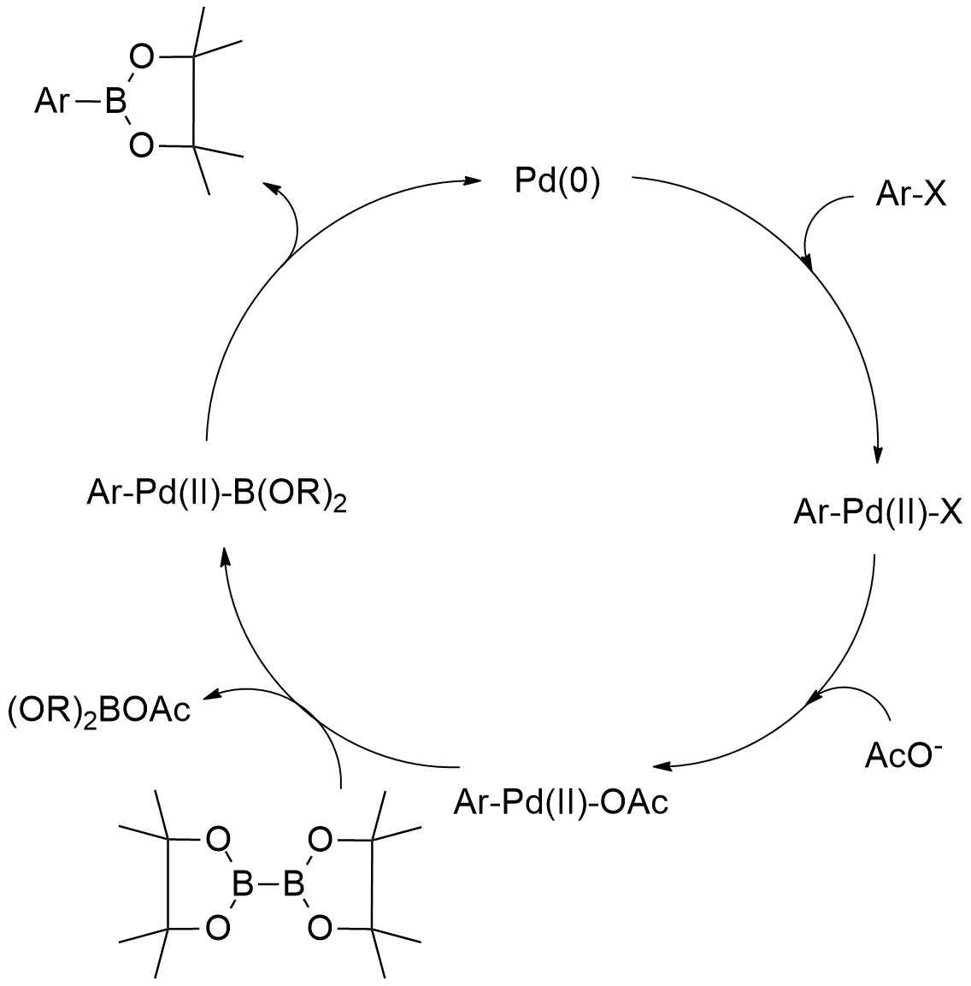
Figure 3.19: The proposed catalytic cycle for coupling aryl halides with B₂pin₂.¹⁶²

In 2004, Sakaki and co-workers studied the transmetalation process in the palladium-catalysed-borylation of iodobenzene with diboron compounds, using DFT calculations. They proposed an important model for the transmetalation step, where hydroxide or fluoride ligands can make strong X-B bonds. This energy compensation balances the weakening of the Pd-X and B-B bonds and accelerates the transmetalation and polarization of the diboron compound, which permits for the facile heterolytic cleavage of the B-B bond. These theoretical calculations also showed that not only the Lewis base but also a fluoride ligand can, significantly, promote the transmetalation process.¹⁶²
Later, Masuda and co-workers described the preparation of aryl boronates by coupling aryl halides with pinacolboranes.⁴⁶ The interaction between trimethylamine and pinacolboranes was proposed to provide an ammonium boride ion pair, in which the boride acts as the active transmetallating anion.^{46,}
Apart from the Pd(0) / Pd(II) cycle, another conceivable pathway includes the oxidative addition of pinacolborane to a Pd(II) center. The putative Pd(IV) intermediate is then followed by a reductive elimination to afford the Ar-Bpin product.⁵³ However it is accepted that the ‘‘H’’ of H-Bpin is hydridic rather than protic, as the electronegativity of hydrogen is superior to that of boron. Bearing this in mind, Lin and Marder suggested that it is highly unlikely for pinacolboranes to protonate trimethylamine, to yield the triethylammonium salt and the boryl anion. With the help of DFT calculations, an alternate mechanism associated with a cationic pathway of σ-bond metathesis is reported (Figure 3.20). In these studies, a highly unfavourable intermediate was calculated, thus making the possibility of a Pd(II) / Pd(IV) cycle unlikely.⁴⁶

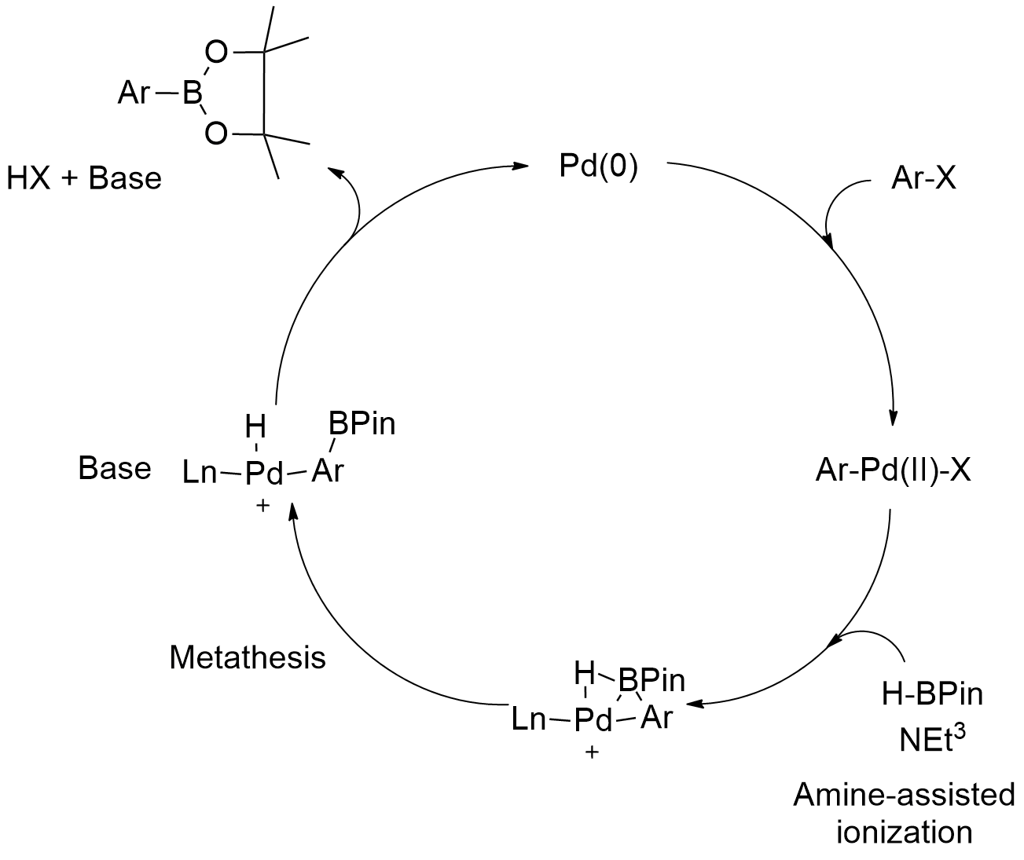
Figure 3.20: The proposed catalytic cycle for coupling aryl halides with pinacolborane, involving a cationic palladium intermediate.⁴⁶

3.3.5.3 Synthesis of the borylated derivatives

In order to successfully borylate our substrates, we first tried the palladium-catalysed borylation of aryl halides using B₂pin₂, as previously described in 1995, by Miyaura.⁴⁵ We adapted Miyaura´s procedure and reacted compound (9a) with pinacolborane, in the presence of Pd(dppf)Cl₂ and potassium acetate (KOAc), in dioxane, at 80ºC, for several hours (Scheme 3.24).

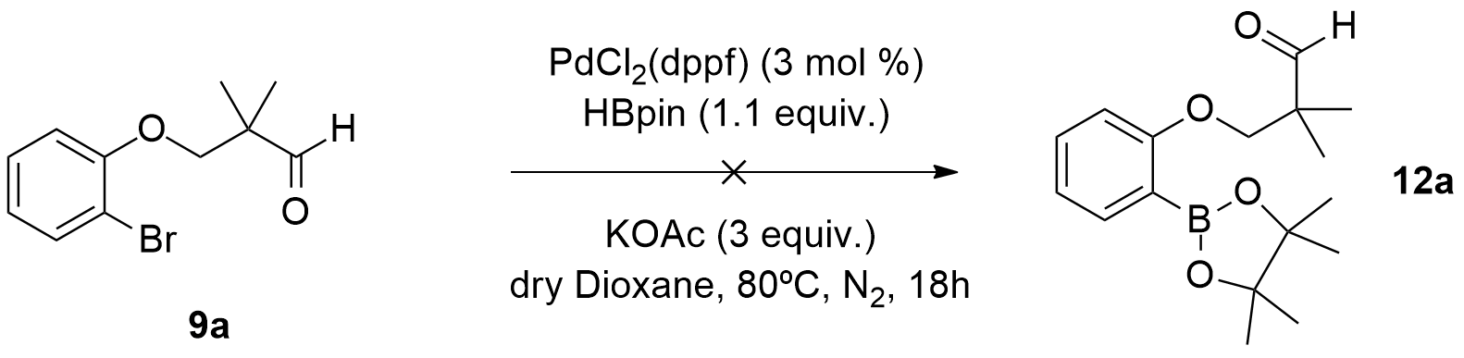
Scheme 3.24: Attempted borylation of (9a) with pinacolborane using Pd(dppf)Cl₂ as catalyst.

¹H NMR analysis of the crude mixture showed no presence of the desired borylated product (12a). Instead, we detected 2-bromophenol (3a). In 2007, Buchwald and co-workers reported that aryl chlorides could undergo borylation under the employment of newly developed dialkylphosphino biphenyl ligands, specifically S-Phos. The authors established that the bulky nature of the ligand helps in the formation of the highly active LPd⁰ complex, which is much more reactive than the corresponding L₂Pd species.¹⁹³ Considering this, we attempted a second borylation and reacted compound (9a) with pinacolborane, using Pd(OAc)₂, S-Phos and K₂CO₃, in dioxane, at 80ºC, for several hours (Scheme 3.25).

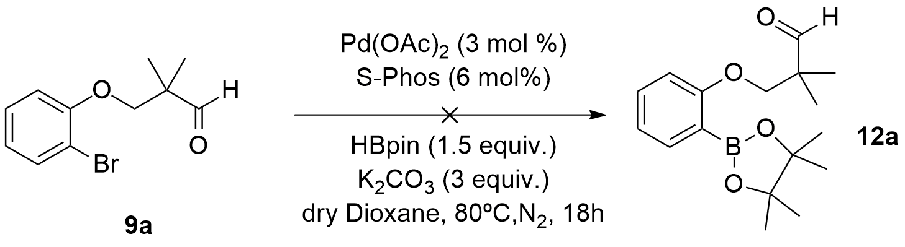
Scheme 3.25: Attempted borylation of (9a) with pinacolborane using Pd(OAc)₂ and S-Phos.

Once again, the reaction did not provide the borylated product (12a) and 2-bromophenol (3a) was the only compound observed in the ¹H NMR spectrum of the crude mixture. Concerned that the carbonyl function of our substrate could be interfering with the reaction, we carried out another reaction. Consequently, we reacted 3-(2-bromophenoxy)-2,2-dimethylpropan-1-ol (4a) with pinacolborane using Pd(dppf)Cl₂ and K₂CO₃, in THF, at 80ºC, for several hours (Scheme 3.26).

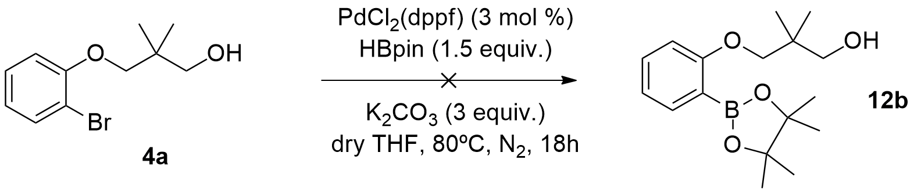
Scheme 3.26: Attempted borylation of (4a) with pinacolborane, using Pd(dppf)Cl₂.

Once again, we did not detect any traces of the borylated product (12b) in the ¹H NMR spectra of the reaction mixture. As detected in previous reactions, compound (3a) was observed in the spectrum. We then returned to our previous aldehyde substrate, this time using a derivative bearing no gem-dimethyl function, as we also hypothesised that this group could be interfering in the reaction, specifically, hindering the access of the palladium species to the carbonyl group. We carried out a reaction repeating conditions described in Scheme 3.26 and using 2-(2-bromophenoxy)acetaldehyde (11a) as the substrate, but unfortunately this reaction also was unsuccessful (Scheme 3.27). Starting material was detected in the ¹H NMR spectrum of the crude mixture.

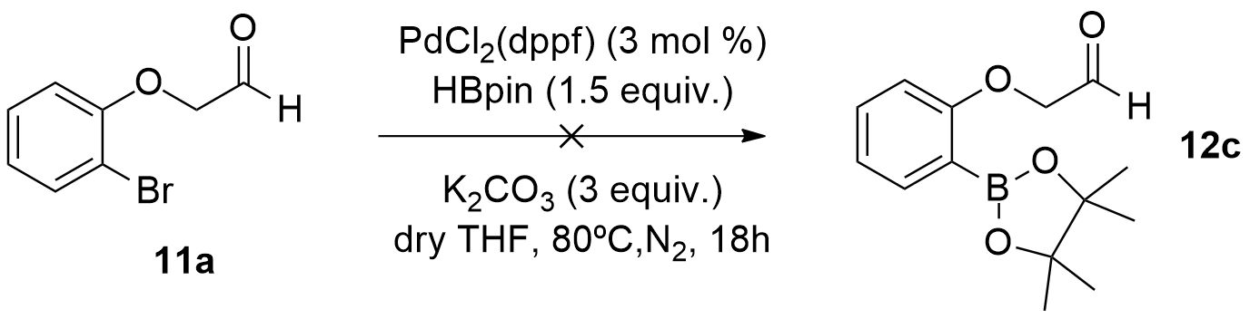
Scheme 3.27: Attempted borylation of (11a) with pinacolborane, using Pd(dppf)Cl₂.

In order to check if the solvent was interfering with the reaction, we decided to repeat reaction described in Scheme 3.27, with a more basic solvent as dioxane, but again the reaction failed to provide the borylated product. Similarly, we also changed the base from K₂CO₃ to KOAc, but likewise the reaction failed.
In the belief that the substrate could be the problem, specifically the presence of the carbonyl group, we examined a different substrate lacking both gem-dimethyl and carbonyl groups. Consequently, we reacted 3-(2-bromophenoxy)propan-1-ol (4c) with pinacolborane, in the presence of Pd(dppf)Cl₂ and K₂CO₃, in THF, at 80ºC, for several hours (Scheme 3.28), but this also didn’t work.

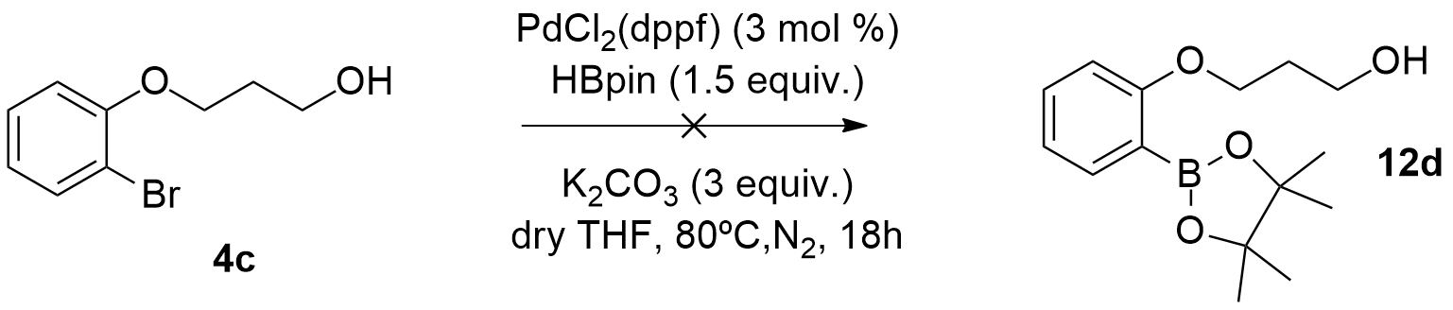
Scheme 3.28: Attempted borylation of (4c) with pinacolborane, using Pd(dppf)Cl₂.

Concurrently with these reactions, we also tried to borylate these substrates using other catalytic methods. For instance, chemists from Eli Lilly reported the borylation of aryl halides with pinacolborane using a Pd/C catalyst and NEt₃, in acetonitrile (MeCN), at 75ºC, for 24h (Scheme 3.29).
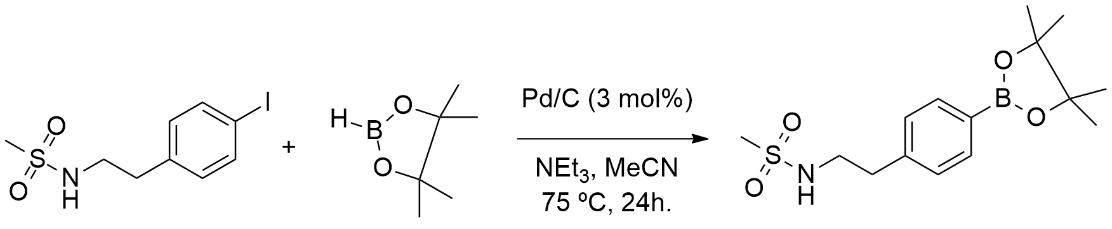
Scheme 3.29: Lilly´s borylation of aryl halides with Pd/C.¹⁶⁷

We adapted these conditions to our substrates and reacted 3-(2-bromophenoxy)-2,2-dimethylpropan-1-ol (9a) with pinacolborane using Pd/C NEt₃, in MeCN, at 75ºC, for 24h (Scheme 3.30). Again, the reaction failed to work. This time we detected 2-bromophenol (3a) in the ¹H NMR spectrum of the crude mixture.
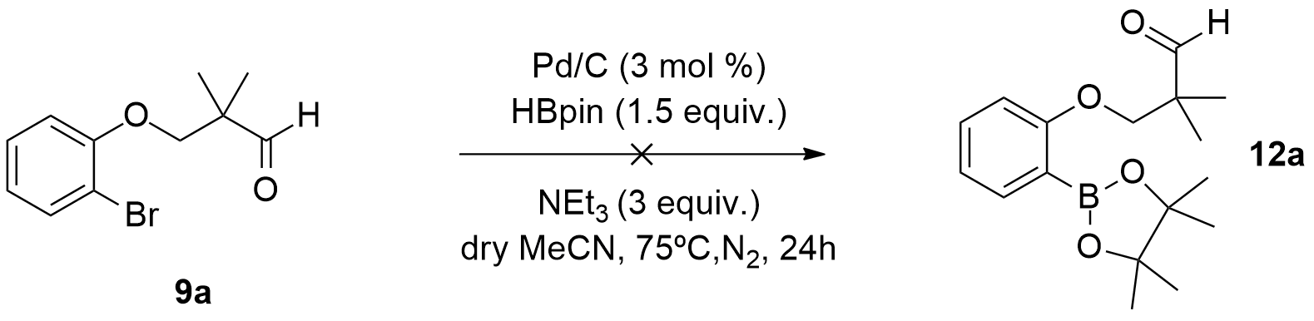
Scheme 3.30: Attempted borylation of (9a), using Lilly´s method.

Other palladium sources and reaction conditions were additionally tested. Compound (9b) was reacted with pinacolborane using Pd(PPh₃)₂Cl₂ and NEt₃, in toluene, at 80ºC, for several hours (Scheme 3.31), but this reaction failed to give the borylated product.
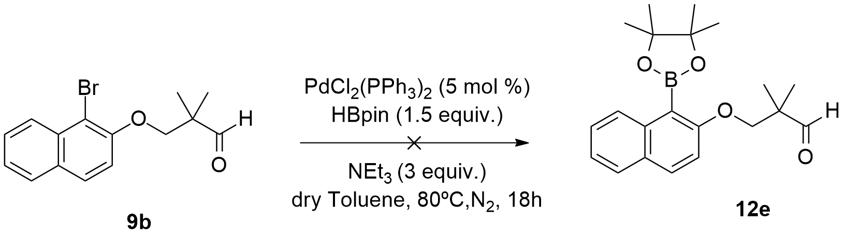
Scheme 3.31: Attempted borylation of (9b), using Pd(PPh₃)₂Cl₂.

In 2001, Miyaura and co-workers reported the synthesis of pinacol arylboronates via cross-coupling reaction of B₂pin₂ with chloroarenes, catalysed by palladium(0)-tricyclohexylphosphine complexes.
We adapted their protocol using tris(dibenzylideneacetone)dipalladium (0) (Pd₂(dba)₃) and tricyclohexylphosphine (PCy₃) and reacted 2-((3-bromo naphthalen-2-yl)oxy)ethanol (6e) with pinacolborane and KOAc, in dioxane, at 80ºC, for several hours (Scheme 3.32), again without success.
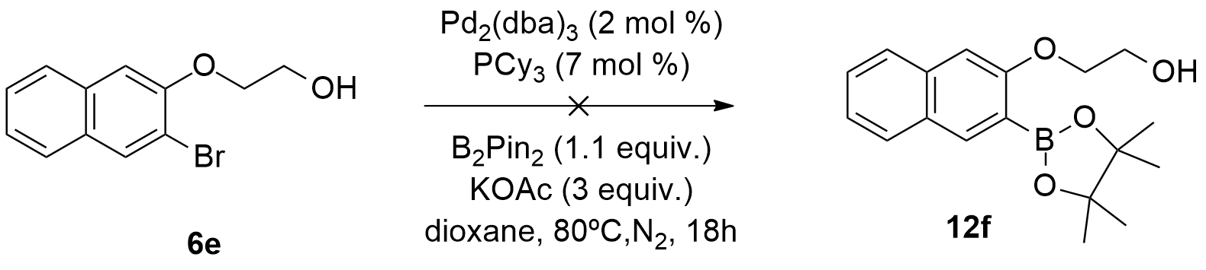
Scheme 3.32: Attempted borylation of (6e), using Pd₂(dba)₃.

Considering the different results obtained in the attempted borylation reactions, there are some plausible reasons to explain why the borylation reactions failed. The first explanation is steric hindrance, since the arrangement of the atoms in our substrates could indeed have prevented or retarded the borylation reactions from occurring. A second plausible reason could be the effect that the ether oxygen exerts over the C-Halogen bond or on the nascent C-Pd bond, consequently, deactivating them. As a third reason, the aldehyde or the alcohol could have coordinated to the palladium via dative bonding and thus deactivating it. After carrying out several reactions and employing different conditions (Table 3.1), we could not obtain the desired borylated products.

Table 3.1 Summary of the attempted borylation reactions

Entry | Substrate | Catalyst  (mol %) | Ligand  (mol %) | Boron source  (equiv.) |  | Base  (equiv.) | Solvent  (dry) |  | Temperature  (º C)
1 | 9a | Pd(dppf)Cl₂  (3) | - | pinacolborane  (1.1) |  | KOAc  (3) | Dioxane |  | 80
2 | 9a | Pd(OAc)₂  (3) | S-Phos  (6) | pinacolborane  (1.5) |  | K₂CO₃  (3) | Dioxane |  | 80
3 | 4a | Pd(dppf)Cl₂  (3) | - | pinacolborane  (1.5) |  | K₂CO₃  (3) | THF |  | 80
4 | 11a | Pd(dppf)Cl₂  (3) | - | pinacolborane  (1.5) |  | K₂CO₃  (3) | THF |  | 80
5 | 11a | Pd(dppf)Cl₂  (3) | - | pinacolborane  (1.5) |  | K₂CO₃  (3) | Dioxane |  | 80
6 | 4c | Pd(dppf)Cl₂  (3) | - | pinacolborane  (1.5) |  | KOAc  (3) | THF |  | 80
7 | 9a | Pd(dppf)Cl₂  (3) | - | pinacolborane  (1.5) |  | K₂CO₃  (3) | THF |  | 80
8 | 9b | Pd/C  (3) | - | pinacolborane  (1.5) |  | NEt₃  (3) | MeCN |  | 80
9 | 6e | Pd₂(dba)₃  (2) | PCy₃  (7) | bis(pinacolato)diboron  (1.2) |  | KOAc  (3) | Dioxane |  | 75

Consequently, in order to obtain our Rasagiline analogues we needed to use another synthetic strategy. The one, which we opted for involved the direct cyclization of the bromoaryl-aldehyde derivatives with or without a boronic-ester additive. This was to be achieved through performing palladium-catalysed intramolecular nucleophilic additions on our previously synthesized bromoaryl-aldehydes.

3.3.6 Palladium-catalysed intramolecular nucleophilic additions
3.3.6.1 Intramolecular nucleophilic additions in general

The palladium-catalysed intramolecular coupling reaction between aryl halides and carbonyl compounds is a stimulating area of study, because of the potential ambiphilic character of the transient σ-arylpalladium intermediates. Consequently, the α-arylation of carbonyl compounds that exploits the electrophilic character of the palladium(II) species, has emerged as an exceptionally dominant synthetic methodology. In contrast, the palladium-catalysed nucleophilic addition of aryl halides to electrophilic carbon-heteroatom multiple bonds, has been similarly explored and now includes couplings with aldehydes, ketones, esters,, and others. Regardless of the intrinsic determination to control the ambiphilic character of the σ-arylpalladium intermediates present in these types of reactions, little effort has been employed on selectively promoting either their electrophilic or nucleophilic reactivity from the same starting material.^{171 f)} As previously mentioned, intermolecular palladium-catalysed nucleophilic addition of arylborons to aldehydes currently represents a powerful methodology for the synthesis of di-arylmethanols. On the contrary, there are limited reported examples of reactions between aryl halides and aldehydes. The intermolecular version of this process requires bimetallic systems or occurs via a Heck-type mechanism, by means of palladium-amine cooperative catalysis., In contrast, the intramolecular palladium-catalysed direct acylation of aryl halides with aldehydes, although scarcely explored, has been successfully used for the preparation of benzocyclobutenones and for the synthesis of a variety of azaheterocycles starting from 2-iodoanilines.⁷⁴

  - 3.3.6.2 Solé´s work: possibilities for divergence

Previously, the direct intramolecular cyclization of (2-iodoanilino)-aldehydes using palladium(0) catalysts was reported, (Scheme 3.33).^{72 a)}

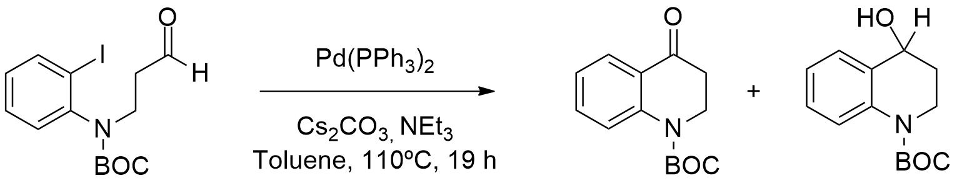
Scheme 3.33: Palladium-catalysed intramolecular arylation developed by Solé and co-workers.^{72 a)}

These authors showed the efficient cyclization of arylpalladium species onto o-iodoaryl aldehydes, where β-hydride elimination quickly (ΔG298 = 0,7 Kcal/mol) gives the ketone derivative (Figure 3.21). With specific additives, trace amounts of the corresponding alcohol were also observed.^{72 a)}

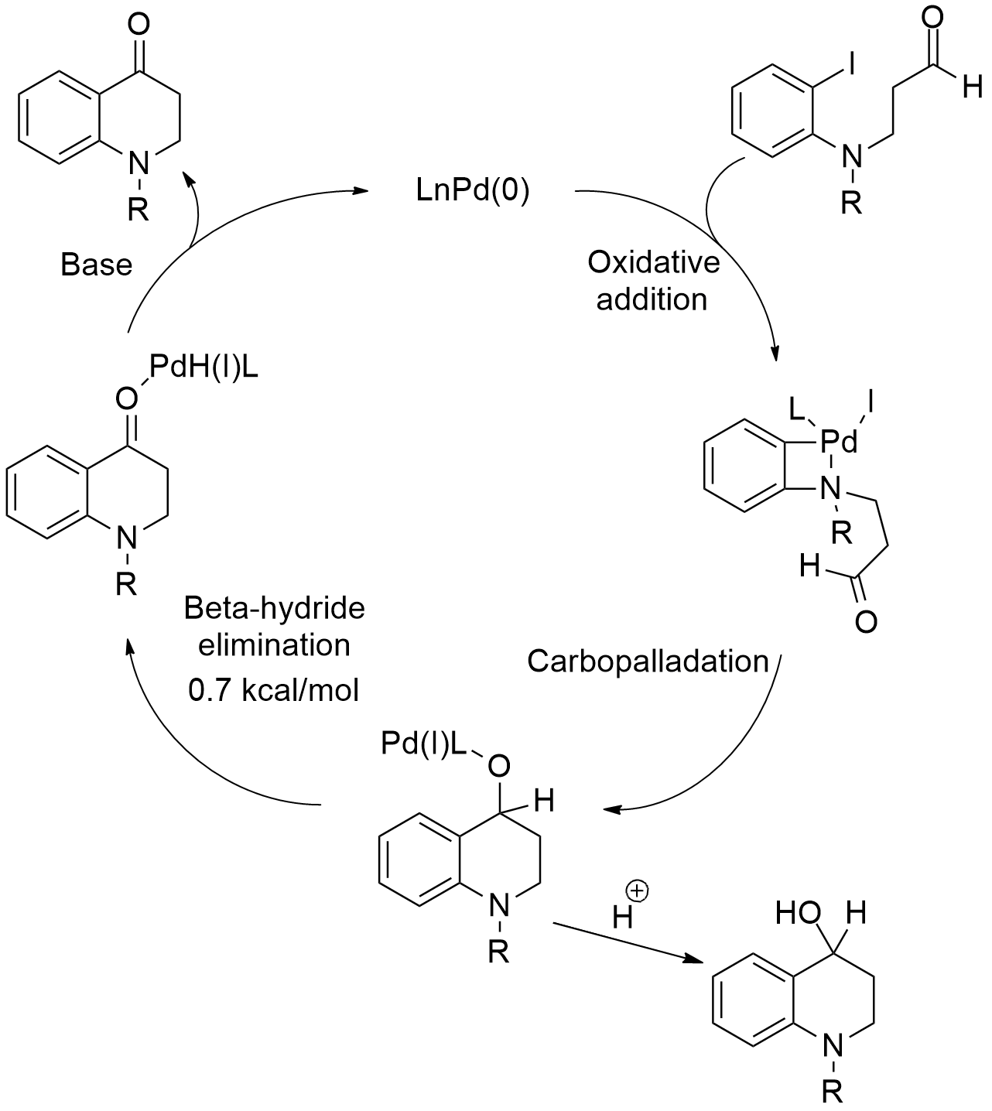
Figure 3.21: Proposed catalytic cycle for the palladium-catalysed intramolecular arylation by Solé et al.^{72 a)}

Additionally, Solé and co-workers reported the palladium-catalysed synthesis of isoquinolin-4-ols through intramolecular nucleophilic addition of aryl iodides to aldehydes.⁷³ In this work, they revealed two mechanistic scenarios for the intramolecular processes involved in the reactions (Figure 3.22):
- The first includes a carbopalladation of the arylpalladium(II) moiety across the C=O bond, followed by β-hydride elimination to afford the ketone and regenerate the Pd(0) catalyst (mechanism A);⁷³
- The second scenario describes a C-H bond activation (on the aldehyde C-H), loss of H-X from the resulting palladium(IV) intermediate and a subsequent reductive elimination from the acylpalladium complex, which would also form the ketone and regenerate the catalyst (mechanism B).⁷³

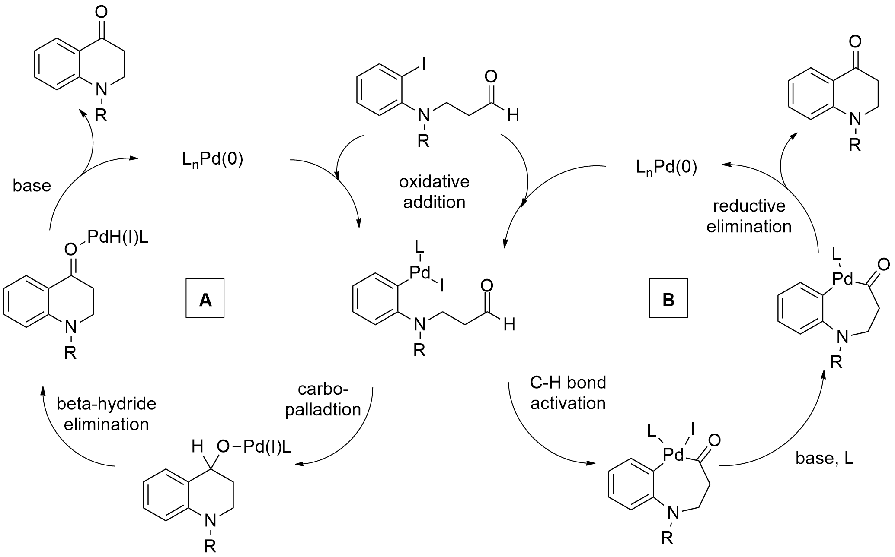
Figure 3.22: Solé´s proposed catalytic cycles for the intramolecular acylation of aryl halides with aldehydes.⁷³

Based on the DFT calculations performed by this group, they claimed that mechanism A is kinetically and thermodynamically favoured over mechanism B. They attributed this preference to the high nucleophilicity of the carbon directly bonded to the transition metal, because of the π-donor effect of the ortho-nitrogen atom.⁷³ The computational data from these studies also showed that the use of NEt₃ as the base was essential in the formation of isoquinolin-4-ols, as it suggests that the C-H activation process needs CO3₂⁻ to take place. Consequently, in the absence a carbonate counter ion, the reaction pathway switches from C-H activation to nucleophilic addition, turning the reaction into a catalytic coupling process, thus forming isoquinolin-4-ols.⁷³ Additionally, the DFT calculations showed a competition between the nucleophilic addition and the C-H bond activation processes, when Cs₂CO₃ was used the base.⁷³ However, when the base was changed to NEt₃, tetrahydroisoquinolin-4-ol was isolated in 97% yield. This confirms that the formation of tetrahydroisoquinolin-4-ol in the presence of NEt₃ originates from a nucleophilic addition reaction.⁷³ In contrast, the competition between a CO₃⁻² mediated concerted metallation-deprotonation process and nucleophilic addition to the carbonyl group were observed when using Cs₂CO₃, which eventually generated mixtures of the acylation product (i.e. tetrahydroisoquinolin-4-one) and stable tridentate [C,N,O] Pd(II) complexes.⁷³ While the tetrahydroisoquinolin-4-one derivative could be obtained through two different reaction pathways (Figure 3.22), the production of the tridentate [C,N,O] Pd(II) complexes could only be explained only by a bias towards a C-H bond activation process. In addition, the adventitious presence of O₂ in the reaction mixture allows the formation of these complexes, eventually diverting the metal from the productive cycle, thus leading to the synthesis of tetrahydroisoquinolin-4-one derivative. This feature can explain why the acylation reaction is not truly catalytic when using Cs₂CO₃, as the base.⁷³

3.3.6.3 Study on the direct intramolecular cyclization of (2-bromophenol)-aldehydes

Between other important remarks, Solé´s work indicated that with the addition of specific additives, trace amounts of the corresponding cycloalkanols could be obtained.⁷³ Considering this premise, we hypothesized that by controlling the electronics around the palladium species along with the addition of certain additives, we could fully divert the reaction pathway towards the formation of cycloalkanols.
Consequently, we started our study on the direct intramolecular cyclization of (2-bromophenol)-aldehydes using 3-(2-bromophenoxy)-2,2-dimethylpropan-1-ol (9a) as starting material.⁹⁸ We reacted compound (9a) and pinacolborane with PdCl₂(MeCN)₂ and KOAc, in dioxane, for several hours (Scheme 3.34), expecting that compound (9a) could undergo a one-pot borylation and subsequent cyclization.

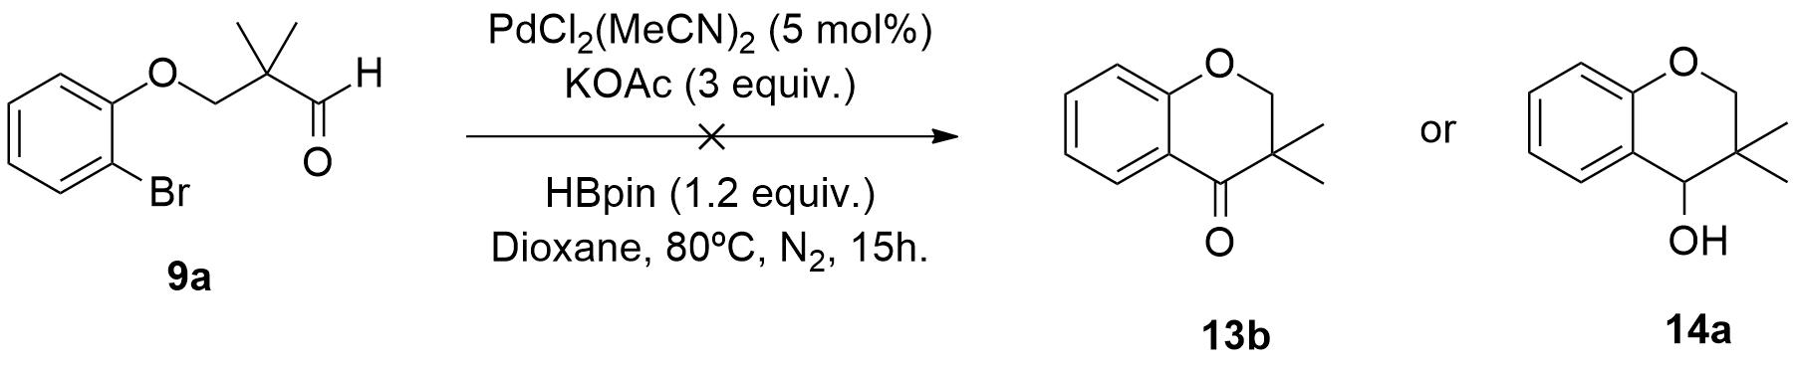
Scheme 3.34: Attempted one-pot borylation and cyclization of compound (9a).

However, upon analysis of the ¹H NMR spectrum of the reaction, we observed no traces of either the alcohol or the cyclic ketone. Instead, we observed the presence of the initial substrate (9a).
Alternatively, we changed the base from KOAc to tetrabutylammonium acetate (TBAAc) and increased the temperature from 80 ºC to 120 ºC (Solé´s work⁷³ included temperatures as high as 110 ºC), as these conditions provided us with the first trace amount of the ketone product (13b). At this point, we did not know if this result was a consequence of changing the base or the reaction temperature. In another reaction variation, we removed the pinacolborane from the reaction set-up, but unfortunately the results were the same as those obtained using the previous conditions (employing a borane additive). Moreover, we hypothesized that by adding specific additives like NEt₃ (reduces palladium(II) species to the active palladium(0) species) or a Lewis acid (augments the electrophilicity of the aldehyde carbon) we could enhance this reaction. Consequently, we added silver hexafluoroantimonate to the reaction, unfortunately no product was observed. In an additional variation, we added a ligand (PPh₃) to the reactional mixture. By employing this modification, we successfully managed to obtain, for the first time, both the cycloalkanol and the cyclized ketone, in about equal amounts (Scheme 3.35).

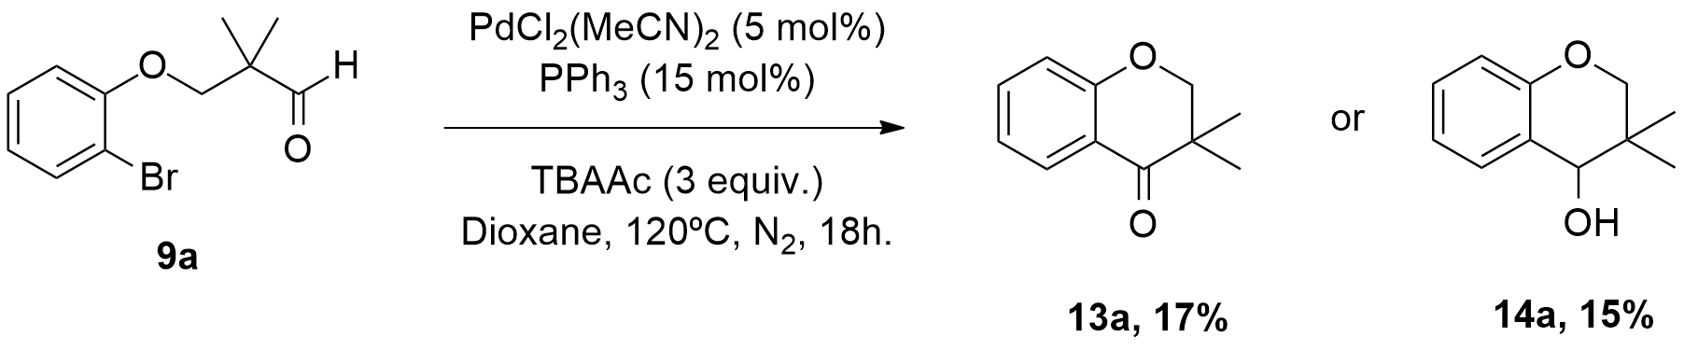
Scheme 3.35: First successful cyclization of compound (9a) to the correspondent cyclic ketone (13a) and the cycloalkanol (14a).

Observing that the presence of a ligand was crucial in this reaction, we tested other ligands to see how these modifications would affect the selectivity of the reaction. The results showed that the mixture of Pd(MeCN)₂Cl₂ and DPE-Phos represented the best catalyst-ligand combination to obtain the highest aldehyde cyclization.
In the next stage, we sought to improve the reaction yield. Consequently, employing the same conditions described in Scheme 3.35, but using DPE-Phos as the ligand and 1.2 equivalents of boron trifluoride diethyl etherate (BF₃OEt₂), the results showed a rise in the yield of the alcohol derivative (49 % yield measured through the addition of an internal standard, mesitylene). Likewise, the increment in the loading of the catalyst (loading was doubled) and the ligand (loading was doubled) helped increasing the yield of the alcohol derivative.
After these preliminary reactions, we conducted a screening of bases using compound (9a) in Pd(MeCN)₂Cl₂ and PPh₃, in dioxane, at 120ºC, for 18 hours (Scheme 3.36). The results of this screening are shown in Table 3.2.

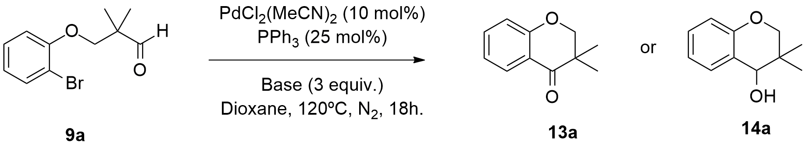
Scheme 3.36: General conditions for the base screening studies.

Table 3.2 Base screening studies

Entry | Base | Yield/% ^{(a)}
Entry | Base | Starting Material | Ketone | Alcohol
1 | KOAc | 68 | 10 | 22
2 | Cs₂CO₃ | 7 | 82 | 11
3 | TBAAc | 26 | 50 | 24
4 | NEt₃ | 100 | 0 | 0
5 | K₂CO₃ | 2 | 92 | 6
6 | DABCO | 94 | 2 | 4
7 | NaHCO₃ | 86 | 5 | 9
8 | Na₂CO₃ | 42 | 47 | 11
9 | NaOAc | 72 | 14 | 14
10 | DBU | 100 | 0 | 0
^{(a)} Determined by addition of an internal standard (mesitylene).

Table 3.2 shows that Cs₂CO₃ and K₂CO₃ can efficiently convert the starting material into the ketone product (Table 3.2, entries 2 and 5). Despite giving lower yields (compared to entries 2 and 5), TBAAc also showed to be an important additive for this transformation (Table 3.2, entry 3). While NaOAc exhibited no selectivity to any of the derivatives (Table 3.2, entry 9), the employment of either KOAc, DABCO or NaHCO₃ indicated an inversion in the selectivity, with formation of more alcohol derivative, even if in very low yields (Table 3.2, entries 1, 6 and 7). Finally, employing the organic bases NEt₃ or DBU led to no reactivity at all, since we could only detect starting material in the ¹H NMR spectra.
The next step was to evaluate the level of influence the ligand had on the selectivity of this reaction. Employing the same conditions used in the base screening studies and using K₂CO₃ as the base, a ligand screening study was made. Several ligands were tested and compared under the following headings: complexation, which were more favourable? Monodentate or bidentate ligands; in the case of the bidentate ligands, we examined the influence of the bite angle; was the Tolman angle or the chelate size of the bidentate-metal complex important?; was the electron density around the P atom important (Table 3.3)? The ligands used in these reactions are represented in Figure 3.23

Table 3.3 Ligand screening studies

Entry | Type of  Ligand | Ligand | Bite  Angle/ º | Yield/% ^{(a)}
Entry | Type of  Ligand |  |  | Starting Material | Ketone | Alcohol
1 | Monodentate | L1 | - | 60 | 12 | 2
2 | Monodentate | L2 | - | 89 | 0 | 0
3 | Monodentate | L3 | - | 7 | 77 | 0
4 | Monodentate | L4 | - | 5 | 85 | 0
5 | Monodentate | L5 | - | 66 | 12 | 0
6 | Monodentate | L6 | - | 28 | 30 | 14
7 | Bidentate | L7 | n.f. | 58 | 2 | 4
8 | Bidentate | L8 | n.f. | 62 | 4 | 8
9 | Bidentate | L9 | 84.7 | 82 | 0 | 0
10 | Bidentate | L10 | 91.56 | 52 | 4 | 18
11 | Bidentate | L11 | 82.55 | 69 | 0 | 0
12 | Bidentate | L12 | 100 | 72 | 8 | 8
13 | Bidentate | L13 | 101.46 | 4 | 63 | 27
14 | Bidentate | L14 | 104.64 | 72 | 18 | 6
15 | Bidentate | L15 | 92.77 | 50 | 3 | 4
16 | Bidentate | L16 | n.f. | 15 | 69 | 0
17 | Bidentate | L17 | 92.77 | 56 | 6 | 6
^{(a)} Determined by addition of an internal standard (mesitylene).
n.f. not found.

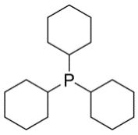
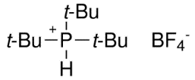
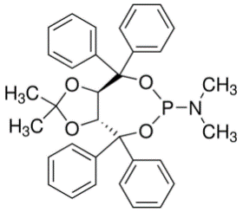
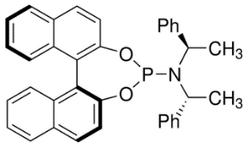
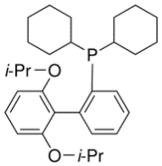
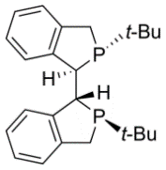
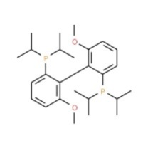
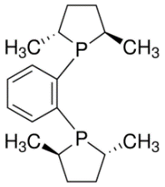
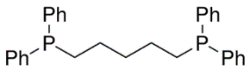
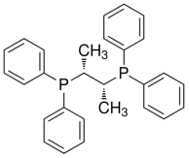
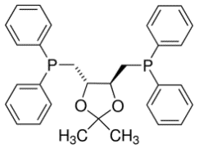
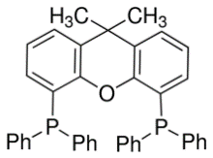
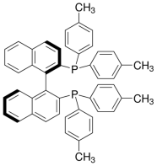
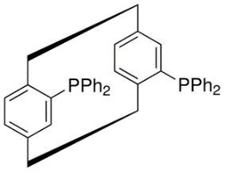
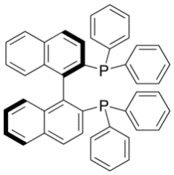
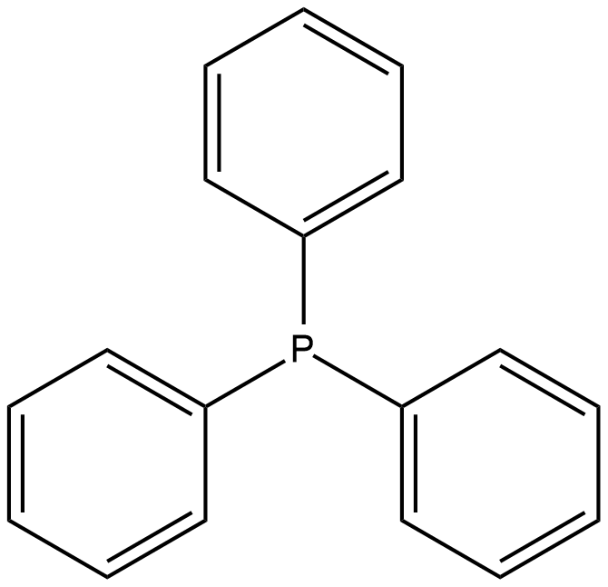
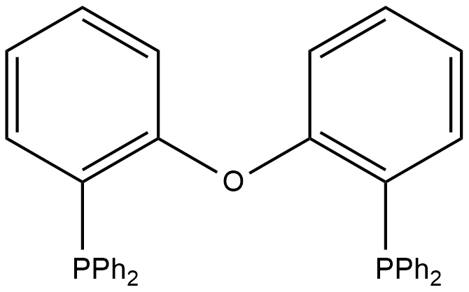
L1
L2
L3
L4
L5
L7
L8
L9
L10
L11
L12
L14
L15
L16
L17
L6
L13
Figure 3.23: Structure of the ligands used in this study.

The results show that both monodentate and bidentate ligands can efficiently convert our substrate into its corresponding cyclic ketone (for best results see Table 3.3, entries 4 and 16). Moreover, if we examined more closely these two classes of ligands, specifically, for the synthesis of the cyclic ketone product, in the case of the monodentate ligands, the O-P-N type ligands (L3 and L4) gave the best yields (Table 3.3, entries 3 and 4). Since L3 and L4 are phosfites and thus more electron poor than phosphanes, the employment of monodentate electron rich ligands in this reaction (specifically for the synthesis of the cyclic ketone derivative) isn´t the best choice. On the other hand, regarding the synthesis of the cycloalkanol derivative, the reactivity is generally very low and the better yields of this product were obtained employing a bidentate a ligand (i.e. DPE-Phos gave a yield of 27%) (Table 3.3, entry 13). Consequently, we can assume that while monodentate ligands push the reactivity of this system towards the cyclic ketone products, bidentate ligands drive this reaction towards the formation of the cycloalkanol product. It must be noted that the less rigid bidentate ligands (i.e. L10 and L13) gave the best yields of cycloalkanol product. The more flexible open-chain ligands (i.e. L10) gave virtually almost no cyclic ketone product (Table 3.3, entry 10). Regarding bidentate ligands and their respective bite angles, this feature doesn´t appear to significantly affect the reactivity of this system, as we did not observe any particular relationship between the ligand bite angles and the corresponding reaction yields (Table 3.3, entries 11, 13 and 14). The chelate sizes were of some importance and it were the big chelates (i.e. L12-L15, 7-, 8-, 8- and 7-membered chelate) that gave the best results, or at least some reaction conversion, whereas the small chelates gave poor results; in fact there was no conversion with either L9 or L11 (which would give 5-membered chelates (Table 3.3, entries 9 and 11).
It is commonly accepted that changing substituents on phosphorus ligands can produce significant changes in the behaviour of the free ligands and of their transition metal complexes. The Tolman cone angle or ligand cone angle is a measure of the size or volume of a ligand, which can be defined as the solid angle formed with the metal at the vertex and the hydrogen atoms at the perimeter of the cone.¹⁸² Both the steric and electronic nature of the P-donor ligands are important and ultimately the results obtained with the ligand are a balance between these two parameters. Considering this information, bulky monodentate or bidentate phosphines tend to show larger Tolman angles. Therefore, regarding the Tolman angles of monodentate ligands used in the synthesis of the cyclic ketone derivative, bulky ligands with larger Tolman angles (i.e. L3 and L4) are desirable (Table 3.3, entries 3 and 4). The same is applied to bidentate ligands (L13 and L16). On the other hand, in the case of bidentate ligands for the synthesis of cycloalkanol product, smaller ligands (L10 and L13) are preferable over ligands that exhibit larger Tolman angles (L12, L15 and L17).
It should also be noted that one of the reasons for using the chiral phosphorous-based ligands in this study was to obtain enantioenriched cycloalkanol product via an enantioselective cyclization. However, the enantiopurity of the cycloalkanol was not determined as the yields were low and the cycloalkanol was invariably obtained as a mixture with the ketone product. (See also Section 3.3.8) Using the conditions described in Scheme 3.36 and employing K₂CO₃ as the base we chose to conduct a temperature screening study, starting at 80 ºC and applying small temperature increments until 140 ºC. The result of this study is shown in Table 3.4.

Table 3.4 Temperature screening studies

Entry | Temperature  (ºC) | Yield/%^{(a)}
Entry | Temperature  (ºC) | Starting Material | Ketone | Alcohol
1 | 80 | 37 | 11 | 6
2 | 100 | 70 | 17 | 12
3 | 110 | 1 | 45 | 5
4 | 120 | 14 | 15 | 7
5 | 140 | 1 | 60 | 2
^{(a)} Determined by addition of an internal standard (mesitylene).

The results of this study were not very consistent and somewhat erratic. Considering selectivity and yield parameters, both 80 ºC and 120 ºC displayed similar effects (Table 3.4, entries 1 and 4). Applying either 110 ºC or 140 ºC provided the best results for substrate conversion into ketone derivative (Table 3.4, entries 3 and 5). Furthermore, a better conversion and ketone yield was obtained using 110 ºC, instead of 120 ºC (Table 3.4, entries 3 and 4). It was clear that the best temperature to obtain the highest yield of ketone was 140 ºC (Table 3.4, entry 5). In general, raising the temperature had no positive effect on the yield of the alcohol.
After this, a solvent screening study was conducted using different types of solvents, ranging from polar protic like MeOH, to polar aprotic like MeCN and DMF, to mildly polar aprotic solvents like 1,4-Dioxane and THF, to mildly polar protic solvent t-BuOH and finally the apolar aprotic like toluene. The conditions used are those described in Scheme 3.36 and the base of choice was K₂CO₃ (Table 3.5).

Table 3.5 Solvent screening studies

Entry | Nature of solvent | Solvent ^{(a)} | Yield/%^{(b)}
Entry | Nature of solvent | Solvent ^{(a)} | Starting Material | Ketone | Alcohol
1 | Polar  Aprotic | DMF | 6 | 1 | 2
2 | Polar  Aprotic | MeCN | 2 | 52 | 0
3 | Polar  Aprotic | THF | 23 | 0 | 0
4 | Polar  Aprotic | Toluene | 85 | 8 | 3
5 | Polar  Aprotic | Dioxane | 1 | 80 | 0
6 | Polar  Protic | t-BuOH | 9 | 50 | 8
7 | Polar  Protic | MeOH | 8 | 1 | 2

^{(a)} Solvents were dry through common laboratory procedures.
^{(b)} Determined by addition of an internal standard (mesitylene).

Table 3.5 shows that the best solvent for this reaction is dioxane (Table 3.5, entry 5). t-BuOH also provided a good yield of the ketone (Table 3.5, entry 6), as well as the polar aprotic solvent MeCN (Table 3.5, entry 2). The low mass balance obtained with both MeOH and DMF (Table 3.5, entries 1 and 7) deserves special attention. It seems that there was substrate degradation via an unknown reaction, which failed to afford either the alcohol or the ketone. Since the reaction work-up didn´t include washing with water, we can exclude the hypothesis that some of the products entered the aqueous phase. Instead, perhaps the silica gel may have degraded these compounds. In addition, both these polar chelating solvents are capable of complexing with the metal and thus modulating the catalyst, enabling a possible alternative degradative pathway. Due to the bulky nature of t-BuOH, together with its partial apolarity, this type of interaction does not occur. One important point to make is that due to the preference for the ketone product, we can assume that the β-hydride elimination (see above) takes place. This would seem to imply that these solvents facilitate this process.
3.3.6.4 Synthesis of 3,3-dimethylchroman-4-one and 3,3-dimethylchroman-4-ol derivatives

Some of the earlier reports regarding the synthesis of dimethylchroman-4-ones included the microwave-assisted synthesis of 2,2-dimethylchroman-4-ones from 5-alkyl-substituted resorcinols, the asymmetric synthesis of (S)-2,6-dimethylchroman-4-one by Hodgetts, the synthesis of fluorinated analogues of natural 2,2-dimethylchroman-4-ones and the synthesis of 2,3-dimethyl chroman-4-ones through Aldol/Mitsunobu reactions.
Since we discovered the best conditions to synthesize the 3,3-dimethylchroman-4-one (13a) (Scheme 3.36, using K₂CO₃ as the base) from the corresponding aldehyde derivative, we decided to evaluate the scope of the reaction, applying this methodology to some of our aldehyde derivatives synthesized previously (Figure 3.24). The conditions used for this reaction are shown in Scheme 3.37.

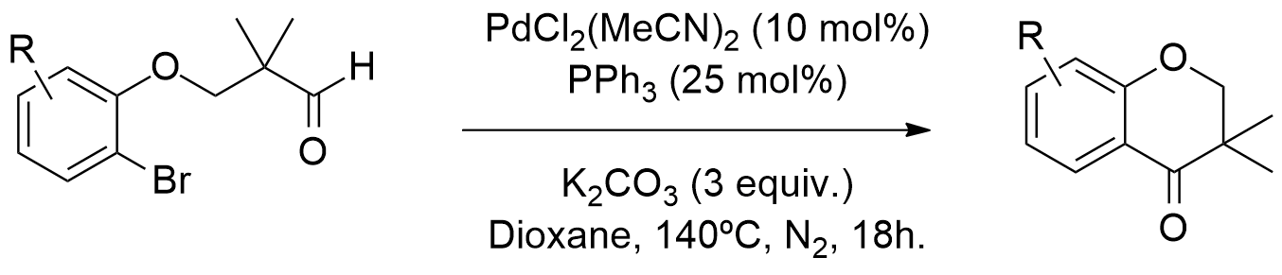
Scheme 3.37: Conditions employed for the synthesis of the cyclic ketone derivatives.

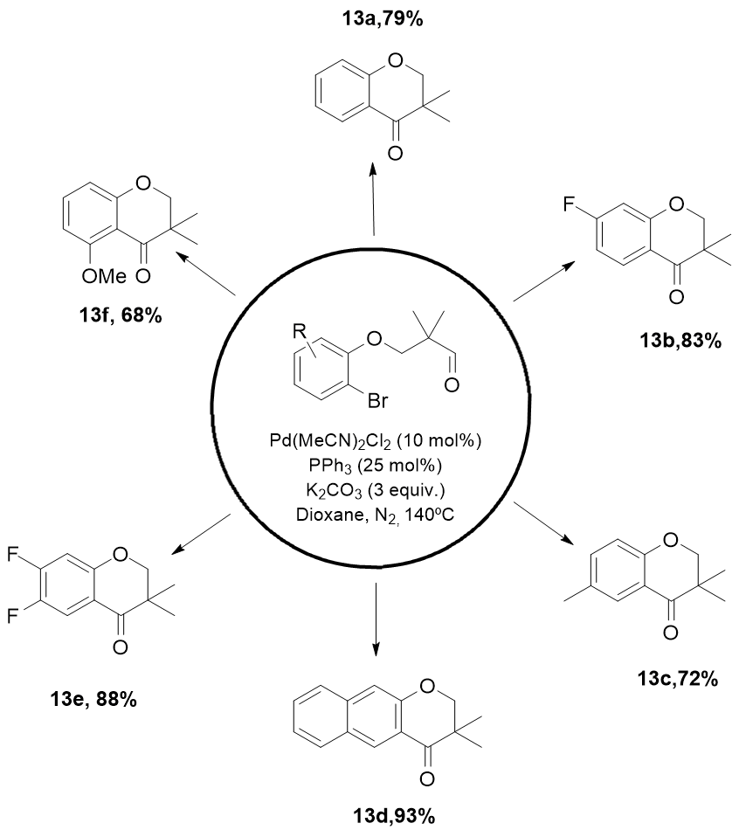
Figure 3.24: Synthesized 3,3-dimethylchroman-4-one derivatives (13a)-(13-f).

For this study, we tested six different aldehyde substrates. Results show that compared to non-substituted substrates, the presence of electron withdrawing groups (EWG) placed in the 7-position moderately favour this reaction (Figure 3.24 compound (13b)), as well as the presence of a fused-aromatic rings (Figure 3.24 compound (13d)). The presence of an electron donating group (EDG) in the 6-position doesn´t seem to significantly affect this reaction (Figure 3.24 compound (13c)), while the presence of a methoxyl group in the 5-position (Figure 3.24 compound (13f)) slightly decreased the yield of the reaction. One hypothesis to explain this result lays in the fact that the methoxyl group (a moderately bulky group) could sterically hinder the access of the palladium species to the substrate in the oxidative addition step (the most important step in the cycle). Consequently, this would slow down the formation of the organopalladium intermediate species required to start the catalytic cycle, thus lowering the yield of the reaction. Finally, when a 6,7-difluoro substituted aldehyde was employed, the yield of the reaction increased slightly (Figure 3.24, compound (13e)). This information seems to imply that both EWGs and fused-aromatic ring extensions possibly pull electron density from the carbonylic carbon, thus easing the complexation of the latter with the palladium species and accelerating the reaction.
In parallel with this work, we also studied the best conditions to synthesize the corresponding cycloalkanol derivatives. For this, we went back and examined our first results. We knew that by using conditions described in Scheme 3.35, we could obtain almost equal amounts of cycloalkanol and cyclic ketone derivatives. Comparing these conditions to the ones described in Scheme 3.37, we came to realize that the key strategy for the switch from the synthesis of cycloalkanols to cyclic ketones was the replacement of TBAAc with K₂CO₃ (since this base gave the best results for the synthesis of the alcohol derivative, Table 3.1 entry 3). It was also apparent from our previous studies (Table 3.3 entry 13; this ligand provided the best results for the synthesis of the alcohol derivative) that the presence of DPE-Phos, selectively provided the cycloalkanol product. By using the conditions shown in Scheme 3.38, we observed selective formation of compound (14a).

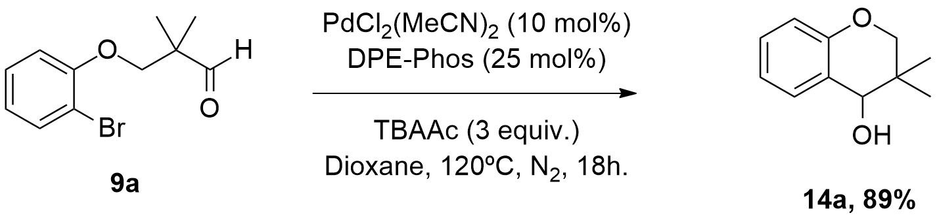
Scheme 3.38: Conditions used for the synthesis of the cycloalkanol (14a).

Once again and having discovered the best conditions to synthesize the 3,3-dimethylchroman-4-ol (14a), we sought to evaluate the scope of the reaction applying this procedure to some of our aldehyde substrates. We reacted six different aldehyde derivatives, using the conditions shown in Scheme 3.38 (Figure 3.25).

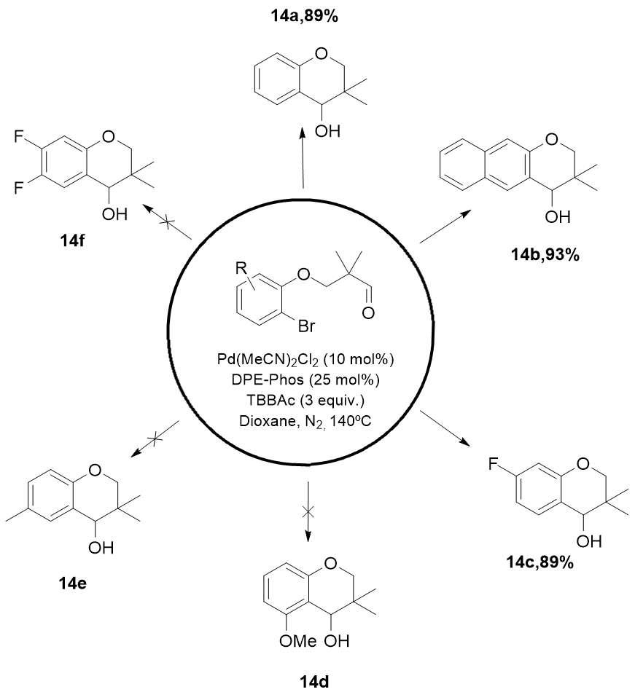
Figure 3.25: Synthesized 3,3-dimethylchroman-4-ol derivatives (14a)-(14c).

The results show that compared to non-substituted substrates, molecules bearing EWG´s placed in the 7-position do not affect this reaction, whereas the presence of a fused aromatic ring extension significantly increases the yield of this reaction (Figure 3.25, compounds (14c) and (14b), respectively). Both the presence of an EDG in the 5-position and the 6,7-difluoro substitutions favour the formation of the ketone product (Figure 3.25, compound (14d) and (14f)). With the employment of a substrate bearing a methyl group in the 6-position (Figure 3.25, compound (14e)) the reaction didn´t work, since we only detected substrate (9a) in the ¹H NMR spectrum of the crude mixture.
In addition, we tried both of these conditions on non-gem-dimethyl derivatives (i.e. compound (11a)), but no product was observed in any of these cases. By carefully monitoring the reaction via ¹H NMR, we observed hydrolysis of the starting material to the 2-bromophenol and 2-hydroxyacetaldehyde. We considered this outcome the result of not using completely anhydrous conditions, such as the presence of water in the base or in the solvent. For this reason, we dried K₂CO₃ under vacuum (with a pump for 24h) and used freshly distilled solvent. However, the results were the same and no cyclized product was obtained from these reactions. Consequently, it seems clear that the presence of the gem-dimethyl group is essential to avoid coordination of the ether alcohol to the palladium catalyst and subsequent formation of 2-bromophenol and 2-hydroxyacetaldehyde products.

3.3.7 Flow chemistry
3.3.7.1 Comparing batch and continuous flow systems

In the next step, we wanted to confirm if our previous catalytic intramolecular arylation studies performed in batch systems, could be successfully transferred to continuous flow systems. This work was done in collaboration with the group of Professor Peter H. Seeberger, at Max Planck Institute for Colloids and Interfaces, in Berlin, Germany. The first step was to assemble a very simple flow chemistry system, (Figure 3.26).

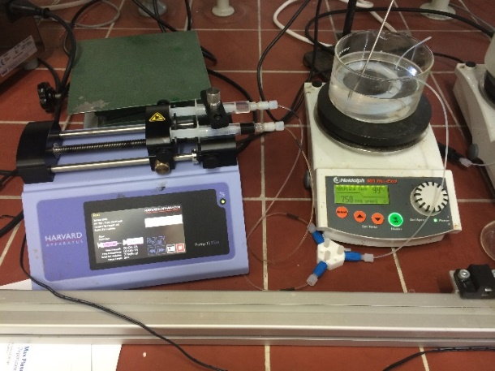
Figure 3.26: Flow chemistry setup used for our reactions.

Subsequently, we dissolved palladium catalyst, ligand (if necessary) and base in dry degassed solvent and loaded it into syringe A. Likewise, the substrate and the boron source were dissolved in the same solvent and loaded into syringe B. An IDEX T-mixer provided the necessary mixing of both solutions, present in syringes A and B and fed a 4mL reactor tube (dried under nitrogen and flushed with dry degassed solvent before use) immersed in an oil bath at pre-programmed temperatures. We added a 3 bar backpressure regulator (BPR) at the end of the reactor, to prevent solvent boiling (Figure 3.27).

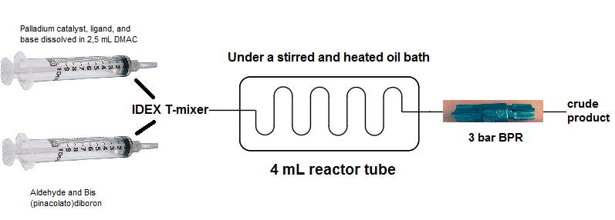
Figure 3.27: Representation of our flow reaction setup.

At the same time, we performed batch reactions using the same conditions, in order to compare the reactivity in both systems. We performed the reactions in batch using degassed and sealed microwave tubes. Furthermore, in some cases a mixture of solvents was employed in order to achieve acceptable reagent dissolution states.

3.3.7.2 Transfer to continuous flow systems

Before testing our substrates, we decided to carry out several model borylation reactions using continuous flow conditions with commercially available reagents. This was done with the objective of obtaining the best borylating conditions and subsequently adapt them to our substrates. Since we were only aiming at the presence or not of borylated product, no yields were calculated for these reactions.
The first model reaction using our continuous flow setup included the borylation of commercially available bromobenzene (15a) with B₂pin₂, using Pd(dppf)Cl₂ and TBAAc, at 100°C, with a residence time of 15 minutes (Scheme 3.39).

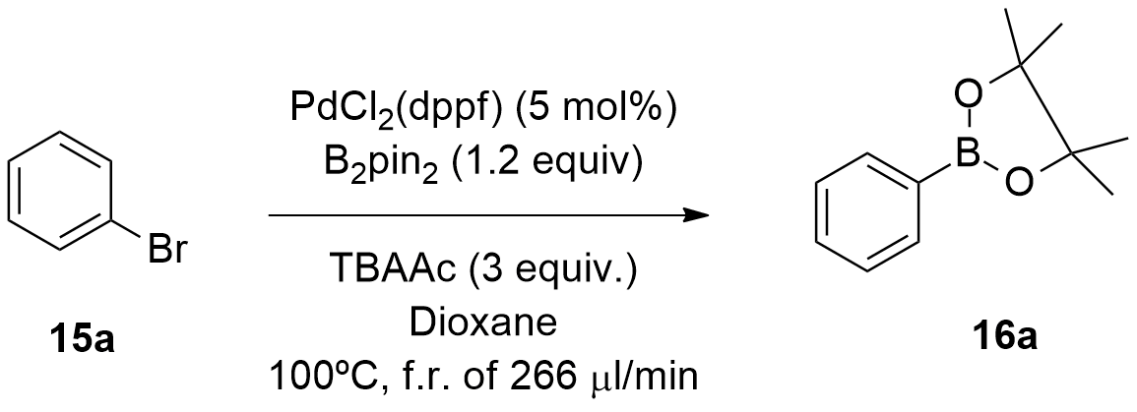
Scheme 3.39: Conditions employed for the borylation of bromobenzene under continuous-flow conditions.

After the work-up we detected compound (16a) in the ¹H NMR spectrum of the crude mixture. In the next step, the substrate was changed to 2-bromoanisole (15b) and another model reaction was conducted. We chose this substrate for its similarity with ours, particularly the presence of the ether oxygen. We discovered compound (15b) could be borylated with B₂pin₂, using Pd(MeCN₂)Cl₂ and TBAAc, at 100°C, with a residence time of 1 hour (Scheme 3.40).

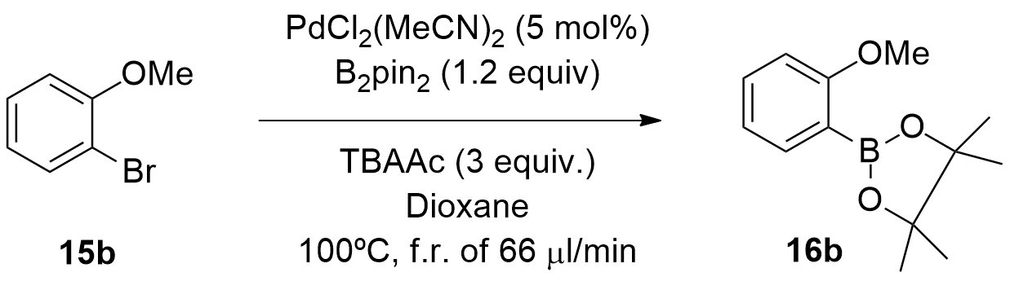
Scheme 3.40: Conditions employed for the borylation of 2-bromoanisole under continuous-flow conditions.

Likewise, we successfully managed to borylate substrate (15a) using this set of conditions. After these preliminary model reactions, we attempted the borylation of compound (9a). In order to optimize this reaction in flow, after several reactions were conducted (mostly in batch) (Table 3.6), we discovered that using the conditions shown in Scheme 3.41 we could obtain the cycloalkanol product (14a), as it was observed in the ¹H NMR spectrum of the crude mixture. Additionally, we observed the presence of substrate (15b). Unfortunately, in this particular case the yield of the reaction was not calculated.

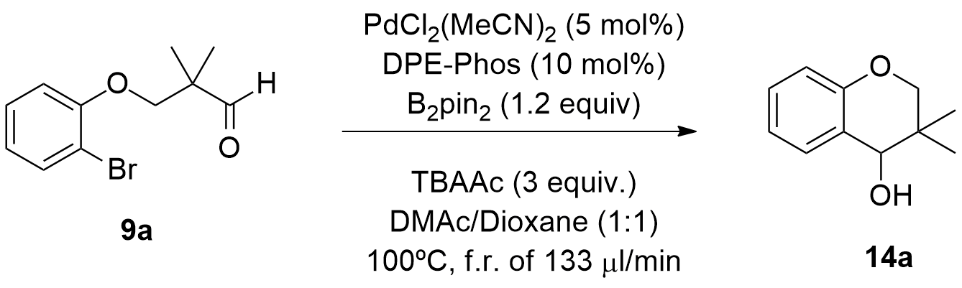
Scheme 3.41: First successful transformation of (9a) into its correspondent cycloalkanol (14a) employing continuous flow conditions.

Despite using a boron source as a reagent (Scheme 3.41), we did not isolate any of the borylated intermediate and no evidence of its presence was detected in the ¹H NMR spectra of the reactions. Therefore, we hypothesized that the B₂pin₂ was behaving as a Lewis acid (L.A.), thus activating the system. The presence of a carbonyl group in our substrate would suggest that the oxygen could datively bond to B₂pin₂, therefore activating the carbon for nucleophilic attack.

Table 3.6 Results (batch and flow) for the catalytic intramolecular arylation of compound (9a).

Entry | Pd source  (mol %) | Ligand  (mol %) | Additives  (equiv.) | Yield/%^{(a)}
Entry | Pd source  (mol %) |  |  | Starting Material | Ketone | Alcohol
1ª | Pd(dppf)Cl₂ (5) | - | - | 84 | 12 | 4
2 | Pd(dppf)Cl₂ (5) | - | - | - | 20 | 5
3 | Pd(MeCN)₂Cl₂ (5) | DPE-Phos (15) | - | 21 | 14 | 29
4 | Pd(MeCN)₂Cl₂ (5) | PPh₃ (15) | - | 36 | 17 | 7
5 | Pd(MeCN)₂Cl₂ (5) | XantPhos (15) | - | 50 | 12 | 17
6 | Pd(MeCN)₂Cl₂ (5) | XPhos (15) | - | 39 | 20 | 27
7 | PdCl₂(PPh₃)₂ (5) | - | - | 46 | 23 | 3
8ª | Pd(dppf)Cl₂ (5) | - | - | 23 | 2 | 13
9 | Pd(dppf)Cl₂ (5) | - | BF_{3.}OEt₂ (1,2) | 0 | 0 | 8
10 | Pd(MeCN)₂Cl₂ (10) | DPE-Phos (25) | BF_{3.}OEt₂/NEt₃ (1,2/2) | 19 | 14 | 54
11^{b} | Pd(MeCN)₂Cl₂ (10) | DPE-Phos (25) | BF_{3.}OEt₂/NEt₃ (1,2/2) | 9 | 10 | 11
12^{b, c} | Pd(MeCN)₂Cl₂ (10) | DPE-Phos (25) | BF_{3.}OEt₂/NEt₃ (1,2/2) | 10 | 15 | 4
13^{b} | Pd(MeCN)₂Cl₂ (10) | DPE-Phos (25) | BF_{3.}OEt₂/NEt₃ (1,2/2) | 4 | 6 | 40
14^{d,e} | Pd(MeCN)₂Cl₂ (10) | DPE-Phos (25) | BF_{3.}OEt₂/NEt₃ (1,2/2) | 8 | 6 | 4
15^{f} | Pd(MeCN)₂Cl₂ (10) | DPE-Phos (25) | BF_{3.}OEt₂/NEt₃ (1,2/2) | 0 | 6 | 56
16^{d,f} | Pd(MeCN)₂Cl₂ (10) | DPE-Phos (25) | BF_{3.}OEt₂/NEt₃ (1,2/2) | 34 | 4 | 0
^{(a)} Use of a borane source; ^{(b)} Reaction in DMAc; ^{(c)} Temperature at 140 °C; ^{(d)} Flow reaction; ^{(e)} Mixture of solvents, dioxane: DMAc (1: 1); ^{(f)} Reaction in DMF.

The first time we observed alcohol formation in our crude mixture, was using Pd(MeCN)₂Cl₂ with DPE-Phos (Table 3.6, entry 3). After this, we tried using different ligands with the same palladium source (Table 3.6, entries 4 to 6). The results show that using DPE-Phos (Table 3.6, entry 3) represented the best palladium-ligand combination for obtaining the highest alcohol conversion (ratio of aldehyde: ketone: alcohol of 21:14:29). Between all these ligands, PPh₃ showed to have the highest selectivity for ketone formation (Table 3.6, entry 4) (ratio of ketone: alcohol of 17:7). Later, we tried two different palladium sources, (PdCl₂(PPh₃)₂ and Pd(dppf)Cl₂) (Table 3.6, entries 7 and 8) and found that PdCl₂(PPh₃)₂ was a less promising palladium source for obtaining the cyclized alcohol derivative (ratio of ketone: alcohol of 23:3). Table 3.6, entries 2 and 8 were performed using Pd(dppf)Cl₂ as the catalyst, in the absence and presence of a boron source (B₂pin₂), respectively. While the recovered yield of substrate was low, we observed almost exclusive formation of the cycloalkanol derivative. This indicated that the presence of boron is important for selectively obtaining the alcohol derivative. It wasn´t clear if the B₂pin₂ was participating directly in the cycle, as a borylating agent or acting as a L.A. (inhibiting β-hydride elimination from the putative palladium-alkoxy intermediate).
In order to get some insight on the possibility of L.A. activation, we examined the effect of the latter on the outcome of the reaction (Table 3.6, entry 9). Using Pd(dppf)Cl₂ and BF₃.OEt₂ we obtained no ketone or starting material and although the mass balance was low, it indicated that the borane was probably serving as a L.A. (improving the electrophilicity of the aldehyde), thus diverting the reaction pathway away from β-hydride elimination to yield the corresponding benzylic cycloalkanol.
In addition, we observed that a higher ratio of cycloalkanol to cyclic ketone was obtained on increasing the electron-donating ability of the ligand. The presence of a L.A., as well as NEt₃ also favour cycloalkanol formation, with BF₃.OEt₂ (1.2 equiv.) and NEt₃ (2 equiv.) giving the best results (i.e. a ratio of cycloalkanol: ketone of 4:1) (Table 3.6, entry 10). Curiously, when comparing the results between Table 3.6 - entries 10 and 14, one can quickly observe that changing from batch to continuous flow systems results in a drop in the regioselectivity and in the overall yields. This outcome might be attributed to the fact that we used a mixture of solvents. Finally, employing DMF as solvent provided the best yield for the cycloalkanol product (56%), (Table 3.6, entry 15).

3.3.8 Obtaining enantioenriched cycloalkanol derivatives-asymmetric catalysis

As described previously, over the last number of years, transition-metal catalysed reactions have played an important role in asymmetric organic synthesis, by providing easy, selective, feasible and ecologically friendly processes to produce a wide variety of organic products. The formation of enantiomerically pure compounds is particularly desirable, particularly in the context of the synthesis of complex molecules of biological and industrial interest. The importance of this area is reflected in the attribution of the Nobel Prize in chemistry, in 2001, to Sharpless, Noyori and Knowles for their work on asymmetric oxidations and hydrogenations.
Enantiomerically pure compounds are particularly important in fields, such as pharmacy, medicine, nutrition or materials with optical properties, among others. Between the different approaches to acquire enantiomerically chiral molecules, asymmetric catalysis is perhaps the most stimulating, simply by the fact that one single chiral molecule is able to transfer its chiral information to thousands or even millions of prochiral or chiral substrate molecules. This molecule of course is the chiral catalyst. It is an enantiopure organic compound, which can consist of the combination of a metal center chelated with a chiral ligand or as a wholly organic molecule (an organocatalyst). This asymmetric catalyst participates in the chemical reaction, transferring its chirality to the substrate to form the reaction product. Theoretically, one mole of catalyst can turn over many more moles of reactant, consequently, allowing the synthesis of significant amounts of the chiral product, generally from achiral substrates.
One of the objectives in this work was to synthesize enantiomerically pure or enriched analogues of rasagiline. For this purpose, we examined two different approaches:
- The first approach involved the use of chiral catalysts to impart asymmetric induction during the cyclization step. This was to be achieved via the addition of chiral phosphane ligands to form the chiral catalyst with the pre-catalyst, in situ;
- The second approach involved the application of the Corey-Bakshi-Shibata (CBS) asymmetric catalytic reduction reaction to our 3,3-dimethylchroman-4-ones to afford chiral 3,3-dimethylchroman-4-ols.

3.3.8.1 The first approach: in situ formation of the metal based chiral catalyst

We applied this methodology to our system and conducted a number of studies involving many different chiral ligands (Scheme 3.42).

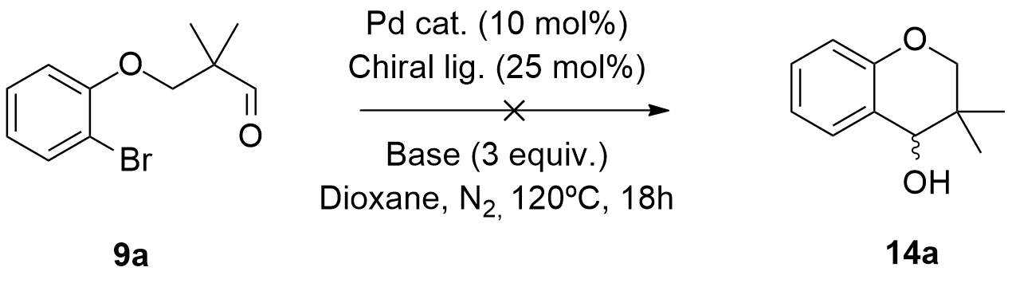
Scheme 3.42: Attempted synthesis of the chiral cyclic alkanol (14a).

Despite our best efforts, all the reactions carried out with the objective of transforming the racemic aldehyde precursors into their enantioenriched (or pure) 3,3-dimethylchroman-4-ol derivatives failed. Reactions where this type of chiral catalysts were used showed very little or no reactivity at all, since we could only see both starting material or very small traces of the reaction product in their corresponding ¹H NMR spectra (see above Table 3.3 in section 3.2.6.3, reactions using chiral ligands). We then turned to the second strategy.

3.3.8.2 Application of the Corey-Bakshi-Shibata (CBS) asymmetric reduction

In 1981, Itsuno and co-workers first described the employment of chiral alkoxy-amine-borane complexes to enantioselectively reduce achiral ketones into their corresponding chiral alcohols, in high yield. In 1987, E. J. Corey and co-workers reported the preparation of oxazaborolidines by reacting chiral amino alcohols and borane (BH₃). These compounds demonstrated to catalyse the enantioselective reduction of achiral ketones in the presence of BH₃., This procedure, now known as the Corey-Bakshi-Shibata (CBS) reduction or the Corey-Itsuno reduction, includes a reaction in which an achiral ketone is enantioselectively reduced to give the corresponding chiral alcohol. It displays excellent enantioselectivity, high chemical yield, high catalytic turnover of the catalyst and exceptional rate enhancement. Furthermore, it was proposed that this reduction undergoes a catalytic cycle that includes four main steps:
- The coordination of the nitrogen atom of the Lewis base to the borane;
- The complexation of the ketone to the endocyclic boron (functioning as a L.A.) via the Lewis acid-base interaction;
- The hydride transfer from borane to the carbonyl carbon;
- The dissociation of the alkoxyborane moiety and regeneration of the catalyst.
It was established that up to two of the three hydrides of the borane could be transferred for reduction (Figure 3.29).
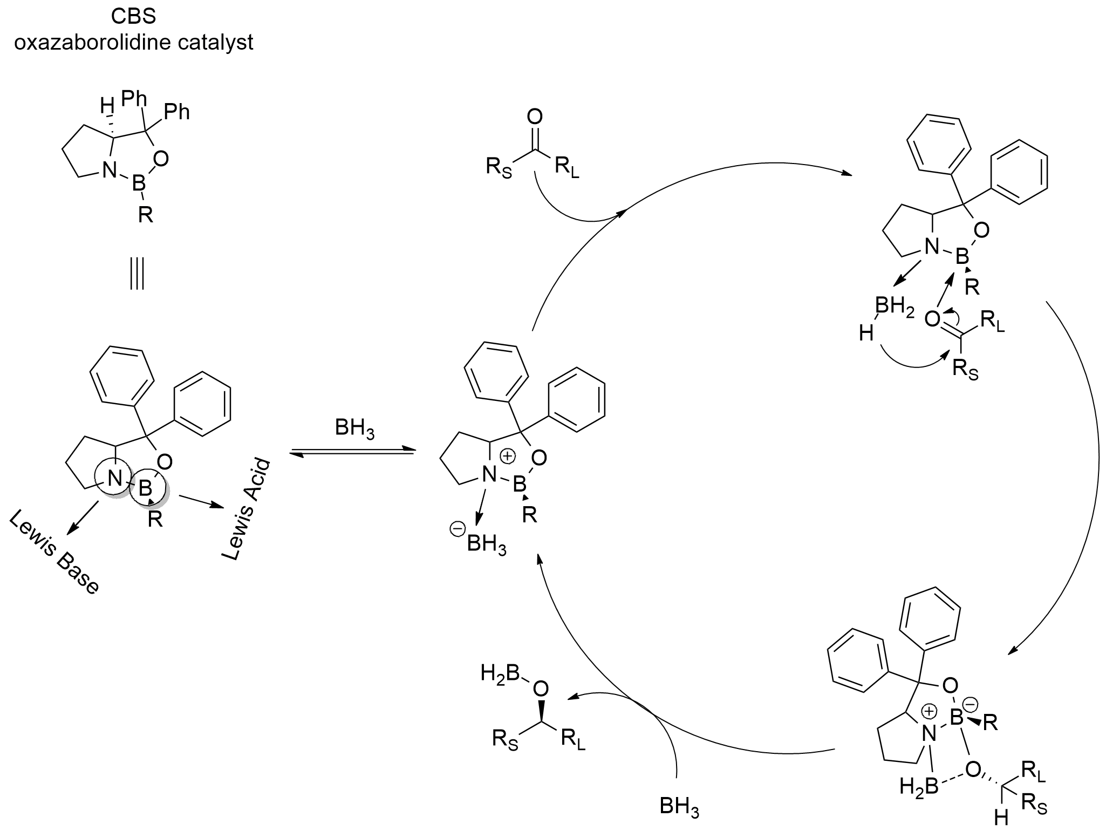
Figure 3.29: The generally accepted Corey-Bakshi-Shibata (CBS) reduction mechanism.¹⁹⁴

In order to obtain chiral 3,3-dimethylchroman-4-ols, we investigated two different CBS protocols. The first protocol included the reaction of a solution of compound (13a) in THF with a BH₃-THF complex and (R)-(+)-2-Methyl-CBS-oxazaborolidine, at 0 ºC, for 3h (Scheme 3.43).
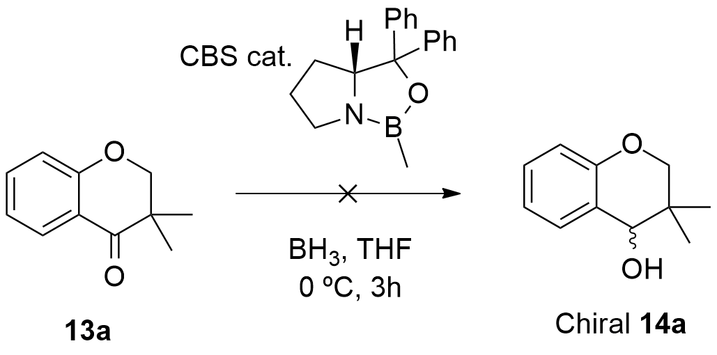
Scheme 3.43: First attempted reduction of cyclic ketone (13a) using CBS reagent.

We found no traces of chiral (14a) in the ¹H NMR spectra of the crude mixture. Subsequent purification of the reaction mixture provided only compound (13a). The second protocol consisted in the reaction of a 1.0 M toluene solution of (R)-(+)-2-Methyl-CBS-oxazaborolidine with a THF solution of compound (13a) and a 1.0 M THF solution of BH₃-THF complex, at room temperature, for 4h (Scheme 3.44).
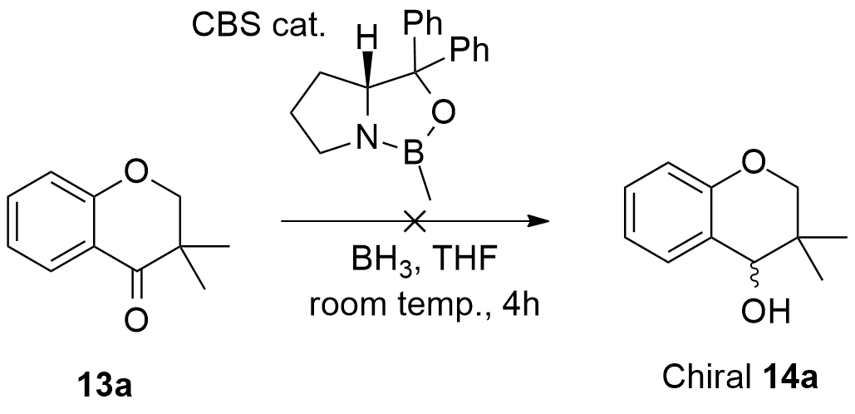
Scheme 3.44: Second attempted reduction of cyclic ketone (13a) with CBS reagent.

After the work-up, we found no traces of (14a) or other byproducts in the ¹H NMR spectrum of the crude mixture. Moreover, after purification of the crude mixture, we observed that the reaction did not work as expected, since substrate (13a) was the only isolated compound. In 1999, Gerlach and co-workers reported the asymmetric synthesis of 4-amino-3,4-dihydro-2,2-dimethyl-2H-1-benzopyrans. One of the synthetic steps encompassed in their methodology, involved the asymmetric reduction of 3,4.dihydro-2,2-dimethyl-2H-1-benzopyran-4-ones using the CBS protocol. Despite employing different conditions, the main difference in this reaction lays in the fact that in their substrate the gem-dimethyl group is placed further away from the carbonyl group, than was the case in our system.
After a careful analysis of the CBS reduction mechanism represented in Figure 3.29, we can provide some probable causes for the failure of these reactions. The first could be steric hindrance, since the structure of our substrate could complicate the approach of chiral oxazaborolidine catalyst to the reaction center, specifically, due to the presence of the gem-dimethyl group in the α-position. In the mechanism, the endocyclic boron of the CBS catalyst coordinates to the cyclic ketone (specifically the carbonyl) at the sterically more accessible electron lone pair (i.e. the lone pair closer to the least hindered substituent). This preferential binding acts to minimize the steric interactions between the ketone and the methyl group (of the CBS catalyst) and aligns the carbonyl and the coordinated borane for a favorable and face-selective hydride transfer through a six-membered transition state. The presence of the gem-dimethyl group (near the carbonyl group) can probably inhibit the coordination of the carbonyl group of the substrate, to the oxazaborolidine. Since, in Gerlach´s substrates, the gem-dimethyl group was placed further away from the carbonyl, this issue was not present in their synthesis.
Moreover, 2 oxygens are present in our substrate. Both of these oxygens are capable of coordinating to the CBS catalyst. The presence of the bulky gem-dimethyl group near the carbonyl group could alternatively drive the coordination of the CBS reagent to the ether oxygen. This would culminate in the degradation of the catalyst and ultimately stop the reaction.

3.3.9 Biological assays
3.3.9.1 Preliminary AChE and BuChE inhibition assays

Due to the general large-spectrum biological activity demonstrated by chromanols and chromanones, some of our 3,3-dimethylchroman-4-one and 3,3-dimethylchroman-4-ol derivatives were assayed for both acetylcholinesterase (AChE) and butyrylcholinesterase (BuChE) inhibition. Patricia Bacalhau, from the laboratory of Prof. Rosário Martins and Prof. Ana Teresa Caldeira, Chemistry Department, University of Évora, as part of the INMOLFARM project of Prof. Burke, conducted this work.
These two enzymes (AChE and BuChE) are responsible for the degradation of acetylcholine; consequently, drugs that target their inhibition are important for symptomatic treatment of Alzheimer´s disease (AD).
Acetylcholine (ACh) is a molecule that participates in the neurotransmission process, at the synapses of the central nervous system, thus controlling and affecting the learning and memory processes. The human body synthesizes this molecule by the reacting choline with acetyl coenzyme-A; choline acetyltransferase (ChAT) is responsible for its catalysis.
Patients suffering from ACh deficiency tend to exhibit uncontrolled muscle movement, as well as memory loss. Nevertheless, degeneration of the cholinergic neurons is not enough to cause AD; nonetheless, it plays a critical part in the exhibition of several clinical symptoms, including a significant deficit in the perceptive and cognitive processes. Recognising the importance of Ach for maintaining a healthy central nervous system, one can quickly deduce the enormous value of inhibiting both AChE and BuChE, consequently increasing the availability of Ach at synapses and providing a tool against the symptoms associated with this disease.
Considering this, we investigated on the possibility that our synthesized 3,3-dimethylchroman-4-ones and 3,3-dimethylchroman-4-ols could effectively inhibit AChE, BuChE or even both. Table 3.7 shows the results of the inhibition assays of several 3,3-dimethylchroman-4-ones and 3,3-dimethylchroman-4-ols (Figure 3.29) tested against AChE and BuChE enzymes. Due to its structural similarity with our compounds, Donepezil (Figure 3.30), a potent acetylcholinesterase inhibitor that is prescribed for the treatment of Alzheimer’s disease, was used as a standard.
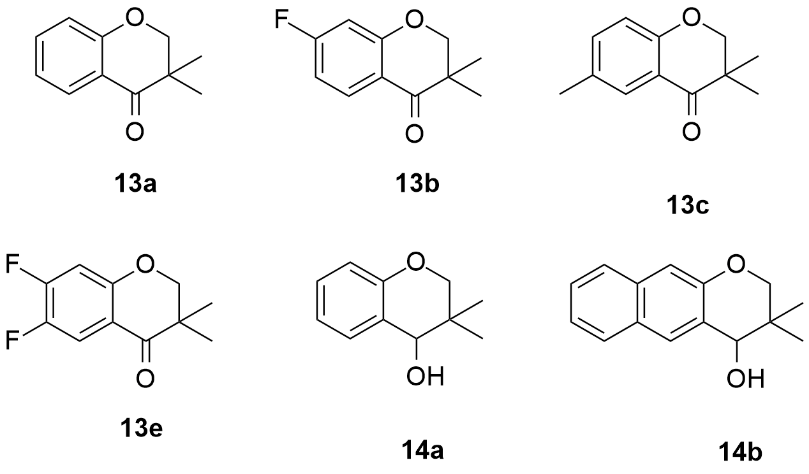
Figure 3.29: Compounds tested against AChE and BuChE.

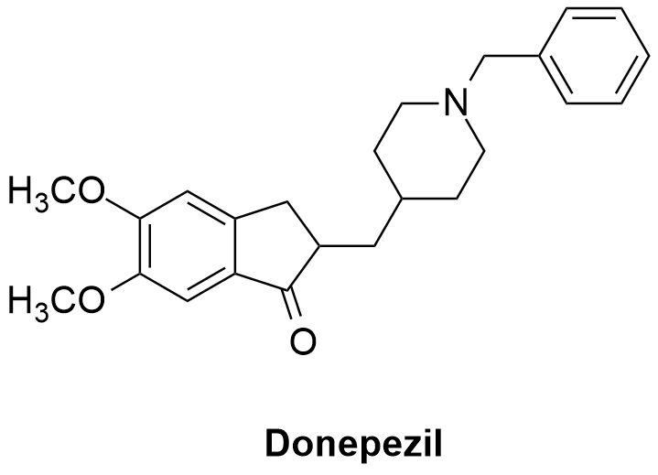
Figure 3.30: Structure of Donepezil.

Table 3.7 Inhibition assays against AChE and BuChE

Entry | Compound | MW | IC50 AChE (μM) | IC50 BuChE (μM)
1 | 13a | 176.21 | 692.6 ± 22.0 | 123.3 ± 6.1
2 | 13b | 194.20 | 100.0 | 12.0
3 | 13c | 190.24 | 380.0 | >1500
4 | 13e | 212.19 | 215.14 ± 10.4 | 249.0 ± 17.8
5 | 14a | 178.23 | 181.6 ± 10.1 | 147.0 ± 10.1
6 | 14b | 228.29 | >1500 | 874.9 ± 84.7
Standard  (Donepezil) | - | 379.48 | 14.3 ± 0.1 | 107.2 ± 6.5

Comparing both chroman-4-ones (Table 3.7, entry 1) and chroman-4-ols (Table 3.7, entry 5), we can observe that whilst the chroman-4-ols show no selectivity towards any of the enzymes, the chroman-4-ones show more affinity towards BuChE. Nonetheless, with the exception of compound (13b) (very high activity towards BuChE), none of the compounds show any significant inhibition of either AChE or BuChE, and their activities were lower than the benchmark, Donepezil. The results also show that regarding chroman-4-ones activity towards AChE, the presence of substituents in the aromatic ring generally provides an increased interaction with the enzyme. Amongst the tested substituents, the presence of EWGs in the 5-position seems to favour their activity against AChE, as well as BuChE (Table 3.7, entry 2). Even though the presence of an EDG in the 4-position seems to favour the interaction with AChE, the same is not observed for BuChE (Table 3.7, entry 3). Of course, this will be undoubtedly to the structural differences of the active sites of both enzymes. In the same way, the presence of an extra aromatic ring fused to the chromane benzene, as in compound (10b), seems to have no beneficial effect on the inhibitory activity of both AChE and BuChE. Whilst in case of the ketone derivative (13b), the presence of EWG´s in the 5-position favours the interaction with both enzymes, the presence of a second EWG in the 4-position leads to a loss of activity (Table 3.7, entry 4).
After examining these results, we came to conclusion that compound (13b) showed the best inhibition results towards both enzymes. Consequently, this compound seems to be a good hit, which might be used in further studies, in an attempt to obtain interesting lead compounds.

  - 3.4 Conclusions

In this chapter, we discussed a new intramolecular reaction with the objective of obtaining a plethora of structures based on the Rasagiline core.
Numerous strategies were studied, including etherifications (to give 29 compounds), alcohol oxidations with PCC (to give eight compounds), the adapted Williamson synthesis of ethers (to give eleven compounds), the Lemieux-Johnson Oxidation method (to give seven compounds). We also investigated several different borylation methodologies and conditions, but none of them provided us with the desired borylated products.
Concerning the cyclization reactions, various studies were carried out using different substrates, catalyst-ligand systems, base, temperature and solvent studies. After this, the best conditions were used to synthesize 3,3-dimethylchroman-4-ones (6 compounds) and 3,3-dimethylchroman-4-ols (six compounds). Furthermore, we tried to transfer these conditions from batch to continuous flow systems but without much success.
We also attempted the synthesis of the enantioenriched versions of these cycloalkanol derivatives using: 1) chiral palladium catalysts to impart asymmetric induction during the cyclization of the aldehyde substrates; 2) with the application of the Corey-Bakshi-Shibata (CBS) asymmetric catalytic reduction reaction on our 3,3-dimethylchroman-4-ones to afford chiral 3,3-dimethylchroman-4-ols. However, none of these methods provided us with the desired enantioenriched 3,3-dimethylchroman-4-ols.
Finally, some of our 3,3-dimethylchroman-4-ones and 3,3-dimethylchroman-4-ols were tested against AChE and BuChE enzymes. We observed that compound (13b) efficiently inhibits BuChE activity and could ultimately be used as hit compound for the development of interesting lead compounds.

  - 3.5 Experimental section
3.5.1 General observations
3.5.1.1 Reagents and solvents

All the commercially available starting materials used in this work were purchased from Sigma-Aldrich, Fluka, Acros or Alfa Aeser.
Solvents used in this work were dried and purified under inert atmosphere and subjected to common laboratory purification techniques, including:
- Dichloromethane (DCM) was distilled over CaH₂;
- N,N-Dimethylformamide (DMF) was distilled over MgSO₄ under reduced pressure at 60 ºC;
- Methanol was distilled over CaH₂;
- t-BuOH was distilled over CaH₂;
- THF was distilled over sodium and benzophenone;
- Toluene was distilled over LiAlH₄;
- NEt₃ was distilled LiAlH₄;
- MeCN was distilled over CaH₂;
- DMSO was dried over MgSO₄ under reduced pressure at 70 ºC;
- 1,4-Dioxane was distilled over sodium and benzophenone.

3.5.1.2 Detection, purification and characterisation of the synthesized compounds

All the reactions were followed by thin layer chromatography (TLC). The plates (Merck) were revealed by either using UV light or a solution of phosphomolybdic acid in ethanol.
Column chromatography was carried out on silica gel (SDS, 70-200 μm). All the eluents are described for each specific compound.
Some of the NMR analysis was made in the Faculdade de Ciências e Tecnologia/Universidade Nova de Lisboa, on a Bruker Avance Instrument (400 MHz), using CDCl₃ and DMSO-d₆ as solvents. Most of the NMR analysis was made at Universidade de Évora, Centro de Química, using a Bruker Avance Instrument III (400 MHz). Mesitylene was used as the internal standard to calculate NMR yields. All ¹H and ¹³C chemical shifts are reported in ppm and are referenced against the deuterated solvent peak.
Mass spectra were obtained from C.A.C.T.I., at Universidade de Vigo, on a Waters-Micromass (MicroTOF, ESI) or FAB Focus (Bruker Daltonics), using the TOF technique.
Everytime inert atmosphere was needed, it was described in the procedure.

3.5.2 Synthesis of arylethers via phenol etherification
3.5.2.1 General procedure

The various substituted 2-bromophenols or 1-bromonaphthalen-2-ol (5a) or 3-bromonaphthalen-2-ol (5b) or 2-bromo-3-pyridol (7a) or 7-bromo-8-hydroxyquinoline (7b) were added to a round bottom flask and dissolved in DMF. Next, 6 equivalents of K₂CO₃ were added to the solution. The mixture was left stirring for 20 minutes, at 60ºC. After this, 1.2 equivalents of the aliphatic alcohol reagent were added to the mixture and the temperature was raised to 120ºC. The reaction was left stirring for several hours, followed by TLC. After total consumption of starting material, the reaction was stopped and the mixture was left to cool down. The solvent was evaporated under reduced pressure. The crude mixture was washed with distilled water and the organic layer was extracted with ethyl acetate, (EtOAc). The solvent was dried with anhydrous MgSO₄ and evaporated under reduced pressure. After purification by silica gel chromatography compounds (4a)-(4r), (6a)-(6e) and (8a)-(8f) were obtained in very good to excellent yields.

3.5.2.2 Synthesis of 3-(2-bromophenoxy)-2,2-dimethylpropan-1-ol (4a)

Following the general procedure, 2-bromophenol (3a) (0.50 g, 2.89 mmol), K₂CO₃ (2.40 g, 17.34 mmol), and 3-bromo-2,2-dimethylpropan-1-ol (0.60 g, 3.61 mmol) were dissolved in DMF (5 mL) and allowed react as described above. After purification by silica gel chromatography (Hex: EtOAc (5:1)) compound (4a) was obtained as a yellow pale oil (0.62 g, 83%).
¹H NMR (400 MHz, CDCl₃) δ (ppm): 7.55 (d, J = 7.9 Hz, 1H), 7.28 (dd, J = 9.3, 6.4 Hz, 1H), 6.91 (d, J = 8.2 Hz, 1H), 6.86 (t, J = 7.6 Hz, 1H), 3.85 (s, 2H), 3.63 (s, 2H), 1.10 (s, 6H).
¹³C NMR (100 MHz, CDCl₃) δ (ppm): 155.12 (C), 133.19 (CH), 128.50 (CH), 121.98 (CH), 112.85 (CH), 112.19 (C), 70.32 (CH₂), 21.77 (2xCH₃).

3.5.2.3 Synthesis of 2-(2-bromophenoxy)ethanol (4b)

Following the general procedure, 2-bromophenol (3a) (1.00 g, 5.80 mmol), K₂CO₃ (4.81 g, 34.80 mmol), and 2-bromoethanol (0.92 g, 7.30 mmol) were dissolved in DMF (10 mL) and allowed react as described above. After purification by silica gel chromatography (Hex: EtOAc (5:1)) compound (4b) was obtained as a pale yellow oil (0.96g, 76%).
¹H NMR (400 MHz, CDCl₃) δ (ppm): 7.56 (dd, J = 7.9, 1.6 Hz, 1H), 7.28 (ddd, J = 8.2, 7.5, 1.6 Hz, 1H), 6.97-6.83 (m, 2H), 4.19-4.11 (m, 2H), 4.00 (dd, J = 9.6, 5.3 Hz, 2H).
¹³C NMR (100 MHz, CDCl₃) δ (ppm): 154.97 (C), 133.38 (CH), 128.61 (CH), 122.50 (CH), 113.92 (CH), 112.50 (C), 70.78 (CH₂), 61.25 (CH₂).
ESI-TOF MS (m/z): 216.98 (M+1).

3.5.2.4 Synthesis of 3-(2-bromophenoxy)propan-1-ol (4c)

Following the general procedure, 2-bromophenol (3a) (1.00 g, 5.80 mmol), K₂CO₃ (4.81 g, 34.80 mmol), and 2-bromopropanol (1.01 g, 7.29 mmol) were dissolved in DMF (10 mL) and allowed react as described above. After purification by silica gel chromatography (Hex: EtOAc (5:1)) compound (4c) was obtained as a pale yellow oil (1.06 g, 78%).
¹H NMR (400 MHz, CDCl₃) δ (ppm): 7.56 (dd, J = 7.8, 0.9 Hz, 1H), 7.29 (dd, J = 11.8, 3.7 Hz, 1H), 6.99-6.80 (m, 2H), 4.22 (t, J = 5.7 Hz, 2H), 3.95 (t, J = 5.5 Hz, 2H), 2.15-2.12 (m, 2H).
ESI-TOF MS (m/z): 233.00 (M+1).

3.5.2.5 Synthesis of 3-(2-bromo-4,5-difluorophenoxy)-2,2-dimethylpropan-1-ol (4d)

Following the general procedure, 2-bromo-4,5-difluorophenol (3b) (1.00 g, 4.80 mmol), K₂CO₃ (3.97 g, 28.80 mmol), and 3-bromo-2,2-dimethylpropan-1-ol (1.00 g, 6.00 mmol) were dissolved in DMF (10 mL) and allowed react as described above. After purification by silica gel chromatography (Hex: EtOAc (5:1)) compound (4d) was obtained as a white solid (1.20 g, 83%).
¹H NMR (400 MHz, CDCl₃) δ (ppm): 7.41 (dd, J = 9.4, 8.4 Hz, 1H), 6.78 (dd, J = 11.7, 6.9 Hz, 1H), 3.78 (s, 2H), 3.61 (d, J = 5.4 Hz, 2H), 1.09 (s, 6H).
¹³C NMR (100 MHz, CDCl₃) δ (ppm): 150.89-150.76 (CF), 148.41-148.28 (CF), 146.08-145.94 (C), 143.63 (C),121.45-121.04 (CH), 102.60-102.39 (CH), 76.65 (CH₂), 69.66 (CH₂), 21.65 (2xCH₃).

3.5.2.6 Synthesis of 2-(2-bromo-4,5-difluorophenoxy)ethanol (4e)

Following the general procedure, 2-bromo-4,5-difluorophenol (3b) (1.00 g, 4.80 mmol), K₂CO₃ (3.97 g, 28.80 mmol), and 2-bromoethanol (0.76 g, 6.00 mmol) were dissolved in DMF (10 mL) and allowed react as described above. After purification by silica gel chromatography (Hex: EtOAc (5:1)) compound (4e) was obtained as a transparent crystal solid (1.11 g, 92%).
¹H NMR (400 MHz, CDCl₃) δ (ppm): 7.42 (dd, J = 9.4, 8.4 Hz, 1H), 6.82 (dd, J = 11.5, 6.9 Hz, 1H), 4.11 (dd, J = 5.0, 3.8 Hz, 2H), 4.05-3.98 (m, 2H).
¹³C NMR (100 MHz, CDCl₃) δ (ppm): 150.90-150.77 (CF), 148.42-148.29 (CF), 146.09-145.96 (C), 143.64 (C), 121.54-121.33 (CH), 103.64-103.53 (CH), 71.70 (CH₂), 61.12 (CH₂).
ESI-TOF MS (m/z): 252.96 (M+1).

3.5.2.7 Synthesis of 2-(2-bromo-4,5-difluorophenoxy)ethanol (4f)

Following the general procedure, 2-bromo-4,5-difluorophenol (3b) (0.50 g, 2.39 mmol), K₂CO₃ (1.98 g, 14.34 mmol), and 2-bromopropanol (0.41 g, 2.96 mmol) were dissolved in DMF (5 mL) and allowed react as described above. After purification by silica gel chromatography (Hex: EtOAc (5:1)) compound (4f) was obtained as a transparent crystalline solid (0.63 g, 98%).
¹H NMR (400 MHz, CDCl₃) δ (ppm): 7.41 (dd, J = 9.4, 8.4 Hz, 1H), 6.80 (dd, J = 11.7, 6.9 Hz, 1H), 4.15 (t, J = 5.8 Hz, 2H), 3.93 (dd, J = 10.2, 5.2 Hz, 2H), 2.16-2.09 (m, 2H).
¹³C NMR (100 MHz, CDCl₃) δ (ppm): 150.92-150.78 (CF), 148.44-148.31 (CF), 145.75-145.62 (C), 143.31-143.18 (C), 121.46-121.25 (CH), 102.72-102.50 (CH), 68.07 (CH₂), 60.33 (CH₂), 31.65 (CH₂).

3.5.2.8 Synthesis of 3-bromo-4-(3-hydroxy-2,2-dimethylpropoxy) benzonitrile (4g)

Following the general procedure, 3-bromo-4-hydroxybenzonitrile (3c) (0.50 g, 2.52 mmol), K₂CO₃ (2.09 g, 15.12 mmol), and 3-bromo-2,2-dimethylpropan-1-ol (0.53 g, 3.15 mmol) were dissolved in DMF (5 mL) and allowed react as described above. After purification by silica gel chromatography (Hex: EtOAc (5:1)) compound (4g) was obtained as an opaque oil (0.67 g, 94%).
¹H NMR (400 MHz, CDCl₃) δ (ppm): 7.84 (d, J = 2.0 Hz, 1H), 7.60 (dd, J = 8.6, 2.0 Hz, 1H), 6.96 (d, J = 8.6 Hz, 1H), 3.90 (s, 2H), 3.62 (s, 2H), 1.11 (s, 6H).
¹³C NMR (100 MHz, CDCl₃) δ (ppm): 158.83 (C), 136.55 (CH), 133.14 (CH), 117.78 (C), 112.68 (CH), 105.20 (C), 75.64 (CH₂), 69.19 (CH₂), 21.59 (2xCH₃).

3.5.2.9 Synthesis of 3-bromo-4-(2-hydroxyethoxy)benzonitrile (4h)

Following the general procedure, 3-bromo-4-hydroxybenzonitrile (3c) (1.00 g, 5.00 mmol), K₂CO₃ (4.15 g, 30.00 mmol), and 2-bromoethanol (0.79 g, 6.30 mmol) were dissolved in DMF (10 mL) and allowed react as described above. After purification by silica gel chromatography (Hex: EtOAc (5:1)) compound (4h) was obtained as an opaque oil (1.09 g, 90%).
¹H NMR (400 MHz, CDCl₃) δ (ppm): 7.78 (d, J = 2.0 Hz, 1H), 7.53 (dd, J = 8.6, 2.0 Hz, 1H), 6.89 (d, J = 8.6 Hz, 1H), 4.16-4.11 (m, 2H), 4.00-3.95 (m, 2H).
¹³C NMR (100 MHz, CDCl₃) δ (ppm): 158.54 (C), 136.82 (CH), 133.15 (CH), 117.62 (C), 113.11 (CH), 112.84 (C), 70.88 (CH₂), 60.98 (CH₂).
ESI-TOF MS (m/z): 261.03 (M+1).

3.5.2.10 Synthesis of 3-bromo-4-(3-hydroxypropoxy)benzonitrile (4i)

Following the general procedure, 3-bromo-4-hydroxybenzonitrile (3c) (0.50 g, 2.53 mmol), K₂CO₃ (2.09 g, 15.18 mmol), and 2-bromopropanol (0.44 g, 3.13 mmol) were dissolved in DMF (5 mL) and allowed react as described above. After purification by silica gel chromatography (Hex: EtOAc (5:1)) compound (4i) was obtained as an opaque oil (0.53 g, 81%).
¹H NMR (400 MHz, CDCl₃) δ (ppm): 7.85 (d, J = 2.0 Hz, 1H), 7.61 (dd, J = 8.6, 2.0 Hz, 1H), 6.98 (d, J = 8.6 Hz, 1H), 4.27 (t, J = 5.9 Hz, 2H), 3.94 (t, J = 5.7 Hz, 2H), 2.22-2.09 (m, 2H).
¹³C NMR (100 MHz, CDCl₃) δ (ppm): 158.73 (C), 136.66 (CH), 133.15 (CH), 117.74 (C), 112.67 (CH), 105.32 (C), 67.24 (CH₂), 59.85 (CH₂), 31.56 (CH₂).
ESI-TOF MS (m/z): 255.99 (M+1).

3.5.2.11 Synthesis of 3-(2-bromo-4-methylphenoxy)-2,2-dimethylpropan-1-ol (4j)

Following general procedure, 2-bromo-4-methylphenol (3d) (0.50 g, 2.67 mmol), K₂CO₃ (2.21 g, 16.02 mmol), and 3-bromo-2,2-dimethylpropan-1-ol (0.46 g, 3.34 mmol) were dissolved in DMF (5 mL) and allowed react as described above. After purification by silica gel chromatography (Hex: EtOAc (5:1)) compound (4j) was obtained as a yellow oil (0.70 g, 96%).
¹H NMR (400 MHz, CDCl₃) δ (ppm): 7.37 (dd, J = 2.0, 0.5 Hz, 1H), 7.08-7.05 (m, 1H), 6.82-6.78 (m, 1H), 3.82 (s, 2H), 3.62 (s, 2H), 2.29 (s, 3H), 1.09 (s, 6H).
¹³C NMR (100 MHz, CDCl₃) δ (ppm): 152.72 (C), 134.52 (CH), 131.77 (C), 128.82 (CH), 112.43 (CH), 111.04 (C), 66.14 (CH₂), 60.23 (CH₂), 30.23 (CH₂), 24.57 (CH₃), 21.23 (2xCH₃).
ESI-TOF MS (m/z): 255.99 (M+1).

3.5.2.12 Synthesis of 2-(2-bromo-4-methylphenoxy)ethanol (4k)

Following general procedure, 2-bromo-4-methylphenol (3d) (0.30 g, 1.60 mmol), K₂CO₃ (1.33 g, 9.60 mmol), and 2-bromoethanol (0.25 g, 2.02 mmol) were dissolved in DMF (3 mL) and allowed react as described above. After purification by silica gel chromatography (Hex: EtOAc (5:1)) compound (4k) was obtained as a yellow solid (0.35 g, 95%).
¹H NMR (400 MHz, CDCl₃) δ (ppm): 7.39 (dd, J = 2.1, 0.6 Hz, 1H), 7.10-7.06 (m, 1H), 6.85 (d, J = 8.3 Hz, 1H), 4.14 (dd, J = 5.1, 3.9 Hz, 2H), 4.03-3.96 (m, 2H), 2.30 (s, 3H).
¹³C NMR (100 MHz, CDCl₃) δ (ppm): 152.82 (C), 133.74 (CH), 132.41 (C), 129.01 (CH), 114.15 (CH), 92.67 (C), 71.09 (CH₂), 61.37 (CH₂), 29.71 (CH₃).

3.5.2.13 Synthesis of 3-(2-bromo-4-methylphenoxy)propan-1-ol (4l)

Following the general procedure, 2-bromo-4-methylphenol (3d) (0.30 g, 1.60 mmol), K₂CO₃ (1.33 g, 9.60 mmol), and 2-bromopropanol (0.28 g, 1.98 mmol) were dissolved in DMF (3 mL) and allowed react as described above. After purification by silica gel chromatography (Hex: EtOAc (5:1)) compound (4l) was afforded as a yellow solid (0.33 g, 85%).
¹H NMR (400 MHz, CDCl₃) δ (ppm): 7.38 (dd, J = 2.1, 0.6 Hz, 1H), 7.12-7.01 (m, 1H), 6.89-6.77 (m, 1H), 4.19 (t, J = 5.8 Hz, 2H), 3.97 (d, J = 21.0 Hz, 2H), 2.30 (s, 3H), 2.12 (dt, J = 11.3, 5.7 Hz, 2H).
¹³C NMR (100 MHz, CDCl₃) δ (ppm): 152.89 (C), 133.66 (CH), 131.86 (C), 128.90 (CH), 112.92 (CH), 111.78 (C), 67.98 (CH₂), 61.15 (CH₂), 31.79 (CH₂), 20.19 (CH₃).

3.5.2.14 Synthesis of 3-(2-bromo-4-methylphenoxy)propan-1-ol (4m)

Following the general procedure, 2-bromo-5-fluorophenol (3e) (0.50 g, 2.60 mmol), K₂CO₃ (2.16 g, 15.60 mmol), and 3-bromo-2,2-dimethylpropan-1-ol (0.54 g, 3.25 mmol) were dissolved in DMF (5 mL) and allowed react as described above. After purification by silica gel chromatography (Hex: EtOAc (5:1)) compound (4m) was obtained as a white solid (0.59 g, 82%).
¹H NMR (400 MHz, CDCl₃) δ (ppm): 7.48 (dd, J = 8.7, 6.1 Hz, 1H), 6.71-6.55 (m, 2H), 3.82 (s, 2H), 3.62 (s, 2H), 1.10 (s, 6H).
¹³C NMR (100 MHz, CDCl₃) δ (ppm): 163.97 (C), 161.52 (C), 156.09 (C), 133.31 (CH), 108.50 (CH), 106.38 (C), 101.23 (CH), 69.88 (CH₂), 36.57 (CH₂), 21.69 (2xCH₃).

3.5.2.15 Synthesis of 2-(2-bromo-5-fluorophenoxy)ethanol (4n)

Following the general procedure, 2-bromo-5-fluorophenol (3e) (1.00 g, 5.24 mmol), K₂CO₃ (4.30 g, 31.44 mmol), and 2-bromoethanol (0.82 g, 6.60 mmol) were dissolved in DMF (10 mL) and allowed react as described above. After purification by silica gel chromatography (Hex: EtOAc (5:1)) compound (4n) was obtained as a white solid (1.05 g, 85%).
¹H NMR (400 MHz, CDCl₃) δ (ppm): 7.50 (dd, J = 8.7, 6.1 Hz, 1H), 6.72-6.58 (m, 2H), 4.14 (dd, J = 5.1, 3.9 Hz, 2H), 4.08-3.99 (m, 2H).
¹³C NMR (100 MHz, CDCl₃) δ (ppm): 163.90 (C), 161.45 (C), 155.91 (C), 133.64 (CH), 109.22 (CH), 102.11 (CH), 70.89 (CH₂), 61.09 (CH₂).
ESI-TOF MS (m/z): 234.97 (M+1).

3.5.2.16 Synthesis of 3-(2-bromo-5-fluorophenoxy)propan-1-ol (4o)

Following general procedure, 2-bromo-5-fluorophenol (3e) (0.50 g, 2.60 mmol), K₂CO₃ (2.16 g, 15.60 mmol), and 2-bromopropanol (0.45 g, 3.24 mmol) were dissolved in DMF (5 mL) and allowed react as described above. After purification by silica gel chromatography (Hex: EtOAc (5:1)) compound (4o) was obtained as a white solid (0.1 g, 79%).
¹H NMR (400 MHz, CDCl₃) δ (ppm): 7.49 (dd, J = 8.7, 6.2 Hz, 1H), 6.71-6.59 (m, 2H), 4.19 (t, J = 5.8 Hz, 2H), 3.94 (dd, J = 11.0, 5.4 Hz, 2H), 2.17-2.11 (m, 2H).
¹³C NMR (100 MHz, CDCl₃) δ (ppm): 163.97 (C), 161.52 (C), 156.05 (C), 133.48 (CH), 108.75 (CH), 101.40 (CH), 67.59 (CH₂), 60.56 (CH₂), 31.62 (CH₂).

3.4.2.17 Synthesis of 3-(2-bromo-3-methoxyphenoxy)-2,2-dimethylpropan-1-ol (4p)

Following the general procedure, 2-bromo-3-methoxyphenol (3f) (0.50 g, 2.46 mmol), K₂CO₃ (2.04 g, 14.76 mmol), and 3-bromo-2,2-dimethylpropan-1-ol (0.51 g, 3.05 mmol) were dissolved in DMF (5 mL) and allowed react as described above. After purification by silica gel chromatography (Hex: EtOAc (5:1)) compound (4p) was obtained as a brown solid (0.56 g, 79%).
¹H NMR (400 MHz, CDCl₃) δ (ppm): 7.26-7.20 (m, 1H), 6.59 (td, J = 8.1, 1.1 Hz, 2H), 3.92 (s, 3H), 3.85 (s, 2H), 3.63 (s, 2H), 1.10 (s, 3H).
¹³C NMR (101 MHz, CDCl₃) δ (ppm): 157.72 (C), 156.63 (C), 128.39 (CH), 105.27 (CH), 104.61 (CH), 101.87 (C), 68.43 (CH₂), 61.19 (CH₂), 56.64 (CH₃), 31.43 (CH₂), 24.76 (2xCH₃).

3.5.2.18 2-(2-bromo-3-methoxyphenoxy)ethanol (4q)

Following the general procedure2-bromo-3-methoxyphenol (3f) (0.30 g, 1.48 mmol), K₂CO₃ (1.23 g, 8.88 mmol), and 2-bromoethanol (0.23 g, 1.87 mmol) were dissolved in DMF (3 mL) and allowed react as described above. After purification by silica gel chromatography (Hex: EtOAc (5:1)) compound (4q) was obtained as a brown solid (0.32 g, 87%).
¹H NMR (400 MHz, CDCl₃) δ (ppm): 7.28-7.22 (m, 1H), 6.62 (ddd, J = 8.3, 4.6, 1.1 Hz, 2H), 4.17 (dd, J = 5.1, 4.0 Hz, 2H), 4.01 (dt, J = 9.1, 4.7 Hz, 2H), 3.93 (s, 3H).
¹³C NMR (101 MHz, CDCl₃) δ (ppm): 157.27 (C), 156.24 (C), 128.33 (CH), 106.54 (CH), 105.24 (CH), 101.98 (C), 70.96 (CH₂), 61.33 (CH₂), 56.48 (CH₃).

3.5.2.19 Synthesis of 3-(2-bromo-3-methoxyphenoxy)propan-1-ol (4r)

Following the general procedure, 2-bromo-3-methoxyphenol (3f) (0.30 g, 1.48 mmol), K₂CO₃ (1.23 g, 8.88 mmol), and 2-bromopropanol (0.26 g, 1.84 mmol) were dissolved in DMF (3 mL) and allowed react as described above. After purification by silica gel chromatography (Hex: EtOAc (5:1)) compound (4r) was obtained as a brown solid (0.33 g, 86%).
¹H NMR (400 MHz, CDCl₃) δ (ppm): 7.27-7.20 (m, 1H), 6.61 (dd, J = 7.8, 3.7 Hz, 2H), 4.23 (t, J = 5.8 Hz, 2H), 3.95 (t, J = 5.3 Hz, 2H), 3.92 (s, 3H), 2.14 (dt, J = 11.2, 5.7 Hz, 2H).
¹³C NMR (101 MHz, CDCl₃) δ (ppm): 157.24 (C), 156.33 (C), 128.29 (CH), 105.55 (CH), 104.91 (CH), 101.37 (C), 68.02 (CH₂), 61.12 (CH₂), 56.47 (CH₃), 31.78 (CH₂).

3.5.2.20 Synthesis of 3-((1-bromonaphthalen-2-yl)oxy)-2,2-dimethylpropan-1-ol (6a)

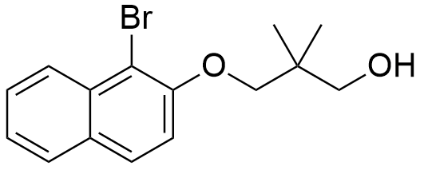

Following the general procedure, 1-bromonaphthalen-2-ol (5a) (0.50 g, 2.24 mmol), K₂CO₃ (1.86 g, 13.44 mmol), and 3-bromo-2,2-dimethylpropan-1-ol (0.47 g, 2.80 mmol) were dissolved in DMF (5 mL) and allowed react as described above. After purification by silica gel chromatography (Hex: EtOAc (5:1)) compound (3a) was obtained as a dark yellow solid (0.63 g, 92%).
¹H NMR (400 MHz, CDCl₃) δ (ppm): 8.20 (d, J = 8.6 Hz, 1H), 7.79 (t, J = 8.7 Hz, 2H), 7.56 (t, J = 7.2 Hz, 1H), 7.39 (t, J = 7.1 Hz, 1H), 7.25 (d, J = 2.8 Hz, 1H), 3.98 (s, 2H), 3.67 (s, 2H), 1.12 (s, 6H).
¹³C NMR (100 MHz, CDCl₃) δ (ppm): 153.10 (C), 133.07 (C), 129.91 (C), 128.96 (CH), 128.05 (CH), 127.77 (CH), 126.46 (C), 126.11 (CH), 124.42 (CH), 123.55 (C), 114.58 (CH), 70.22 (CH₂), 68.12 (CH₂), 21.81 (2XCH₃).
ESI-TOF MS (m/z): 309.05 (M+1).

3.5.2.21 Synthesis of 2-((1-bromonaphthalen-2-yl)oxy)ethanol (6b)

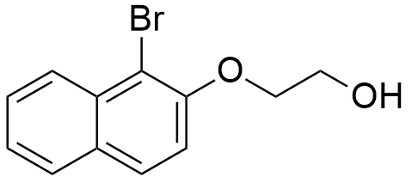

Following the general procedure, 1-bromonaphthalen-2-ol (5a) (0.50 g, 2.24 mmol), K₂CO₃ (1.86 g, 13.44 mmol), and 2-bromoethanol (0.35 g, 2.83 mmol) were dissolved in DMF (5 mL) and allowed react as described above. After purification by silica gel chromatography (Hex: EtOAc (5:1)) compound (3b) was obtained as a yellow solid (0.57 g, 95%).
¹H NMR (400 MHz, CDCl₃) δ (ppm): 8.25 (d, J = 8.6 Hz, 1H), 7.83 (dd, J = 8.4, 7.8 Hz, 2H), 7.61 (ddd, J = 8.4, 6.9, 1.2 Hz, 1H), 7.45 (ddd, J = 8.1, 6.9, 1.1 Hz, 1H), 7.30 (d, J = 9.0 Hz, 1H), 4.35-4.31 (m, 2H), 4.05 (dt, J = 6.2, 4.7 Hz, 2H).
¹³C NMR (100 MHz, CDCl₃) δ (ppm): 153.04 (C), 133.03 (C), 129.87 (C), 128.92 (CH), 128.01 (CH), 127.74 (CH), 126.44 (C), 126.08 (CH), 124.39 (CH), 114.56 (CH), 70.20 (CH₂), 68.09 (CH₂).
ESI-TOF MS (m/z): 267.00 (M+1).

3.4.2.22 Synthesis of 3-((1-bromonaphthalen-2-yl)oxy)propan-1-ol (6c)

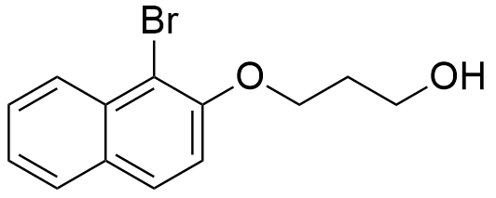

Following the general procedure, 1-bromonaphthalen-2-ol (5a) (0.50 g, 2.24 mmol), K₂CO₃ (1.86 g, 13.44 mmol), and 2-bromopropanol (0.39 g, 2.78 mmol) were dissolved in DMF (5 mL) and allowed to react as described above. After purification by silica gel chromatography (Hex: EtOAc (5:1)) compound (3c) was obtained as a yellow solid (0.54 g, 86%).
¹H NMR (400 MHz, CDCl₃) δ (ppm): 8.24 (d, J = 8.6 Hz, 1H), 7.88-7.79 (m, 2H), 7.60 (ddd, J = 8.4, 6.9, 1.2 Hz, 1H), 7.43 (ddd, J = 8.1, 6.9, 1.1 Hz, 1H), 7.31 (d, J = 9.0 Hz, 1H), 4.38 (t, J = 5.8 Hz, 2H), 4.01 (d, J = 4.5 Hz, 2H), 2.19 (dt, J = 11.4, 5.7 Hz, 2H).
¹³C NMR (100 MHz, CDCl₃) δ (ppm): 153.07 (C), 133.08 (C), 129.91 (C), 128.95 (CH), 128.05 (CH), 127.76 (CH), 126.47 (C), 126.12 (CH), 124.42 (CH), 114.58 (CH), 70.23 (CH₂), 68.12 (CH₂), 32.56. (CH₂).
ESI-TOF MS (m/z): 288.01 (M+1).

3.5.2.23 Synthesis of 3-((3-bromonaphthalen-2-yl)oxy)-2,2-dimethylpropan-1-ol (6d)

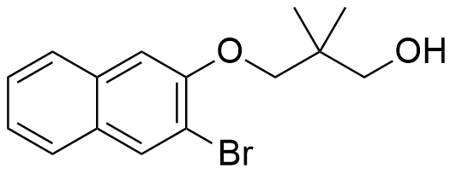

Following the general procedure, 3-bromonaphthalen-2-ol (5b) (1.00 g, 4.48 mmol), K₂CO₃ (3.71 g, 26.88 mmol), and 3-bromo-2,2-dimethylpropan-1-ol (0.94 g, 5.60 mmol) were dissolved in DMF (10 mL) and allowed to react as described above. After purification by silica gel chromatography (Hex: EtOAc (5:1)) compound (6d) was obtained as a brown solid (1.14 g, 83%).
¹H NMR (400 MHz, CDCl₃) δ (ppm): 8.08 (s, 1H), 7.72 (t, J = 6.7 Hz, 2H), 7.48 (t, J = 7.4 Hz, 1H), 7.39 (t, J = 7.5 Hz, 1H), 7.18 (s, 1H), 3.97 (s, 2H), 3.68 (s, 2H), 1.16 (s, 6H).

3.5.2.24 Synthesis of 2-((3-bromonaphthalen-2-yl)oxy)ethanol (6e)

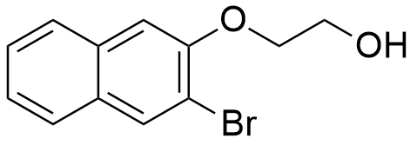

Following the general procedure, 3-bromonaphthalen-2-ol (5b) (0.25 g, 1.10 mmol), K₂CO₃ (0.91 g, 6.60 mmol), and 2-bromoethanol (0.18 g, 1.42 mmol) were dissolved in DMF (2.5 mL) and allowed to react as described above. After purification by silica gel chromatography (Hex: EtOAc (5:1)) compound (3e) was obtained as a brown solid (0.26 g, 89%).
¹H NMR (400 MHz, CDCl₃) δ (ppm): 7.68-7.60 (m, 2H), 7.39 (t, J = 7.5 Hz, 1H), 7.31 (t, J = 7.5 Hz, 1H), 7.19 (s, 1H), 7.12 (s, 1H), 4.21-4.16 (m, 1H), 4.00 (s, 1H).
¹³C NMR (100 MHz, CDCl₃) δ (ppm): 152.48 (C), 133.43 (C), 132.34 (CH), 129.68 (C), 126.80 (CH), 126.76 (CH), 126.65 (CH), 124.76 (CH), 113.70 (C), 108.23 (CH), 70.54 (CH₂), 61.28 (CH₂).

3.5.2.25 Synthesis of 3-((2-bromopyridin-3-yl)oxy)-2,2-dimethylpropan-1-ol (8a)

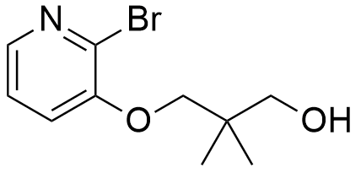

Following the general procedure, 2-bromo-3-pyridol (7a) (1.00 g, 5.80 mmol), K₂CO₃ (4.77 g, 34.80 mmol), and 3-bromo-2,2-dimethylpropan-1-ol (1.21 g, 7.25 mmol) were dissolved in DMF (10 mL) and allowed to react as described above. After purification by silica gel chromatography (Hex: EtOAc (1:1)) compound (8a) was obtained as a white solid (1.01 g, 67%).
¹H NMR (400 MHz, CDCl₃) δ (ppm): 8.00 (dd, J = 4.6, 1.6 Hz, 1H), 7.22 (dd, J = 8.1, 4.6 Hz, 2H), 7.16 (dd, J = 8.1, 1.6 Hz, 1H), 3.85 (s, 2H), 3.63 (d, J = 5.5 Hz, 2H), 1.10 (s, 6H).
¹³C NMR (101 MHz, CDCl₃) δ (ppm): 152.34 (C), 141.28 (CH), 133.12 (C), 123.39 (CH), 119.38 (CH), 75.70 (CH₂), 69.43 (CH₂), 30.92 (2xCH₃).
ESI-TOF MS (m/z): 276.00 (M+1).

3.5.2.26 Synthesis of 2-((2-bromopyridin-3-yl)oxy)ethanol (8b)

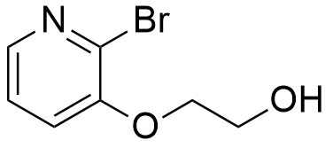

Following the general procedure, 2-bromo-3-pyridol (7a) (1.00 g, 5.80 mmol), K₂CO₃ (4.77 g, 34.80 mmol), and 2-bromoethanol (0.88 g, 7.00 mmol) were dissolved in DMF (10 mL) and allowed to react as described above. After purification by silica gel chromatography (Hex: EtOAc (1:1)) compound (8b) was obtained as a white solid (0.87 g, 69%).
¹H NMR (400 MHz, CDCl₃) δ (ppm): 8.05 (dd, J = 4.5, 1.7 Hz, 1H), 7.26 (dd, J = 8.1, 4.5 Hz, 1H), 7.21 (dd, J = 8.1, 1.7 Hz, 1H), 4.22-4.17 (m, 2H), 4.09-4.02 (m, 2H).
¹³C NMR (101 MHz, CDCl₃) δ (ppm): 152.13 (C), 141.96 (CH), 133.33 (C), 123.48 (CH), 120.34 (CH), 70.90 (CH₂), 61.10 (CH₂).

3.5.2.27 Synthesis of 3-((2-bromopyridin-3-yl)oxy)propan-1-ol (8c)

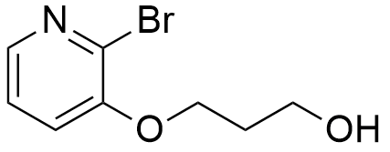

Following the general procedure, 2-bromo-3-pyridol (7a) (1.00 g, 5.80 mmol), K₂CO₃ (4.77 g, 34.80 mmol), and 2-bromopropanol (0.88 g, 7.20 mmol) were dissolved in DMF (10 mL) and allowed to react as described above. After purification by silica gel chromatography (Hex: EtOAc (1:1)) compound (8c) was obtained as a white solid (1.02 g, 76%).
¹H NMR (400 MHz, CDCl₃) δ (ppm): 8.01 (dd, J = 4.6, 1.6 Hz, 1H), 7.24 (dd, J = 8.1, 4.6 Hz, 1H), 7.18 (dd, J = 8.1, 1.6 Hz, 1H), 4.23 (t, J = 5.9 Hz, 2H), 3.95 (s, 2H), 2.14 (dt, J = 11.5, 5.8 Hz, 2H).
¹³C NMR (101 MHz, CDCl₃) δ (ppm): 152.22 (C), 141.41 (CH), 133.03 (C), 123.44 (CH), 119.50 (CH), 67.13 (CH₂), 60.08 (CH₂), 31.65 (CH₂).

3.5.2.28 Synthesis of 3-((7-bromoquinolin-8-yl)oxy)-2,2-dimethylpropan-1-ol (8d)

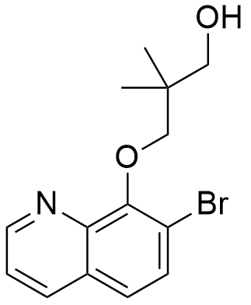

Following the general procedure, 7-Bromo-8-hydroxyquinoline (7b) (0.10 g, 0.45 mmol), K₂CO₃ (0.37 g, 2.70 mmol), and 3-bromo-2,2-dimethylpropan-1-ol (0.09 g, 0.54 mmol) were dissolved in DMF (1 mL) and allowed to react as described above. After purification by silica gel chromatography (Hex: EtOAc (2:1)) compound (8d) was obtained as a white solid (0.06 g, 43%).
¹H NMR (400 MHz, CDCl₃) δ (ppm): 8.87 (d, J = 4.1 Hz, 1H), 8.20 (d, J = 8.3 Hz, 1H), 7.69 (d, J = 8.8 Hz, 1H), 7.48 (dd, J = 8.4, 5.2 Hz, 2H), 3.97 (s, 2H), 3.74 (s, 2H), 1.09 (s, 6H).
¹³C NMR (101 MHz, CDCl₃) δ (ppm): 151.81 (C), 149.98 (CH), 142.52 (C), 137.24 (CH), 131.06 (CH), 129.12 (C), 124.23 (CH), 121.68 (CH), 117.95 (C), 78.85 (CH₂), 68.56 (CH₂), 21.88 (2xCH₃).

3.5.2.29 Synthesis of 2-((7-bromoquinolin-8-yl)oxy)ethanol (8e)

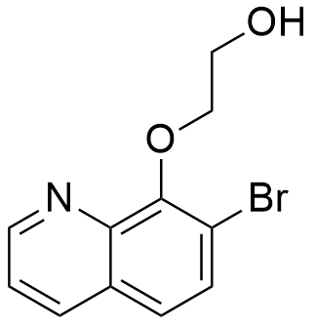

Following the general procedure, 7-Bromo-8-hydroxyquinoline (7b) (1.03 g, 4.59 mmol), K₂CO₃ (3.70 g, 27.54 mmol), and 2-bromoethanol (0.67 g, 5.35 mmol) were dissolved in DMF (10 mL) and allowed to react as described above. After purification by silica gel chromatography (Hex: EtOAc (2:1)) compound (8e) was obtained as a white solid (0.69 g, 56%).
¹H NMR (400 MHz, CDCl₃) δ (ppm): 8.93 (dd, J = 4.3, 1.7 Hz, 1H), 8.23 (dd, J = 8.3, 1.7 Hz, 1H), 7.74 (d, J = 8.8 Hz, 1H), 7.56-7.50 (m, 2H), 4.52-4.42 (m, 2H), 3.97-3.91 (m, 2H).
¹³C NMR (101 MHz, CDCl₃) δ (ppm): 152.15 (C), 150.09 (CH), 143.23 (C), 136.97 (CH), 131.15 (CH), 128.92 (C), 124.49 (CH), 121.89 (CH), 117.80 (C), 76.97 (CH₂), 61.65 (CH₂).
ESI-TOF MS (m/z): 268.00 (M+1).

3.5.2.30 Synthesis of 3-((7-bromoquinolin-8-yl)oxy)propan-1-ol (8f)

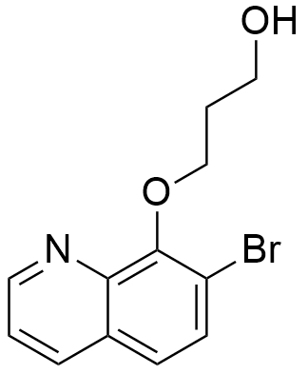

Following the general procedure, 7-Bromo-8-hydroxyquinoline (7b) (0.50 g, 2.23 mmol), K₂CO₃ (1.85 g, 13.38 mmol), and 2-bromopropanol (0.38 g, 2.76 mmol) were dissolved in DMF (5 mL) and allowed to react as described above. After purification by silica gel chromatography (Hex: EtOAc (2:1)) compound (8f) was obtained as a white solid (0.39 g, 62%).
¹H NMR (400 MHz, CDCl₃) δ (ppm): 8.91 (dd, J = 4.3, 1.7 Hz, 1H), 8.23 (dd, J = 8.3, 1.7 Hz, 1H), 7.75-7.70 (m, 1H), 7.54-7.47 (m, 2H), 4.43 (t, J = 5.6 Hz, 2H), 4.16-4.10 (m, 2H), 2.16-2.09 (m, 2H).
¹³C NMR (101 MHz, CDCl₃) δ (ppm): 152.25 (C), 150.02 (CH), 142.68 (C), 137.20 (CH), 131.10 (CH), 129.18 (C), 124.28 (CH), 121.70 (CH), 117.79 (C), 71.08 (CH₂), 58.75 (CH₂), 31.88 (CH₂).
ESI-TOF MS (m/z): 282.01 (M+1).

3.5.3 Synthesis of the aldehyde derivatives through PCC oxidation reactions
3.5.3.1 General procedure

The alcohol precursors were added to a degassed round bottom flask with dry DCM. After this, celite, (double of the mass of PCC), and 2 equivalents of PCC were added to the solution and the round bottom flask was degassed one more time. The mixture was left stirring vigorously for several hours at room temperature, under N₂, monitored by TLC. After total consumption of the starting material, the solvent was evaporated and a mixture of hexane/EtOAc (5:1) was added to the crude mixture. This mixture was filtered under reduced pressure, over a silica pad and the filtrate was evaporated under reduced pressure. After purification by silica gel chromatography compounds (9a)-(9h) were obtained in excellent yields.

3.5.3.2 Synthesis of 3-(2-bromophenoxy)-2,2-dimethylpropanal (9a)

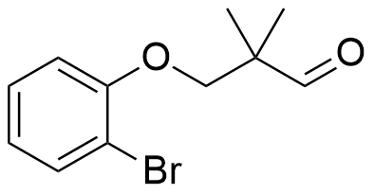

Following the general procedure, compound (4a) (0.36 g, 2.50 mmol), celite (2.15 g, 10.00 mmol), and PCC (1.08 g, 5.00 mmol) were dissolved in DCM (5 mL) and allowed react as described above. After purification by silica gel chromatography (Hex: EtOAc (5:1)) compound (9a) was obtained as a yellow oil (0.58 g, 91%).
¹H NMR (400 MHz, CDCl₃) δ (ppm): ¹H NMR (400 MHz, CDCl₃) δ 9.72 (s, 1H), 7.54 (d, J = 7.8 Hz, 1H), 7.29-7.25 (m, 1H), 6.89 (dd, J = 12.8, 7.9 Hz, 2H), 4.02 (s, 2H), 1.29 (s, 6H).
¹³C NMR (101 MHz, CDCl₃) δ (ppm): ¹³C NMR (101 MHz, CDCl₃) δ 204.43 (C=O), 181.21 (C), 133.38 (CH), 128.42 (CH), 122.30 (CH), 113.22 (CH), 99.06 (C), 73.56 (CH₂), 19.27 (2xCH₃).
ESI-TOF MS (m/z): 257.10 (M+1).

3.5.3.3 Synthesis of 3-((1-bromonaphthalen-2-yl)oxy)-2,2-dimethylpropanal (9b)

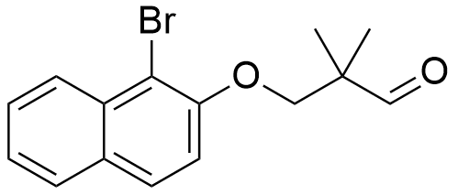

Following the general procedure, compound (6a) (0.36 g, 1.18 mmol), celite (1.02 g, 4.72 mmol), and PCC (0.51 g, 2.36 mmol), were dissolved in DCM (5 mL) and allowed react as described above. After purification by silica gel chromatography (Hex: EtOAc (5:1)) compound (9b) was obtained as a yellow oil (0.34 g, 94%).
¹H NMR (400 MHz, CDCl₃) δ (ppm): 9.80 (s, 1H), 8.24 (d, J = 8.6 Hz, 1H), 7.82 (t, J = 8.4 Hz, 2H), 7.62-7.56 (m, 1H), 7.43 (t, J = 7.5 Hz, 1H), 7.26 (s, 1H), 4.32-4.05 (m, 2H), 1.35 (s, 6H).
¹³C NMR (101 MHz, CDCl₃) δ (ppm): 204.55 (C=O), 152.94 (C), 133.14 (C), 130.13 (C), 128.97 (CH), 128.05 (CH), 127.78 (CH), 126.29 (CH), 124.63 (CH), 115.06 (CH), 109.92 (C), 74.75 (CH₂), 19.34 (2xCH₃).

3.5.3.4 Synthesis of 3-(2-bromo-4,5-difluorophenoxy)-2,2-dimethylpropanal (9c)

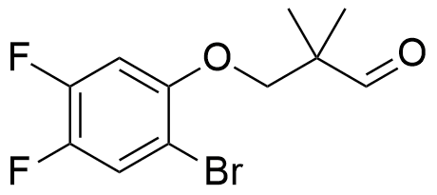

Following the general procedure, compound (4d) (0.29 g, 0.99 mmol), celite (0.85 g, 3.96 mmol), and PCC (0.43 g, 1.98 mmol) were dissolved in DCM (5 mL) and allowed react as described above. After purification by silica gel chromatography (Hex: EtOAc (5:1)) compound (9c) was obtained as a yellow oil (0.28 g, 98%).
¹H NMR (400 MHz, CDCl₃) δ (ppm): 9.69 (s, 1H), 7.40 (dd, J = 9.5, 8.4 Hz, 1H), 6.78 (dd, J = 11.5, 6.9 Hz, 1H), 3.97 (s, 2H), 1.29 (s, 6H).
¹³C NMR (101 MHz, CDCl₃) δ (ppm): 203.82 (C=O), 151.48 (d, J = 4.8 Hz, C), 150.77 (d, J = 13.4 Hz, C), 148.29 (d, J = 13.5 Hz, C), 145.88 (d, J = 13.4 Hz, C), 143.44 (d, J = 13.5 Hz, C), 121.43 (d, J = 19.7 Hz, CH), 102.93 (d, J = 21.7 Hz, CH), 74.24 (CH₂), 19.26 (2xCH₃).

3.4.3.5 Synthesis of 3-(2-bromo-3-methoxyphenoxy)-2,2-dimethylpropanal (9d)

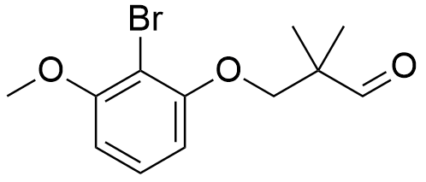

Following the general procedure, compound (4p) (0.12 g, 0.40 mmol), celite (0.35 g, 1.60 mmol), and PCC (0.17 g, 0.80 mmol) were dissolved in DCM (5 mL) and allowed react as described above. After purification by silica gel chromatography (Hex: EtOAc (5:1)) compound (9d) was obtained as a yellow pale oil (0.11 g, 96%).
¹H NMR (400 MHz, CDCl₃) δ (ppm): 9.73 (d, J = 5.6 Hz, 1H), 7.25-7.20 (m, 1H), 6.65-6.53 (m, 2H), 4.03 (s, 2H), 3.91 (s, 3H), 1.29 (s, 6H).
¹³C NMR (101 MHz, CDCl₃) δ (ppm): 204.51 (C=O), 157.29 (C), 156.28 (C), 128.23 (CH), 105.83 (CH), 105.09 (CH), 101.76 (C), 73.79 (CH₂), 56.46 (OCH₃), 19.27 (2xCH₃).

3.5.3.6 Synthesis of 3-(2-bromo-4-methylphenoxy)-2,2-dimethylpropanal (9e)

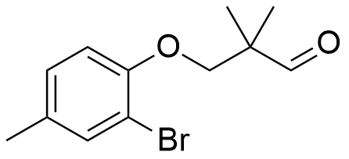

Following the general procedure, compound (4j) (0.16 g, 0.58 mmol), celite (0.50 g, 2.32 mmol), and PCC (0.25 g, 1.16 mmol) were dissolved in DCM (5 mL) and allowed react as described above. After purification by silica gel chromatography (Hex: EtOAc (5:1)) compound (9e) was obtained as yellow oil (0.15 g, 94%).
¹H NMR (400 MHz, CDCl₃) δ (ppm): 9.73 (s, 1H), 7.36 (d, J = 1.6 Hz, 1H), 7.06 (ddd, J = 8.3, 2.1, 0.6 Hz, 1H), 6.81 (dd, J = 8.3, 4.1 Hz, 1H), 3.99 (s, 2H), 2.29 (s, 3H), 1.28 (s, 6H).
¹³C NMR (101 MHz, CDCl₃) δ (ppm): 204.55 (C=O), 152.92 (C), 133.75 (CH), 132.09 (C), 128.83 (CH), 113.35 (CH), 112.18 (C), 73.91 (CH₂), 20.20 (CH₃), 19.24 (2xCH₃).

3.5.3.7 Synthesis of 3-(2-bromo-5-fluorophenoxy)-2,2-dimethylpropanal (9f)

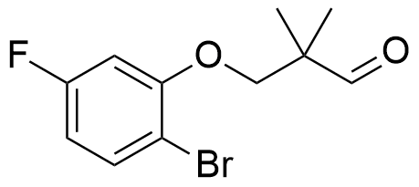

Following the general procedure, compound (4m) (0.24 g, 0.86 mmol), celite (0.74 g, 3.44 mmol), and PCC (0.37 g, 1.72 mmol) were dissolved in DCM (5 mL) and allowed react as described above. After purification by silica gel chromatography (Hex: EtOAc (5:1)) compound (9f) was obtained as a dark yellow oil (0.23 g, 97%).
¹H NMR (400 MHz, CDCl₃) δ (ppm): 9.70 (s, 1H), 7.54-7.41 (m, 1H), 6.73-6.53 (m, 2H), 4.00 (s, 2H), 1.29 (s, 6H).
¹³C NMR (101 MHz, CDCl₃) δ (ppm): 203.97 (C=O), 163.86 (C), 161.41 (C), 155.84 (d, J = 10.2 Hz, C), 133.53 (d, J = 9.6 Hz, CH), 108.86 (d, J = 22.4 Hz, CH), 106.58 (d, J = 3.7 Hz, C), 101.46 (d, J = 26.7 Hz, CH), 73.56 (CH₂), 19.25 (2xCH₃).

3.5.3.8 Synthesis of 3-((2-bromopyridin-3-yl)oxy)-2,2-dimethylpropanal (9g)

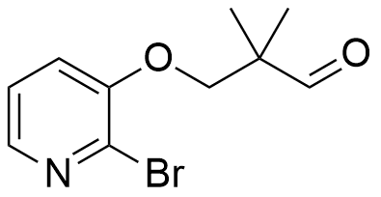

Following the general procedure, compound (8a) (0.27 g, 1.05 mmol), celite (0.90 g, 4.20 mmol), and PCC (0.45 g, 2.10 mmol) were dissolved in DCM (5 mL) and allowed react as described above. After purification by silica gel chromatography (Hex: EtOAc (2:1)) compound (9g) was obtained as a dark yellow oil (0.27 g, 98%).
¹H NMR (400 MHz, CDCl₃) δ (ppm): 9.63 (s, 1H), 7.93 (dd, J = 4.5, 1.7 Hz, 1H), 7.21-7.09 (m, 2H), 3.99 (s, 2H), 1.24 (s, 6H).
¹³C NMR (101 MHz, CDCl₃) δ (ppm): 203.83 (C=O), 151.99 (C), 141.60 (CH), 133.04 (C), 123.45 (CH), 119.80 (CH), 73.38 (CH₂), 19.23 (2xCH₃).

3.5.3.9 Synthesis of 3-((3-bromonaphthalen-2-yl)oxy)-2,2-dimethylpropanal (9h)

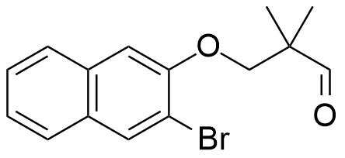

Following general procedure, compound (6d) (1.24 g, 4.01 mmol), celite (3.46 g, 16.04 mmol), and PCC (1.73 g, 8.02 mmol) were dissolved in DCM (20 mL) and allowed react as described above. After purification by silica gel chromatography (Hex: EtOAc (2:1)) compound (9h) was obtained as a yellow oil (1.15 g, 93%).
¹H NMR (400 MHz, CDCl₃) δ (ppm): 9.68 (s, 1H), 7.98 (s, 1H), 7.62 (dd, J = 11.5, 4.1 Hz, 2H), 7.39 (ddd, J = 8.2, 6.9, 1.4 Hz, 1H), 7.30 (ddd, J = 8.1, 6.9, 1.3 Hz, 1H), 7.08 (s, 1H), 4.06 (s, 2H), 1.26 (d, J = 2.3 Hz,6H).
¹³C NMR (101 MHz, CDCl₃) δ (ppm): 204.41 (C=O), 152.57 (C), 133.39 (C), 132.28 (CH), 129.59 (C), 126.76 (2xCH), 126.60 (CH), 124.68 (CH), 113.75 (C), 107.60 (CH), 73.40 (CH₂), 19.37 (2xCH₃).

3.5.4 Synthesis of allyl aryl and heteroaryl ether derivatives
3.5.4.1 General procedure

The aryl and heteroaryl alcohol precursors were added to a round bottom flask with acetone. Next, 1.1 equivalents of allyl bromide were added to the solution along with 2 equivalents of K₂CO₃. The mixture was left stirring for several hours at reflux temperature, (60ºC). The reaction was followed by TLC. After total consumption of starting material, the reaction was stopped and mixture was left to cool. The solids were filtered with a sinter glass funnel and the solvent removed under reduced pressure. After purification by silica gel chromatography compounds (7a)-(7k) were obtained in excellent yields.

3.5.4.2 Synthesis of 1-(allyloxy)-2-bromobenzene (10a)

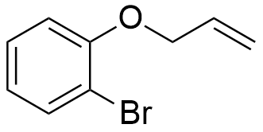

Following the general procedure, 2-bromophenol (3a) (1.00 g, 5.78 mmol), allyl bromide (0.79 g, 6.34 mmol) and K₂CO₃ (1.60 g, 11.56 mmol), were dissolved in acetone (10 mL) and allowed to react as described above. After purification by silica gel chromatography (Hex: EtOAc (9:1)) compound (10a) was obtained as a dark yellow solid (1.21 g, 98%).
¹H NMR (400 MHz, CDCl₃) δ (ppm): 7.57 (dd, J = 7.9, 1.6 Hz, 1H), 7.32-7.23 (m, 1H), 6.94-6.90 (m, 1H), 6.86 (dq, J = 5.6, 1.6 Hz, 1H), 6.10 (ddt, J = 17.2, 10.4, 5.0 Hz, 1H), 5.52 (ddd, J = 17.2, 3.3, 1.7 Hz, 1H), 5.34 (dq, J = 10.6, 1.5 Hz, 1H), 4.64 (dt, J = 5.0, 1.6 Hz, 2H).
¹³C NMR (101 MHz, CDCl₃) δ (ppm): 154.97 (C), 133.44 (CH), 132.66 (CH), 128.39 (CH), 122.02 (CH), 117.74 (CH₂), 113.64 (CH), 112.34 (C), 69.66 (CH₂).

3.5.4.3 Synthesis of 2-(allyloxy)-1-bromonaphthalene (10b)

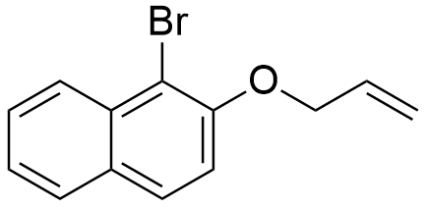

Following the general procedure, 1-bromonaphthalen-2-ol (5a) (0.30 g, 1.30 mmol), allyl bromide (0.18 g, 1.43 mmol) and K₂CO₃ (0.36 g, 2.60 mmol), were dissolved in acetone (5 mL) and allowed to react as described above. After purification by silica gel chromatography (Hex: EtOAc (9:1)) compound (7b) was obtained as a brown solid (0.33 g, 96%).
¹H NMR (400 MHz, CDCl₃) δ (ppm): 8.27 (dd, J = 8.6, 0.7 Hz, 1H), 7.81 (d, J = 8.7 Hz, 2H), 7.60 (ddd, J = 8.5, 5.5, 2.1 Hz, 1H), 7.43 (ddd, J = 8.0, 6.9, 1.1 Hz, 1H), 7.30-7.24 (m, 1H), 6.24-6.07 (m, 1H), 5.56 (ddd, J = 17.2, 3.2, 1.7 Hz, 1H), 5.40-5.33 (m, 1H), 4.82-4.74 (m, 2H).
¹³C NMR (101 MHz, CDCl₃) δ (ppm): 152.96 (C), 133.22 (C), 132.93 (CH), 130.02 (C), 128.82 (CH), 128.05 (CH), 127.71 (CH), 126.30 (CH), 124.50 (CH), 117.91 (CH₂), 115.42 (CH), 109.73 (C), 70.71 (CH₂).

3.5.4.4 Synthesis of 2-(allyloxy)-3-bromonaphthalene (10c)

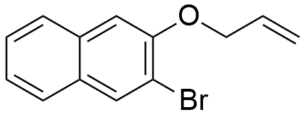

Following the general procedure, 3-bromonaphthalen-2-ol (5b) (0.30 g, 1.30 mmol), allyl bromide (0.18 g, 1.43 mmol) and K₂CO₃ (0.36 g, 2.60 mmol), were dissolved in acetone (5 mL) and allowed to react as described above. After purification by silica gel chromatography (Hex: EtOAc (9:1)) compound (10c) was obtained as a brown solid (0.34 g, 97%).
¹H NMR (400 MHz, CDCl₃) δ (ppm): 8.10 (s, 1H), 7.76-7.68 (m, 2H), 7.52-7.44 (m, 1H), 7.39 (ddd, J = 11.3, 6.2, 2.8 Hz, 1H), 7.17 (s, 1H), 6.25-6.10 (m, 1H), 5.65-5.56 (m, 1H), 5.45-5.35 (m, 1H), 4.74 (dt, J = 4.9, 1.6 Hz, 2H).
¹³C NMR (101 MHz, CDCl₃) δ (ppm): 152.51 (C), 133.46 (C), 132.47 (CH), 132.33 (CH), 129.49 (C), 126.73 (CH), 126.68 (CH), 126.64 (CH), 124.55 (CH), 117.83 (CH2), 113.81 (C), 108.02 (CH), 69.60 (CH₂).

3.5.4.5 Synthesis of 1-(allyloxy)-2-bromo-4-methylbenzene (10d)

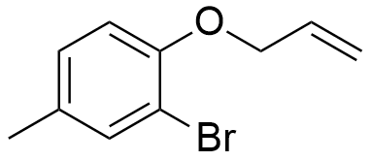

Following the general procedure, 2-bromo-4-methylphenol (3d) (0.30 g, 1.60 mmol), allyl bromide (0.22 g, 1.76 mmol) and K₂CO₃ (0.44 g, 3.20 mmol), were dissolved in acetone (5 mL) and allowed to react as described above. After purification by silica gel chromatography (Hex: EtOAc (9:1)) compound (10d) was obtained as a dark yellow solid (0.36 g, 99%).
¹H NMR (400 MHz, CDCl₃) δ (ppm): 7.39 (d, J = 1.6 Hz, 1H), 7.08-7.03 (m, 1H), 6.81 (d, J = 8.3 Hz, 1H), 6.08 (ddt, J = 17.2, 10.3, 5.0 Hz, 1H), 5.49 (ddd, J = 17.3, 3.3, 1.6 Hz, 1H), 5.32 (dq, J = 10.6, 1.5 Hz, 1H), 4.60 (dt, J = 5.0, 1.6 Hz, 2H), 2.29 (d, J = 2.6 Hz, 3H).
¹³C NMR (101 MHz, CDCl₃) δ (ppm): 152.82 (C), 133.80 (CH), 132.87 (CH), 131.76 (C), 128.76 (CH), 117.64 (CH₂), 113.70 (CH), 112.07 (C), 69.92 (CH₂), 20.18 (CH₃).

3.5.4.6 Synthesis of 4-(allyloxy)-3-bromobenzonitrile (10e)

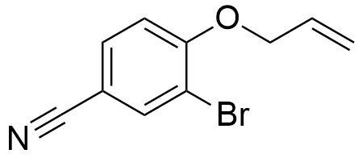

Following the general procedure, 3-bromo-4-hydroxybenzonitrile (3e) (0.30 g, 1.52 mmol), allyl bromide (0.21 g, 1.67 mmol) and K₂CO₃ (0.42 g, 3.04 mmol), were dissolved in acetone (5 mL) and allowed to react as described above. After purification by silica gel chromatography (Hex: EtOAc (9:1)) compound (10e) was obtained as a pale white solid (0.35 g, 97%).
¹H NMR (400 MHz, CDCl₃) δ (ppm): 7.84 (t, J = 2.8 Hz, 1H), 7.58 (dt, J = 4.8, 3.5 Hz, 1H), 7.00-6.90 (m, 1H), 6.15-5.97 (m, 1H), 5.51 (ddd, J = 17.3, 3.0, 1.7 Hz, 1H), 5.38 (ddd, J = 10.6, 2.7, 1.4 Hz, 1H), 4.69 (dt, J = 5.0, 1.6 Hz, 2H).
¹³C NMR (101 MHz, CDCl₃) δ (ppm): 158.49 (C), 136.79 (CH), 132.99 (CH), 131.36 (CH), 118.66 (CH₂), 117.76 (C), 113.17 (CH), 112.73 (C), 105.28 (C), 69.89 (CH₂).

3.5.4.7 Synthesis of 1-(allyloxy)-2-bromo-3-methoxybenzene (10f)

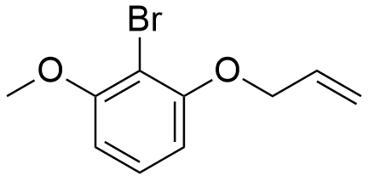

Following the general procedure, 2-bromo-3-methoxyphenol (3f) (0.30 g, 1.48 mmol), allyl bromide (0.20 g, 1.63 mmol) and K₂CO₃ (0.41 g, 2.96 mmol), were dissolved in acetone (5 mL) and allowed to react as described above. After purification by silica gel chromatography (Hex: EtOAc (9:1)) compound (10f) was obtained as a pale yellow solid (0.34 g, 95%).
¹H NMR (400 MHz, CDCl₃) δ (ppm): 7.24-7.19 (m, 1H), 6.58 (ddd, J = 8.3, 3.6, 1.1 Hz, 2H), 6.09 (ddt, J = 17.2, 10.5, 5.0 Hz, 1H), 5.58-5.45 (m, 1H), 5.32 (d, J = 10.6, 1.5 Hz, 1H), 4.63 (dt, J = 5.0, 1.6 Hz, 2H), 3.91 (s, 3H).
¹³C NMR (101 MHz, CDCl₃) δ (ppm): 157.27 (C), 156.26 (C), 132.73 (CH), 128.14 (CH), 117.62 (CH₂), 106.25 (CH), 104.80 (CH), 101.64 (C), 69.84 (CH₂), 56.45 (OCH₃).

3.5.4.8 Synthesis of 1-(allyloxy)-2-bromo-4-fluorobenzene (10g)

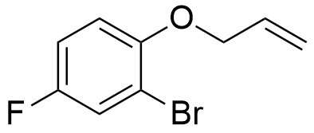

Following the general procedure, 2-bromo-4-fluorophenol (3g) (0.30 g, 1.57 mmol), allyl bromide (0.22 g, 1.73 mmol) and K₂CO₃ (0.43 g, 3.14 mmol), were dissolved in acetone (5 mL) and allowed to react as described above. After purification by silica gel chromatography (Hex: EtOAc (9:1)) compound (10g) was obtained as a white solid (0.36 g, 98%).
¹H NMR (400 MHz, CDCl₃) δ (ppm): 7.35-7.31 (m, 1H), 7.03-6.95 (m, 1H), 6.86 (dd, J = 9.1, 4.8 Hz, 1H), 6.14-6.00 (m, 1H), 5.49 (ddd, J = 17.3, 3.2, 1.7 Hz, 1H), 5.33 (dq, J = 10.6, 1.5 Hz, 1H), 4.59 (dt, J = 5.0, 1.6 Hz, 2H).
¹³C NMR (101 MHz, CDCl₃) δ (ppm): 157.94 (C), 155.52 (C), 151.61 (d, J = 2.7 Hz, C), 132.53 (CH), 120.47 (d, J = 25.7 Hz, CH), 117.94 (CH₂), 114.60 (d, J = 22.6 Hz, CH), 114.28 (d, J = 8.4 Hz, CH), 70.48 (CH₂).

3.5.4.9 Synthesis of 2-(allyloxy)-1-bromo-4-fluorobenzene (10h)

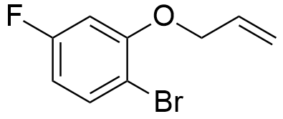

Following the general procedure, 2-bromo-5-fluorophenol (3g) (0.30 g, 1.57 mmol), allyl bromide (0.22 g, 1.73 mmol) and K₂CO₃ (0.43 g, 3.14 mmol), were dissolved in acetone (5 mL) and allowed to react as described above. After purification by silica gel chromatography (Hex: EtOAc (9:1)) compound (10h) was obtained as a white pale solid (0.35 g, 96%).
¹H NMR (400 MHz, CDCl₃) δ (ppm): 7.50 (dd, J = 8.7, 6.2 Hz, 1H), 6.71-6.55 (m, 2H), 6.07 (ddt, J = 15.6, 10.2, 5.0 Hz, 1H), 5.52 (ddd, J = 17.3, 3.0, 1.5 Hz, 1H), 5.36 (dd, J = 10.6, 1.4 Hz, 1H), 4.61 (dt, J = 4.9, 1.5 Hz, 2H).
¹³C NMR (101 MHz, CDCl₃) δ (ppm): 163.85 (C), 161.41 (C), 155.85 (d, J = 10.2 Hz, C), 133.57 (d, J = 9.7 Hz, CH), 131.97 (CH), 118.20 (CH₂), 108.60 (d, J = 22.5 Hz, CH), 101.81 (d, J = 26.8 Hz, CH), 69.85 (CH₂).

3.5.4.10 Synthesis of 1-(allyloxy)-2-bromo-4,5-difluorobenzene (10i)

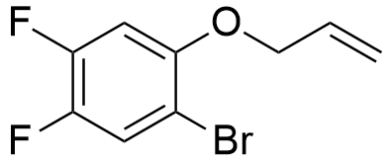

Following the general procedure, 2-bromo-4,5-difluorophenol (3i) (0.30 g, 1.44 mmol), allyl bromide (0.20 g, 1.58 mmol) and K₂CO₃ (0.40 g, 2.88 mmol), were dissolved in acetone (5 mL) and allowed to react as described above. After purification by silica gel chromatography (Hex: EtOAc (9:1)) compound (10i) was obtained as a white solid (0.35 g, 98%).
¹H NMR (400 MHz, CDCl₃) δ (ppm): 7.45-7.35 (m, 1H), 6.75 (dt, J = 11.0, 5.5 Hz, 1H), 6.13-5.98 (m, 1H), 5.49 (ddd, J = 17.3, 3.1, 1.7 Hz, 1H), 5.35 (dq, J = 10.6, 1.4 Hz, 1H), 4.57 (dt, J = 5.0, 1.6 Hz, 2H).
¹³C NMR (101 MHz, CDCl₃) δ (ppm): 150.70 (d, J = 13.4 Hz, C), 148.23 (d, J = 13.4 Hz, C), 145.66 (d, J = 13.5 Hz, C), 143.22 (d, J = 13.5 Hz, C), 131.89 (CH), 121.39 (dd, J = 20.9, 1.3 Hz, CH), 118.31 (CH₂), 103.19 (d, J = 21.7 Hz, CH), 70.52 (CH₂).

3.5.4.11 Synthesis of 3-(allyloxy)-2-bromopyridine (10j)

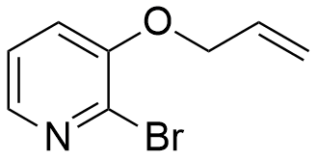

Following the general procedure, 2-bromo-3-pyridol (3j) (0.30 g, 1.72 mmol), allyl bromide (0.24 g, 1.90 mmol) and K₂CO₃ (0.48 g, 3.44 mmol), were dissolved in acetone (5 mL) and allowed to react as described above. After purification by silica gel chromatography (Hex: EtOAc (2:1)) compound (10j) was obtained as a white solid (0.35 g, 94%).
¹H NMR (400 MHz, CDCl₃) δ (ppm): 7.94 (dt, J = 6.3, 3.2 Hz, 1H), 7.17 (dd, J = 8.1, 4.6 Hz, 1H), 7.12 (dd, J = 8.1, 1.6 Hz, 1H), 6.09-5.91 (m, 1H), 5.46 (ddd, J = 17.3, 3.1, 1.7 Hz, 1H), 5.32 (dq, J = 10.6, 1.4 Hz, 1H), 4.61 (dt, J = 5.0, 1.6 Hz, 2H).
¹³C NMR (101 MHz, CDCl₃) δ (ppm): 151.94 (C), 141.35 (CH), 133.04 (C), 131.71 (CH), 123.36 (CH), 120.13 (CH), 118.41 (CH₂), 69.69 (CH₂).

3.5.4.12 Synthesis of 8-(allyloxy)-7-bromoquinoline (10k)

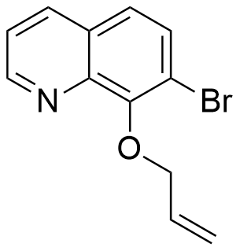

Following the general procedure, 2-bromo-3-pyridol (3k) (0.30 g, 1.34 mmol), allyl bromide (0.18 g, 1.47 mmol) and K₂CO₃ (0.37 g, 2.68 mmol), were dissolved in acetone (5 mL) and allowed to react as described above. After purification by silica gel chromatography (Hex: EtOAc (2:1)) compound (10k) was obtained as a brown solid (0.35 g, 91%).
¹H NMR (400 MHz, CDCl₃) δ (ppm): 8.91 (dd, J = 4.2, 1.7 Hz, 1H), 8.08 (dd, J = 8.3, 1.7 Hz, 1H), 7.62 (d, J = 8.8 Hz, 1H), 7.38 (dd, J = 8.6, 4.7 Hz, 2H), 6.34-6.18 (m, 1H), 5.46-5.34 (m, 1H), 5.23 (ddd, J = 10.4, 2.8, 1.1 Hz, 1H), 5.03-4.92 (m, 2H).
¹³C NMR (101 MHz, CDCl₃) δ (ppm): 152.34 (C), 150.07 (CH), 143.50 (C), 136.20 (CH), 134.02 (CH), 130.72 (CH), 128.93 (C), 124.01 (CH), 121.46 (CH), 118.21 (CH₂), 117.14 (C), 75.70 (CH₂).

3.5.5 Synthesis of aldehyde derivatives through Lemieux-Johnson Oxidation
3.5.5.1 General procedure

We dissolved the substituted allyl aryl and heteroaryl ether derivatives in a a mixture of dioxane/H₂O (3:1) and added them to a round bottom flask. Next, 0.1 equivalents of osmium tetroxide were added to the flask and the solution was left stirring for 30 minutes at room temperature. Subsequently, 2 equivalents of sodium periodate were added to the mixture and the reaction was left stirring vigorously for several hours, followed by TLC. After total consumption of the starting material (verified through TLC) the reaction was quenched by the addition of distilled water. The organic layer was extracted with EtOAc, dried over anhydrous MgSO₄ and evaporated under reduced pressure. Cmpounds (11a)-(11g) were obtained in good or very good yields, after purification through silica gel chromatography.

3.5.5.2 Synthesis of 2-(2-bromophenoxy)acetaldehyde (11a)

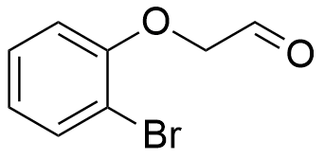

Following the general procedure, compound (10a) (0.10 g, 0.47 mmol), osmium tetroxide (0.48 g, 0.05 mmol) and sodium periodate (0.20 g, 0.94 mmol), were dissolved in dioxane/H₂O (3:1) (8 mL) and allowed to react as described above. After purification by silica gel chromatography (Hex: EtOAc (5:1)) compound (11a) was obtained as a colourless oil (0.08 g, 78%).
¹H NMR (400 MHz, CDCl₃) δ (ppm): 9.92 (t, J = 1.1 Hz, 1H), 7.61 (dd, J = 7.9, 1.6 Hz, 1H), 7.32-7.27 (m, 1H), 6.94 (td, J = 7.7, 1.4 Hz, 1H), 6.81 (d, J = 8.2 Hz, 1H), 4.64 (s, 2H).
¹³C NMR (101 MHz, CDCl₃) δ (ppm): 198.94 (C=O), 154.20 (C), 133.92 (CH), 128.66 (CH), 123.34 (CH), 113.68 (CH), 112.42 (C), 73.61 (CH₂).

3.5.5.3 Synthesis of 2-((1-bromonaphthalen-2-yl)oxy)acetaldehyde (11b)

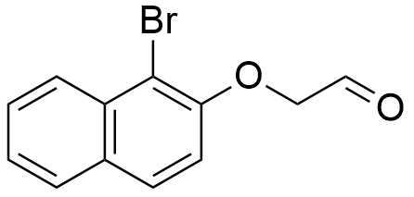

Following the general procedure, compound (10b) (0.24 g, 0.90 mmol), osmium tetroxide (0.92 g, 0.09 mmol) and sodium periodate (0.32 g, 1.80 mmol), were dissolved in dioxane/H₂O (3:1) (8 mL) and allowed react as described above. After purification by silica gel chromatography (Hex: EtOAc (5:1)) compound (11b) was obtained as a yellow oil (0.16 g, 67%).
¹H NMR (400 MHz, CDCl₃) δ (ppm): 9.97 (t, J = 1.0 Hz, 1H), 8.27 (dd, J = 8.6, 0.8 Hz, 1H), 7.82-7.77 (m, 2H), 7.64-7.58 (m, 1H), 7.46 (ddd, J = 8.1, 6.9, 1.1 Hz, 1H), 7.13-7.08 (m, 1H), 4.74 (d, J = 1.0 Hz, 2H).
¹³C NMR (101 MHz, CDCl₃) δ (ppm): 198.96 (C=O), 152.20 (C), 133.17 (C), 130.56 (C), 129.29 (CH), 128.15 (CH), 128.09 (CH), 126.46 (CH), 125.19 (CH), 115.21 (CH), 110.45 (C), 74.81 (CH₂).

3.5.5.4 Synthesis of 2-((1-bromonaphthalen-2-yl)oxy)acetaldehyde (11c)

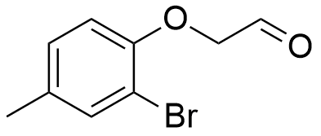

Following the general procedure, compound (10d) (0.03 g, 0.13 mmol), osmium tetroxide (0.15 g, 0.01 mmol) and sodium periodate (0.20 g, 0.06 mmol), were dissolved in dioxane/H₂O (3:1) (4 mL) and allowed react as described above. After purification by silica gel chromatography (Hex: EtOAc (5:1)) compound (11c) was obtained as a dark yellow oil (0.03 g, 83%).
¹H NMR (400 MHz, CDCl₃) δ (ppm): 9.91 (s, 1H), 7.43 (s, 1H), 7.10-7.00 (m, 1H), 6.71 (d, J = 8.3 Hz, 1H), 4.60 (s, 2H), 1.45 (s, 3H).
¹³C NMR (101 MHz, CDCl₃) δ (ppm): 199.26 (C=O), 173.28 (C), 152.14 (C), 134.27 (CH), 129.02 (CH), 113.80 (CH), 112.15 (C), 73.94 (CH₂), 14.12 (CH₃).

3.5.5.5 Synthesis of 2-(2-bromo-3-methoxyphenoxy)acetaldehyde (11d)

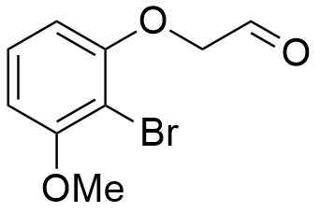

Following the general procedure, compound (10f) (0.07 g, 0.28 mmol), osmium tetroxide (0.29 g, 0.03 mmol) and sodium periodate (0.12 g, 0.56 mmol), were dissolved in dioxane/H₂O (3:1) (4 mL) and allowed react as described above. After purification by silica gel chromatography (Hex: EtOAc (5:1)) compound (11d) was obtained as a yellow oil (0.05 g, 76%).
¹H NMR (400 MHz, CDCl₃) δ (ppm): 9.92 (s, 1H), 7.23 (d, J = 8.3 Hz, 1H), 6.66 (d, J = 8.4 Hz, 1H), 6.46 (d, J = 8.3 Hz, 1H), 4.63 (s, 2H), 3.94 (s, 2H).
¹³C NMR (101 MHz, CDCl₃) δ (ppm): 199.18 (C=O), 157.59 (C), 155.48 (C), 128.45 (CH), 106.03 (CH), 105.95 (CH), 101.81 (C), 73.74 (CH₂), 56.52 (OCH₃).

3.5.5.6 Synthesis of 2-(2-bromo-5-fluorophenoxy)acetaldehyde (11e)

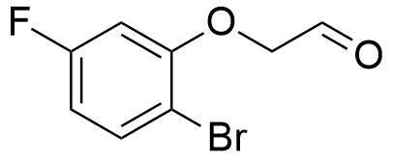

Following the general procedure, compound (10h) (0.03 g, 0.14 mmol), osmium tetroxide (0.15 g, 0.01 mmol) and sodium periodate (0.06 g, 0.28 mmol), were dissolved in dioxane/H₂O (3:1) (4 mL) and allowed react as described above. After purification by silica gel chromatography (Hex: EtOAc (5:1)) compound (11e) was obtained as a colourless crystalline solid (0.03 g, 82%).
¹H NMR (400 MHz, CDCl₃) δ (ppm): 9.91 (s, 1H), 7.36 (dd, J = 7.7, 2.9 Hz, 1H), 7.04-6.97 (m, 1H), 6.80 (dd, J = 9.0, 4.6 Hz, 1H), 4.62 (s, 2H).
¹³C NMR (101 MHz, CDCl₃) δ (ppm): 198.49 (C=O), 173.31 (C), 167.80 (C), 132.44 (C), 129.72 (CH), 121.00 (d, J = 25.9 Hz, CH), 114.98 (d, J = 22.8 Hz, CH), 74.42 (CH₂).

3.5.5.7 Synthesis of 2-(2-bromo-4,5-difluorophenoxy)acetaldehyde (11f)

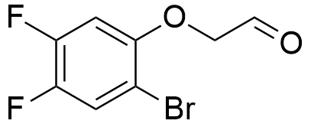

Following the general procedure, compound (10i) (0.19 g, 0.78 mmol), osmium tetroxide (0.90 g, 0.08 mmol) and sodium periodate (0.06 g, 1.56 mmol), were dissolved in dioxane/H₂O (3:1) (4 mL) and allowed react as described above. After purification by silica gel chromatography (Hex: EtOAc (5:1)) compound (11f) was obtained as a white solid (0.15 g, 77%).
¹H NMR (400 MHz, CDCl₃) δ (ppm): 9.86 (s, 1H), 7.43 (t, J = 8.9 Hz, 1H), 6.70 (dd, J = 11.2, 6.8 Hz, 1H), 4.60 (s, 2H).
¹³C NMR (101 MHz, CDCl₃) δ (ppm): 197.39 (C=O), 148.24 (d, J = 13.6 Hz, C), 146.54 (d, J = 13.3 Hz, C), 144.08 (d, J = 13.3 Hz, C), 121.95 (d, J = 21.0 Hz, CH), 106.04 (dd, J = 7.2, 4.2 Hz, C), 103.83 (d, J = 21.7 Hz, CH), 74.32 (CH₂).

3.5.5.8 Synthesis of 2-((2-bromopyridin-3-yl)oxy)acetaldehyde (11g)

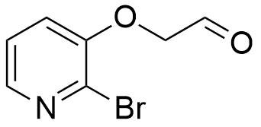

Following the general procedure, compound (10j) (0.19 g, 0.88 mmol), osmium tetroxide (1.05 g, 0.09 mmol) and sodium periodate (0.44 g, 1.76 mmol), were dissolved in dioxane/H₂O (3:1) (4 mL) and allowed react as described above. After purification by silica gel chromatography (Hex: EtOAc (5:1)) compound (11g) was obtained as a dark white solid (0.12 g, 63%).
¹H NMR (400 MHz, CDCl₃) δ (ppm): 9.88 (s, 1H), 8.06 (d, J = 4.5 Hz, 1H), 7.27 (d, J = 15.0 Hz, 1H), 7.07 (d, J = 8.0 Hz, 1H), 4.69 (s, 2H).
¹³C NMR (101 MHz, CDCl₃) δ (ppm): 197.31 (C=O), 151.30 (C), 142.69 (CH), 133.08 (C), 123.52 (CH), 120.56 (CH), 73.42 (CH₂).

3.5.6 Synthesis of 3,3-dimethylchroman-4-one and 3,3-dimethylchroman-4-ol derivatives
3.5.6.1 General catalytic procedure

The palladium catalyst (0.1 equivalents), the ligand (0.25 equivalents) and the base (3 equivalents) were loaded into a Radleys reaction tube (A Radleys® 12 position carousel reactor station was used) under N₂. After, we added the aldehyde substrate and the solvent. We closed the tube and raised the temperature up to 140ºC. The reaction was left stirring for several hours, followed by TLC. We stopped the reaction after total consumption of the starting material (verified through TLC) or signs of no further reactivity and left it to cool. The solvent was evaporated under reduced pressure. We added distilled water to the mixture and extracted the organic layer with EtOAc, which was subsequently dried over anhydrous MgSO₄ and evaporated under reduced pressure. After purification by silica gel chromatography compounds (13a)-(13d) and (14a)-(14c) were obtained in very good to excellent yields.

3.5.6.2 Synthesis of 3,3-dimethylchroman-4-one (13a)

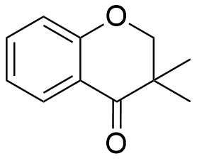

Following the general procedure, Pd(MeCN)Cl₂ (0.005 g, 0.020 mmol), PPh₃ (0.013 g, 0.049 mmol), K₂CO₃ (0.081 g, 0.585 mmol) and compound (9a) (0.050 g, 0.195 mmol), were dissolved in dioxane (4 mL) and allowed react as described above. After purification by silica gel chromatography (Hex: EtOAc (5:1)) compound (13a) was afforded as a brown solid (0.027 g, 79%).
¹H NMR (400 MHz, CDCl₃) δ (ppm): 7.96 (dd, J = 7.9, 1.7 Hz, 1H), 7.53-7.48 (m, 1H), 7.07 (ddd, J = 8.0, 7.3, 1.0 Hz, 1H), 7.01 (dd, J = 8.4, 0.7 Hz, 1H), 4.19 (s, 2H), 1.25 (s, 6H).

3.5.6.3 Synthesis of 7-fluoro-3,3-dimethylchroman-4-one (13b)

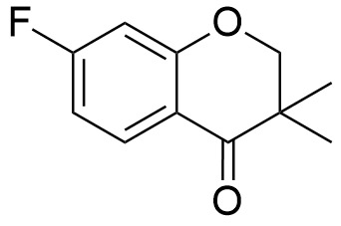

Following the general procedure, Pd(MeCN)Cl₂ (0.002 g, 0.009 mmol), PPh₃ (0.006 g, 0.023 mmol), K₂CO₃ (0.038 g, 0.273 mmol) and compound (9f) (0.025 g, 0.091 mmol), were dissolved in dioxane (4 mL) and allowed react as described above. After purification by silica gel chromatography (Hex: EtOAc (5:1)) compound (13b) was obtained as a white solid (0.015 g, 83%).
¹H NMR (400 MHz, CDCl₃) δ (ppm): 7.94 (dd, J = 8.8, 6.7 Hz, 1H), 6.77 (ddd, J = 8.8, 8.2, 2.4 Hz, 1H), 6.67 (dd, J = 9.9, 2.4 Hz, 1H), 4.19 (s, 2H), 1.23 (s, 6H).

3.5.6.4 Synthesis of 3,3,6-trimethylchroman-4-one (13c)

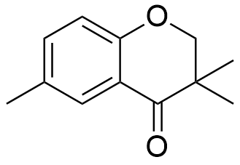

Following the general procedure, Pd(MeCN)Cl₂ (0.002 g, 0.006 mmol), PPh₃ (0.004 g, 0.015 mmol), K₂CO₃ (0.0 g, 0.177 mmol) and compound (9e) (0.016 g, 0.059 mmol), were dissolved in dioxane (4 mL) and allowed react as described above. After purification by silica gel chromatography (Hex: EtOAc (5:1)) compound (13c) was obtained as a dark yellow solid (0.008 g, 72%).
¹H NMR (400 MHz, CDCl₃) δ (ppm): 7.56 (dd, 1H), 7.30 (dd, J = 8.5, 2.0 Hz, 1H), 7.15 (dd, J = 8.6, 2.5 Hz, 1H), 4.14 (s, 2H), 2.33 (s, 3H), 1.22 (s, 6H).

3.5.6.5 Synthesis of 3,3-dimethyl-2H-benzo[g]chromen-4(3H)-one (13d)

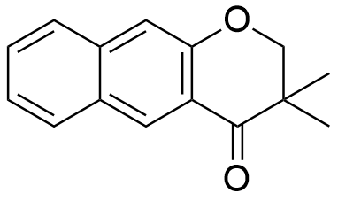

Following the general procedure, Pd(MeCN)Cl₂ (0.005 g, 0.020 mmol), PPh₃ (0.004 g, 0.050 mmol), Cs₂CO₃ (0.196 g, 0.400 mmol) and compound (9h) (0.061 g, 0.200 mmol), were dissolved in dioxane (4 mL) and allowed react as described above. After purification by silica gel chromatography (Hex: EtOAc (5:1)) compound (13d) was obtained as a yellow solid (0.042 g, 93%).
¹H NMR (400 MHz, CDCl₃) δ (ppm): 8.55 (s, 1H), 7.91 (d, J = 7.9 Hz, 1H), 7.81-7.71 (m, 1H), 7.57-7.50 (m, 1H), 7.38-7.35 (m, 1H), 4.23 (s, 1H), 1.30 (s, 1H).
¹³C NMR (101 MHz, CDCl₃) δ (ppm): 196.90 (C=O), 155.60 (C), 136.64 (C), 128.90 (CH), 128.85 (CH), 128.01 (CH), 127.57 (C), 125.55 (CH), 123.54 (CH), 123.35 (C), 119.44 (C), 111.30 (CH), 76.85 (d, J = 75.2 Hz, CH₂), 20.53 (2xCH₃).

3.5.6.6 Synthesis of 6,7-difluoro-3,3-dimethylchroman-4-one (13e)

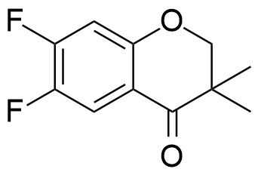

Following the general procedure, Pd(MeCN)Cl₂ (0.002 g, 0.008 mmol), PPh₃ (0.005 g, 0.019 mmol), Cs₂CO₃ (0.073 g, 0.225 mmol) and compound (9c) (0.022 g, 0.075 mmol), were dissolved in dioxane (3 mL) and allowed react as described above. After purification by silica gel chromatography (Hex: EtOAc (5:1)) compound (13e) was obtained as a white solid (0.014 g, 88%).
¹H NMR (400 MHz, CDCl₃) δ (ppm): 7.39 (t, J = 8.9 Hz, 1H), 6.77 (dd, J = 11.6, 7.0 Hz, 1H), 3.98 (s, 2H), 1.38 (s, 6H).
¹³C NMR (101 MHz, CDCl₃) δ (ppm): 175.60 (C=O), 151.80 (C), 150.68 (C), 143.16 (C), 121.31 (d, J = 20.8 Hz, CH), 105.62 (s), 102.85 (d, J = 21.7 Hz, CH), 64.77 (CH₂), 22.37 (2xCH₃).

3.5.6.7 Synthesis of 5-methoxy-3,3-dimethylchroman-4-one (13f)

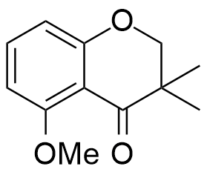

Following the general procedure, Pd(MeCN)Cl₂ (0.005 g, 0.020 mmol), PPh₃ (0.013 g, 0.050 mmol), Cs₂CO₃ (0.195 g, 0.600 mmol) and compound (9d) (0.057 g, 0.199 mmol), were dissolved in dioxane (4 mL) and allowed react as described above. After purification by silica gel chromatography (Hex: EtOAc (5:1)) compound (13f) was obtained as a yellow solid (0.038 g, 93%).
¹H NMR (400 MHz, CDCl₃) δ (ppm): 7.38 (t, J = 8.3 Hz, 1H), 6.59-6.52 (m, 2H), 4.12 (s, 2H), 3.92 (s, 3H), 1.21 (s, 6H).
¹³C NMR (101 MHz, CDCl₃) δ (ppm): 162.95 (C=O), 135.52 (CH), 129.19 (C), 109.75 (CH), 109.71 (C), 103.89 (CH), 102.15 (C), 76.18 (CH₂), 56.10 (OCH₃), 20.77 (2xCH₃).

3.5.6.8 Synthesis of 3,3-dimethylchroman-4-ol (14a)

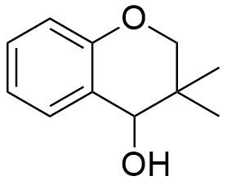

Following general procedure, Pd(MeCN)Cl₂ (0.005 g, 0.020 mmol), DPE-Phos (0.026 g, 0.050 mmol), TBAAc (0.181 g, 0.600 mmol) and compound (9a) (0.050 g, 0.200 mmol), were dissolved in dioxane (4 mL) and allowed react as described above. After purification by silica gel chromatography (Hex: EtOAc (5:1)) compound (14a) was obtained as a colourless oil (0.029 g, 89%).
¹H NMR (400 MHz, CDCl₃) δ (ppm): 7.36-7.32 (m, 1H), 7.22 (dd, J = 6.2, 4.6 Hz, 1H), 6.98-6.95 (m, 1H), 6.81 (dd, J = 8.2, 1.1 Hz, 1H), 4.27 (s, 1H), 4.00-3.95 (m, 1H), 3.75 (dd, J = 10.8, 1.1 Hz, 1H), 1.04 (s, 3H), 0.97 (s, 3H).

3.5.6.9 Synthesis of 3,3-dimethyl-3,4-dihydro-2H-benzo[g] chromen-4-ol (14b)

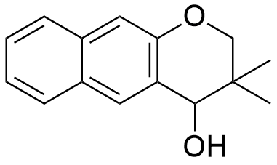

Following the general procedure, Pd(MeCN)Cl₂ (0.008 g, 0.030 mmol), DPE-Phos (0.042 g, 0.071 mmol), TBAAc (0.285 g, 0.946 mmol) and compound (9h) (0.094 g, 0.306 mmol), were dissolved in dioxane (4 mL) and allowed react as described above. After purification by silica gel chromatography (Hex: EtOAc (5:1)) compound (14b) was obtained as a colourless oil (0.065 g, 93%).
¹H NMR (400 MHz, CDCl₃) δ (ppm): 7.88 (s, 1H), 7.77 (dd, J = 8.2, 0.5 Hz, 1H), 7.71 (dd, J = 8.3, 0.4 Hz, 1H), 7.46-7.40 (m, 1H), 7.33 (ddd, J = 8.1, 6.8, 1.2 Hz, 1H), 7.23 (s, 1H), 4.52 (s, 1H), 4.12 (d, J = 10.9 Hz, 1H), 3.87 (dd, J = 10.9, 0.7 Hz, 1H), 1.09 (s, 3H), 1.05 (s, 3H).
¹³C NMR (101 MHz, CDCl₃) δ (ppm): 151.78 (C), 134.56 (C), 128.78 (C), 128.73 (CH), 127.64 (CH), 126.60 (C), 126.50 (CH), 126.36 (CH), 123.59 (CH), 110.97 (CH), 73.11 (CH₂), 72.42 (CH₂), 22.54 (CH₃), 19.01 (CH₃).

3.5.6.10 Synthesis of 7-fluoro-3,3-dimethylchroman-4-ol (14c)

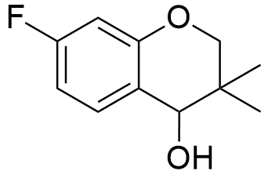

Following the general procedure, Pd(MeCN)Cl₂ (0.011 g, 0.044 mmol), DPE-Phos (0.060 g, 0.110 mmol), TBAAc (0.410 g, 1.320 mmol) and compound (9f) (0.121 g, 0.440 mmol), were dissolved in dioxane (4 mL) and allowed react as described above. After purification by silica gel chromatography (Hex: EtOAc (5:1)) compound (14c) was obtained as a white solid (0.077 g, 89%).
¹H NMR (400 MHz, CDCl₃) δ (ppm): 7.29 (dd, J = 8.2, 6.8 Hz, 1H), 6.66 (td, J = 8.4, 2.2 Hz, 1H), 6.56 (dd, J = 10.3, 2.2 Hz, 1H), 4.25 (s, 1H), 3.99 (d, J = 10.9 Hz, 1H), 3.77 (d, J = 10.9 Hz, 1H), 1.06 (s, 3H), 0.97 (s, 3H).
¹³C NMR (101 MHz, CDCl₃) δ (ppm): 163.47 (C), 161.03 (C), 153.82 (C), 153.70 (C), 129.88 (d, J = 10.1 Hz, CH), 119.07 (d, J = 3.0 Hz, C), 107.01 (d, J = 21.8 Hz, CH), 102.48 (d, J = 24.4 Hz, CH), 70.83 (CH₂), 70.79 (CH₂), 21.37 (CH₃), 18.39 (CH₃).

3.5.7 Other attempted reactions
3.5.7.1 General procedure for the alkylation of o-boronophenol substrates (1a) and (1b) (Schemes 3.6 and 3.8)

A solution of (2-hydroxyphenyl)boronic acid (1a) or 2-(4,4,5,5-tetramethyl-1,3,2-dioxaborolan-2-yl)phenol (1b) in DMF was added to a two-neck round-bottom flask under N₂. The mixture was left to stir for 20 minutes, at 80 ºC. Subsequently, base and 4-chlorobutan-1-ol were added to the flask and the mixture was left stirring for 18 hours, at 80 ºC, followed by TLC. After this time, the reaction was left to cool and the solvent was evaporated under reduced pressure. The organic layer was extracted using a mixture of AcOEt and ammonium chloride (1:1), washed with brine and dried over anhydrous MgSO₄. Finally, the solvent was evaporated under reduced pressure.

3.5.7.2 General procedure for the borylation of compounds (4a), (4c), (6e), (9a), (9b) and (11a) (Schemes 3.24, 3.25, 3.26, 3.27, 3.28, 3.30 and 3.31, 3.32)

The following reagents were added sequentially to a two-neck round-bottom flask with solvent under N₂: Pd(dppf)Cl₂ or Pd(OAc)₂ or PdCl₂(PPh₃)₂ or Pd₂(dba)₃, S-Phos or PCy₃ (only when ligands were employed), KOAc or K₂CO₃ or NEt₃, pinacolborane and correspondent substrate. The mixture was left stirring for 18 hours at 80 ºC, followed by TLC. After this time, the reaction was left to cool and the mixture was filtrated under a silica pad. The solvent was evaporated under reduced pressure.

3.5.7.3 General procedure for the palladium-catalysed reactions in continuous flow systems (Schemes 3.39-3.41)

Palladium catalyst, ligand (if necessary) and base were dissolved in 2 mL of dry degassed solvent and loaded it into syringe A. The substrate, the boron source and NEt₃ (if necessary) were dissolved in the same volume of solvent and loaded into syringe B. The content of both syringes was pushed over to the reactor tube at a predetermined rate, with the help of a Harvard Apparatus Pump 11 Elite. After the syringes were empty, 4 mL of solvent (2 mL in each syringe) were additionally loaded into the reactor, to push the remaining reagents and products out of the reactor tube. The product was washed with brine and water. Subsequently, the organic layer was extracted with EtOAc and dried over anhydrous MgSO₄. The solvent was evaporated under reduced pressure.

3.5.7.4 General procedure for the synthesis of the chiral cyclic alkanol (14a) (Scheme 3.42)

The following reagents were added sequentially to a two-neck round-bottom flask with dioxane under N₂: Palladium catalyst, chiral ligand, base and 4-(2-bromophenoxy)-3,3-dimethylbutan-2-one (9a). The mixture was left stirring at 120 ºC, for 18 hours, followed by TLC. The reaction was left to cool and the mixture was filtrated under a silica pad. The solvent was evaporated under reduced pressure.

3.5.7.5 General procedure for the reduction of cyclic ketone (13a) with CBS-oxazaborolidine reagent (Scheme 3.43)

To a round-bottom flask were added a 1.0 M toluene solution of (R)-2-methyl-CBS-oxazaborolidine, a solution of compound (13a) in THF and a solution of BH₃-THF complex, each at a rate of 1.0 mL/min. The resulting mixture was stirred at room temperature for 4 hours, followed by the addition of water over an ice bath. The organic layer was extracted with AcOEt, washed with brine and dried over anhydrous MgSO₄. The solvent was evaporated under reduced pressure.

3.5.7.6 General procedure for the attempted reduction of cyclic ketone (13a) with CBS-oxazaborolidine reagent (Scheme 3.44)

Compound (13a), 0.6 equivalents of BH₃ and 0.1 equivalents of (R)-2-methyl-CBS-oxazaborolidine were added dropwise to a round-bottom flask with THF, at 0 ºC. The mixture was allowed to stir for 3 hours, followed by addition of MeOH and 1.2 equivalents of HCl in Et₂O. After removal of the volatiles, toluene was added and subsequently removed under reduced pressure.

3.5.8 Biological assays

We modified the assay to measure AChE and BuChE activities from the assay described by Ellman et al. 75 μL of sample were dissolved in buffer with no more than 10 % DMSO (different concentrations), 25 μL of ATCI 15 mM or BTCI 15 mM. After, 125 μL of DTNB (3 mM) were added to the wells, followed by 25 μL of 0,3 U/mL AChE or 0,3 U/mL BuChE. The microplate was read at 405 nm, every minute for 20 minutes, in a BIO-TEK ELX800G microplate reader (using Gen5 v.1.05 software). Subsequently, a standard curve was drawn for each enzyme using seven different concentrations, ranging from 0.1 U/mL to 1 U/mL and the velocities of the reactions were measured. Enzyme activity was calculated as a percentage of the velocities, compared to that of the assay using buffer without inhibitor. Inhibitory activity was calculated from 100 subtracted of enzyme activity. Enzymatic activity was determined using Origin 8 software. Every experiment was done in triplicate.

4. Metal-Catalysed Intramolecular Arylations of α-Keto Esters

“Not explaining science seems to me perverse. When you´re in love you want to tell the world.”
Carl Sagan

  - 4.1 Introduction

Regarding the presence and relevance of the 2,3-dihydrobenzofuran scaffold in natural products and pharmaceutical compounds, molecules containing this framework are important targets, like for instance, 3-hydroxy-2,3-dihydrobenzofurans containing a stereogenic center at the 3-position. This skeleton is also present in many biologically active natural products, such as platyphyllarin A, rocaglaol, smyrindiol, avicenol A, brosimacutin G and vaginidiol (Figure 4.1).

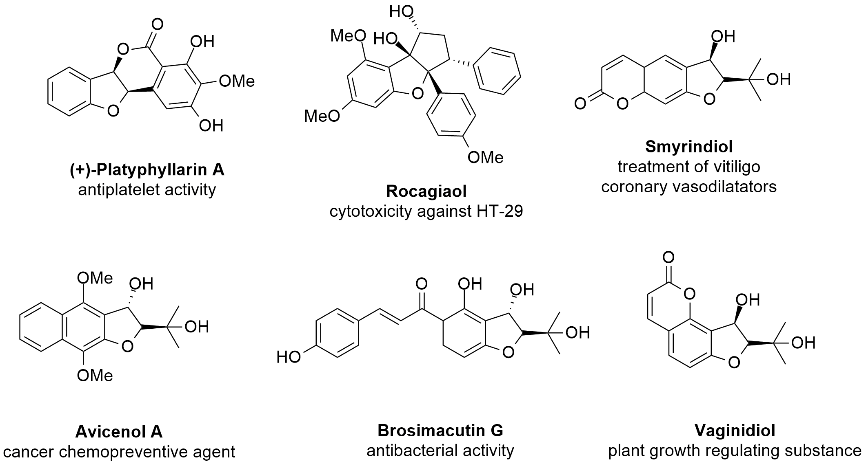
Figure 4.1: Some examples of natural products bearing the 3-hydroxy-2,3-dihydrobenzofuran scaffold.²⁰⁸

Consequently, the development of modern efficient methodologies for stereoselective access to optically active 3-hydroxy-2,3-dihydrobenzofurans is of great importance.
The first protocols for the asymmetric synthesis of this skeleton included enzymatic resolution, asymmetric borane reduction, intramolecular aldol reaction, transition metal-catalysed asymmetric addition, hydrogenation and intramolecular ring opening of oxetanes. Although, asymmetric intramolecular addition of carbon nucleophiles to ketones is an interesting method to synthesize this type of molecule, there have been few reports on its successful execution to date. This is probably due to the lower reactivity of ketones and the inherent difficulties with the reaction stereocontrol.²⁰⁹
Finally, our interest in this class of molecules has its origins in their similarity with 3-substituted-3-hydroxyoxindoles, which are well-known biologically active compounds and of considerable interest regarding cholinesterase inhibition.,

4.1.1 Metal-catalysed intramolecular addition to ketones

As mentioned before (Scheme 2.12, Chapter 2), in 2006, Lu´s group described the first example of an enantioselective intramolecular addition of arylboronic acids to ketones, using a chiral cationic Pd-BINAP complex as the catalyst. High enantioselectivities (84-96% ee) were obtained in the presence of a stoichiometric amount of anion exchange resin.⁸³ Also, rhodium-catalysed asymmetric intramolecular addition of arylboronic acid to tert-butyl ketone was accomplished by Lam, employing an isopropenyl-substituted sulfinamide ligand, though only one substrate was tested, (Scheme 2.6, Chapter 2).⁷⁷
Due to the importance of this structural motif and the general lack of efficient catalytic asymmetric methods, there is a high demand for the development of new practical catalytic cyclization methods for the enantioselective synthesis of 3-hydroxy-2,3-dihydrobenzofurans bearing a tetrasubstituted carbon stereocenter in the 3-position.
Regarding the intramolecular addition reaction, recently, Zhu and co-workers have developed a novel class of simple chiral sulphur-based olefin ligands (SOLs) and successfully employed them in the rhodium catalysed asymmetric 1,2-addition of arylboronic acids to activated ketones, such as α-ketoesters (Scheme 4.1)^{213 a)} and α-diketones (Scheme 4.2).
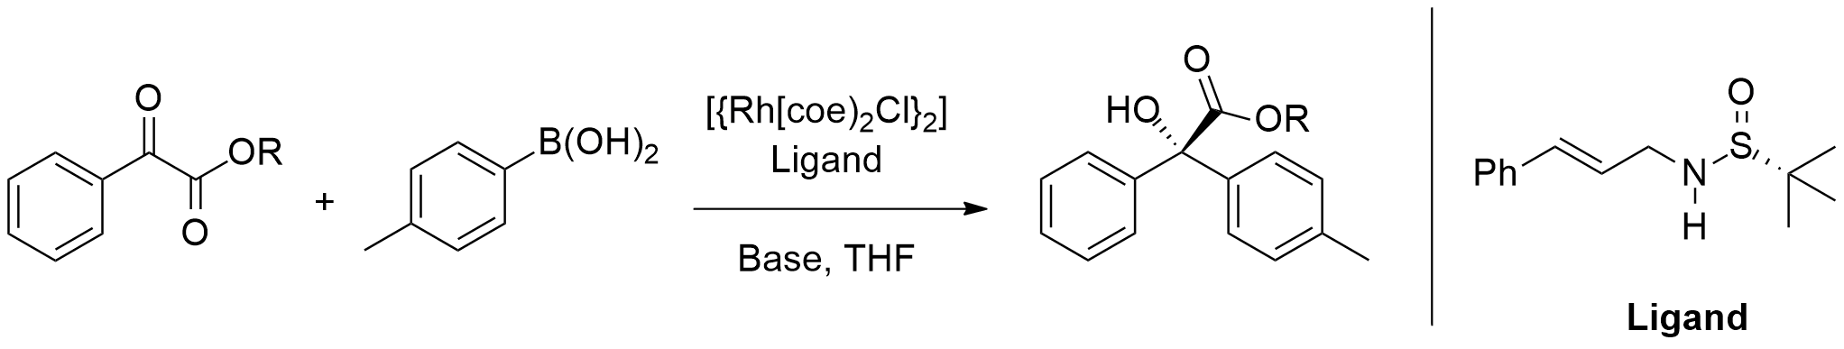
Scheme 4.1: Rhodium-catalysed asymmetric 1,2-addition of arylboronic acids to activated α-ketoesters.^{212 a)}

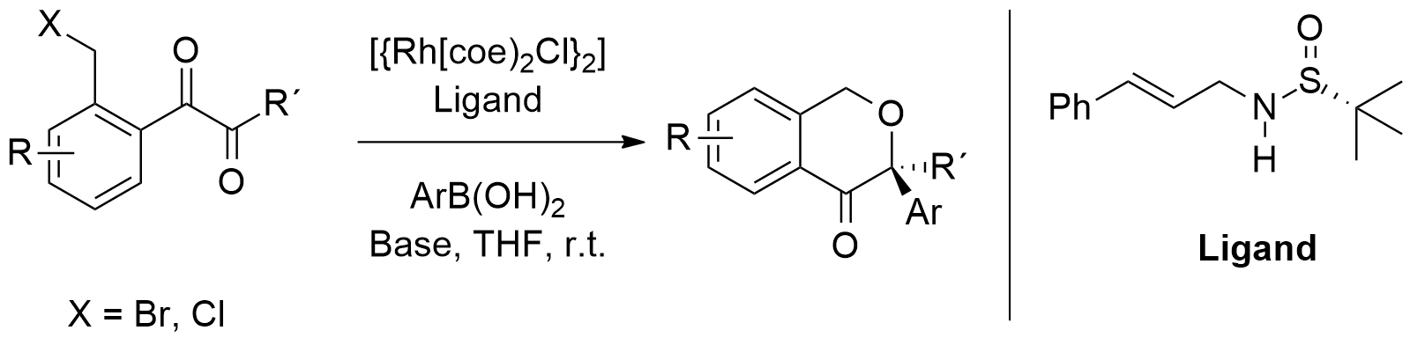
Scheme 4.2: Rhodium-catalysed asymmetric 1,2-addition of arylboronic acids to activated α-diketones.²¹³

In 2013, Marques and Burke reported a new and efficient route for the synthesis of α-hydroxyesters from ethyl glyoxalate, using rhodium(I) complexes formed in situ ([Rh(COD)OH]₂ or Rh(COD)₂BF₄ and NHC based ligands) (Scheme 4.3).

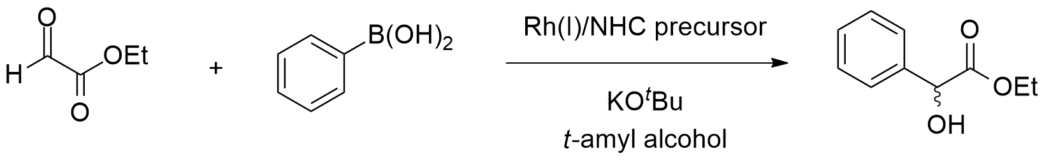
Scheme 4.3: Rh(I)-catalysed synthesis of α-hydroxyesters using ethyl glyoxalate.²¹⁴

The same authors also reported the catalytic synthesis of a library of aromatic α-amino acids, involving the addition of aryl-organoboron reagents to α,α-ditosylamino esters using transition metal catalysts (rhodium and palladium) (Scheme 4.4).

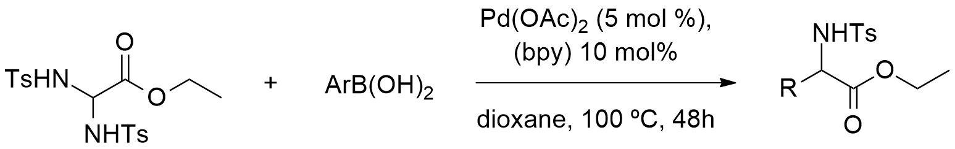
Scheme 4.4: Palladium-catalysed synthesis of aromatic α-amino acids using aryl-organoboron reagents.²¹⁵

Later in 2014, the same authors reported the asymmetric catalytic arylation of ethyl glyoxylate using rhodium(I)–phosphine and phosphine–phosphite catalysts with organoboron reagents (Scheme 4.5).
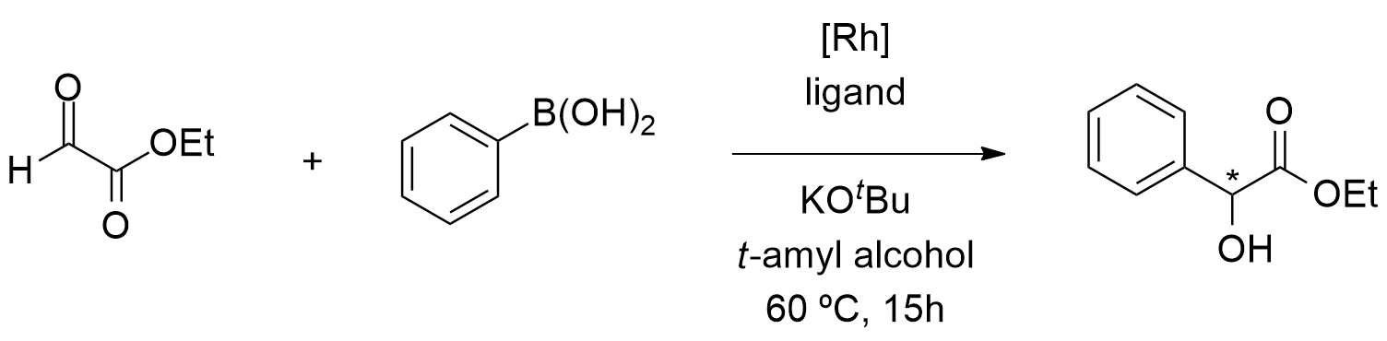
Scheme 4.5: Rhodium(I)-catalysed asymmetric catalytic arylation of ethyl glyoxylate.²¹⁶

In 2000, Yamamoto and co-workers reported a palladium-catalysed intramolecular nucleophilic addition of aryl bromides and iodides to ketones using a primary alcohol as the stoichiometric reductant (Scheme 4.6).^{172 b)}

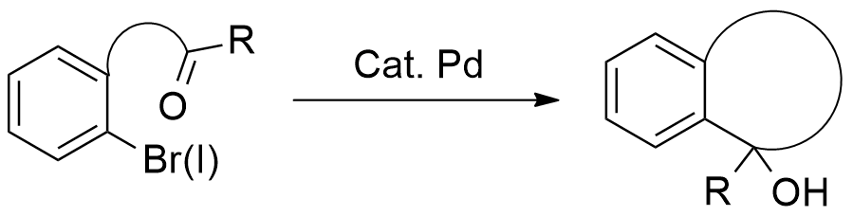
Scheme 4.6: Yamamoto´s palladium-catalysed intramolecular nucleophilic addition of aryl bromides and iodides to ketones.^{172 b)}

Our group recently reported the synthesis of a dihydrobenzofuranol compound using a palladium catalyst (Scheme 4.7).^{202, 211}

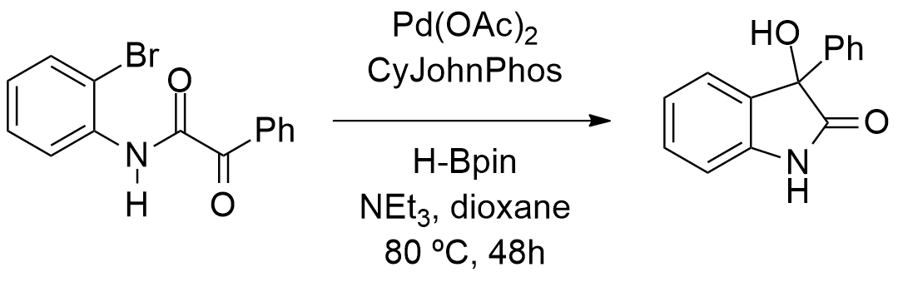
Scheme 4.7: Palladium-catalysed intramolecular nucleophilic addition of aryl bromides to ketones. ^{202, 211}

These compounds can also be accessed using isatin and derivatives as the substrate. (see Chapter 2, section 2.1.3)
However, there are, as far as we know, no reports of similar cyclizations, although, the strategy can be used to access oxindole compounds. For example, in 2010, Kündig’s group reported a racemic version of this type of 3-hydroxy-2-oxindole synthesis under Yamamoto´s original conditions (Scheme 4.8).

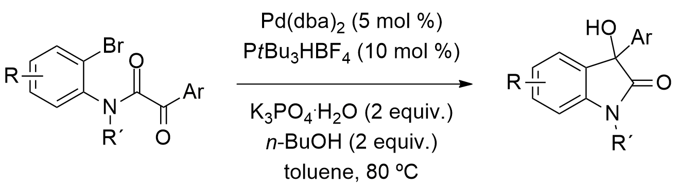
Scheme 4.8: Kündig´s palladium-catalysed intramolecular aryl-transfer reaction from aryl bromides to ketones. ²¹⁷

In the following year, Shibasaki and co-workers reported an asymmetric intramolecular arylation of α-keto amides catalysed by a palladium DifluorPhos complex (Scheme 4.9).

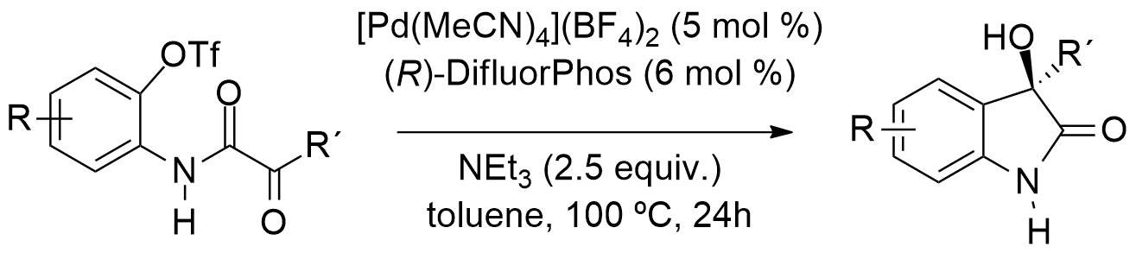
Scheme 4.9: Shibasaki ´s asymmetric intramolecular arylation of α-keto amides.²¹⁸

In 2012, Ley and co-workers reported the synthesis of enantiomerically enriched 3‑amino-2-oxindoles through a palladium-mediated asymmetric intramolecular arylation of α‑ketimino amides (Scheme 4.10).

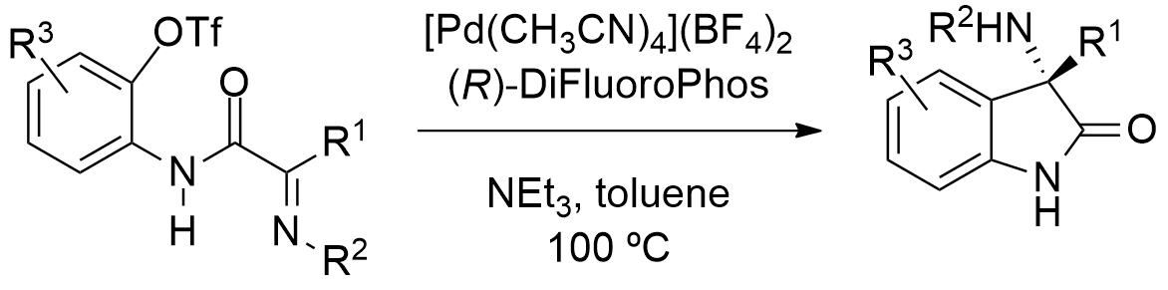
Scheme 4.10: Ley´s palladium-catalysed intramolecular arylation of α‑ketimino amides. ²¹⁹

  - 4.2 Results and Discussion
4.2.1 Synthesis of the precursors

With the objective of synthesizing a library of new substituted 3-hydroxy-3-phenylbenzofuran-2(3H)-ones, the initial work consisted in the preparation of some substituted 2-bromophenyl 2-oxo-2-phenylacetate substrates (α-keto esters). In order to accomplish this task, we studied 2 different approaches; the first approach consisted in the direct amidation of carboxylic acids catalysed by ortho-iodo arylboronic acids (i.e. MIBA, Figure 4.2), reported by Hall and co-workers, in 2012.
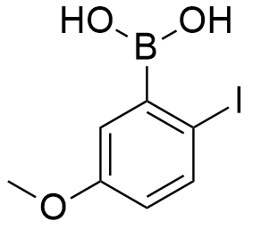
Figure 4.2: Structure of 5-methoxy-2-iodophenylboronic acid (MIBA).

The authors stated that MIBA acts as a catalyst, accelerating the orthoaminal formation step (the attack of the amine to the carboxylic acid). This occurs by the formation of an acylborate intermediate, which activates the acyl group for nucleophilic attack by the amine. The subsequent elimination of water by the orthoaminal intermediate becomes the rate-determining step (rds) (Scheme 4.11).²²⁰ This step was proposed to be facilitated by a halogen−hydrogen bond that decreases overall degrees of freedom while rendering the boron more electrophilic to ease the required shuﬄing of B−O bonds.

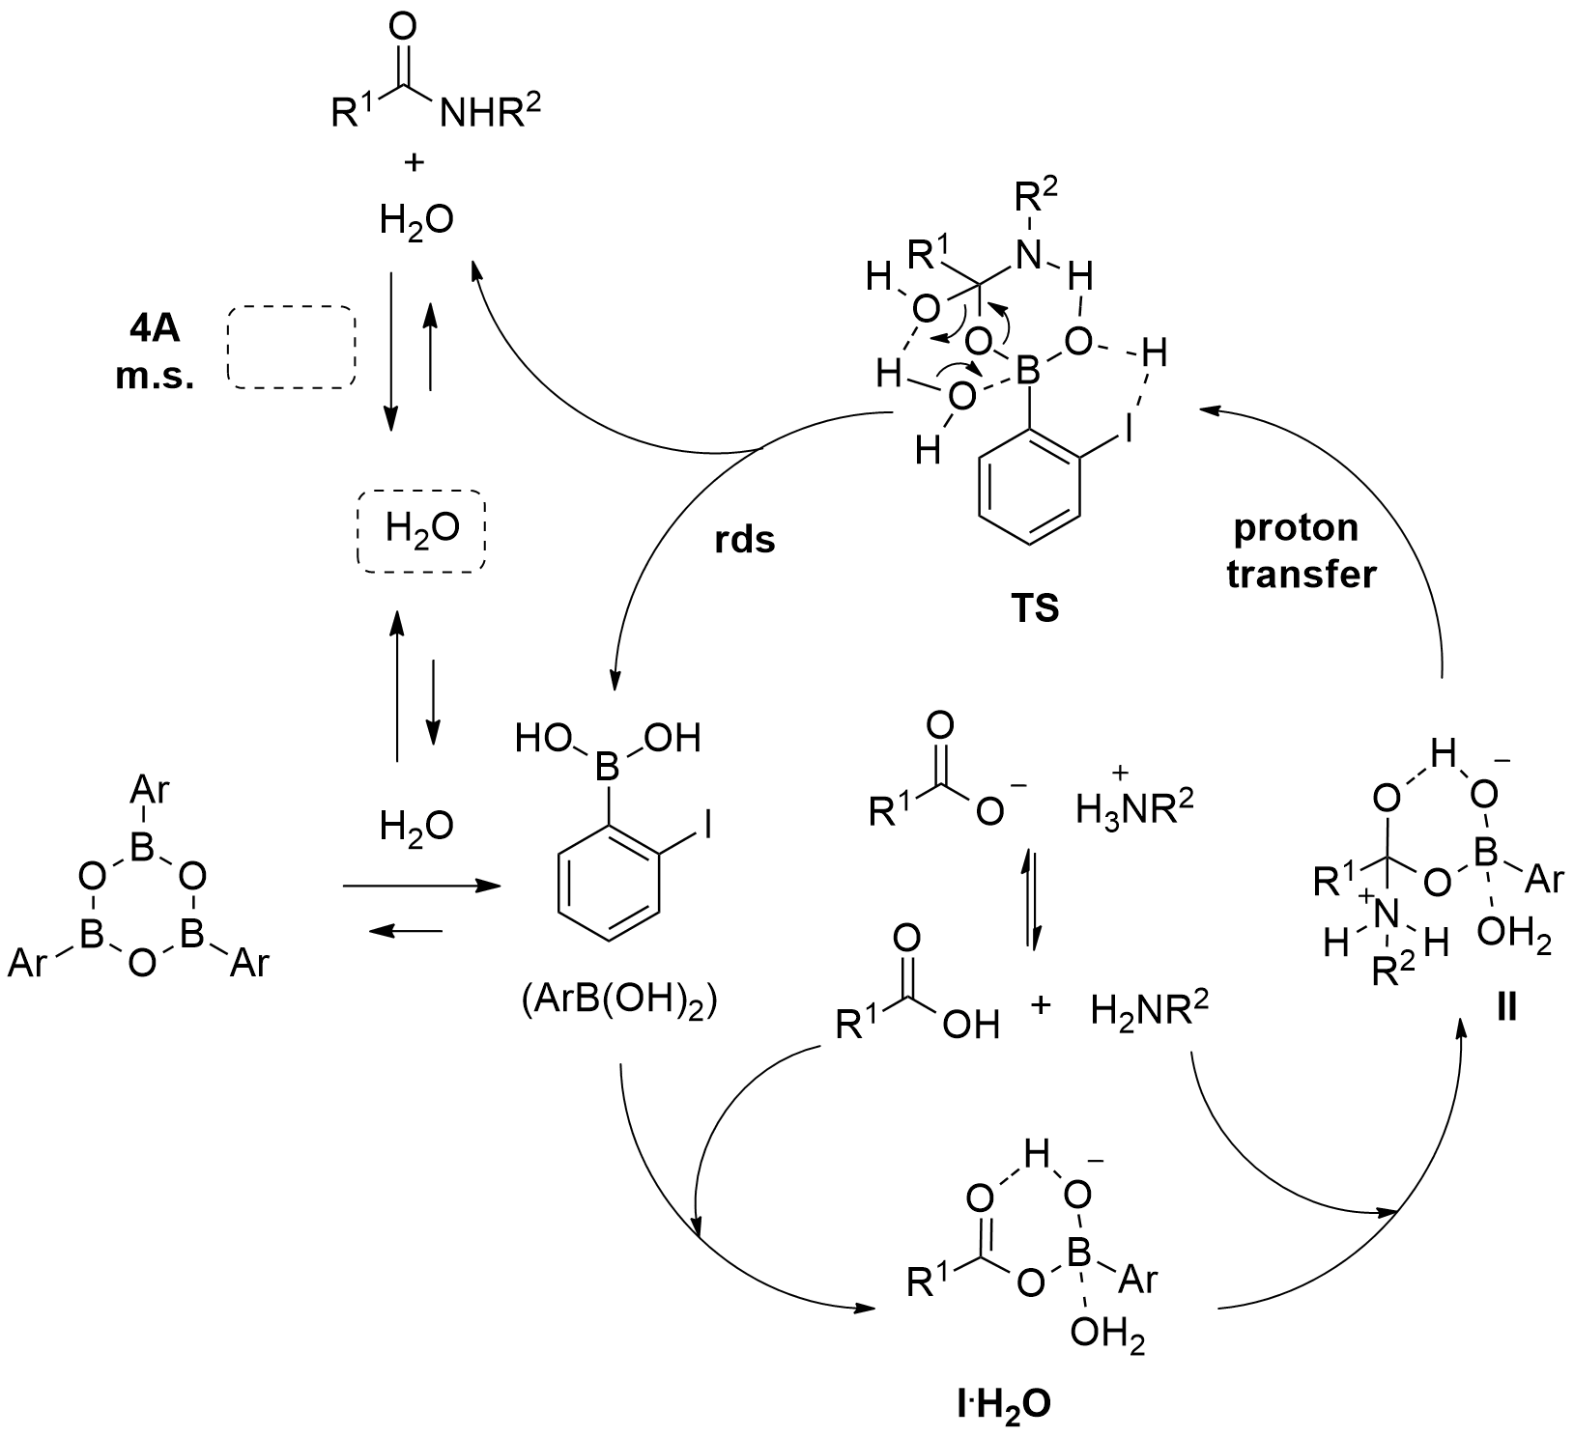
Scheme 4.11: Hall´s proposed catalytic cycle for the amidation of carboxylic acids using MIBA. Copyright American Chemical Society, reproduced with permission.²²⁰

We attempted the synthesis of 2-bromophenyl 2-oxo-3-phenylpropanoate (15a) by adapting Hall´s methodology and reacted 2-bromophenol (3a) with phenylpyruvic acid, using MIBA as catalyst, in DCM (Scheme 4.12).

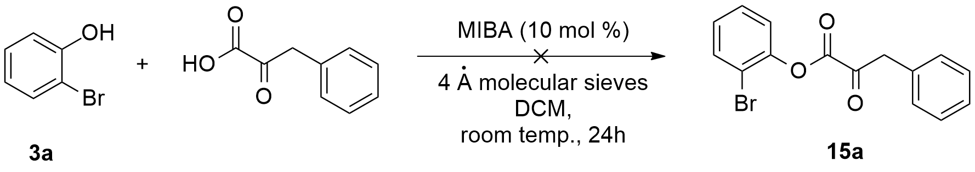
Scheme 4.12: Attempted esterification of (3a) with phenylpyruvic acid catalysed by MIBA.

This methodology failed to deliver the desired product (15a), since 2-bromophenol was the only compound detected in the ¹H NMR spectrum of the reaction mixture.
After this, we employed the more classical route involving the synthesis of acyl chlorides using oxalyl chloride and DMF (as a reaction activating agent) and subsequent nucleophilic addition / elimination reaction between the pre-formed acyl chlorides and the substituted bromophenols. Using this protocol, we reacted phenylglyoxylic acid (16) and oxalyl chloride with DMF (2-4 drops), in DCM and successfully managed to synthesize 2-oxo-2-phenylacetyl chloride (17), in quantitative yield (Scheme 4.13).

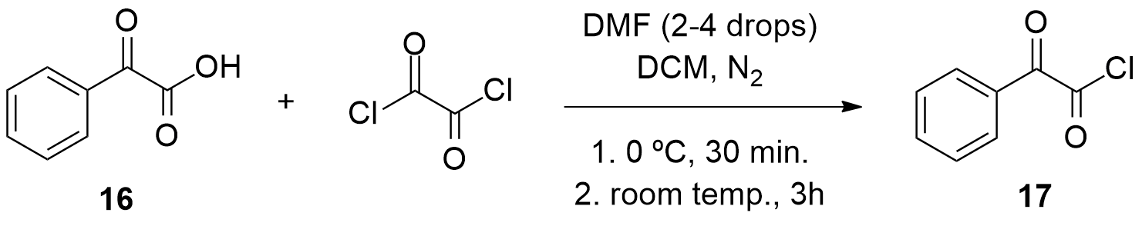
Scheme 4.13: Synthesis of 2-oxo-2-phenylacetyl chloride (17).

Next, we reacted several substituted 2-bromophenols, 1-bromonaphthalen-2-ol (5a) or 3-bromonaphthalen-2-ol (5b) with 2-oxo-2-phenylacetyl chloride (17), using NEt₃ as base, in DCM, to obtain the corresponding 2-bromophenyl 2-oxo-2-phenylacetates (18a)-(18f), 1-bromonaphthalen-2-yl 2-oxo-2-phenylacetate (18g) or 3-bromonaphthalen-2-yl 2-oxo-2-phenylacetate (18h) (Scheme 4.14), in very high or excellent yields, as shown in Table 4.1.
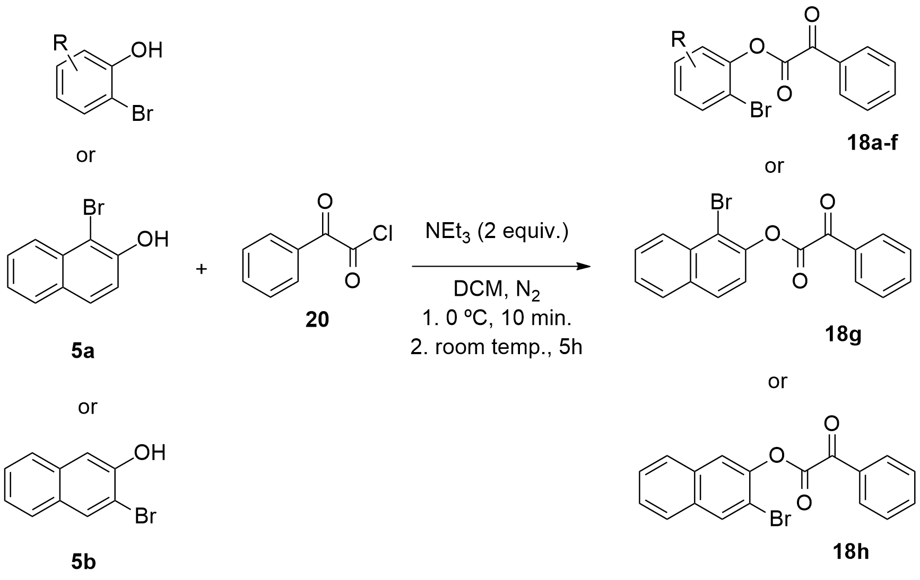
Scheme 4.14 Synthesis of the α-keto esters (18a)-(18h).

Table 4.1 Results for the synthesis of the α-keto ester substrates (18a)-(18h)

Entry | Substrate | Product | Yield/%^{(a)}
1 | 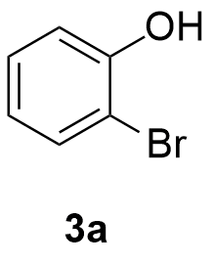 | 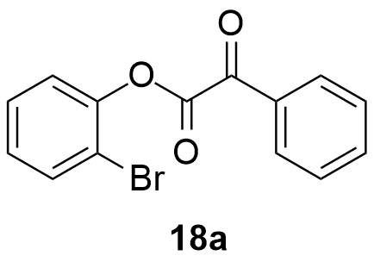 | 87
2 | 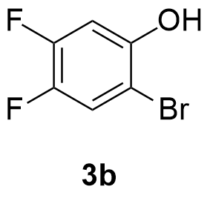 | 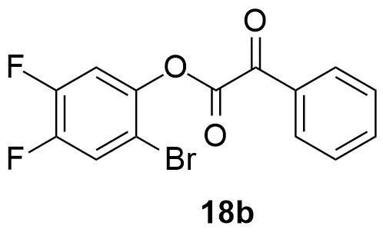 | 86
3 | 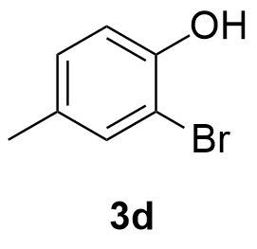 | 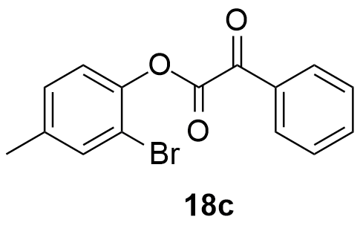 | 93
4 | 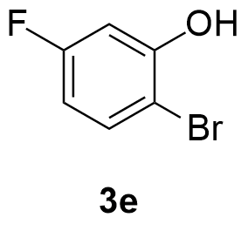 | 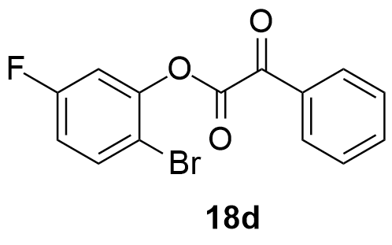 | 96
5 | 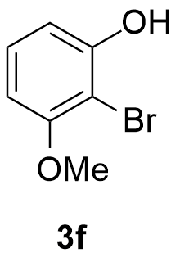 | 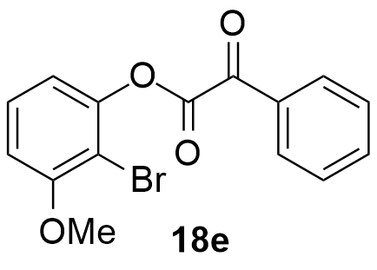 | 94
6 | 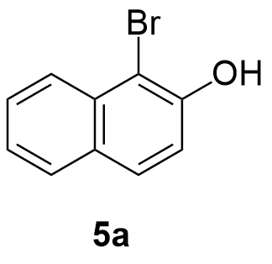  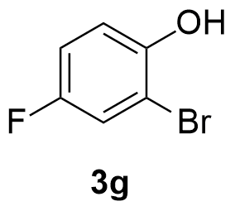 | 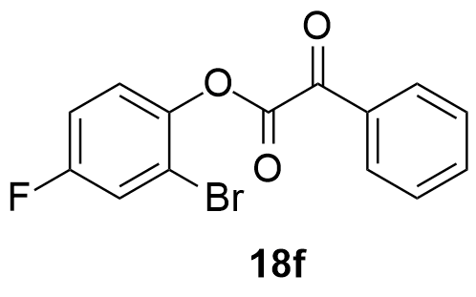 | 88
7 |  | 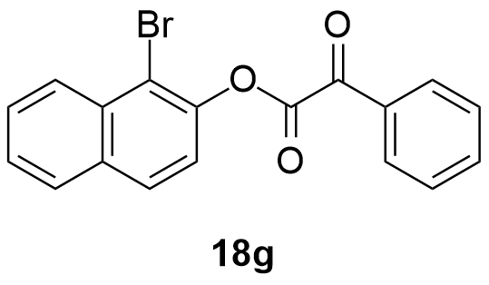  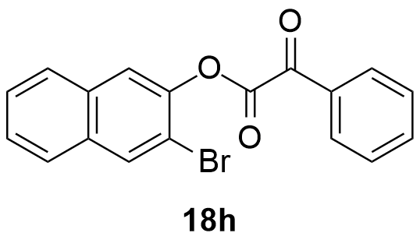 | 85
8 | 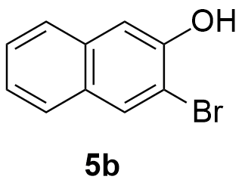 |  | 82
^{(a)} Determined by addition of an internal standard (mesitylene).

These results revealed that the reactions were very efficient and clean, since in some reactions no further purifications were needed.

4.2.2 Metal-catalysed borylation of α-keto esters

After having successfully synthesized the α-keto ester substrates, and following the know-how already existing in the Burke group^{202, 211} we investigated the best reaction conditions to convert these substrates into their corresponding cyclic products. The objective was to obtain the corresponding borylated derivatives and then cyclize them via metal-catalysis, instead of using o-halogen substituted derivatives, as used by the Kundig’s and Shibasaki groups.
The first attempted borylation involved the reaction of 1-bromonaphthalen-2-yl 2-oxo-2-phenylacetate (18g) with pinacolborane catalysed by Pd(dppf)Cl₂ (Scheme 4.15), accordingly to the established protocol (see Chapter 3).

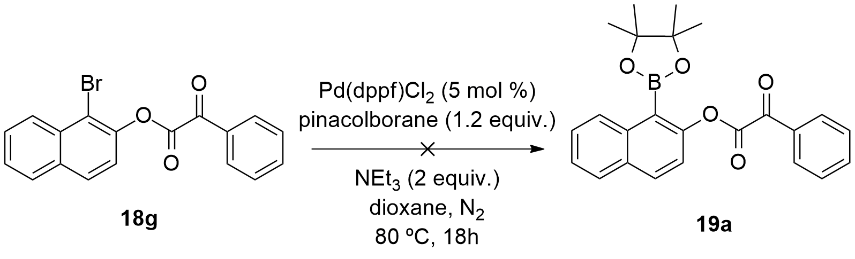
Scheme 4.15: Attempted borylation of compound (18g) employing a Pd(dppf)Cl₂ catalyst.

However, after purification of the reaction mixture by silica gel chromatography, we did not detect any traces of the desired borylated product (19a) in the corresponding ¹H NMR spectrum. Instead, we identified the presence of 1-bromonaphthalen-2-ol (5a), which presumably resulted from the hydrolysis of the ester substrate (18g), during the work-up stage (Figure 4.3).

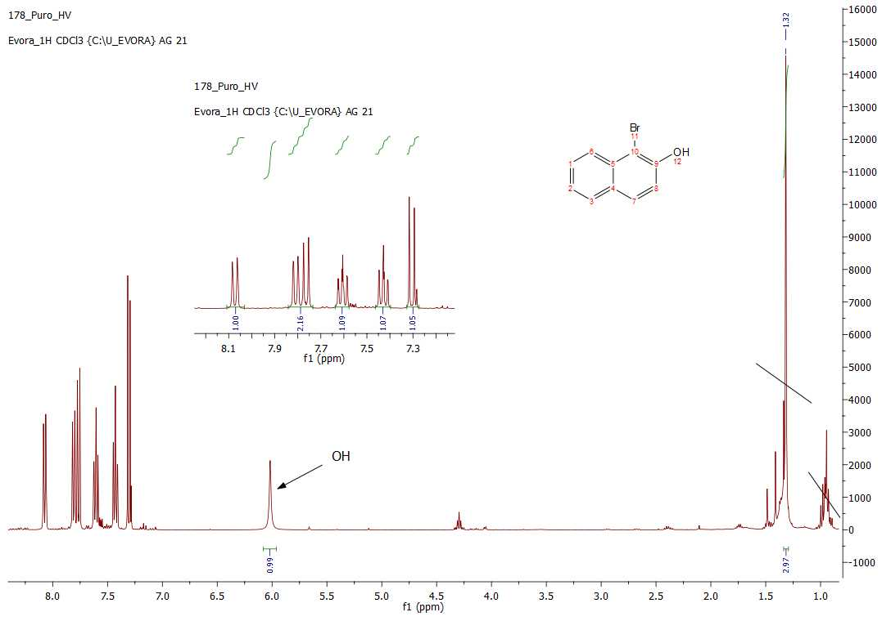
Figure 4.3: ¹H NMR spectra of 1-bromonaphthalen-2-ol (5a).

We then turned to another borylation methodology, reported by Molander et al. We used this methodology expecting that it could help us converting substrate (18g) into its borylated counterpart (19b), using tetrahydroxydiboron and Ni(dppp)Cl₂, in the presence of DIPEA, in EtOH (Scheme 4.16).
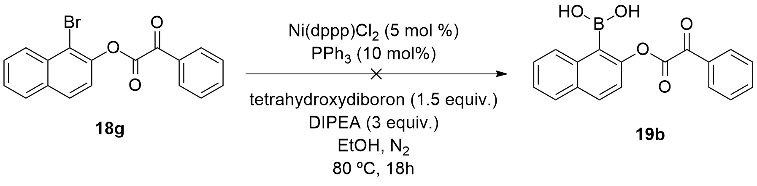
Scheme 4.16: Attempted borylation of substrate (18g) employing a nickel catalyst.

Again, after purification of the reaction mixture by silica gel chromatography, we failed to detect any traces of the desired borylated product (19b) in the corresponding ¹H NMR spectrum. Still, we managed to identify two different products in about almost equal quantities; 1-bromonaphthalen-2-ol (5a) and 1-bromonaphthalene (presumably obtained by the reduction of (18g)) (Figure 4.4).
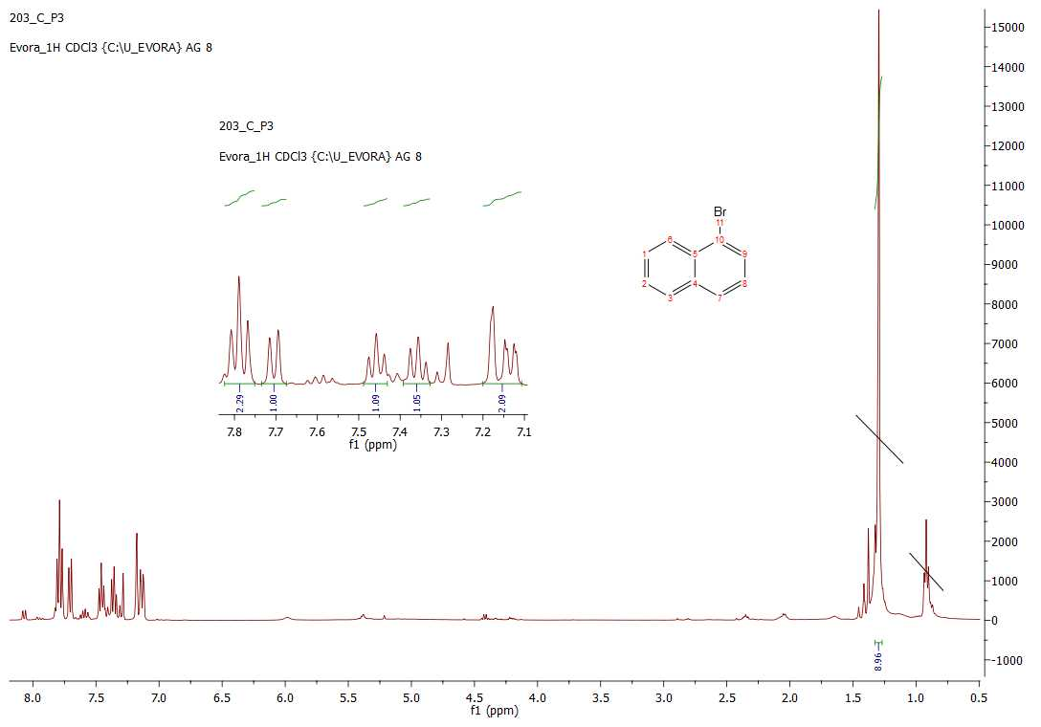
Figure 4.4: ¹H NMR spectra of 1-bromonaphthalene.

Considering the products obtained in both of these reactions, we can try to provide some probable explanations to why these reactions failed. Regarding the formation of 1-bromonaphthalen-2-ol (5a) (Figure 4.3), for this compound to be synthesized, the hydrolysis of the starting material had to occur. Regarding the formation of 1-bromonaphthalene (Figure 4.4), there is literature precedent for it formation via a reductive cleavage. In 2015, Chatani and co-workers reported the nickel-catalysed reductive cleavage of aryl alkyl ethers to arenes, in absence of an external reductant (Scheme 4.17).
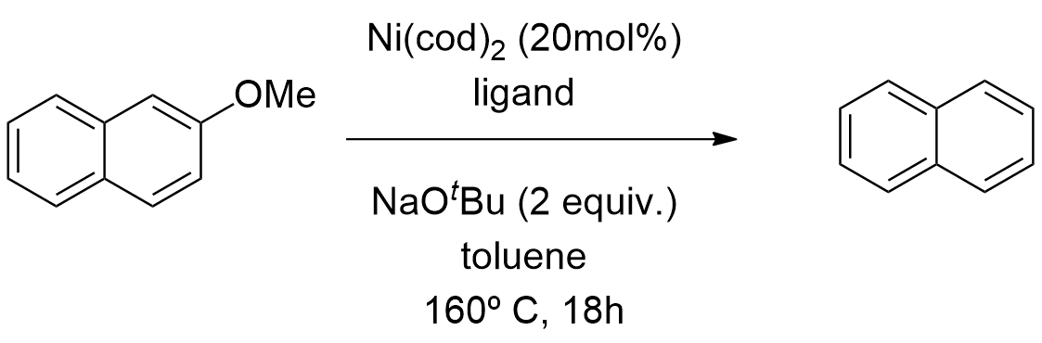
Scheme 4.17: Nickel-catalyzed reduction of 2-methoxynaphthalene to give naphthalene.²²³

These authors claim that this process involves an oxidative addition of the C(aryl)-O bond to form nickel(II)-methoxide. β-hydrogen elimination would lead to the formation of the reductive cleavage product. Since we used a nickel catalyst and that EtOH could deliver the hydride, we can presume that the same situation occurred with our substrate, thus providing the product of the reductive cleavage, 1-bromonaphthalene. Unfortunately, none of the other ester substrates was investigated, as we believed that this study would be representative of the reactivity of all the other substrates.
Considering all of these results, we decided to change our synthetic approach, avoiding the use of boronic ester intermediates. Consequently, we decided to conduct the cyclizations directly on the original α-keto ester substrates (18a)-(18h), in a similar fashion to the methods of Kündig and Shibasaki.

4.2.3 Metal-catalysed intramolecular arylations of α-keto esters

We tried performing a series of reactions using different metal catalysts, ligands, bases, temperatures and solvents. The first attempted cyclization of our α-keto esters involved the reaction of 1-bromonaphthalen-2-yl 2-oxo-2-phenylacetate (18g) catalysed by chloro(1,5-cyclooctadiene) rhodium(I) dimer ([Rh(cod)Cl]₂) and K₂CO₃, in dioxane, at 100 ºC, for 18 h (Scheme 4.18).
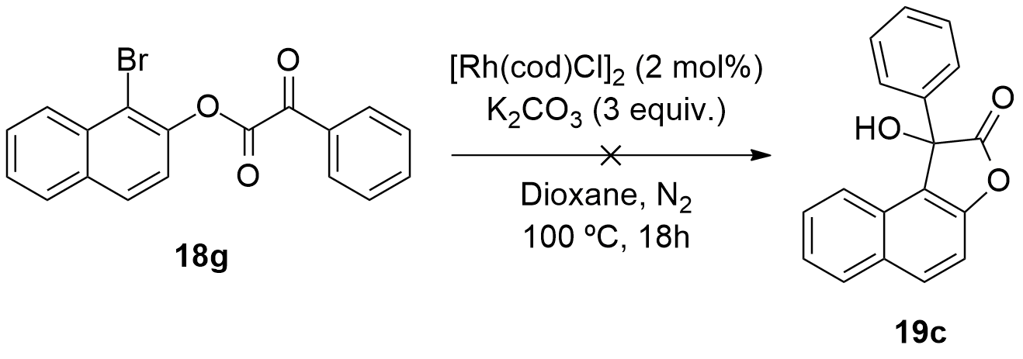
Scheme 4.18: Attempted cyclization of compound (18g) employing a rhodium catalyst.

These conditions failed to provide the desired cyclized product (19c). After purification of the crude product with silica gel chromatography, ¹H NMR analysis of the fractions showed the presence of two different compounds; 1-bromonaphthalen-2-ol (5a) and 1-bromonaphthalene (products of the C-O cleavage and the reductive cleavage, respectively).
Next, 4 different catalysts including ruthenium(III)Cl hydrate (RuCl₃.H₂O), dichloro(p-cymene)ruthenium(II) dimer, tris(triphenylphosphine) ruthenium(II) dichloride, ([Ru(PPh₃)₃Cl₂]), and Pd(MeCN)₂Cl₂ were tested, employing the same conditions described in Scheme 4.18 (Scheme 4.19).

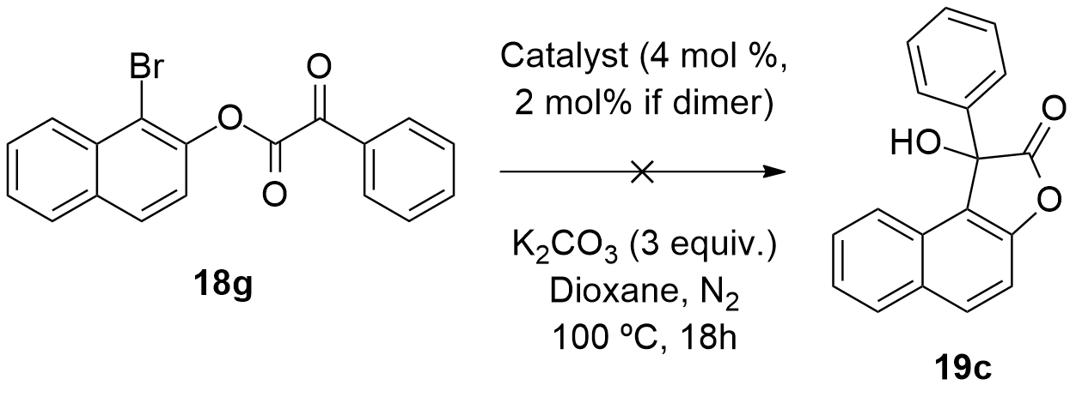
Scheme 4.19: Attempted cyclization of compound (18g) using 4 different Rh catalysts.

Once again, none of these reactions provided the cyclic derivative (19c). All of the ¹H NMR spectra showed presence of 1-bromonaphthalen-2-ol (5a), which was probably obtained by the hydrolysis of the ester substrate.
After this, we performed a sequence of reactions using different combinations of variables such as catalyst, ligand, base and solvent. Table 4.2 summarizes the different conditions that were screened.

Table 4.2 Screening of various conditions for cyclizing (18g) to (19c).
ª Reaction was carried at 100 ºC; ^{b} 1 equivalent of acetic acid was used as an additive.

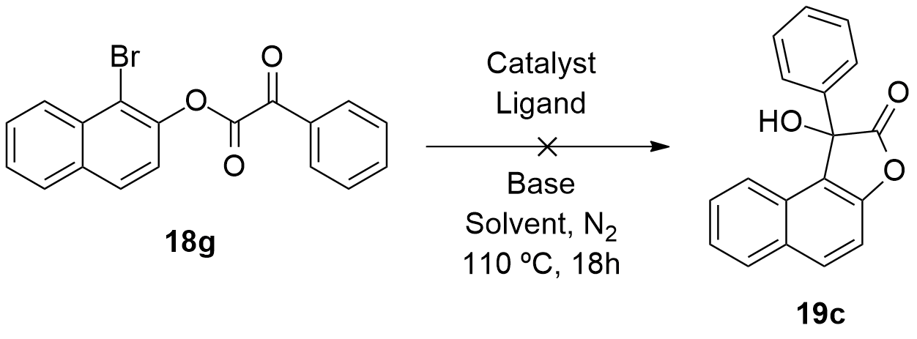

Entry | Catalyst (mol %) | Ligand (mol %) | Base (equiv.) | Solvent | Reaction  Outcome
1ª | [Rh[(1,5-cyclooctadiene)₂Cl₂]₂ (1.5) | BINAP (3.3) | K₂CO₃ (3) | Dioxane | n.r.
2ª | Rh(1,5-cyclooctadiene)₂.BF₄ (3) | BINAP (3.3) | K₂CO₃ (3) | Dioxane | n.r.
3ª | Pd(MeCN)₄.(BF₄)₂ (10) | BINAP (12) | NEt₃ (3) | THF | n.r.
4ª | Pd(MeCN)₂Cl₂ (10) | BINAP (12) | NEt₃ (3) | THF | n.r.
5ª | Pd(MeCN)₂Cl₂ (10) | PPh₃ (25) | K₂CO₃ (3) | Dioxane | n.r.
6 | Pd(MeCN)₄.(BF₄)₂ (10) | T-BINAP (12) | NEt₃ (4) | Toluene | n.r.
7 | Pd(MeCN)₄.(BF₄)₂ (10) | PPh₃ (12) | NEt₃ (4) | Toluene | n.r.
8 | Pd(MeCN)₄.(BF₄)₂ (10) | DPE-Phos (12) | NEt₃ (4) | Toluene | n.r.
9 | Pd(MeCN)₄.(BF₄)₂ (10) | (R)-T-BINAP (12) | K₂CO₃ (4) | Toluene | n.r.
10 | Pd(MeCN)₄.(BF₄)₂ (10) | PPh₃ (12) | K₂CO₃ (4) | Toluene | n.r.
11 | Pd(MeCN)₄.(BF₄)₂ (10) | DPE-Phos (12) | K₂CO₃ (4) | Toluene | n.r.
12 | Pd(MeCN)₂Cl₂ (10) | T-BINAP (25) | NEt₃ (4) | Toluene | n.r.
13 | Pd(MeCN)₂Cl₂ (10) | PPh₃ (25) | K₂CO₃ (4) | Toluene | n.r.
14 | Pd(MeCN)₂Cl₂ (10) | DPE-Phos (25) | TBAAc (4) | Toluene | n.r.
15^{b} | Pd(MeCN)₄.(BF₄)₂ (10) | T-BINAP (12) | NEt₃ (4) | Toluene | n.r.
^{(a)} Reaction was carried at 100 ºC; ^{(b)} 1 equivalent of acetic acid was used as an additive. n.r. no reaction

Unfortunately, none of these reactions provided us the cyclized derivative (19c). ¹H NMR analysis of the reaction mixtures for the reactions performed in entries 1, 2 and 6 (Table 5.2) were the only ones to show a mixture of 1-bromonaphthalene and 1-bromonaphthalen-2-ol (5a). Entries 3 and 7 (Table 4.2) showed merely the presence of starting material, 1-bromonaphthalen-2-ol (5a). In entry 4 (Table 4.2) we detected the presence of the substrate (18g). In entries 11 and 12 (Table 4.2) we identified the substrate (18g), as well as 1-bromonaphthalen-2-ol (5a). The ¹H NMR spectra of the reaction mixtures from both entries 9 and 14 (Table 4.2) were very dirty and no product was discerned. Once again, the presence of 1-bromonaphthalen-2-ol (5a) was observed in entries 8 and 15 (Table 4.2). In entry 9 (Table 4.2), we employed a chiral ligand hoping to obtain an enantioselective version of (19c). However, this reaction also didn´t work, since we only detected substrate (18g) in the ¹H NMR spectrum of the reaction mixture.
Moreover, none of the other ester substrates were investigated, as we believed that this study would be representative of the reactivity of all the other substrates.

4.3 Conclusions

In this chapter we reported the attempted synthesis of a library of substituted 3-hydroxy-3-phenylbenzofuran-2(3H)-ones derived from a series of α-keto ester substrates.
Regarding the synthesis of the α-keto ester substrates, we looked at two different methodologies; the direct amidation of carboxylic acids catalysed by MIBA, reported by Hall and co-workers and the classical methodology for forming esters using alcohols or phenols and acyl chlorides, followed by a nucleophilic addition / elimination mechanism. Only the latter methodology provided us with the desired products. Eight α-keto ester substrates were synthesized in very high to excellent yields.
Moreover, two methodologies were examined in an attempt to borylate the new α-keto ester substrates, employing palladium and nickel catalysts. None of the methodologies successfully provided us with the desired borylated compounds.
Based on previous literature reports from the groups of Kündig and Shibasaki, we conducted the cyclization reactions starting from the previously synthesized α-keto esters, employing a series of rhodium and palladium catalysts and different catalytic conditions. Again, these attempts were unsuccessful and the main product, in almost all cases, was the product of the ether cleavage, 1-bromonaphthalen-2-ol (5a).

4.4 Experimental Section
4.4.1 General Observations
4.4.1.1 Reagents and solvents

All the starting materials commercially available used in this work were purchased from Sigma-Aldrich, Fluka, Acros and Alfa Aeser.
Solvents used in this work were dried and purified under inert atmosphere and subjected to common laboratory purification techniques.²⁰³
- DCM was distilled over CaH₂;
- THF was distilled over sodium and benzophenone;
- Toluene was distilled over LiAlH₄;
- 1,4-Dioxane was distilled over sodium and benzophenone;
- EtOH was distilled over CaH₂.

4.4.1.2 Detection, purification and characterisation of synthesized compounds

All the reactions were followed by TLC. The plates (Merck) were revealed by either using UV light or a solution of phosphomolybdic acid in ethanol.²⁰⁴
Column chromatography was carried out on silica gel (SDS, 70-200 μm). All the eluents are described for each specific compound.
Some of the NMR analysis was made in the Faculdade de Ciências e Tecnologia/Universidade Nova de Lisboa, on a Bruker Avance Instrument (400 MHz), using CDCl₃ and DMSO-d₆ as solvents. Most of the NMR analysis was made at Universidade de Évora, Centro de Química, using a Bruker Avance Instrument III (400 MHz). Mesitylene was used as the internal standard to calculate NMR yields. All ¹H and ¹³C chemical shifts are reported in ppm and are referenced against the deuterated solvent peak.
Mass spectra were obtained from C.A.C.T.I., at Universidade de Vigo, on a Waters-Micromass (MicroTOF, ESI) or FAB Focus (Bruker Daltonics), using the TOF technique.
Everytime inert atmosphere was needed, it was described in the procedure.

4.4.2 Synthesis of the 2-oxo-2-phenylacetyl chloride (17)
4.4.2.1 General procedure

Following Kündig´s protocol,²¹⁷ phenylglyoxylic acid (0.5 g, 3.3 mmol) and 1.2 equivalents of oxalyl chloride were added to a two neck round bottom flask. DCM was added and the solution was degassed and placed under a nitrogen atmosphere. The flask was cooled with an ice bath. Next, DMF (2-4 drops) were added dropwise to the flask. After 30 minutes, the reaction was removed from the ice bath and was left stirring at room temperature, for 3 hours, monitored by TLC. The solvent was evaporated under reduced pressure. 2-oxo-2-phenylacetyl chloride (17) was obtained as a translucid oil, in quantitative yield (0.56 g, 3.3 mmol).

4.4.3 Synthesis of the α-keto ester substrates (18a)-(18h)
4.4.3.1 General procedure

2-oxo-2-phenylacetyl chloride (17) and 1.2 equivalents of the substituted 2-bromophenols or 1-bromonaphthalen-2-ol (5a) or 3-bromonaphthalen-2-ol (5b), were dissolved in DCM and added to a round bottom flask, over an ice bath. Next, 2 equivalents of NEt₃ were added to the mixture and the reaction was left stirring at room temperature, for 5 hours, monitored by TLC. The solvent was evaporated under reduced pressure. The crude mixture was washed with HCl (1M), brine and distilled water. The organic layer was extracted with EtOAc, dried over anhydrous MgSO₄ and evaporated under reduced pressure. After purification by silica gel chromatography, compounds (18a)-(18h) were obtained in very high or excellent yields.

4.4.3.2 Synthesis of 2-bromophenyl 2-oxo-2-phenylacetate (18a)

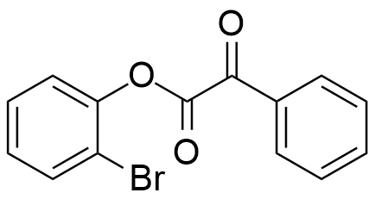

Following the general procedure, 2-oxo-2-phenylacetyl chloride (20) (0.55 g, 3.30 mmol), 2-bromophenol (3a) (0.71 g, 4.10 mmol) and NEt₃ (0.67 g, 6.60 mmol) were dissolved in DCM (6 mL) and allowed to react as described above. After purification by silica gel chromatography (Hexane) compound (18a) was obtained as a pale yellow oil (0.88 g, 87%).
¹H NMR (400 MHz, CDCl₃) δ (ppm): 8.23 (d, J = 7.7 Hz, 2H), 7.72 (t, J = 8.1 Hz, 2H), 7.59 (t, J = 7.7 Hz, 2H), 7.44 (t, J = 7.7 Hz, 1H), 7.34 (d, J = 8.0 Hz, 1H), 7.24 (t, J = 7.6 Hz, 1H).
¹³C NMR (101 MHz, CDCl₃) δ (ppm): 184.77 (C=O), 160.91 (C=O), 147.45 (C), 135.42 (CH), 133.72 (CH), 132.19 (C), 130.39 (CHx2), 129.10 (CHx2), 128.86 (CH), 128.30 (CH), 123.56 (CH), 115.72 (C).

4.4.3.3 Synthesis of 2-bromo-4,5-difluorophenyl 2-oxo-2-phenylacetate (18b)

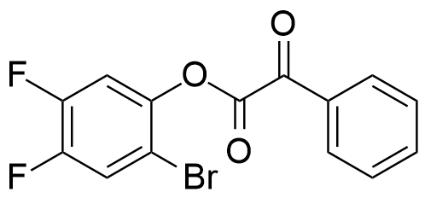

Following the general procedure, 2-oxo-2-phenylacetyl chloride (20) (0.55 g, 3.30 mmol), 2-bromo-4,5-difluorophenol (3b) (0.84 g, 4.04 mmol) and NEt₃ (0.67 g, 6.60 mmol) were dissolved in DCM (6 mL) and allowed to react as described above. After purification by silica gel chromatography (Hex: EtOAc (5:1)) compound (18b) was obtained as an opaque oil (0.97 g, 86%).
¹H NMR (400 MHz, CDCl₃) δ (ppm): 8.19 (d, J = 7.8 Hz, 2H), 7.76 (t, J = 7.4 Hz, 1H), 7.63-7.53 (m, 3H), 7.26 (dd, J = 10.2, 7.7 Hz, 1H).
¹³C NMR (101 MHz, CDCl₃) δ (ppm): 183.95 (C=O), 160.25 (C=O), 150.71 (C-F), 149.99 (C-F), 148.26 (d, J = 13.8 Hz, C-Br), 147.60 (C-O), 135.60 (CH), 131.98 (C), 130.36 (CHx2), 129.16 (CHx2), 121.71 (d, J = 21.3 Hz, CH), 113.07 (d, J = 21.4 Hz, CH).

4.4.3.4 Synthesis of 2-bromo-4-methylphenyl 2-oxo-2-phenylacetate (18c)

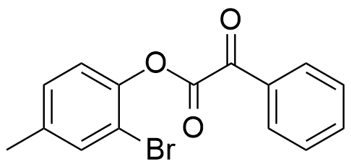

Following the general procedure, 2-oxo-2-phenylacetyl chloride (20) (0.55 g, 3.30 mmol), 2-bromo-4-methylphenol (3d) (0.78 g, 4.17 mmol) and NEt₃ (0.67 g, 6.60 mmol) were dissolved in DCM (6 mL) and allowed to react as described above. After purification by silica gel chromatography (Hexane) compound (18c) was obtained as a yellow oil (0.98 g, 93%).
¹H NMR (400 MHz, CDCl₃) δ (ppm): 8.22 (d, J = 8.0 Hz, 2H), 7.74 (t, J = 7.3 Hz, 1H), 7.59 (t, J = 7.7 Hz, 2H), 7.52 (s, 1H), 7.21 (s, 2H), 2.40 (s, 3H).
¹³C NMR (101 MHz, CDCl₃) δ (ppm): 184.90 (C=O), 161.15 (C=O), 145.11 (C-Br), 138.54 (C), 135.32 (CH), 133.97 (CH), 132.24 (C), 130.38 (CHx2), 129.45 (CH), 129.05 (CHx2), 123.01 (CH), 115.17 (C), 29.71 (CH₃).

4.4.3.5 Synthesis of 2-bromo-5-fluorophenyl 2-oxo-2-phenylacetate (18d)

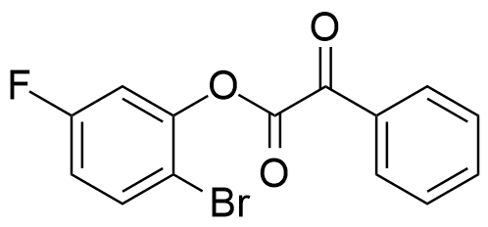

Following the general procedure, 2-oxo-2-phenylacetyl chloride (20) (0.55 g, 3.30 mmol), 2-bromo-5-fluorophenol (3e) (0.79 g, 4.12 mmol) and NEt₃ (0.67 g, 6.60 mmol) were dissolved in DCM (6 mL) and allowed to react as described above. After purification by silica gel chromatography (Hex: EtOAc (5:1)) compound (18d) was obtained as a transparent oil (1.04 g, 96%).
¹H NMR (400 MHz, CDCl₃) δ (ppm): 8.21 (d, J = 7.5 Hz, 2H), 7.75 (t, J = 7.4 Hz, 1H), 7.67 (dd, J = 8.9, 5.7 Hz, 1H), 7.60 (t, J = 7.8 Hz, 2H), 7.13 (dd, J = 8.4, 2.8 Hz, 1H), 7.01 (td, J = 8.8, 2.8 Hz, 1H).
¹³C NMR (101 MHz, CDCl₃) δ (ppm): 184.17 (C=O), 163.22 (C=O), 160.74 (C), 160.29 (C), 148.02 (d, J = 11.0 Hz, C-F), 135.53 (CH), 134.17 (d, J = 8.9 Hz, CH), 132.05 (C), 130.39 (CHx2), 129.13 (CHx2), 115.67 (d, J = 22.3 Hz, CH), 111.82 (d, J = 25.7 Hz, CH).
4.4.3.6 Synthesis of 2-bromo-3-methoxyphenyl 2-oxo-2-phenylacetate (18e)

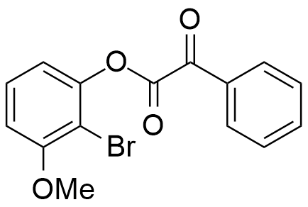

Following the general procedure, 2-oxo-2-phenylacetyl chloride (20) (0.55 g, 3.30 mmol), 2-bromo-3-methoxyphenol (3f) (0.84 g, 4.13 mmol) and NEt₃ (0.67 g, 6.60 mmol) were dissolved in DCM (6 mL) and allowed to react as described above. After purification by silica gel chromatography (Hex: EtOAc (5:1)) compound (18e) was obtained as a dark yellow oil (1.04 g, 94%).
¹H NMR (400 MHz, CDCl₃) δ (ppm): 8.22 (d, J = 7.8 Hz, 2H), 7.73 (t, J = 7.4 Hz, 1H), 7.58 (t, J = 7.7 Hz, 2H), 7.38 (t, J = 8.3 Hz, 1H), 6.96 (d, J = 8.2 Hz, 1H), 6.90 (d, J = 8.4 Hz, 1H), 3.96 (s, 3H).
¹³C NMR (101 MHz, CDCl₃) δ (ppm): 184.83 (C=O), 160.86 (C=O), 157.53 (C), 148.65 (C), 135.37 (CH), 132.20 (C-OMe), 130.40 (CHx2), 129.07 (CHx2), 128.65 (CH), 115.38 (CH), 110.07 (CH), 105.94 (CH), 56.70 (OCH₃).

4.4.3.7 Synthesis of 2-bromo-4-fluorophenyl 2-oxo-2-phenylacetate (18f)

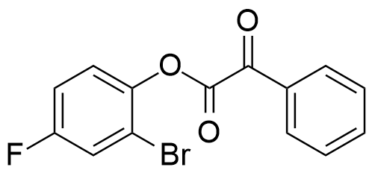

Following the general procedure, 2-oxo-2-phenylacetyl chloride (20) (0.55 g, 3.30 mmol), 2-bromo-4-fluorophenol (3g) (0.78 g, 4.08 mmol) and NEt₃ (0.67 g, 6.60 mmol) were dissolved in DCM (6 mL) and allowed to react as described above. After purification by silica gel chromatography (Hex: EtOAc (5:1)) compound (18f) was obtained as a transparent oil (0.94 g, 88%).
¹H NMR (400 MHz, CDCl₃) δ (ppm): 8.21 (d, J = 7.7 Hz, 2H), 7.75 (t, J = 7.4 Hz, 1H), 7.60 (t, J = 7.7 Hz, 2H), 7.45 (dd, J = 7.7, 2.7 Hz, 1H), 7.32 (dd, J = 9.0, 5.0 Hz, 1H), 7.19-7.13 (m, 1H).
¹³C NMR (101 MHz, CDCl₃) δ (ppm): 184.48 (C=O), 161.75 (C=O), 160.82 (C-F), 159.26 (C-Br), 143.70 (C), 135.47 (CH), 132.11 (C), 130.36 (CHx2), 129.11 (CHx2), 124.30 (d, J = 9.0 Hz, CH), 120.79 (d, J = 26.1 Hz, CH), 115.79 (d, J = 23.3 Hz, CH).

4.4.3.8 Synthesis of 3-bromonaphthalen-2-yl 2-oxo-2-phenylacetate (18g)

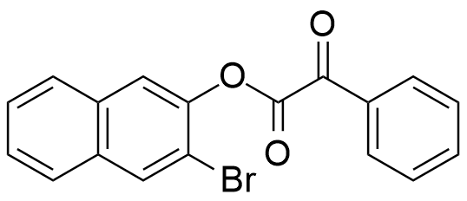

Following the general procedure, 2-oxo-2-phenylacetyl chloride (20) (0.55 g, 3.30 mmol), 3-bromonaphthalen-2-ol (5b) (0.89 g, 4.00 mmol) and NEt₃ (0.67 g, 6.60 mmol) were dissolved in DCM (6 mL) and allowed to react as described above. After purification by silica gel chromatography (Hex: EtOAc (5:1)) compound (18g) was obtained as a dark yellow oil (0.99 g, 85%).
¹H NMR (400 MHz, CDCl₃) δ (ppm): 8.27 (d, J = 7.6 Hz, 2H), 8.23 (s, 1H), 7.89-7.81 (m, 3H), 7.76 (t, J = 7.4 Hz, 1H), 7.64-7.56 (m, 4H).
¹³C NMR (101 MHz, CDCl₃) δ (ppm): 184.76 (C=O), 161.27 (C=O), 144.54 (C-Br), 135.41 (C-H), 132.81 (C), 132.77 (CH), 132.65 (C), 132.24 (C), 130.45 (CHx2), 129.10 (CHx2), 127.73 (CH), 127.33 (CH), 127.24 (CH), 126.96 (CH), 121.04 (CH), 114.03 (C).
4.4.3.9 Synthesis of 1-bromonaphthalen-2-yl 2-oxo-2-phenylacetate (18h)

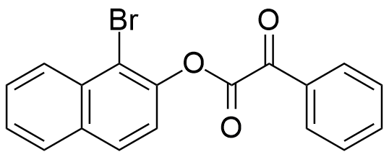

Following the general procedure, 2-oxo-2-phenylacetyl chloride (20) (0.55 g, 3.30 mmol), 1-bromonaphthalen-2-ol (5a) (0.88 g, 3.96 mmol) and NEt₃ (0.67 g, 6.60 mmol) were dissolved in DCM (6 mL) and allowed to react as described above. After purification by silica gel chromatography (Hex: EtOAc (5:1)) compound (18h) was obtained as a pale brown solid (0.97 g, 82%).
¹H NMR (400 MHz, CDCl₃) δ (ppm): 8.34 (d, J = 8.3 Hz, 1H), 8.27 (dt, J = 6.4, 2.9 Hz, 2H), 7.94 (t, J = 8.3 Hz, 2H), 7.79-7.73 (m, 1H), 7.69 (tt, J = 9.8, 1.9 Hz, 1H), 7.65-7.58 (m, 3H), 7.45 (d, J = 8.8 Hz, 1H).
¹³C NMR (101 MHz, CDCl₃) δ (ppm): 184.85 (C=O), 161.10 (C=O), 145.56 (C-Br), 135.41 (CH), 132.83 (C), 132.68 (C), 132.25 (C), 130.42 (CHx2), 129.31 (CH), 129.11 (CHx2), 128.36 (CH), 128.21 (CH), 127.16 (CH), 126.93 (CH), 121.19 (CH), 114.96 (C).

4.4.4 Other attempted reactions
4.4.4.1 General procedure for the attempted esterification of 2-bromophenol phenylpyruvic acid using MIBA as activating agent (Scheme 4.12)

To a round bottom flask were added 1.1 equivalents of phenylpyruvic acid, 10 mol% of 5-methoxy-2-iodophenylboronic acid (MIBA) and 1g of 4 Å activated molecular sieves. Subsequently, 10 mL of DCM were added and the mixture was stirred vigorously for 10 min. 1 equivalent of 2-bromophenol was added and the resulting mixture was stirred for 24h, at room temperature. After this time, the reaction mixture was filtered through a pad of celite and the filtrate washed with aqueous HCl (10%), NaHCO₃ (10%) and brine. The organic layer was extracted with DCM and dried over MgSO₄. The solvent was evaporated under reduced pressure to provide a yellow oil. Analysis of the latter by ¹H NMR showed that no product had formed.

4.4.4.2 General procedure for the attempted borylation of 1-bromonaphthalen-2-yl 2-oxo-2-phenylacetate using palladium catalyst (Scheme 4.14)

The following reagents were added sequentially to a two-neck round-bottom flask with dioxane under N₂: Pd(dppf)Cl₂ (5 mol%), NEt₃ (2 equiv.), pinacolborane (1.2 equiv.) and compound (18g). The mixture was left stirring at 80 ºC, for 18 hours, monitored by TLC. After this time, the reaction was left to cool and the mixture was filtered using a silica pad. The solvent was evaporated under reduced pressure to provide a brown solid. Analysis of the latter by ¹H NMR showed that no product had formed.

4.4.4.3 General procedure for the attempted borylation of 1-bromonaphthalen-2-yl 2-oxo-2-phenylacetate using nickel catalyst (Scheme 4.15)

To a Radleys reaction tube (using a Radleys® 12 position carousel reactor station) under N₂ were added Ni(dppp)Cl₂ (5 mol%), PPh₃ (10 mol%) and tetrahydroxydiboron ( 1.5 equiv.). Subsequently, EtOH (5 mL), DIPEA (3 equiv.) and compound (18g) were added and the reaction was allowed to stir at 80 ºC, for 18h, monitored by TLC. The reaction mixture was transferred to a separatory funnel, followed by the addition of EtOAc and aqueous HCl (1M). The organic layer was extracted and dried over MgSO₄. The solvent was evaporated under reduced pressure to provide a yellow solid. Analysis of the latter by ¹H NMR showed that no product had formed.

4.4.4.4 General procedure for the attempted arylation of 1-bromonaphthalen-2-yl 2-oxo-2-phenylacetate (18g) (Schemes 4.17 and 4.18)

The following reagents were added sequentially to 4 Radleys reaction tubes with dioxane under N₂: Ruthenium(III)Cl hydrate (RuCl₃.H₂O) (4 mol %) or dichloro(p-cymene)ruthenium(II) dimer (2 mol%), or tris(triphenylphosphine) ruthenium(II) dichloride [Ru(PPh₃)₃Cl₂] (4 mol%) or Pd(MeCN)₂Cl₂ (4 mol%), K₂CO₃ (3 equiv.) and compound (18g). The mixtures were allowed to stir at 120 ºC, for 18 hours, monitored by TLC. The reactions were allowed to cool down and the mixtures were filtered with silica pads. The solvents were evaporated under reduced pressure.

4.4.4.5 General procedure for the attempted arylation of 1-bromonaphthalen-2-yl 2-oxo-2-phenylacetate (18g) using different conditions (Scheme 4.19)

The following reagents were added sequentially to a Radleys reaction tube with solvent under N₂: Catalyst, base and compound (18g). The mixtures were left stirring different temperatures, for 18 hours, monitored by TLC. The reactions were allowed to cool down and the mixtures were filtered using silica pads. The solvents were evaporated under reduced pressure.

5. Direct Oxidative Esterification of Primary Alcohols: A Tool for Synthesising New Bioactive Macrocycles

“The good thing about science is that it´s true whether or not you believe in it.”
Carl Sagan

  - 5.1 Introduction

Esterification represents a powerful tool for converting alcohols to esters. Due to their importance, chemists have been preoccupied with the synthesis of esters for more than 100 years.
Classical esterification methods rely on nucleophilic substitution reactions between carboxylic acid derivatives and alcohols (Figure 5.1). Typically, carboxylic halides and anhydrides are synthesized from their corresponding carboxylic acids. Consequently, esterification procedures usually entail several steps, including the production of undesired side products, which is in contrast with the existing demand for friendly environmental processes.

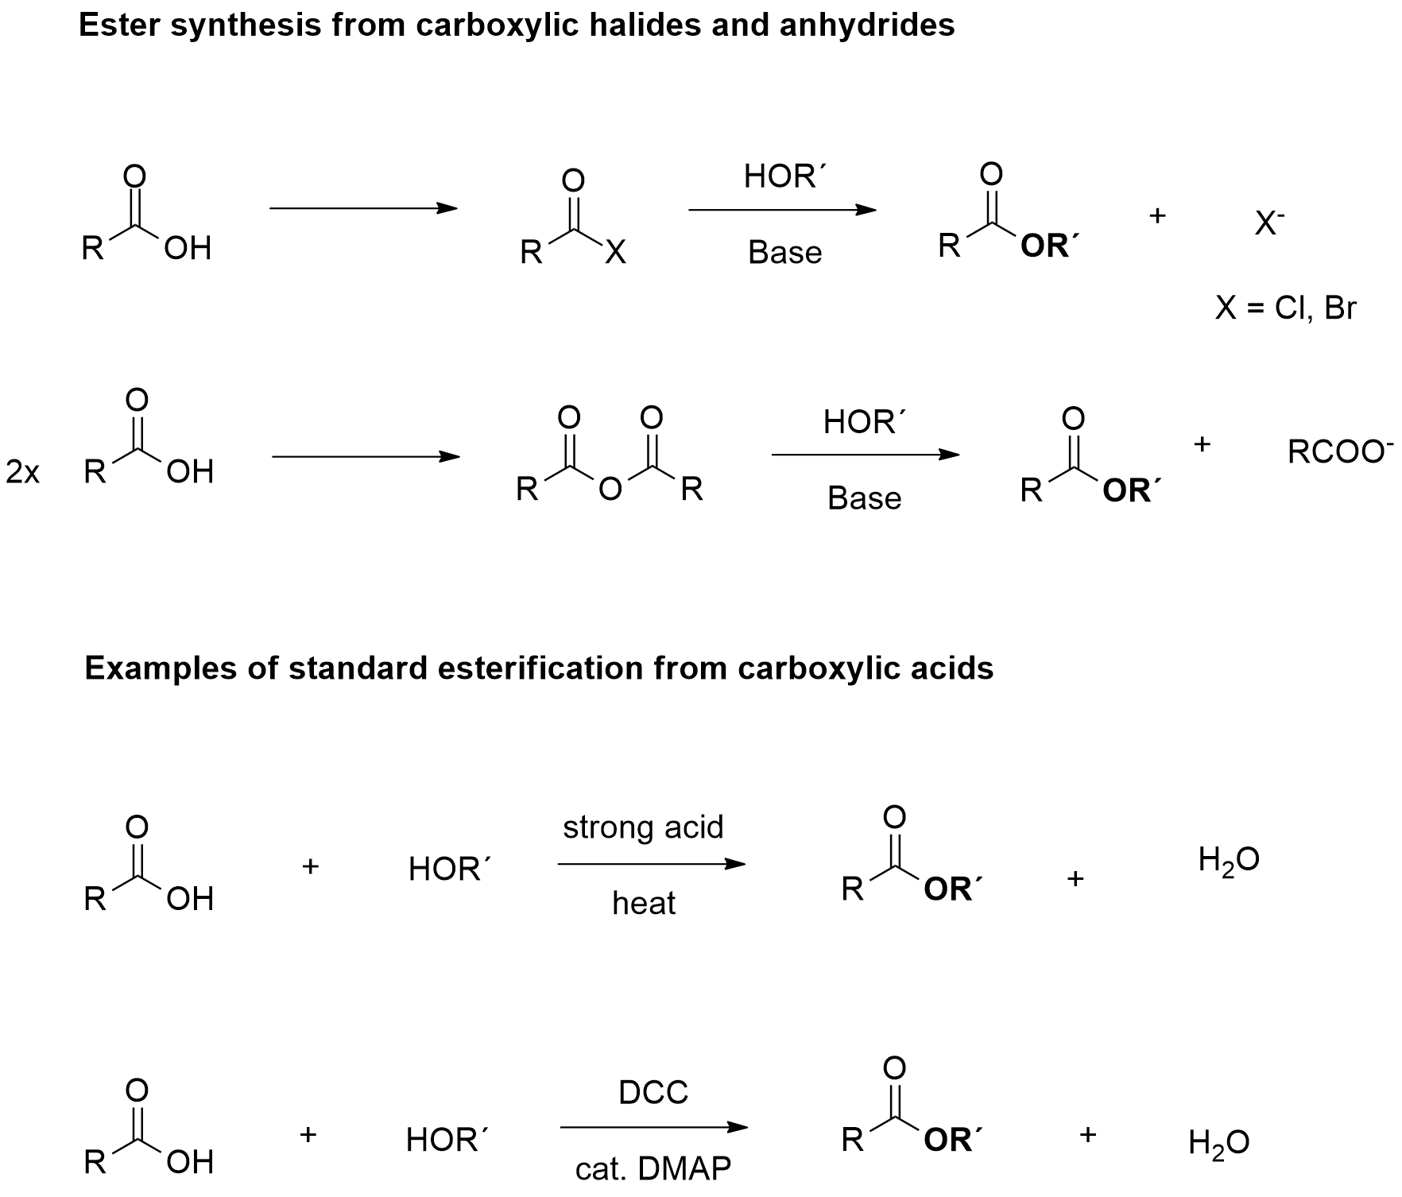
Figure 5.1: Common esterification methods for alcohols.²²⁵

Considering all of this, constant efforts have been engaged towards the direct esterification of alcohols, with the employment of different easily available chemicals and in the presence of oxidants.²²⁵ Nevertheless, some challenges still remain, including key issues like the selectivity between esterification and direct alcohol oxidation or aldehyde formation. Therefore, it is crucial to identify the factors that control the selectivity for alcohols in oxidative esterification.
Aldehydes are on other class of bulk chemicals, which have been extensively employed in processes like these ones (Scheme 5.1 - a).²²⁵

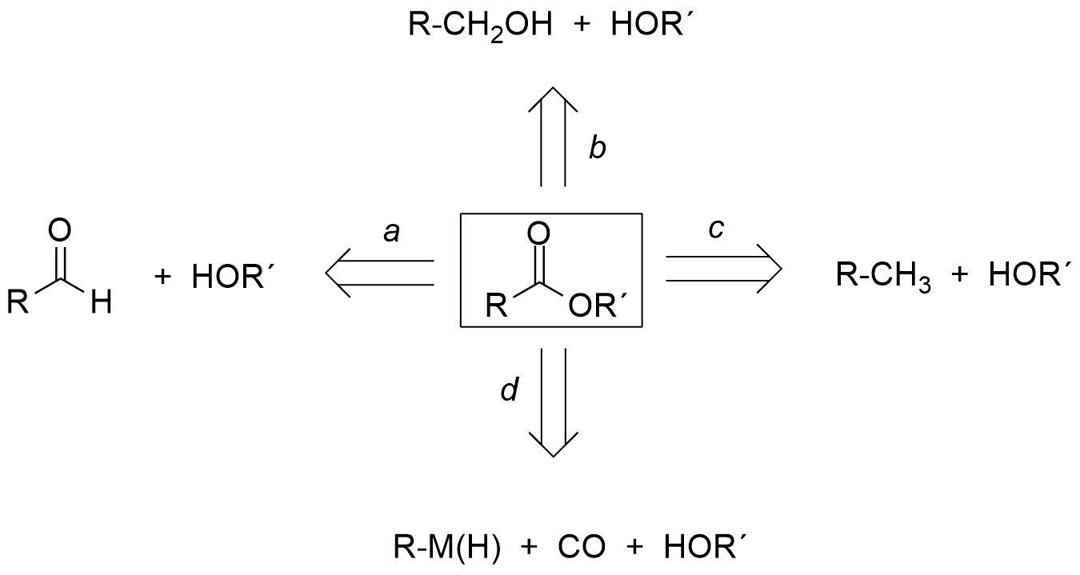
Scheme 5.1: Different synthetic pathways for the esterification of alcohols.²²⁵

During the past decade, numerous successful efforts have target the direct esterification of aldehydes with alcohols, in the presence of oxidants and catalysts. Compared with the synthesis of esters from aldehydes, direct oxidative esterification between two alcohols is a much more appealing approach, since aldehydes are typically prepared by the oxidation of alcohols. Currently, this method has drawn a lot of attention and is being progressively developed (Scheme 5.1 - b).²²⁵
Even unactivated alkanes were used to achieve oxidative esterification with alcohols; this constitutes an enormous advance in green chemistry (Scheme 5.1 - c).²²⁵ Organometallic compounds (R–M) or hydrocarbons (R–H) can react with alcohols (ROH) and carbon monoxide (CO) to afford esters, via an oxidative carbonylation process (Scheme 5.1 - d).

5.1.1 The oxidative esterification of alcohols with aldehydes
5.1.1.1 Metal free oxidative esterification of alcohols with aldehydes

Aldehydes are readily available and abundant raw materials in industry, thus the oxidative esterification of aldehydes with alcohols has lately attracted much attention, as an alternative to traditional protocols. Oxidative transformation of aldehydes to esters is a very challenging procedure; for this reason, much effort has been invested in the discovery of innovative methods for the synthesis of these compounds.²²⁵ The straightforward synthesis of esters from aldehydes via oxidation of intermediate hemiacetals, formed in situ, has gained widespread popularity (Scheme 5.2).²²⁵

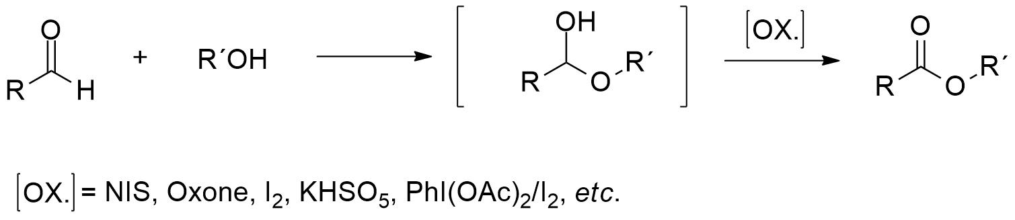
Scheme 5.2: Different synthetic pathways for the esterification of alcohols.²²⁵

In the past few decades, numerous organic and inorganic oxidants have been described in the literature. Although, this transformation has been extensively studied, most of the discoveries to date include only methyl esters, due to selectivity issues. In order to overcome this problem, new selective synthetic procedures of wide scope are highly desired. Inorganic reagents, including cyanide and 3,4,5-trimethylthiazolium, have been described as successful catalysts for the direct oxidative esterification between aldehydes and alcohols.²³²
In addition, N-heterocyclic carbenes (NHCs) are known to catalyse interesting redox processes. In 2008, Scheidt et al. reported that carbenes could be employed in the catalytic oxidative transformation of aldehydes to esters, without the use of transition metal catalysts. By employing MnO₂ as oxidant, several aliphatic aldehydes could esterify specific alcohols, in good yields. Nevertheless, the substrates are limited to saturated aldehydes (Scheme 5.3 - a).²²⁵

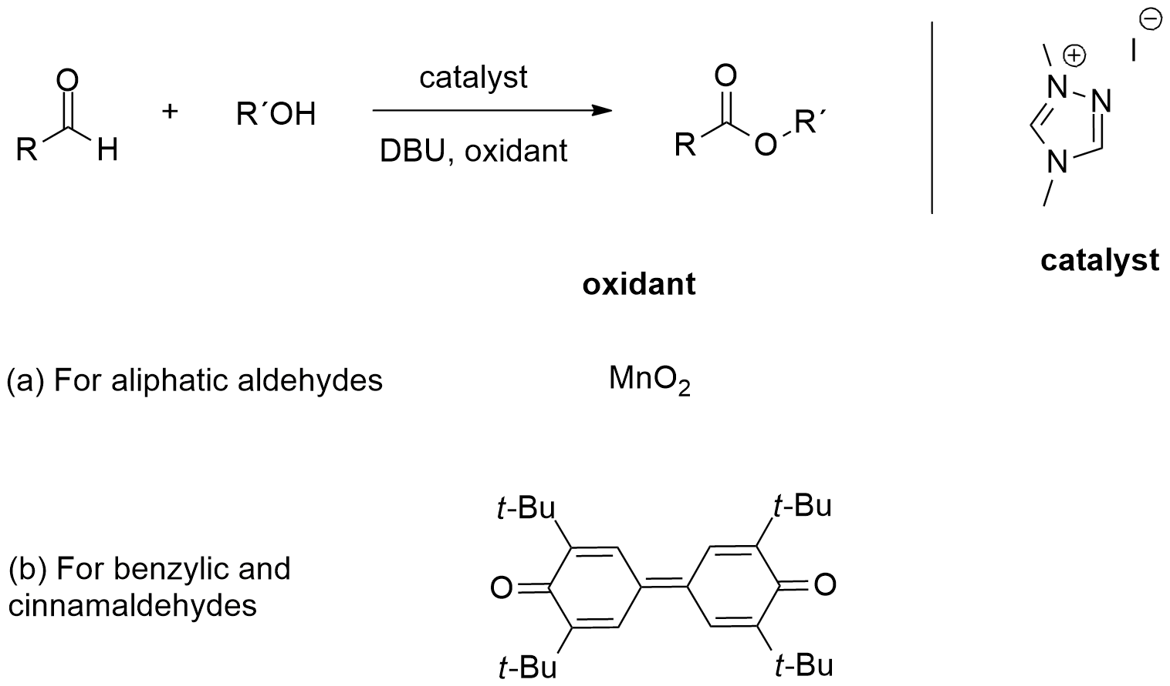
Scheme 5.3: NHC-catalysed direct esterification of distinctive types of aldehydes.²²⁵

In the case of activated aldehydes, a conjugated two-electron oxidant was developed. Species such as substituted benzaldehydes and cinnamaldehydes are all compatible substrates (Scheme 5.3 - b).
Regarding the mechanism of this reaction, in the commonly accepted version, the carbene first undergoes nucleophilic addition to the aldehyde and generates an activated alcohol. In the next stage the activated alcohol is oxidized by an oxidant (MnO₂ in this case) to form an acyl carbine (Breslow intermediate). The final stage includes a nucleophilic substitution by the alcohol to provide the desired esters, as it is shown in Scheme 5.4.^{234, 235} Similar results were achieved by employing azobenzene as the oxidant, even though with lower efficiency.

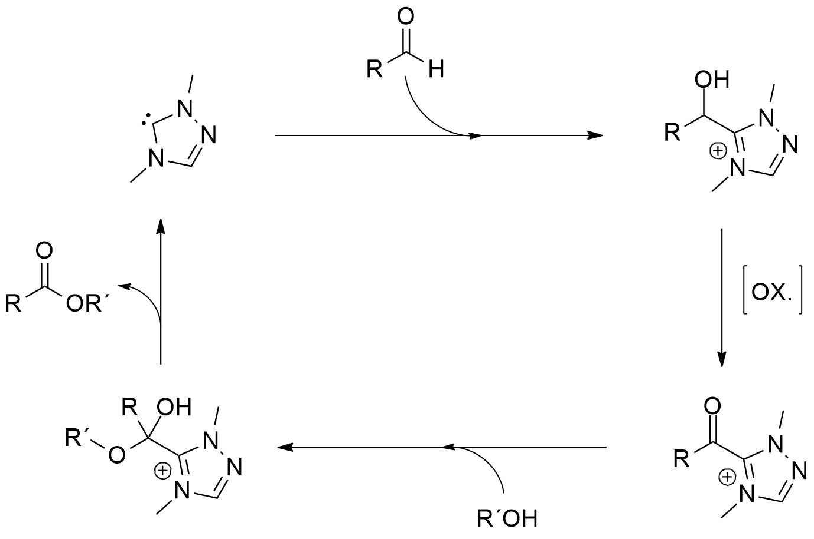
Scheme 5.4: Proposed mechanism for the catalytic oxidative esterification of aldehydes to esters.^{234, 235}

Furthermore, Scheidt and co-workers stated that NHC´s not only affected the oxidation of aldehydes, but also activated the alcohol. This group also discovered that aromatic aldehydes accomplish preliminary chemoselective acylation of alcohols in the presence of amines. This happens because the favoured activation of the alcohol by H-bonding to the carbene increases the nucleophilicity of the hydroxyl group.^{234,}
Lately, Connon and co-workers accomplished the NHC-catalysed aerobic oxidative esterification of aldehydes with alcohols. The authors observed significant differences in the yields during the esterification process, by using different alcohols with different pKa values (Scheme 5.5).²³⁸

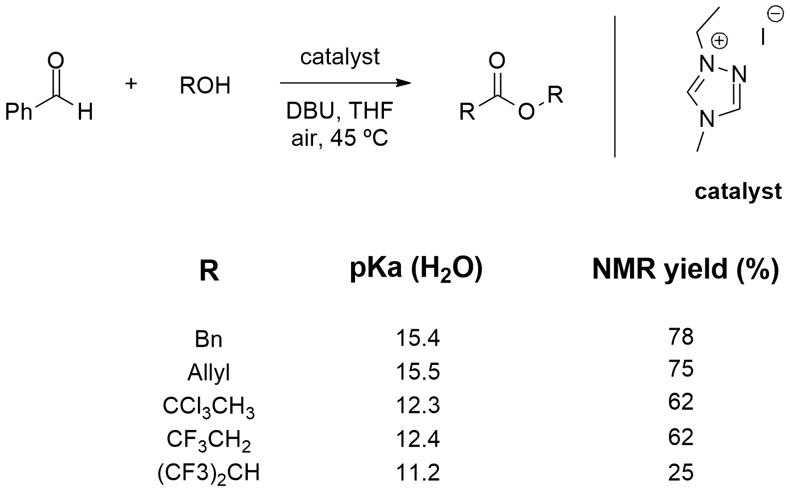
Scheme 5.5: NHC-catalysed aerobic oxidative esterification of aldehydes with alcohols.²³⁸

This reaction turned out to be very hard to explain using the mechanism shown in Scheme 5.4, since the Breslow intermediate is highly electrophilic. After identifying the active intermediates in the reaction system, benzoin was unequivocally identified as an active intermediate, which was oxidized by oxygen, in the aerobic NHC-catalysed aldehyde esterification (Scheme 5.6).²³⁸

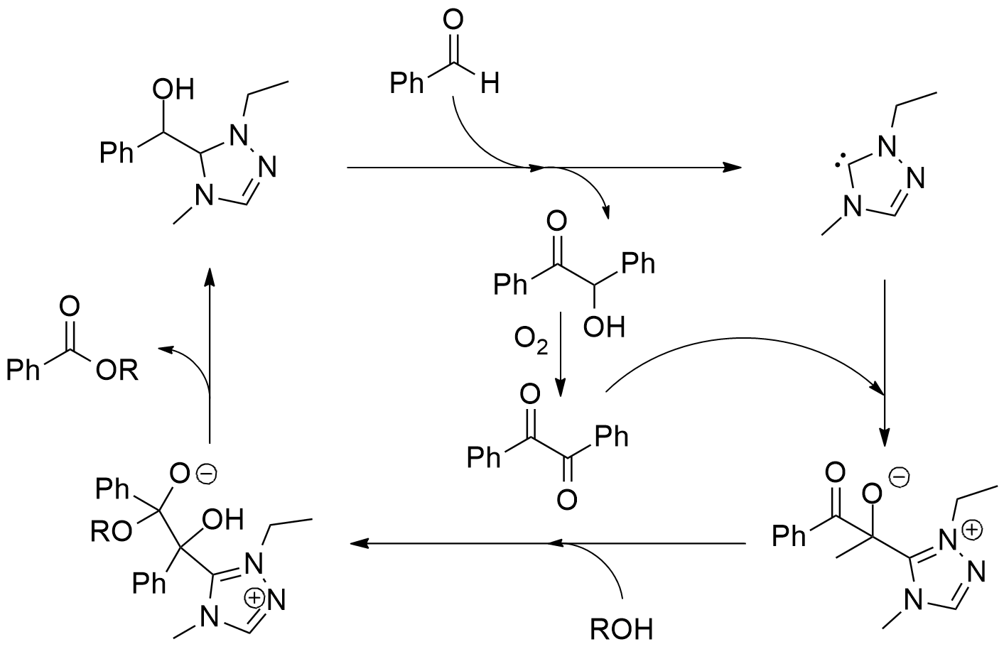
Scheme 5.6: Proposed mechanism for the aerobic NHC-catalysed oxidative esterification.²³⁸

5.1.1.2 Transition metal-catalysed oxidative esterification of aldehydes to esters

Since 1999, transition metals have been widely employed as catalysts in the oxidative esterification of aldehydes.²²⁵ Starting with vanadium and titanium catalysis, efficient conversion of aldehydes to methyl esters was accomplished using methyltrioxorhenium(VII) as the catalyst and hydrogen peroxide (H₂O₂) as the oxidant. A co-catalyst, such as bromide or chloride ions, was also required. However, complex, harsh and delicate reaction conditions were required, which prevented its future application. In addition, it failed to produce the desired product from the specific oxidation of aldehydes, in systems containing deactivating groups and olefinic groups.²³⁹
Later, Patel and co-workers reported important improvements to this procedure, with the employment of vanadium pentoxide as the catalyst and hydrogen peroxide as the oxidant (Scheme 5.7).

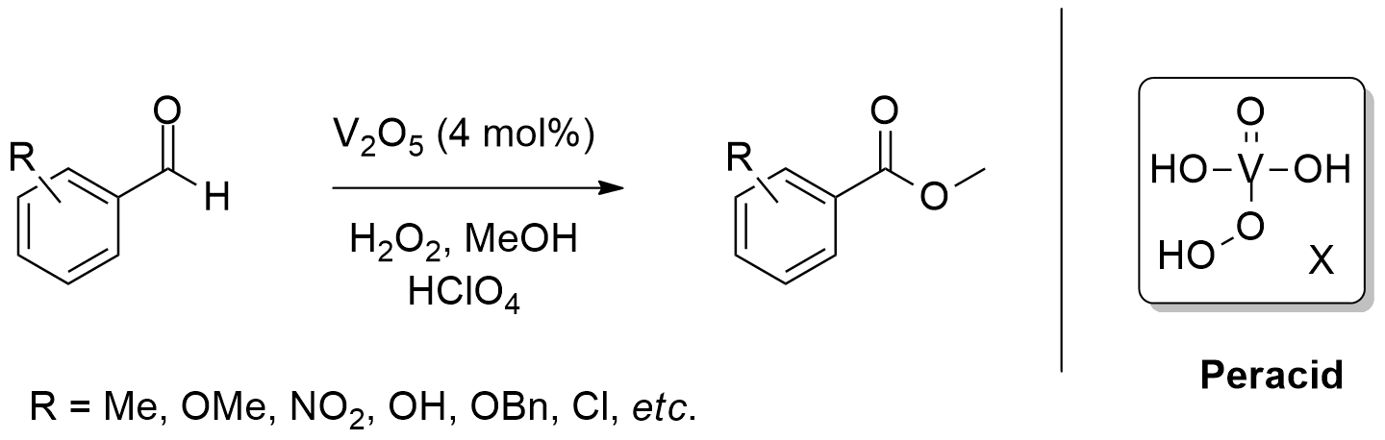
Scheme 5.7: Patel´s vanadium catalysed oxidative esterification of substituted benzaldehydes, to provide the corresponding esters.²⁴⁰

This is a valuable method, as the reagents are cheap and non-toxic and the resulting inorganic salts can be easily removed. In the presence of methanol, aldehydes readily undergo oxidative transformation to the corresponding methyl esters, in excellent yields.²⁴⁰
A subsequent study discovered that sodium perborate (SPB) or sodium percarbonate (SPC) in combination with perchloric acid, could be used to substitute the concentrated hydrogen peroxide. In addition, different alcohols could be substituted for methanol, to yield the corresponding esters. Linear alkyl alcohols such as ethanol, 1-propanol and 1-butanol were all compatible substrates. However, benzyl alcohols and branched alcohols were not suitable for this transformation.²⁴
Analogous to the vanadium-catalysed system, Chayan and co-workers reported a heterogeneous catalytic system employing titanium-containing molecular sieves TS-1, to provide the oxidation of aromatic aldehydes. By using 30% of H₂O₂ as the oxidant, in refluxed methanol, aromatic esters were isolated in yields of 65-99% (Scheme 5.8). This group also proposed a mechanism for the oxidation of the hemiacetal by the peracid, formed after the addition of H₂O₂ to titanium oxide.²⁴²

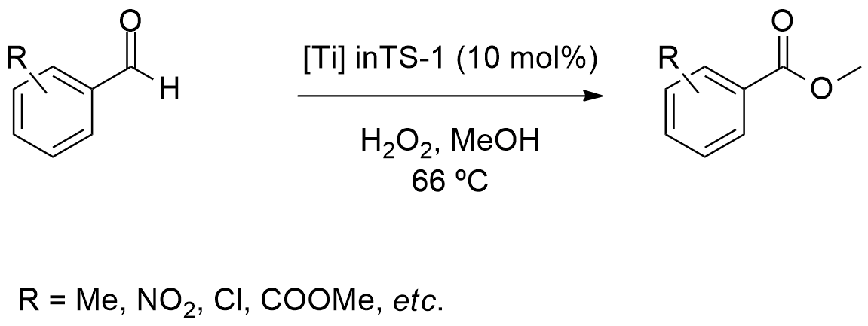
Scheme 5.8: Titanium-catalysed esterification of aldehydes using H₂O₂ as the oxidant.²⁴²

In 2006, Li and co-workers reported the copper catalysed oxidative esterification between an aldehyde and the in situ generated enol, employing tert-butyl hydroperoxide (TBHP) as oxidizing agent. Immediately afterwards, they discovered that by adding a Lewis acid (i.e. InBr₃) oxidative esterification with simple alcohols could be achieved under similar conditions. The key factor responsible for the efficiency of the reaction was InBr₃, which probably promotes the formation of hemiacetals during the reaction. Both aliphatic and aromatic aldehydes are suitable substrates in these reactions. Moreover, a key advantage of this system was that only 1.5 equivalents of alcohol are needed for successful esterification (Scheme 5.9).²⁴⁴

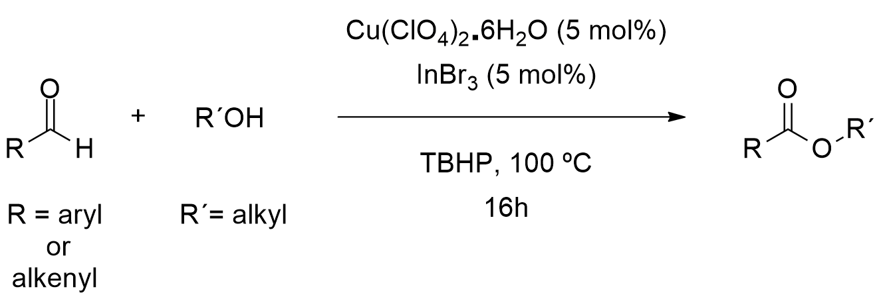
Scheme 5.9: Copper-catalysed esterification of aldehydes with TBHP as the oxidant.²⁴⁴

Mononuclear gold complexes and gold nanoparticles can also serve as active catalysts in oxidative esterifications. In a recent study, HAuCl₄ demonstrated to be a suitable catalyst for oxidative esterifications of aldehydes, with TBHP as the oxidant. In addition, both aromatic and aliphatic aldehydes are compatible substrates, which can esterify aliphatic alcohols, in good yields (Scheme 5.10).²⁴⁵

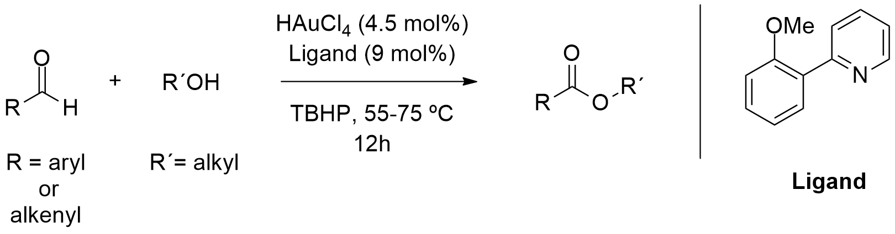
Scheme 5.10: Homogeneous gold-catalysed esterification of aldehydes with tert-butyl hydroperoxide as the oxidant.²⁴⁵

In 2011, Kobayashi and co-workers reported that the aerobic oxidative esterification of aldehydes with 1,2-and 1,3-diols and their derivatives, proceeded efficiently in the presence of polymer-incarcerated gold nanoclusters. In this procedure, the esterification was much faster with 1,2-and 1,3-diols and their derivatives, than with methanol. Because both the oxygen and the remaining hydroxyl group could coordinate with the gold nanoparticle, this stabilized the hemiacetal intermediate and benefited the following oxidation step (Scheme 5.11).²⁴⁶

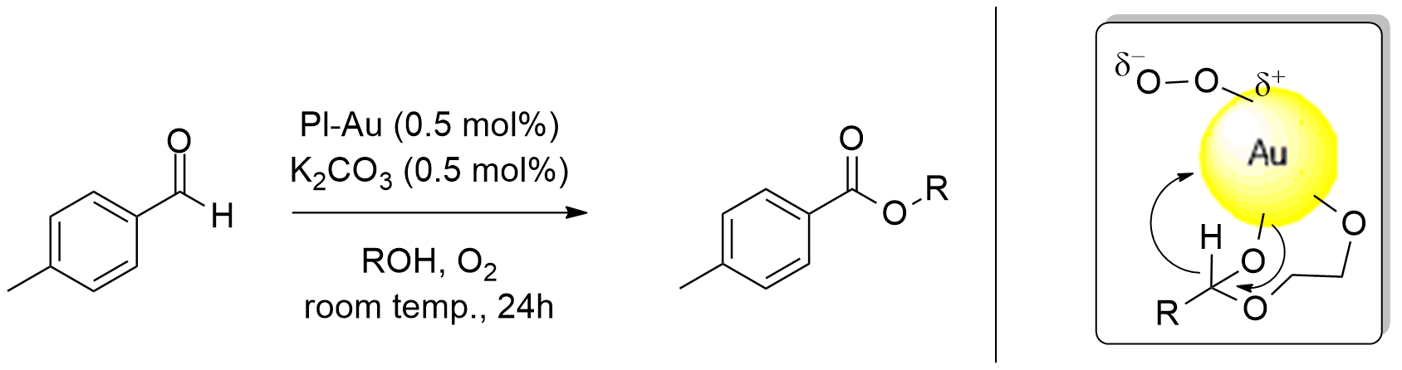
Scheme 5.11: Aerobic oxidative esterification of aldehydes with polymer-incarcerated gold nanoclusters.²⁴⁶

Finally, the oxidation of primary alcohols to aldehydes employing palladium catalysts has also been studied. Numerous oxidants, such as O₂ and aryl halides have been applied in these reactions. In such transformations, an aldehyde is synthesized and remains unreactive, resulting in selective aldehyde formation.²⁴⁷ These results seem to imply that in most of the cases, the selective palladium-catalysed oxidation of an alcohol into an aldehyde occurs in advance of esterification of the aldehyde by the alcohol. Lei and co-workers reported a versatile and selective synthesis of different esters using benzyl chloride (BnCl) as an oxidant, in a palladium-catalysed system, in the presence of stoichiometric amounts of aldehyde and alcohol (Scheme 5.12).

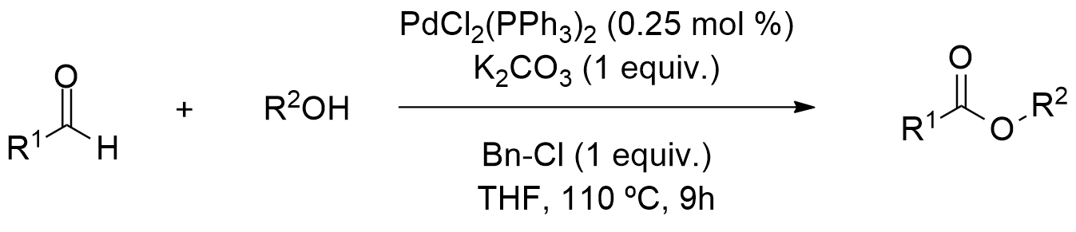
Scheme 5.12: Aerobic oxidative esterification of aldehydes, with polymer-incarcerated gold nanoclusters.²⁴⁸

The authors established that the oxidant (BnCl₂) was responsible for the high selectivity of the esterification. Aromatic, alkenyl and aliphatic aldehydes could all react effortlessly with alcohols. At the same time, aliphatic alcohols, phenyl, allylic and even secondary alcohols were esterified in high efficiency. More importantly, the electronic properties had little influence in the yields. Further studies showed that this approach could be scaled up in a solvent-free system with a low catalyst loading.²⁴⁸ The proposed catalytic cycle for this reaction is shown in Figure 5.2.

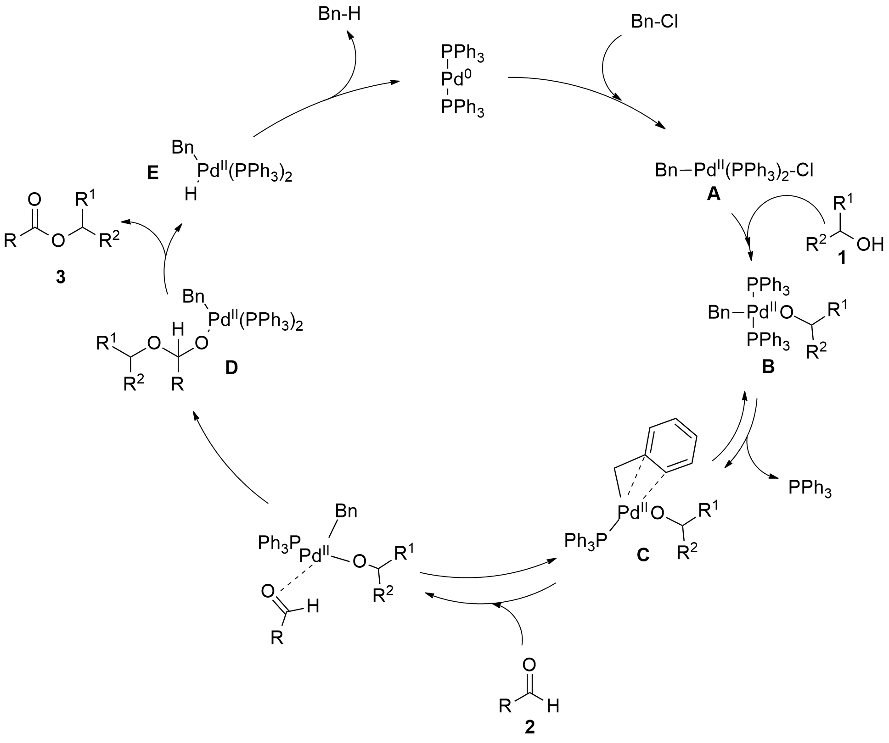
Figure 5.2: Proposed catalytic cycle for the oxidative esterification of aldehydes with benzyl chloride as the oxidant.²⁴⁸

In the first step, the oxidative addition of benzyl chloride to Pd(0) generates the intermediate Bn-Pd(II)-Cl (A). The following alcoholysis step selectively occurs at the Pd-Cl bond of A with the alcohol, to produce an alkoxy palladium intermediate B, in the presence of a base. The following η³ coordination of the benzyl group eases the dissociation of PPh₃ to produce C, which helps the coordination of the aldehyde to the palladium center. Next, the aldehyde coordinates and inserts into intermediate C to produce the hemiacetal palladium intermediate D. After this, β-hydride elimination occurs to release esters and the Pd-H intermediate E. Over this catalytic cycle, alcohols are selectively esterified by aldehydes. Remarkably, benzyl chloride not only serves as the oxidant but also acts as a covalent carbon ligand.²⁴⁸
In 2013, a hydrogen transfer protocol was established to achieve direct oxidative esterification between aldehydes and alcohols. Aliphatic and aromatic aldehydes are effectively transformed into their corresponding esters, by employing Pd(OAc)₂ as the catalyst and XPhos as the ligand. Simultaneous reduction of acetone to isopropanol provides an inexpensive and sustainable approach, which diminishes the need for other oxidants. In this system, alcohols are required as solvents and the reaction efficiency is not very high; furthermore, the substrate scope was limited (Scheme 5.13).²⁴⁹ As early as 2007, the iridium catalysed oxidative esterification of aldehydes with alcohols was reported, though this also involved hydrogen transfer.

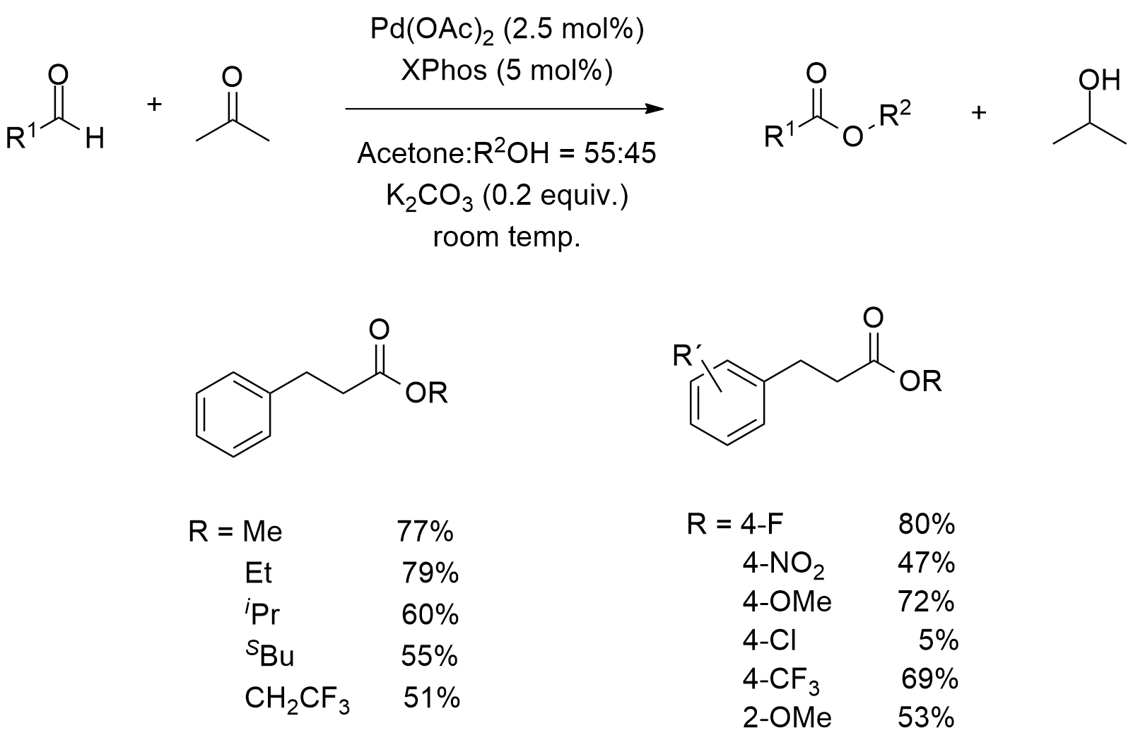
Scheme 5.13: Palladium-catalysed direct oxidative esterification of aldehydes employing acetone as the oxidant.²⁴⁹

5.1.2 Oxidative esterification between two alcohols
5.1.2.1 Direct oxidation of primary alcohols to dimeric esters

In 2004, Bobbitt and co-workers reported the oxidative dimeric esterification of primary alcohols in the presence of 4-acetylamino-2,2,6,6-tetramethylpiperidine-1-oxoammonium tetrafluoroborate (Bobbitt′s salt), in combination with pyridine. Selective esterification could be detected in alcohols containing an α-oxygen (Scheme 5.14).

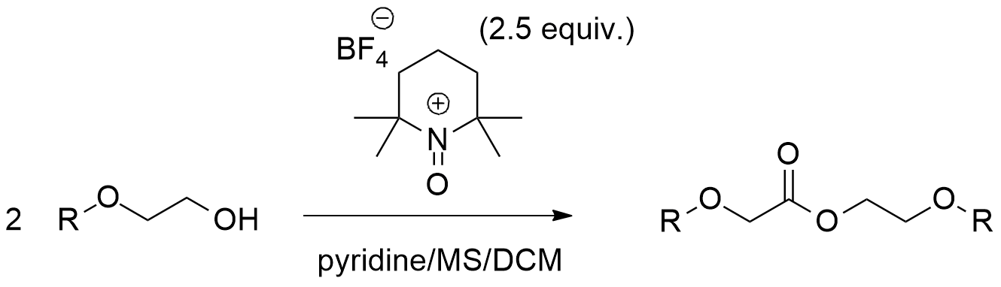
Scheme 5.14: Direct oxidation of primary alcohols to esters with Bobbitt′s salt as the oxidant.²⁵¹

Recently, this procedure was adapted for the oxidative esterification of varied aldehydes to hexafluoroisopropyl (HFIP) esters using the same oxidant. Furthermore, transition metal-catalysed selective oxidation of primary alcohols to the corresponding dimeric esters was studied.
Iridium is commonly known for its capability to catalyse hydrogen transfer reactions. In 2005, Katoh and co-workers reported the use of an iridium catalyst for the selective oxidation of alcohols (Scheme 5.15). In this procedure, 2-butanone was used as the oxidant.

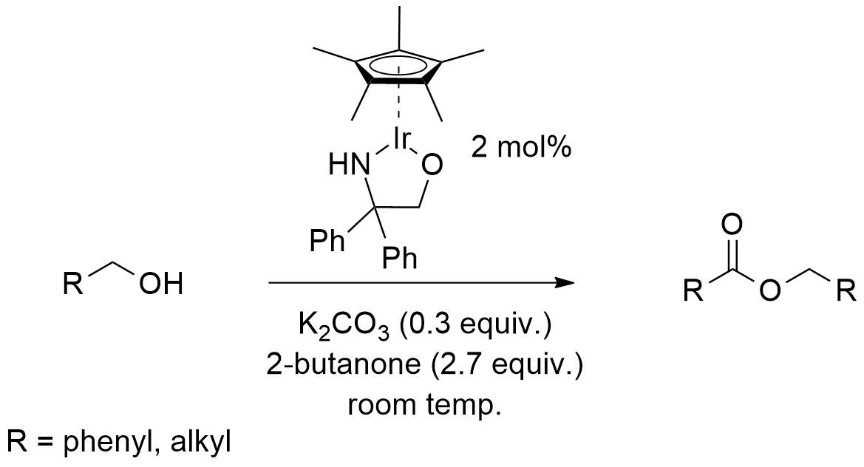
Scheme 5.15: Iridium-catalysed oxidation of primary alcohols using 2-butanone as the oxidant.²⁵³

Regarding to the palladium-catalysed selective oxidation of primary alcohols to esters, the selectivity of the formation of aldehydes and esters is always challenging. Typically, primary benzyl alcohols tend to form aldehydes, while primary aliphatic alcohols tend to form esters. As a continuation of this study, Lei and co-workers revealed that selective alcohol oxidation was accomplished for primary alcohols in the absence of aldehydes (Scheme 5.16).²²⁷

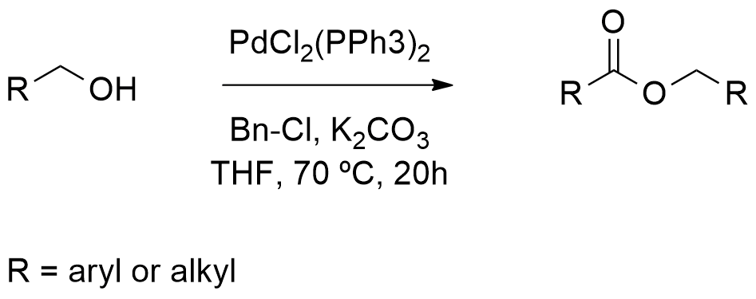
Scheme 5.16: Palladium-catalysed oxidation of primary alcohols using benzyl chloride as the oxidant.²²⁷

5.1.2.2 Metal-catalysed oxidative esterification between two different alcohols

Commonly, the oxidative esterification of different alcohols was considered to be very difficult, since both of the alcohols can be oxidized. Consequently, these reactions typically result in poor selectivity. Evidently, the most challenging task in this field is controlling the selectivity of the two esters. Because methanol is not readily oxidized, the synthesis of methyl esters with benzyl alcohols have been achieved using few catalytic systems. Later, ruthenium, rhodium and iridium were employed in these transformations through a hydrogen transfer approach.
In 2011, Beller and Lei discovered the first palladium-catalysed direct aerobic oxidative esterification of benzylic alcohols with methanol and several long-chain aliphatic alcohols, individually but concurrently. Long chain aliphatic alcohols were originally used to obtain the direct esterification product. Beller and co-workers efficaciously attained this transformation for long-chain aliphatic alcohols by using a bulky phosphane ligand. The major disadvantage is that alcohols are required as solvents (Scheme 5.17).^{256 a)}

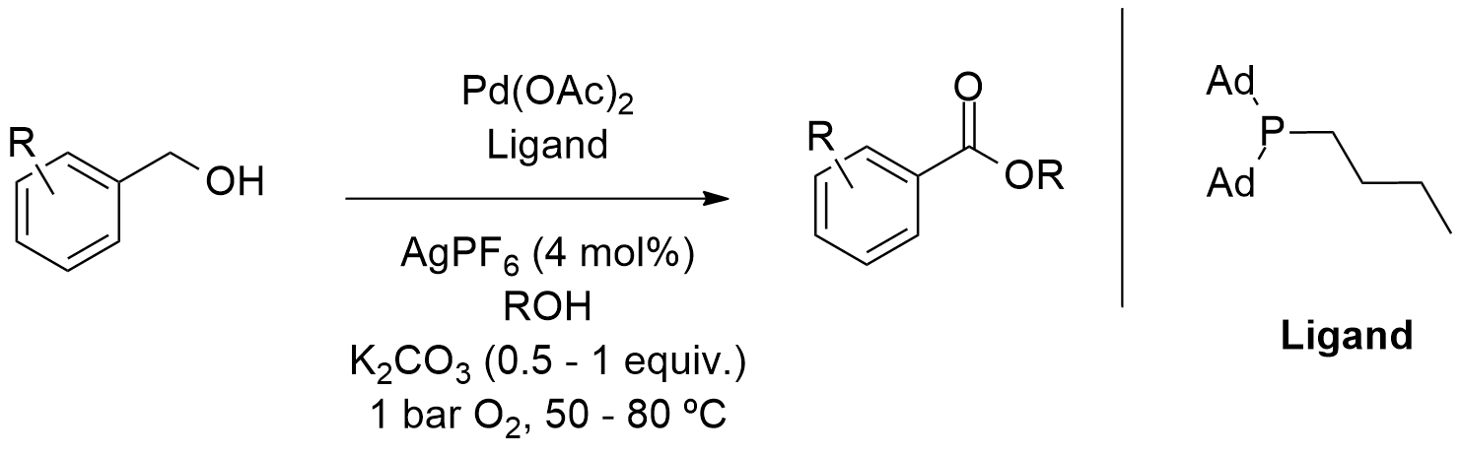
Scheme 5.17: Palladium-catalysed aerobic oxidative esterification of different benzylic alcohols.^{256 a)}

In Lei’s work, the difficult esterification of long-chain aliphatic alcohols was achieved by using a P-olefin ligand, to control the selectivity, which lowered the quantity of the long-chain aliphatic alcohols. This required up to two more equivalents compared to benzylic alcohols.^{256 b)} These reactions are inherently atom economical and thus environmentally friendly (Scheme 5.18).^{256 b)}

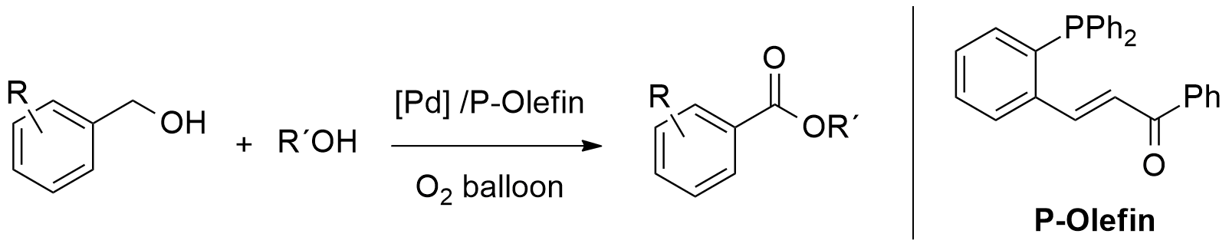
Scheme 5.18: Palladium-catalysed aerobic oxidative esterification of different benzylic alcohols in hexane.^{256 b)}

Remarkably, Milstein originally described the oxidative esterification of primary and secondary alcohols through a pincer ruthenium catalysed reaction (Scheme 5.19).

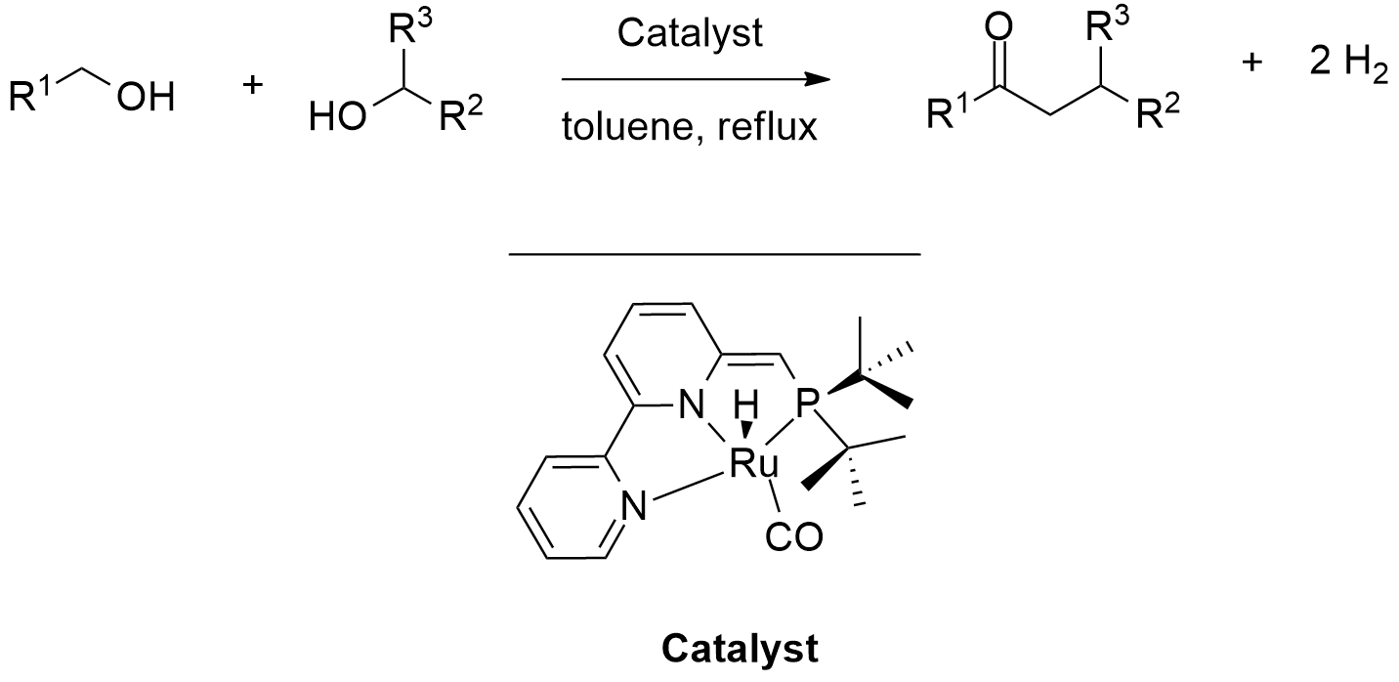
Scheme 5.19: Oxidative esterification of primary and secondary alcohols through a pincer ruthenium catalyzed reaction.²⁵⁷

In most cases, the yield of the cross-esterification was excellent, while in some cases, a small amount of the homocoupling product of the primary alcohol was detected. By adding the ketone, another byproduct was occasionally produced, in low yields, by dehydrogenation of the secondary alcohol. Surprisingly, the dehydrogenation of the secondary alcohols to the corresponding ketones is slower than the dehydrogenative coupling of the alcohols to esters, resulting in excellent yields of the desired cross-esterification products. In addition, the self-esterification product was detected only as a minor product.²⁵⁷

  - 5.2 Results and Discussion
5.2.1 New PCC promoted oxidative esterification of primary alcohols – synthesis of diether-esters

As mentioned in Chapter 3, pyridinium chlorochromate (PCC) oxidation reactions of linear non-bulky aryl alkyl alcohols failed to afford any corresponding aldehyde products. Instead, these alcohol substrates underwent oxidative esterification to provide the corresponding esters. This was first observed when 2-(2-bromophenoxy)ethanol (4b) was oxidized under specific oxidation conditions (Scheme 5.20). After a quick purification by silica gel column chromatography, 2-(2-bromophenoxy)ethyl 2-(2-bromophenoxy)acetate (20a) was identified by ¹H NMR. In addition, a very small amount of the corresponding aldehyde product (11a) was detected in the ¹H NMR spectrum of the crude product.

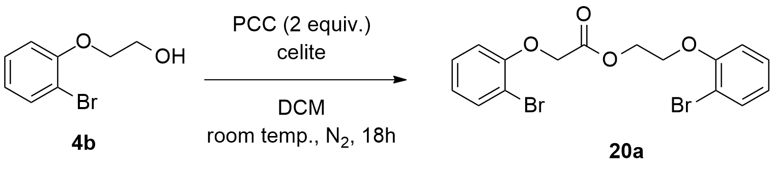
Scheme 5.20: Oxidative esterification of primary alcohol (4b) using PCC.

In order to understand the precise mechanism of this reaction, we initiated a series of studies, which included varying the conditions of the reaction, such as the amount of PCC, the use of different solvents and different combinations of substrates. Additionally, we studied the kinetic profile of the original reaction under a kinetic ¹H NMR experiment.
We started with a set of optimization experiments to determine the minimum amount of PCC required to obtain compound (20a). Table 5.1 shows the results of these experiments.

Table 5.1 PCC optimization study

Entry | PCC  (equiv.) | Yield/%^{(a)}
Entry | PCC  (equiv.) | Starting Material | Aldehyde | Ester
1 | 4 | 0 | 6 | 92
2 | 2 | 0 | 4 | 96
3 | 1 | 43 | 9 | 48
4 | 0.5 | 92 | 3 | 5
5 | 0.25 | 98 | 1 | 0
^{(a)} Determined by addition of an internal standard (mesitylene).

The results show that the minimum amount of PCC required to carry out this reaction is 2 equivalents (Table 5.1, entry 2). If less than this quantity is used (1 equivalent), the yield of the reaction decreases significantly (Table 5.1, entry 3) or no reaction is observed (Table 5.1, entries 4 and 5). On the other hand, if more than 2 equivalents are used (4 equivalents), the yield of the reaction is not significantly affected (Table 5.1, entry 1).
Indeed, these results are very interesting; the fact that 2 equivalents of PCC provide almost quantitative amount of the product and 1 equivalent gives only 48%, would seem to indicate that the PCC is required for 2 distinct steps in this reaction. What is most likely to be the case is that 1 equivalent of PCC is required to oxidize the initial alcohol substrate and the other equivalent of PCC is used as a Lewis acid, thus activating the carbonylic carbon present in the aldehyde intermediate (see Scheme 5.21 for our putative mechanism).
Next, a solvent screening study was carried out in order to examine the effect of the solvent on the reactivity of the system. Consequently, different types of solvents, including polar solvents (MeOH), apolar protic solvents (DMF, MeCN), mild polar aprotic solvents (DCM, THF and dioxane) and the apolar solvent toluene were tested under the conditions shown in Scheme 5.20. The results of this study are shown in Table 5.2.
Table 5.2 Solvent screening studies

Entry | Solvent | Yield/%^{(a)}
Entry | Solvent | Starting Material | Aldehyde | Ester
1 | MeOH | 100 | 0 | 0
2 | DMF | 91 | 0 | 9
3 | Dioxane | 83 | 0 | 17
4 | Toluene | 100 | 0 | 0
5 | MeCN | 100 | 0 | 0
6 | THF | 86 | 14 | 0
7 | DCM | 0 | 4 | 96
^{(a)} Determined by addition of an internal standard (mesitylene).

This study indicated that only DCM was effective in this reaction (Table 5.2, entry 7). Both DMF and dioxane also supported the reaction, but to a lesser extent than DCM. When MeOH, toluene and MeCN were employed (Table 5.2, entries 1, 4 and 5, respectively) no reactivity was detected, since only starting material was observed in the ¹H NMR spectra. In the case of MeOH and DMF, these solvents obviously reacted with the oxidant, thus deactivating the system. In the case of THF, only a small amount of aldehyde intermediate was detected (Table 5.2, entry 6). It is hard to explain why the reaction only works best in DCM. One possible explanation – which is probably the most likely explanation – is the optimal solubilizing characteristics of this solvent, promoting maximum diffusion and mass transfer of the main reactants during the course of the reaction. Another possible explanation might be some type of activation bestowed by DCM, via hydrogen bonding, which will enhance the final elimination step to afford the product ester. Another possibility (although less likely), is the background formation of an HCCl carbene species via β-elimination on the DCM molecule, which would increase the concentration of chloride ion in solution and consequently accelerate the crucial β-elimination reaction to form the ester product (see Scheme 5.21)
After these initial experiments, we wanted to examine the kinetic profile of this reaction. This was accomplished by performing a ¹H NMR kinetic experiment. We prepared some samples as follows: 0.5 mL of deuterated chloroform were added into a NMR tube under N₂. After this, the alcohol and PCC were also loaded into the tube. The tube was closed and placed inside the NMR machine, for analysis. Several ¹H spectra were taken (one spectra per hour) during the interval of 20 hours. Subsequently, all the NMR spectra were treated and analysed, providing us important information about the kinetic behaviour of the reaction. Figure 5.3 shows the formation of product over time. There was an almost linear relationship between the formation of product over time.

Figure 5.3: Reaction kinetic studies.

These results show that this reaction formed product at an almost constant rate during the entire experiment. We can also observe that after 20 hours, there was still product formation and the reaction had not yet finished. Therefore, analysis of this result seems to indicate a zero order reaction, as the quantity of product increases linearly with time. To gain further insight into the reaction mechanism and to understand the intermediates involved, we carefully analysed the ¹H NMR spectra. The progress of the reaction is shown in Figure 5.4.

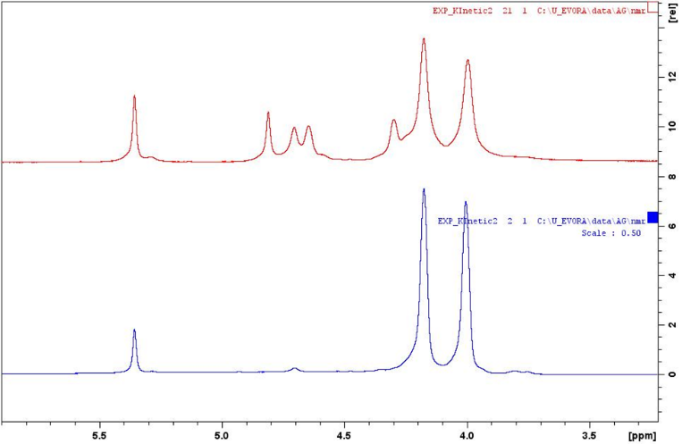
Figure 5.4: Formation of 2-(2-bromophenoxy)ethyl 2-(2-bromophenoxy)acetate (20a).
2xCH₂
Alcohol substrate
3xCH₂
Ester product
2xCH₂
Alcohol substrate

T = 20

gg

2xCH₂

T = 0

gg

2xCH₂

The blue spectrum shows the beginning of the experiment (time = 0). At this point, one can only see the peaks corresponding to the 2xCH₂ units present in the alcohol substrate. The red spectrum shows the end of the experiment (time = 20h). At this point, the peaks corresponding to the 3xCH₂ present in the ester product are already visible. Given this information, we can confirm that the reaction wasn´t finished when the experiment was stopped. This observation can probably be explained by the fact that mixing of the substrate and other reactants is not so efficient inside an NMR tube, when compared to a common batch system. Consequently, the time of the reaction increased substantially.

5.2.2 Proposed mechanism

As mentioned above, in parallel with these experiments, we proposed a mechanism for this reaction (Scheme 5.21).

Scheme 5.21: Proposed mechanism for the direct PCC oxidative esterification of alcohols.

Scheme 5.21 shows that the first step of the mechanism involves the attack of the lone pair of electrons from the oxygen on the chromium to form the Cr-O bond. After this, the proton of the now positive oxygen is transferred to one of the oxygens present on the chromium, possibly through the aid of the pyridinium salt. A chloride ion is then displaced in a reaction reminiscent of a 1,2-elimination reaction, to form what is known as a chromate ester. The C=O bond is formed when chlorine removes the proton on the carbon adjacent to the oxygen; it is also possible for pyridine to be used as the base here, although only very low concentrations of the deprotonated form will be present, under these acidic conditions. In this step, the electrons from the C-H bond move to form the C=O bond, the electrons from the O-Cr move to Cr, breaking this bond, while Cr(VI) probably becomes Cr(IV). The scientific community already had established this first part of the mechanism. However, what happens next defines the outcome of this reaction.
Supported by the ¹H NMR kinetic experiments, we noticed that the amount of aldehyde species remains constant in the mixture during the entire reaction. This information was very important in the sense that it suggested that after the initial alcohol is oxidized, forming aldehyde species, an atom of oxygen from the alcohol substrate attacks the carbonylic carbon (from the newly formed aldehyde species), thus forming an intermediate with two negatively charged oxygens. As one of the negative charged oxygen attacks the chromium to form a new Cr-O bond, one of the negative charged oxygens from the chromium abstracts the proton from the positive charged oxygen. Again one chloride ion is displaced, which removes the proton bonded directly to the C-O group. The electrons from the C-H bond move to form the C=O bond, the electrons from the O-Cr move to Cr, breaking the bond, while Cr(VI) becomes Cr(IV) to give the desired product and form possibly chromous acid and pyridin-1-ium chloride as secondary products. The mechanism proposed above is supported by all our studies.
As we have seen above from Table 5.1, a minimum of 2 equivalents of PCC are required for this reaction. However, analysis of our putative mechanism suggests that since 1 equivalent of PCC is used to activate the aldehyde species, we decided to investigate if this step would be possible using another reagent. So we hypothesized that by using 1 equivalent of PCC and 1 equivalent of a Lewis acid, we might obtain similar results. Consequently, we reacted compound (4b) with 1 equivalent of PCC and 1 equivalent of the Lewis acid BF₃.OEt₂, under the conditions described in Scheme 5.20 (Scheme 5.22).

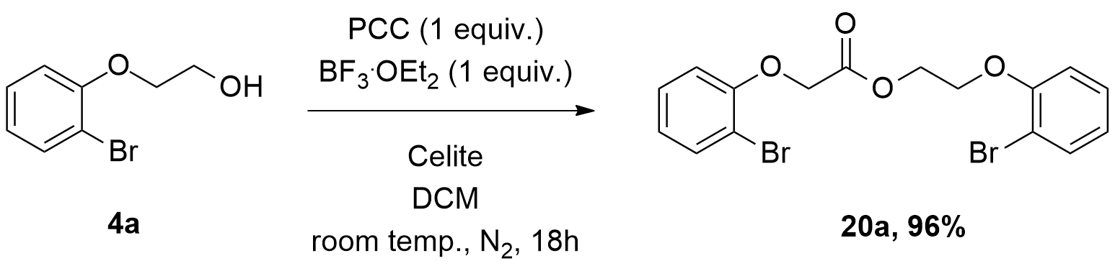
Scheme 5.22: Oxidative esterification of (4a) using PCC and BF₃.OEt₂.

Using these conditions the product was obtained in 96% yield as opposed to 48% (Table 5.1, entry 3), using just 1 equivalent of PCC. This result provided a strong support for the activation role of PCC, in the second part of the mechanism (Scheme 5.21). This was a very welcome development, since we could reduce the amount of toxic PCC needed to carry out this oxidative esterification.

5.2.3 PCC promoted oxidative esterification of alcohols – evaluating the reaction scope

After having established the best conditions for carrying out this new oxidative esterification methodology, we embarked on studying the reaction scope using a set of different alcohols previously synthesized by our group. Using the conditions described in Scheme 5.20, 8 additional diether-esters (20b)-(20i) were synthesized, in excellent yields (Table 5.3).

Table 5.3 Direct PCC oxidative esterification of primary alcohols

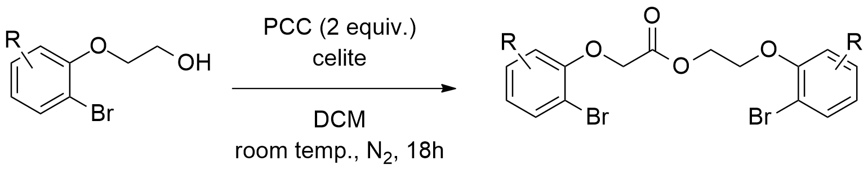

Entry | Substrate | Product | Yield/%^{(a)}
1 | 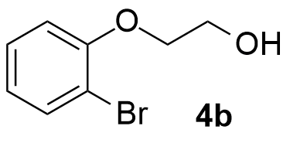 | 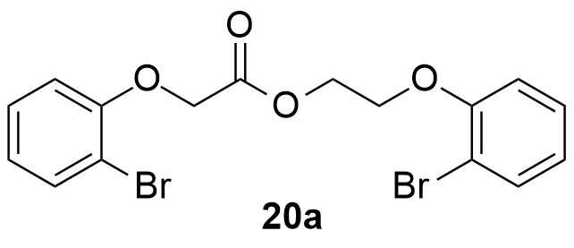 | 96
2 | 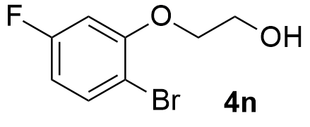 | 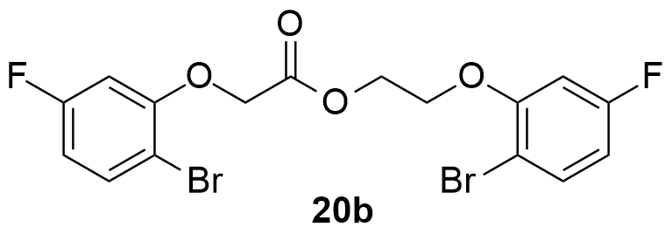 | 94
3 | 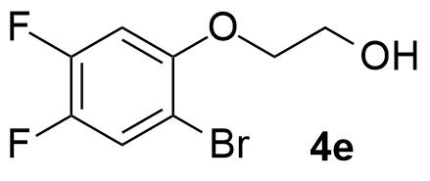 | 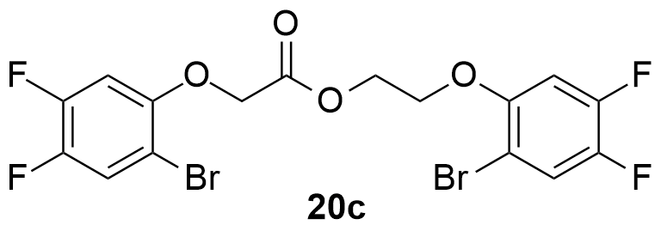 | 97
4 | 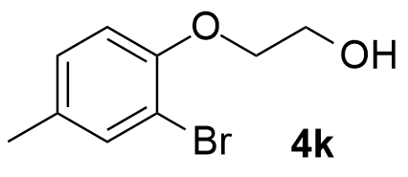 | 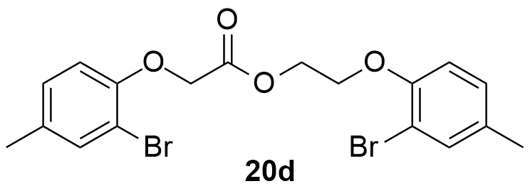 | 92
5 | 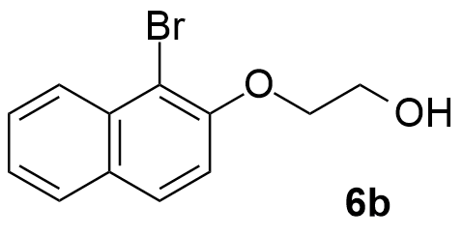 | 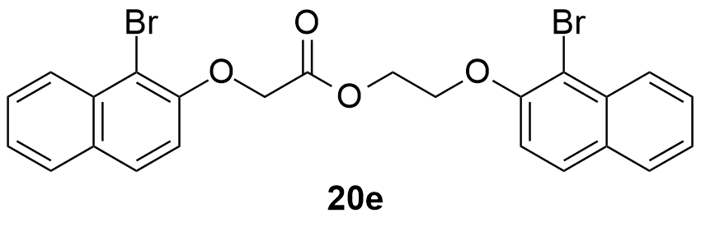 | 95
6 | 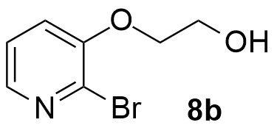 | 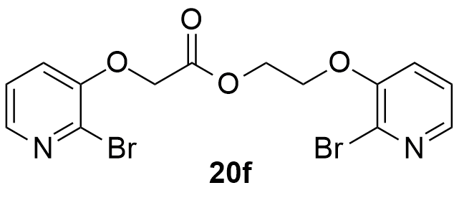 | 87
7 | 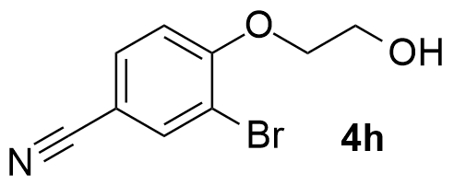 | 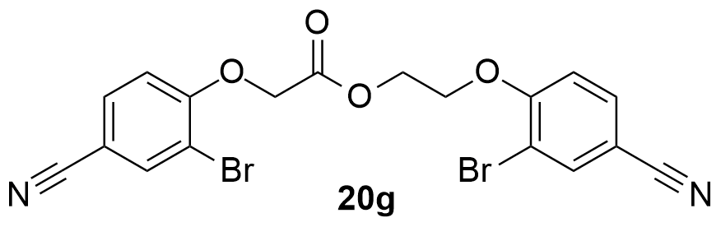 | 85
8 | 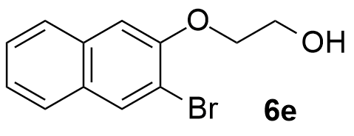 | 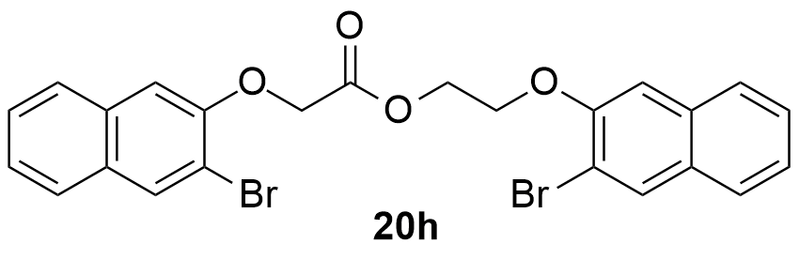 | 93
9 | 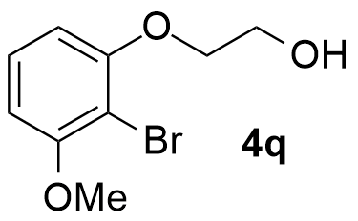 | 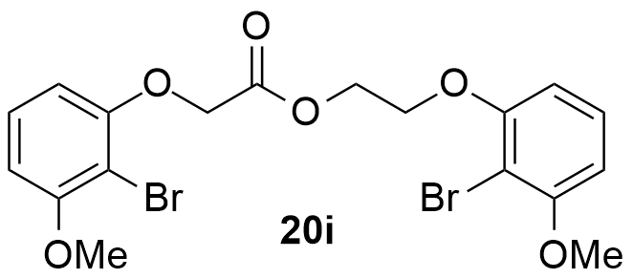 | 90
^{(a)} Determined by addition of an internal standard (mesitylene).

The yields of the reactions were excellent and although column chromatographic purifications where required to isolate the products, these reactions were generally quite clean. All these compounds were obtained as light colored solids. Comparing the reactivity of this system with different substituents, we can conclude that there were no pronounced electronic effects as both molecules bearing EWGs (with exception of nitriles, Table 5.3, entry 7) and EDGs, in the benzene ring, (Table 5.3, entries 2 and 3) gave good results. In contrast, when a substrate containing a pyridine ring was used the reactivity dropped significantly. In the case of those molecules bearing a nitrile group in the 4-position, there was the possibility of the nitrile nitrogen lone pair of electrons bonding with the chromium diverting the pathway of this reaction, thus decreasing its yield. In the case of the pyridine substrate something like this might also have occurred. This is a very interesting development, as we have a new method for synthesizing interesting polythioetherester compounds.

5.2.4 Additional reactions in the scope of the oxidative esterification

To gain further insight into the reaction scope, namely, if this methodology could provide also non-dimeric (or asymmetric) esters or amides, we conducted further studies. Therefore, we reacted 2-(2-bromophenoxy)ethanol (4b) with 3-bromopropan-1-ol and benzaldehyde (21a) with benzylamine and under the conditions described in Scheme 5.20, expecting that we could obtain the corresponding ester (22a) and amide (22b) (Scheme 5.23).
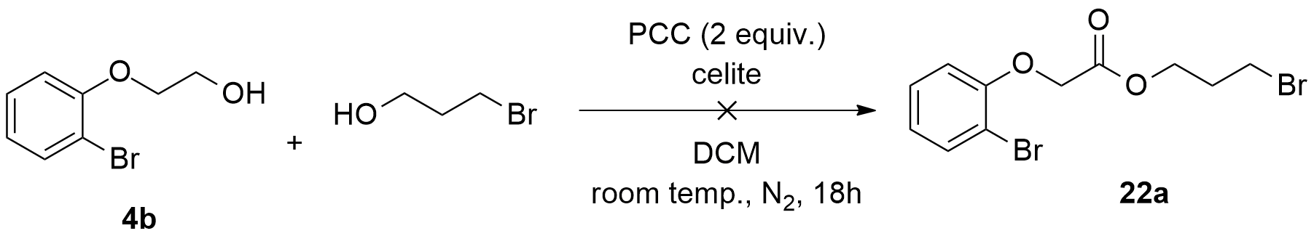
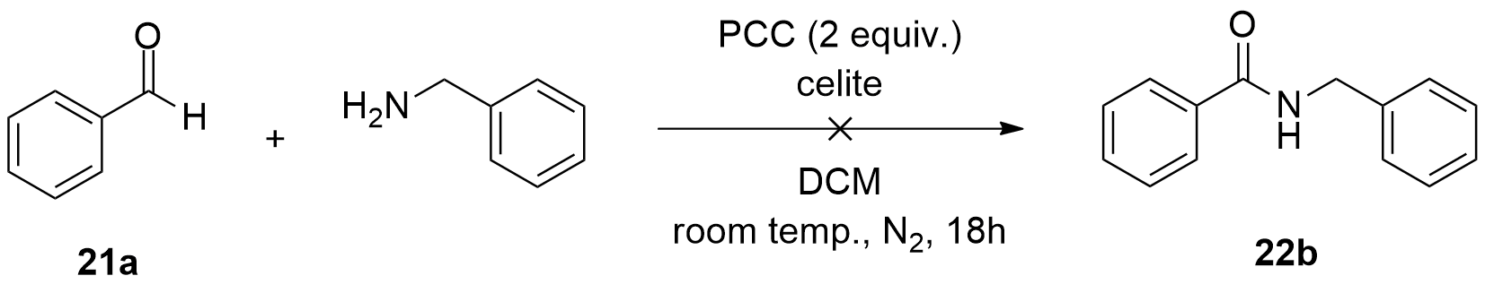
Scheme 5.23: Attempted synthesis of compound (22a) and (22b) using with PCC.

Both of the reactions failed to provide us the desired products. Regarding the first reaction, no esterification product could be obtained. In this particular case, both of the alcohols potentially can be oxidized into their corresponding aldehydes. However, since the spectrum was very dirty (i.e. with many peaks), no product peaks could be identified. Likewise, in the second reaction, after a careful analysis of the ¹H NMR spectrum of the crude mixture, we detected a very small amount of both benzaldehyde (21a) and benzylamine. Moreover, we could also detect the presence of another product in the mixture. After comparing the predicted ¹H NMR spectrum of product (22a) with our spectrum of the crude mixture, we concluded that it wasn´t N-benzylbenzamide (22a). Despite our best efforts, we could not identify this compound´s structure. Besides the possibility of obtaining the imine side-product, one possible cause for the failure of this reaction may have been due to coordination of the benzylamine to the chromium reagent, with concomitant deactivation of both reagents.
In addition, we reacted an aldehyde intermediate (11a) (previously synthesized by our group) and a number of different commercially available alcohols and amines, under the same reaction conditions described in Scheme 5.20 (Scheme 5.24). These reactions were carried out in an effort to confirm our mechanistic hypothesis, that an aldehyde intermediate was transformed into the corresponding ester or amide (when the alcohol was replaced by an amine).

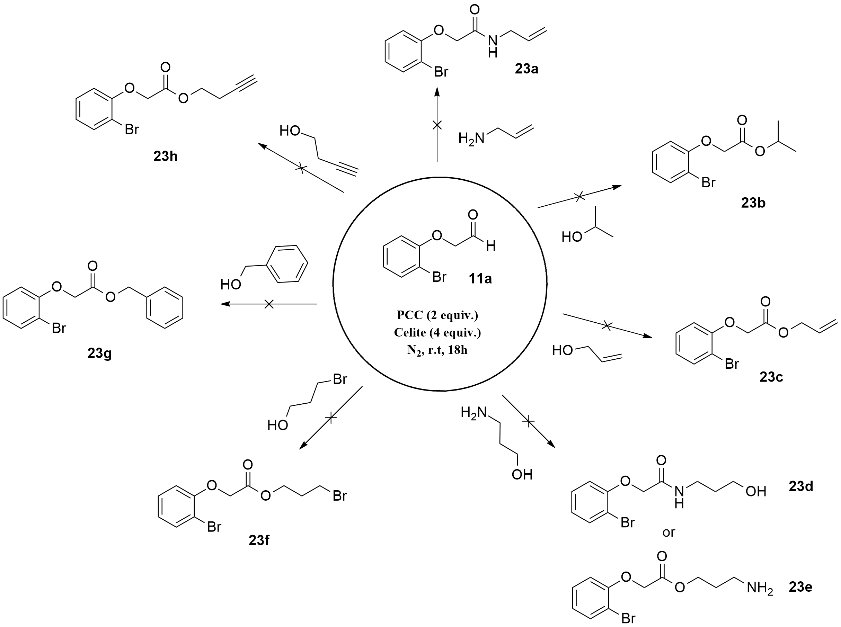

Scheme 5.24: Study of the scope of our PCC promoted oxidative esterification using an aldehyde substrate.

[Atraia a atenção do seu leitor colocando uma boa citação no documento ou utilize este espaço para enfatizar um ponto chave. Para colocar esta caixa de texto noutro local da página, arraste-a.]

Unfortunately, after purification and ¹H NMR screening of the reaction mixtures, there was no traces of the desired products, with no presence or very small amounts of the initial aldehyde substrate, the ¹H NMR spectra showed many peaks, which we were not able to identify. Since we employed several alcohols as reagents, these could easily be oxidized to their corresponding aldehydes. In the case of those reactions involving amines, the formation of imines was also very much possible. In conclusion, this study failed to afford any support to our proposed mechanism.

5.2.5 Synthetic route to macrocycle drug-like molecules from diether-esters

Over the last years, the occurrence of biologically active macrocycles (molecules that include ring architectures of 12 or more atoms) in the medicinal chemistry literature has increased. Several recent review articles have revealed the significant role that macrocycles can play in medicinal chemistry, specifically looking beyond the established importance of natural product macrocycles in drug discovery. The macrocycle ring allows a molecule to reach such a degree of structural pre-organization that important functional groups can interact across extended binding sites, in proteins, without a major entropic loss on binding. Consequently, these molecules can be very selective, as well as extremely potent. They also provide a compromise between structural pre-organization and adequate flexibility to mold to a target surface and maximize binding interactions. Additionally, macrocycles epitomize not only the bigger versions of small molecules, but also the smallest examples of biomolecules that exhibit functional sub-domains.^{261 a)} Existing macrocyclic drugs are almost exclusively derived from natural sources (mostly from microorganisms) and are either identical to or closely derived from naturally occurring macrocycles. Some examples include: Erythromycin, which was originally isolated from Saccharopolyspora erythrea (formerly Streptomyces erythraeus), Abamectin, which was isolated from Streptomyces avermitilis and the antituberculosis compound Rifampin, which was isolated from Amycolatopsis rifamycinica (formerly Streptomyces mediterranei) (Figure 5.5).^{261 a)}

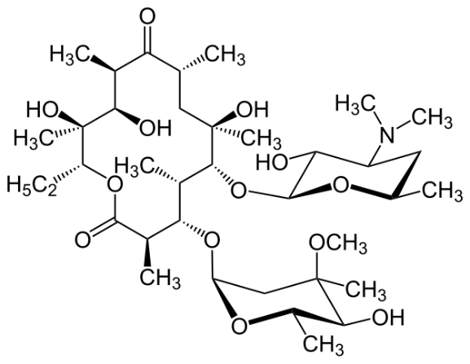
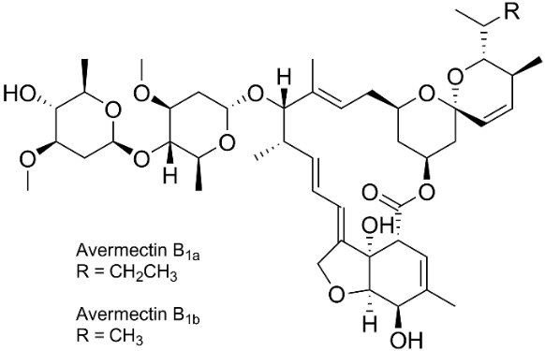
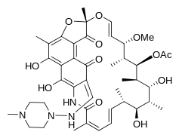
Erythromycin
Abamectin
Rifampin
Figure 5.5: Some natural macrocycles.

While the dominance of natural-product macrocycles among marketed drugs reflects areas that synthetic medicinal chemistry have found challenging, it also demonstrates the rich pharmacopoeia provided from natural sources.^{261 a)} Consequently, the pursuit and development of new and active macrocycle drug-like molecules, nowadays, represents a very interesting field of research.
We considered taking advantage of the diether-esters (20a)-(20i) obtained using our novel oxidative-esterification protocol and by using an appropriate synthetic strategy, convert them to the corresponding macrocycles; this was to be our proof-of-concept. We conceived a synthetic strategy that included the mono borylation of the esters and subsequent Suzuki-Miyaura coupling to deliver the desired macrocyclic products (Scheme 5.25).

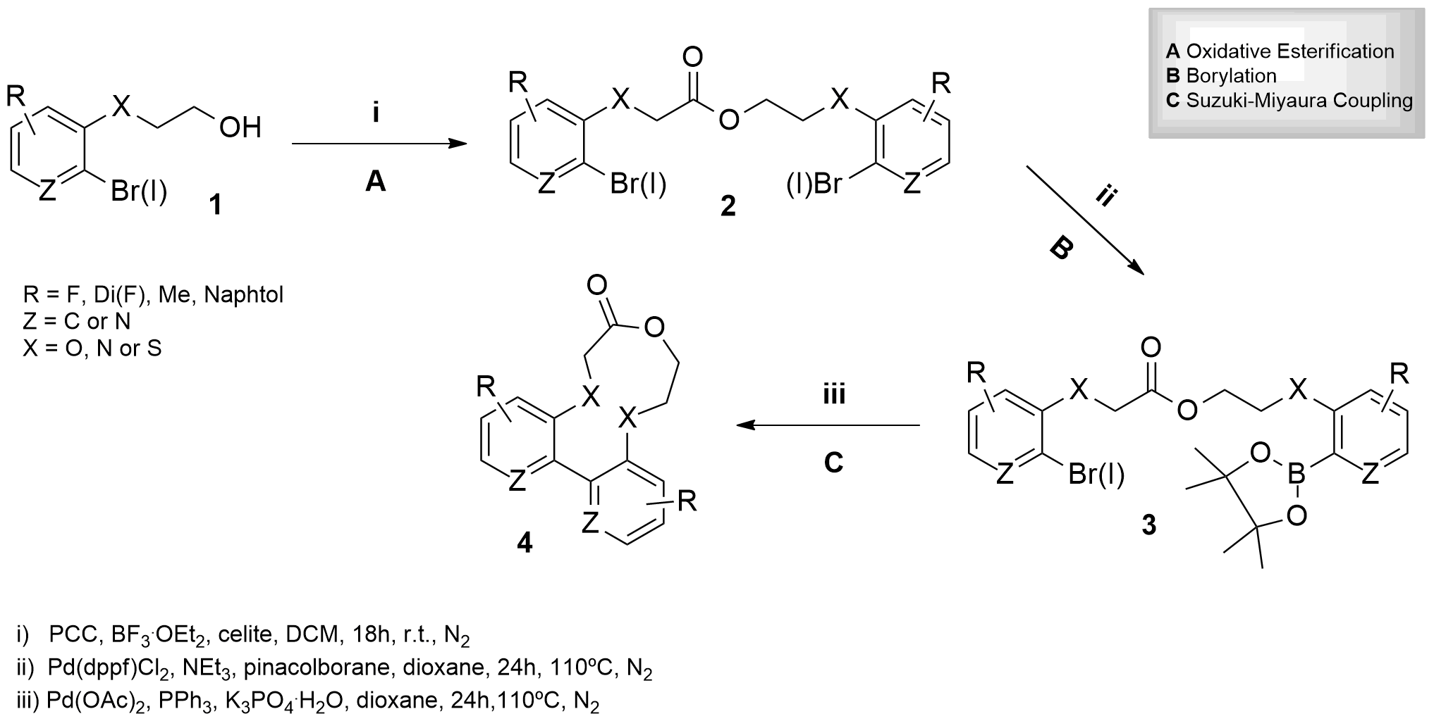

Scheme 5.25: Our synthetic strategy for the synthesis of macrocycles – roadmap for key proof of concept studies.

The strategy was to conduct a catalytic borylation reaction (B, Scheme 5.25) after the previous oxidative esterification step, (A, Scheme 5.25). Since our previous borylation reactions failed to work, we examined two other procedures.
In the first method, we reacted compound (20a) with pinacolborane over Pd(dppf)Cl₂ and NEt₃, in dioxane, at 110 ºC, for 24h (Scheme 5.26). This reaction afforded the borylated product, which was assigned structure (24a) on the basis of ¹³C NMR simulations, which are described below.

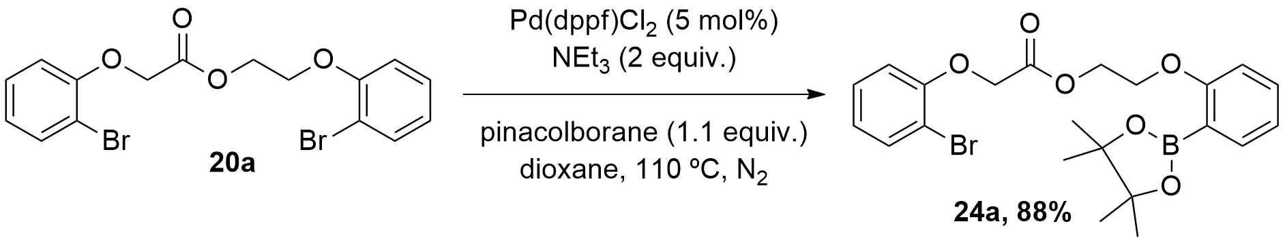
Scheme 5.26: Borylation of compound (20a) with Pd(dppf)Cl₂ and pinacolborane to give (24a).

When we compared the predicted ¹³C NMR spectra for (24a) and its regioisomer (24b) with the ¹³C NMR data for our compound, we observed that it was (24a) that showed the best correlation with our compound. We immediately saw that the predicted ¹³C NMR spectrum for (24a) had a greater degree of similarity to ours, while the predicted spectrum of the compound borylated at the left hand side (24b) was slightly different, particularly in the aliphatic area. Whereas in both spectra (ours and (24a)) we observed 3 singlet signals corresponding to the 3xCH₂ units present in the product (Figures 5.6 and 5.7, respectively), in the predicted spectrum (24b) we only observed 2 singlets (Figure 5.8). This happens because 2 of the 3 CH₂ units are considered to be identical, therefore only 2 singlets are detected by ¹³C NMR. We also examined the predicted ¹H NMR spectra of both regioisomers (24a) and (24b), but didn´t observe any significant differences between them.
An important aspect of this reaction is its regioselectivity, specifically why the borylation occurred on the right hand side bromoaryl unit (Scheme 5.26). Comparing both of the bromoaryl units present in the substrate (20a), one can easily recognise that the right hand side aryl group is placed further away from the ester group. For this reason, it is expected that the bromoaryl unit placed on the right hand side of the molecule is less sterically hindered and more susceptible to borylation.

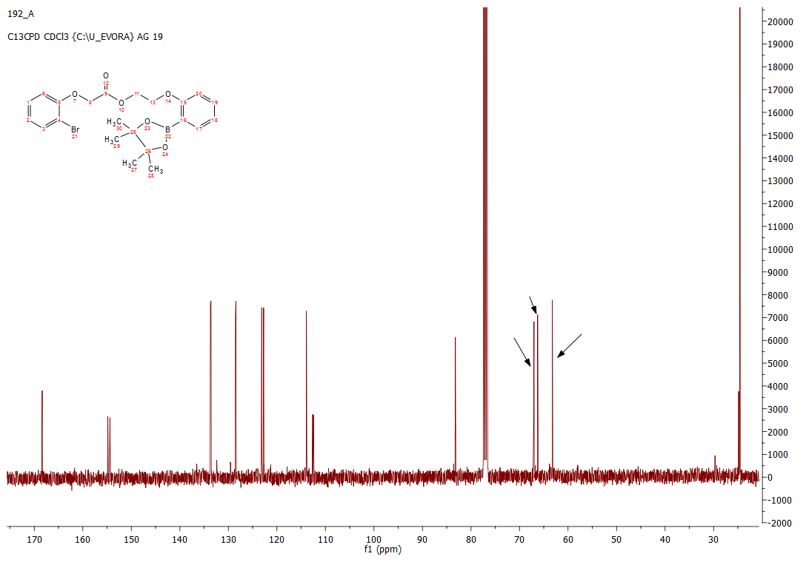
Figure 5.6: ¹³C NMR spectrum of the compound assigned structure (24a).

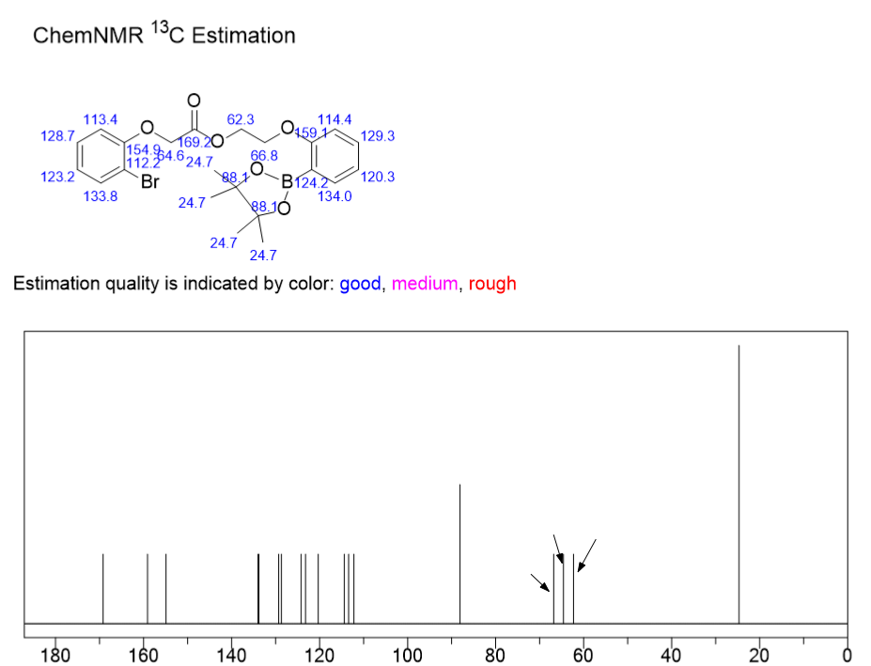
Figure 5.7: Predicted ¹³C NMR spectrum for compound (24a) borylated on the right hand side.

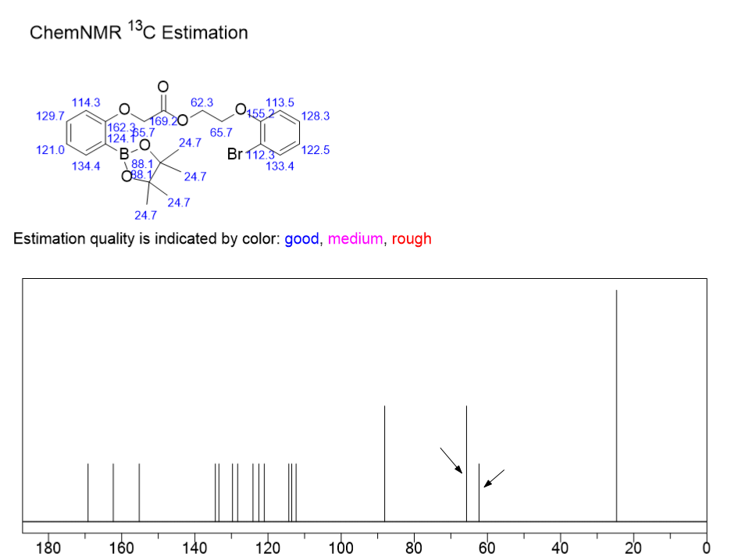
Figure 5.8: Predicted ¹³C NMR spectrum for compound (24b) borylated on the left hand side.

In the second method, we reacted compound (20a) with B₂pin₂, Pd(MeCN)₂Cl₂ and K₂CO₃, in dioxane, at 110 ºC, for 24h (Scheme 5.27), but this reaction failed to work.

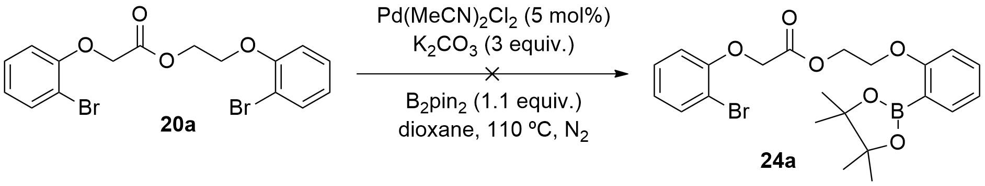
Scheme 5.27: Attempted borylation of compound (20a) with Pd(MeCN)₂Cl₂ and B₂pin₂.

Whereas the first procedure showed high efficiency (88% yield) in providing the desired 2-(2-(4,4,5,5-tetramethyl-1,3,2-dioxaborolan-2-yl) phenoxy)ethyl 2-(2-bromophenoxy)acetate (24a) the second methodology failed to provide compound (24a). Instead, we only detected initial substrate (20a) in the ¹H NMR spectrum of the reaction mixture.
The final step was to perform a Suzuki-Miyaura C-C coupling on compound (24a) in order to cyclize it, thus obtaining its corresponding macrocycle (25a). Once again, since it was the first time we attempted C-C coupling reactions using these type of substrates, we examined two different procedures. The first procedure included the reaction of compound (24a) using Pd(dppf)Cl₂ and KOAc, in aqueous dioxane, at 100 ºC, for 24h (Scheme 5.28).

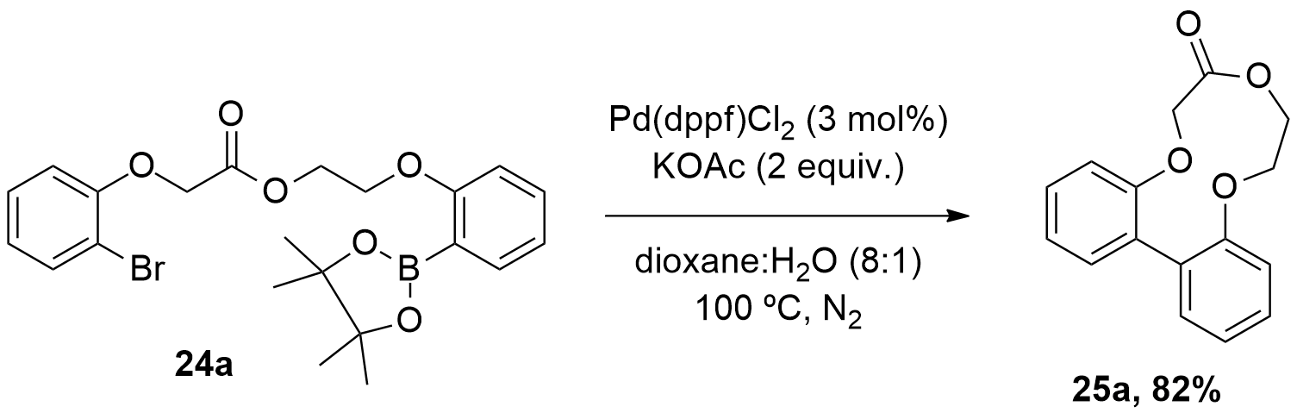
Scheme 5.28: Synthesis of macrocycle (25a) using Pd(dppf)Cl₂.

In the second methodology we reacted compound (24a) with Pd(OAc)₂, PPh₃ and K₃PO₄.H₂O, in dioxane, at 100 ºC, for 24h (Scheme 5.29).
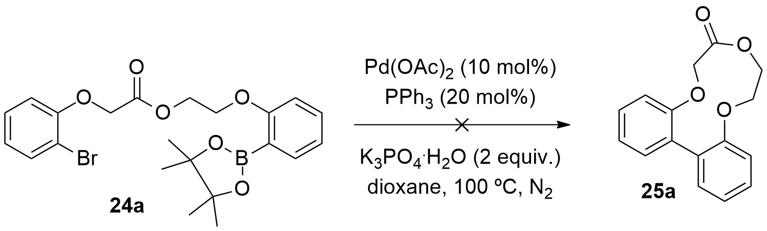
Scheme 5.29: Attempted synthesis of macrocycle (25a) using Pd(OAc)₂.

Only the first methodology (Scheme 5.28) provided the desired 9,10-dihydrodibenzo[h,j][1,4,7]trioxacycloundecin-7(6H)-one (25a). Employing conditions described in Scheme 5.29, the ¹H NMR spectrum of the reaction mixture showed only the presence of substrate (24a). In this particular case, possibly the palladium catalyst (Pd(OAc)₂) was not compatible with our substrate. This incompatibility, might have inhibited the oxidative addition step in the catalytic cycle and thus no cyclic product was provided under these conditions.

  - 5.2.6 Biological Assays
5.2.6.1 Inhibition assays on AChE and BuChE

As mentioned above, considering the fact that many important biologically active molecules are in fact macrocylic in nature, we decided to conduct some bioassays for both AChE and BuChE inhibition with some of our molecules. Unfortunately, as we only had one macrocyclic compound (25a) available, we decided to include also a fragment based screening approach, in which we used the open-chain precursor of (25a), (24a) and its analogues (see below). Once again, this work was conducted by Patricia Bacalhau from the the Biotec labs at the Chemistry Department, University of Evora. We modified the assay to measure AChE and BuChE activities from the assay described by Ellman et al.²⁰⁵
Table 5.4 shows the results of the inhibition assays for compounds (20b), (20c), (20e) and (25a) tested against both AChE and BuChE enzymes.

Table 5.4 Inhibition assays of esters (20b), (20c), (20e) and macrocycle (25a) towards AChE and BuChE

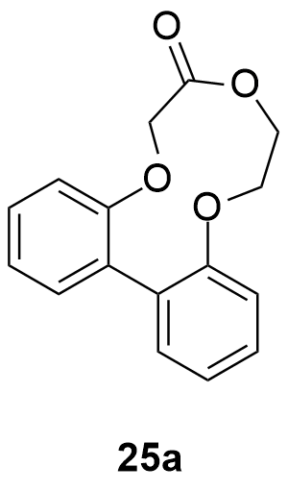

Entry | Compound | MW | IC50 AChE (μM) | IC50 BuChE (μM)
1 | 20b | 466.07 | 157.1 ± 4.7 | 785.4 ± 76.6
2 | 20c | 502.05 | 197.5 ± 3.4 | 895.7 ± 132.6
3 | 20e | 530.21 | 155.5 ± 14.1 | >1500
4 | 25a | 270.28 | 144.4 ± 5.7 | 339.2 ± 65.0
Standard  (Donepezil) | - | 379.48 | 14.3 ± 0.1 | 107.2 ± 6.5

The results show that both the diether-esters and the macrocycle (25a) display close inhibition values for AChE, with compound (25a) showing the lowest value. In the case of BuChE, none of the compounds tested exhibited significant inhibitory activity. These compounds showed inferior inhibitory activity compared to donepezil. The fact that the macrocycle (25a) gave the best results is probably due to the reasons given above, as well as the fact that it is much less conformationally flexible than the open-chain analogues, which is generally a requirement for good inhibition.

  - 5.3 Conclusions

In this chapter, we reported a new methodology for the direct oxidative esterification of primary alcohols, which provides interesting diether-esters. Numerous studies were carried out to probe the reaction mechanism and at the same time optimize the reaction conditions. These included oxidant loading, solvent screening and kinetic studies. It was established that 1 equivalent of PCC and 1 equivalent of Lewis acid were the best combination of reagents to be employed. Furthermore, a mechanism for this reaction was proposed based on all these studies. Using this efficient methodology, we synthesized nine new diether-esters in very good to excellent yields; some of these molecules were subsequently tested against both AChE and BuChE. In addition, we also disclosed a new synthetic strategy for the synthesis of interesting diether-ester macrocycles with potential biological activity. This methodology included the borylation of the synthesized esters and a subsequent Suzuki-Miyaura coupling to obtain the desired macrocycle. Using this methodology, we synthesized one diether-ester macrocycle, which was also tested against both AChE and BuChE. However, their inhibitory activity were inferior to the benchmark used, i.e. donepezil.

  - 5.4 Experimental Section
5.1 General Observations
5.4.1.1 Reagents and solvents

All the starting materials commercially available used in this work were purchased from Sigma-Aldrich, Fluka, Acros and Alfa Aeser.
Solvents used in this work were dried and purified under inert atmosphere and subjected to common laboratory purification techniques.²⁰³
- DCM was distilled over CaH₂;
- N,N-Dimethylformamide (DMF) was distilled over MgSO₄ under reduced pressure at 60 ºC;
- MeOH was distilled over CaH₂;
- THF was distilled over sodium and benzophenone;
- Toluene was distilled over LiAlH₄;
- MeCN was distilled over CaH₂;
- 1,4-Dioxane was distilled over sodium and benzophenone.

5.4.1.2 Detection, purification and characterisation of synthesized compounds

All the reactions were followed by TLC. The plates (Merck) were revealed by either using UV light or a solution of phosphomolybdic acid in ethanol.²⁰⁴
Column chromatography was carried out on silica gel (SDS, 70-200 μm). All the eluents are described for each specific compound.
Some of the NMR analysis was made in the Faculdade de Ciências e Tecnologia/Universidade Nova de Lisboa, on a Bruker Avance Instrument (400 MHz), using CDCl₃ and DMSO-d₆ as solvents. Most of the NMR analysis was made at Universidade de Évora, Centro de Química, using a Bruker Avance Instrument III (400 MHz). Mesitylene was used as the internal standard to calculate NMR yields. All ¹H and ¹³C chemical shifts are reported in ppm and are referenced against the deuterated solvent peak.
Mass spectra were obtained from C.A.C.T.I., at Universidade de Vigo, on a Waters-Micromass (MicroTOF, ESI) or FAB Focus (Bruker Daltonics), using the TOF technique.
Everytime inert atmosphere was needed, it was described in the procedure.

5.4.1.3 ¹H NMR kinetic experiments

The samples were prepared as follows: 0.5 mL of deuterated chloroform were filled into a NMR tube under N₂. After this, the alcohol and PCC were also loaded into the tube. The tube was closed and placed inside the NMR machine, for analysis. Several ¹H spectra were taken (one spectra per hour) during the interval of 20 hours. Subsequently, all the NMR spectra were treated and analysed, providing us with important information about the kinetic behaviour of the reaction.

5.4.2 Direct synthesis of esters via PCC oxidative esterification
5.4.2.1 General procedure

The appropriate alcohol derivative was added to a degassed round bottom flask containing dry DCM. After this, celite (double of the mass of PCC) and 2 equivalents of PCC were added to the solution and the flask was degassed one more time. The mixture was left stirring vigorously for several hours, at room temperature, monitored by TLC. After total consumption of the starting material, the solvent was evaporated and a mixture of hexane/EtOAc (5:1) was added to the crude product. This mixture was filtered over a silica pad under vacuum. The solvent was evaporated under reduced pressure. After purification by silica gel chromatography compounds, products (20a)-(20i) were obtained in excellent yields.

5.4.2.2 Synthesis of 2-(2-bromophenoxy)ethyl 2-(2-bromophenoxy)acetate (20a)

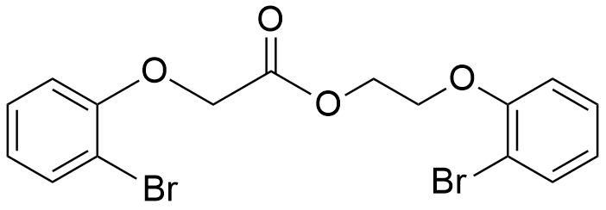

Following the general procedure, compound (4b) (0.30 g, 1.38 mmol), celite (1.20 g), and PCC (0.60 g, 2.76 mmol), were added to DCM (5 mL) in a round-bottom-flask and allowed to react as described above. After purification by silica gel chromatography (Hex: EtOAc (5:1)) compound (20a) was obtained as a white solid (0.57 g, 96%).
¹H NMR (400 MHz, CDCl₃) δ (ppm): 7.57 (ddd, J = 4.8, 3.5, 1.7 Hz, 2H), 7.28 (qd, J = 7.1, 1.6 Hz, 1H), 7.23-7.15 (m, 1H), 6.94-6.82 (m, 4H), 4.79 (s, 2H), 4.64 (dd, J = 5.3, 4.1 Hz, 2H), 4.27 (dd, J = 5.3, 4.1 Hz, 2H).
¹³C NMR (101 MHz, CDCl₃) δ (ppm): 168.37 (C=O), 154.83 (C), 154.41 (C), 133.70 (CH), 133.58 (CH), 128.54 (CH), 128.46 (CH), 123.14 (CH), 122.73 (CH), 113.92 (CH), 113.87 (CH), 112.62 (C), 112.48 (C), 67.01 (CH₂), 66.25 (CH₂), 63.23 (CH₂).
ESI-TOF MS (m/z): 438.93 (M+1).

5.4.2.3 Procedure using Lewis Acid

Alcohol derivative (4b) (0.25 g, 1.16 mmol) was added to a degassed round bottom flask containing dry DCM. After this, celite (double of the mass of PCC), 1 equivalent of PCC (0.25 g, 1.16 mmol) and 1 equivalent of BF₃.OEt₂ (0.164 g, 1.16 mmol) were added to the solution and the flask was degassed one more time. The mixture was left stirring vigorously for several hours, at room temperature, monitored by TLC. After total consumption of the starting material, the solvent was evaporated and a mixture of hexane/EtOAc (5:1) was added to the crude product. This mixture was filtered over a silica pad under vacuum. The solvent was evaporated under reduced pressure. After purification by silica gel chromatography (Hex: EtOAc (5:1)) compound (20a) was obtained as a white solid (0.47 g, 96%).
¹H NMR (400 MHz, CDCl₃) δ (ppm): 7.55 (ddd, J = 4.8, 3.5, 1.7 Hz, 2H), 7.25 (qd, J = 7.1, 1.6 Hz, 1H), 7.23-7.15 (m, 1H), 6.90-6.85 (m, 4H), 4.76 (s, 2H), 4.61 (dd, J = 5.3, 4.1 Hz, 2H), 4.22 (dd, J = 5.3, 4.1 Hz, 2H).

5.4.2.4 Synthesis of 2-(2-bromo-5-fluorophenoxy)ethyl 2-(2-bromo-5-fluorophenoxy)acetate (20b)

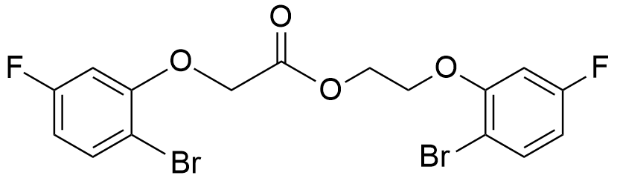

Following the general procedure, compound (4n) (0.30 g, 1.28 mmol), celite (1.10 g), and PCC (0.55 g, 2.56 mmol), were added to DCM (5 mL) in a round-bottom-flask and allowed to react as described above. After purification by silica gel chromatography (Hex: EtOAc (5:1)) compound (20b) was obtained as a white solid (0.56 g, 94%).
¹H NMR (400 MHz, CDCl₃) δ (ppm): 7.50 (dd, J = 8.7, 6.4 Hz, 2H), 6.63 (ddd, J = 15.3, 8.0, 4.8 Hz, 4H), 4.77 (s, 2H), 4.68-4.62 (m, 2H), 4.27-4.21 (m, 2H).
¹³C NMR (101 MHz, CDCl₃) δ (ppm): 167.74 (C=O), 163.73 (d, J = 13.4 Hz, CF), 161.28 (d, J = 13.7 Hz, CF), 155.61 (d, J = 10.1 Hz, CBr), 155.20 (d, J = 10.0 Hz, CBr), 133.89 (dd, J = 18.5, 9.5 Hz, CHx2), 109.59 (dd, J = 57.5, 22.4 Hz, CHx2), 106.73 (d, J = 1.6 Hz, CO), 106.69 (d, J = 1.6 Hz, CO), 101.98 (dd, J = 26.7, 22.8 Hz, CHx2), 67.04 (CH₂), 66.14 (CH₂), 63.05 (CH₂).
ESI-TOF MS (m/z): 464.91 (M+1).

5.4.2.5 Synthesis of 2-(2-bromo-4,5-difluorophenoxy)ethyl 2-(2-bromo-4,5-difluorophenoxy)acetate (20c)

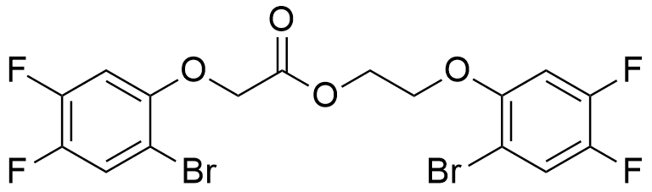

Following the general procedure, compound (4e) (0.30 g, 1.19 mmol), celite (1.02 g), and PCC (0.51 g, 2.37 mmol), were added to DCM (5 mL) in a round-bottom-flask and allowed to react as described above. After purification by silica gel chromatography (Hex: EtOAc (5:1)) compound (20c) was obtained as a dark white solid (0.58 g, 97%).
¹H NMR (400 MHz, CDCl₃) δ (ppm): 7.42 (ddd, J = 9.4, 8.4, 2.7 Hz, 2H), 6.77 (ddd, J = 11.2, 6.8, 0.9 Hz, 2H), 4.74 (s, 2H), 4.66-4.61 (m, 2H), 4.24-4.19 (m, 2H).
¹³C NMR (101 MHz, CDCl₃) δ (ppm): 167.72 (C=O), 151.21 (dd, J = 7.5, 2.8 Hz, CF), 150.88 (dd, J = 7.6, 3.0 Hz, CF), 150.76-150.53 (m, CF), 148.42-148.04 (m, CF), 146.36 (dd, J = 37.9, 13.4 Hz, CBr), 143.91 (dd, J = 37.2, 13.4 Hz, CBr), 121.91-121.52 (CHx2), 106.26 (dd, J = 7.2, 4.2 Hz, CO), 106.02 (dd, J = 7.2, 4.1 Hz, CO), 104.13 (d, J = 21.6 Hz, CHx2), 103.51 (d, J = 21.6 Hz, CHx2), 67.82 (CH₂), 66.93 (CH₂), 63.09 (CH₂).
ESI-TOF MS (m/z): 500.89 (M+1).
5.4.2.6 Synthesis of 2-(2-bromo-4-methylphenoxy)ethyl 2-(2-bromo-4-methylphenoxy)acetate (20d)

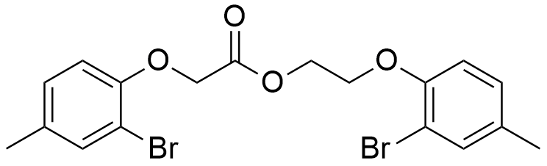

Following the general procedure, compound (4k) (0.30 g, 1.30 mmol), celite (1.12 g), and PCC (0.56 g, 2.60 mmol), were added to DCM (5 mL) in a round-bottom-flask and allowed to react as described above. After purification by silica gel chromatography (Hex: EtOAc (5:1)) compound (20d) was obtained as a dark yellow solid (0.55 g, 92%).
¹H NMR (400 MHz, CDCl₃) δ (ppm): 7.39 (d, J = 7.5 Hz, 2H), 6.81-6.74 (m, 4H), 4.74 (d, J = 2.0 Hz, 2H), 4.62 (dt, J = 9.7, 4.6 Hz, 2H), 4.22 (dd, J = 9.2, 4.5 Hz, 2H), 2.28 (d, J = 13.4 Hz, 6H).
¹³C NMR (101 MHz, CDCl₃) δ (ppm): 167.73 (C=O), 152.73 (CBr), 152.33 (CBr), 133.97 (d, J = 11.9 Hz, CHx2), 132.99 (CO), 132.57 (CO), 128.90 (d, J = 5.3 Hz, CHx2), 114.11 (d, J = 14.5 HzCHx2), 112.42 (CCH₃), 112.20 (CCH₃), 67.82 (CH₂), 66.94 (CH₂), 63.29 (CH₂), 20.21 (d, J = 1.9 Hz, CH₃x2).
ESI-TOF MS (m/z): 456.14 (M+1).

5.4.2.7 Synthesis of 2-((1-bromonaphthalen-2-yl)oxy)ethyl 2-((1-bromonaphthalen-2-yl)oxy)acetate (20e)

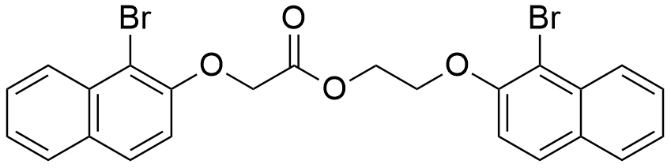

Following the general procedure, compound (6b) (0.30 g, 1.12 mmol), celite (0.97 g), and PCC (0.48 g, 2.24 mmol), were added to DCM (5 mL) in a round-bottom-flask and allowed to react as described above. After purification by silica gel chromatography (Hex: EtOAc (5:1)) compound (20e) was obtained as a pale yellow solid (0.56 g, 95%).
¹H NMR (400 MHz, CDCl₃) δ (ppm): 8.24 (d, J = 8.5 Hz, 2H), 7.78 (t, J = 9.1 Hz, 2H), 7.69 (dd, J = 12.9, 8.7 Hz, 2H), 7.61-7.55 (m, 2H), 7.47-7.37 (m, 2H), 7.20 (d, J = 8.9 Hz, 2H), 4.92 (s, 2H), 4.72-4.67 (m, 2H), 4.40 (dd, J = 8.1, 3.9 Hz, 2H).
¹³C NMR (101 MHz, CDCl₃) δ (ppm): 168.68 (C=O), 152.79 (C), 152.41 (C), 133.12 (C), 130.46 (C), 130.34 (C), 130.03 (C), 129.05 (CH), 128.99 (CH), 128.08 (CH), 128.03 (CH), 127.84 (CH), 127.82 (CH), 126.43 (CHx2), 124.92 (CH), 124.85 (CH), 115.71 (CH), 115.24 (CH), 110.47 (C), 110.35 (C), 68.19 (CH₂), 67.17 (CH₂), 63.62 (CH₂).
ESI-TOF MS (m/z): 528.96 (M+1).

5.4.2.8 Synthesis of 2-((2-bromopyridin-3-yl)oxy)ethyl 2-((2-bromopyridin-3-yl)oxy)acetate (20f)

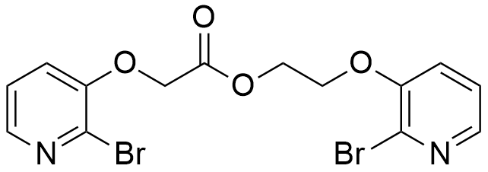

Following the general procedure, compound (8b) (0.30 g, 1.38 mmol), celite (1.19 g), and PCC (0.59 g, 2.75 mmol), were added to DCM (5 mL) in a round-bottom-flask and allowed to react as described above. After purification by silica gel chromatography (Hex: EtOAc (2:1)) compound (20f) was obtained as a white solid (0.52 g, 87%).
¹H NMR (400 MHz, CDCl₃) δ (ppm): 8.07-8.01 (m, 2H), 7.27-7.21 (m, 2H), 7.17-7.13 (m, 2H), 4.82 (s, 2H), 4.68-4.63 (m, 2H), 4.30-4.26 (m, 2H).
¹³C NMR (101 MHz, CDCl₃) δ (ppm): 167.66 (C=O), 151.82 (CBr), 151.48 (CBr), 142.69 (CH), 142.22 (CH), 133.24 (CO), 133.22 (CO), 123.49 (CH), 123.35 (CH), 120.76 (CH), 120.31 (CH), 66.97 (CH₂), 66.04 (CH₂), 63.09 (CH₂).
ESI-TOF MS (m/z): 430.92 (M+1).

5.4.2.9 Synthesis of 2-(2-bromo-4-cyanophenoxy)ethyl 2-(2-bromo-4-cyanophenoxy)acetate (20g)

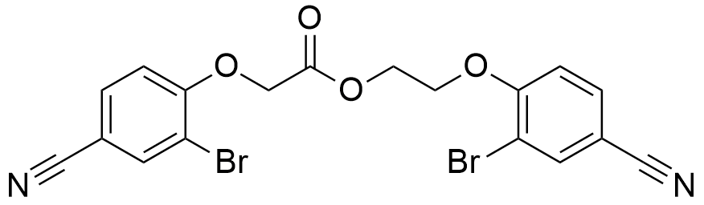

Following the general procedure, compound (4h) (0.08 g, 0.33 mmol), celite (0.28 g), and PCC (0.14 g, 0.66 mmol), were added to DCM (2.5 mL) in a round-bottom-flask and allowed to react as described above. After purification by silica gel chromatography (Hex: EtOAc (5:1)) compound (20g) was obtained as a white solid (0.13 g, 85%).
¹H NMR (400 MHz, CDCl₃) δ (ppm): 7.87 (dd, J = 5.7, 1.2 Hz, 2H), 7.65-7.52 (m, 2H), 6.89 (dd, J = 28.8, 8.6 Hz, 2H), 4.87 (s, 2H), 4.71-4.67 (m, 2H), 4.35-4.30 (m, 2H).
¹³C NMR (101 MHz, CDCl₃) δ (ppm): 167.18 (C=O), 158.11 (C-Br), 157.72 (C-Br), 139.31 (C), 137.10 (d, J = 17.0 Hz, CH), 133.11 (C), 133.04 (d, J = 17.2 Hz, CH), 117.45 (C), 117.34 (C), 114.08 (C), 113.11 (C), 112.98 (C), 112.93 (d, J = 17.1 Hz, CH), 106.66 (C), 106.22 (C), 66.92 (CH₂), 65.80 (CH₂), 62.95 (CH₂).
ESI-TOF MS (m/z): 478.92 (M+1).

5.4.2.10 Synthesis of 2-((3-bromonaphthalen-2-yl)oxy)ethyl 2-((3-bromonaphthalen-2-yl)oxy)acetate (20h)

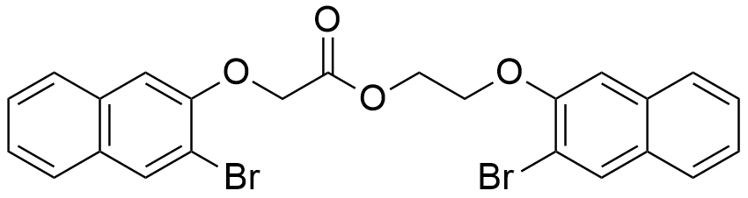

Following the general procedure, compound (6e) (0.20 g, 0.75 mmol), celite (0.65 g), and PCC (0.32 g, 1.50 mmol), were added to DCM (5 mL) in a round-bottom-flask and allowed to react as described above. After purification by silica gel chromatography (Hex: EtOAc (5:1)) compound (20h) was obtained as a yellow solid (0.34 g, 93%).
¹H NMR (400 MHz, CDCl₃) δ (ppm): 8.15 (d, J = 8.5 Hz, 2H), 7.69 (t, J = 8.7 Hz, 2H), 7.60 (dd, J = 12.6, 8.6 Hz, 2H), 7.50 (dt, J = 11.1, 7.9 Hz, 2H), 7.33 (dd, J = 16.2, 8.1 Hz, 2H), 7.11 (dd, J = 8.9, 1.6 Hz, 1H), 4.83 (s, 2H), 4.65-4.55 (m, 2H), 4.33 (dd, J = 11.6, 6.9 Hz, 2H).
¹³C NMR (101 MHz, CDCl₃) δ (ppm): 176.92 (C=O), 168.68 (C), 157.96 (C), 152.79 (C), 152.41 (C), 135.86 (C), 133.12 (C), 129.05 (CH), 128.99 (CH), 128.08 (CHx2), 128.03 (CH), 127.84 (CH), 127.82 (C), 126.46 (C), 126.43 (CHx2), 124.92 (CH), 124.86 (CH), 115.71 (CH), 115.24 (CH), 68.20 (CH₂), 67.18 (CH₂), 63.62 (CH₂).
ESI-TOF MS (m/z): 528.97 (M+1).

5.4.2.11 Synthesis of 2-(2-bromo-3-methoxyphenoxy)ethyl 2-(2-bromo-3-methoxyphenoxy)acetate (20i)

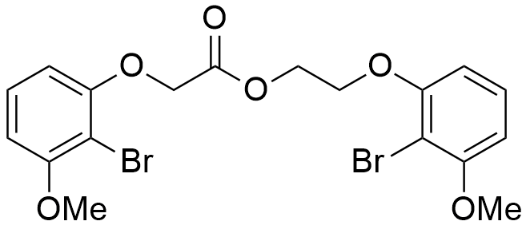

Following the general procedure, compound (4q) (0.20 g, 0.81 mmol), celite (0.70 g), and PCC (0.35 g, 1.62 mmol), were added to DCM (5 mL) in a round-bottom-flask and allowed to react as described above. After purification by silica gel chromatography (Hex: EtOAc (5:1)) compound (20i) was obtained as a yellow solid (0.36 g, 90%).
¹H NMR (400 MHz, CDCl₃) δ (ppm): 7.23 (dd, J = 11.3, 5.2 Hz, 1H), 7.15 (t, J = 8.3 Hz, 1H), 6.62 (d, J = 9.5 Hz, 2H), 6.56 (d, J = 8.4 Hz, 1H), 6.50 (d, J = 8.3 Hz, 1H), 4.79 (s, 2H), 4.65-4.61 (m, 2H), 4.29-4.24 (m, 2H), 3.92 (s, 3H), 3.90 (s, 3H).
¹³C NMR (101 MHz, CDCl₃) δ (ppm): 168.41 (C=O), 157.38 (C), 157.35 (C), 156.12 (C), 155.66 (C), 128.30 (CH), 128.25 (CH), 106.40 (CH), 106.17 (CH), 105.70 (CH), 105.35 (CH), 101.96 (C), 101.87 (C), 67.14 (CH2), 66.33 (CH2), 63.23 (CH2), 56.49 (CH3x2).
ESI-TOF MS (m/z): 488.95 (M+1).
5.4.3 Borylation of 2-(2-bromophenoxy)ethyl 2-(2- bromophenoxy)acetate (20a)
5.4.3.1 General procedure

To a two-neck round-bottom flask containing dioxane was added, Pd(dppf)Cl₂, NEt₃ and 2-(2-bromophenoxy)ethyl 2-(2-bromophenoxy)acetate (20a), followed by pinacolborane. The mixture was allowed to stir for 24h, at 110 ºC, under N₂, monitored by TLC. After this period of time the reaction was left to cool and AcOEt was added to the flask. The mixture was filtered with vacuum, over a silica pad. The solvent was evaporated.

5.4.3.2 Synthesis of 2-(2-(4,4,5,5-tetramethyl-1,3,2-dioxaborolan-2-yl)phenoxy)ethyl 2-(2-bromophenoxy)acetate (24a)

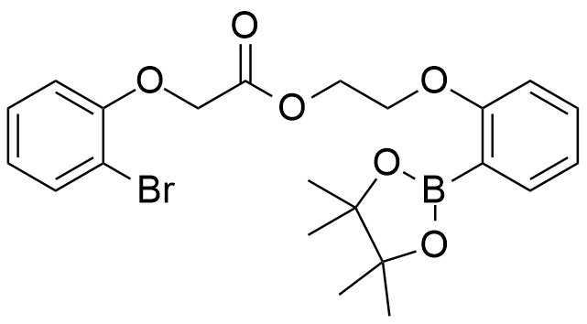

Following the general procedure, Pd(dppf)Cl₂ (0.01 g, 0.02 mmol), NEt₃ (0.07 g, 0.70 mmol), 2-(2-bromophenoxy)ethyl 2-(2-bromophenoxy)acetate (20a) (0.15 g, 0.35 mmol) and pinacolborane (0.05 g, 0.40 mmol), were dissolved in dioxane (4 mL) and allowed to react as described above. After purification by silica gel chromatography (Hex: EtOAc (5:1)) compound (24a) was obtained as a yellow solid (0.15 g, 88%).
¹H NMR (400 MHz, CDCl₃) δ (ppm): 7.60-7.54 (m, 2H), 7.31-7.25 (m, 1H), 7.19 (t, J = 7.7 Hz, 1H), 6.89 (dd, J = 16.9, 8.4 Hz, 4H), 4.79 (s, 2H), 4.66-4.63 (m, 2H), 4.30-4.24 (m, 2H), 1.30 (s, 12H).
¹³C NMR (101 MHz, CDCl₃) δ (ppm): 168.37 (C=O), 154.83 (C), 154.42 (C), 133.70 (CH), 133.58 (CH), 128.54 (CH), 128.45 (CH), 123.13 (CH), 122.73 (CH), 113.92 (CH), 113.88 (CH), 112.63 (C), 112.48 (C), 83.21 (C-Ox2), 67.01 (CH₂), 66.26 (CH₂), 63.23 (CH₂), 24.55 (CH₃x4).

5.4.4 Procedure for the Suzuki-Miyaura coupling of 2-(2-(4,4,5,5-tetramethyl-1,3,2-dioxaborolan-2-yl)phenoxy)ethyl 2-(2-bromo phenoxy)acetate (24a)
5.4.4.1 Synthesis of 9,10-dihydrodibenzo [h,j] [1,4,7] trioxacycloundecin-7(6H)-one (25a)

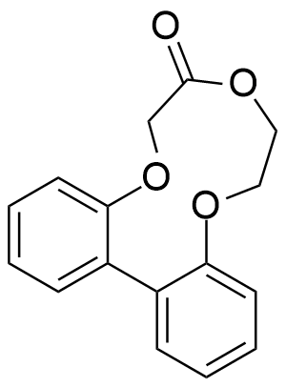

To a schlenk flask containing dioxane:H₂O (8:1) we added Pd(dppf)Cl₂ (0.008 g, 0.01 mmol), KOAc (0.07 g, 0.38 mmol) and 2-(2-(4,4,5,5-tetramethyl-1,3,2-dioxaborolan-2-yl)phenoxy)ethyl 2-(2-bromophenoxy)acetate (24a) (0.18 g, 0.38 mmol). The mixture was allowed to stir at 100 ºC, for 24h, under N₂, monitored by TLC. After this period, the reaction was left to cool and AcOEt was added to the flask. The mixture was filtered with vacuum over a silica pad. The solvent was evaporated. After purification by silica gel chromatography (Hex: EtOAc (5:1)) compound (25a) was obtained as a brown solid (0.08 g, 82%).
¹H NMR (400 MHz, CDCl₃) δ (ppm): 7.57 (ddd, J = 4.8, 3.5, 1.7 Hz, 2H), 7.30-7.26 (qd, J = 7.1, 1.6 Hz, 1H), 7.21-7.17 (m, 1H), 6.91-6.85 (m, 4H), 4.79 (s, 2H), 4.64 (dd, J = 5.3, 4.1 Hz, 2H), 4.26 (dd, J = 5.3, 4.1 Hz, 2H).
¹³C NMR (101 MHz, CDCl₃) δ (ppm): 168.36 (C=O), 154.83 (C), 154.41 (C), 133.70 (CH), 133.58 (CH), 128.55 (CH), 128.47 (CH), 123.13 (CH), 122.73 (CH), 113.92 (CH), 113.87 (CH), 112.61 (C), 112.47 (C), 67.01 (CH₂), 66.24 (CH₂), 63.23 (CH₂).

5.4.5 Other attempted reactions
5.4.5.1 General procedure for the attempted synthesis of 3-bromopropyl 2-(2-bromophenoxy)acetate (22a) (Scheme 5.23)

2-(2-bromophenoxy)ethanol ((4b), chapter 3) (1 equiv.) and 3-bromopropan-1-ol (1.2 equiv.) were added to a degassed round bottom flask containing dry DCM. After this, celite (double of the mass of PCC) and 2 equivalents of PCC were added to the solution and the flask was degassed one more time. The mixture was left stirring vigorously for several hours, at room temperature, under N₂, monitored by TLC. The solvent was evaporated and a mixture of hexane/EtOAc (5:1) was added to the crude product. This mixture was filtered over a silica pad under vacuum. The solvent was evaporated under reduced pressure.

5.4.5.2 General procedure for the attempted synthesis of N-benzylbenzamide (22b) (Scheme 5.23)

Benzaldehyde (1 equiv.) and benzylamine (1.1 equiv.) were added to a degassed round bottom flask containing dry DCM. After this, celite (double of the mass of PCC) and 2 equivalents of PCC were added to the solution and the flask was degassed one more time. The mixture was left stirring vigorously for several hours, at room temperature, under N₂, monitored by TLC. The solvent was evaporated and a mixture of hexane/EtOAc (5:1) was added to the crude product. This mixture was filtered over a silica pad under vacuum. The solvent was evaporated under reduced pressure.

5.4.5.3 General procedure for the scope of the oxidative esterification with PCC (Scheme 5.24)

The aldehyde (11a) and the appropriate alcohol or amine substrates (1.2 equiv.) were added to a degassed round bottom flask containing dry DCM. After this, celite (double of the mass of PCC) and 2 equivalents of PCC were added to the solution and the flask was degassed one more time. The mixture was left stirring vigorously for several hours, at room temperature, under N₂, monitored by TLC. The solvent was evaporated and a mixture of hexane/EtOAc (5:1) was added to the crude product. This mixture was filtered over a silica pad under vacuum. The solvent was evaporated under reduced pressure.

5.4.5.4 General procedure for the attempted borylation of compound (20a) (Scheme 5.27)

To a two-neck round-bottom flask filled with dioxane were added Pd(MeCN)₂Cl₂, K₂CO₃ and 2-(2-bromophenoxy)ethyl 2-(2-bromophenoxy) acetate (20a), followed by B₂pin₂. The mixture was allowed to stir at 110 ºC, for 24h, under N₂, monitored by TLC. After this period, the reaction was left to cool and AcOEt was added to the flask. The mixture was filtered over a silica pad with vacuum. The solvent was evaporated.

5.4.5.5 General procedure for the attempted Suzuki-Miyaura coupling of (24a) (Scheme 5.29)

To a schlenk flask filled with dioxane we added Pd(OAc)₂, PPh₃, K₃PO₄.H₂O and 2-(2-(4,4,5,5-tetramethyl-1,3,2-dioxaborolan-2-yl)phenoxy)ethyl 2-(2-bromophenoxy)acetate (24a). The mixture was allowed to stir at 100 ºC, for 24h, under N₂, monitored by TLC. After this period, the reaction was left to cool and AcOEt was added to the flask. The mixture was filtered over a silica pad with vacuum. The solvent was evaporated and the starting material (24a) was recovered.

5.4.6 Biological assays

We modified the assay to measure AChE and BuChE activities from the assay described by Ellman et al.²⁰⁵ 75 μL of sample were dissolved in buffer with no more than 10 % DMSO (different concentrations), 25 μL of ATCI 15 mM or BTCI 15 mM. After, 125 μL of DTNB (3 mM) were added to the wells, followed by 25 μL of 0,3 U/mL AChE or 0,3 U/mL BuChE. The microplate was read at 405 nm, every minute for 20 minutes, in a BIO-TEK ELX800G microplate reader (using Gen5 v.1.05 software). Subsequently, a standard curve was drawn for each enzyme using seven different concentrations, ranging from 0.1 U/mL to 1 U/mL and the velocities of the reactions were measured. Enzyme activity was calculated as a percentage of the velocities, compared to that of the assay using buffer without inhibitor. Inhibitory activity was calculated from 100 subtracted of enzyme activity. Enzymatic activity was determined using Origin 8 software. Every experiment was done in triplicate.

Bibliography

Every story has an end but in science every ending is a new beginning.

- Bates, R. “Organic Synthesis Using Transition Metals”. 2012, Wiley, 2nd Edition.
- Seechurn, C. C. C. J.; Kitching, M. O.; Colacot T. J., Snieckus, V. Angew. Chem. Int. Ed. 2012, 51, 5062 – 5085.
- Berzelius, J. J. Ann. Chimm. et. Phys. 1836, 61, 146.
- Hoffmann, R. American Scientist. 1998, 86, 326.
- Roberts, M. W. Catalysis Lett. 2000, 67, 1.
- Crabtree, R. H. “The Organometallic Chemistry of the Transition Metals”. 4th ed.; John Wiley and Sons, New Jersey, 2005, pp 1 – 53.
- Ackermann, L. “Modern Arylation Methods“. Wiley – VCH, Weinheim. 2009, pp. 1 – 24.
- Smidt J.; Hafner, W.; Jira, R.; Sedlmeie, J.; Sieber, R.; Kojer, H.; Ruttinger, R. Angew. Chem. 1959, 71, 176 – 182.
- Jira, R. Angew. Chem. 2009, 121, 9196 – 9199.
- Jira, R. Angew. Chem. 2009, 121, 9196 – 9199.
- Collman, J. P.; Hegedus, L. S.; Norton, J. R.; Finke, R. G. “Principles and Applications of Organotransition Metal Chemistry.” University Science Books: Mill Valley. 1987.
- a) Heck, R. F. “Palladium Reagents in Organic Syntheses”. Academic Press: New York. 1985; b) Hegedus, L. S. “Organometallics in Synthesis”. Schlosser, M., Ed.; Wiley: New York. 1994.
- Negishi, E.; Coperet, C.; Ma, S.; Liou, S. Y.; Liu, F. Chem. Rev., 1996, 96, 365.
- a) Negishi, E. Acc. Chem. Res. 1982, 15, 340; b) Stille, J. K. Angew. Chem. Int. Ed. Engl. 1986, 25, 508; c) Suzuki, A. Acc. Chem. Res. 1982, 15, 178.
- a) Heck, R. F. Acc. Chem. Res. 1979, 12, 146; b) Heck, R. F. Org. React. 1982, 27, 345; c) Heck, R. F. “Comprehensive Organic Synthesis”. Trost, B. M.; Fleming, I., Eds.; Pergamon: Oxford. 1991; Vol. 4; d) de Meijere, A.; Meyer, F. E. Angew. Chem., Int. Ed. Engl. 1994, 33, 2379; e) Cabri, W.; Candiani, I. Acc. Chem. Res. 1995, 28, 2.
- a) Tsuji, J. Acc. Chem. Res. 1969, 2, 144; b) Tsuji, J. Tetrahedron. 1986, 42, 4361; c) Trost, B. M. Tetrahedron. 1977, 33, 2615; d) Trost, B. M. Acc. Chem. Res. 1980, 13, 385.
- Maitlis, P. M. Acc. Chem. Res. 1976, 9, 93.
- Heck, R. F. J. Am. Chem. Soc. 1968, 90, 5518.
- a) Owczarczyk, Z.; Lamaty, F.; Vawter, E. J.; Negishi, E. J. Am. Chem. Soc. 1992, 114, 10091. b) Terakado, M.; Miyazawa, M.; Yamamoto K. Synlett. 1994, 134.
- Fitton, P.; Johnson, M. P.; McKeon, J. E. Chem. Commun. 1968, 6 – 7.
- a) Dieck, H. A.; Heck, R. F. J. Am. Chem. Soc. 1974, 96, 1133 – 1136; b) Heck, R. F.; Nolley, J. P.; Jr. J. Org. Chem. 1972, 37, 2320 – 2322.
- a) Mizoroki, T.; Mori, K.; Ozaki, A. Bull. Chem. Soc. Jpn. 1973, 46, 1505 – 1508; b) Mizoroki, T.; Mori, K.; Ozaki A. Bull. Chem. Soc. Jpn. 1971, 44, 581 – 581.
- a) Mori, M.; Ban, Y. Tetrahedron Lett. 1977, 1037; 1979, 1133; 1982, 23, 3894 ; b) Cortese, N. A.; Ziegler, C. B.; Hrnjez, B. J.; Heck, R. F. J. Org. Chem. 1978, 43, 2952; c) Terpko, M. O.; Heck, R. F. J. Am. Chem. Soc. 1979, 101, 5281; d) Odle, R.; Blevins, B.; Ratcliff, M.; Hegedus, L. S. J. Org. Chem. 1980, 45, 2709; e) Iida, H.; Yuasa, Y.; Kibayashi, C. J. Org. Chem. 1980,45, 2938; f) Ziegler, F. E.; Chakraborty, U. R.; Weisenfeld, R. B. Tetrahedron. 1981, 37, 4035.; g) Kasahara, A.; Izumi, T.; Murakami, S.; Yanai, H.; Takatori, M. Bull. Chem. Soc. Jpn. 1986, 59, 927.
- a) Narula, C. K.; Mak, K. T.; Heck, R. F. J. Org. Chem. 1983, 48, 2792. b) Shi, L.; Narula, C. K.; Mak, K. T.; Kao, L.; Xu, Y.; Heck, R. F. J. Org. Chem. 1983, 48, 3894.
- Grigg, R.; Stevenson, P.; Worakun, T., J. Chem. Soc. Chem. Commun. 1984, 1073.
- Negishi, E.; Tour, J. M. J. Am. Chem. Soc. 1985, 107, 8289.
- Stille, J. K. Angew. Chem. Int. Ed. Engl. 1986, 25, 508 – 524.
- Azarian, D.; Dua, S. S.; Eaborn, C.; Walton, D. R. M. J. Organomet. Chem. 1976, 117, C55 – C57.
- Kosugi. M.; Shimizu, Y.; Migita, T. Chem. Lett. 1977, 1423 – 1424.
- Milstein, D.; Stille, J. K. J. Am. Chem. Soc. 1978, 100, 3636 – 3638.
- a) Kosugi M.; Fugami K. “Handbook of Organopalladium Chemistry for Organic Synthesis.” (Ed.: E. Negishi), Wiley, New York, 2002, pp. 263 – 283; b) Stille, J. K. Angew. Chem. 1986, 98, 504 – 519; Angew. Chem. Int. Ed. Engl. 1986, 25, 508 – 524.
- Dieck, H. A.; Heck, R. F. J. Org. Chem. 1975, 40, 1083 – 1090.
- Miyaura, N.; Yamada, K.; Suzuki, A. Tetrahedron Lett. 1979, 20, 3437 – 3440.
- Miyaura, N.; Suzuki, A. J. Chem. Soc. Chem. Commun. 1979, 866 – 867.
- Yoshida, J.; Tamao, K.; Yamamoto, H.; Kakui, T.; Uchida, T.; Kumada, M. Organometallics 1982, 1, 542 – 549.
- Hallberg, A.; Westerlund, C. Chem. Lett. 1982, 1993 – 1994.
- Hatanak, Y.; Hiyama, T. J. Org. Chem. 1988, 53, 918 – 920.
- Hiyama, T. J. Organomet. Chem. 2002, 653, 58 – 61.
- Strotman, N. A.; Sommer, S.; Fu, G. C. Angew. Chem. 2007, 119, 3626 – 3628; Angew. Chem. Int. Ed. 2007, 46, 3556 – 3558.
- a) Denmark, S. E.; Choi, J. Y. J. Am. Chem. Soc. 1999, 121, 5821 – 5822; b) Denmark, S. E.; Regens, C. S. Acc. Chem. Res. 2008, 41, 1486 – 1499.
- a) Hoke, M. E.; DeShong, P. J. Org. Chem. 1999, 64, 1684 – 1688; b) Mowery, M. E.; DeShong, P. J. Org. Chem. 1999, 64, 3266 – 3270; c) DeShong, P.; Handy, C. J.; Mowery, M. Pure Appl. Chem. 2000, 72, 1655 – 1658.
- Atwell, W.; Bokerman, G. N. U.S. Patent 3772347. 1973.
- Azarian, D.; Dua, S. S.; Eaborn, C.; Walton, D. R. M. J. Organomet.Chem. 1976, 117, C55 – C57
- Ishiyama, T.; Matsuda, N.; Miyaura, N.; Suzuki, A. J. Am. Chem. Soc. 1993, 115, 11018 – 11019.
- Ishiyama, T.; Murata, M.; Miyaura, N. J. Org. Chem. 1995, 60, 7508 – 7510.
- Murata, M.; Watanabe, S.; Masuda, Y. J. Org. Chem. 1997, 62, 6458 – 6459.
- Kosugi, M.; Kameyama, M.; Migita, T. Chem. Lett. 1983, 927 – 927.
- Kondratenko, N. V.; Kolomeitsev, A. A.; Mogilevskaya, V. O.; Varlamova, N. M.; Yagupol´skii, L. M. Zh. Org. Khim. 1986, 22, 1721 – 1729.
- a) Guram, A. S.; Rennels, R. A.; Buchwald, S. L. Angew. Chem. 1995, 107, 1456 – 1459; Angew. Chem. Int. Ed. Engl. 1995, 34, 1348 – 1350; b) Louie, J.; Hartwig, J. F. Tetrahedron Lett. 1995, 36, 3609 – 3612.
- Fauvarque, J. F.; Jutand, A. J. Organomet. Chem. 1979, 177, 273 – 281.
- a) Galarini, R.; Musco, A.; Pontellini, R.; Santi, R. J. Mol. Catal. 1992, 72, L11 – L13; b) Kuwajima, I.; Nakamura, E. Acc. Chem. Res. 1985, 18, 181 – 187; c) Kosugi, M.; Hagiwara, I.; Sumiya, T.; Migita, T. Bull. Chem. Soc. Jpn 1984, 57, 242 – 246; d) Kosugi, M.; Negishi, Y.; Kameyama, M.; Migita, T. Bull. Chem. Soc. Jpn. 1985, 58, 3383 – 3384.
- Semmelhack, M. F.; Stauffer, R. D.; Rogerson, T. D. Tetrahedron Lett. 1973, 4519 – 4522.
- Millard, A. A.; Rathke, M. W. J. Am. Chem. Soc. 1977, 99, 4833 – 4835.
- Culkin, D. A.; Hartwig, J. F. Acc. Chem. Res. 2003, 36, 234 – 245.
- Bordwell, F. G. Acc. Chem. Res. 1988, 21, 456 – 463.
- Hamann, B. C.; Hartwig, J. F. J. Am. Chem. Soc. 1997, 119, 12382 – 12383.
- Palucki, M.; Buchwald, S. L. J. Am. Chem. Soc. 1997, 119, 11108 – 11109.
- Satoh, T.; Kawamura, Y.; Miura, M.; Nomura, M. Angew. Chem., Int. Ed. 1997, 36, 1740 – 1742.
- a) Kawatsura, M.; Hartwig, J. F. J. Am. Chem. Soc. 1999, 121, 1473 – 1478; b) Satoh, T.; Kametani, Y.; Terao, Y.; Miura, M.; Nomura, M. Tetrahedron Lett. 1999, 40, 5345 – 5348 ; c) Fox, J. M.; Huang, X.; Chieffi, A.; Buchwald, S. L. J. Am. Chem. Soc. 2000, 122, 1360 – 1370 ; d) Terao, Y.; Kametani, Y.; Wakui, H.; Satoh, T.; Miura, M.; Nomura, M. Tetrahedron 2001, 57, 5967 – 5974 ; e) Ehrentraut, A.; Zapf, A.; Beller, M. Adv. Synth. Catal. 2002, 344, 209 – 217; f) Satoh, T.; Jones, W. D. Organometallics, 2001, 20, 2916 – 2919.
- Fox, J. M.; Huang, X.; Chieffi, A.; Buchwald, S. L. J. Am. Chem. Soc. 2000, 122, 1360 – 1370.
- a) Shaughnessy, K. H.; Hamann, B. C.; Hartwig, J. F. J. Org. Chem. 1998, 63, 6546 – 6553; b) Lee, S.; Hartwig, J. F. J. Org. Chem. 2001, 66, 3402 – 3415.
- a) Lee, S.; Beare, N. A.; Hartwig, J. F. J. Am. Chem. Soc. 2001, 123, 8410 – 8411; b) Moradi, W. A.; Buchwald, S. L. J. Am. Chem. Soc. 2001, 123, 7996 – 8002; c) Gaertzen, O.; Buchwald, S. L. J. Org. Chem. 2002, 67, 465 – 475; d) Jørgensen, M.; Lee, S.; Liu, X.; Wolkowski, J. P.; Hartwig, J. F. J. Am. Chem. Soc. 2002, 124, 12557 – 12565.
- Terao, Y.; Fukuoka, Y.; Satoh, T.; Miura, M.; Nomura, M. Tetrahedron Lett. 2002, 43, 101 – 104.
- a) Lee, S.; Hartwig, J. F. J. Org. Chem. 2001, 66, 3402 – 3415; b) Spielvogel, D. J.; Buchwald, S. L. J. Am. Chem. Soc. 2002, 124, 3500 – 3501; c) Ahman, J.; Wolfe, J. P.; Troutman, M. V.; Palucki, M.; Buchwald, S. L. J. Am. Chem. Soc. 1998, 120, 1918 –1919; d) Hamada, T.; Chieffi, A.; Ahman, J.; Buchwald, S. L. J. Am. Chem. Soc. 2002, 124, 1261 – 1268.
- Cardellicchio, C.; Fiandanese, V.; Marchese, G.; Ronzini, L. Tetrahedron Lett. 1987, 28, 2053.
- Malanga, C.; Aronica, L. A.; Lardicci, L. Tetrahedron Lett. 1995, 36, 9185.
- Kabalka, G. W.; Malladi, R. R.; Tejedor, D.; Kelley, S. Tetrahedron Lett. 2000, 41, 999.
- Huang, Y.-C.; Majumdar, K. K.; Cheng, C.-H. J. Org. Chem. 2002, 67, 1682 – 1684.
- Ko, S.; Kang, B.; Chang, S. Angew. Chem. 2005, 117, 459; Angew. Chem. Int. Ed. 2005, 44, 455.
- a) Álvarez-Bercedo, P.; Flores-Gaspar, A.; Correa, A.; Martin, R. J. Am. Chem. Soc. 2010, 132, 466; b) Flores- Gaspar, A.; Gutiérrez-Bonet, A.; Martin, R. Org. Lett. 2012, 14, 5234.
- a) Ruan, J.; Saidi, O.; Iggo, J. A.; Xiao, J. J. Am. Chem. Soc. 2008, 130, 10510; b) Colbon, P.; Ruan, J.; Purdie, M.; Xiao, J. Org. Lett. 2010, 12, 3670; c) Adak, L.; Bhadra, S.; Ranu, B. C. Tetrahedron Lett. 2010, 51, 3811; d) Colbon, P.; Ruan, J.; Purdie, M.; Mulholland, K.; Xiao, J. Org. Lett. 2011, 13, 5456; e) Nareddy, P.; Mazet, C. Chem. Asian J., 2013, 8, 2579.
- a) Solé, D.; Mariani, F.; Fernández, I.; Sierra, M. A. J. Org. Chem. 2012, 77, 10272; b) Solé, D.; Mariani, F. J. Org. Chem. 2013, 78, 8136. c) Solé, D.; Fernández, I. Acc. Chem. Res. 2014, 47, 168.
- Solé, D.; Mariani, F.; Fernández, I. Adv. Synth. Catal. 2014, 356, 3237 – 3243.
- Ramón, D. J.; Yus, M. Angew. Chem. Int. Ed. 2004, 43, 284.
- Sakai, M.; Ueda, M.; Miyaura, N. Angew. Chem. Int. Ed. 1998, 37, 3279.
- Pucheault, M.; Darses, S.; Genet, J. P. J. Am. Chem. Soc. 2004, 126, 15356.
- Low, D. W.; Pattison, G.; Wieczysty, M. D.; Churchill, G. H.; Lam, H. W. Organic Letters. 2012, 2548 – 2551.
- Gallego, G. M.; Sarpong, R. Chem. Sci. 2012, 3, 1338 – 1342.
- Gui, J.; Chen, G.; Cao, P.; Liao, J. Tetrahedron: Asymmetry. 2012, 23, 554.
- Marques, C. S.; Peixoto, D.; Burke, A. J. RSC Adv. 2015, 5, 20108.
- Peixoto, D. PhD dissertation, Universidade de Évora. 2015.
- a) Yamamoto, T.; Ohta, T.; Ito, Y. Org. Lett. 2005, 7, 4153; b) Suzuki, K.; Arao, T.; Ishii, S.; Maeda, Y.; Kondo, K.; Aoyama, T. Tetrahedron Lett. 2006, 47, 5789.
- Liu, G.; Lu, X. J. Am. Chem. Soc. 2006, 128, 16504 – 16505.
- Lin, S.; Lu, X. J. Org. Chem. 2007, 72, 9757.
- Qin, C.; Chen, J.; Wu, H.; Cheng, J.; Zhang, Q.; Zuo, B.; Su, W.; Ding, J. Tetrahedron Lett. 2008, 49, 1884.
- Kuriyama, M.; Shimazawa, R.; Shirai, R. J. Org. Chem. 2008, 73, 1597.
- Lai, H.; Huang, Z.; Wu, Q.; Qin, Y. J. Org. Chem. 2009, 74, 283.
- a) Marques, C.S.; Burke, A.J. “Catalytic Arylation Methods – From the Academic Lab to Industrial Processes”. 2014, Wiley-VCH, Weinheim; b) Li, Y.; Zhu, D-X.; Xu, M-H. Chem. Commun. 2013, 49, 11659 and references cited therein.
- Liu, Z.; Gu, P.; Shi, M.; McDowell, P.; Li, G. Org. Lett. 2011, 13, 2314.
- Zhuang, Y.; He, Y.; Zhou, Z.; Xia, W.; Cheng, C.; Wang, M.; Chen, B.; Zhou, Z.; Pang, J.; Qiu, L. J. Org. Chem. 2015, 80, 6968.
- a) Negishi, E. “Handbook of Organopalladium Chemistry for Organic Synthesis”. Wiley – VCH: New York. 2002; Vols. I and II; b) Tsuji, J. “Palladium in Organic Synthesis”, in “Topics in Organometallic Chemistry”. Springer – Verlag: Berlin; 2005; c) de Meijere, A., Diederich, F. “Metal – Catalysed Cross – coupling Reactions”. Wiley – VCH: New York, 2004.
- a) Plietker, B.; Dieskau, A.; Möws, K.; Jatsch, A. Angew. Chem. Int. Ed. 2008, 47, 198; b) Ohmura, T.; Oshima, K.; Taniguchi, H.; Suginome, M. J. Am. Chem. Soc. 2010, 132, 12194; c) Yamauchi, M.; Morimoto, M.; Miura, T.; Murakami, M. J. Am. Chem. Soc. 2010, 132, 54; d) Gao, F.; Hoveyda, A. H. J. Am. Chem. Soc. 2010, 132, 10961; e) Tsvelikhovsky, D.; Buchwald, S. L. J. Am. Chem. Soc. 2010, 132, 14048; f) Pucheault, M.; Darses, S.; Genet, J. – P. J. Am. Chem. Soc. 2004, 126, 15356.
- a) Pucheault, M.; Darses, S.; Genet, J. – P. J. Am. Chem. Soc. 2004, 126, 15356; b) ImLinger, N.; Mayr, M.; Wang, D.; Wurst, K.; Buchmeiser, M. R. Adv. Synth. Catal. 2004, 346, 1836; c) Shukla, P.; Cheng, C. H. Org. Lett. 2006, 8, 2867; d) Chuzel, O.; Roesch, A.; Genet, J. – P.; Darses, S. J. Org. Chem. 2008, 73, 7800; e) Liao, Y. – H.; Hu, Q. – S. J. Org. Chem. 2010, 75, 6986; f) Li, H.; Xu, Y.; Shi, E.; Wei, W.; Suo, X.; Wan, X. Chem. Commun. 2011, 47, 7880; g) Karthikeyan, J.; Parthasarathy, K.; Cheng, C. – H. Chem. Commun. 2011, 47, 10461; h) Zheng, H.; Ding, J; Chen, J.; Liu, M.; Gao, W.; Wu, H. Synlett 2011, 1626.
- a) Yamamoto, T.; Ohta, T.; Ito, Y. Org. Lett. 2005, 7, 4153; b) Suzuki, K.; Arao, Ishii; Maeda T., S.; Y.; Kondo, K.; Aoyama T. Tetrahedron Lett. 2006, 47, 5789; c) He, P.; Lu, Y.; Dong, C. – G.; Hu, Q. – S. Org. Lett. 2007, 9, 343 d) Novodomsk, A.; Dudicov, M.; Leroux, F. R.; Colobert, F. Tetrahedron: Asymmetry, 2007, 18, 1628; e) Lin, S.; Lu, X. J. Org. Chem. 2007, 72, 9757; f) Kuriyama, M.; Shimazawa, R.; Shirai, R. J. Org. Chem. 2008, 73, 1597; g) Francesco, I. N.; Wagner, A.; Colobert, F. Eur. J. Org. Chem. 2008, 5692; h) Qin, C.; Chen, J.; Wu, H.; Cheng, J.; Zhang, Zuo, Q., B.; Su, W.; Ding, J. Tetrahedron Lett. 2008, 49, 1884; i) Zhang R.; Xu, Q.; Zhang, X.; Zhang, T.; Shi, M. Tetrahedron: Asymmetry 2010, 21, 1928; j) Liao, Y. – X.; Xing, C. – H.; Israel, M.; Hu, Q. – S. Tetrahedron Lett. 2011, 52, 3324; k) Luo, F.; Pan, S.; Pan, C.; Qian, P.; Cheng, J. Adv. Synth. Catal. 2011, 353, 320; l) Ye, Z.; Lv, G.; Wang, W.; Zhang, M., Cheng, J. Angew. Chem. 2010, 122, 3753; Angew. Chem. Int. Ed. 2010, 49, 3671.
- Ritter. S.K. Chem. Eng News, 2013, July 29, pp34.
- Hyttel, J.; Larsen, J.J. J. Neurochem. 1985, 44, 1615 – 1622.
- Business concentrates, Chem. Eng News, 2013, June 3, pp23. (http://www.trinotherapeutics.com/trino – candidates/).
- Fournet A.; Barrios, A.A.; Munoz, V.; Hocque – Miller, R.; Roblot, F.; Cave, A. Planta Med. 1994, 60, 8.
- Garcia, A. E.; Ouizem, S.; Cheng, X.; Romanens, P.; Kundig E. P. Adv. Synth. Catal. 2010, 352, 2306 – 2314.
- Ohkuma, T.; Kitamura, M.; Noyori, R. “Asymmetric Hydrogenation in Catalytic Asymmetric Synthesis”. 2nd edition, Wiley – VCH (I. Ojima, Ed.). 2000, Ch. 1, pp – 1 – 110.
- Taber, G.P.; Pfisterer, D.M.; Colberg, J.C. Org. Proc. Res. Dev., 2004, 8, 385.
- a) Han, Z.; Koenig, S.G.; Zhao, H.; Su, X.; Singh, S.P.; Bakale, R.P. Org. Proc. Res. Dev. 2007, 11, 726. b) Hayashi, T.; Ueyama, K.; Tokunaga, N.; Yoshida, K. J. Am. Chem. Soc. 2003, 125, 11508.
- Gore, V.; Manojkumar, B.; Sonawane, S.; Kokane, D. “A process for the preparation of enantiomerically pure amines”, WO2009147430, 2 June 2009.
- Gutman, A.L.; Zaltzman, I.; Ponomarez, V.; Sotrihin, M.; Nisnevich, G. “Process for the preparation of rasagiline and its salts”, WO2002068376, 25 Feb., 2002.
- Gerlach, U.; Brendel, J.; Lang, H – J.; Paulus, E.F.; Weidmann, K.; Brüggemann, A.; Busch, A.E.; Suessbrich, H.; Bleich, M.; Greger, R. J. Med. Chem. 2001, 44, 3831.
- Davies, H.M.L.; Gregg, T.M.,Tetrahedron Lett. 2002, 43, 4951.
- Binda, C.; Hubálek, F.; Li, M.; Herzig, Y.; Sterling, J.; Edmondson, D. E.; Mattevi, A. J. Med. Chem., 2005, 48, 8148 – 8154.
- Weinreb, O.; Amit, T.; Bar – Am, O.; M. Youdim, B.H. Progress in Neurobiology, 2010, 92, 330 – 344.
- Hessel, V.; Kralisch, D.; Kockmann, N.; Noel, T.; Wang, Q. ChemSusChem. 2013, 6, 746 – 789.
- Ley, S. V.; Ingham, R. J.; O’Brien, M.; Browne, D. L. Beilstein J. Org. Chem. 2013, 9, 1051 – 1072.
- Wegner, J.; Ceylan, S.; Kirschning, A. Adv. Synth. Catal. 2012, 354, 17 – 57.
- a) Pastre, J. C.; Browne, D. L.; Ley, S. V. Chem. Soc. Rev. 2013, 42, 8849 – 8869; b) Hessel, V.; Gursel, I. V.; Wang, Q.; Noel, T.; Lang, J. Chem. Eng. Technol. 2012, 35, 1184 – 1204.
- a) Marre, S.; Jensen, K. F. Chem Soc.Rev. 2010, 39, 1183; b) Hessel, V. R. A.; Schouten, J. C.; Yoshida, J.I. “Handbook of Micro Process Technology”. Vol.1 – 3; Wiley – VCH: Weinheim, Germany. 2009; c) Hartman, R.L.; McMullen,J.P.; Jensen, K. F. Angew.Chem.Int.Ed. 2011, 50, 7502; d) Hessel, V.; Gursel, I. V.; Wang, Q.; Noel, T.; Lang, J. Chem. Eng. Technol. 2012, 35, 1184; e) Ley, S. V. Chem. Rec. 2012, 12, 378; f) Malet – Sanz, L.; Susanne, F. J. Med.Chem. 2012, 55, 4062; g) Webb, D.; Jamison, T. F. Chem. Sci. 2010, 1, 675; h) Wegner, J.; Ceylan, S.; Kirschning, A. Adv.Synth.Catal. 2012, 354, 17; i) Wiles, C.; Watts, P. Chem. Commun. 2011, 47, 6512.
- Born, S.; O’Neal, E.; Jensen, K. F. “Comprehensive Organic Synthesis II”. Volume 9. 2014
- Marre, S.; Adamo, A.; Basak, S.; Aymonier, C.; Jensen, K. F. Ind. Eng. Chem. Res. 2010, 49, 11310.
- a) Nguyen, N. – T.; Wu, Z., J. Micromech. Microeng. 2005, 15, R1; b) Hessel, V.; Lowe, H.; Schonfeld, F. Chem. Eng.Sci. 2005, 60, 2479.
- Nagy, K. D.; Jensen, K. F. Chem. Today. 2011, 29, 29.
- a) McMullen, J. P.; Jensen, K. F. Ann. Rev. Anal. Chem. 2010, 3, 19; b) deMello, A. J. Nature. 2006, 442, 394.
- Kralj, J. G.; Sahoo, H. R.; Jensen, K. F. Lab Chip. 2007, 7, 256.
- a) Hartman, R. L.; Sahoo, H. R.; Yen, B. C.; Jensen, K. F. Lab Chip. 2009, 9, 1843. b) Lam, K. F.; Cao, E.; Sorensen, E.; Gavriilidis, A. Lab Chip. 2011, 11, 1311.
- a) Muller, G.; Gaupp, T.; Wahl, F.; Wille, G. Chimia, 2006, 60, 618 – 622; b) Klemm, E.; Dçring, H.; Geißelemann, A.; Schirrmeister, S. Chem. Ing. Tech. 2007, 79, 697 – 706.
- Wegner, J.; Ceylan, S.; Kirschninga, A. Adv. Synth. Catal. 2012, 354, 17 – 57.
- Fang, H.; Xiao, Q.; Wu, F.; Floreancig, P. E.; Weber, S. G. J. Org. Chem. 2010,75, 5619 – 5626.
- Lange, P. P.; Gooßen, L. J.; Podmore, P.; Underwood, T.; Sciammetta, N. Chem. Commun. 2011, 47, 3628 – 3630.
- Noël, T.; Buchwald, S.L. Chem. Soc. Rev., 2011, 40, 5010.
- Naber, J. R.; Buchwald, S. L. Angew. Chem., Int. Ed., 2010, 49, 9469 – 9474.
- Hartman, R. L.; Naber, J. R.; Zaborenko, N.; Buchwald, S. L.; Jensen, K. F. Org. Process Res. Dev., 2010, 14, 1347 – 1357.
- Horie, T.; Sumino, M.; Tanaka, T.; Matsushita, Y.; Ichimura, T.; Yoshida, J. – i. Org. Process Res. Dev., 2010, 14, 405 – 410.
- Noël, T.; Naber, J. R.; Hartman, R. L.; McMullen, J. P.; Jensen, K. F.; Buchwald, S. L. Chem. Sci., 2011, 2, 287 – 290.
- a) Ceylan, S.; Friese, C.; Lammel, C.; Mazac, K.; Kirschning, A. Angew. Chem, Int. Ed., 2008, 47, 8950 – 8953; b) Zhang, Y.; Jamison, T. F.; Patel, S.; Mainolfi, N. Org. Lett., 2011, 13, 280 – 283.
- Burke, A. J.; Marques, C.S.; Peixoto, D. A. S.; Viana, H. R.M.; Goth, A.J.P. PCT/IB2014/064179.
- Harkal, S.; Kumar, K.; Michalik; D.; Zapf, A.; Jackstell, R.; Rataboul, F.; Riermeier, T.; Monsees, A.; Beller, A. Tetrahedron Lett. 2005, 46, 3237 – 3240.
- Yu, J.L.; Wang, H.; Zou, K.F.; Zhang, J.R.; Gao, X.; Zhang, W.; Li, Z.T. Tetrahedron Lett. 2013, 69, 310 – 315.
- Paul, S.; Gupta, M. Tetrahedron Lett. 2004, 45, 8825 – 8829.
- Freedman, H.H.; Bubois, R.A. Tetrahedron Lett. 1975, 38, 5251 – 3254.
- Weissberg, A.; Dahan, A.; Portnoy, M. J. Comb. Chem. 2001, 3, 154 – 156.
- Fuhrmann, E.; Talbiersky, J. Organic Process Research & Development. 2005, 9, 206 – 211.
- Jin, C. H.; Lee, H. Y.; Lee, S. H.; Jung, Y. H. SYNLETT. 2007, 17, 2695 – 2698.
- Kazemi, M.; Noori, Z.; Kohzadi, H; Sayadi, M.; Kazemi, A. Iran. Chem. Commun. 2013, 1, 43 – 50.
- a) Kiuru, P.; Yli – Kauhaluoma, J.“Pyridine and Its Derivatives”. In “Heterocycles in Natural Product Synthesis”; b) Majumdar, K.; Chattopadhyay, S. K., Eds.; Wiley – VCH Verlag GmbH & Co. KGaA: Weinheim, Germany. 2011; pp 267 – 297.
- Carlson, G. P. Toxicol. Lett. 1996, 85, 173 – 178.
- Pryde, D. C.; Dalvie, D.; Hu, Q.; Jones, P.; Obach, R. S.; Tran, T. – D. J. Med. Chem. 2010, 53, 8441 – 8460.
- Garvey, D. S.; Wasicak, J. T.; Elliott, R. L.; Lebold, S. A.; Hettinger, A. – N.; Carrera, G. M.; Lin, N. – H.; He, Y.; Holladay, M. W.; Anderson, D. J.; Cadman, E. D.; Raszkiewicz, J. L.; Sullivan, J. P.; Arneric, S. P. J. Med. Chem. 1994, 37, 4455 – 4463.
- Olesen, P. H.; Tønder, J. E.; Hansen, J. B.; Hansen, H. C.; Rimvall, K. Bioorg. Med. Chem. 2000, 8, 1443 – 1450.
- Tojo, G.; Fernández, M.”Oxidation of Alcohols to Aldehydes and Ketones”. 2006. Springer, New York.
- Ley, S. V.; Norman, J.; Griffith, W. P.; Marsden, S. P. Synthesis, 1994, 639.
- Corey, E. J.; Suggs, W. J. Tetrahedron Letters. 1975, 31, 2647 – 2650.
- a) Ferriera, E. M.; Stoltz, B. M. J. Am. Chem. Soc. 2001, 123, 7725; b) Jensen, D. R.; Pugsley, J. S.; Sigman, M. S. J. Am. Chem. Soc. 2001, 123, 7475.
- De Nooy, A. E. J.; Besemer, A. C.; van Bekkum, H. Synthesis. 1996, 1174.
- Dess, D. B.; Martin, J.C. J. Org. Chem. 1983, 48, 4155.
- Frigerio, M.; Santagostino, M.; Sputore, S.; Palmisano, G. J. Org. Chem. 1995, 60, 7272.
- a) Nicolaou, K. C.; Zhong, Y. – L.; Baran, P. S. J. Am. Chem. Soc. 2000, 122, 7596; b) Nicolaou, K. C.; Zhong, Y. – L.; Baran, P. S. J. Am. Chem. Soc., 2001, 123, 3183.
- Mancuso, A. J.; Huang, S.L.; Swern, D. J. Org. Chem. 1978, 43, 2480.
- a) Mancuso, A. J.; Swern, D. Synthesis. 1981, 165; b) Tidwell, T. T. Org. React. 1990, 39, 297; c) Tidwell, T. T. Synthesis. 1990, 857.
- Sanford, E. M.; Lis, C. C.; McPherson, N. R. Journal of Chemical Education. 2009, Vol. 86, No. 12.
- Pappo, R.; Allen, D. S., Jr.; Lemieux, R. U.; Johnson, W. S. J. Org. Chem. 1956, 21, 478 – 479.
- Molander, G. A. “Science of Synthesis: Cross – coupling and Heck – Type Reactions”. ed., Thieme Chem. 2012, vol. 5 – 6.
- Nicolaou, K. C.; Bulger, P. G.; Sarlah, D. Angew. Chem. Int. Ed. 2005, 44, 4442.
- Suzuki, A. Angew. Chem. Int. Ed. 2011, 50, 6723.
- Hall, D. G. “Boronic Acids”. ed., Wiley – VCH, Weinheim, 2nd edn. 2011, vol. 1 – 2.
- a) Primas, N.; Bouillon, A.; Rault, S. Tetrahedron. 2010, 66, 8121; b) Ishiyama, T.; Miyaura, N. Chem. Rec. 2004, 3, 271; c) Ishiyama, T.; Miyaura, N. J. Organomet. Chem. 2000, 611, 392; d) Vogels, C. M.; Westcott, S. A. ChemCatChem. 2012, 4, 47; e) Pilarski, L. T.; Szabo, K. J. Angew. Chem. Int. Ed. 2011, 50, 8230; f) Merino, P.; Tejero, T. Angew. Chem. Int. Ed. 2010, 49, 7164.
- a) Braga, A. A. C.; Ujaque, G.; Maseras, F. “Computational Modeling for Homogeneous and Enzymatic Catalysis”. ed. Morokuma, K.; Musaev, D. G., Wiley – VCH, Weinheim. 2008, ch. 5; b) Ackermann, L. “Modern Arylation“. ed., Wiley – VCH, Weinheim. 2009.
- Sumimoto, M.; Iwane, N.; Takahama, T.; Sakaki, S. J. Am. Chem. Soc. 2004, 126, 10457.
- Murata, M.; Oyama, T.; Watanabe, S.; Masuda, Y. J. Org. Chem. 2000, 65, 164.
- Lam, K. C.; Marder, T. B.; Lin, L. Organometallics 2010, 29, 1849.
- Billingsley, K. L.; Barder, T. E.; Buchwald, S. L. Angew. Chem. Int. Ed. 2007, 46, 5359 – 5363.
- Miller, W. D.; Fray, A. H.; Quatroche, J. T.; Sturgill, C. D. Org. Process Res. Dev. 2007, 11, 359.
- Ishiyama, T.; Ishida, K.; Miyaura, N. Tetrahedron. 2001, 57, 9813 – 9816.
- Tsuji, J. “Palladium in Organic Synthesis”. In “Topics in Organometallic Chemistry”. Springer – Verlag: Berlin. 2005.
- a) Culkin, D. A.; Hartwig, J. F. Acc. Chem. Res. 2003, 36, 234; b) Bellina, F.; Rossi, R. Chem. Rev. 2010, 110, 1082; c) Johansson, C. C. C.; Colacot, T. J. Angew. Chem. Int. Ed. 2010, 49, 676.
- a) Larock, R. C.; Doty, M. J.; Cacchi, S. J. Org. Chem. 1993, 58, 4579; b) Gevorgyan, V.; Quan, L. G.; Yamamoto, Y. Tetrahedron Lett. 1999, 40, 4089; c) Zhao, L.; Lu, X. Angew. Chem. Int. Ed. 2002, 41, 4343; d) Vicente, J.; Abad, J. – A.; López – Peláez, B.; Martínez – Viviente, E. Organometallics. 2002, 21, 58; e) Yang, M.; Zhang, X.; Lu, X. Org. Lett. 2007, 9, 5131; f) Zhao, Y. – B.; Mariampillai, B.; Candito, D. A.; Laleu, B.; Li, M.; Lautens, M. Angew. Chem. Int. Ed. 2009, 48, 1849; g) Álvarez – Bercedo, P.; Flores – Gaspar, A.; Correa, A.; Martin, R. J. Am. Chem. Soc. 2010, 132, 466; h) Han, X.; Lu, X. Org. Lett. 2010, 12, 108.
- a) Quan, L. G.; Gevorgyan, V.; Yamamoto, Y. J. Am. Chem. Soc. 1999, 121, 3545; b) Quan, L. G.; Lamrani, M.; Yamamoto, Y. J. Am. Chem. Soc. 2000, 122, 4827. c) Solé, D.; Vallverdú, L.; Peidró, E.; Bonjoch, J. Chem. Commun. 2001, 1888. d) Solé, D.; Vallverdú, L.; Solans, X.; Font – Bardia, M.; Bonjoch, J. J. Am. Chem. Soc. 2003, 125, 1587. e) Liu, G.; Lu, X. J. Am. Chem. Soc. 2006, 128, 16504. f) Song, J.; Shen, Q.; Xu, F.; Lu, X. Org. Lett. 2007, 9, 2947. g) Liu, G.; Lu, X. Adv. Synth. Catal. 2007, 349, 2247. h) Liu, G.; Lu, X. Tetrahedron. 2008, 64, 7324. i) Jia, Y. – X.; Katayev, D.; Kündig, E. P. Chem. Commun. 2010, 130. j) Yin, L.; Kanai, M.; Shibasaki, M. Angew. Chem. Int. Ed. 2011, 50, 7620. k) Giorgi, G.; Maiti, S.; López – Alvarado, P.; Menéndez, J. C. Org. Biomol. Chem. 2011, 9, 2722.
- Zhao, Y. – B.; Mariampillai, B.; Candito, D. A.; Laleu, B.; Li, M.; Lautens, M. Angew. Chem. Int. Ed. 2009, 48, 1849.
- Solé, D.; Serrano, O. Angew. Chem. Int. Ed. 2007, 46, 7270.
- Martín, R.; Buchwald, S. L. Org. Lett. 2008, 10, 4546 – 4564.
- a) Huang, Y. – C.; Majumdar, K. – K.; Cheng, C. – H. J. Org. Chem. 2002, 67, 1682; b) Ko, S.; Kang, B.; Chang, S. Angew. Chem. 2005, 117, 459; Angew. Chem. Int. Ed. 2005, 44, 455.
- a) Ruan, J.; Saidi, O.; Iggo, J. A.; Xiao, J. J. Am. Chem. Soc. 2008, 130, 10510; b) Colbon, P.; Ruan, J.; Purdie, M.; Xiao, J. Org. Lett. 2010, 12, 3670; c) Adak, L.; Bhadra, S.; Ranu, B. C. Tetrahedron Lett. 2010, 51, 3811; d) Colbon, P.; Ruan, J.; Purdie, M.; Mulholland, K.; Xiao, J. Org. Lett. 2011, 13, 5456.
- Nareddy, P.; Mazet, C. Chem. Asian J. 2013, 8, 2579.
- a) Álvarez – Bercedo, P.; Flores – Gaspar, A.; Correa, A.; Martin, R. J. Am. Chem. Soc. 2010, 132, 466; b) Flores – Gaspar, A.; Gutiérrez – Bonet, A.; Martin, R. Org. Lett. 2012, 14, 5234.
- Yin, L.; Liebscher, J. Chem. Rev. 2006, 107, 133 – 173.
- Dierkes, P.; van Leeuwen, W. N. M. J. Chem. Soc. Dalton Trans. 1999,10, 1519.
- Tolman, C. A. Chem. Rev. 1977, 77, 3, 313–348.
- Morales, P.; Azofra, L. M.; Cumella, J.; Hernandez – Folgado, L.; Roldán, M.; Alkorta, I.; Jagerovic, N. ARKIVOC. 2014, 319 – 332.
- Hodgetts, K. J. ARKIVOC. 2001, 74 – 79.
- Sosnovskikh, V. Y.; Usachev, B. I.; Sevenard, D. V.; Röschenthaler, G. – V. J. Org. Chem. 2003, 68, pp 7747 – 7754.
- Khilevich, A.; Rizzo, J. D.; Flavin, M. T.; Sheinkman, A. K.; Mar, A.; Kucherenko, A.; Yan, C.; Dzekhtser, S.; Brankovic, D.; Lin, L.; Liu, J.; Rizzo, T. M.; Xu, Z. – Q. SYNTHETIC COMMUN. 1996, 26, 3757 – 3771.
- a) Jacobsen, E. N.; Pfaltz, A.; Yamamoto, H. “Comprehensive Asymmetric Catalysis”. Springer – Verlag, Berlin, Germany. 1999. b) Ojima, I. “Catalytic asymmetric synthesis”. 3rd ed.; Wiley, New York, USA. 2010.
- Hirao, A.; Itsuno, S.; Nakahama, S.; Yamazaki, N. J. Chem. Soc., Chem. Commun. 1981, 7, 315 – 317.
- Corey, E. J.; Bakshi, R. K.; Shibata, S. J. Am. Chem. Soc. 1987, 109, 5551 – 5553.
- Corey, E. J.; Bakshi, R. K.; Shibata, S.; Chen, C. – P.; Singh, V. K. J. Am. Chem. Soc. 1987, 109, 7925.
- Price, M. D.; Sui, J. K.; Kurth, M. J.; Schore, N. E. J. Org. Chem., 2002, 67, 8086.
- Rowlands, G. J. Tetrahedron. 2001, 57, 1865.
- Alagona, G.; Ghio, C.; Persico, M.; Tomasi, S. J. Am. Chem. Soc. 2003, 125, 10027.
- a) Prasad, K. R. K. and Joshi, N. N. Tetrahedron: Asymmetry. 1996, 7, 3147; b) Stone, G. B. Tetrahedron: Asymmetry. 1994, 5, 465; c) Mathre, D. J.; Thompson, A. S.; Douglas, A. W.; Hoogsteen, K.; Carrol, J. D.; Corley, E. G., Grabowski, E. J. J. J. Org. Chem. 1993, 58, 2880; d) Corey, E. J.; Shibata, S., Bakshi, R. K. J. Org. Chem. 1988, 53, 2861.
- Butenschön, H. “Organic Syntheses Based on Name Reactions and Unnamed Reactions”. Von A. Hassner und C. Stumer. Pergamon, Oxford. 1994, page 77.
- Takemoto, T.; Nakajima, K.; Lio, Y., Tamura, M.; Nishi, T. Tetrahedron: Asymmetry. 1999, 10, 1787 – 1793.
- Burgard, A.; Lang, H.-J.; Gerlach, U. Tetrahedron. 1999, 55, 7555 – 7562.
- Saengchantara, S. T.; Wallace, T. W. Nat. Prod. Rep. 1986, 3, 465 – 475.
- Blokland, A. Brain Res. Rev. 1995, 21, 285 – 300.
- Francis, P.; Palmer, A.; Snape, M.; Wilcock, G. Neurol. Neurosurg., Psychiatry. 1999, 66, 137 – 147.
- Jelic, V.; Darreh – Shori, T. Clin. Med. Ins. Ther. 2010, 2, 771.
- San Juan, A. A.; Bacalhau, P.; Marques, C. S.; Peixoto, D.; Goth, A.; Martins, M. R.; Caldeira, A. T.; Burke, A. J. Bioorg. Med. Chem. submitted.
- Perrin, W. L. F. A. “Purification of Laboratory Chemicals”. Butterworth Heinemann, Oxford. 1996.
- Burstein, S. Anal. Chem. 1953, 25, 422 – 424.
- a) Ingkaninan, K.; Temkitthawon, P.; Chuenchom, K.; Yuyaem, T.; Thongnoi, W. Journal of Ethnopharmacology. 2003, 89, 261 – 264; b) Ellman, G.; Courtney, K.; Andres, V.; Featherstone, R. Biochemical Pharmacology. 1961, 7, 88 – 95.
- a) Porter, L. J. “In The Flavonoids: Advances in Research Since”. 1986; Harborne, J. B., Ed.; Chapman and Hall: London, UK. 1994; p 23; b) Dewick, P. M.“The Flavonoids: Advances in Research Since. 1986; Harborne, J. B., Ed.; Chapman and Hall: London, UK. 1994; p 117; c) Middleton, E. Jr.; Kandaswami, C. “The Flavonoids: Advances in Research Since”. 1986; Harborne, J. B., Ed.; Chapman and Hall: London, UK. 1994; p 619; d) Antus, S.; Kurtan, T.; Juhasz, L.; Kiss, L.; Hollosi, M.; Majer, Z. S. Chirality. 2001, 13, 493; e) Schmidt, T. J.; Hildebrand, M. R.; Willuhn, G. Planta Med. 2003, 69, 258; f) Natori, Y.; Tsutsui, H.; Sato, N.; Nakamura, S.; Nambu, H.; Shiro, M.; Hashimoto, S. J. Org. Chem. 2009, 74, 4418.
- a) Tsai, Y. – C.; Chiang, S. – Y.; El – Shazly, M.;Wu, C. – C.; Beerhues, L.; Lai,W. – C.;Wu, S. – F.; Yen, M. – H.; Wu, Y. – C.; Chang, F. – R. Food Chem. 2013, 140, 305; b) Thuaud, F.; Bernard, Y.; Turkeri, G.; Dirr, R.; Aubert, G.; Cresteil, T.; Baguet, A.; Tomasetto, C.; Svitkin, Y.; Sonenberg, N.; Nebigil, C. G.; Desaubry, L. J. Med. Chem. 2009, 52, 5176; c) Chaidir; Lin, W. H.; Ebel, R.; Edrada, R.; Wray, V.; Nimtz, M.; Sumaryono, W.; Proksch, P. J. Nat. Prod. 2001, 64, 1216; d) Lemmich, J.; Havelund, S.; Thastrup, O. Phytochemistry. 1983, 22, 553; e) Vilegas,W.; Pozetti, G. L.; Vilegas, J. H. Y. J. Nat. Prod. 1993, 56, 416; f) Jiménez, B.; Grande, M. C.; Anaya, J.; Torres, P.; Grande, M. Phytochemistry, 2000, 53, 1025; g) Appendino, G.; Bianchi, F.; Bader, A.; Campagnuolo, C.; Fattorusso, E.; Taglialatela – Scafati, O.; Blanco – Molina, M.; Macho, A.; Fiebich, B. L.; Bremmer, P.; Heinrich, M.; Ballero, M.; Mu~noz, E. J. Nat. Prod. 2004, 67, 532; h) Ito, C.; Katsuno, S.; Kondo, Y.; Tan, H. T.; Furukawa, H. Chem. Pharm. Bull. 2000, 48, 339; i) Itoigawa, M.; Ito, C.; Tan, H. T.; Okuda, M.; Tokuda, H.; Nishino, H.; Furukawa, H. Cancer Lett. 2001, 174, 135; j) Takashima, J.; Ohsaki, A. J. Nat. Prod. 2002, 65, 1843; k) Yin, S.; Fan, C.;Wang, Y.; Dong, L.; Yue. J. Bioorg. Med. Chem. 2004, 12, 4387; l) Seshadri, T. R.; Vishwapaul. Indian J. Chem. 1971, 9, 418; m) Gupta, B. D.; Banerjee, S. K.; Handa, K. L. Phytochemistry. 1976, 15, 576; n) Shimomura, H.; Sashida, Y.; Nakata, H.; Kawasaki, J.; Ito, Y. Phytochemistry. 1982, 21, 2213.
- Zhu, D. – X.; Chen, W. – W.; Xu, M. – H. Tetrahedron. 2015, 1 – 6.
- a) Honig, H. Biocatalysis. 1994, 9, 61; b) Stepanenko, V.; De Jesús, M.; Correa, W.; Bermúdez, L.; Vázquez, C.; Guzmán, I.; Ortiz – Marciales, M. Tetrahedron: Asymmetry. 2009, 20, 2659; c) Enders, D.; Niemeier, O.; Straver, L. Synlett. 2006, 3399; d) Utsumi, N.; Tsutsumi, K.; Watanabe, M.; Murata, K.; Arai, N.; Kurono, N.; Ohkuma, T. Heterocycles. 2010, 80, 141; e) Loy, R. N.; Jacobsen, E. N. J. Am. Chem. Soc. 2009, 131, 2786.
- Akrami, H.; Mirjalili, B.F.; Khoobi, M.; Nadri, H.; Moradi, A.; Sakhteman, A.; Emami, S.; Foroumadi, A.; Shafiee, A. European Journal of Medicinal Chemistry. 2014, 375.
- Bacalhau, P.; Marques, C.; Peixoto, D.; San Juan, A.; Burke, A.; Caldeira, A.T.; Martins, M.R., “The role of Cholinesterases in Alzheimer´s disease: Screening of target compounds.” 2015, conference paper at 12th International conference on Alzheimers’s & Parkinson’s diseases, Nice, France.
- a) Zhu, T. – S.; Jin, S. – S.; Xu, M. – H. Angew. Chem. Int. Ed. 2012, 51, 780; b) Wang, H.; Zhu, T.-S.; Xu, M.-H. Org. Biomol. Chem. 2012, 10, 9158; c) Zhu, T.-S.; Xu, M.- H. Chin. J. Chem. 2013, 31, 321; d) Li, Y.; Zhu, D.-X.; Xu, M.-H. Chem. Commun. 2013, 11659.
- Zhu, T. – S.; Chen, J. – P.; Xu, M. – H. Chem. – Eur. J. 2013, 19, 865.
- Marques, C.; Burke, A.J. Tetrahedron: Asymmetry. 2013, 24, 628 – 632.
- Marques, C.; Burke, A.J. Tetrahedron. 2013, 69, 10091 – 10097.
- Marques, C.; Dindaroglu, M.; Schmalz, H. – G.M.; Burke, A.J. RSC Adv. 2014, 4, 6035 – 6041.
- Jia, Y.; Katayev, D.; Kündig, E. P. Chem. Commun. 2010, 46, 130 – 132.
- Yin, L.; Kanai, M.; Shibasaki, M. Angew. Chem. Int. Ed. 2011, 50, 7620 –7623.
- Tolstoy, P.; Lee, S. X. Y.; Sparr, C.; Ley, S. V. Org. Lett. 2012, 14, 4810 – 4813.
- Gernigon, N.; Al – Zoubi, R. M.; Hall, D. G. J. Org. Chem. 2012, 77, 8386 – 8400.
- Clayden, J., „Organic chemistry”. 2001. Oxford: Oxford University Press, pp. 296.
- Molander, G. A.; Cavalcanti, L. N.; García – García, C. J. Org. Chem. 2013, 78, 6427 – 6439.
- Tobisu, M.; Morioka, T.; Ohtsuki, A.; Chatani, N. Chem. Sci. 2015, 6, 3410 – 3414.
- Otera, J.; Nishikido, J., “Esterification: methods, reactions, and applications”. Wiley – VCH, Weinheim, 2nd edn. 2010.
- Tang, S.; Yuan, J.; Liu, C.; Lei, A. Dalton Trans. 2014, 43, 13460 – 13470.
- a) Otera, J. Chem. Rev., 1993, 93, 1449 – 1470. b) Larock, R. C. “Comprehensive organic transformations: a guide to functional group preparations”. Wiley – VCH, New York, 2nd edn. 1999. c) Taarning, E.; Nielsen, I. S.; Egeblad, K., Madsen, R.; Christensen, C. H. ChemSusChem. 2008, 1, 75 – 78.
- Liu, C.; Tang, S.; Lei, A. Chem. Commun. 2013, 49, 1324 – 1326.
- Ekoue – Kovi, K.; Wolf, C. Chem. – Eur. J. 2008, 14, 6302 – 6315.
- Liu, Q.; Zhang, H.; Lei, A. Angew. Chem. Int. Ed. 2011, 50, 10788 – 10799.
- a) Williams, D. R.; Klingler, F. D.; Allen, E. E.; Lichtenthaler, F. W. Tetrahedron Lett. 1988, 29, 5087 – 5090; b) McDonald, C.; Holcomb, H.; Kennedy, K.; Kirkpatrick, E.; Leathers, T.; Vanemon, P. J. Org. Chem. 1989, 54, 1213 – 1215; c) Yamada, S.; Morizono, D.; Yamamoto, K. Tetrahedron Lett. 1992, 33, 4329 – 4332; d) Travis, B. R.; Sivakumar, M.; Hollist, G. O.; Borhan, B. Org. Lett. 2003, 5, 1031 – 1034; e) Mori, N.; Togo, H. Tetrahedron. 2005, 61, 5915 – 5925; f) Karade, N. N.; Budhewar, V. H.; Katkar, A. N.; Tiwari, G. B. ARKIVOC. 2006, 162 – 167
- Castells, J.; Moreno – Mañas, M.; Pujol, F. Tetrahedron Lett. 1978, 19, 385 – 388.
- Castells, J.; Llitjos, H.; Moreno – Mañas, M. Tetrahedron Lett. 1977, 18, 205 – 206.
- Enders, D.; Niemeier, O.; Henseler, A. Chem. Rev. 2007, 107, 5606 – 5655.
- Maki, B. E.; Scheidt, K. A. Org. Lett. 2008, 10, 4331 – 4334.
- Sarkar, S. D.; Grimme, S.; Studer, A. J. Am. Chem. Soc. 2010, 132, 1190 – 1191.
- Noonan C.; Baragwanath, L.; Connon, S. J. Tetrahedron Lett. 2008, 49, 4003 – 4006.
- Samanta, R. C.; De Sarkar, S.; Frohlich, R.; Grimme, S.; Studer, A. Chem. Sci. 2013, 4, 2177 – 2184.
- Delany, E. G.; Fagan, C. – L.; Gundala, S.; Zeitler, K.; Connon, S. J. Chem. Commun. 2013, 49, 6513 – 6515.
- Espenson, J. H.; Zhu, Z.; Zauche, T. H. J. Org. Chem. 1999, 64, 1191 – 1196.
- Gopinath, R.; Patel, B. K. Org. Lett. 2000, 2, 577 – 579.
- Gopinath, R.; Barkakaty, B.; Talukdar, B.; Patel, B. K. J. Org. Chem. 2003, 68, 2944 – 2947.
- Chayan, S. P.; Dantale, S. W.; Govande, C. A.; Venkatraman, M. S.; Praveen C. Synlett. 2002, 267 – 268.
- Yoo W. – J.; Li, C. – J. J. Org. Chem. 2006, 71, 6266 – 6268.
- Yoo W. – J.; Li, C. – J. Tetrahedron Lett. 2007, 48, 1033 – 1035.
- Hashmi, A. S. K.; Lothschuetz, C.; Ackermann, M.; Doepp, R.; Anantharaman, S.; Marchetti, B.; Bertagnolli, H.; Rominger, F. Chem. – Eur. J. 2010, 16, 8012 – 8019.
- Yasukawa, T.; Miyamura, H.; Kobayashi, S. Chem. – Asian J. 2011, 6, 621 – 627.
- a) Sheldon, R. A.; Kochi, J. K. “Metal – catalysed oxidations of organic compounds: mechanistic principles and synthetic methodology including biochemical processes”. Academic Press, New York. 1981; b) Sheldon, R. A.; Arends, I. W. C. E.; ten Brink, G. – J.; Dijksman, A. Acc. Chem. Res. 2002, 35, 774 – 781; c) Sigman, S.; Jensen, D. R. Acc. Chem. Res. 2006, 39, 221 – 229; d) Mallat, T.; Baiker, A. Chem. Rev. 2004, 104, 3037 – 3058.
- Liu, C.; Tang, S.; Zheng, L.; Liu, D.; Zhang, H.; Lei A., Angew. Chem. Int. Ed., 2012, 51, 5662 – 5666.
- Tschaen, B. A.; Schmink, J. R.; Molander, G. A. Org. Lett. 2013, 15, 500 – 503.
- Kiyooka, S. – i.; Wada, Y.; Ueno, M.; Yokoyama, T.; Yokoyama, R. Tetrahedron. 2007, 63, 12695 – 12701.
- Merbouh, N.; Bobbitt, J. M.; Brückner, C. J. Org. Chem. 2004, 69, 5116 – 5119.
- Kelly, C. B.; Mercadante, M. A.; Wiles, R. J.; Leadbeater, N. E. Org. Lett. 2013, 15, 2222 – 2225.
- Suzuki, T.; Matsuo, T.; Watanabe, K.; Katoh, T. Synlett. 2005, 1453 – 1455.
- a) Owston, N. A.; Parker, A. J.; Williams, J. M. J. Chem. Commun. 2008, 624 – 625; b) Owston, N. A.; Nixon, T. D.; Parker, A. J.; Whittlesey, M. K.; Williams, J. M. J. Synthesis. 2009, 1578 – 1581.
- Zweifel, T.; Naubron, J. – V.; Grützmacher, H. Angew. Chem. Int. Ed. 2009, 48, 559 – 563.
- a) Gowrisankar, S.; Neumann, H.; Beller, M. Angew. Chem. Int. Ed. 2011, 50, 5139 – 5143; b) Liu, C.; Wang, J.; Meng, L.; Deng, Y.; Li, Y.; Lei, A., Angew. Chem. Int. Ed. 2011, 50, 5144 – 5148.
- Srimani, D.; Balaraman, E.; Gnanaprakasam, B.; Ben – David, Y.; Milstein, D. Adv. Synth. Catal. 2012, 354, 2403 – 2406.
- Jackson, R.A. “Mechanisms in Organic Reactions”. RSC Tutorial Chemistry Texts, Cambridge. 2004.
- Banerji, K. K. J. Org. Chem. 1988, 53, 2154.
- Kato, M.; Toshima, K.; Matsumura, S. Macromol. Rapid. Commun. 2006, 27, 605.
- a) Driggers, E., M.; Hale, S., P.; Lee, J.; Terrett, N., K. Nat. Rev. Drug Discov. 2008, 7, 608 – 624; b) Oyelere, A., K. Curr. Top. Med. Chem. 2010, 10, 1359 – 1360; c) Marsault, E,; Peterson, M., L. J. Med. Chem. 2011, 54, 1961 – 2004.

Bates, R. “Organic Synthesis Using Transition Metals”. 2012, Wiley, 2nd Edition.
Seechurn, C. C. C. J.; Kitching, M. O.; Colacot T. J., Snieckus, V. Angew. Chem. Int. Ed. 2012, 51, 5062 – 5085.
Berzelius, J. J. Ann. Chimm. et. Phys. 1836, 61, 146.
Hoffmann, R. American Scientist. 1998, 86, 326.
Roberts, M. W. Catalysis Lett. 2000, 67, 1.
Crabtree, R. H. “The Organometallic Chemistry of the Transitions Metals”. 4th ed.; John Wiley and Sons, New Jersey, 2005, pp 1-53.
Ackermann, L. “Modern Arylation Methods“. Wiley-VCH, Weinheim, 2009, pp. 1 – 24.
Smidt J.; Hafner, W.; Jira, R.; Sedlmeie, J.; Sieber, R.; Kojer, H.; Ruttinger, R. Angew. Chem. 1959, 71, 176 – 182.
Jira, R. Angew. Chem. 2009, 121, 9196 – 9199.
Jira, R. Angew. Chem. Int. Ed. 2009, 48, 9034 – 9037.
Collman, J. P.; Hegedus, L. S.; Norton, J. R.; Finke, R. G. Principles and Applications of Organotransition Metal Chemistry. University Science Books: Mill Valley. 1987.
a) Heck, R. F.“ Palladium Reagents in Organic Syntheses”. Academic Press: New York. 1985. b) Hegedus, L. S. “Organometallics in Synthesis”. Schlosser, M., Ed.; Wiley: New York. 1994.
Negishi, E.; Coperet, C.; Ma, S.; Liou, S. Y.; Liu, F. Chem. Rev., 1996, 96, 365.
a) Negishi, E. Acc. Chem. Res. 1982, 15, 340. b) Stille, J. K. Angew. Chem. Int. Ed. Engl. 1986, 25, 508. c) Suzuki, A. Acc. Chem. Res. 1982, 15, 178.
a) Heck, R. F. Acc. Chem. Res. 1979, 12, 146… (See bibliography for the complete reference).
a) Tsuji, J. Acc. Chem. Res. 1969, 2, 144. b) Tsuji, J. Tetrahedron. 1986, 42, 4361. c) Trost, B. M. Tetrahedron. 1977, 33, 2615. d) Trost, B. M. Acc. Chem. Res. 1980, 13, 385.
Maitlis, P. M. Acc. Chem. Res. 1976, 9, 93.
Heck, R. F. J. Am. Chem. Soc. 1968, 90, 5518.
a) Owczarczyk, Z.; Lamaty, F.; Vawter, E. J.; Negishi, E. J. Am. Chem. Soc. 1992, 114, 10091. b) Terakado, M.; Miyazawa, M.; Yamamoto K. Synlett. 1994, 134.
Fitton, P.; Johnson, M. P.; McKeon, J. E. Chem. Commun. 1968, 6 – 7.
a) Dieck, H. A.; Heck, R. F. J. Am. Chem. Soc. 1974, 96, 1133 – 1136; b) Heck, R. F.; Nolley, J. P.; Jr. J. Org. Chem. 1972, 37, 2320 – 2322.
a) Mizoroki, T.; Mori, K.; Ozaki, A. Bull. Chem. Soc. Jpn. 1973, 46, 1505 – 1508; b) Mizoroki, T.; Mori, K.; Ozaki A. Bull. Chem. Soc. Jpn. 1971, 44, 581 – 581.
a) Mori, M.; Ban, Y. Tetrahedron Lett. 1977, 1037; 1979, 1133; 1982, 23, 3894… (See bibliography for the complete reference).
a) Narula, C. K.; Mak, K. T.; Heck, R. F. J. Org. Chem. 1983, 48, 2792. b) Shi, L.; Narula, C. K.; Mak, K. T.; Kao, L.; Xu, Y.; Heck, R. F. J. Org. Chem. 1983, 48, 3894.
Grigg, R.; Stevenson, P.; Worakun, T., J. Chem. Soc. Chem. Commun. 1984, 1073.
Negishi, E.; Tour, J. M. J. Am. Chem. Soc. 1985, 107, 8289.
Stille, J. K. Angew. Chem. Int. Ed. Engl. 1986, 25, 508 – 524.
Azarian, D.; Dua, S. S.; Eaborn, C.; Walton, D. R. M. J. Organomet. Chem. 1976, 117, C55 – C57.
Kosugi. M.; Shimizu, Y.; Migita, T. Chem. Lett. 1977, 1423 – 1424.
Milstein, D.; Stille, J. K. J. Am. Chem. Soc. 1978, 100, 3636 – 3638.
a) Kosugi M.; Fugami K. “Handbook of Organopalladium Chemistry for Organic Synthesis.” (Ed.: E. Negishi), Wiley, New York, 2002, pp. 263 – 283; b) Stille, J. K. Angew. Chem. 1986, 98, 504 – 519; Angew. Chem. Int. Ed. Engl. 1986, 25, 508 – 524.
Dieck, H. A.; Heck, R. F. J. Org. Chem. 1975, 40, 1083 – 1090.
Miyaura, N.; Yamada, K.; Suzuki, A. Tetrahedron Lett. 1979, 20, 3437 – 3440.
Miyaura, N.; Suzuki, A. J. Chem. Soc. Chem. Commun. 1979, 866 – 867.
Yoshida, J.; Tamao, K.; Yamamoto, H.; Kakui, T.; Uchida, T.; Kumada, M. Organometallics 1982, 1, 542 – 549.
Hallberg, A.; Westerlund, C. Chem. Lett. 1982, 1993 – 1994.
Hatanak, Y.; Hiyama, T. J. Org. Chem. 1988, 53, 918 – 920.
Hiyama, T. J. Organomet. Chem. 2002, 653, 58 – 61.
Strotman, N. A.; Sommer, S.; Fu, G. C. Angew. Chem. 2007, 119, 3626 – 3628; Angew. Chem. Int. Ed. 2007, 46, 3556 – 3558.
a) Denmark, S. E.; Choi, J. Y. J. Am. Chem. Soc. 1999, 121, 5821 – 5822; b) Denmark, S. E.; Regens, C. S. Acc. Chem. Res. 2008, 41, 1486 – 1499.
a) Hoke, M. E.; DeShong, P. J. Org. Chem. 1999, 64, 1684 – 1688; b) Mowery, M. E.; DeShong, P. J. Org. Chem. 1999, 64, 3266 – 3270; c) DeShong, P.; Handy, C. J.; Mowery, M. Pure Appl. Chem. 2000, 72, 1655 – 1658.
Atwell, W.; Bokerman, G. N. U.S. Patent 3772347. 1973.
Azarian, D.; Dua, S. S.; Eaborn, C.; Walton, D. R. M. J. Organomet.Chem. 1976, 117, C55 – C57.
Ishiyama, T.; Matsuda, N.; Miyaura, N.; Suzuki, A. J. Am. Chem. Soc. 1993, 115, 11018 – 11019.
Ishiyama, T.; Murata, M.; Miyaura, N. J. Org. Chem. 1995, 60, 7508 – 7510.
Murata, M.; Watanabe, S.; Masuda, Y. J. Org. Chem. 1997, 62, 6458 – 6459.
Kosugi, M.; Kameyama, M.; Migita, T. Chem. Lett. 1983, 927 – 927.
Kondratenko, N. V.; Kolomeitsev, A. A.; Mogilevskaya, V. O.; Varlamova, N. M.; Yagupol´skii, L. M. Zh. Org. Khim. 1986, 22, 1721 – 1729.
a) Guram, A. S.; Rennels, R. A.; Buchwald, S. L. Angew. Chem. 1995, 107, 1456 – 1459; Angew. Chem. Int. Ed. Engl. 1995, 34, 1348 – 1350; b) Louie, J.; Hartwig, J. F. Tetrahedron Lett. 1995, 36, 3609 – 3612.
Fauvarque, J. F.; Jutand, A. J. Organomet. Chem. 1979, 177, 273 – 281.
a) Galarini, R.; Musco, A.; Pontellini, R.; Santi, R. J. Mol. Catal. 1992, 72, L11 – L13… (See bibliography for the complete reference).
Semmelhack, M. F.; Stauffer, R. D.; Rogerson, T. D. Tetrahedron Lett. 1973, 4519 – 4522.
Millard, A. A.; Rathke, M. W. J. Am. Chem. Soc. 1977, 99, 4833 – 4835.
Culkin, D. A.; Hartwig, J. F. Acc. Chem. Res. 2003, 36, 234 – 245.
Bordwell, F. G. Acc. Chem. Res. 1988, 21, 456 – 463.
Hamann, B. C.; Hartwig, J. F. J. Am. Chem. Soc. 1997, 119, 12382 – 12383.
Palucki, M.; Buchwald, S. L. J. Am. Chem. Soc. 1997, 119, 11108 – 11109.
Satoh, T.; Kawamura, Y.; Miura, M.; Nomura, M. Angew. Chem. Int. Ed. 1997, 36, 1740 – 1742.
a) Kawatsura, M.; Hartwig, J. F. J. Am. Chem. Soc. 1999, 121, 1473-1478… (See bibliography for the complete reference).
Fox, J. M.; Huang, X.; Chieffi, A.; Buchwald, S. L. J. Am. Chem. Soc. 2000, 122, 1360 – 1370.
Shaughnessy, K. H.; Hamann, B. C.; Hartwig, J. F. J. Org. Chem. 1998, 63, 6546 – 6553… (See bibliography for the complete reference).
a) Lee, S.; Beare, N. A.; Hartwig, J. F. J. Am. Chem. Soc. 2001, 123, 8410 – 8411… (See bibliography for the complete reference).
Terao, Y.; Fukuoka, Y.; Satoh, T.; Miura, M.; Nomura, M. Tetrahedron Lett. 2002, 43, 101 – 104.
a) Lee, S.; Hartwig, J. F. J. Org. Chem. 2001, 66, 3402 – 3415… (See bibliography for the complete reference).
Cardellicchio, C.; Fiandanese, V.; Marchese, G.; Ronzini, L. Tetrahedron Lett. 1987, 28, 2053.
Malanga, C.; Aronica, L. A.; Lardicci, L. Tetrahedron Lett. 1995, 36, 9185.
Kabalka, G. W.; Malladi, R. R.; Tejedor, D.; Kelley, S. Tetrahedron Lett. 2000, 41, 999.
Huang, Y.-C.; Majumdar, K. K.; Cheng, C.-H. J. Org. Chem. 2002, 67, 1682 – 1684.
Ko, S.; Kang, B.; Chang, S. Angew. Chem. 2005, 117, 459; Angew. Chem. Int. Ed. 2005, 44, 455.
a) Álvarez-Bercedo, P.; Flores-Gaspar, A.; Correa, A.; Martin, R. J. Am. Chem. Soc. 2010, 132, 466; b) Flores- Gaspar, A.; Gutiérrez-Bonet, A.; Martin, R. Org. Lett. 2012, 14, 5234.
a) Ruan, J.; Saidi, O.; Iggo, J. A.; Xiao, J. J. Am. Chem. Soc. 2008, 130, 10510; b) Colbon, P.; Ruan, J.; Purdie, M.; Xiao, J. Org. Lett. 2010, 12, 3670; c) Adak, L.; Bhadra, S.; Ranu, B. C. Tetrahedron Lett. 2010, 51, 3811; d) Colbon, P.; Ruan, J.; Purdie, M.; Mulholland, K.; Xiao, J. Org. Lett. 2011, 13, 5456; e) Nareddy, P.; Mazet, C. Chem. Asian J., 2013, 8, 2579.
a) Solé, D.; Mariani, F.; Fernández, I.; Sierra, M. A. J. Org. Chem. 2012, 77, 10272; b) Solé, D.; Mariani, F. J. Org. Chem. 2013, 78, 8136. c) Solé, D.; Fernández, I. Acc. Chem. Res. 2014, 47, 168.
Solé, D.; Mariani, F.; Fernández, I. Adv. Synth. Catal. 2014, 356, 3237 – 3243.
Ramón, D. J.; Yus, M. Angew. Chem. Int. Ed. 2004, 43, 284.
Sakai, M.; Ueda, M.; Miyaura, N. Angew. Chem. Int. Ed. 1998, 37, 3279.
Pucheault, M.; Darses, S.; Genet, J. P. J. Am. Chem. Soc. 2004, 126, 15356.
Low, D. W.; Pattison, G.; Wieczysty, M. D.; Churchill, G. H.; Lam, H. W. Organic Letters. 2012, 2548 – 2551.
Gallego, G. M.; Sarpong, R. Chem. Sci. 2012, 3, 1338 – 1342.
Gui, J.; Chen, G.; Cao, P.; Liao, J. Tetrahedron: Asymmetry. 2012, 23, 554.
Marques, C. S.; Peixoto, D.; Burke, A. J. RSC Adv. 2015, 5, 20108.
Peixoto, D. PhD dissertation, Universidade de Évora. 2015.
a) Yamamoto, T.; Ohta, T.; Ito, Y. Org. Lett. 2005, 7, 4153; b) Suzuki, K.; Arao, T.; Ishii, S.; Maeda, Y.; Kondo, K.; Aoyama, T. Tetrahedron Lett. 2006, 47, 5789.
Liu, G.; Lu, X. J. Am. Chem. Soc. 2006, 128, 16504 – 16505.
Lin, S.; Lu, X. J. Org. Chem. 2007, 72, 9757.
Qin, C.; Chen, J.; Wu, H.; Cheng, J.; Zhang, Q.; Zuo, B.; Su, W.; Ding, J. Tetrahedron Lett. 2008, 49, 1884.
Kuriyama, M.; Shimazawa, R.; Shirai, R. J. Org. Chem. 2008, 73, 1597.
Lai, H.; Huang, Z.; Wu, Q.; Qin, Y. J. Org. Chem. 2009, 74, 283.
a) Marques, C.S.; Burke, A.J. “Catalytic Arylation Methods – From the Academic Lab to Industrial Processes”. 2014, Wiley-VCH, Weinheim; b) Li, Y.; Zhu, D-X.; Xu, M-H. Chem. Commun. 2013, 49, 11659 and references cited therein.
Liu, Z.; Gu, P.; Shi, M.; McDowell, P.; Li, G. Org. Lett. 2011, 13, 2314.
Zhuang, Y.; He, Y.; Zhou, Z.; Xia, W.; Cheng, C.; Wang, M.; Chen, B.; Zhou, Z.; Pang, J.; Qiu, L. J. Org. Chem. 2015, 80, 6968.
a) Negishi, E.” Handbook of Organopalladium Chemistry for Organic Synthesis”. Wiley-VCH: New York. 2002; Vols. I and I… (See bibliography for the complete reference).
a) Plietker, B.; Dieskau, A.; Möws, K.; Jatsch, A. Angew. Chem. Int. Ed. 2008, 47, 198… (See bibliography for the complete reference).
a) Pucheault, M.; Darses, S.; Genet, J.-P. J. Am. Chem. Soc. 2004, 126, 15356… (See bibliography for the complete reference).
a) Yamamoto, T.; Ohta, T.; Ito, Y. Org. Lett. 2005, 7, 4153… (See bibliography for the complete reference).
Ritter. S.K. Chem. Eng News. 2013, July 29, pp34.
Hyttel, J.; Larsen, J.J. J. Neurochem. 1985, 44, 1615 – 22.
Business concentrates, Chem. Eng News, 2013, June 3, pp23. (http://www.trinotherapeutics.com/trino-candidates).
Fournet A.; Barrios, A.A.; Munoz, V.; Hocque-Miller, R.; Roblot, F.; Cave, A. Planta Med. 1994, 60, 8.
Garcia, A. E.; Ouizem, S.; Cheng, X.; Romanens, P.; Kundig E. P. Adv. Synth. Catal. 2010, 352, 2306 – 2314.
Ohkuma, T.; Kitamura, M.; Noyori, R. “Asymmetric Hydrogenation in Catalytic Asymmetric Synthesis”. 2nd edition, Wiley-VCH (I. Ojima, Ed.). 2000, Ch. 1, pp. 1 – 110.
Taber, G.P.; Pfisterer, D.M.; Colberg, J.C. Org. Proc. Res. Dev. 2004, 8, 385.
a) Han, Z.; Koenig, S.G.; Zhao, H.; Su, X.; Singh, S.P.; Bakale, R.P. Org. Proc. Res. Dev. 2007, 11, 726. b) Hayashi, T.; Ueyama, K.; Tokunaga, N.; Yoshida, K. J. Am. Chem. Soc. 2003, 125, 11508.
Gore, V.; Manojkumar, B.; Sonawane, S.; Kokane, D. “A process for the preparation of enantiomerically pure amines”. WO2009147430, 2 June 2009.
Gutman, A.L.; Zaltzman, I.; Ponomarez, V.; Sotrihin, M.; Nisnevich, G. “Process for the preparation of rasagiline and its salts”. WO2002068376, 25 Feb 2002.
Gerlach, U.; Brendel, J.; Lang, H-J.; Paulus, E.F.; Weidmann, K.; Brüggemann, A.; Busch, A.E.; Suessbrich, H.; Bleich, M.; Greger, R. J. Med. Chem. 2001, 44, 3831.
Davies, H.M.L.; Gregg, T.M. Tetrahedron Lett. 2002, 43, 4951.
Binda, C.; Hubálek, F.; Li, M.; Herzig, Y.; Sterling, J.; Edmondson, D. E.; Mattevi, A., J. Med. Chem. 2005, 48, 8148 – 8154.
Weinreb, O.; Amit, T.; Bar-Am, O.; M. Youdim, B.H., Progress in Neurobiology. 2010, 92, 330 – 344.
Hessel, V.; Kralisch, D.; Kockmann, N.; Noel, T.; Wang, Q. ChemSusChem. 2013, 6, 746 – 789.
Ley, S. V.; Ingham, R. J.; O’Brien, M.; Browne, D. L. Beilstein J. Org. Chem. 2013, 9, 1051 – 1072.
Wegner, J.; Ceylan, S.; Kirschning, A. Adv. Synth. Catal. 2012, 354, 17 – 57.
a) Pastre, J. C.; Browne, D. L.; Ley, S. V. Chem. Soc. Rev. 2013, 42, 8849 – 8869; b) Hessel, V.; Gursel, I. V.; Wang, Q.; Noel, T.; Lang, J. Chem. Eng. Technol. 2012, 35, 1184–1204.
a) Marre, S.; Jensen, K. F. Chem Soc.Rev. 2010, 39, 1183… (See bibliography for the complete reference).
Born, S.; O’Neal, E.; Jensen, K. F. “Comprehensive Organic Synthesis II”. 2014, Volume 9.
Marre, S.; Adamo, A.; Basak, S.; Aymonier, C.; Jensen, K. F. Ind. Eng. Chem. Res. 2010, 49, 11310.
a) Nguyen, N.-T.; Wu, Z., J. Micromech. Microeng. 2005, 15, R1. b) Hessel, V.; Lowe, H.; Schonfeld, F. Chem. Eng.Sci. 2005, 60, 2479.
Nagy, K. D.; Jensen, K. F. Chem. Today. 2011, 29, 29.
a) McMullen, J. P.; Jensen, K. F. Ann. Rev. Anal. Chem. 2010, 3, 19. b) deMello, A. J. Nature. 2006, 442, 394.
Kralj, J. G.; Sahoo, H. R.; Jensen, K. F. Lab Chip. 2007, 7, 256.
a) Hartman, R. L.; Sahoo, H. R.; Yen, B. C.; Jensen, K. F. Lab Chip. 2009, 9, 1843. b) Lam, K. F.; Cao, E.; Sorensen, E.; Gavriilidis, A. Lab Chip. 2011, 11, 1311.
a) Muller, G.; Gaupp, T.; Wahl, F.; Wille, G. Chimia. 2006, 60, 618 – 622; b) Klemm, E.; Dçring, H.; Geißelemann, A.; Schirrmeister, S. Chem. Ing. Tech. 2007, 79, 697 – 706.
Wegner, J.; Ceylan, S.; Kirschninga, A. Adv. Synth. Catal. 2012, 354, 17 – 57.
Fang, H.; Xiao, Q.; Wu, F.; Floreancig, P. E.; Weber, S. G. J. Org. Chem. 2010,75, 5619 – 5626.
Lange, P. P.; Gooßen, L. J.; Podmore, P.; Underwood, T.; Sciammetta, N. Chem. Commun. 2011, 47, 3628 – 3630.
Noël, T.; Buchwald, S.L. Chem. Soc. Rev. 2011, 40, 5010.
Naber, J. R.; Buchwald, S. L. Angew. Chem. Int. Ed. 2010, 49, 9469 – 9474.
Hartman, R. L.; Naber, J. R.; Zaborenko, N.; Buchwald, S. L.; Jensen, K. F. Org. Process Res. Dev. 2010, 14, 1347 – 1357.
Horie, T.; Sumino, M.; Tanaka, T.; Matsushita, Y.; Ichimura, T.; Yoshida, J.-i. Org. Process Res. Dev. 2010, 14, 405 – 410.
Noël, T.; Naber, J. R.; Hartman, R. L.; McMullen, J. P.; Jensen, K. F.; Buchwald, S. L. Chem. Sci. 2011, 2, 287 – 290.
a) Ceylan, S.; Friese, C.; Lammel, C.; Mazac, K.; Kirschning, A. Angew. Chem. Int. Ed. 2008, 47, 8950–8953; b) Zhang, Y.; Jamison, T. F.; Patel, S.; Mainolfi, N. Org. Lett. 2011, 13, 280–283.
Burke, A. J.; Marques, C.S.; Peixoto, D. A. S.; Viana, H. R.M.; Goth, A.J.P, Patent App. WO2015033261.
Harkal, S.; Kumar, K.; Michalik; D.; Zapf, A.; Jackstell, R.; Rataboul, F.; Riermeier, T.; Monsees, A.; Beller, A. Tetrahedron Lett. 2005, 46, 3237 – 3240.
Yu, J.L.; Wang, H.; Zou, K.F.; Zhang, J.R.; Gao, X.; Zhang, W.; Li, Z.T. Tetrahedron Lett. 2013, 69, 310 – 315.
Paul, S.; Gupta, M. Tetrahedron Lett. 2004, 45, 8825 – 8829.
Freedman, H.H.; Bubois, R.A. Tetrahedron Lett. 1975, 38, 5251 – 3254.
Weissberg, A.; Dahan, A.; Portnoy, M. J. Comb. Chem. 2001, 3, 154 – 156.
Fuhrmann, E.; Talbiersky, J. Organic Process Research & Development. 2005, 9, 206 – 211.
Jin, C. H.; Lee, H. Y.; Lee, S. H.; Jung, Y. H. SYNLETT. 2007, 17, 2695 – 2698.
Kazemi, M.; Noori, Z.; Kohzadi, H; Sayadi, M.; Kazemi, A. Iran. Chem. Commun. 2013, 1, 43 – 50.
a) Kiuru, P.; Yli-Kauhaluoma, J. Pyridine and Its Derivatives. “In Heterocycles in Natural Product Synthesis”. b) Majumdar, K.; Chattopadhyay, S. K. Eds.; Wiley-VCH Verlag GmbH & Co. KGaA: Weinheim, Germany. 2011; pp 267 – 297.
Carlson, G. P. Toxicol. Lett. 1996, 85, 173 – 178.
Pryde, D. C.; Dalvie, D.; Hu, Q.; Jones, P.; Obach, R. S.; Tran, T.-D. J. Med. Chem. 2010, 53, 8441 – 8460.
Garvey, D. S.; Wasicak, J. T.; Elliott, R. L.; Lebold, S. A.; Hettinger, A.-N.; Carrera, G. M.; Lin, N.-H.; He, Y.; Holladay, M. W.; Anderson, D. J.; Cadman, E. D.; Raszkiewicz, J. L.; Sullivan, J. P.; Arneric, S. P. J. Med. Chem. 1994, 37, 4455 – 4463.
Olesen, P. H.; Tønder, J. E.; Hansen, J. B.; Hansen, H. C.; Rimvall, K. Bioorg. Med. Chem. 2000, 8, 1443 – 1450.
Tojo, G.; Fernández, M. ”Oxidation of Alcohols to Aldehydes and Ketones”. 2006. Springer, New York.
Ley, S. V.; Norman, J.; Griffith, W. P.; Marsden, S. P. Synthesis. 1994, 639.
Corey, E. J.; Suggs, W. J. Tetrahedron Letters. 1975, 31, 2647 – 2650.
a) Ferriera, E. M.; Stoltz, B. M. J. Am. Chem. Soc. 2001, 123, 7725. b) Jensen, D. R.; Pugsley, J. S.; Sigman, M. S. J. Am. Chem. Soc. 2001, 123, 7475.
De Nooy, A. E. J.; Besemer, A. C.; van Bekkum, H. Synthesis. 1996, 1174.
Dess, D. B.; Martin, J.C. J. Org. Chem. 1983, 48, 4155.
Frigerio, M.; Santagostino, M.; Sputore, S.; Palmisano, G. J. Org. Chem. 1995, 60, 7272.
a) Nicolaou, K. C.; Zhong, Y.-L.; Baran, P. S. J. Am. Chem. Soc. 2000, 122, 7596. b) Nicolaou, K. C.; Zhong, Y.-L.; Baran, P. S. J. Am. Chem. Soc. 2001, 123, 3183.
Mancuso, A. J.; Huang, S.L.; Swern, D. J. Org. Chem. 1978, 43, 2480.
a) Mancuso, A. J.; Swern, D. Synthesis, 1981, 165; b) Tidwell, T. T. Org. React. 1990, 39, 297; c) Tidwell, T. T. Synthesis, 1990, 857.
Sanford, E. M.; Lis, C. C.; McPherson, N. R. Journal of Chemical Education. 2009, Vol. 86, No. 12.
Pappo, R.; Allen, D. S., Jr.; Lemieux, R. U.; Johnson, W. S. J. Org. Chem. 1956, 21, 478 – 479.
Molander, G. A.. “Science of Synthesis: Cross-Coupling and Heck-Type Reactions”. ed., Thieme Chem. 2012, vol. 5 – 6.
Nicolaou, K. C.; Bulger, P. G.; Sarlah, D. Angew. Chem. Int. Ed. 2005, 44, 4442.
Suzuki, A. Angew. Chem. Int. Ed. 2011, 50, 6723.
Hall, D. G. “Boronic Acids“. ed., Wiley-VCH, Weinheim, 2nd edn. 2011, vol. 1 – 2.
a) Primas, N.; Bouillon, A.; Rault, S. Tetrahedron. 2010, 66, 8121; b) Ishiyama, T.; Miyaura, N. Chem. Rec. 2004, 3, 271; c) Ishiyama, T.; Miyaura, N. J. Organomet. Chem. 2000, 611, 392; d) Vogels, C. M.; Westcott, S. A. ChemCatChem. 2012, 4, 47; e) Pilarski, L. T.; Szabo, K. J. Angew. Chem. Int. Ed. 2011, 50, 8230; f) Merino, P.; Tejero, T. Angew. Chem. Int. Ed. 2010, 49, 7164.
a) Braga, A. A. C.; Ujaque, G.; Maseras, F., “Computational Modeling for Homogeneous and Enzymatic Catalysis”. ed. Morokuma, K.; Musaev, D. G., Wiley-VCH, Weinheim. 2008, ch. 5; b) Ackermann, L. “Modern Arylation“. ed., Wiley-VCH, Weinheim. 2009.
Sumimoto, M.; Iwane, N.; Takahama, T.; Sakaki, S. J. Am. Chem. Soc. 2004, 126, 10457.
Murata, M.; Oyama, T.; Watanabe, S.; Masuda, Y. J. Org. Chem. 2000, 65, 164.
Lam, K. C.; Marder, T. B.; Lin, L. Organometallics. 2010, 29, 1849.
Billingsley, K. L.; Barder, T. E.; Buchwald, S. L. Angew. Chem. Int. Ed. 2007, 46, 5359 – 5363.
Miller, W. D.; Fray, A. H.; Quatroche, J. T.; Sturgill, C. D. Org. Process Res. Dev. 2007, 11, 359.
Ishiyama, T.; Ishida, K.; Miyaura, N. Tetrahedron. 2001, 57, 9813 – 9816.
Tsuji, J. “Palladium in Organic Synthesis, in Topics in Organometallic Chemistry“. Springer-Verlag: Berlin. 2005.
a) Culkin, D. A.; Hartwig, J. F. Acc. Chem. Res. 2003, 36, 234; b) Bellina, F.; Rossi, R. Chem. Rev. 2010, 110, 1082; c) Johansson, C. C. C.; Colacot, T. J. Angew. Chem. Int. Ed. 2010, 49, 676.
a) Larock, R. C.; Doty, M. J.; Cacchi, S. J. Org. Chem. 1993, 58, 4579… (See bibliography for the complete reference).
a) Quan, L. G.; Gevorgyan, V.; Yamamoto, Y. J. Am. Chem. Soc. 1999, 121, 3545… (See bibliography for the complete reference).
Zhao, Y.-B.; Mariampillai, B.; Candito, D. A.; Laleu, B.; Li, M.; Lautens, M. Angew. Chem. Int. Ed. 2009, 48, 1849.
Solé, D.; Serrano, O. Angew. Chem. Int. Ed. 2007, 46, 7270.
Martín, R.; Buchwald, S. L. Org. Lett. 2008, 10, 4546 – 4564.
a) Huang, Y.-C.; Majumdar, K.-K.; Cheng, C.-H. J. Org. Chem. 2002, 67, 1682; b) Ko, S.; Kang, B.; Chang, S. Angew. Chem. 2005, 117, 459; Angew. Chem. Int. Ed. 2005, 44, 455.
a) Ruan, J.; Saidi, O.; Iggo, J. A.; Xiao, J., J. Am. Chem. Soc. 2008, 130, 10510; b) Colbon, P.; Ruan, J.; Purdie, M.; Xiao, J. Org. Lett. 2010, 12, 3670; c) Adak, L.; Bhadra, S.; Ranu, B. C. Tetrahedron Lett. 2010, 51, 3811; d) Colbon, P.; Ruan, J.; Purdie, M.; Mulholland, K.; Xiao, J. Org. Lett. 2011, 13, 5456.
Nareddy, P.; Mazet, C. Chem. Asian J. 2013, 8, 2579.
a) Álvarez-Bercedo, P.; Flores-Gaspar, A.; Correa, A.; Martin, R. J. Am. Chem. Soc. 2010, 132, 466; b) Flores- Gaspar, A.; Gutiérrez-Bonet, A.; Martin, R. Org. Lett. 2012, 14, 5234.
Yin, L.; Liebscher, J. Chem. Rev. 2006, 107, 133 – 173.
Dierkes, P.; van Leeuwen, W. N. M. J. Chem. Soc., Dalton Trans. 1999,10, 1519.
Tolman, C. A. Chem. Rev. 1977, 77, 3, 313–348.
Morales, P.; Azofra, L. M.; Cumella, J.; Hernandez-Folgado, L.; Roldán, M.; Alkorta, I.; Jagerovic, N. ARKIVOC. 2014, 319 – 332.
Hodgetts, K. J. ARKIVOC. 2001, 74 – 79.
Sosnovskikh, V. Y.; Usachev, B. I.; Sevenard, D. V.; Röschenthaler, G.-V. J. Org. Chem. 2003, 68, 7747 – 7754.
Khilevich, A.; Rizzo, J. D.; Flavin, M. T.; Sheinkman, A. K.; Mar, A.; Kucherenko, A.; Yan, C.; Dzekhtser, S.; Brankovic, D.; Lin, L.; Liu, J.; Rizzo, T. M.; Xu, Z.-Q. Synthetic commun. 1996, 26, 3757 – 3771.
a) Jacobsen, E. N.; Pfaltz, A.; Yamamoto, H.“Comprehensive Asymmetric Catalysis“. Springer-Verlag, Berlin, Germany. 1999. b) Ojima, I.”Catalytic asymmetric synthesis”. Wiley, New York, USA. 2010.
Hirao, A.; Itsuno, S.; Nakahama, S.; Yamazaki, N., J. Chem. Soc. Chem. Commun. 1981, 7, 315 – 317.
Corey, E. J.; Bakshi, R. K.; Shibata, S. J. Am. Chem. Soc. 1987, 109, 5551 – 5553.
Corey, E. J.; Bakshi, R. K.; Shibata, S.; Chen, C.-P.; Singh, V. K. J. Am. Chem. Soc. 1987, 109, 7925.
Price, M. D.; Sui, J. K.; Kurth, M. J.; Schore, N. E. J. Org. Chem. 2002, 67, 8086.
Rowlands, G. J. Tetrahedron. 2001, 57, 1865.
Alagona, G.; Ghio, C.; Persico, M.; Tomasi, S. J. Am. Chem. Soc. 2003, 125, 10027.
a) Prasad, K. R. K. and Joshi, N. N. Tetrahedron: Asymmetry. 1996, 7, 3147… (See bibliography for the complete reference).
Butenschön, H.”Organic Syntheses Based on Name Reactions and Unnamed Reactions”. Von A. Hassner und C. Stumer. Pergamon, Oxford. 1994, page 77.
Takemoto, T.; Nakajima, K.; Lio, Y., Tamura, M.; Nishi, T. Tetrahedron: Asymmetry. 1999, 10, 1787 – 1793.
Burgard, A.; Lang, H.-J.; Gerlach, U. Tetrahedron. 1999, 55, 7555 – 7562.
Saengchantara, S. T.; Wallace, T. W. Nat. Prod. Rep. 1986, 3, 465 – 475.
Blokland, A. Brain Res. Rev. 1995, 21, 285 – 300.
Francis, P.; Palmer, A.; Snape, M.; Wilcock, G. Neurol. Neurosurg. Psychiatry. 1999, 66, 137 – 147.
Jelic, V.; Darreh-Shori, T. Clin. Med. Ins. Ther. 2010, 2, 771.
San Juan, A. A.; Bacalhau, P.; Marques, C. S.; Peixoto, D.; Goth, A.; Martins, M. R.; Caldeira, A. T.; Burke, A. J. Bioorg. Med. Chem. submitted.
Perrin, W. L. F. A.”Purification of Laboratory Chemicals.” Butterworth Heinemann, Oxford. 1996.
Burstein, S. Anal. Chem. 1953, 25, 422 – 424.
a) Ingkaninan, K.; Temkitthawon, P.; Chuenchom, K.; Yuyaem, T.; Thongnoi, W. Journal of Ethnopharmacology. 2003, 89, 261 – 264; b) Ellman, G.; Courtney, K.; Andres, V.; Featherstone, R. Biochemical Pharmacology. 1961, 7, 88 – 95.
a) Porter, L. J. “In The Flavonoids: Advances in Research Since”. 1986; Harborne, J. B., Ed.; Chapman and Hall: London, UK. 1994; p 23… (See bibliography for the complete reference).
a) Tsai, Y.-C.; Chiang, S.-Y.; El-Shazly, M.;Wu, C.-C.; Beerhues, L.; Lai,W.-C.;Wu, S.-F.; Yen, M.-H.; Wu, Y.-C.; Chang, F.-R. Food Chem. 2013, 140, 305… (See bibliography for the complete reference).
Zhu, D.-X.; Chen, W.-W.; Xu, M.-H. Tetrahedron. 2015, 1 – 6.
a) Honig, H. Biocatalysis. 1994, 9, 61… (See bibliography for the complete reference).
Akrami, H.; Mirjalili, B.F.; Khoobi, M.; Nadri, H.; Moradi, A.; Sakhteman, A.; Emami, S.; Foroumadi, A.; Shafiee, A. European Journal of Medicinal Chemistry. 2014, 375.
Bacalhau, P.; Marques, C.; Peixoto, D.; San Juan, A.; Burke, A.; Caldeira, A.T.; Martins, M.R. “The role of Cholinesterases in Alzheimer´s disease: Screening of target compounds.” 2015, conference paper at 12th International conference on Alzheimers’s & Parkinson’s diseases, Nice, France.
a) Zhu, T.-S.; Jin, S.-S.; Xu, M.-H. Angew. Chem. Int. Ed. 2012, 51, 780… (See bibliography for the complete reference).
Zhu, T.-S.; Chen, J.-P.; Xu, M.-H. Chem. - Eur. J. 2013, 19, 865.
Marques, C.; Burke, A.J. Tetrahedron: Asymmetry. 2013, 24, 628 – 632.
Marques, C.; Burke, A.J. Tetrahedron. 2013, 69, 10091 – 10097.
Marques, C.; Dindaroglu, M.; Schmalz, H.-G.M.; Burke, A.J. RSC Adv. 2014, 4, 6035 – 6041.
Jia, Y.; Katayev, D.; Kündig, E. P. Chem. Commun. 2010, 46, 130 – 132.
Yin, L.; Kanai, M.; Shibasaki, M. Angew. Chem. Int. Ed. 2011, 50, 7620 –7623.
Tolstoy, P.; Lee, S. X. Y.; Sparr, C.; Ley, S. V. Org. Lett. 2012, 14, 4810 – 4813.
Gernigon, N.; Al-Zoubi, R. M.; Hall, D. G. J. Org. Chem. 2012, 77, 8386 – 8400.
Clayden, J. “Organic chemistry”. 2001. Oxford: Oxford University Press, pp. 296.
Molander, G. A.; Cavalcanti, L. N.; García-García, C. J. Org. Chem. 2013, 78, 6427 – 6439.
Tobisu, M.; Morioka, T.; Ohtsuki, A.; Chatani, N. Chem. Sci. 2015, 6, 3410 – 3414.
Otera, J.; Nishikido, J. “Esterification: methods, reactions, and applications.” Wiley-VCH, Weinheim, 2nd edn. 2010.
Tang, S.; Yuan, J.; Liu, C.; Lei, A. Dalton Trans. 2014, 43, 13460 – 13470.
a) Otera, J. Chem. Rev. 1993, 93, 1449–1470; b) Larock, R. C. “Comprehensive organic transformations: a guide to functional group preparations.” Wiley-VCH, New York, 2nd edn 1999; c) Taarning, E.; Nielsen, I. S.; Egeblad, K., Madsen, R.; Christensen, C. H. ChemSusChem. 2008, 1, 75 – 78.
Liu, C.; Tang, S.; Lei, A., Chem. Commun. 2013, 49, 1324 – 1326.
Ekoue-Kovi, K.; Wolf, C. Chem. – Eur. J. 2008, 14, 6302 – 6315.
Liu, Q.; Zhang, H.; Lei, A. Angew. Chem. Int. Ed. 2011, 50, 10788 – 10799.
a) Williams, D. R.; Klingler, F. D.; Allen, E. E.; Lichtenthaler, F. W. Tetrahedron Lett. 1988, 29, 5087 – 5090… (See bibliography for the complete reference).
Castells, J.; Moreno-Mañas, M.; Pujol, F. Tetrahedron Lett. 1978, 19, 385 – 388.
Castells, J.; Llitjos, H.; Moreno-Mañas, M. Tetrahedron Lett. 1977, 18, 205 – 206.
Enders, D.; Niemeier, O.; Henseler, A. Chem. Rev. 2007, 107, 5606 – 5655.
Maki, B. E.; Scheidt, K. A. Org. Lett. 2008, 10, 4331 – 4334.
Sarkar, S. D.; Grimme, S.; Studer, A. J. Am. Chem. Soc. 2010, 132, 1190 – 1191.
Noonan C.; Baragwanath, L.; Connon, S. J. Tetrahedron Lett. 2008, 49, 4003 – 4006.
Samanta, R. C.; De Sarkar, S.; Frohlich, R.; Grimme, S.; Studer, A. Chem. Sci. 2013, 4, 2177 – 2184.
Delany, E. G.; Fagan, C.-L.; Gundala, S.; Zeitler, K.; Connon, S. J. Chem. Commun. 2013, 49, 6513 – 6515.
Espenson, J. H.; Zhu, Z.; Zauche, T. H. J. Org. Chem. 1999, 64, 1191 – 1196.
Gopinath, R.; Patel, B. K. Org. Lett. 2000, 2, 577 – 579.
Gopinath, R.; Barkakaty, B.; Talukdar, B.; Patel, B. K. J. Org. Chem. 2003, 68, 2944 – 2947.
Chayan, S. P.; Dantale, S. W.; Govande, C. A.; Venkatraman, M. S.; Praveen C. Synlett. 2002, 267 – 268.
Yoo W.-J.; Li, C.-J. J. Org. Chem. 2006, 71, 6266 – 6268.
Yoo W.-J.; Li, C.-J. Tetrahedron Lett. 2007, 48, 1033 – 1035.
Hashmi, A. S. K.; Lothschuetz, C.; Ackermann, M.; Doepp, R.; Anantharaman, S.; Marchetti, B.; Bertagnolli, H.; Rominger, F. Chem. – Eur. J. 2010, 16, 8012 – 8019.
Yasukawa, T.; Miyamura, H.; Kobayashi, S. Chem. – Asian J. 2011, 6, 621 – 627.
a) Sheldon, R. A.; Kochi, J. K. “Metal-catalyzed oxidations of organic compounds: mechanistic principles and synthetic methodology including biochemical processes.” Academic Press, New York. 1981… (See bibliography for the complete reference).
Liu, C.; Tang, S.; Zheng, L.; Liu, D.; Zhang, H.; Lei, A. Angew. Chem. Int. Ed. 2012, 51, 5662 – 5666.
Tschaen, B. A.; Schmink, J. R.; Molander, G. A. Org. Lett. 2013, 15, 500 – 503.
Kiyooka, S.-i.; Wada, Y.; Ueno, M.; Yokoyama, T.; Yokoyama, R. Tetrahedron, 2007, 63, 12695–12701.
Merbouh, N.; Bobbitt, J. M.; Brückner, C. J. Org. Chem. 2004, 69, 5116 – 5119.
Kelly, C. B.; Mercadante, M. A.; Wiles, R. J.; Leadbeater, N. E. Org. Lett. 2013, 15, 2222 – 2225.
Suzuki, T.; Matsuo, T.; Watanabe, K.; Katoh, T. Synlett. 2005, 1453 – 1455.
a) Owston, N. A.; Parker, A. J.; Williams, J. M. J. Chem. Commun. 2008, 624 – 625. b) Owston, N. A.; Nixon, T. D.; Parker, A. J.; Whittlesey, M. K.; Williams, J. M. J. Synthesis. 2009, 1578 – 1581.
Zweifel, T.; Naubron, J.-V.; Grützmacher, H. Angew. Chem. Int. Ed. 2009, 48, 559 – 563.
a) Gowrisankar, S.; Neumann, H.; Beller, M. Angew. Chem. Int. Ed. 2011, 50, 5139 – 5143. b) Liu, C.; Wang, J.; Meng, L.; Deng, Y.; Li, Y.; Lei, A. Angew. Chem. Int. Ed. 2011, 50, 5144 – 5148.
Srimani, D.; Balaraman, E.; Gnanaprakasam, B.; Ben-David, Y.; Milstein, D. Adv. Synth. Catal. 2012, 354, 2403 – 2406.
Jackson, R.A. “Mechanisms in Organic Reactions.” RSC Tutorial Chemistry Texts, Cambridge. 2004.
Banerji, K. K. J. Org. Chem. 1988, 53, 2154.
Kato, M.; Toshima, K.; Matsumura, S., Macromol. Rapid. Commun. 2006, 27, 605.
a) Driggers, E., M.; Hale, S., P.; Lee, J.; Terrett, N., K., Nat. Rev. Drug Discov., 2008, 7, 608 – 624; b) Oyelere, A., K., Curr. Top. Med. Chem., 2010, 10, 1359 – 1360; c) Marsault, E,; Peterson, M., L., J. Med. Chem., 2011, 54, 1961 - 2004.

