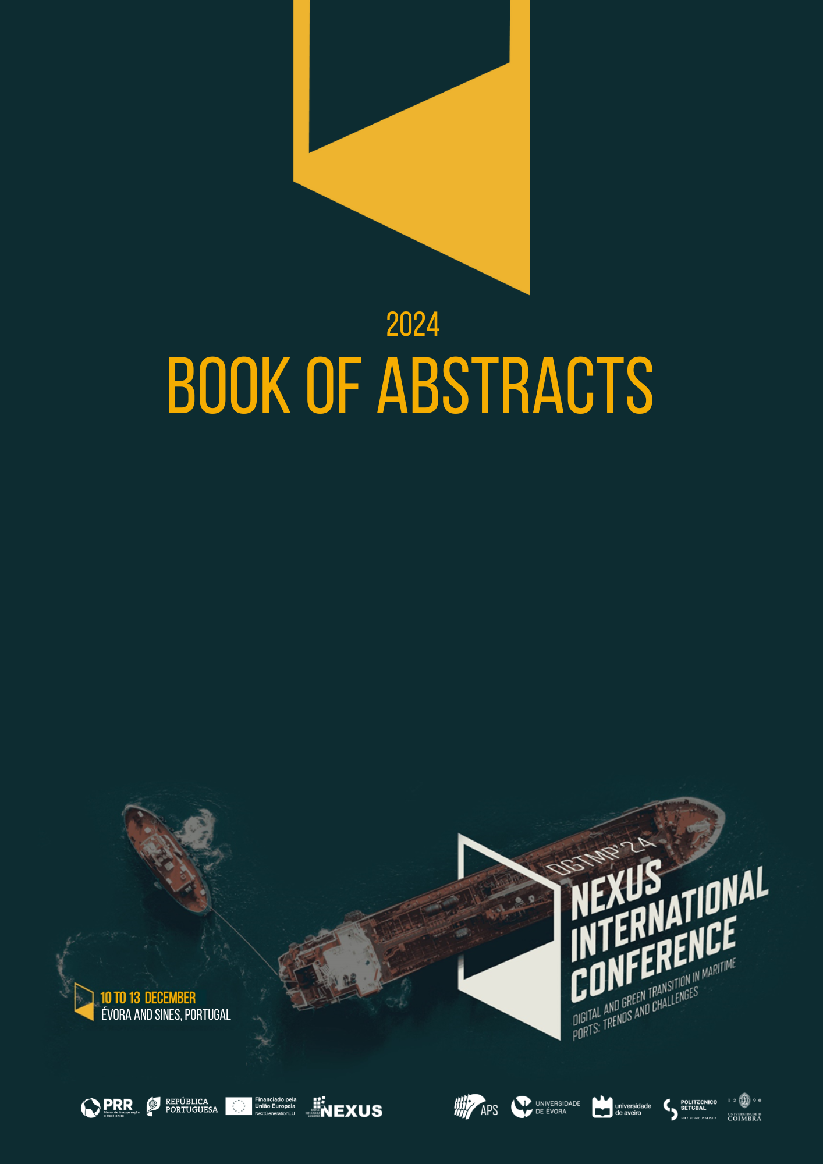
[Editors, editors editors]
[lorem ipsum dolore]

Citation: To be added by editorial staff during production.
Academic Editor: Firstname Lastname
Received: date
Revised: date
Accepted: date
Published: date

Copyright: © 2024 by the authors. Submitted for possible open access publication under the terms and conditions of the Creative Commons Attribution (CC BY) license (https://creativecommons.org/licenses/by/4.0/).
Communication
CCUS and CO₂ transport by ship in Portuguese decarbonization scenarios: from pilot to large-scale.
Paulo Mesquita ^{1 2*}, Júlio Carneiro ^{2 3*}, Pedro Madureira ^{2 3*}, Pedro Pereira ¹ ², Andrés Carro ⁶, Paula Afonso ¹ ⁴, Karwan Khudhur ¹ ², Patrícia Fortes ⁵, Ricardo Chacartegui ⁷
¹ Department of Geosciences, IIFA, University of Évora, 7000-671 Évora, Portugal; pmesquita@uevora.pt (P.M.); pmpereira@uevora.pt (P.P.); pafonso@uevora.pt (P.A.); karwan.khudhur@uevora.pt (K.K.)
² Institute of Earth Sciences (ICT), Center for Sci-Tech Research in Earth System and Energy (CREATE) 7000-671 Évora, Portugal
³ Department of Geosciences, Sciences and Technology School, University of Évora, 7000-671 Évora, Portugal; jcarneiro@uevora.pt (J.C.); pedro@uevora.pt (P.M.);
⁴ HERCULES Laboratory and IN2PAST, Associate Laboratory for Research and Innovation in Heritage, Arts, Sustainability and Territory, Institute for Advanced Studies and Research, University of Évora, 7000-809 Évora, Portugal.
⁵ NOVA School of Science and Technology, CENSE and CHANGE NOVA University of Lisbon, Caparica, Portugal ; p.fs@fct.unl.pt
⁶ Universidad de Sevilla, Sevilla, Spain ; andrescarro@us.es (A.C.)
⁷ Universidad de Sevilla, Laboratory of Engineering for Energy and Environmental Sustainability, Sevilla, Spain ; ricardoch@us.es (R.C.)

Abstract: The Portuguese target for carbon neutrality by 2050 will require the deployment of CO₂ capture, utilization and storage (CCUS). Although Techno-Economic Assessments (TEA) of CCUS scenarios targeting specific industrial sectors have been performed in Portugal in the scope of previous EU projects, the detailed analysis for the early stages of a CCUS chain, focusing on pilot scale, is necessary for policy makers and industry alike. Furthermore, ship transport may be a solution for a long-term large-scale CCUS scenario addressing the Sines industrial cluster, and in this scenario ship transport directly from the Sines port would play an important role. Within the CTS project (CO2 Transport and Storage directly from a ship) the technical and economic assumptions for designing a CCUS pilot in Portugal will be performed along with the study requirements of the possibility of direct CO₂ injection from a ship both for the pilot period and for a scenario focused on Sines emitters and infrastructure.
Keywords: Geologic CO₂ storage; CO₂ ship transport and injection; CCUS.

1. Introduction

Portugal’s national decarbonization strategy is framed by multiple guidelines, including the revised National Energy and Climate Plan (PNEC 2030) [1], the Carbon Neutrality Roadmap 2050 (RNC 2050) [2], the National Hydrogen Strategy (EN-H2) [3], and the Portuguese Climate Law (DL98/2021) [4]. The updated PNEC 2030, adopted in 2024, sets more ambitious goals, such as a 55% reduction in greenhouse gas (GHG) emissions by 2030 (compared to 2005 levels), achieving carbon neutrality by 2045, and sourcing 51% of energy from renewables. This includes significant expansion of solar and wind energy, a 35% reduction in primary energy consumption, and leveraging green hydrogen to decarbonize industries and store energy. While the RNC 2050 initially placed less emphasis on Carbon Capture, Utilization, and Storage (CCUS), the 2024 PNEC revision highlights CCUS as essential for hard-to-abate sectors like cement production. The plan also explores integrating CCUS with low-carbon hydrogen production and sustainable fuels, alongside bioenergy with carbon capture and storage (BECCS) for sectors like pulp & paper, and waste, aiming for negative emissions. Together, these strategies underline Portugal’s commitment to a low-carbon, sustainable economy.

CCUS [5] represents a set of technologies that aim at reducing the CO₂ emissions from stationary facilities into the atmosphere (Figure 1). The emitted CO₂ would be captured in an energy or industrial facility where the flue gas is treated and the CO₂ isolated; after the purification the CO₂ stream usually needs to be transported to a location where it will be used to produce other materials, like synthetic fuels, or to an injection site where the CO₂ will be permanently stored in deep underground geological reservoirs.

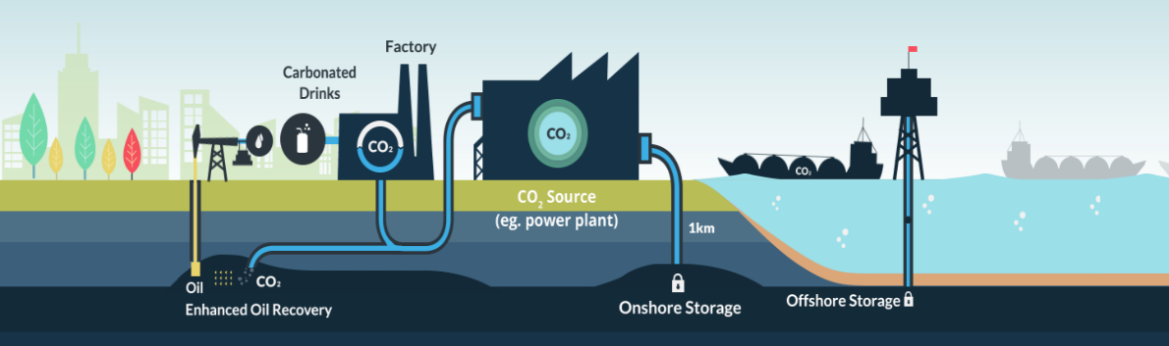
Figure 1. Scheme of the CCUS chain.

The transport of CO₂ in significant quantities can be done by pipeline, train and ship with multimodal solutions being possible in the same transport network. CO₂ pipelines exist in operation since the 70s in the United States, where CO₂ is used for EOR (enhanced oil recovery). Currently the country has more than 7200 km of pipelines dedicated to CO₂ transport that carry around 68 Mt/yr of CO₂. For efficiency, the transport of CO₂ via pipeline is performed at supercritical (temperature above 30 ºC) or dense (typical temperature range from -10 to 30 ºc) phases that demand pressures above 72 bar. In train and ship transport, the CO₂ is cryogenic usually in the configuration of low pressure (~6 bar, -50 ºC) or medium pressure (~15bar, -25 ºC). Train and pipeline transport of CO₂ are more mature technologies in relation to ship transport where only two dedicated ships for large quantities of CO₂ exist, with 7500 m³ of capacity, and built under the scope of the Northern Lights project [6]. Nevertheless, the shipping industry of CO₂ transport is expected to expand in the next years. Currently, the option of injecting CO₂ directly from the ship into offshore reservoirs is also a topic of research, since it has the potential to avoid the necessity of offloading facilities rigs.

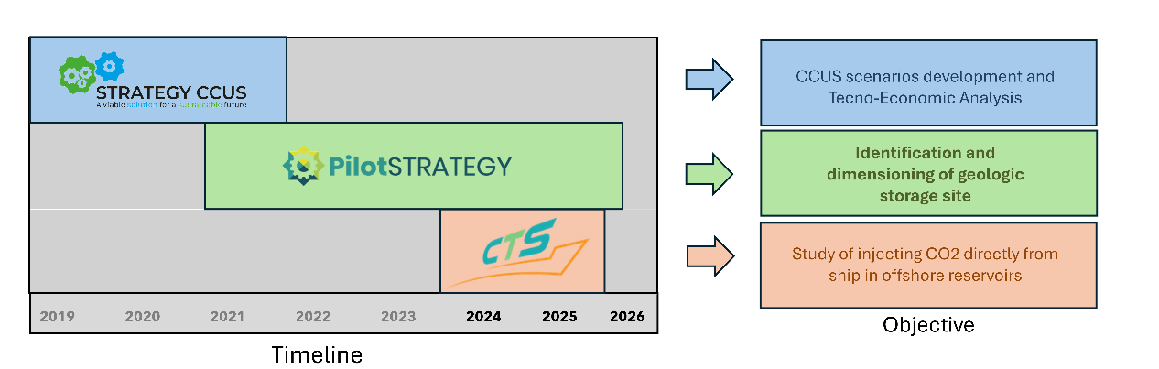
In Portugal, CCUS related studies have been developed since 2009 under the scope of multiple European level projects. The most recent projects (Figure 2) focused on the development and analysis of detailed long term CCUS scenarios until 2050 (StrategyCCUS) [7]; on the identification of suitable geological reservoir and it’s dimensioning for CO₂ injection (PilotSTRATEGY) [8]; and in the assessment of the viability of transport and injection directly from ship in the offshore reservoir for national scenarios (CTS) [9].
Figure 2. Recent CCUS projects with focus on Portuguese decarbonization scenarios.

This work aims at presenting the potential for CO₂ ship transport in Portuguese decarbonization scenarios both in an experimental pilot period that aims at testing the viability of capture in interested industries and testing the reservoir capabilities; and in a large-scale long-term scenario that considers the possibility of transporting the CO₂ captured from the Sines industrial cluster by ship to the offshore reservoir located near Figueira da Foz.

2. Pilot scenario

A pilot scenario was developed taking into consideration emitters interested in installing small-scale capture plants in Souselas and Marinha Grande. Flexible transport options, including direct injection from ship were considered for offshore storage to avoid the deployments of offshore pipelines or platforms. The design aimed at providing the needed CO₂ to conduct an injection pilot to validate the reservoir and injection models that have been developed in the Lusitanian basin in the scope of the project PilotSTRATEGY. The complete chain of processes, from capture to injection, was considered with focus on minimizing the deployment of permanent or hard-to-shift infrastructures.

Figure 3 depicts the pilot scenario scheme. The initial phase of the transport was considered to be by train, between both capture facilities and the Figueira da Foz port and by ship between the port and the offshore injection site. The CO₂ volume and transport conditions were matched between train and ship to allow for the CO₂ to be moved to the ship without the need for intermediate storage and/or intensive reconditioning. The considered train capacity was 4000 t with a roundtrip of ~12h including loading and unloading. The considered ship capacity was 4000 t with a roundtrip of ~80h and an injection rate of 15 kg/s of CO_{2.} Both train and ship roundtrips are matched for around 68 trips in the period of 3 years, with a transport capacity of 90,000 kt/y totalling 270,000 kt of CO₂.

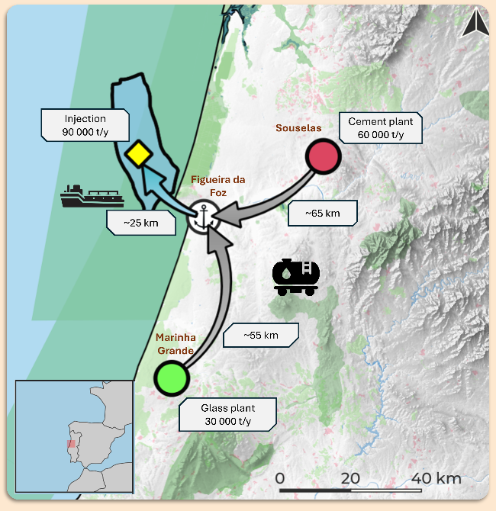

Figure 3. Schematics of the pilot scenario.

3. Towards large scale ship transport and injection

The CTS consortium is planning an innovative concept for the CO₂ transport by a ship. The project envisions bringing more flexibility to the CCUS chain, which would be supported by the construction of ships capable of transporting and directly injecting the CO₂ in the offshore reservoir without the need for permanent offshore platforms.

For the large-scale long-term scenario focused on Sines, some of the CO₂ emitters in the area would be considered for capture with an amount that could surpass 2 Mt of CO₂ per year, and the Sines port as an exportation hub for CO₂ since ships may benefit from the deep-water characteristics of Sines port. For this purpose, the port needs to be equipped with intermediate storage and equipment to prepare the CO₂ into the right conditions for ship transport.

Figure 4 portraits the long-term 2050 offshore scenario developed in the StrategyCCUS project where the transport would be exclusively by pipeline. A new approach on the CTS project will evaluate the inclusion of new emitters from the Sines industrial cluster and will evaluate the CO₂ ship transport and direct injection.

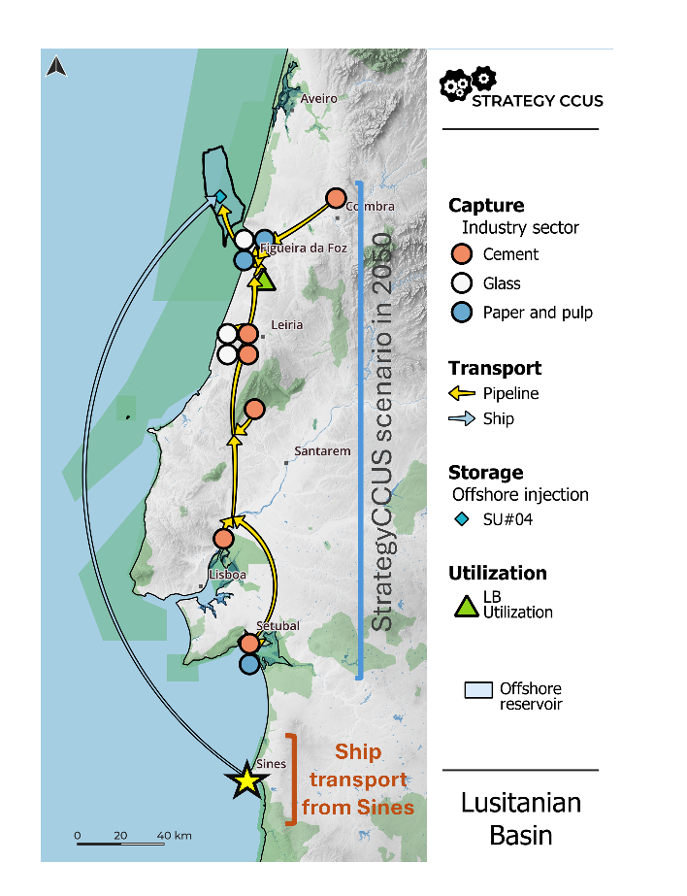
Figure 4. StrategyCCUS long term scenario with addition of the Sines cluster for ship transport.

References
- Direção-Geral de Energia e Geologia. (2023). Plano Nacional Energia e Clima 2030 (PNEC 2030) – Revisão 2023. Ministério do Ambiente e Ação Climática.
- Ministério do Ambiente e Ação Climática. (2019). Roteiro para a Neutralidade Carbónica 2050 (RNC 2050). Governo de Portugal.
- Ministério do Ambiente e Ação Climática. (2020). Estratégia Nacional para o Hidrogénio (EN-H2). Governo de Portugal.
- República Portuguesa. (2021). Lei n.º 98/2021, de 31 de dezembro: Lei de Bases do Clima. Diário da República.
- Global CCS Institute. (2024). Global status of CCS 2024: Collaborating for a Net-Zero Future.
- https://www.northernlightsccs.com
- https://strategyccus.brgm.fr/
- https://pilotstrategy.eu/
- https://www.cts-cetp.net/

